Stackable Instructionally-embedded Portable Science (SIPS) Assessments Project

Grade 5 Science
Unit 2 Instructionally-embedded Assessment Task:
“Lights for Plants, On or Off?”
Matter and Energy in Organisms and Ecosystems
January 2023

The SIPS Grade 5 Science Unit 2 Instructionally-embedded Assessment Task: “Lights for Plants, On or Off?” was developed with funding from the U.S. Department of Education under the Competitive Grants for State Assessments Program, CFDA 84.368A. The contents of this paper do not represent the policy of the U.S. Department of Education, and no assumption of endorsement by the Federal government should be made.

All rights reserved. Any or all portions of this document may be reproduced and distributed without prior permission, provided the source is cited as: Stackable Instructionally-embedded Portable Science (SIPS) Assessments Project. (2023). SIPS Grade 5 Science Unit 2 Instructionally-embedded Assessment Task: “Lights for Plants, On or Off?”. Lincoln, NE: Nebraska Department of Education.

SIPS Grade 5 Unit 2 Instructionally-embedded Assessment Task
Grade 5 | Unit 2 | Group: 5.B | Task Title: Lights for Plants, On or Off?
NGSS Performance Expectations Code(s) and Description(s)
Code | Description
5-PS3-1 | Use models to describe that energy in animals’ food (used for body repair, growth, motion, and to maintain body warmth) was once energy from the sun. [Clarification Statement: Examples of models could include diagrams, and flow charts.]
Acquisition Goals Number(s) and Descriptions(s)
Number | Description
A9 | Analyze and interpret data to determine the role of sunlight in the process of making food by plants.
A10 | Engage in argument from evidence about the role of sunlight in the process plants use to make food.
Evidence Statements
- Describe patterns in data related to the role of sunlight in the process of making food by plants.
- Use data to answer questions related to the role of sunlight in the process of making food by plants.
- Use evidence, data, or a model to support an argument about the role of sunlight in the process plants use to make food.

Source Documentation and Information Resources References (e.g., publications, websites, citations, images, videos, etc.)  Please include source name, description, citation, and a link to its original location below. Include additional rows as needed. | Licensing: Please mark an “X” under the appropriate licensing. If resource is not under a creative commons (CC) license, please attempt to find a source with CC licensing. If you are unable, please select other and provide additional information about the source in the source documentation section.
 | CC0/  Public Domain | CC BY | CC BY-SA | CC BY-NC | CC BY-NC-SA | CC BY-ND | CC BY-NC-ND | Other
Associated with Prompts 1 and 2:  - Table 1. Plants Grown under Different light Conditions and Table 2: Daily Color of Plant Leaves Under Different Conditions, developed by educators | X
Associated with Prompt 2:  - Graph 1. Plant Growth Under Different Conditions (in centimeters) , developed by educators | X

Teacher Administration Guide

Introduction
- Educators developed the accompanying classroom task to align to one or more aspects of the NGSS Performance Expectation(s) (PEs) to determine where students are in their learning at a specific point in time during an instructional sequence. Educators will need to make intentional decisions about when and how to use this task based on their students’ learning needs, the purpose of giving the task, and the intended use of the evidence gathered.
- This task is designed to measure students’ ability to integrate the dimensions and demonstrate their knowledge, skills, and abilities as represented by NGSS Performance Expectations 5-PS3-1. By administering this task, educators can gather and evaluate evidence to make accurate and meaningful judgments about students’ science learning and determine how instruction may need to be adjusted along an instructional sequence to best support students.
- The phenomenon addressed in this phenomenon-based scenario is the role of sunlight in the process used by plants to form plant matter. Students will use data to determine plant placement in relation to the light source. Students will use their prior learning to engage with the task. By the end of grade 2, students know that plants depend on water and light to grow. Students also know that living things need water, air, and resources from the land, and they live in places that have the resources to meet their needs. By the end of grade 4, students know that light transfers energy from place to place. From Segment 1, students also have prior knowledge that animals obtain the food they need from plants and other animals. A key aspect is that the food of almost any animal can be traced back to plants. Another key aspect from Segment 1 includes the fact that food webs, in which some animals eat plants and/or other animals for food, illustrate the relationships among organisms in their environment.
- In this task, students figure out the best location for a plant to be placed in the classroom to reach its maximum potential. They will demonstrate learning by evaluating and analyzing data to explain where a plant should be placed in the classroom for the plant to best grow.
Administration Guidelines
- One (1) class period
- Segment 2, Lesson: “Conditions for Plant Growth”
  - Students will have completed a series of lessons during this instructional segment and informal and formal assessment tasks prior to the administration of this task related to the movement of energy and matter through an ecosystem, the interdependent relationships and interactions among animals and plants in an ecosystem, and the importance of the sun in providing energy to plants that form the foundation of the food web. These learning and assessment opportunities lead to students’ ability to analyze and interpret data to determine the role of sunlight in making food by plants.
- Students individually complete a series of prompts reflecting the following chain of sensemaking:
  - Students are introduced to a scenario related to a school club’s intention to grow vegetables. The students must determine the best growing conditions for the seedlings to grow in the classroom.
  - Students interpret and explain the results of several experiments related to the growth of plants under various light conditions.
  - Students will analyze and interpret a data chart that shows varying degrees of leaf development, leaf color, and stem growth (height and direction).
  - Students create an argument that supports their placement of the plants in a map of a classroom, based on data.
  - Finally, students use the data evidence to create an argument about the role of sunlight in the relationship between energy and plant growth.

Accessibility Considerations
Providing a range of accessibility considerations in the task (e.g., multiple ways of representing information, multiple types of supports, multiple ways in which students respond) promotes equity and fairness across a wide range of students who may be at different points in their science learning. In turn, these considerations can promote student interest and engagement in the tasks resulting in a more complete and accurate collection of evidence of students’ science learning.
Accommodations for students with a disability or Multilingual Learners that are part of their ongoing instructional programs are to be provided during the administration of this task. Accommodations should be consistent with those provided in students’ daily instructional strategies and assessment opportunities, including assistive technology devices if appropriate. These accessibility considerations and accommodations enable accurate inferences about student learning and inform meaningful adjustments to planning and instruction.

Ancillary Materials
N/A

Instructions for Administering the Performance Task or Implementing the Research Task, Design Project, or Lab
- Students engage in observation and gather data to address the question about the pattern between light and plant growth and to argue for the cause-and-effect relationship between light and plant growth.

Scoring Guidance
- A prompt-specific scoring rubric indicates scoring criteria for each prompt or activity across a range of score points.
- Student exemplars represent high-quality responses that align to full-point rubric scores. The exemplar responses are intended to assist educators’ understanding of the nature and expectations of each prompt when applying the scoring rubric. Note the exemplars serve as examples of high-quality responses, and students may respond with equally relevant, scientifically accurate responses and ideas that meet the expectations of a full-point rubric score. In general, the exemplar response associated with the highest score point in the rubric meets expectations and is scientifically accurate, complete, coherent, and consistent with the type of student evidence expected as described in the rubric.
- The approximate scoring time for each student per prompt is:
  - Prompt 1 will require 1 to 2 minutes
  - Prompt 2 will require 1 to 2 minutes
  - Prompt 3 will require 1 to 2 minutes
  - Prompt4 will require 1 to 2 minutes
- The scoring time for this task will be approximately one class period for all students’ responses.

Student Task
This task is about what plants need for growth.
Task Scenario
A group of students in the Farming Club would like to start growing vegetables in their classroom this spring, and then transplant them to the school garden when the weather is warmer. As they do so, they want to learn more about why grass grows, flowers bloom, and fruits blossom and ripen.

Prompt 1
The students design a simple experiment to answer the following question:
What is the most effective light source for plant growth?

The students grow the same number of seedlings under two light conditions: artificial light and natural light. Both light sources have the same amount of brightness. After four weeks the students record the average weight and average number of leaves for each group of plants. Table 1 shows the data the students collect.
Table 1. Plants Grown under Different Light Conditions
Light Condition | Average weight per plant (in grams) | Average number of leaves per plant
Artificial | 1.8 | 11
Natural | 2.0 | 15

What conclusions can you make about the different light sources and plant growth based on the results shown in Table 1? Support your response with data from Table 1.
______________________________________________________________________________

______________________________________________________________________________

______________________________________________________________________________

Prompt 2
The students then have another question to answer.
Does the amount of light a plant gets affect the rate of plant growth?

For this experiment, the students use three identical pots. In each pot, they plant the same number of seeds of the same type of plant. The students place the three pots on a shelf on the opposite side of the classroom from where the windows are located. Five days after the first growth appears, they move one of the pots into a closet with no light and one of the pots onto a windowsill in full sun. They leave the last pot where it is on the shelf.
After one week, the students observe the color of the plant leaves daily. Their results are shown in Table 2.
Table 2: Daily Color of Plant Leaves Under Different Conditions
Condition | Day 1 | Day 2 | Day 3 | Day 4 | Day 5 | Day 6 | Day 7 | Day 8 | Day 9
Shelf | Green | Green | Green | Green | Green | Green | Green | Green | Green
Windowsill | Green | Green | Green | Green | Green | Green | Green | Green | Green
Closet | Green | Green | Green | Green | Yellow | Yellow | Yellow | Yellow | Yellow

The students also record the average height of the plants in each of the three pots. Their results are shown in Graph 1.
Graph 1. Plant Growth Under Different Conditions (in centimeters)
Height
Use the results shown in Table 2 and Graph 1 to answer the students’ question as YES or NO. Explain the evidence you used to determine the answer.
The answer to their question is __________. I know this because ________________________ _______________________________________________________________________________________________________________________________________________________________________________________________________________________________________________________________________________________________________________________.
Prompt 3
The students then have a final question to answer.
Where in the classroom should students in the Farming Club start growing vegetables in their classroom this spring?

Based on the evidence the students gather:
- Mark on Figure 1 where the vegetable plants should be placed.
- Explain your answer using data from Table 1 and Table 2.
Figure 1. Classroom Chart
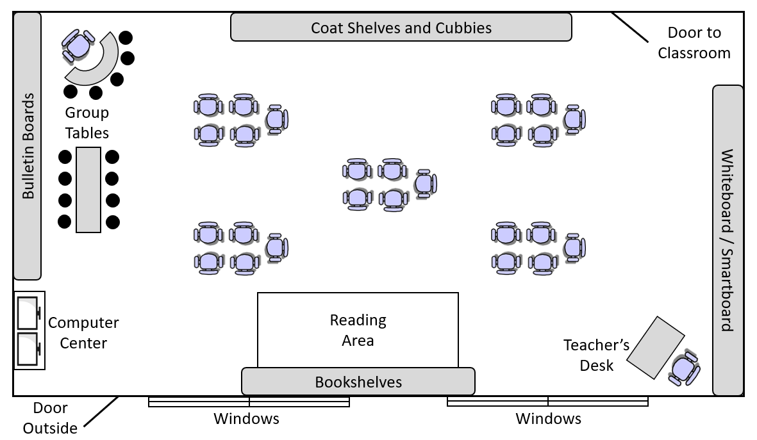

The Farming Club should grow their plants ___________________________________________ ______________________________________________________________________________because_______________________________________________________________________________________________________________________________________________________________________________________________________________________________________________________________________________________________________________________________________________________________________________________________
Prompt 4
Support the claim that there is an energy transfer relationship between plants and the sun using evidence from two of the students’ data sets. Use scientific knowledge to show how the evidence supports the claim.
________________________________________________________________________________________________________________________________________________________________________________________________________________________________________________________________________________________________________________________

Task Rubric to Evaluate Student Evidence
Task | Score Point 0 | Score Point 1 | Score Point 2 | Score Point 3
Prompt 1 | No aspect of the response is correct, or no aspect of the response is provided | Student explanation that plants grow better in natural light references data related to the difference in the plants’ mass OR number of leaves | Student explanation that plants grow better in natural light references data related to the difference in the plants’ mass AND number of leaves | NA
Prompt 2 | No aspect of the response is correct, or no aspect of the response is provided | Response includes one (1) of the four (4) aspects | Response includes two (2) or three (3) of the four (4) aspects | Response includes the following aspects:  - Answer is “Yes”  - References at least two conditions (shelf, windowsill, closet)  - Includes data from Table 2 that shows differences in color of leaves  - Includes data from Graph 1 that shows differences in height of plants
Prompt 3 | No aspect of the response is correct, or no aspect of the response is provided | Response includes one (1) of the three (3) aspects | Response includes two (2) of the three (3) aspects | Response includes the following aspects:  - Indicates the plants should be grown near window  - References at least two data sources (Table 1, Table 2, Graph 1)  - Justifies placement based on data
Prompt 4 | No aspect of the response is correct, or no aspect of the response is provided. | Response includes one (1) of the two (2) aspects | Response includes the following aspects:  - Describes the relationship between a plant’s growth and energy from the sun  - References at least two data sources (Table 1, Table 2, Graph 1) | NA

Exemplar Responses
Prompt 1
What conclusions can you make about the different light sources and plant growth based on the results shown in Table 1? Support your response with data from Table 1.
The plants grown in natural light had a higher mass and a higher number of leaves than the plants grown in artificial light. The plants grown in natural light had an average mass of 0.2 g more than the plants grown in artificial light. The plants in natural light also had 4 more leaves than the plants grown in artificial light.
Prompt 2
Use the results shown in Table 2 and Graph 1 to answer the students’ question as YES or NO. Explain the evidence you used to determine the answer.
The answer to their question is yes. I know this because after 9 days, the plant placed on the windowsill remained green throughout the 9 days while the plant leaves in the closet started turning yellow after Day 4. Also, after 9 days, the plant placed on the windowsill grew much more than the plant that stayed on the shelf. The plant on the windowsill got to be 4.5 cm and the plant on the shelf only got to be 3.25 cm tall. The plant that was placed in the closet got smaller; it went from 1.25 cm to 0.5
Prompt 3
The students then had a final question to answer.
Where in the classroom should students in the Farming Club start growing vegetables in their classroom this spring?

Based on the evidence the students gathered:
- Mark on Figure 1 where the vegetable plants should be placed.
- Make sure to support your answer by referring to the data in Table 1 and Table 2.

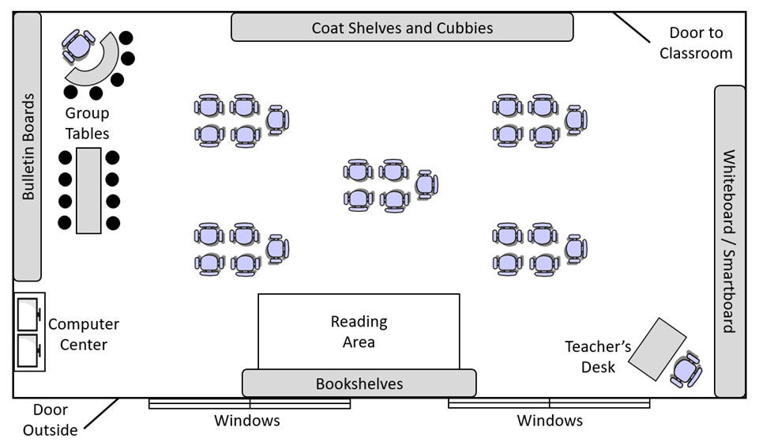
Grow plants here.

The Farming Club should grow their plants on the bookshelves near the windows to receive the best sunlight exposure for maximum growth. The plants will grow the best there because according to Table 1, plants grow more leaves in natural light. So, the plants will get more natural light near the windows. Further away, they will get more artificial light from the classroom lights. Also, Table 2 showed that the plants grew a lot taller on the windowsill than anywhere else in the classroom.
Prompt 4
Support the claim that there is an energy transfer relationship between plants and the sun using evidence from two of the students’ data sets. Use scientific knowledge to show how the evidence supports the claim.
All living things need energy to grow. Plants use the sun’s energy to grow. I know this because the results from both data tables show how plants use sunlight to grow. In a dark closet, the leaves turn yellow. When grown closer to sunlight on the windowsill, plants grow faster. Since living things need energy to grow, plants must get that energy from the sun.
Task Notes
N/A

