Foo

Stackable Instructionally-embedded Portable Science (SIPS) Assessments Project

Grade 5 Science
Unit 2 Instructionally-embedded Assessment Task:
“The Life of a Bear”
Matter and Energy in Organisms and Ecosystems
January 2023

The SIPS Grade 5 Science Unit 2 Instructionally-embedded Assessment Task: “The Life of a Bear” was developed with funding from the U.S. Department of Education under the Competitive Grants for State Assessments Program, CFDA 84.368A. The contents of this paper do not represent the policy of the U.S. Department of Education, and no assumption of endorsement by the Federal government should be made.

All rights reserved. Any or all portions of this document may be reproduced and distributed without prior permission, provided the source is cited as: Stackable Instructionally-embedded Portable Science (SIPS) Assessments Project. (2023). SIPS Grade 5 Science Unit 2 Instructionally-embedded Assessment Task: “The Life of a Bear”. Lincoln, NE: Nebraska Department of Education.

SIPS Grade 5 Unit 2 Instructionally-embedded Assessment Task
Grade 5 | Unit 2 | Instructional Segment 1 | Task Title: The Life of a Bear
NGSS Performance Expectations Code(s) and Description(s)
Code | Description
5-PS3-1 | Use models to describe that energy in animals’ food (used for body repair, growth, motion, and to maintain body warmth) was once energy from the sun. [Clarification Statement: Examples of models could include diagrams, and flow charts.]
5-LS2-1 | Develop a model to describe the movement of matter among plants, animals, decomposers, and the environment. [Clarification Statement: Emphasis is on the idea that matter that is not food (air, water, decomposed materials in soil) is changed by plants into matter that is food. Examples of systems could include organisms, ecosystems, and the Earth.] [Assessment Boundary: Assessment does not include molecular explanations.]
Acquisition Goals Number(s) and Descriptions(s)
Number | Description
A4 | Obtain and communicate information about how the energy for motion and/or body warmth in animals comes from food.
A5 | Use a model to describe how the energy for motion and/or body warmth in animals comes from food.
A6 | Use a model to describe that plants form the foundation of the food web.
Evidence Statements
- Identify information that relates to how energy for motion and/or body warmth in animals comes from food.
- Describe how the energy for motion and/or body warmth in animals comes from food.
- Describe how a model shows how energy for motion and/or body warmth in animals comes from food.
- Use models to show how tracing most animals' food source(s) eventually leads back to plants.

Source Documentation and Information Resources References (e.g., publications, websites, citations, images, videos, etc.)  Please include source name, description, citation, and a link to its original location below. Include additional rows as needed. | Licensing: Please mark an “X” under the appropriate licensing. If resource is not under a creative commons (CC) license, please attempt to find a source with CC licensing. If you are unable, please select other and provide additional information about the source in the source documentation section.
 | CC0/  Public Domain | CC BY | CC BY-SA | CC BY-NC | CC BY-NC-SA | CC BY-ND | CC BY-NC-ND | Other
Associated with Prompt 1:  - “How do Bears Hibernate?”, Making Science Make Sense – You Tube Video File Presented by Bayer US  [https://www.youtube.com/watch?v=03cXAZjgo8k] |  |  |  |  |  |  |  | X
Associated with Prompt 2:  - Bear Bears Grizzley - Free image on Pixabay associated with Prompt 2:  [https://pixabay.com/illustrations/bear-bears-grizzley-predator-wild-6329648/]  - Grasshopper Insect Nature - Free photo on Pixabay  [https://pixabay.com/photos/grasshopper-insect-nature-animal-279532/]  - Berry Blackberries Fruit - Free photo on Pixabay  [https://pixabay.com/photos/berry-blackberries-fruit-food-3513546/]  - Wildlife Elk Calf - Free photo on Pixabay  [https://pixabay.com/photos/wildlife-elk-calf-herd-6003977/]  - Ground Squirrel Animal Outdoor - Free photo on Pixabay  [https://pixabay.com/photos/ground-squirrel-animal-outdoor-144080/]  - 40+ Free Wild Salmon & Salmon Images - Pixabay  [https://pixabay.com/images/search/wild%20salmon/?manual_search=1]  - Meadow Field Grass - Free photo on Pixabay  [https://pixabay.com/photos/meadow-field-grass-green-nature-3375052/]  - Moose Animal Large - Free photo on Pixabay  [https://pixabay.com/photos/moose-animal-large-antler-1180557/]  - 100+ Free Canadian Geese & Geese Images - Pixabay  [https://pixabay.com/images/search/canadian%20geese/?manual_search=1]  - Fox Nature Animals - Free photo on Pixabay  [https://pixabay.com/photos/fox-nature-animals-roux-fauna-715588/]  - Roe Deer Animal - Free photo on Pixabay  [https://pixabay.com/photos/roe-deer-deer-animal-roe-1367182/]  - Acorn Nut Branch Oak - Free photo on Pixabay  [https://pixabay.com/photos/acorn-nut-branch-oak-tree-food-3694485/]  - Animal Rabbit Mammal - Free photo on Pixabay  [https://pixabay.com/photos/animal-rabbit-mammal-species-fauna- 1850192/] | X

Teacher Administration Guide

Introduction
- Educators developed the accompanying classroom task to align to one or more aspects of the NGSS Performance Expectation(s) (PEs) to determine where students are in their learning at a specific point in time during an instructional sequence. Educators will need to make intentional decisions about when and how to use this task based on their students’ learning needs, the purpose of giving the task, and the intended use of the evidence gathered.
- This task is designed to measure students’ ability to integrate the dimensions and demonstrate their knowledge, skills, and abilities as represented by NGSS Performance Expectations 5-PS3-1 and 5-LS2-1. By administering this task, educators can gather and evaluate evidence to make accurate and meaningful judgments about students’ science learning and determine how instruction may need to be adjusted along an instructional sequence to best support students.
- The phenomenon addressed in phenomenon-based scenario is the transfer of energy among organisms in a food web in a forest environment (LS1.C: Organization for Matter and Energy Flow in Organisms), and that animals need energy so they can stay warm, grow, and move to get what is needed to survive (food, water, air, and space). The bear is introduced as an organism in this ecosystem which consumes large amounts of food to obtain energy for its behaviors that contribute to survival.
- In this task, students figure out how these bears obtain energy as a component in a food web in a forest ecosystem. Students gather facts about bears and their environment while watching a video, complete a food web, and then explain their understanding of the transfer of energy in a forest ecosystem that supports animal survival.
Administration Guidelines
- One (1) class period
- Segment 1 Lessons: “Eating for Energy and Matter” and “The Importance of Plants in Food Webs”
- Students individually complete a series of prompts reflecting the following chain of sensemaking:
  - Students watch a video and complete a graphic organizer to identify behaviors of grizzly bears.
  - Students use provided components of an ecosystem in which grizzly bears live to create a model of a food chain and the flow of energy.
  - Students explain the relationship between the consumer (grizzly bear) and the matter (e.g., plants, insect, elk) that is consumed and the use of this energy to support movement and survival.
Accessibility Considerations
Providing a range of accessibility considerations in the task (e.g., multiple ways of representing information, multiple types of supports, multiple ways in which students respond) promotes equity and fairness across a wide range of students who may be at different points in their science learning. In turn, these considerations can promote student interest and engagement in the tasks resulting in a more complete and accurate collection of evidence of students’ science learning.
Accommodations for students with a disability or Multilingual Learners that are part of their on-going instructional programs are to be provided during the administration of this task. Accommodations should be consistent with those provided in students’ daily instructional strategies and assessment opportunities, including assistive technology devices if appropriate. These accessibility considerations and accommodations enable accurate inferences about student learning and inform meaningful adjustments to planning and instruction.

Ancillary Materials
- Computer for students to view a video individually or in small/large group(s) for Prompt 1
  - How do Bears Hibernate? | Making Science Make Sense – You Tube Video File Presented by Bayer US
[https://www.youtube.com/watch?v=03cXAZjgo8k]
- Scissors, glue, or tape associated with Prompt 2

Instructions for Administering the Performance Task or Implementing the Research Task, Design Project, or Lab
- Preview the video, “How do Bears Hibernate”, and identify and pre-teach any general academic vocabulary words or domain-specific vocabulary words. Students should have access to and document the meaning of the vocabulary words to support their interpretation and understanding of the video’s content.
- Show 00:56/01:31 of the video which highlights changes in bear behaviors and the environment in preparation for hibernation. Be sure to enable Closed Captions [CC].
- Print Table 1. Organisms Found in a Forest Ecosystem associated with Prompt 3 which provides organisms (plants and animals) associated with a forest ecosystem in which the bear lives.
- Provide scissors and paste/glue for students to complete Model 1. Grizzly Bear’s Food Web.

Scoring Guidance
- A prompt-specific scoring rubric indicates scoring criteria for each prompt or activity across a range of score points.
- Student exemplars represent high-quality responses that align to full-point rubric scores. The exemplar responses are intended to assist educators’ understanding of the nature and expectations of each prompt when applying the scoring rubric. Note the exemplars serve as examples of high-quality responses, and students may respond with equally relevant, scientifically accurate responses and ideas that meet the expectations of a full-point rubric score. In general, the exemplar response associated with the highest score point in the rubric meets expectations and is scientifically accurate, complete, coherent, and consistent with the type of student evidence expected as described in the rubric.
- The approximate scoring time for each student per prompt is:
  - Prompt 1 will require approximately 3 to 5 minutes
  - Prompt 2 will require approximately 1 to 2 minutes
  - Prompt 3 will require approximately 3 to 5 minutes
  - Prompt 4 will require approximately 1 to 2 minutes
Student Task
This task is about the transfer of energy in an environment.
Task Scenario
Animals live in different environments. During colder seasons, there is less food for animals to eat. This causes animals to change their behaviors. This is true for the grizzly bear.
Picture 1. Grizzly Bear
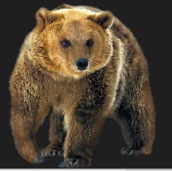

In the spring and summer, grizzly bears find plenty of food to eat. A single bear can eat up to 30 pounds of food each day. This is like eating 20 dozen eggs. But in the fall, bears need to eat much more food. They will eat up to 90 pounds of food each day. This is because they are getting ready for a long, winter hibernation. Why do bears need to eat so much food before they hibernate?
Prompt 1
As you watch the video, “How Do Bears Hibernate?”, use information from the video to fill in the blank spaces in Figure 1 with at least five facts about bears and their environment. Include facts about:
- Changes in weather and food sources
- How the bear stores energy from the food
- Why the bear’s body uses less energy
- How the bear survives the winter without food

Fill in each of the five circles in Figure 1 with one fact about bears and their environment. Use your knowledge and information from the video in your response.
Figure 1. Facts about Bears and their Environment
Grizzly Bear

Prompt 2
List two reasons why bears eat a lot more food in the fall as compared to other seasons.
Reason #1:___________________________________________________________________
____________________________________________________________________________
Reason #2: ___________________________________________________________________
____________________________________________________________________________

Prompt 3
Grizzly bears eat a diet that’s 90% vegetation like berries, nuts, and roots. They also eat salmon and other meats such as deer calves.
Table 1 shows some of the organisms that are found in a forest ecosystem. Think about how these organisms could be used to create the grizzly bear’s food web and how energy would transfer among these organisms.
Table 1. Organisms Found in a Forest Ecosystem
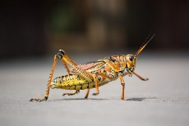  Insects | 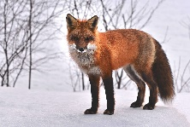  Fox | 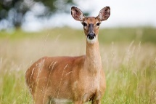  Deer | 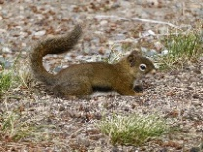  Ground Squirrel
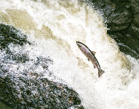  Salmon (Fish) | 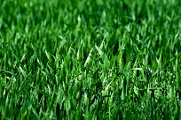  Grass | 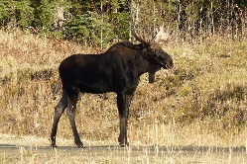  Moose | 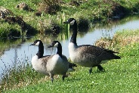  Geese
 | 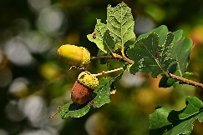  Nuts | 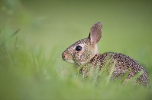  Rabbit
Use the pictures of organisms in Table 1 to complete Model 1. Add arrows to show the transfer of energy among the organisms in the food web.
- Cut out the organisms from Table 1.
- Paste or tape one picture of an organism in each box in Model 1.
- Include at least two producers.
- Use arrows to show the movement of energy among the organisms.
You do not need to use all the organisms.

Model 1. Grizzly Bear’s Food Web

Bear

Grizzly Bear

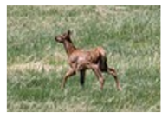
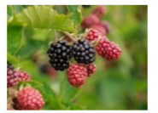
Prompt 4
Berries
Elk Calf
Part A.
An organism in this food web that uses sunlight energy to produce its own food is
_______________________________.

This organism is called a (circle one): producer consumer
Part B.
Describe the transfer of energy in your food web of a forest ecosystem. Use your science knowledge and information from Figure 1 and Model 1 to support your responses.
In the fall, bears get energy by __________________________________________________
___________________________________________________________________________
___________________________________________________________________________
Bears store this energy as fat. During hibernation, bears use this stored energy to _________
__________________________________________________________________________________
__________________________________________________________________________________

Task Rubric to Evaluate Student Evidence
Task | Score Point 0 | Score Point 1 | Score Point 2 | Score Point 3 | Score Point 4 | Score Point 5
Prompt 1 | No aspect of the response is correct | Response includes at least 1 behavior of bears | Response includes at least 3 behaviors of bears | Response includes five (5) facts about the behaviors of bears and/or their environment | NA | NA
Prompt 2 | No aspect of the response is correct | Response includes one (1) reason why bears increase the amount of food they eat in the fall | Response includes two (2) reasons why bears increase the amount of food they eat in the fall | NA | NA | NA
Prompt 3 | No aspect of the response is correct | Response includes:  - Correct direction and placement of an arrow between one (1) producer and one (1) consumer  OR  An arrow from one (1) primary consumer to one (1) secondary consumer | Response includes:  - An organism in each box  - Includes at least one producer  - Correct direction and placement of arrows for the selected organisms  between one (1) producer and at least two (2) consumers  AND  An arrow from one (1) primary consumer to one (1) secondary consumer | Response includes:  - An organism in each box  - Includes at least two producers  - Correct placement and direction of arrows indicating the transfer of energy for all of the selected organisms | NA | NA
Prompt 4  Part A & Part B. | No aspect of the response is correct | Response includes one (1) of the three (3) aspects | Response includes two (2) of the three (3) aspects | Response includes the following aspects:  Part A  - Identifies plants or an example of a plant as organism in the food web that produces its own food  - Circles “producer”  Part B  - Identifies that bears get energy by eating plants/producers and animals/  consumers  AND  - Bears use stored energy to survive in the winter months when they are hibernating and/or not eating | NA | NA

Exemplar Responses
Prompt 1
Fill in each of the five circles in Figure 1 with one fact about bears and their environment. Use your knowledge and information from the video in your response.
(Note: Example correct responses are included and more than one correct fact is included in a single circle.)
Figure 1. Facts About Bears and their Environment
Grizzly Bear

Prompt 2
List two reasons why bears eat a lot more food in the fall as compared to other seasons.
Reason #1: Bears can still find food in the fall. There is less food during the winter months.
Reason #2: Bears eat more to put on extra weight. They gain weight and get fat. They need this fat as a source of energy during the winter.

Prompt 3
Use the pictures of organisms in Table 1 to complete Model 1. Add arrows to show the transfer of energy among the organisms in the food web.
- Cut out the organisms from Table 1.
- Paste or tape one picture of an organism in each box in Model 1.
- Include at least two producers.
- Use arrows to show the movement of energy among the organisms.
You do not need to use all of the organisms.
(Note: Other full point responses should include producers and consumers and correctly indicate the flow of energy among the organisms included in the food web.)
Model 1. Bear Food Web
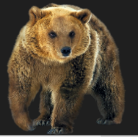

Grizzly bear
Bear

Ground squirrel

Fox
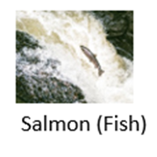
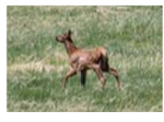

Elk Calf

Rabbit
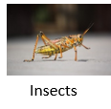

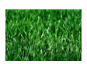
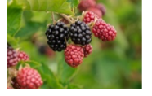
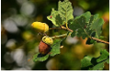

Berries

Nuts

Grass

Prompt 4
Part A.
An organism in this food web that uses sunlight energy to produce its own food is
(roots, berries, or nuts)
This organism is called a (circle one): producer consumer
Part B.
Describe the transfer of energy in your food web of a forest ecosystem. Use your science knowledge and information from Figure 1 and Model 1 to support your responses.
In the fall, bears get energy by eating plants/producers, insects, or other animals.
Bears store this energy as fat. During hibernation, bears use this stored energy to survive the long winter months when they are not eating.
Task Notes
- Present the task and have students watch the following video to respond to Prompt 1:
  - How do Bears Hibernate? | Making Science Make Sense – You Tube Video File Presented by Bayer US
[https://www.youtube.com/watch?v=03cXAZjgo8k]
- Print Table 1. Organisms Found in a Forest Ecosystem associated with Prompt 3 which provide organisms (plants and animals) associated with a forest ecosystem in which the grizzly bear lives.
- Provide scissors and paste/glue for students to complete Model 1. Grizzly Bear’s Food Web, associated with Prompt 3.

