Stackable Instructionally-embedded Portable Science (SIPS) Assessments Project

Grade 5 Science
Unit 2 Student Profile
Matter and Energy in Organisms and Ecosystems
October 2022

The SIPS Grade 5 Science Unit 2 Student Profile: Matter and Energy in Organisms and Ecosystems was developed with funding from the U.S. Department of Education under the Competitive Grants for State Assessments Program, CFDA 84.368A. The contents of this paper do not represent the policy of the U.S. Department of Education, and no assumption of endorsement by the Federal government should be made.

All rights reserved. Any or all portions of this document may be reproduced and distributed without prior permission, provided the source is cited as: Stackable Instructionally-embedded Portable Science (SIPS) Assessments Project. (2022). SIPS Grade 5 Science Unit 2 Student Profile: Matter and Energy in Organisms and Ecosystems. Lincoln, NE: Nebraska Department of Education.

SIPS Grade 5 Science Unit 2 Student Profile
The Stackable, Instructionally-embedded, Portable Science (SIPS) Assessments Unit 2 Student Profile describes what students should know and be able to demonstrate prior to, during, and at the culmination of three-dimensional science instruction in Unit 2 to prepare for new and increasingly sophisticated learning opportunities in Unit 3. The student profile is intended to build science educators’ understanding of the targeted student learning outcomes and how they are situated in the context of year-long instruction to promote and inform the intentional selection of curricular materials and design of instructional opportunities to achieve these outcomes for all students. In addition, the end-of-unit profile can support discussion with students, parents, and guardians about the Unit 2 topic of interest, “Matter and Energy in Organisms and Ecosystems”, and the knowledge, skills, and abilities to which teaching and opportunities to learn will be based.
The SIPS Assessments Unit 2 Student Profile provides a description of:
- The necessary prior learning opportunities and prior knowledge and skills that students are expected to have acquired for all three dimensions—Science and Engineering Practices (SEPs), Disciplinary Core Ideas (DCIs), and Crosscutting Concepts (CCCs)—before engaging in Unit 2. These prior learning opportunities and knowledge and skills serve as entry points to the unit to ensure readiness and to foster understanding of new and increasingly sophisticated learning experiences. This section also explains how prior learning, knowledge, and skills will be built upon in the unit.
- The knowledge, skills, and abilities students are expected to learn and demonstrate by the end of the unit when provided with opportunities to integrate scientific and engineering practices with important disciplinary core ideas and crosscutting concepts to scientifically investigate and understand natural phenomena and solve important science and engineering design problems.
- The learning experiences in Unit 3 allow students to build from and expand their learning in Unit 2 to effectively engage in the SEPs to sense-make using acquired scientific knowledge and understanding of the CCCs in the context of multiple DCIs. This section highlights key connections among important scientific ideas, practices, and concepts that students investigate as they progress from one unit to the next.
The following sections describe the prior learning and knowledge, skills, and abilities that students are expected to bring to and acquire by the end of the unit, respectively, and how these knowledge, skills, and abilities prepare students to deepen their science learning in Unit 3. The content in these sections draws from the dimensional appendices of the NGSS (Appendix E, Appendix F, Appendix G), the performance expectations articulated in the NGSS, A Framework for K12 Science Education, and Stage 1 of the SIPS Unit 2 map.

1. Prior Learning Opportunities
By building on familiarity with previous Unit 1 ideas related to matter in physical systems and developing scientific models, Unit 2 allows students to use and extend this knowledge to explain and model phenomena and solve design problems when investigating life and life systems on Earth. Unit 2 focuses on matter transfer and energy flows in Earth’s ecosystems.
Essential prior learning from grades K to 2 and grades 3 and 4 related to the DCIs, CCCs, and SEPs are provided in Appendix A.

2. End-of-Unit Learning Outcomes
Measurement targets are narrative descriptions that integrate the DCIs, SEPs, and CCCs into a single statement representing what is to be taught and assessed in each unit. The SIPS Measurement Target for this unit is:
- Students are able to apply Science and Engineering Practices with an emphasis on developing and using models and engaging in evidenced-based arguments related to the transfer of matter in ecosystems and the transfer of energy that is required by living things for growth and survival.

By engaging in this unit, students will further deepen their knowledge of the interconnectedness of organisms and environments within ecosystems and how matter cycles and energy flows within these ecosystems that enable living things to grow and survive. In this unit, there is significant overlap and synergy between the DCI and CCC dimensions, where energy and matter are traced throughout the multiple components of a system. Similarly, the particular SEPs allow students to develop their experience and skills with evaluation and explanation through constructing explanations, models, and arguments. Modeling these systems and or the material/energy needs of organisms allows students to engage with these concepts and use them to help make sense of various ecological and life science phenomena and develop arguments based on this sensemaking.

Descriptions of the specific learning expectations associated with each dimension are elaborated below.

DCI
The Grade 5 Unit 2 topic, “Matter and Energy in Organisms and Ecosystems” organizes three performance expectations that together enable the analysis and modeling of food webs, including the materials and energy that plants need to grow, the energy that animals get from food, and the flow of energy and cycling of matter among the different organisms and environments that form ecosystems. In working with these disciplinary core ideas, students are positioned to make connections across organisms within an environment and to consider the (eco) system in which multiple organisms interact with each other and their environment.

CCC
Over the course of Unit 2, students will make frequent use of the Energy and Matter CCC as they trace the transfer/flow of energy from the sun to plants and then to animals. Likewise, students will trace the cycling of matter between the environment, plants, animals, and decomposers. In addition, students will use the Systems and System Models CCC as they model ecosystems and the multitude of components (biotic and abiotic) that interact to sustain life in the ecosystem. Finally, students will also use the Cause-and-Effect CCC to consider, model, and argue for the causes and effects of changes in an ecosystem and/or the requirements for plants and animals to grow and survive.

SEP
Unit 1 introduces students to the concept of modeling by creating a whole class explanatory model. This unit will build on that by asking students to develop an explanatory model in a small group setting. Over the course of this unit, students will Develop and use Models of ecosystems and food webs and construct and support evidence-based Arguments that center around ecosystems, food webs, and the materials and energy that organisms use to grow and survive. Students will start with an anchoring activity in which they will work in small groups to ask questions about the anchoring event. Students will create an initial explanatory model to answer these questions. As students progress through the unit, they will refine and add information to their model, adding complexity and refining their modeling practice. In segment 1, students will Obtain and Evaluate information from multiple sources and then add that information as they refine their model. In segment 2, students Ask Questions and Obtain information from a local expert, Design and Conduct an experiment on the needs of plants, Analyze and Interpret data from their experiment, and use that data and information to revisit and refine their explanatory model. In segment 3, students Obtain and Evaluate more information about ecosystems and use that information to finalize their explanatory models. The unit is focused on the SEP of Models and Modeling. Students will evaluate their model and peer models throughout the unit and then revise their model. This practice of review and revision will support students in developing their modeling practice as they create a more robust explanation over an extended time. Students will build on this practice in Unit 3 as they work on an engineering problem, starting with an explanatory model and then adding the engineering design process to find solutions related to the explanation. Future units will provide opportunities for students to refine their modeling practice further as they work individually on explanatory models.

3. Connections to Unit 3 Learning Opportunities

DCI
Unit 2 focuses extensively on ecosystems and the role of the environment in meeting the needs of the organisms that live within it (and that organisms can change the environment, which affects the other organisms within the environment). These ideas prepare students for Unit 3, in which they will consider other systems on Earth and the role of organisms in these systems.
Unit 2 Unit 3
Matter and Energy in Organisms and Ecosystems Earth Systems & the Solution of Water Problems
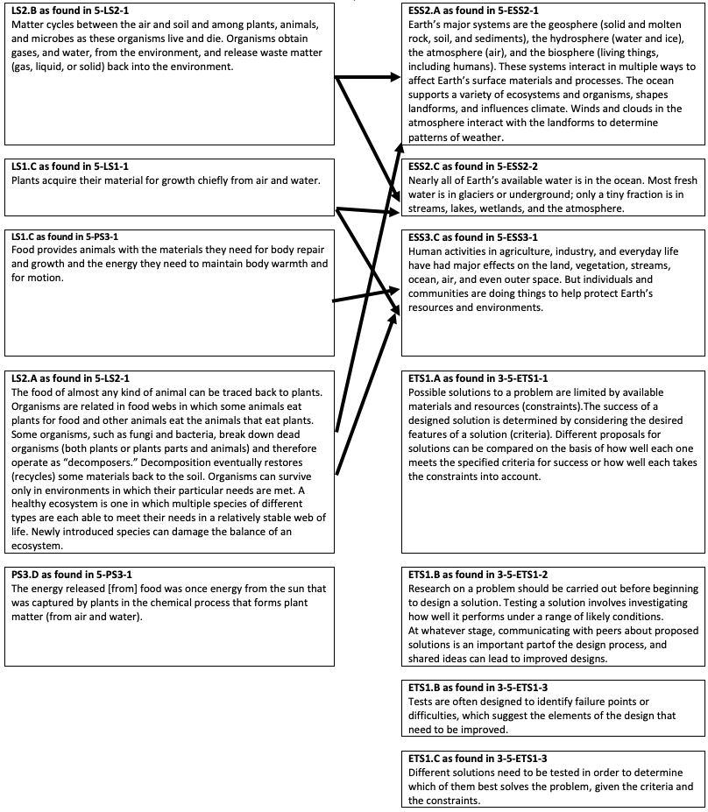

CCC
The Unit 2 CCCs focus on Systems and System Models and focus on the system as a whole and also the interactions between elements within a system. In addition, the unit includes Cause-and-Effect as a CCC that students use as they build their models, explanations, and arguments. Their experience with these concepts will help them as they apply these concepts in Unit 3 to the various Earth systems and the effects of human activities on these systems.

SEP
The Unit 2 SEPs include Developing and Using Models. Students will get extensive practice developing and using models of different sizes to focus on individual organisms (e.g., modeling where a plant gets its materials and energy to grow and survive) and systems of organisms (i.e., an ecosystem). In addition, they will be Obtaining, Evaluating, and Communicating Information about organisms and ecosystems. Students’ experiences developing their skill and ability to use these SEPs will aid them in Unit 3, when they again will be Obtaining, Evaluating, and Communicating Information about Earth Systems and approaches for engineering aspects of these systems, as well as Developing Models to exemplify scientific principles.

Appendix A. DCI, CCC, and SEP Prior Learning Opportunities
DCIs – PS3.D, LS1.C, LS2.A, & LS2.B (from NGSS Appendix E: DCI Progression within NGSS)
- Prior Learning from K-4:
  - Energy can be “produced,” “used,” or “released” by converting stored energy.
  - Plants are living organisms.
  - Plants need water and light to live and grow.
  - Animals obtain food they need from plants or other animals.
  - Living things need water, air, and resources from the land, and they live in places that have the things they need.

CCC – Energy and Matter
- Prior learning from K-2:
  - Minimal/not applicable
- Prior learning from 3-4: Students work with the idea that energy can be transferred. [Appendix G]
  - In 4-PS3-2 & 4-PS3-3 students focus on the concept that energy can be transferred.
CCC – Systems and System Models
- Prior learning from K-2: Students develop experience describing organisms (and other systems) in terms of their parts and by considering how the parts work together to achieve a desirable goal for the organism (or system). [Appendix G]
  - In K-ESS3-1, students work with modeling a system in which multiple plants and animals live in the same area and are able to satisfy their needs.
- Prior learning from 3-4: Students continue to develop experience with considering systems in terms of their parts, with an additional emphasis on the idea that some behaviors of the system are enabled by the functioning of multiple parts working together. [Appendix G]
  - In 3-LS4-4, students work with the idea that the plants and animals living in an ecosystem may be affected when the environment changes. In 4-LS1-1, students interrogate the functioning of plants (and/or animals) in terms of the organisms’ structures that enable the activity of the larger system (i.e., the organism).

SEP – Developing and Using Models
- Prior learning from K-2: Students develop a basic understanding of a model as a representation of the thing (e.g., an object, event, or process), rather than the thing itself. They also gain experience in comparing and developing different models. [Appendix G]
  - Two PEs (K-ESS3-1; 2-LS2-2) focus on using or developing models of plants and/or animals.
- Prior learning from 3-4: Students continue developing their modeling skills and abilities by developing and revising different types of models, along with beginning to consider that models can have limitations. [Appendix G]
  - Two PEs (3-LS1-1; 4-LS1-2) focus on developing models in the context of organisms, including their life cycles and animals’ sensation and perception.

SEP – Engaging in Argument from Evidence
- Prior learning from K-2: Students develop a beginning understanding that arguments must be supported by evidence, evidence in support (or in contradiction) of an argument can be evaluated, and that evidence can be relevant or irrelevant to the specific claim/question. [Appendix F]
  - One PE (K-ESS2-2) focuses on constructing an argument around plants’ and animals’ effects on their environment.
- Prior learning from 3-4: Students continue developing their argumentation skills and abilities by constructing arguments, supporting those arguments with evidence, and forming an argument to critique an explanation or model. [Appendix F]
  - Three PEs (3-LS2-1; 3-LS4-3; 4-LS1-1) focus on constructing arguments around organisms’ collective behavior, effects of an environment on organisms’ survival and prosperity, and the biological structures that enable organisms’ functions.

