Stackable Instructionally-embedded Portable Science (SIPS) Assessments Project

Grade 5 Science
Unit 2 Instructionally-embedded Assessment Task:
“Movement and Decomposition of Matter in an Ecosystem”
Matter and Energy in Organisms and Ecosystems
January 2023

The SIPS Grade 5 Science Unit 2 Instructionally-embedded Assessment Task: “Movement and Decomposition of Matter in an Ecosystem” was developed with funding from the U.S. Department of Education under the Competitive Grants for State Assessments Program, CFDA 84.368A. The contents of this paper do not represent the policy of the U.S. Department of Education, and no assumption of endorsement by the Federal government should be made.

All rights reserved. Any or all portions of this document may be reproduced and distributed without prior permission, provided the source is cited as: Stackable Instructionally-embedded Portable Science (SIPS) Assessments Project. (2023). SIPS Grade 5 Science Unit 2 Instructionally-embedded Assessment Task: “Movement and Decomposition of Matter in an Ecosystem”. Lincoln, NE: Nebraska Department of Education.

SIPS Grade 5 Unit 2 Instructionally-embedded Assessment Task
Grade 5 | Unit 2 | Instructional Segment 3 | Task Title: Movement and Decomposition of Matter in an Ecosystem
NGSS Performance Expectations Code(s) and Description(s)
Code | Description
5-LS2-1 | Develop a model to describe the movement of matter among plants, animals, decomposers, and the environment. [Clarification Statement: Emphasis is on the idea that matter that is not food (air, water, decomposed materials in soil) is changed by plants into matter that is food. Examples of systems could include organisms, ecosystems, and the Earth.] [Assessment Boundary: Assessment does not include molecular explanations.]
Acquisition Goals Number(s) and Descriptions(s)
Number | Description
A12 | Develop a model to describe that matter cycles among living and non-living components within an ecosystem.
A20 | Analyze and interpret data to make sense of the process of decomposition of matter, using logical reasoning.
A21 | Use data to evaluate claims about the role of decomposers in breaking down matter.
Evidence Statements
- Develop a model that describes how matter cycles among biotic and abiotic components within an ecosystem.
- Make observations and/or measurements to produce data about the role of decomposers within an ecosystem.
- Use observations and/or data to generate a conclusion about how interactions in a system of plants, animals, decomposers, and the environment allow multiple species to meet their needs.
- Use evidence, data, or a model to support the claim that there are interdependent relationships among organisms/elements within an ecosystem.

Source Documentation and Information Resources References (e.g., publications, websites, citations, images, videos, etc.)  Please include source name, description, citation, and a link to its original location below. Include additional rows as needed. | Licensing: Please mark an “X” under the appropriate licensing. If resource is not under a creative commons (CC) license, please attempt to find a source with CC licensing. If you are unable, please select other and provide additional information about the source in the source documentation section.
 | CC0/  Public Domain | CC BY | CC BY-SA | CC BY-NC | CC BY-NC-SA | CC BY-ND | CC BY-NC-ND | Other
- Bottle Biology – An Instructional Materials Development Program (National Science Foundation)  [https://www.bottlebiology.org/] | X
- https://pixabay.com/images/search/mushrooms/  - https://pixabay.com/photos/worm-vermiculture-humus-earth-soil-1140767/  - https://pixabay.com/photos/beetle-forest-floor-insects-4105975/  - https://pixabay.com/illustrations/fox-isolated-white-background-937635/  - https://pixabay.com/photos/hawk-flight-raptor-birds-of-prey-2604029/  - https://pixabay.com/photos/snake-terrarium-bastards-animals-1519996/  - https://pixabay.com/photos/rabbit-bunny-pet-cute-isolated-740621/  - https://pixabay.com/photos/lettuce-food-fresh-green-healthy-1239155/  - https://pixabay.com/photos/reed-grass-reed-riverbank-nature-2245808/  - https://pixabay.com/vectors/sun-cloud-sky-sunrays-sunlight-346710/  - https://pixabay.com/photos/dirt-soil-potting-mix-ground-mud-947985/ | X

Teacher Administration Guide

Introduction
- Educators developed the accompanying classroom task to align to one or more aspects of the NGSS Performance Expectation(s) (PEs) to determine where students are in their learning at a specific point in time during an instructional sequence. Educators will need to make intentional decisions about when and how to use this task based on their students’ learning needs, the purpose of giving the task, and the intended use of the evidence gathered.
- This task is designed to measure students’ ability to integrate the dimensions and demonstrate their knowledge, skills, and abilities as represented by NGSS Performance Expectation 5-LS2-1. By administering this task, educators can gather and evaluate evidence to make accurate and meaningful judgments about students’ science learning and determine how instruction may need to be adjusted along an instructional sequence to best support students.
- Using the first three segments as a reference (owl pellets, plant life cycle, and the decomposing pumpkin lessons), students learn about and understand the importance of a decomposer and the relationship it has within its ecosystem. A decomposer is a living thing that breaks down dead plants, animals, or waste. Some examples of decomposers are bacteria, worms, fungi, and flies. They are vital to the food chain because they break down this material into simpler substances that plants need to grow.
- Why are decomposers needed and important in an ecosystem? What relationships do they have with consumers, matter, and organisms in the environment? This task is designed to be administered after the lesson, “Constructing an Ecosystem” in which students (either individually or with partners) design and construct a decomposition ecosystem column. For 1-2 weeks following the lesson, students observe changes in the ecosystem model and record their data. This assessment is designed to elicit evidence of students’ abilities to make observations and/or measurements to produce data about the role of decomposers within an ecosystem, and use evidence, data, and a model to support the claim that there are interdependent relationships among organisms/elements within an ecosystem.

Administration Guidelines
- Two (2) to three (3) weeks to observe and record changes in the ecosystem (Prompt 1). The ecosystem can be kept longer for more data.
- One (1) class period to provide evidence to support the role of decomposers in an ecosystem (Prompt 2), develop a model to show and explain the flow of matter in a land ecosystem (Prompt 3), and use their observations, data, and model to make and support a claim that there are interdependent relationships among organisms/elements within the ecosystem (Prompt 4).
- Segment 3 Lessons: “Movement of Matter Through an Ecosystem: Can You Show It?”, “Matter Cycles through Decomposition: What’s the Breakdown?”, and “Constructing an Ecosystem.”
- Students individually complete a series of activities reflecting the following chain of sensemaking:
  - Over two weeks, students make observations of their eco-column, including the activity of worms, beetles, and other decomposers and the condition of plants and dead plant material.
  - Students use evidence from observations to support the role of decomposers in an ecosystem.
  - Students create and label a model to show the flow of matter among living and nonliving parts of a land ecosystem.
  - Students use evidence from their observations, completed data table, and model to make and support a claim about the interdependent relationships among organisms/elements within an ecosystem by considering what would happen if decomposers were removed from an ecosystem.

Accessibility Considerations
Providing a range of accessibility considerations in the task (e.g., multiple ways of representing information, multiple types of supports, multiple ways in which students respond) promotes equity and fairness across a wide range of students who may be at different points in their science learning. In turn, these considerations can promote student interest and engagement in the tasks resulting in a more complete and accurate collection of evidence of students’ science learning.
Accommodations for students with a disability or Multilingual Learners that are part of their on-going instructional programs are to be provided during the administration of this task. Accommodations should be consistent with those provided in students’ daily instructional strategies and assessment opportunities, including assistive technology devices if appropriate. These accessibility considerations and accommodations enable accurate inferences about student learning and inform meaningful adjustments to planning and instruction.

Ancillary Materials
- Rulers
- Thermometers
- Magnifying glasses
- Scissors
- Glue sticks
- Paper copies of assessment task, one per student
- Eco-columns (from Segment 3 lesson, “Constructing an Ecosystem”)

Instructions for Implementing the Research Task, Design Project, or Lab
- Twice a week for 2-3 weeks, students make observations of their eco-column, including the activity of worms and condition of plants and dead plant material. Guide students as they observe changes over time in their ecosystem. Changes are recorded on paper or in students’ science journals. Changes can be water amounts (evaporation), smell, and change of state in materials (fewer leaves, moss, animals, etc.).
- On the final day of observations, students take apart their ecosystem to collect plants, dead plant materials, and worms. Students take measurements and make observations on the amounts and conditions of each.

Scoring Guidance
- A prompt-specific scoring rubric indicates scoring criteria for each prompt or activity across a range of score points.
- Student exemplars represent high-quality responses that align to full-point rubric scores. The exemplar responses are intended to assist educators’ understanding of the nature and expectations of each prompt when applying the scoring rubric. Note the exemplars serve as examples of high-quality responses, and students may respond with equally relevant, scientifically accurate responses and ideas that meet the expectations of a full-point rubric score. In general, the exemplar response associated with the highest score point in the rubric meets expectations and is scientifically accurate, complete, coherent, and consistent with the type of student evidence expected as described in the rubric.
- The approximate scoring time for each student per prompt is:
  - Prompt 1 will require approximately 3 to 5 minutes.
  - Prompt 2 will require approximately 2 to 3 minutes.
  - Prompt 3 will require approximately 2 to 3 minutes.
  - Prompt 4 will require approximately 2 to 3 minutes.

Student Task
This task is about how living and non-living things interact in an ecosystem.
Task Scenario
An eco-column is a small-scale model of an ecosystem that includes both living and nonliving things. An eco-column is a helpful tool to study how plants, animals, and other organisms interact with each other and the environment. Eco-columns can be used to explore a variety of ecosystems.
You will observe and record observations of the decomposition eco-column you built in class. Consider what changes you will observe over a two-week period.
Decomposition Eco-Column
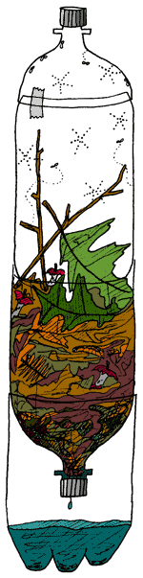

Prompt 1.
Observe and record changes in height, color, shape, texture, odor, and temperature. Use a ruler to measure changes in the height of the eco-column contents. Insert a thermometer at the top of the eco-column to measure temperature changes.
Record your measurements and observations in the Ecosystem Changes Data Sheet. Use the words below to help describe your observations.
- Producer  - Consumer | - Plants  - Organisms | - Decomposer  - Decompose | - Food scraps  - Plant waste | - Air  - Soil | - Water  - Gravel
On the final day of observations (Day 6), gently take apart the eco-column and compare what is left to what you started with at the beginning. Carefully examine the buried part of the ecosystem by digging up some of the soil for evidence of changes beneath the surface.

Ecosystem Changes Data Sheet
Eco-Column Observations | Day 1 | Day 2 | Day 3 | Day 4 | Day 5 | Day 6
 | Date: ___________  Time: ___________ | Date: ___________  Time: ___________ | Date: ___________  Time: ___________ | Date: ___________  Time: ___________ | Date: ___________  Time: ___________ | Date: ___________  Time: ___________
Height
Color
Shape
Texture
Odor
Temperature
Other

Prompt 2.
Decomposers are part of every ecosystem. Examples of decomposers include mushrooms, earthworms, beetles, and flies.

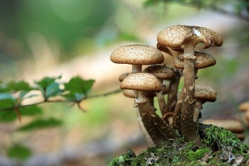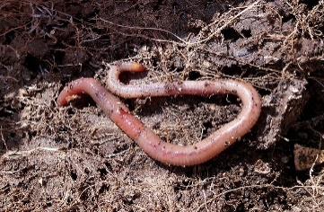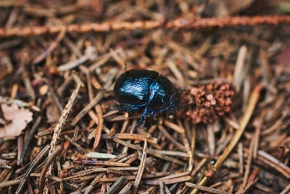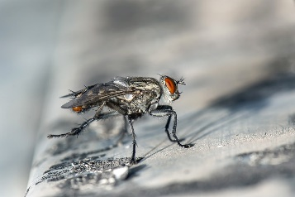
Part A.
Identify if the statements below are true or false about the role of decomposers in a healthy ecosystem. Circle true or false for each statement.
True False Decomposers use energy from the sun, water, and carbon dioxide to produce food.
True False Decomposers digest or break apart the remains of dead plants and animals.
True False Decomposers obtain and transfer nutrients by consuming living organisms.
True False Decomposers provide a source of energy for organisms in an ecosystem.
True False Decomposers recycle nutrients back into the soil to support plant growth.
True False Decomposers support the cycling of matter within an ecosystem.
Part B.
Explain how the changes you observed in your eco-column provide evidence of the role of decomposers in an ecosystem. Use at least two pieces of evidence from your completed Ecosystem Changes Data Sheet and what you know about decomposition to support your response.
_____________________________________________________________________________________
_____________________________________________________________________________________
_____________________________________________________________________________________
_____________________________________________________________________________________
_____________________________________________________________________________________
_____________________________________________________________________________________
_____________________________________________________________________________________

Prompt 3.
An ecosystem is a community of plants, animals, and other organisms that live and interact in the same environment. Each ecosystem, regardless of its size, has living and nonliving parts.
The pictures below show some of the living and nonliving parts of a land ecosystem. Consider how these living and nonliving parts interact to support the flow of matter among producers, consumers, and decomposers within the ecosystem.
Living and Nonliving Parts of a Land Ecosystem
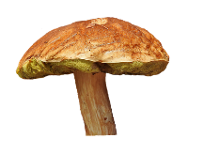  mushroom | snake | grass | 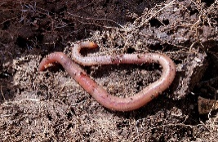  earthworm
lettuce | water | 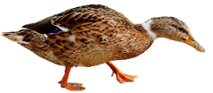  duck | hawk
rabbit | sun | 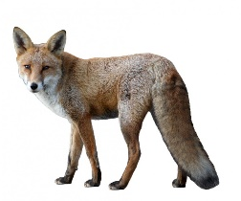  fox | 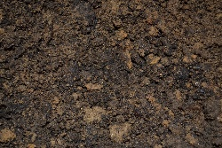  soil

Part A.
Construct a model to show the flow of matter through the land ecosystem. Use the pictures of the Living and Nonliving Parts of a Land Ecosystem to construct your model. Not all pictures need to be used.
Be sure to:
- Label your model using the words Producers, Consumers, and Decomposers.
- Include at least one nonliving part of the ecosystem in your model.
- Add arrows to show the flow of matter through the ecosystem.
Model 1. Flow of Matter through a Land Ecosystem

Part B.
Describe the flow of matter between the living and nonliving parts of the ecosystem as shown in your completed Model 1.
_____________________________________________________________________________________
_____________________________________________________________________________________
_____________________________________________________________________________________
_____________________________________________________________________________________

Prompt 4.
Consider the decomposers in your eco-column and your completed Model 1. What would happen if decomposers were removed from each system? Make a claim about the effects of removing decomposers from an ecosystem.

Claim:
If decomposers were removed from an ecosystem, ____________________________________
______________________________________________________________________________
______________________________________________________________________________

Use at least one piece of evidence from both your completed Ecosystem Changes Data Sheet and your completed Model 1 to support your claim.
Evidence from Ecosystem Changes Data Sheet | Evidence from Model 1: Flow of Matter through a Land Ecosystem
________________________________________  ________________________________________  ________________________________________  ________________________________________  ________________________________________  ________________________________________ | ________________________________________  ________________________________________  ________________________________________  ________________________________________  ________________________________________  ________________________________________

Task Rubric to Evaluate Student Evidence
Task | Score Point 0 | Score Point 1 | Score Point 2 | Score Point 3 | Score Point 4
Prompt 1 | No data or observations are recorded in the data sheet | Response includes:  - Observations of less than four (4) categories in the data sheet with significant gaps in data and/or lack of detail  - Qualitative or quantitative data  - Minimally accurate or little to no use of terms from provided word bank | Response includes:  - Observations of four (4) or more categories in the data sheet with inconsistent use of detail and/or partial gaps in data  - Qualitative and/or quantitative data  - Partially accurate or minimal use of terms from provided word bank | Response includes:  - Detailed scientific observations of four (4) to five (5) categories in the data sheet with little to no gaps in data  - Appropriate qualitative and quantitative data  - Mostly accurate use of terms from provided word bank | Response includes:  - Detailed scientific observations of six (6) to seven (7) categories in the data sheet with little to no gaps in data  - Appropriate qualitative and quantitative data  - Accurate use of terms from provided word bank to connect the ecosystem elements to the observed changes
Prompt 2  Part A. | No aspect of the response is correct | Response correctly identifies one (1) to three (3) statements as TRUE or FALSE | Response correctly identifies four (4) or five (5) statements as TRUE or FALSE | Response includes the following aspects:  - Identifies statements 2, 5, and 6 as TRUE  AND  - Identifies statements 1, 3, and 4 as FALSE | NA
Prompt 2  Part B. | No aspect of the response is correct | Response includes one (1) of the two (2) aspects | Response includes the following aspects:  - At least two (2) pieces of relevant evidence from the completed data sheet  AND  - Statement explaining how evidence from the data sheet supports the role of decomposers in an ecosystem | NA | NA
Prompt 3  Part A & Part B. | No aspect of the response is correct | Response includes one (1) of the four (4) aspects | Response includes two (2) of the four (4) aspects | Response includes three (3) of the four (4) aspects | Response includes the following aspects:  Part A  - Correct categorization and placement of labels for producers, consumers, and decomposers  - A minimum of one producer, one consumer, one, decomposer, and soil and/or water (nonliving)  - Arrows correctly identifying the flow of matter as a cycle from:  - producers to consumers and decomposers  - consumers to decomposers  - decomposers to soil, and  - soil back to producers.  AND  Part B  - Correctly describes the flow of matter as a cycle among producers, consumers, decomposers, and nonliving elements
Prompt 4 | No aspect of the response is correct | Response includes the following aspects:  - A correct claim regarding an effect of removing decomposers from an ecosystem  AND  - No evidence is provided to support the claim | Response includes the following aspects:  - A correct claim regarding an effect of removing decomposers from an ecosystem  AND  - One piece of relevant evidence from either the datasheet or model to support the claim | Response includes the following aspects:  - A correct claim regarding the effect of removing decomposers from an ecosystem  AND  - At least two pieces of relevant evidence (one each from the data sheet and model) to support the claim | NA

Exemplar Responses
Prompt 1
Observe and record changes in height, color, shape, texture, odor, and temperature. Use a ruler to measure changes in the height of the eco-column contents. Insert a thermometer at the top of the eco-column to measure temperature changes.
Record your measurements and observations in the Ecosystem Changes Data Sheet. Use the words below to help describe your observations.
- Producer  - Consumer | - Plants  - Organisms | - Decomposer  - Decompose | - Food scraps  - Plant waste | - Air  - Soil | - Water  - Gravel
On the final day of observations (Day 6), gently take apart the eco-column and compare what is left to what you started with at the beginning. Carefully examine the buried part of the ecosystem by digging up some of the soil for evidence of changes beneath the surface.
- The student data table has a complete set of scientific observations.
- The student records observations using appropriate units and scales for quantitative changes in the eco-column such as temperature changes and demonstrates accurate use of descriptive terms to record qualitative changes in the column contents’ height, color, shape, texture, and odor. For example, the student uses a ruler next to the column to record changes in the height of the contents, a thermometer from the top of the column to determine temperature changes and checks at least once a week to record changes across six days.
- The student observes the changes in the amount and distribution of plant material, waste materials, and decomposers (worms) in the system. The student notes the appearance of any decomposers such as flies, beetles, slugs, millipedes, or snails in the eco-column.
Prompt 2
Part A.
Identify if the statements below are true or false about the role of decomposers in a healthy ecosystem. Circle true or false for each statement.
True False Decomposers use energy from the sun, water, and carbon dioxide to produce food.
True False Decomposers digest or break apart the remains of dead plants and animals.
True False Decomposers obtain and transfer nutrients by consuming living organisms.
True False Decomposers provide a source of energy for organisms in an ecosystem.
True False Decomposers recycle nutrients back into the soil to support plant growth.
True False Decomposers support the cycling of matter within an ecosystem.

Prompt 2
Part B.
Explain how the changes you observed in your eco-column provide evidence of the role of decomposers in an ecosystem. Use at least two pieces of evidence from your completed Ecosystem Changes Data Sheet and what you know about decomposition to support your response.
Decomposers play an important role in an ecosystem because they break down dead plant and animal matter and return nutrients to the soil. In my eco-column, I observed changes in the height of the organic matter in the eco-column and how the amount of food waste decreased as decomposers were breaking it apart. On the last day, I also observed how the dead leaves and food matter changed over time through the decomposition process. This evidence supports the idea that decomposers help break down matter and return nutrients to the soil.
Prompt 3
Part A.
Construct a model to show the flow of matter through the land ecosystem. Use the pictures of the Living and Nonliving Parts of a Land Ecosystem to construct your model. Not all pictures need to be used.
Be sure to:
- Label your model using the words Producers, Consumers, and Decomposers.
- Include at least one nonliving part of the ecosystem in your model.
- Add arrows to show the flow of matter through the ecosystem.
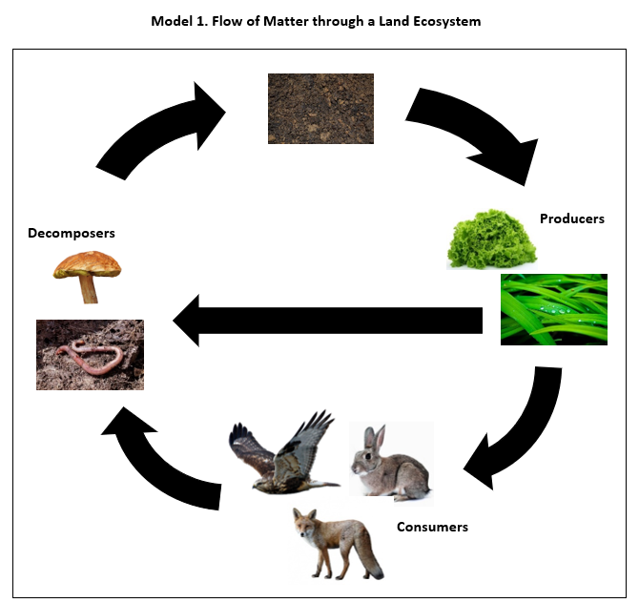
Part B.
Describe the flow of matter between the living and nonliving parts of the ecosystem as shown in your completed Model 1.
The flow of matter in an ecosystem is a cycle, like a circle. In a land ecosystem, the producers need water to grow and soil to grow roots. Plants are producers because they produce food. Consumers are animals that eat plants or animals that eat other animals. When producers and consumers die, their remains lie on top of the soil. Decomposers in the soil break apart or digest the dead material and return the nutrients to the soil. These nutrients are recycled into the ecosystem by producers who use them to grow. The cycle goes on and on.
Prompt 4
What would happen if decomposers were removed from each system? Make a claim about the effects of removing decomposers from an ecosystem.
Claim:
If decomposers were removed from an ecosystem, there would be a buildup of dead leaves, dead animals, and dead insects everywhere.
Use at least one piece of evidence from both your completed Ecosystem Changes Data Sheet and your completed Model 1 to support your claim.
Evidence from Ecosystem Changes Data Sheet | Evidence from Model 1: Flow of Matter through a Land Ecosystem
In my eco-column, I observed the height of the dead leaves decreased over time. That shows that the leaf material was being broken down into the soil by decomposers. This shows how important decomposers are for breaking apart dead plants. | My model shows that matter flows from producers and consumers to decomposers living in the soil. The nutrients in the soil are needed by plants to grow. Without decomposers, the cycle of matter in the ecosystem would stop.

Task Notes

