Stackable Instructionally-embedded Portable Science (SIPS) Assessments Project

Grade 5 Science
Unit 3 Student Profile
Earth Systems and the Solution of Water Problems
January 2023

The SIPS Grade 5 Science Unit 3 Student Profile: Earth Systems and the Solution of Water Problems was developed with funding from the U.S. Department of Education under the Competitive Grants for State Assessments Program, CFDA 84.368A. The contents of this paper do not represent the policy of the U.S. Department of Education, and no assumption of endorsement by the Federal government should be made.

All rights reserved. Any or all portions of this document may be reproduced and distributed without prior permission, provided the source is cited as: Stackable Instructionally-embedded Portable Science (SIPS) Assessments Project. (2023). SIPS Grade 5 Science Unit 3 Student Profile: Earth Systems and the Solution of Water Problems. Lincoln, NE: Nebraska Department of Education.

SIPS Grade 5 Science Unit 3 Student Profile
The Stackable, Instructionally-embedded, Portable Science (SIPS) Assessments Unit 3 Student Profile describes what students should know and be able to demonstrate prior to, during, and at the culmination of three-dimensional science instruction in Unit 3 to prepare for new and increasingly sophisticated learning opportunities in Unit 4. The student profile is intended to build science educators’ understanding of the targeted student learning outcomes and how they are situated in the context of year-long instruction to promote and inform the intentional selection of curricular materials and design of instructional opportunities to achieve these outcomes for all students. In addition, the end-of-unit profile can support discussion with students, parents, and guardians about the Unit 3 topic of interest “Earth Systems and the Solution of Water Problems” and the knowledge, skills, and abilities to which teaching and opportunities to learn will be based.
The SIPS Assessments Unit 3 student profile provides a description of:
- The necessary prior learning opportunities and prior knowledge and skills that students are expected to have acquired for all three dimensions—Science and Engineering Practices (SEPs), Disciplinary Core Ideas (DCIs), and Crosscutting Concepts (CCCs)—before engaging in Unit 3. These prior learning opportunities and knowledge and skills serve as entry points to the unit to ensure readiness and to foster understanding of new and increasingly sophisticated learning experiences. This section also includes an explanation of how prior learning, knowledge, and skills will be built upon in the unit.
- The knowledge, skills, and abilities students are expected to learn and demonstrate by the end of the unit when provided with opportunities to integrate scientific and engineering practices with important disciplinary core ideas and crosscutting concepts to scientifically investigate and understand natural phenomena and solve important science and engineering design problems.
- The learning experiences in Unit 4 allow students to build from and expand their learning in Unit 3 to effectively engage in the SEPs to sense-make using acquired scientific knowledge and understanding of the CCCs in the context of multiple DCIs. This section highlights key connections among important scientific ideas, practices, and concepts that students investigate as they progress from one unit to the next.
The following sections describe the prior learning and knowledge, skills, and abilities that students are expected to bring to and acquire by the end of the unit, respectively, and how these knowledge, skills, and abilities prepare students to deepen their science learning in Unit 4. The content in these sections draws from the dimensional appendices of the NGSS (Appendix E, Appendix F, Appendix G), the performance expectations articulated in the NGSS, A Framework for K12 Science Education, and Stage 1 of the SIPS Unit 3 map.

1. Prior Learning Opportunities
By building on familiarity with the previous Unit 2 ideas related to matter and energy in organisms and ecosystems, Unit 3 allows students to use and extend this knowledge of system thinking to even larger systems, such as Earth’s four systems. The practices of explaining and modeling phenomena and solving design problems are also further explored in this unit as students define and develop possible solutions to problems such as human impacts on Earth’s system. Unit 2 ideas related to the flow of matter and energy within living systems and ecosystems Unit 3 allows students to consider how these fit within the larger structure of earth systems of the geosphere, hydrosphere, biosphere, and atmosphere. The issue of water is then considered, allowing students to engage with ETS PEs that focus on the solution of a problem, including specifying resources, criteria for success, and constraints.
Essential prior learning from grades K to 2 and grades 3 and 4 related to the DCIs, CCCs, and SEP are provided in Appendix A.

2. End-of-Unit Learning Outcomes
Measurement targets are narrative descriptions that integrate the DCIs, SEPs, and CCCs into a single statement representing what is to be taught and assessed in each unit. The SIPS Measurement Target for this unit is:
- Students are able to apply Scientific and Engineering Practices with an emphasis on using mathematical and computational thinking to draw or support conclusions about the interactions of the geosphere, biosphere, hydrosphere, and/or atmosphere to address obtain, and evaluate information on issues related to the distribution of water on Earth, protecting Earth’s resources and environment and to design solutions to a problem with consideration of criteria, constraints, and resources.

By engaging in this unit, students will deepen their knowledge of the interconnectedness of how different Earth systems interact with each other and how water plays an important role for each of the four Earth systems, especially the biosphere. With a focus on defining problems, finding solutions, and understanding how multiple solutions are compared using criteria and constraints, students will engage in real-world problem-solving around human impacts on Earth’s systems.

Descriptions of the specific learning expectations associated with each dimension are elaborated below.

DCI
The Grade 5 Unit 3 topic, “Earth Systems and the Solution of Water Problems” organizes six performance expectations that together enable developing models and using mathematics and computational thinking with graphical displays of data of Earth’s systems, and the role of water in Earth’s processes. In working with these disciplinary core ideas, students are positioned to make connections across the different Earth systems (i.e., geosphere, hydrosphere, biosphere, and atmosphere) and to consider the multiple ways in which the systems interact with each other, often affecting another system. The students also use their knowledge of the earth system and water as part of designing a solution to a problem, attending to criteria for success, constraints, and available resources.

CCC
Over the course of Unit 3, students will make frequent use of the System and System Models CCC as they study each of the Earth’s systems and deepen their understanding of the interactions across the different systems. In addition, students will use the Scale, Proportion, and Quantity CCC as they graph quantities of water on Earth. Finally, students will also consider the Influence of Science, Engineering, and Technology on Society and the Natural World as they consider the ways that a particular problem requires the definition of relevant resources under applicable constraints.

SEP
Over the course of this unit, students will develop and use models of Earth’s systems, use mathematics and computational thinking as they describe and graph quantities of water on Earth, and obtain, evaluate, and communicate information on their models and graphs. Additionally, students will have opportunities to ask questions and define problems, design solutions and plan and carry out investigations to as part of a design solution, using the additional practice of obtaining and evaluating the information on constraints and resources.

3. Connections to Unit 4 Learning Opportunities

DCI
Unit 3 focuses extensively on Earth’s systems, the interactions across systems, and the role of water in Earth’s processes. Additionally, this unit has a strong emphasis on defining problems and designing solutions. These ideas, especially understanding Earth’s major systems prepare students for Unit 4, in which they will consider how earth’s gravitational force pulls objects towards the planet’s center.
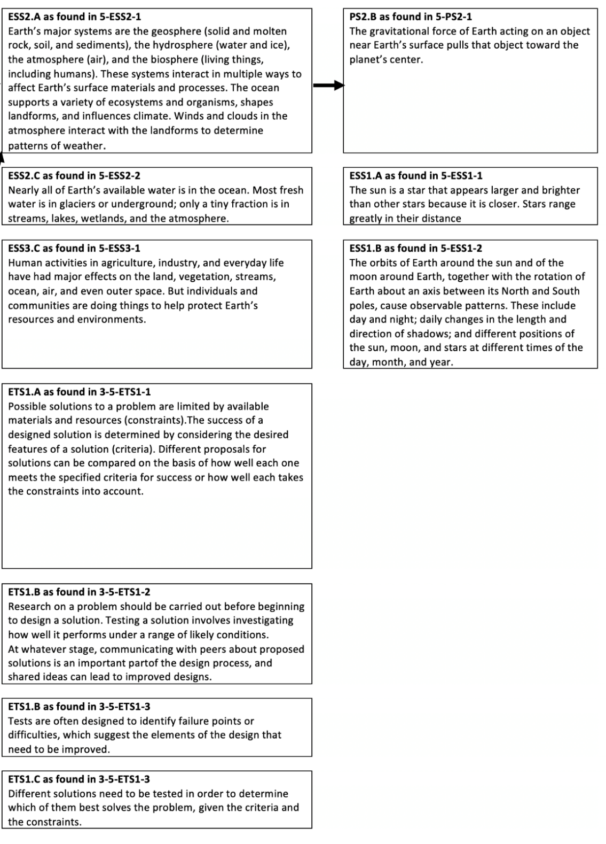

CCC
Unit 3 CCCs focus on Systems and System Models and the whole system, including the interactions between elements within a system. In addition, the unit includes Scale, Proportion, and Quantity as a CCC that students use as they build their models, explanations, and arguments. Their experience with these concepts will help them as they apply these concepts in Unit 4 to learn about gravitational force, the distance between different stars, and how it impacts their apparent brightness from the Earth.

SEP
Unit 3 SEPs include Developing and Using Models, as students will get extensive practice developing and using different types of models to focus on individual systems and interactions across Earth’s systems. In addition, they will be Obtaining, Evaluating, and Communicating Information as they learn about Earth’s systems and the role of water in Earth’s surface processes. They will also be engaged in using mathematics and computational thinking as they describe and graph quantities of water on Earth. Their work on defining solutions to a problem will engage them in practices associated with understanding criteria for success and constraints. Students’ experiences develop their skills and abilities to use these SEPs, which will aid them in Unit 4 when they again will be representing data in graphical displays and using information from models and other sources to support arguments on topics from Unit 4.
Appendix A. DCI, CCC, and SEP Prior Learning Opportunities
DCIs – ESS2.A, ESS2.C, ESS3.C, ETS1.A, ETS1.B & ETS1.C (from NGSS Appendix E: DCI Progression within NGSS)
- Prior Learning from K-4:
  - Wind and water change the shape of the land.
  - Water is found in many types of places and in different forms on Earth.
  - Things people do can affect the environment, but they can make choices to reduce their impacts.
  - Designs require understanding a problem and conveying solutions through sketches, drawings, or models. Multiple solutions may also be possible.
CCC – Systems and System Models
- Prior learning from K-2: Students develop experience describing organisms (and other systems) in terms of their parts and considering how the parts work together to achieve a desirable goal for the organism (or system). [Appendix G]
  - In K-ESS3-1 students work with modeling a system in which multiple plants and animals live in the same area and can satisfy their needs.
- Prior learning from this grade band (e.g., Grades 3 & 4): Students continue developing experience with considering systems in terms of their parts, with an additional emphasis on the idea that some behaviors of the system are enabled by the functioning of multiple parts working together. [Appendix G]
  - In 3-LS4-4 students work with the idea that the plants and animals living in an ecosystem may be affected when the environment changes. In 4-LS1-1 students interrogate the functioning of plants (and/or animals) in terms of the organisms’ structures that enable the activity of the larger system (i.e., the organism).
SEP- Developing and Using Models
- Prior learning from K-2: Students develop a basic understanding of a model as a representation of the thing (e.g., an object, event, or process), rather than the thing itself. They also gain experience in comparing and developing different models. [Appendix G]
  - Two PEs (K-ESS3-1; 2-LS2-2) focus on using or developing models of plants and/or animals.
- Prior learning from this grade band (e.g., Grades 3 & 4): Students continue developing their modeling skills and abilities by developing and revising different types of models, along with beginning to consider those models that can have limitations. [Appendix G]
  - Two PEs (3-LS1-1; 4-LS1-2) focus on developing models in the context of organisms, including their life cycles and animals’ sensations and perceptions.
SEP- Using Mathematics and Computational Thinking
- Prior learning from K-2: Students may have had opportunities to recognize that mathematics can be used to describe the natural and designed world(s). More specifically, students should be able to:
  - Decide when to use qualitative vs. quantitative data.
  - Use counting and numbers to identify and describe patterns in the natural and designed world(s).
  - Describe, measure, and/or compare quantitative attributes of different objects and display the data using simple graphs.
  - Use quantitative data to compare two alternative solutions to a problem.
  - However, there is no PE in K-2 that ever uses this SEP; its first introduction is in Grade 5. Therefore, it is likely that students will have minimal or no exposure to formal learning of this SEP prior to Grade 5, Unit 4.
- Prior learning from this grade band (e.g., Grades 3 & 4 and/or prior SIPS G5 units): During grades 3-5, students are expected to extend quantitative measurements to a variety of physical properties and use computation and mathematics to analyze data and compare alternative design solutions.
  - No other PE in grades 3 and 4 uses this practice.
SEP- Obtaining, Evaluating, and Communicating Information
- Prior learning from K-2: Students have had opportunities to use observations and texts to communicate new information. More specifically, students should be able to:
  - Read grade-appropriate texts and/or use media to obtain scientific and/or technical information to determine patterns in and/or evidence about the natural and designed world(s).
  - Describe how specific images (e.g., a diagram showing how a machine works) support a scientific or engineering idea.
  - Obtain information using various texts, text features (e.g., headings, tables of contents, glossaries, electronic menus, icons), and other media that will be useful in answering a scientific question and/or supporting a scientific claim.
  - Communicate information or design ideas and/or solutions with others in oral and/or written forms using models, drawings, writing, or numbers that provide detail about scientific ideas, practices, and/or design ideas.
- Prior learning from this grade band (e.g., Grades 3 & 4 and/or prior SIPS G5 units): During grades 3-5, students are expected to progress to evaluate the merit and accuracy of ideas and methods. [Appendix F]
  - Two PEs (3-ESS2-2; 4-ESS3-1) focus on obtaining, evaluating, and communicating information in the domain of earth and space science.
SEP- Asking Questions and Defining Problems
- Prior learning from K-2: Students have had opportunities in the context of asking questions about systems and defining a simple problem. More specifically, students should be able to:
  - Define how a new or improved object or tool can be developed.
- Prior learning from this grade band (e.g., Grades 3 & 4 and/or prior SIPS G5 units): During grades 3-5, students should progress in their ability to define problem statements and to identify how objects or tools can be used to address the problem [Appendix F].
  - Define a statement of a problem that can be addressed by an object or tool.
  - Two PEs (3-PS2-3 and 3-PS2-4) focus on Asking Questions and Defining Problems in the domain of relationships of electrical and magnetic interactions.
  - One PE (4-PS4-3) focuses on generating solutions to use patterns to transfer information. (This also integrates Connections of Science, Engineering, and Technology).
SEP- Planning and Carrying out Investigations
- Prior learning from K-2: Students are expected to have had opportunities to plan and carry out simple investigations, based on fair tests, which provide data to support explanations or design solutions More specifically, students should be able to:
  - With guidance, plan and conduct an investigation in collaboration with peers (for K).
  - Plan and conduct an investigation collaboratively to produce data to serve as the basis for evidence to answer a question.
  - Evaluate different ways of observing and/or measuring a phenomenon to determine which way can answer a question.
  - Make observations (firsthand or from media) and/or measurements to collect data that can be used to make comparisons.
  - Make observations (firsthand or from media) and/or measurements of a proposed object or tool or solution to determine if it solves a problem or meets a goal.
  - Make predictions based on prior experiences.
- Prior learning from this grade band (e.g., Grades 3 & 4 and/or prior SIPS G5 units): During grades 3-5, students are expected to include investigations that control variables and provide evidence to support explanations or design solutions.
  - 5 PEs in grades 3 and 4 use this practice. They are: 3-PS2-1, 3-PS2-2, 4-PS3-2, 4-ESS2-1 and 3-5-ETS1-3.
SEP- Constructing Explanations and Designing Solutions
- Prior learning from K-2: Students are expected to have had opportunities to design multiple simple solutions to a problem associated with wind or water and its impact on the shape of the land.
  - Students can construct a device to address a problem in a way that mimics the way plants or animals survive, grow, and meet their needs.
  - Students can develop evidence-based accounts of the way multiple solutions can address a problem.
- Prior learning from this grade band (e.g., Grades 3 & 4 and/or prior SIPS G5 units): During grades 3-5, students are expected to include investigations that design solutions to problems using appropriate information.
  - Two PEs (4-ESS3-2 and 4-PS3-4) ask students to consider multiple solutions based on how they meet criteria and constraints in the context of the impact of natural Earth processes on humans or to develop a device for energy conversion. (These also integrate the Influence of Science, Engineering, and Technology on Society and the Natural World).

