Stackable Instructionally-embedded Portable Science (SIPS) Assessments Project

Grade 8 Science
Unit 1 Instructionally-embedded Assessment Task:
“Designing Solutions to a Problem Involving a Collision”
Forces and Energy
April 2023

The SIPS Grade 8 Science Unit 1 Instructionally-embedded Assessment Task: “Designing Solutions to a Problem Involving a Collision” was developed with funding from the U.S. Department of Education under the Competitive Grants for State Assessments Program, CFDA 84.368A. The contents of this paper do not represent the policy of the U.S. Department of Education, and no assumption of endorsement by the Federal government should be made.

All rights reserved. Any or all portions of this document may be reproduced and distributed without prior permission, provided the source is cited as: Stackable Instructionally-embedded Portable Science (SIPS) Assessments Project. (2023). SIPS Grade 8 Science Unit 1 Instructionally-embedded Assessment Task: “Designing Solutions to a Problem Involving a Collision.” Lincoln, NE: Nebraska Department of Education.

SIPS Grade 8 Unit 1 Instructionally-emedded Assessment Task
Grade 8 |  | Unit 1 | Instructional Segment 4 | Task Title: Designing Solutions to a Problem Involving a Collision
NGSS Performance Expectations Code(s) and Description(s)
Code | Description
MS-PS2-1 | Apply Newton’s Third Law to design a solution to a problem involving the motion of two colliding objects.
Acquisition Goals Number(s) and Description(s)
Number | Description
A1 | Design a solution to a problem that utilizes the fact that when two objects interact, they exert a force on each other in opposite directions.
A3 | Create a model to show the direction of the forces exerted by two interacting objects on each other is opposite.
A4 | Construct an explanation that describes the relationship between force and motion to describe phenomena.
A6 | Apply Newton’s Third Law to explain a situation involving the motion of two colliding objects. (MS-PS2-1)
Evidence Statements
- Apply Newton’s third law of motion to justify and identify the best design and to provide justification for the selection based on the application of Newton’s third law of motion when provided a description of a physical situation involving a collision between two objects and a list of multiple designs with given criteria.
- Refer to the system model to identify how objects are interacting to design the system model.
- Construct a system model to analyze Newton’s third law forces in a collision (force directions).
- Determine the effect of speed within a collision.
- Identify the action-reaction force pair during the collision of two objects and the statement regarding the magnitude of the action-reaction forces involved in the collision.
- Use the appropriate scientific principle (e.g., action-reaction forces) that supports the effectiveness of the design solution to a problem involving the motion of two objects.
Source Documentation and Information Resources References (e.g., publications, websites, citations, images, videos, etc.)  Please include source name, description, citation, and a link to its original location below. Include additional rows as needed. |  |  |  |  | Licensing: Please mark an “X” under the appropriate licensing. If resource is not under a creative commons (CC) license, please attempt to find a source with CC licensing. If you are unable, please select other and provide additional information about the source in the source documentation section.
 |  |  |  |  | CC0/  Public Domain | CC BY | CC BY-SA | CC BY-NC | CC BY-NC-SA | CC BY-ND | CC BY-NC-ND | Other
https://www.youtube.com/watch?v=3Cl3VEyseLc |  |  |  |  |  |  |  |  |  |  |  | X
Baseball Sport Game - Free vector graphic on Pixabay |  |  |  |  | X

Teacher Administration Guide

Introduction
- Educators developed the accompanying classroom task to align to one or more aspects of the NGSS Performance Expectation(s) (PEs) to determine where students are in their learning at a specific point in time during an instructional sequence. Educators will need to make intentional decisions about when and how to use this task based on their students’ learning needs, the purpose of giving the task, and the intended use of the evidence gathered.
- This task is designed to measure students’ ability to integrate the dimensions and demonstrate their knowledge, skills, and abilities as represented by NGSS Performance Expectation MS-PS2-1. By administering this task, educators can gather and evaluate evidence to make accurate and meaningful judgments about students’ science learning and determine how instruction may need to be adjusted along an instructional sequence to best support students.
- The phenomenon in this task involves a physical situation involving a collision between two objects. The scenario is based on Newton’s third law and the forces acting on a water balloon.
- In this task, students apply Newton’s third law of motion to explain action-reaction forces when provided a description of a physical situation involving a collision between two objects. Students will construct a system model to analyze Newton’s third law forces in a collision (force directions) in two different systems. Students use their model to identify the action-reaction force pair during the collision of objects and explain the magnitude of the action-reaction forces involved in the collisions in two different systems.

Administration Guidelines
- One (1) class period
- Segment 4 Lesson: “Applying Understanding of Forces and Kinetic Energy to a Design Project”
- Students individually complete a series of prompts reflecting the following chain of sensemaking:
  - Students apply Newton’s third law of motion to explain action-reaction forces when provided a description of a physical situation involving a collision between two objects.
  - Students construct a system model to analyze Newton’s third law forces in a collision (force directions) in two different systems.
  - Students use their model to identify the action-reaction force pair during the collision of objects and explain the magnitude of the action-reaction forces involved in the collisions in two different systems.
  - Students reflect upon the action-reaction force examples to address the anchor phenomenon described at the beginning of the task.

Accessibility Considerations
Providing a range of accessibility considerations in the task (e.g., multiple ways of representing information, multiple types of supports, multiple ways in which students respond) promotes equity and fairness across a wide range of students who may be at different points in their science learning. In turn, these considerations can promote student interest and engagement in the tasks resulting in a more complete and accurate collection of evidence of students’ science learning.
Accommodations for students with a disability or Multilingual Learners that are part of their ongoing instructional programs are to be provided during the administration of this task. Accommodations should be consistent with those provided student’s daily instructional strategies and assessment opportunities including assistive technology devices if appropriate. These accessibility considerations and accommodations enable accurate inferences about student learning and inform meaningful adjustments to planning and instruction.

Ancillary Materials
- None

Instructions for Administering the Performance Task or Implementing the Research Task, Design Project, or Lab
- Pose the scenario: a water balloon fight.
- Students will explore how forces determine whether a water balloon will pop when it hits the ground.

Scoring Guidance
- A task- and prompt-specific scoring rubric indicates scoring criteria for each prompt across a range of score points.
- Student exemplars represent high-quality responses that align to full-point rubric scores. The exemplar responses are intended to assist educators’ understanding of the nature and expectations of each prompt when applying the scoring rubric. Note the exemplars serve as examples of high-quality responses, and students may respond with equally relevant, scientifically accurate responses and ideas that meet the expectations of a full-point rubric score. In general, the exemplar response associated with the highest score point in the rubric meets expectations and is scientifically accurate, complete, coherent, and consistent with the type of student evidence expected as described in the rubric.
- The approximate scoring time for this task will be 5 to 10 minutes per student or small group.

Student Task
This task is about action-reaction pairs of forces.
Task Scenario
According to Guinness World Records, the largest water balloon fight consisted of 8,957 participants and was achieved on August 27, 2011. On that day, 175,141 water balloons were used during the fight. Many of the balloons popped. But some of the water balloons at the event did not pop.

A group of friends wants to set up a neighborhood water balloon fight. For their event, they want to be sure that all of the water balloons pop.

Prompt 1.
The same group of friends go to a baseball game. They notice that the catcher wears an extra padded glove to protect his hand when catching the baseball.

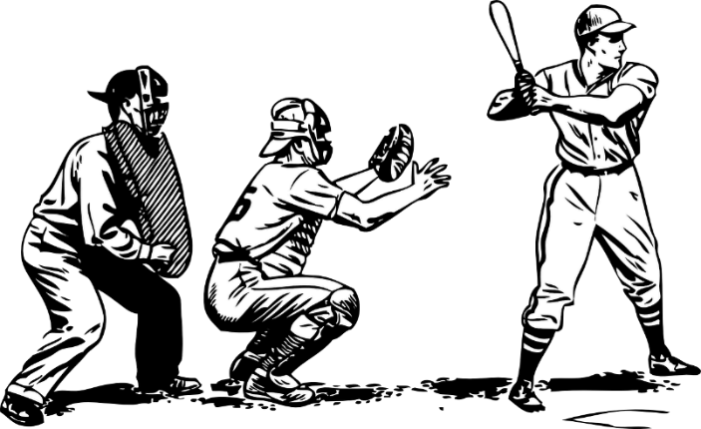

Part A.
When does the baseball stop more gradually, when it is caught by a bare hand OR when it is caught by a hand wearing a baseball glove?
_____________________________________________________________________________________

_____________________________________________________________________________________

Part B.
Is the force applied to stop the ball with the glove smaller, greater, or the same than the force applied without the glove?
_____________________________________________________________________________________

_____________________________________________________________________________________
Part C.
What does this mean about the force the ball applies to the player’s hand with or without the glove? Use what you know about Newton’s third law to explain your answer.

_____________________________________________________________________________________

_____________________________________________________________________________________

_____________________________________________________________________________________

Prompt 2.
The friends conduct an investigation to learn more about why some of the balloons in the record breaking event did not pop. They set up two trials. For both trials, they drop one water balloon of equal weight, from the same height. In System 1, the balloon lands onto a concrete floor. In System 2, the balloon lands on a blanket suspended over the ground.

Part A.
Draw two diagrams to show action-reaction force pairs between a water balloon in two different systems.

The Diagram of System 1 shows the action-reaction force pair during the water balloon’s interaction with a concrete floor.

The Diagram of System 2 shows the action-reaction force pair during the water balloon’s interaction with a blanket suspended over the ground.

In each diagram, label:
- the action-reaction force pairs involved in each collision in each system;
- the water balloon; and
- the concrete floor or the blanket.

Diagram of System 2
Diagram of System 1
Part B.
Use Newton’s third law to describe the force pairs in System 1 and System 2 and compare the magnitude of the forces of the action-reaction force pairs. Use the terms elasticity, magnitude, and force to support your answer.

_____________________________________________________________________________________

_____________________________________________________________________________________

_____________________________________________________________________________________

____________________________________________________________________________________

Prompt 3.
The friends set up another investigation to find out how forces determine under what conditions a water balloon will pop. The friends have many balloons that are the same size and shape. They partially fill some of the balloons with water, but the balloons are not tightly stretched. They completely fill other balloons with water until the balloons are tightly stretched. They go outside and toss the water balloons on the ground. Many of the balloons pop. But some of the water balloons in the investigation do not pop.

Part A.
Why do you think some of the water balloons do not pop when they were tossed? Use Newton’s third law and the terms elasticity, force, and direction in your response.
_____________________________________________________________________________________

_____________________________________________________________________________________

_____________________________________________________________________________________

_____________________________________________________________________________________

Part B.
The group of friends want as many water balloons to pop as possible during the water balloon fight so that as many people as possible get soaking wet.
What should the friends consider when preparing the water balloons and what advice should they give to participants about the type of clothing to wear to the water balloon fight? Should participants wear thin and lightweight clothing OR loose and fluffy clothing? Use what the friends learned when watching the baseball game to support your answer.
The friends should prepare the water balloons by_________________________________________

_____________________________________________________________________________________

because______________________________________________________________________________

____________________________________________________________________________________.

The participants should wear___________________________________________________________

because______________________________________________________________________________

____________________________________________________________________________________.

Task Rubric to Evaluate Student Evidence
Task | Score Point 0 | Score Point 1 | Score Point 2 | Score Point 3
Prompt 1 | No aspect of the response is correct | Response includes one (1) of the three (3) aspects | Response includes two (2) of the three (3) aspects | Response includes the following aspects:  Part A  - Baseball stops gradually when it hits the glove  Part B  - The force of the ball stopped by a glove is smaller compared to a bare hand (or vice versa)  Part C  - The force is less if the ball comes to a stop more slowly
Prompt 2 Part A. | No aspect of the response is correct | Response includes one (1) of the three (3) aspects | Response includes two (2) of the three (3) aspects | Response includes the following aspects:  - System 1 and System 2 diagrams  - Both diagrams show action-reaction force pairs  - Both diagrams include all labels for each component
Prompt 2 Part B. | No aspect of the response is correct | Response includes one (1) of the three (3) aspects | Response includes two (2) of the three (3) aspects | Response includes the following aspects:  - Applies the terms elasticity, magnitude, and force  - Describes the action-reaction force pairs as equal and in opposite direction to one another  - Provides a comparison of the magnitude of the forces in System 1 (larger) to System 2
Prompt 3 Part A. | No aspect of the response is correct | Response includes one (1) of the three (3) aspects. | Response includes two (2) of the three (3) aspects. | Response includes the following aspects:  - Applies Newton’s third law and the terms elasticity, force, and direction in their explanation  - Includes the idea that some objects stop quickly, while others stop slowly  - Describes the force of different tosses and/or the elasticity of the less filled balloons slowing the time of the impact meaning the force is less
Prompt 3 Part B. | No aspect of the response is correct | Response includes one (1) of the aspects | Response includes the following aspects:  - References the examples from the task to support the explanation  - Describes that the reduced elasticity of the fully filled balloons will result in more popped balloons  - Describes how thin and light clothing will result in more popped balloons when they land on a person | NA

Exemplar Responses
Prompt 1  Part A. | The baseball stops more gradually when it is caught by a hand wearing a glove.
Prompt 1  Part B. | If the ball stops slower with the glove, it means the force applied to it is smaller.
Prompt 1  Part C. | If the force applied to the ball is smaller, then according to Newton’s third law, the force the ball applies to the hand is also smaller. When wearing a glove, the hand feels a smaller force when catching the ball.
Prompt 2  Part A. | 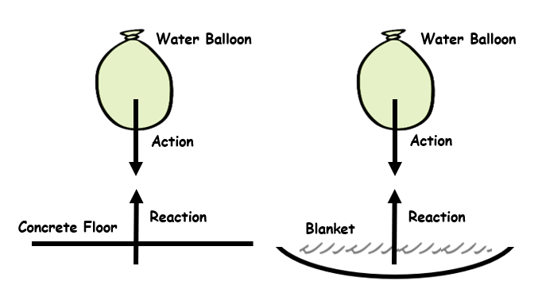
Prompt 2  Part B. | In System 1, the action force is the water balloon pushing on the solid ground. The reaction force is the ground pushing on the water balloon. The magnitude of the forces equal each other. In System 2 the action force is the water balloon pushing on the flexible blanket. The reaction is the blanket pushing on the water balloon. The magnitude of the forces equal each other. However, the water balloon is slowed down before stopping when it hits the blanket due to the blanket’s elasticity. That means the magnitude of the forces in System 2 are smaller than the forces in System 1.
Prompt 3.  Part A | According to Newton’s third law, every force is paired to another force of equal magnitude acting in the opposite direction. That means the force the balloon applies to the ground is the same as the force the ground applies to the balloon. The force the ground applies to the balloon is what makes it stop moving. If the balloon is not filled all the way, the balloon will stretch and have elasticity when it hits the floor and slow the impact before stopping. So, the stopping force will be small. If a very full balloon hits the floor, it will stop quickly and cause the balloon to burst. (Answers will vary but should include the idea that some objects stop quickly, while others stop slowly.)
Prompt 3  Part B | The friends should consider making all the water balloons filled with as much water as possible. This will cause the balloons to have less stretch and elasticity and stop faster when they land on somebody. The balloon will be more likely to pop. This is the opposite of when the acrobats land on soft mats. That is also why the participants should wear light and thin clothing. Fluffy clothes will slow the balloon like the catcher’s glove and the balloons may not pop when they land on somebody.
Task Notes

