Stackable Instructionally-embedded Portable Science (SIPS) Assessments Project

Grade 8 Science
Unit 1: Designing Equitable Assessments for Diverse Learners
Forces and Energy
January 2023

The SIPS Grade 8 Science Unit 1: Designing Equitable Assessments for Diverse Learners, Forces and Energy was developed with funding from the U.S. Department of Education under the Competitive Grants for State Assessments Program, CFDA 84.368A. The contents of this paper do not represent the policy of the U.S. Department of Education, and no assumption of endorsement by the Federal government should be made.

All rights reserved. Any or all portions of this document may be reproduced and distributed without prior permission, provided the source is cited as: Stackable Instructionally-embedded Portable Science (SIPS) Assessments Project. (2023). SIPS Grade 8 Science Unit 1: Designing Equitable Assessments for Diverse Learners, Forces and Energy. Lincoln, NE: Nebraska Department of Education.

SIPS Grade 8 Unit 1: Designing Equitable Assessments for Diverse Learners
How do we optimize accessibility for diverse learners and why is this important? This document provides steps to planning and developing equitable assessments that incorporate the principles of Universal Design for Learning (UDL) and the elements of Universally Designed Assessments (UDA). Both UDL and UDA are designed to promote access to instruction and/or assessment to the widest range of students. This includes, but is not limited to, students with varying abilities, cultures, primary languages, background knowledge, and interests. For more information about equitable assessment design and use, and why it is important, view Chapter 4: Fairness and Accessibility of the Strengthening Claims-based Interpretations and Uses of Local and Large-scale Science Assessment Scores (SCILLSS) Digital Workbook on Educational Assessment Design and Evaluation: Creating and Evaluating Effective Educational Assessments.
A multi-step process to promote the selection and design of equitable assessments for diverse learners is detailed which includes planning, selection and development, and evaluation and reflection. General information, links to tools and resources, and guiding questions provide additional considerations to support the implementation of this multi-step process.

Planning
Consider all students when designing the assessment task, including students’ gender, race, and ethnicity, socio-economic status, primary and secondary language, disability, cultural experiences, background knowledge, etc. Knowing what understandings and abilities different students bring to the assessment is vital to removing or reducing barriers to students’ ability to demonstrate attainment of the assessed acquisition goals.
It is important to ensure that the requirements of the assessment task clearly target the selected acquisition goals. Consider how to include additional knowledge and skills that are related, but not specifically assessed, and how to elicit students' background knowledge to support students' accurate and complete demonstration of their learning through the evidence they produce.
Use the Bias, Sensitivity, and Accessibility Review Worksheet (see page 11) as part of the planning process.
Selection and Development
When selecting or developing an assessment task, consider how it will engage students, how the directions and information are presented to students, and how students will interact with the task requirements and materials. Developing the assessment task while considering these three components helps identify possible barriers and provides access to the widest range of students taking the assessment. Each component includes guiding questions to prompt a deeper look at the assessment task.

Student Engagement
- Select or develop an assessment task that will engage students and encourage students to put forth the effort and time to fully demonstrate their understanding of the acquisition goals.
  - Are the goals clear and understandable for students?
  - Is the assessment task authentic and relevant?
  - Are options available for individual choices and decisions?
  - Is the time allotted to complete the task reasonable?
  - Does the task allow students to actively participate?
  - Are there opportunities to collaborate with peers?

Presentation of Content
- Provide multiple and accessible ways to present the assessment task, including the directions, the information, and the materials.
  - Can the assessment task directions be accessed as needed?
  - Are the directions and information presented using simple, clear, and intuitive language (e.g., limit unnecessary wording, avoid multiple-meaning words, avoid unnecessary scientific terminology)?
  - Can the assessment task directions and information be accessed in more than one way (e.g., auditorily, visually, use of technology, in the primary language, etc.)?
  - Is the readability and comprehensibility of the information appropriate for the widest range of students (e.g., length, direct sentence structure, scientific and academic terminology explained or glossed)?
  - Is the physical appearance of the included material easily read (e.g., plenty of white space, adequate font size; the standard font, etc.)?
  - Is necessary background knowledge activated or supplied?

Student Interaction
- Ensure all students can interact with the assessment task requirements and materials.
  - Are there options for how the student can complete the task (choice of materials, tools, methods, etc.)?
  - Are there multiple ways to participate in the task (e.g., technology, physical manipulation, variety of strategies)?
  - Are the materials and task requirements easily accommodated for a student with a visual impairment, physical disability, cognitive disability, for a student using assistive technology (AT), or an alternative, assistive communication (AAC) system, etc.?
  - Are differentiated levels of support available (e.g., modeling the process, peer mentoring, supplying background knowledge)?
  - Are there varied opportunities to ask questions or express observations (e.g., designated time, individually, within small groups)?
  - Are there multiple ways and levels of feedback throughout the task (e.g., using a checklist to self-monitor, encouraging students through the steps, and teacher checking for accuracy at each step)?

Evaluation and Reflection
Two evaluation and reflection checkpoints should occur. First, prior to administering the task, use the guiding questions above (see Selection and Development section) along with the Bias, Sensitivity, and Accessibility Review Worksheet (see page 11) to review how the assessment task will engage students, the presentation of the assessment task materials, and how the student interacts with the assessment task requirements and materials. Make any needed revisions to maximize equity to a wide range of students. Remember to ensure the assessment task can be further accommodated as necessary (e.g., tactile model for a student who is blind).
The second checkpoint should occur following the administration of the assessment task. Determine any barriers observed while students were completing the assessment task and note additional revisions that could be applied to remove or reduce the barriers. Use these notes when planning for instruction and when selecting or developing another assessment task.

Annotated Example
An annotated assessment task supports understanding and interpretation of the features of a well-designed, high-quality assessment task that promote students’ ability to respond fully and accurately to each prompt or item. The annotations on the example science assessment task, “Energy,” provided for use by the Nebraska Department of Education highlight features of an assessment task and suggest additional features that could be applied to optimize accessibility and equity for the widest range of students.

Grade 8 Science Assessment Task: Energy

Student Worksheet
Orients student to the task and elicits background knowledge.
Directions and information can be translated for students.
CCR-Science Standard
SC.8.4.3 Gather, analyze, and communicate evidence of energy.
Scenario is authentic and relevant.

Task
This task is about energy. Answer prompts 1-5 in part 1 and prompts 1-3 in part 2.
There are thousands of artificial satellites that orbit Earth today. They are used for communication, navigation, scientific investigations, and for military purposes. Satellites stay in orbit around the Earth. There is also debris that orbits the Earth. Orbital debris is any man-made object that does not work but still orbits the Earth. Satellites must avoid space debris to stay in orbit. Analyze the data to see the link between speed and kinetic energy. Then use the data can be used to develop a plan to avoid satellite collisions with orbital debris.
Watch this satellite video clip: https://www.youtube.com/watch?v=BMoH_zr2y8A.
Unfamiliar terminology (e.g., orbital debris) is defined.
Photograph with alternative text supply additional background knowledge.
Video provides background knowledge and closed captioning for additional accessibility.
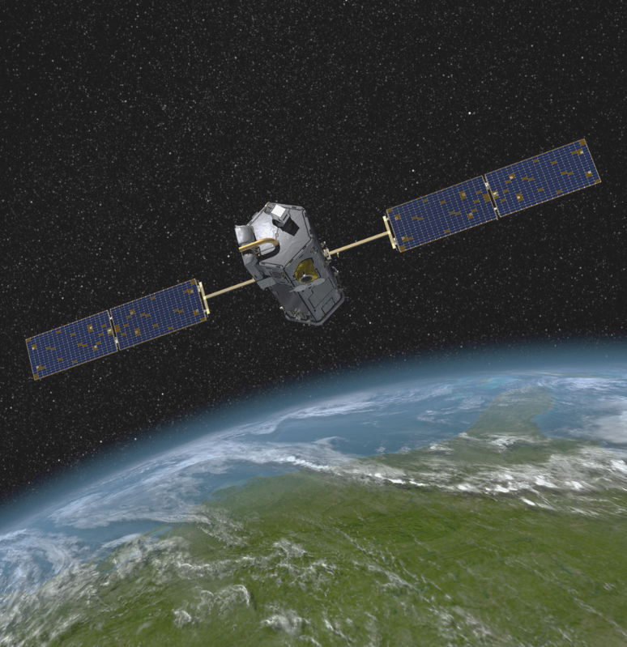
Courtesy of NASA/JPL-Caltech
[Picture shows Earth from space with a satellite in orbit above Earth]

Part 1
Scientific terminology defined or included in a glossary.
Orbital velocity is the speed that would need to be reached in order to keep satellites in orbit around the Earth. If a satellite travels too quickly, its inertia will cause it to fly off into space. If a satellite travels too slowly, Earth’s gravitational force will pull it back to the Earth.
Orbital Velocity (Speed) and Kinetic Energy of Satellites Data Table
Satellites | Speed (mph) | Kinetic Energy (MJ)
Satellite A | 9,000 | 12,000
Satellite B | 4,500 | 3,000
Satellite C | 7,000
Satellite D | 14,000 | 29,000
Satellite E | 18,000 | 48,000

Prompt 1
The relationship between kinetic energy and speed needs to be determined. Create a graph using an appropriate scale to plot the values of kinetic energy on the y-axis and speed on the x-axis. Be sure to label the axes and include a title.
As needed, a student could be reminded which axis is x and y.
Directions use simple, clear, and limit the complex terminology to scientific terms and include essential information (e.g., labeling the x-and y-axis).
Graph paper can be accommodated (bold line, tactile, background/line contrast, etc.) allowing active participation.
Use evidence from the graph to complete the following questions.
Information can be easily accommodated by enlarging the font, placing the words to circle on an eye-gaze board, or on an AAC device.

Prompt 2
Circle the word that makes the following statements true:

- The kinetic energy of the satellites is directly/indirectly (circle one) proportional to its speed.
- The relationship between the satellites kinetic energy and speed is linear/nonlinear. (circle one)

Prompt 3
If a satellite’s speed is doubled. The kinetic energy would be _________________.
- Cut in half
Information can be easily accommodated by enlarging the font, placing the words to circle on an eye-gaze board, or on an AAC device.
- Doubled
Individual choices and decisions for the example allow for students to draw from their own experiences.
- The same
- Quadrupled

Prompt 4
Use the graph to give an example that shows the proportional relationship between kinetic energy and speed. The example cannot be on the Orbital Velocity (Speed) and Kinetic Energy of Satellites Data Table.

Prompt 5
Satellite C has an unknown kinetic energy. Predict what the kinetic energy of Satellite C would be based on its speed of 7,000 mph. Explain how this prediction was made. Use the data table, graph, and the answers from questions 2 and 3 to help explain your reasoning.
Text can be presented multiple ways (e.g., in print, enlarged print, read by the teacher, online and accessed via a screen reader) and students can respond in writing, dictating, typing, use of AAC, etc.)
Part 2: Orbital Debris
Watch satellite/space debris video clips.
https://www.youtube.com/watch?v=PsvWAfHo4ow
Space junk, called debris, is material in space that is no longer functional. There are more than 500,00 pieces of varying sizes. The sizes can be larger than a softball to smaller than a marble. Space junk is a threat to orbiting satellites. The debris can damage them or throw them off course. More than 21,000 debris objects are being tracked to determine the risk of collision. Some travel at speeds of 17,500 mph.
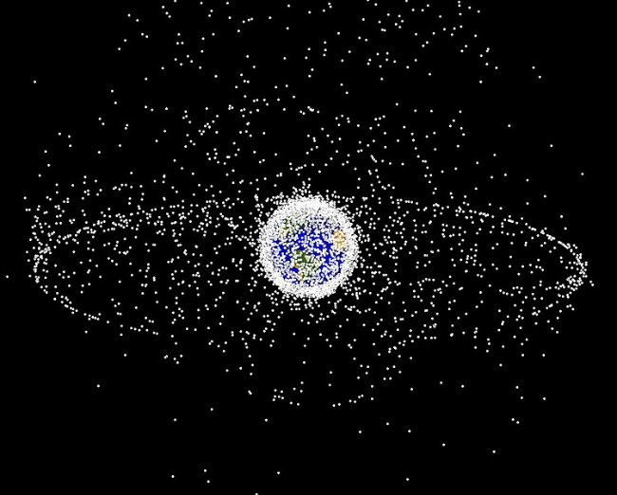
Courtesy NASA/JPL-Caltech
Refer to Data Table and Graph from part 1 to answer the following questions.

Prompt 1
The kinetic energy of Satellite B is decreased by a factor of 4. If the new kinetic energy is 750 MJ, what is the speed? Explain this answer using a proportional relationship.

Prompt 2
The kinetic energy of Satellite D needs to be increased from 29,000 MJ to 116,000 MJ because of space debris. What speed would it need to go? Show the steps taken to arrive at the answer.

Prompt 3
Orbital Debris Data Table
Orbital Debris | Mass (kg) | Speed (mph) | Kinetic Energy (MJ)
Debris #1 | 0.2 | 17,500 | 6
Debris #2 | 0.4 | 17,500 | 12
Debris #3 | 100 | 4,000 | 160
Debris #4 | 200 | 4000
Debris #5 | 100 | 8000
If a satellite is hit with 500 J of kinetic energy, it will go out of orbit. The engineer needs to determine which space debris to avoid. Analyze the data table above to answer the following questions.

            - Fill in the missing values in the data table. Explain how the values were determined.

- Which orbital debris is more important to avoid, Debris #4 or Debris #5? Explain why.

This task references
Brown. G, & Harris, W. (2000, May 19). How Satellites Work. HowStuffWorks.com. Retrieved from https://science.howstuffworks.com/satellite6.htm
European Space Imaging. (n.d.). QuickBird: MISSION SUCCESS: A LEGACY OF QUALITY. Retrieved from https://www.euspaceimaging.com/about/satellites/quickbird/
Smithsonian National Air and Space Museum. (n.d.) How Do Things Fly? Retrieved from https://howthingsfly.si.edu/
GIS Geography. (2020, July 3). 50 Satellites in Space: Types and Uses of Satellites. Retrieved from https://gisgeography.com/earth-satellite-list/
Riebeek, H. (2009, September 4). Catalog of Earth Satellite Orbits. NASA Earth Observatory. Retrieved from https://earthobservatory.nasa.gov/features/OrbitsCatalog
NASA. (2013, September 26). Space Debris and Human Spacecraft. Retrieved from https://www.nasa.gov/mission_pages/station/news/orbital_debris.html

SIPS Three-dimensional Classroom Science Task Accessibility Checklist
Accessibility and Fairness Review Worksheet

Review Criteria Category | Description | Agree | Disagree | For any statements of Disagree, please provide specific feedback to explain aspects of the tasks that need improvement.
The scenario, design problem, prompts, presented information, and expectations for the collection of student evidence…
Bias/Sensitivity:  The task does not provide an unfair disadvantage for a sub-group of students through the use of unfamiliar language, contexts or examples or content that provokes negative feelings or challenges beliefs or values. | use appropriate vocabulary, phrases, and/or sentence structure for the assessed grade level. | ☐ | ☐ | Click or tap here to enter text.
 | do not use content and language that may be considered offensive based on race, gender, sexual orientation, age, religion, ethnicity, socio-economic status and regional location. | ☐ | ☐ | Click or tap here to enter text.
 | do not use vocabulary that may be considerably more familiar to some groups than others. | ☐ | ☐ | Click or tap here to enter text.
 | do not include content that portrays any group of people in a negative or stereotypical manner. | ☐ | ☐ | Click or tap here to enter text.
Accessibility:  The task is accessible to all students and adheres to the principles of Universal Design for Learning. | are accessible to students from Nebraska and will not interfere with students’ ability to demonstrate their knowledge or understanding. | ☐ | ☐ | Click or tap here to enter text.
 | provide equal opportunities for students to demonstrate their knowledge, skills, and abilities without giving students an unfair advantage over other students. | ☐ | ☐ | Click or tap here to enter text.
 | include all information needed for students to demonstrate their knowledge, skills and abilities in response to each question. | ☐ | ☐ | Click or tap here to enter text.
 | provide a variety of response modes as represented by the types of work products (constructed response, drawing, completing a graph, selected response, etc.). | ☐ | ☐ | Click or tap here to enter text.

