Stackable Instructionally-embedded Portable Science (SIPS) Assessments Project

Grade 5 Science
Unit 3 Instructionally-embedded Assessment Task:
“Clean Water on the Trail”
Earth Systems and the Solution of Water Problems
April 2023

The SIPS Grade 5 Science Unit 3 Instructionally-embedded Assessment Task: “Clean Water on the Trail” was developed with funding from the U.S. Department of Education under the Competitive Grants for State Assessments Program, CFDA 84.368A. The contents of this paper do not represent the policy of the U.S. Department of Education, and no assumption of endorsement by the Federal government should be made.

All rights reserved. Any or all portions of this document may be reproduced and distributed without prior permission, provided the source is cited as: Stackable Instructionally-embedded Portable Science (SIPS) Assessments Project. (2023). SIPS Grade 5 Science Unit 3 Instructionally-embedded Assessment Task: “Clean Water on the Trail”. Lincoln, NE: Nebraska Department of Education.
SIPS Grade 5 Unit 3 Instructionally-embedded Assessment Task
Grade 5 | Unit 3 | Instructional Segment 2 | Task Title: Clean Water on the Trail
NGSS Performance Expectations Code(s) and Description(s)
Code | Description
3-5-ETS1-1. | Define a simple design problem that can be solved through the development of an object, tool, process, or system and includes several criteria for success and constraints on materials, time, or cost.
Acquisition Goals Number(s) and Descriptions(s)
Number | Description
A5. | Define the problem provided to them in ways that specify criteria for success and the nature of the resources and materials that will be used in solving the problem.
A8. | Specify a design that provides a solution to a given problem, indicating the way resources and materials will support meeting the design criteria and addressing constraints.
Evidence Statements
- Identify how elements of a design are supported by information from available resources, materials and/or prior design ideas.
- Describe the constraints of a problem, including criteria for success, and available resources and materials for solving problems.
- Describe a design for a solution to a problem.
- Describe how resources and materials support the design of a problem.
- Describe how a solution to a problem addresses constraints of a problem.

Source Documentation and Information Resources References (e.g., publications, websites, citations, images, videos, etc.)  Please include source name, description, citation, and a link to its original location below. Include additional rows as needed. | Licensing: Please mark an “X” under the appropriate licensing. If resource is not under a creative commons (CC) license, please attempt to find a source with CC licensing. If you are unable, please select other and provide additional information about the source in the source documentation section.
 | CC0/  Public Domain | CC BY | CC BY-SA | CC BY-NC | CC BY-NC-SA | CC BY-ND | CC BY-NC-ND | Other
Associated with Prompt 1:  - Water purification facts for kids  Source: YouTube https://www.youtube.com/watch?v=__JWa0ftr5k  Video created by: Fun Facts Kids TV |  |  |  |  |  |  |  | x
Associated with Prompt 4:  - Water purification facts for kids  Water purification Facts for Kids. Kiddle Encyclopedia. Modified content available under a CC BY-SA 3.0 license.  [https://kids.kiddle.co/Water_purification] |  |  | x
Associated with Prompt 4:  - Image: Water purification systems a Bret lake, Switzerland  Usine Bret MG 1680. Created by Rama. Image available under a CC BY-SA 2.0 license.  [https://kids.kiddle.co/Image:Usine_Bret_MG_1680.jpg] |  |  | x

Teacher Administration Guide
Introduction
- Educators developed the accompanying classroom task to align to one or more aspects of the NGSS Performance Expectation(s) (PEs) to determine where students are in their learning at a specific point in time during an instructional sequence. Educators will need to make intentional decisions about when and how to use this task based on their students’ learning needs, the purpose of giving the task, and the intended use of the evidence gathered.
- This task is designed to measure students’ ability to integrate the dimensions and demonstrate their knowledge, skills, and abilities as represented by NGSS Performance Expectation 3-5-ETS1-1. By administering this task, educators can gather and evaluate evidence to make accurate and meaningful judgments about students’ science learning and determine how instruction may need to be adjusted along an instructional sequence to best support students.
- The phenomenon in this task involves the need to “clean” dirty water. The scenario is based on someone on a hiking/camping trip who discovered the water they packed for cooking purposes has leaked out of a hole in the water bottle. They now have to sort through items in their backpack to create a method of filtering pond water that isn’t very translucent.
- In this task, students will develop a design plan to filter dirty water based on materials available in the backpack. Students create a diagram of their design plan and test their design using only materials provided, evaluating the clarity of the filtered water compared to that of the original water. Students will document and analyze the results of their test, and then develop a revised design plan to filter a new sample of the original dirty water. Students create a diagram of their revised design, test the revised design and document/analyze results. Students compare/contrast results from each test by comparing the filtered water samples to that of the original water, along with comparing/contrasting each design plan. Finally, students reflect upon what did/didn’t go well in each trial, along with what parts of their design were most successful and how designs could be improved upon if they created a third design trial.
Administration Guidelines
- One (1) class period
- Segment 2 Lessons: “Water, Water, Everywhere and Not a Drop to Drink” and “You Are What You Drink”
- Students individually complete a series of prompts reflecting the following chain of sensemaking:
- Students develop a design plan to filter dirty water based on available materials.
- Students identify the need for the design and the criteria for success.
- Students create a diagram of their design plan.
- Students describe the elements of their design.
- Students evaluate their design plan to filter dirty water based on reading a short article about water purification.
- Students reflect on what parts of their design were most successful and how the design may have limitations.
Accessibility Considerations
Providing a range of accessibility considerations in the task (e.g., multiple ways of representing information, multiple types of supports, multiple ways in which students respond) promotes equity and fairness across a wide range of students who may be at different points in their science learning. In turn, these considerations can promote student interest and engagement in the tasks resulting in a more complete and accurate collection of evidence of students’ science learning.
Accommodations for students with a disability or Multilingual Learners that are part of their on-going instructional programs are to be provided during the administration of this task. Accommodations should be consistent with those provided student’s daily instructional strategies and assessment opportunities including assistive technology devices if appropriate. These accessibility considerations and accommodations enable accurate inferences about student learning and inform meaningful adjustments to planning and instruction.
Ancillary Materials
- Computer for students to view a video individually
  - Water purification facts for kids - YouTube (Fun Facts Kids TV)
[https://www.youtube.com/watch?v=__JWa0ftr5k]
Instructions for Administering the Performance Task or Implementing the Research Task, Design Project, or Lab
- Grab a water bottle filled with muddy water. Ask the class how we could make this muddy water drinkable. Elicit responses.
- Pose the scenario - Jessie is on a long hiking trip to where she will camp overnight. She just discovered a hole in the bottle of water that she planned to use for cooking. Her water must have drained while she walked. The only water source nearby is a creek, but the water isn’t very translucent (clear). Jessie empties the contents of her bag to search for materials that she could use to clean the water before she cooks with it.
- Students develop a design plan to filter dirty water based on materials available.
- Students create a diagram of their design plan.
- Students determine whether the design solution meets all the criteria of success.
Scoring Guidance
- A task-and prompt-specific scoring rubric indicates scoring criteria for each prompt across a range of score points.
- Student exemplars represent high-quality responses that align to full-point rubric scores. The exemplar responses are intended to assist educators’ understanding of the nature and expectations of each prompt when applying the scoring rubric. Note the exemplars serve as examples of high-quality responses, and students may respond with equally relevant, scientifically accurate responses and ideas that meet the expectations of a full-point rubric score. In general, the exemplar response associated with the highest score point in the rubric meets expectations and is scientifically accurate, complete, coherent, and consistent with the type of student evidence expected as described in the rubric.
- The approximate scoring time for this task will be 5-10 minutes per student or small group.

Student Task
This task is about designing a solution to a given problem.
Task Scenario
Jessie is on a hiking trip. It is beginning to get dark and she finds a spot where she will camp overnight. As she is unpacking, she discovers the bottle of fresh water that she planned to use for cooking rice for her dinner is empty. The bottle has a small hole, and the water must have drained while she walked. The only water source nearby is a creek, but the water is not very clear. Jessie empties the contents of her bag to search for materials that she could use to clean the dirt and debris from the water before she cooks with it. In her bag she finds:
- 10 cotton balls
- 2 new empty plastic water bottles (each holds 2 cups of water)
- 4 paper towels
- 1 cup dry rice
- 1 sheet of aluminum foil
- 4 coffee filters
- Small cooking pot
- Small propane camp stove
Jesse needs two (2) cups of boiling water to cook the rice for dinner.
Read and watch the video, Water purification facts for kids to gain more knowledge of water purification.
Prompt 1

Define the problem that Jessie needs to solve.

- What are the criteria for a successful solution?

The criteria for a successful solution are_____________________________________________

Prompt 2
Develop a design plan to filter the creek water based on the available materials. You do not need to use all of the materials. Create a diagram of your design plan. Clearly label the materials that you plan to use and where they are located within your design.

Prompt 3

Describe your solution. In your description, be sure to include how your solution addresses the problem.
_____________________________________________________________________________________
_____________________________________________________________________________________
_____________________________________________________________________________________
_____________________________________________________________________________________

Prompt 4

Read the article “Water purification facts for kids” to help you answer the question.

Water purification facts for kids
Adapted for Use from Kiddle Encyclopedia

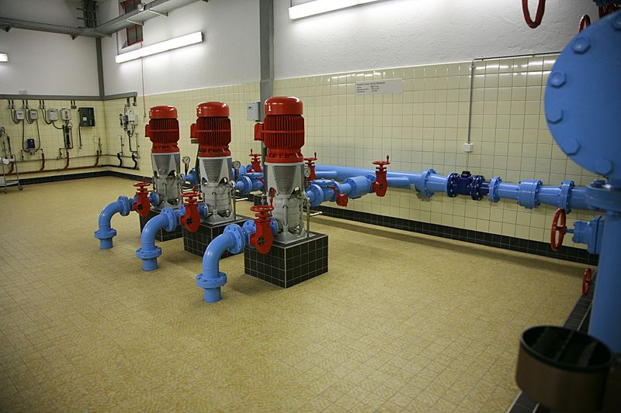
Water purification is the process of removing unwanted living and non-living materials from water. It is not possible to tell whether water is safe to drink just by looking at it. Simple methods such as boiling, or the use of homemade filters, are not enough for removing all the possible impurities in water from an unknown source. Chemical analysis is the only way to ensure the water is safe for drinking. Water must be safe before it can be used as drinking water.
Water purification systems at
Bret Lake, Switzerland

Describe how well your solution will work. Use the article to determine if you have done enough to ensure that the water is safe to use for cooking. Why or why not?

_____________________________________________________________________________________
_____________________________________________________________________________________
_____________________________________________________________________________________
_____________________________________________________________________________________
_____________________________________________________________________________________

Task Rubric to Evaluate Student Evidence
Task | Score Point 0 | Score Point 1 | Score Point 2 | Score Point 3 | Score Point 4
Prompt 1  Part A. | No aspect of the response is correct | Response includes one (1) of the two (2) aspects | Response includes the following aspects:  - two cups of clear water to cook with  - plan to filter the water | NA | NA
Prompt 1 Part B. | No aspect of the response is correct | Response includes one (1) of the two (2) aspects | Response includes the following aspects:  - filter the dirt and debris from the water  - be able to cook with the water (at least 2 cups) | NA | NA
Prompt 2. | No aspect of the response is correct | Response includes one (1) of the two (2) following aspects:  - uses at least one (1) of the following materials for filtering:  - aluminum foil  - cotton balls  - paper towels  - coffee filter  - cooking pot  - camp stove  OR  - uses a new bottle to collect the filtered water | Response includes the following aspects:  - uses at least one (1) of the following materials for filtering:  - aluminum foil  - cotton balls  - paper towels  - coffee filter  - cooking pot  - camp stove  - uses a new bottle to collect the filtered water | Response includes the following aspects:  - uses at least two (2) of the following materials for filtering:  - aluminum foil  - cotton balls  - paper towels  - coffee filter  - cooking pot  - camp stove  - uses a bottle to collect creek water  - uses a new bottle to collect the filtered water | Response includes the following aspects:  - uses three (3) or four (4) of the following materials for filtering:  - aluminum foil  - up to 10 cotton balls  - up to 4 paper towels  - up to 4 coffee filters  - cooking pot  - camp stove  - uses a bottle to collect creek water  - uses a new bottle to collect the filtered water  - boils the water for cooking
Prompt 3 | No aspect of the response is correct | Response includes one (1) of the three (3) aspects. | Response includes two (2) of the three (3) aspects. | Response includes the following aspects:  - description of the purpose of two (2) to four (4) of the filtration solution materials  - description of the use of the empty water bottles for gathering dirty water and/or collecting filtered water  - description of boiling the water before cooking | NA
Prompt 4 | No aspect of the response is correct | Response includes one (1) of the three (3) aspects. | Response includes two (2) of the three (3) aspects. | Response includes the following aspects:  - provides a reasonable statement about if their solution meets the criteria  - provides evidence of their choice (met or does not meet).  - references the article support their conclusion | NA

Exemplar Responses
Prompt 1 Part A. | Jesse needs 2 cups of clear water to cook with. She must come up with a way to remove the dirt and debris from the creek water. She needs to finish cleaning the water before it gets too dark.
Prompt 1 Part B. | The criteria for a successful solution are that she needs to filter two cups of water and she needs to boil the water to cook the rice for dinner.
Prompt 2 | 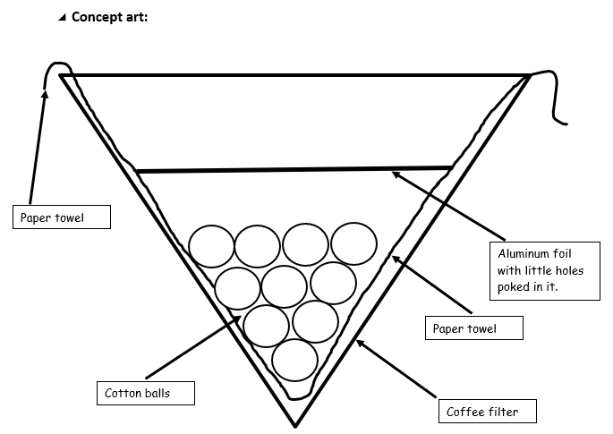
Prompt 3 | She can build a filter system like the one in the video. As the water passes through the aluminum foil with little holes in it, the bigger sticks and leaves will be blocked. Then the water moves through the cotton ball to remove more of the dirt. Finally, it will pass through the paper towel layer and the coffee filter to remove the smaller pieces of dirt and debris. She can use the leaky bottle to collect the dirty stream water and fill the two clean water bottles with her filtered water. She can set this up before dark.
Prompt 4. | The solution will remove most of the dirt and debris from the water. The water will be clear, but the water is still not safe to use for cooking even if she boils the water. According to the article, boiling the water may not remove all possible contaminants.
Task Notes

Water purification Facts for Kids. Kiddle Encyclopedia. Content modified and made available under a CC BY-SA 3.0 license.

