Stackable Instructionally-embedded Portable Science (SIPS) Assessments Project

Grade 8 Science
Unit 2: Designing Equitable Assessments for Diverse Learners
Gravity and Motion of Objects in the Solar System
May 2023

The SIPS Grade 8 Science Unit 2: Designing Equitable Assessments for Diverse Learners, Gravity and Motion of Objects in the Solar System was developed with funding from the U.S. Department of Education under the Competitive Grants for State Assessments Program, CFDA 84.368A. The contents of this paper do not represent the policy of the U.S. Department of Education, and no assumption of endorsement by the Federal government should be made.

All rights reserved. Any or all portions of this document may be reproduced and distributed without prior permission, provided the source is cited as: Stackable Instructionally-embedded Portable Science (SIPS) Assessments Project (2023). SIPS Grade 8 Science Unit 2: Designing Equitable Assessments for Diverse Learners, Gravity and Motion of Objects in the Solar System. Lincoln, NE: Nebraska Department of Education.

SIPS Grade 8 Unit 2: Designing Equitable Assessments for Diverse Learners
How do we optimize accessibility for diverse learners and why is this important? This document provides steps for planning and developing equitable assessments that incorporate the principles of Universal Design for Learning (UDL) and the elements of Universally Designed Assessments (UDA). Both UDL and UDA are designed to promote access to instruction and/or assessment to the widest range of students. This includes, but is not limited to, students with varying abilities, cultures, primary languages, background knowledge, and interests. For more information about equitable assessment design and use, and why it is important, view Chapter 4: Fairness and Accessibility of the Strengthening Claims-based Interpretations and Uses of Local and Large-scale Science Assessment Scores (SCILLSS) Digital Workbook on Educational Assessment Design and Evaluation: Creating and Evaluating Effective Educational Assessments.
A multi-step process to promote the selection and design of equitable assessments for diverse learners is detailed which includes planning, selection and development, and evaluation and reflection. General information, links to tools and resources, and guiding questions provide additional considerations to support the implementation of this multi-step process.

Planning
Consider all students when designing the assessment task, including students’ gender, race, and ethnicity, socio-economic status, primary and secondary language, disability, cultural experiences, background knowledge, etc. Knowing what understandings and abilities different students bring to the assessment is vital to removing or reducing barriers to students’ ability to demonstrate attainment of the assessed acquisition goals.
It is important to ensure that the requirements of the assessment task clearly target the selected acquisition goals. Consider how to include additional knowledge and skills that are related, but not specifically assessed, and how to elicit students' background knowledge to support students' accurate and complete demonstration of their learning through the evidence they produce.
Use the Bias, Sensitivity, and Accessibility Review Worksheet (see page 9) as part of the planning process.
Selection and Development
When selecting or developing an assessment task, consider how it will engage students, how the directions and information are presented to students, and how students will interact with the task requirements and materials. Developing the assessment task while considering these three components helps identify possible barriers and provides access to the widest range of students taking the assessment. Each component includes guiding questions to prompt a deeper look at the assessment task.

Student Engagement
- Select or develop an assessment task that will engage students and encourage students to put forth the effort and time to fully demonstrate their understanding of the acquisition goals.
  - Are the goals clear and understandable for students?
  - Is the assessment task authentic and relevant?
  - Are options available for individual choices and decisions?
  - Is the time allotted to complete the task reasonable?
  - Does the task allow students to actively participate?
  - Are there opportunities to collaborate with peers?

Presentation of Content
- Provide multiple and accessible ways to present the assessment task, including the directions, the information, and the materials.
  - Can the assessment task directions be accessed as needed?
  - Are the directions and information presented using simple, clear, and intuitive language (e.g., limit unnecessary wording, avoid multiple-meaning words, avoid unnecessary scientific terminology)?
  - Can the assessment task directions and information be accessed in more than one way (e.g., auditorily, visually, use of technology, in the primary language, etc.)?
  - Is the readability and comprehensibility of the information appropriate for the widest range of students (e.g., length, direct sentence structure, scientific and academic terminology explained or glossed)?
  - Is the physical appearance of the included material easily read (e.g., plenty of white space, adequate font size; the standard font, etc.)?
  - Is necessary background knowledge activated or supplied?

Student Interaction
- Ensure all students can interact with the assessment task requirements and materials.
  - Are there options for how the student can complete the task (choice of materials, tools, methods, etc.)?
  - Are there multiple ways to participate in the task (e.g., technology, physical manipulation, variety of strategies)?
  - Are the materials and task requirements easily accommodated for a student with a visual impairment, physical disability, cognitive disability, for a student using assistive technology (AT), or an alternative, assistive communication (AAC) system, etc.?
  - Are differentiated levels of support available (e.g., modeling the process, peer mentoring, supplying background knowledge)?
  - Are there varied opportunities to ask questions or express observations (e.g., designated time, individually, within small groups)?
  - Are there multiple ways and levels of feedback throughout the task (e.g., using a checklist to self-monitor, encouraging students through the steps, and teacher checking for accuracy at each step)?

Evaluation and Reflection
Two evaluation and reflection checkpoints should occur. First, prior to administering the task, use the guiding questions above (see Selection and Development section) along with the Bias, Sensitivity, and Accessibility Review Worksheet (see page 9) to review how the assessment task will engage students, the presentation of the assessment task materials, and how the student interacts with the assessment task requirements and materials. Make any needed revisions to maximize equity to a wide range of students. Remember to ensure the assessment task can be further accommodated as necessary (e.g., tactile model for a student who is blind).
The second checkpoint should occur following the administration of the assessment task. Determine any barriers observed while students were completing the assessment task and note additional revisions that could be applied to remove or reduce the barriers. Use these notes when planning for instruction and when selecting or developing another assessment task.

Annotated Example
An annotated assessment task supports understanding and interpretation of the features of a well-designed, high-quality assessment task that promote students’ ability to respond fully and accurately to each prompt or item. The annotations on the example science assessment task, “Space Systems,” provided for use by the Nebraska Department of Education highlight features of an assessment task and suggest additional features that could be applied to optimize accessibility and equity for the widest range of students.

Grade 8 Science Assessment Task: Space Systems
An example of a model that demonstrates scale presented prior to beginning the assessment can support background knowledge.
Presenting the assessment digitally in addition to paper-based helps students independently access directions as often as needed.

Student Worksheet
Orients student to the task and elicits prior knowledge.
CCR-Science Standard
SC.8.11.6 Gather, analyze and communicate evidence of interactions among bodies in space.

Task
Clearly states the requirements.
Authentic scenario that leads to the prompts.
This task is about space systems. Be sure to answer prompts 1, 2, 3, and 4.
Next week there will be a near Earth object. The local news channel needs a press release to show how far away the object will be and how large it is. Near Earth objects (NEO) are defined as comets and asteroids that have entered Earth’s neighborhood
Background knowledge is provided.

Prompt 1
The first thing that needs to be represented in the press release is the distance to the near Earth object. The distance from the Earth to the moon is one lunar distance or LD.
Using the term “create” instead of “draw” and providing options on how students can create and label a model increases options for student choice and accessibility.
Table 1. Distances from Earth
Moon | 1 LD
Near Earth Object | 5 LD
Adapted from data on https://cneos.jpl.nasa.gov/ca/
Use a ruler and in the area below, draw and label a model of how close the object will be to Earth. In your model, be sure to show:
- the Earth,
Clearly states the requirements.
- the moon,
- the Near Earth Object,
- the scale used.
Providing shapes representing each object for the student to cut and paste or digitally for the student to drag and drop provides choices and increases accessibility.
Physical appearance of the bulleted list and plenty of white space makes it easy to read.
Providing the blank model in a variety of formats (digital, larger size, separate sheet, mounted on slant board) increases student choice and accessibility.
Specifying that it is the relative size of the Near Earth Object would make the directions clearer (e.g., The press release needs to address the relative size of the Near Earth Object).

Prompt 2
The press release needs to address the relative size and how to model this size using an appropriate scale. First, make a scale with connections to everyday objects.
Draw a model below to represent the relative sizes of these objects. Please label your objects and communicate your scale in the key. (It is okay to use lines, boxes, symbols or pictures in your model.)
- Semi-truck, 14 meters
“Relative size” can be glossed.
- Football field, 110 meters
- Near Earth Object, 25 meters
Placing images of each of these in a digital format increases accessibility by allowing students to enlarge or shrink to show the appropriate scale.
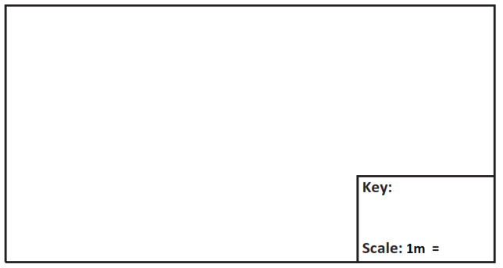

Prompt 3
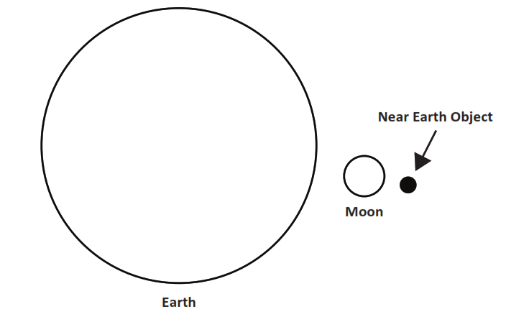
The press release needs to compare the size of the Near Earth Object to the Earth and moon. The following illustration was made by a fellow coworker.
Table 2. Diameter of Objects
Object | Diameter Size (Kilometers)
Earth | 12,742
Moon | 3,474
Near Earth Object | 0.025
Adapted from data on https://cneos.jpl.nasa.gov/ca/

Provide feedback to your coworker on the appropriateness of the scale used in the drawing.
Provide options for the means student uses to respond to the prompt (e.g., writing, dictating, use of a word bank, etc.).

Prompt 4
Draw a scale model to illustrate the location of the near Earth object from the Earth and the size of the near Earth object. This model is for the press release.
A lunar distance is the distance from the Earth to the moon. A NEO is the near Earth object.
Restating what NEO stands for ensures the correct information is being assessed (i.e., ability to draw a scale model vs. understanding an acronym).
Table 3. Variables Needed
Distance from Earth to Moon | 1 LD
Distance from Earth to NEO | 5 LD
Diameter of the Earth | 0.033 LD
Diameter of the Moon | 0.009 LD
Diameter of the NEO | 0.000000065 LD
Adapted from data on https://cneos.jpl.nasa.gov/ca/
Allowing students to cut this chart out and choose where to place it while working provides student choice and increases accessibility (i.e., no need to scroll from page to page).
What scale challenges are present when looking at the image for the press release? What fine print needs to be included with the illustration?

SIPS Three-dimensional Classroom Science Task Accessibility Checklist
Accessibility and Fairness Review Worksheet
Review Criteria Category | Description | Agree | Disagree | For any statements of Disagree, please provide specific feedback to explain aspects of the tasks that need improvement.
The scenario, design problem, prompts, presented information, and expectations for the collection of student evidence…
Bias/Sensitivity:  The task does not provide an unfair disadvantage for a sub-group of students through the use of unfamiliar language, contexts or examples or content that provokes negative feelings or challenges beliefs or values. | use appropriate vocabulary, phrases, and/or sentence structure for the assessed grade level. | ☐ | ☐ | Click or tap here to enter text.
 | do not use content and language that may be considered offensive based on race, gender, sexual orientation, age, religion, ethnicity, socio-economic status and regional location. | ☐ | ☐ | Click or tap here to enter text.
 | do not use vocabulary that may be considerably more familiar to some groups than others. | ☐ | ☐ | Click or tap here to enter text.
 | do not include content that portrays any group of people in a negative or stereotypical manner. | ☐ | ☐ | Click or tap here to enter text.
Accessibility:  The task is accessible to all students and adheres to the principles of Universal Design for Learning. | are accessible to students from Nebraska and will not interfere with students’ ability to demonstrate their knowledge or understanding. | ☐ | ☐ | Click or tap here to enter text.
 | provide equal opportunities for students to demonstrate their knowledge, skills, and abilities without giving students an unfair advantage over other students. | ☐ | ☐ | Click or tap here to enter text.
 | include all information needed for students to demonstrate their knowledge, skills and abilities in response to each question. | ☐ | ☐ | Click or tap here to enter text.
 | provide a variety of response modes as represented by the types of work products (constructed response, drawing, completing a graph, selected response, etc.). | ☐ | ☐ | Click or tap here to enter text.

This task references Center for Near Earth Object Studies. (N.D.). Retrieved at https://cneos.jpl.nasa.gov/.ec

