Stackable Instructionally-embedded Portable Science (SIPS) Assessments Project

Grade 8 Science
Unit 2 Instructionally-embedded Assessment Task:
“Forces Modeling How Gravitational Forces Affect Motion”
Gravity and Motion of Objects in the Solar System
May 2023

The SIPS Grade 8 Science Unit 2 Instructionally-embedded Assessment Task: “Forces Modeling How Gravitational Forces Affect Motion” was developed with funding from the U.S. Department of Education under the Competitive Grants for State Assessments Program, CFDA 84.368A. The contents of this paper do not represent the policy of the U.S. Department of Education, and no assumption of endorsement by the Federal government should be made.

All rights reserved. Any or all portions of this document may be reproduced and distributed without prior permission, provided the source is cited as: Stackable Instructionally-embedded Portable Science (SIPS) Assessments Project. (2023). SIPS Grade 8 Science Unit 2 Instructionally-embedded Assessment Task: “Forces Modeling How Gravitational Forces Affect Motion”. Lincoln, NE: Nebraska Department of Education.
SIPS Grade 8 Unit 2 Instructionally-embedded Assessment Task
Grade 8 | Unit 2 | Instructional Segment 1 | Task Title: Forces Modeling How Gravitational Forces Affect Motion
NGSS Performance Expectations Code(s) and Description(s)
Code | Description
MS-ESS1-2. | Develop and use a model to describe the role of gravity in the motions within galaxies and the solar system. [Clarification Statement: Emphasis for the model is on gravity as the force that holds together the solar system and Milky Way galaxy and controls orbital motions within them. Examples of models can be physical (such as the analogy of distance along a football field or computer visualizations of elliptical orbits) or conceptual (such as mathematical proportions relative to the size of familiar objects such as students' school or state).] [Assessment Boundary: Assessment does not include Kepler’s Laws of orbital motion or the apparent retrograde motion of the planets as viewed from Earth.]
MS-PS2-4. | Construct and present arguments using evidence to support the claim that gravitational interactions are attractive and depend on the masses of interacting objects. [Clarification Statement: Examples of evidence for arguments could include data generated from simulations or digital tools; and charts displaying mass, strength of interaction, distance from the Sun, and orbital periods of objects within the solar system.] [Assessment Boundary: Assessment does not include Newton’s Law of Gravitation or Kepler’s Laws.]
Acquisition Goals Number(s) and Descriptions(s)
A4. | Construct and present an argument to support an explanation that gravitational forces are always attractive (or refute an explanation that gravitational forces can be repulsive).
A19. | Construct and present an argument about how gravitational forces lead to a regular orbital motion of a moving object.
Evidence Statements
- Communicate information from science and technical texts to support the claim that gravitational interactions are attractive.
- Use data on mass and gravitational force to determine similarities and differences in forces exhibited with objects of varying masses.
- Identify evidence or data that supports an explanation that gravitational forces are always attractive.
- Use reasoning to connect appropriate evidence about the forces on objects and construct the argument that gravitational forces are attractive.
- Identify evidence, data, or models that support an argument that gravity causes a pattern of smaller/less massive objects orbiting around larger/more massive objects at all system scales in the universe.
Source Documentation and Information Resources References (e.g., publications, websites, citations, images, videos, etc.)  Please include source name, description, citation, and a link to its original location below. Include additional rows as needed. |  |  |  | Licensing: Please mark an “X” under the appropriate licensing. If resource is not under a creative commons (CC) license, please attempt to find a source with CC licensing. If you are unable, please select other and provide additional information about the source in the source documentation section.
 |  |  |  | CC0/  Public Domain | CC BY | CC BY-SA | CC BY-NC | CC BY-NC-SA | CC BY-ND | CC BY-NC-ND | Other
Data for Table 1  - How does gravity differ on different bodies in the solar system? | World Economic Forum (weforum.org)  [https://www.weforum.org/agenda/2021/08/visualizing-gravitational-pull-planets-solar-system/] |  |  |  |  |  |  |  |  |  | X
Data for Table 2  - Asteroid Fact Sheet (nasa.gov)  [https://nssdc.gsfc.nasa.gov/planetary/factsheet/asteroidfact.html] |  |  |  | X
Geocentric vs. Heliocentric  - Geocentric vs. Heliocentric  [https://www.thinglink.com/scene/799311354304397314] |  |  |  |  |  |  |  |  |  |  | X
Figure 1. Jupiter and its Moons Io, Europa, Ganymede, and Callisto  - File:Jupiter family.jpg - Wikimedia Commons  [https://commons.wikimedia.org/wiki/File:Jupiter_family.jpg] |  |  |  | X

Teacher Administration Guide

Introduction
- Educators developed the accompanying classroom task to align to one or more aspects of the NGSS Performance Expectation(s) (PEs) to determine where students are in their learning at a specific point in time during an instructional sequence. Educators will need to make intentional decisions about when and how to use this task based on their students’ learning needs, the purpose of giving the task, and the intended use of the evidence gathered.
- This task is designed to measure students’ ability to integrate the dimensions and demonstrate their knowledge, skills, and abilities as represented by NGSS Performance Expectations MS-ESS1-2 and MS-PS2-4. By administering this task, educators can gather and evaluate evidence to make accurate and meaningful judgments about students’ science learning and determine how instruction may need to be adjusted along an instructional sequence to best support students.
- The phenomenon in this task involves patterns in data illustrating that (1) gravitational forces are attractive and (2) the mass and distance determine the gravitational force of attraction.
- In this task, students apply their understandings associated with gravitational interactions to explore the interactions between objects in the solar system and to compare and discuss two competing models of our solar system. One model will show Earth as the center of the solar system and the other model will show the sun as the center of the solar system. Students will use data provided about the mass of objects in our solar system and their acceleration due to gravity.
- Background information:
  - Students previously discovered that (1) gravitational forces are attractive and (2) the mass and distance determine the gravitational force of attraction.
  - In this assessment, students will be presented with two competing models of our solar system. One model will show Earth as the center of the solar system and the other model will show the sun as the center of the solar system. Using the data provided about the mass of objects in our solar system and their acceleration due to gravity, students will support a claim related to the structure of the solar system.
Administration Guidelines
- One (1) class period
- Segment 1 Lessons: “How Does JWST Stay in Orbit?” and “Modeling How Gravitational Forces Affect Motion”
- Students individually complete a series of prompts reflecting the following chain of sensemaking:
- Compare heliocentric vs. geocentric models of the solar system.
- Analyze data about the masses of different categories of objects in the solar system and how that relates to acceleration/gravitational pull and orbital behaviors due to gravity.
- Use the data to write a C-E-R argument about which model is currently supported today.
- Communicate and summarize their argument by making a presentation using multiple means of representation.
Accessibility Considerations
Providing a range of accessibility considerations in the task (e.g., multiple ways of representing information, multiple types of supports, multiple ways in which students respond) promotes equity and fairness across a wide range of students who may be at different points in their science learning. In turn, these considerations can promote student interest and engagement in the tasks resulting in a more complete and accurate collection of evidence of students’ science learning.
Accommodations for students with a disability or Multilingual Learners that are part of their on-going instructional programs are to be provided during the administration of this task. Accommodations should be consistent with those provided student’s daily instructional strategies and assessment opportunities including assistive technology devices if appropriate. These accessibility considerations and accommodations enable accurate inferences about student learning and inform meaningful adjustments to planning and instruction.
Ancillary Materials
- None
Instructions for Administering the Performance Task or Implementing the Research Task, Design Project, or Lab
- Pose the scenario: heliocentric vs. geocentric models of the solar system.
- Students will explore how gravity determines the structure of the solar system.
Scoring Guidance
- A task-and prompt-specific scoring rubric indicates scoring criteria for each prompt across a range of score points.
- Student exemplars represent high-quality responses that align to full-point rubric scores. The exemplar responses are intended to assist educators’ understanding of the nature and expectations of each prompt when applying the scoring rubric. Note the exemplars serve as examples of high-quality responses, and students may respond with equally relevant, scientifically accurate responses and ideas that meet the expectations of a full-point rubric score. In general, the exemplar response associated with the highest score point in the rubric meets expectations and is scientifically accurate, complete, coherent, and consistent with the type of student evidence expected as described in the rubric.
- The approximate scoring time for this task will be 5 to 10 minutes per student.

Student Task
This task is about the role of gravity in the solar system.
Task Scenario
Students in a physics class learn about the solar system. They learn that the earliest models of the solar system were geocentric. Geocentric is defined as “having the Earth at the center.” It was believed for many centuries that the Earth has a special position in the solar system. Later models, including the one used today, are heliocentric. Heliocentric is defined as “having the sun as the center”. Today’s heliocentric model was not generally accepted until only about 500 years ago.
The students want to investigate more about why the sun and not Earth is at the center of the universe.

Prompt 1

The students collect data about objects in our solar system. They collect the data in Table 1 which shows the mass, diameter, and gravity of the sun, planets, Pluto, and Earth’s moon.
Table 1. Mass, Diameter, and Gravity of Objects in the Solar System
Name | Mass (10²⁴ kg) | Diameter (km) | Gravity (m/s²)
Sun | 1,991,000 | 1,392,000 | 293.0
Mercury | 0.33 | 4,879 | 3.7
Venus | 4.87 | 12,104 | 8.9
Earth | 5.97 | 12,756 | 9.8
Moon | 0.073 | 3,475 | 1.6
Mars | 0.642 | 6,792 | 3.7
Jupiter | 1.898 | 142,984 | 23.1
Saturn | 568.0 | 120,536 | 9.0
Uranus | 86.8 | 51,118 | 8.7
Neptune | 102.0 | 49,528 | 11.0
Pluto | 0.0146 | 2,370 | 0.7
Source: LePan N 2021, This visualization shows the gravitational pull of objects in our solar system, digital article, Visual Capitalist,
accessed 19 May 2023, <https://www.weforum.org/agenda/2021/08/visualizing-gravitational-pull-planets-solar-system/>

Part A.
How does the relationship between mass and the gravitational pull of the sun compare to that of Earth? Use information from Table 1 to support your answer.
_____________________________________________________________________________________
_____________________________________________________________________________________

_____________________________________________________________________________________
Part B.
Use the patterns in Table 1 to:
  - Arrange the following four objects in our solar system in order from the least gravitational force of attraction to the greatest: Earth, Sun, Mercury, and Neptune.
  - Draw circles to represent the relative diameter of each object relative to the size of the other objects.
 | Object with the least gravitational pull |  |  | Object with the greatest gravitational pull
Picture representation of object
Name of object

Part C.
Imagine a ball being dropped from the same distance above the ground on Earth and on Mercury.

Will the ball reach the ground at the same time on both planets? Why or why not? Use data from Table 1 to support your answer.

_____________________________________________________________________________________

_____________________________________________________________________________________

______________________________________________________________________________
Prompt 2
Like a magnetic force, gravitational interactions occur at a distance and not through direct contact. As part of their data collection, the students record the planets’ distance from the sun in Table 2.

Table 2. Distance from the Sun of the Major Objects in the Solar System
Planet | Distance (miles)
Mercury | 35,980,000
Venus | 67,230,000
Earth | 92,897,000
Mars | 141,600,000
Jupiter | 483,600,000
Saturn | 888,200,000
Uranus | 1,786,400,000
Neptune | 2,798,800,000

The students are interested in learning more about other planetary objects in Earth’s solar system and the surface gravity of the planets. They learn that surface gravity is the gravitational pull of an object at the surface of a planet toward its center. They also find out that there are hundreds of moons in the solar system. Earth has one moon. In the outer solar system, planets have dozens of moons. For example, Jupiter has between 80 and 95 moons. One of Jupiter’s moons is Ganymede, the largest moon in the solar system. Its diameter is larger than the planet Mercury but has less surface gravity than Mercury. Ganymede has a surface gravity of 1.428 m/s² and a mass of 0.148 × 10²⁴ kg. Figure 1 shows Jupiter and four of its moons.

Figure 1. Jupiter and its Moons Io, Europa, Ganymede, and Callisto
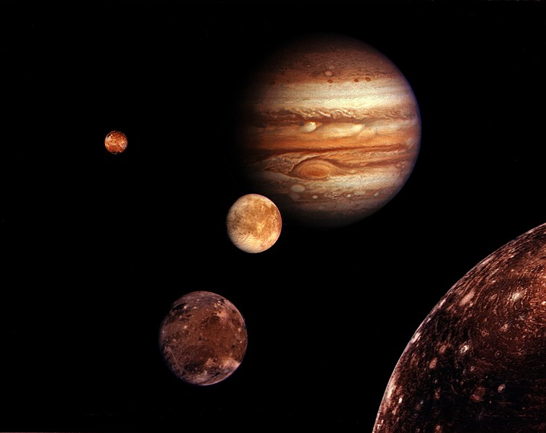
Image in the Public Domain. Source: NASA
Part A.
Scientists believe moons were probably formed from the discs of gas and dust circulating around planets in the early solar system. Remember, the sun has a gravitational pull of 293.0 m/s². Whereas, Jupiter has a gravitational pull of 24.8 m/s².

Why does Ganymede orbit Jupiter instead of orbiting the sun like Mercury? Use information from Table 2 to support your answer.

_____________________________________________________________________________________

_____________________________________________________________________________________

_____________________________________________________________________________________

_____________________________________________________________________________________
Part B.
Some moons are captured objects that formed elsewhere and fell into orbit around larger worlds. Mars has two moons, Phobos and Deimos. Both are believed to be captured asteroids. Asteroids are rocky objects that exist in our solar system. Table 3 shows the mass of a few asteroids that are found in our solar system.

Table 3. Masses of Some Asteroids in the Solar System
Asteroid | Mass (10¹⁵ kg)
Ceres | 9.393
Eugenia | 6.1
Siwa | 1.5
Ida | 1.0

How does the gravitational force of attraction of an asteroid compare to that of the objects in our solar system shown in Table 1? Your answer should include the following:

  - One example object from Table 1
  - One example object from Table 3
  - A comparison of the mass of the two objects you identified and the magnitude of force.

_____________________________________________________________________________________

_____________________________________________________________________________________

_____________________________________________________________________________________

_____________________________________________________________________________________

_____________________________________________________________________________________

Prompt 3
The students find two historical models that depict how objects are believed to move in our solar system. These are shown in Figure 2.

Figure 2: Historical Models of the Solar System
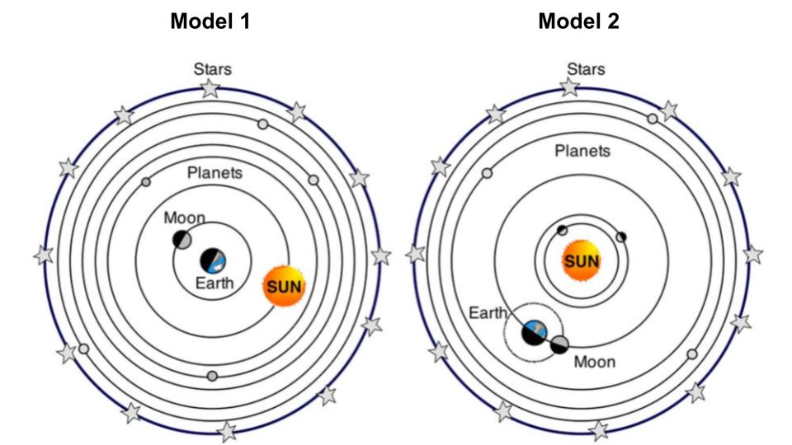
Bell L 2017, Geocentric vs. Heliocentric, digital image, Thinglink, accessed 19 May 2023, <https://www.thinglink.com/scene/799311354304397314>
Part A.
Compare and contrast the two models of Earth’s solar system using the Venn diagram below. To receive full credit, you must have at least one idea written in each section of the diagram.
Model 2
Model 1

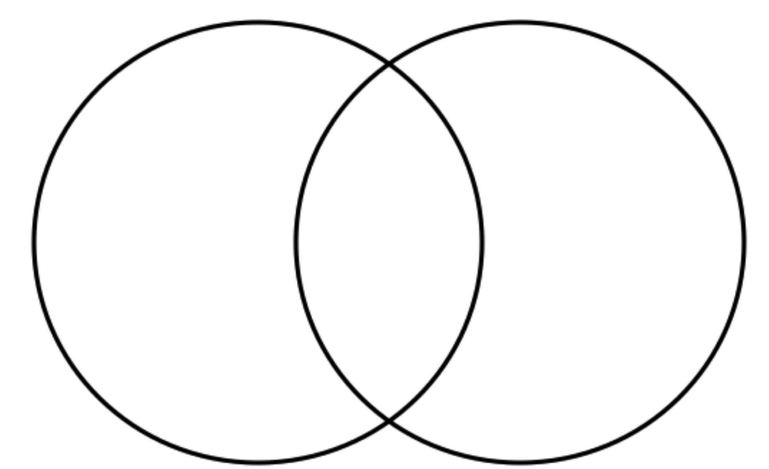

Part B.

Consider which model, Model 1 or Model 2, best represents the movement of objects in our solar system.

Write an evidence-based claim in support of the model, using your knowledge of gravitational forces of attraction.
Claim:
_____________________________________________________________________________________

_____________________________________________________________________________________

Evidence: Identify two (2) pieces of evidence that support your claim:

1.___________________________________________________________________________________

_____________________________________________________________________________________

2.___________________________________________________________________________________

_____________________________________________________________________________________

_____________________________________________________________________________________
Reasoning: Using your knowledge of science and understanding of gravitational forces, explain how the evidence you identified supports your claim about which model best shows how objects move in the solar system. In your answer, be sure to include the following terms: (1) gravitational force of attraction, (2) mass, (3) orbits, (4) sun, and (5) Earth.
_____________________________________________________________________________________

_____________________________________________________________________________________

_____________________________________________________________________________________

_____________________________________________________________________________________

_____________________________________________________________________________________

_____________________________________________________________________________________

_____________________________________________________________________________________

_____________________________________________________________________________________

Task Rubric to Evaluate Student Evidence
Task | Score Point 0 | Score Point 1 | Score Point 2 | Score Point 3 | Score Point 4
Prompt 1  Part A. | No aspect of the response is correct | Response includes one (1) of the two (2) aspects. | Response includes the following aspects:  Part A  - Statement comparing the sun’s greater mass and gravitational pull to Earth’s  - Supported by data from Table 1 | NA | NA
Prompt 1  Part B. & Part C. | No aspect of the response is correct | Response includes one (1) of the four (4) aspects | Response includes two (2) of the four (4) aspects | Response includes three (3) of the four (4) aspects | Response includes the following aspects:  Part B  - Names of each of the required four objects are arranged in order from the least gravitational force of attraction to the most  - The relative diameters are drawn in order from the least to the greatest  Part C  - The speed of a falling object will be greater on Earth than on Mercury  - Supports answer with data from Table 1
Prompt 2 | No aspect of the response is correct | Response includes one (1) of the four (4) aspects | Response includes two (2) of the four (4) aspects | Response includes three (3) of the four (4) aspects | Response includes the following aspects:  Part A.  - Relationship between the distance between objects and strength of the gravitational pull  - Supports answer with data from Table 2  AND  Part B.  - Relationship between an object’s mass and its gravitational pull  - Compares the masses of objects in Table 1 to those in Table 3
Prompt 3 Part A. | No aspect of the response is correct | Response includes one (1) of the three (3) aspects | Response includes two (2) of the three (3) aspects | Response includes the following aspects:  - At least one unique characteristic of Model 1  - At least one unique characteristic of Model 2  - At least one shared characteristic between Model 1 and Model 2 | NA
Prompt 3 Part B. | No aspect of the response is correct | Response includes one (1) of the four (4) aspects | Response includes two (2) of the four (4) aspects | Response includes three (3) of the four (4) aspects | Response includes the following aspects:  - Selects Model 2 as the basis for the claim  - Evidence statements 1 and 2 support the claim  - Reasoning refers to including both pieces of evidence  - Reasoning includes all five (5) of the vocabulary words

Exemplar Responses
Prompt 1
Part A.
How does the relationship between mass and the gravitational pull of the sun compare to that of Earth? Use information from Table 1 to support your answer.
According to the data table, the Sun has much more mass than Earth, 1,991,000 compared to 5.97. This corresponds with a greater gravitational pull than Earth’s 293 to 9.8 m/s².
Prompt 1
Part B.
Use the patterns in Table 1 to:
- Arrange the following four objects in our solar system in order from the least gravitational force of attraction to the most: Earth, Sun, Mercury, and Neptune.
  - Draw circles to represent the relative diameter of each object relative to the size of the other objects.
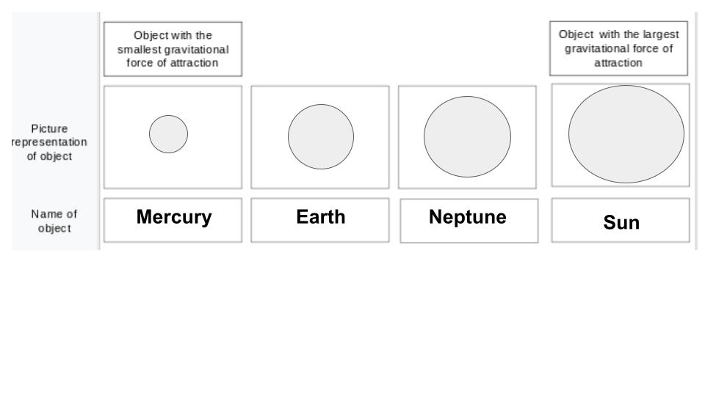
Prompt 1
Part C.
Will the ball reach the ground at the same time on both planets? Why or why not? Use data from Table 1 to support your answer.
The ball will fall faster on Earth than on Mercury. This happens because the gravitational pull on Earth is 9.8 m/s² compared to Mercury’s at 3.7 m/s². So, the ball on Earth will fall almost three times faster than on Mercury.
Prompt 2
Part A.
Why does Ganymede orbit Jupiter instead of orbiting the sun like Mercury? Use information from Table 2 to support your answer.
Even though Ganymede and Mercury are about the same size, their orbits are due to distances. Mercury is 35,980,000 miles from the sun. Jupiter is 483,600,000 miles from the sun. So, even though the sun has a much greater gravitational pull than Jupiter, Ganymede is very much closer to Jupiter than to the sun. That is why Ganymede experiences a much stronger gravitational pull from Jupiter than the sun and stays in orbit around Jupiter.
Prompt 2
Part B.
How does the gravitational force of attraction of an asteroid compare to that of the objects in our solar system shown in Table 1? Your answer should include the following:
  - One example object from Table 1
  - One example object from Table 3
  - A comparison of the mass of the two objects you identified and the magnitude of force.
The mass of asteroids is many times less than the mass of planets. According to the data tables, asteroids’ masses are in the range of 10¹⁵ compared to planets which are in the range of 10²⁴. So, asteroids will have a much smaller gravitational pull than the planets. The greater the mass of an object, the greater the gravitational pull.
Prompt 3
Part A.
Compare and contrast the two models of Earth’s solar system using the Venn diagram below. To receive full credit, you must have at least one idea written in each section of the diagram.
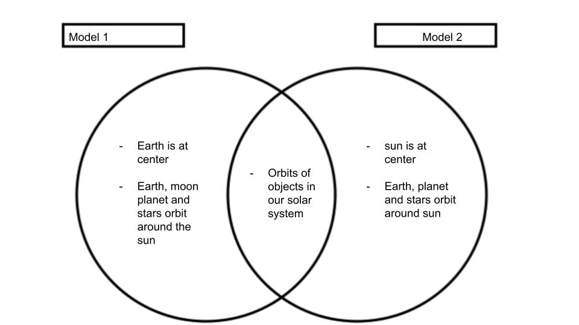
Prompt 3
Part B.
Consider which model, Model 1 or Model 2, best represents the movement of objects in our solar system.
Write an evidence-based claim in support of the model, using your knowledge of gravitational forces of attraction.
Note: Answers will vary.
Claim: Model 2 best shows the movement of objects in our solar system.
Evidence: Identify two (2) pieces of evidence that support your claim:
- According to the provided information, the sun is the largest object in our solar system.
- According to the provided information, the sun has the greatest gravitational pull.
Reasoning: Using your knowledge of science and understanding of gravitational forces, explain how the evidence you chose supports your claim about which model best shows how objects move in the solar system. In your answer be sure to include the following terms: (1) gravitational force of attraction, (2) mass, (3) orbits, (4) sun, and (5) Earth.
Objects with a larger mass also have a greater gravitational force of attraction. The sun has the largest mass and therefore will have the biggest gravitational force of attraction. Therefore, the sun has to be the center of our solar system, because it attracts other smaller objects, including Earth. The large gravitational force of attraction from the sun, because of its large mass, pulls all the other less massive objects into orbit around it. Because of this understanding, I know that Model 2 best shows the movement of objects in our solar system.
Task Notes

