SIPS Grade 5 Unit 1 EOU Assessment Task 1: What’s the Matter?

Student Worksheet
This task is about the results of mixing solids with liquids.

Task
Ms. Kim’s students are learning about matter. Matter can be a liquid, solid, or gas. Ms. Kim plans to show what can happen when a liquid and solid are mixed together. Vinegar is a clear liquid. Baking soda is a white powder.

Prompt 1
Before mixing, Ms. Kim pours some vinegar into a bottle. Then she places some baking soda into an uninflated balloon. Next, she attaches the balloon to the top of the bottle. To mix the two materials, Ms. Kim lifts the balloon and the baking soda falls into the vinegar.
Before Mixing | After Mixing
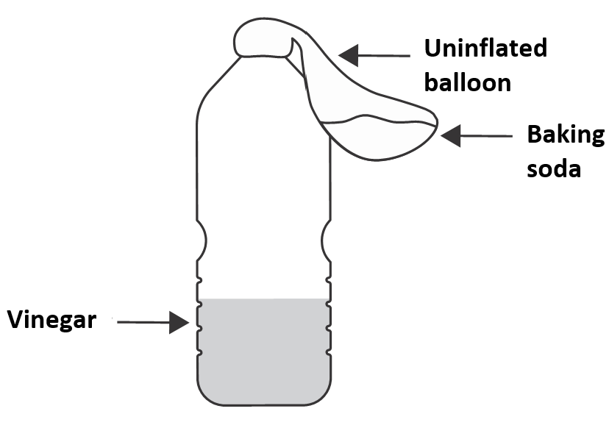 | 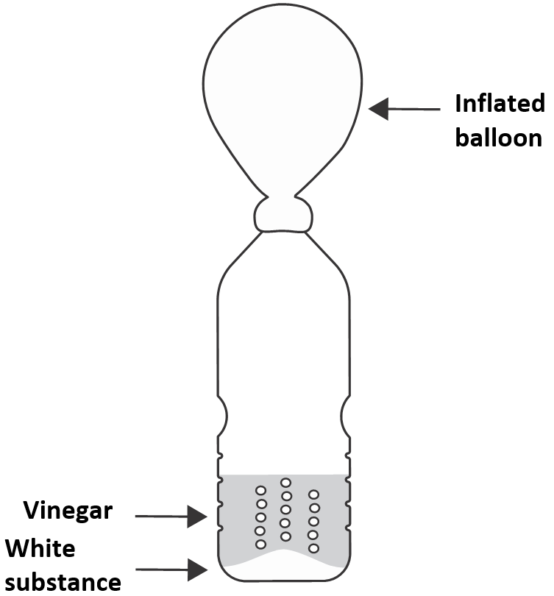

Part A.
After mixing the vinegar and baking soda, bubbles form. The balloon begins to expand. Ms. Kim tells the students that the gas from the bubbles fills the balloon.
In the space below, draw the arrangement of the particles in the balloon after mixing. Use the symbol of a particle in the key to draw the particles.
KEY

Particle

Gas

Part B.
Ms. Kim tells the students that when materials are mixed, they can make a gas. Gases cannot be seen.
Use your particle arrangement drawing to explain why the students cannot see the gas particles inside the balloon.
______________________________________________________________________________
______________________________________________________________________________
______________________________________________________________________________
______________________________________________________________________________

Part C.
Ms. Kim tells the students that we can see solids and liquids. Solids and liquids are also made of particles like gases. Then, a student says the following:
The particles of solids and liquids are arranged the same as gases. We can see solids and liquids because their particles are much bigger than gas particles.

Do you agree with the student’s description of why we can see solids and liquids?
Circle your answer. YES NO
Use what you know about the arrangement AND size of particles of matter to explain your answer.
______________________________________________________________________________
______________________________________________________________________________
______________________________________________________________________________
______________________________________________________________________________

Prompt 2
Ms. Kim provides Table 1. It shows the properties of three solids. It also shows reactions, or changes, when each of the solids is mixed with water or vinegar.
Table 1. Material Properties
Solid | Description  of Appearance | Mixed with Water | Mixed with Vinegar
Baking Soda | White powder | Dissolves | Forms bubbles
Corn Starch | White powder | Forms a white mixture | Forms a white mixture
Powdered Sugar | White powder | Dissolves | Dissolves

Next, Ms. Kim shows the students three unknown solids. Ms. Kim tells the class each of the unknown solids is one of the solids in Table 1.
The unknown solids are labeled as:
- Solid A
- Solid B
- Solid C
Ms. Kim asks the students to think of a way to identify the unknown solids.
Complete Diagram 1 with mixtures of unknown solids, water, and vinegar that can be used to identify the unknown solids. One mixture is filled in.
Diagram 1. Mixtures of Unknown Solids with Liquids

Prompt 3
Which mixtures and observations would determine that Solid B is powdered sugar? Use Table 1 and the completed Diagram 1 to support your explanation.
I would mix Solid B with ___________________________________________________because
__________________________________________________________________________ .
I will know Solid B is powdered sugar if____________________________________________ _
__________________________________________________________________________ .

SIPS Grade 5 Unit 1 EOU Assessment Task 2: What Just Happened?

Student Worksheet
This task is about properties of matter.

Task
Have you ever reached for a glass of ice water to have the glass slip from your hand? When you pour the water over the ice, the glass is dry on the outside. But when you pick it up later, the outside of the glass is covered with water droplets. Condensation occurs when water vapor cools and forms water droplets on a surface.
The pictures below show Glass 1 with no ice and Glass 2 with ice.
- Each glass is the same size.
- Each glass is filled with the same amount of room temperature water.
- Ice cubes are only added to Glass 2.
Glass 1 with No Ice Glass 2 with Ice
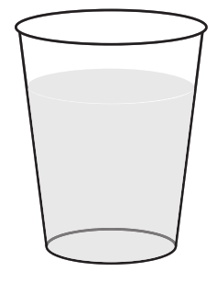
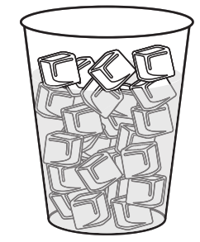

After a few minutes, there is no change to Glass 1.
After a few more minutes, water droplets form on the surface of Glass 2.

Prompt 1

Part A.
Condensation happens when particles in a gas cool down. As the gas particles cool, they begin to move closer together. Finally, the particles form a liquid.
When water is a gas, it is called water vapor. When water vapor cools, it forms liquid water.

Use Model 1 to draw the particle arrangement of water particles in water vapor.

Use Model 2 to draw the particle arrangement of water particles in liquid water.
- Use the symbol of a particle in the key to draw the particles.

KEY

Particle

Part B.
Explain how the process of condensation supports the idea that all single water particles are too small to be seen. Use your particle arrangement drawings to support your response.
______________________________________________________________________________
______________________________________________________________________________
______________________________________________________________________________
______________________________________________________________________________
______________________________________________________________________________

Prompt 2
Materials can be identified by their properties. One property is how long it takes heat to flow through a material.
An investigation is conducted to measure how quickly heat flows through three different materials used to make drinking containers. Each container is filled with the same amount of water. For each of the three containers:
- The starting temperature of the water is measured.
- After 20 minutes, the final temperature of the water is measured.
- The total amount of heat loss is calculated.

Table 1 describes the observable properties of the three different drinking containers A, B, and C. It also shows the property of heat flow as the amount of heat lost by the water in each drinking container after 20 minutes.
Table 1. Properties of Drinking Containers
Drinking  Container | Property of Material | Amount of Heat Lost (in Degrees Fahrenheit
A | - clear, blue color  - stiff | 41°F
B | - white color  - bends slightly  - goes back into shape without breaking | 38°F
C | - bright silver  - bendable  - bending results in a dent | 48°F

Materials with high heat flow lose heat much faster than materials with low heat flow.
Use Table 1 to identify the drinking container with the highest rate of heat flow. Compare data from all three drinking containers to explain your answer.
The drinking container with the highest rate of heat flow is_________.
I know this because___________________________________________________________________
_____________________________________________________________________________
_____________________________________________________________________________.

Prompt 3

Part A.
Table 2 shows the properties of three different materials used to make drinking containers.
Table 2. Properties of Drinking Container Materials
Material | Properties
Foam | - extremely light weight and flexible  - usually white in color  - very low heat flow
Metal | - moderately light material  - shiny surface  - high heat flow
Plastic | - light weight material  - may be transparent  - low heat flow

Use the results from Table 1 and information from Table 2 to identify the material used to make one of the drinking containers used in the investigation. Compare the data from all three drinking containers to explain how you identified the material.
The material used to make Drinking Container ______ is _______________________________.
I know this because __________________________________________________________________
_____________________________________________________________________________
______________________________________________________ _________________.

Part B.
Which measurements AND observations are the most useful to identify the material used to make the drinking container?
The most useful measurements are ________________________________________________
_____________________________________________________________________________.
The most useful observations are__________________________________________________
_____________________________________________________________________________.
SIPS Grade 5 Unit 1 EOU Assessment Task 3: Change or Not?

Student Worksheet
This task is about the results of mixing materials.

Task
Mr. Carter and his students design an investigation to determine if mixing different substances can result in a new substance. The students ask if the total mass of the combined substances will stay the same if a new substance is formed. Mr. Carter says, “Great question! Let’s investigate to find out what happens.”

Prompt 1
Mr. Carter has a solution of water and soda ash in Jar A and a solution of water and Epsom salt in Jar B. Mr. Carter slowly combines the solutions from Jar A and Jar B into Jar C.
Table 1 shows the students’ record of their observations.

Table 1. Record of Observations
Solution in Jar A | Solution in Jar B | Solution in Jar C
After mixing the soda ash and water, the solution is clear. | After mixing the Epsom salt and water, the solution is clear. | After mixing the two clear solutions together, a white solid is seen on the bottom of the jar.

Part A.
Did mixing the two solutions together cause a new substance to form? Circle your answer.
A new substance IS formed. A new substance IS NOT formed.

Part B.
Use Table 1 showing the students’ observations of Jar A, Jar B, and Jar C to support your answer to Part A.
_____________________________________________________________________________
_____________________________________________________________________________
_____________________________________________________________________________
_____________________________________________________________________________

Prompt 2
In Table 2 and Table 3, Mr. Carter writes the mass, in grams, of the materials in Jar A and Jar B on the board.
Table 2. Table 3.
Mass of Solution in Jar A  Substance Mass (in g)  Water 40  Soda ash 13 | Mass of Solution in Jar B  Substance Mass (in g)  Water 40  Epsom salt 8

Part A.
Graph 1 shows the total mass of the materials in Jar A.
Use the data in Table 3 to complete Graph 1 to show the total mass of the solution in Jar B.
Graph 1. Mass of the Solution in Jar A and the Mass of the Solution in Jar B
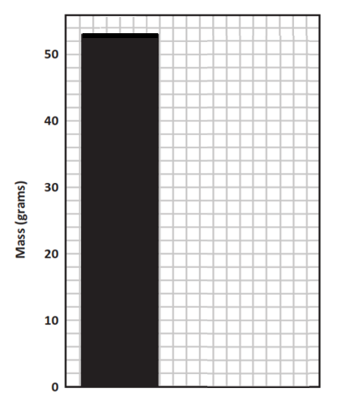
Mass of Solution in Jar B
Mass of Solution in Jar A

Part B.
Mr. Carter tells the students that the total mass of the combined solutions in Jar C is 101 grams. Then, Mr. Carter writes the following sentence on the board:
When a new substance is formed by mixing different materials, the total mass of the new substance is equal to the combined masses of the original materials.

Do you agree with Mr. Carter's description of the results of the investigation?
Circle your answer. YES NO
Use the information from Graph 1 and the total mass of Jar C to support your answer to Part B.
Graph 1 shows________________________________________________________________
____________________________________________________________________________
____________________________________________________________________________.
The total mass of the solution of Jar C is____________________________________________.
So, when the solutions were mixed and a change occurred, ____________________________
____________________________________________________________________________
____________________________________________________________________________.

