Stackable Instructionally-embedded Portable Science (SIPS) Assessments Project

Grade 8 Science
Unit 2 Student Profile
Gravity and Motion of Objects in the Solar System
May 2023

The SIPS Grade 8 Science Unit 2 Student Profile: Gravity and Motion of Objects in the Solar System was developed with funding from the U.S. Department of Education under the Competitive Grants for State Assessments Program, CFDA 84.368A. The contents of this paper do not represent the policy of the U.S. Department of Education, and no assumption of endorsement by the Federal government should be made.

All rights reserved. Any or all portions of this document may be reproduced and distributed without prior permission, provided the source is cited as: Stackable Instructionally-embedded Portable Science (SIPS) Assessments Project. (2023). SIPS Grade 8 Science Unit 2 Student Profile: Gravity and Motion of Objects in the Solar System. Lincoln, NE: Nebraska Department of Education

SIPS Grade 8 Science Unit 2 Student Profile
The Stackable, Instructionally-embedded, Portable Science (SIPS) Assessments Unit 2 Student Profile describes what students should know and be able to demonstrate prior to, during, and at the culmination of three-dimensional science instruction in Unit 2 to prepare for new and increasingly sophisticated learning opportunities in Unit 3. The student profile is intended to build science educators’ understanding of the targeted student learning outcomes and how they are situated in the context of year-long instruction to promote and inform the intentional selection of curricular materials and design of instructional opportunities to achieve these outcomes for all students. In addition, the end-of-unit profile can support discussion with students, parents, and guardians about the Unit 2 topic of interest “Gravity and Motion of Objects in the Solar System” and the knowledge, skills, and abilities to which teaching and opportunities to learn will be based.
The SIPS Assessments Unit 2 student profile provides a description of:
- The necessary prior learning opportunities and prior knowledge and skills that students are expected to have acquired for all three dimensions—Science and Engineering Practices (SEPs), Disciplinary Core Ideas (DCIs), and Crosscutting Concepts (CCCs)—before engaging in Unit 2, “Gravity and Motion of Objects in the Solar System.” These prior learning opportunities and knowledge and skills serve as entry points to the unit to ensure readiness and to foster understanding of new and increasingly sophisticated learning experiences. This section also includes an explanation of how prior learning, knowledge, and skills will be built upon in the unit.
- The knowledge, skills, and abilities students are expected to learn and demonstrate by the end of the unit when provided with opportunities to integrate scientific and engineering practices with important disciplinary core ideas and crosscutting concepts to scientifically investigate and understand natural phenomena and solve important science and engineering design problems.
- The learning experiences in Unit 3 allow students to build from and expand their learning in Unit 2 to effectively engage in the SEPs to sense-make using acquired scientific knowledge and understanding of the CCCs in the context of multiple DCIs. This section highlights key connections among important scientific ideas, practices, and concepts that students investigate as they progress from one unit to the next.
The following sections describe the prior learning and knowledge, skills, and abilities that students are expected to bring to and acquire by the end of the unit, respectively, and how these knowledge, skills, and abilities prepare students to deepen their science learning in Unit 3. The content in these sections draws from the dimensional appendices of the NGSS (Appendix E, Appendix F, Appendix G), the performance expectations articulated in the NGSS, A Framework for K12 Science Education, and Stage 1 of the SIPS Unit 2 map.

1. Prior Learning Opportunities
By building on familiarity with previous Unit 1 ideas related to forces and energy, Unit 2 allows students to use and extend this knowledge to explain phenomena and solve design problems when investigating the distance and motion of various planetary objects in relation to the force of gravity. Unit 2 focuses on the universe and its stars, particularly on the role of gravity in keeping planetary objects in orbit in the solar system.
Essential prior learning (from earlier grades) from upper elementary (Grades 3–5) and middle school (Grades 6 and 7) related to the DCIs, CCCs, and SEP are provided in Appendix A.

2. End-of-Unit Learning Outcomes
Measurement targets are narrative descriptions that integrate the DCIs, SEPs, and CCCs into a single statement representing what is to be taught and assessed in each unit. The SIPS Measurement Target for this Unit is:
- Students are able to apply Science and Engineering Practices with emphasis on analyzing and interpreting data, developing and using models, and using evidence and observable patterns in support of arguments illustrating different characteristics of objects in the solar system, including differences in scale, that the solar system consists of the sun and a collection of objects, including planets, their moons, and asteroids that are held in orbit around the sun by its gravitational pull on them, and use models to explain patterns of the apparent motion of the sun, the moon, and stars in the sky including eclipses of the sun and the moon, the Earth’s spin axis, and seasons.

By engaging in this unit, students will further deepen their knowledge about the force of gravity between objects with mass and its role in keeping planetary objects in orbit within the solar system and about Earth’s place in the universe. In this unit, there is significant overlap and synergy between the DCI and CCC dimensions, where patterns of different scales and proportions are traced throughout the multiple components of a system represented in a model. Similarly, the particular SEPs allow students to analyze and interpret similarities and differences in findings which can provide empirical evidence to support or refute an argument based on a model of a phenomenon in the universe.

Descriptions of the specific learning expectations associated with each dimension are elaborated below.

DCI
The Grade 8 Unit 2 topic, “Gravity and Motion of Objects in Solar System” organizes four performance expectations that together enable argumentation supported by empirical evidence in the universe about how objects with mass are affected by gravity. Also, through analyzing similarities and differences of planetary objects at different scales, students can understand how they are kept in place in the universe. In working with these disciplinary core ideas, students are positioned to make connections across systems of planetary objects at different scales and the role that gravity plays in keeping them in orbit.

CCC
Over the course of Unit 2, students will identify patterns that reveal the relationships between gravity and the place of objects with mass on Earth and the universe. By using models, students can make sense of how time, space, and gravitational force interact with each other within the solar system. These types of analyses will enable students to see continuity across systems of objects on Earth and across the universe, and how they are all affected by gravity in the same way.

SEP
Over the course of this unit, students will develop and use models to construct and support evidence-based arguments that center around the role of gravity in keeping objects in orbit in the solar system. Additionally, students will have opportunities to analyze and interpret data to determine similarities and differences between objects in the solar system. The findings can provide empirical evidence that explains a model and how gravity affects objects of varying masses and/or can be used as evidence for their arguments about the connections between gravitational forces and orbital motion.
3. Connections to Unit 3 Learning Opportunities

DCI
Unit 2 focuses extensively on the role of gravity in keeping planetary objects in place and in orbit within the solar system and the universe. These ideas prepare students for Unit 3, in which they will focus on how changes in life and land over Earth’s history, how this is related to the adaptations and evolutionary pressures on all types of organisms, and how we use the fossil record and rock strata to learn about the history of organisms and landforms/rocks.
Unit 2 Unit 3
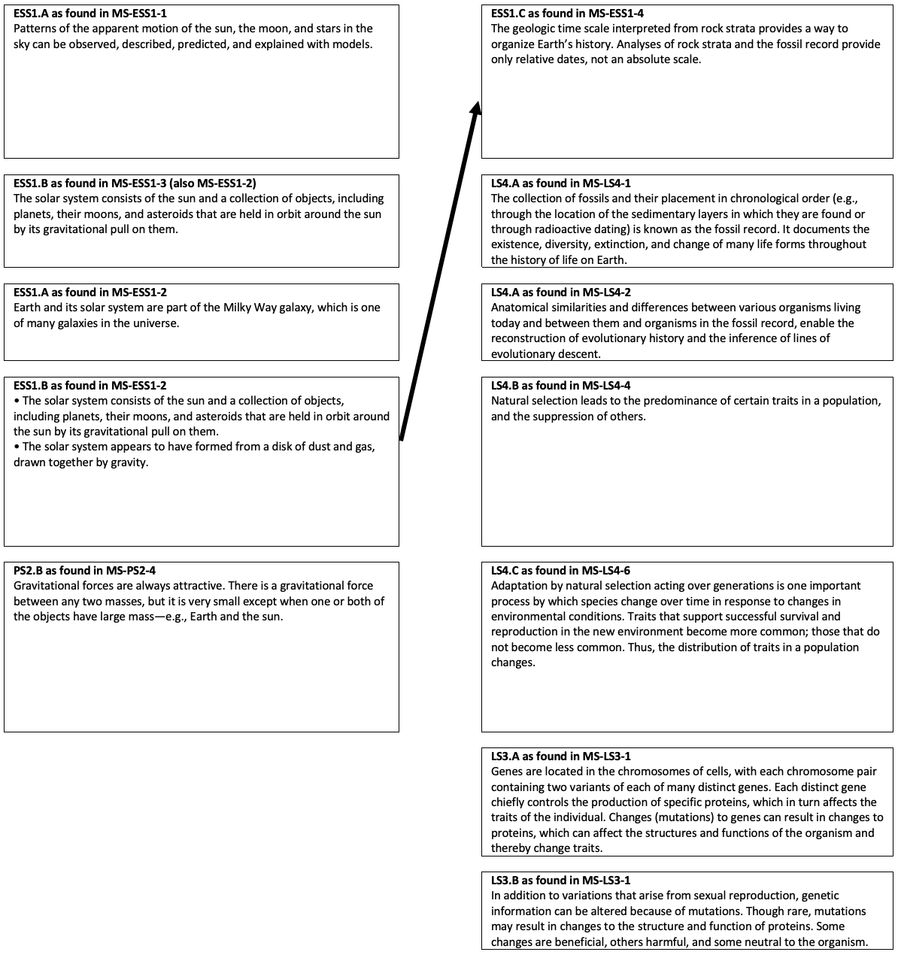
CCC
Unit 2 CCCs focus on Systems and System Models, the system as a whole, and the interactions between elements within a system. In addition, the unit includes identifying patterns obtained from models and objects of various Scales, Proportions, and Quantities and using them to draw inferences to explain the universe. Their experience with these concepts will help them as they apply these concepts in Unit 3 to use a geological timescale to organize Earth’s history and to identify cause and effect relationships as they pertain to the adaptations, evolutionary pressures on all types of organisms, and how we use the fossil record and rock strata to learn about the history of organisms and landforms/rocks. They will also use graphs, charts, and images to identify patterns in data from fossil records as they document the existence of various lifeforms and various factors and mechanisms that lead to genetic variation.
SEP
Unit 2 uses the Developing and Using Models SEP: Students get extensive practice developing and using models of different sizes to focus on how gravity helps keep objects in orbit in the universe (e.g., modeling using a tennis ball and a marble to learn about how the sun and earth are influenced by gravity due to the differences in mass). In addition, in Unit 2, students will be analyzing and interpreting data to determine similarities and differences between how gravity influences the way objects in the solar system are kept in orbit to explain phenomena in the universe. Thus, students’ experiences developing their skill and ability to use these SEPs in Unit 2 will aid them in Unit 3 when they will be analyzing and interpreting data, constructing explanations, and using models to describe and/or explain the phenomena and scientific concepts in Unit 3 that connect LS and ESS DCIs around evolution and the history of the Earth.
Appendix A. DCI, CCC, and SEP Prior Learning Opportunities
DCI
- Prior Learning from 3-5 (NRC Framework)
  - The sun is a star that appears larger and brighter than other stars because it is closer. Stars range greatly in size and distance from Earth.
  - The orbits of Earth around the sun and of the moon around Earth, together with the rotation of Earth about an axis between its North and South poles, cause observable patterns.
  - Some objects in the solar system can be seen with the naked eye. Planets in the night sky change positions and are not always visible from Earth as they orbit the sun. Stars appear in patterns called constellations, which can be used for navigation and appear to move together across the sky because of Earth’s rotation.
  - Each force acts on one object and has both strength and direction. An object at rest typically has multiple forces acting on it, but they add to give zero net force on the object. Forces that do not sum to zero can cause changes in the object’s speed or direction of motion. (Boundary: Qualitative and conceptual, but not quantitative addition of forces is used at this level.) The patterns of an object’s motion in various situations can be observed and measured. When past motion exhibits a regular pattern, future motion can be predicted from it. (Boundary: Technical terms, such as magnitude, velocity, momentum, and vector quantity, are not introduced at this level, but the concept that some quantities need both size and direction to be described is developed.)
- Prior learning from this grade band (e.g., Grades 6 & 7):
  - Minimal/not applicable.
CCC - Patterns
- Prior learning from 3-5:
  - Patterns can be observed when the earth, which rotates on an axis, orbits the sun and the moon orbits the earth about an axis. These include day and night; daily and seasonal changes in the length and direction of shadows; phases of the moon; and different positions of the sun, moon, and stars at different times of the day, month, and year.
- Prior learning from this grade band (e.g., Grades 6 & 7): Students are expected to use graphs, charts, and images to identify patterns in data. They are also expected to use cause-and-effect relationships to identify patterns in data (Appendix G).
  - Multiple MS PEs use this CCC, so students will likely have some experience with the CCC’s MS elements, prior to starting Grade 8 Unit 2.
CCC - Scale, Proportion, & Quantity
- Prior learning from 3-5: Students are expected to understand that events depend on phenomena that operate at very different scales, but also that fundamental interactions are present through these differences. They are also expected to understand the importance of units and their association with observable quantities.
  - In Grades 3-5, students learn to recognize that natural objects and observable phenomena exist from the very small to the immensely large. They will also learn to use standard units to measure and describe physical quantities such as weight, time, temperature, and volume (Appendix G).
- Prior learning from this grade band (e.g., Grades 6 & 7): Students are expected to become adept at working across different scales and how phenomena observed at one scale may not be observable at another scale. They use proportional relationships (e.g., speed) to gather information about the magnitude of properties and processes.
  - Multiple MS PEs use this CCC, so students will likely have some experience with the CCC’s MS elements, prior to starting Grade 8 Unit 2.
CCC – Systems and System Models
- Prior learning from 3-5: Students are expected to understand that a system is composed of components that interact with one another and also that the system can do things that depend on the different components, which may each have a unique function, and that the components operating together can enable the system to carry out functions that individual parts cannot.
- Prior learning from this grade band (e.g., Grades 6 & 7): Students are expected to develop additional sophistication in identifying the way that components of a system interact with one another and with the environment (surroundings) of the system.
  - Multiple MS PEs use this CCC, so students will likely have some experience with the CCC’s MS elements, prior to starting Grade 8 Unit 2.
SEP - Developing and Using Models
- Prior learning from 3-5: Students continue developing their modeling skills and abilities by developing and revising different types of models, along with beginning to consider that those models can have limitations (Appendix G).
  - PE 4-PS4-2 is an example of a 3-5 grade band PE that uses a Developing and Using Models SEP element that is very similar to the SEP element used by two Unit 2 MS PEs (MS-ESS1-1 and MS-ESS1-2).
- Prior learning from this grade band (e.g., Grades 6 & 7): Students develop, use, and revise models to describe, test, and predict more abstract phenomena and to design systems.
  - Multiple MS PEs use this SEP, so students will likely have some experience with the SEP’s MS elements, prior to starting Grade 8 Unit 2. MS-PS4-2 is an example MS PE that uses the same SEP element as two Unit 2 MS PEs (MS-ESS1-1 and MS-ESS1-2).
SEP - Analyzing and Interpreting Data
- Prior learning from 3-5: Students will have experience with the collection of data using quantitative approaches to collecting data and conducting multiple trials of qualitative observations. They will be able to carry out the analysis and interpretation of the data using logical reasoning, mathematics, and/or computation.
  - In Grades 3-5, students will represent data in tables and/or various graphical displays to reveal patterns that indicate relationships. They will analyze data to refine a problem statement or the design of a proposed object, tool, or process.
- Prior learning from this grade band (e.g., Grades 6 & 7): Students will build understanding and skills with quantitative analysis of data. They will distinguish between correlation and causation and carry out basic statistical techniques of data and error analysis.
  - Multiple MS PEs use this SEP, so students will likely have some experience with the SEP’s MS elements, prior to starting Grade 8 Unit 2.

SEP - Engaging in Argument from Evidence
- Prior learning from 3-5: Students will develop their argumentation skills and abilities by constructing arguments, supporting those arguments with evidence, and forming an argument to critique an explanation or model (Appendix F).
- Prior learning from this grade band (e.g., Grades 6 & 7): Students progress to constructing a convincing argument that supports or refutes claims for either explanations or solutions about the natural and designed world(s). This will include presenting an oral and written argument supported by empirical evidence and scientific reasoning to support or refute an explanation or a model for a phenomenon or a solution to a problem.
- Multiple MS PEs use this SEP, so students will likely have some experience with the SEP’s MS elements, prior to starting Grade 8 Unit 2. MS-LS1-3 is an example MS PE that uses a similar version of the SEP element as Unit 2 MS PEs (MS-PS2-4).

