Stackable Instructionally-embedded Portable Science (SIPS) Assessments Project

Grade 5 Science
Unit 1: Designing Equitable Assessments for Diverse Learners
Matter and Its Interactions
March 2023

The SIPS Grade 5 Science Unit 1: Designing Equitable Assessments for Diverse Learners, Matter and Its Interactions was developed with funding from the U.S. Department of Education under the Competitive Grants for State Assessments Program, CFDA 84.368A. The contents of this paper do not represent the policy of the U.S. Department of Education, and no assumption of endorsement by the Federal government should be made.

All rights reserved. Any or all portions of this document may be reproduced and distributed without prior permission, provided the source is cited as: Stackable Instructionally-embedded Portable Science (SIPS) Assessments Project. (2023). SIPS Grade 5 Science Unit 1: Designing Equitable Assessments for Diverse Learners, Matter and Its Interactions. Lincoln, NE: Nebraska Department of Education.

SIPS Grade 5 Unit 1: Designing Equitable Assessments for Diverse Learners
How do we optimize accessibility for diverse learners and why is this important? This document provides steps to planning and developing equitable assessments that incorporate the principles of Universal Design for Learning (UDL) and the elements of Universally Designed Assessments (UDA). Both UDL and UDA are designed to promote access to instruction and/or assessment to the widest range of students. This includes, but is not limited to, students with varying abilities, cultures, primary languages, background knowledge, and interests. For more information about equitable assessment design and use, and why it is important, view Chapter 4: Fairness and Accessibility of the Strengthening Claims-based Interpretations and Uses of Local and Large-scale Science Assessment Scores (SCILLSS) Digital Workbook on Educational Assessment Design and Evaluation: Creating and Evaluating Effective Educational Assessments.
A multi-step process to promote the selection and design of equitable assessments for diverse learners is detailed which includes planning, selection and development, and evaluation and reflection. General information, links to tools and resources, and guiding questions provide additional considerations to support the implementation of this multi-step process.

Planning
Consider all students when designing the assessment task, including students’ gender, race, and ethnicity, socio-economic status, primary and secondary language, disability, cultural experiences, background knowledge, etc. Knowing what understandings and abilities different students bring to the assessment is vital to removing or reducing barriers to students’ ability to demonstrate attainment of the assessed acquisition goals.
It is important to ensure that the requirements of the assessment task clearly target the selected acquisition goals. Consider how to include additional knowledge and skills that are related, but not specifically assessed, and how to elicit students' background knowledge to support students' accurate and complete demonstration of their learning through the evidence they produce.
Use the Bias, Sensitivity, and Accessibility Review Worksheet (see page 5) as part of the planning process.
Selection and Development
When selecting or developing an assessment task, consider how it will engage students, how the directions and information are presented to students, and how students will interact with the task requirements and materials. Developing the assessment task while considering these three components helps identify possible barriers and provides access to the widest range of students taking the assessment. Each component includes guiding questions to prompt a deeper look at the assessment task.

Student Engagement
- Select or develop an assessment task that will engage students and encourage students to put forth the effort and time to fully demonstrate their understanding of the acquisition goals.
  - Are the goals clear and understandable for students?
  - Is the assessment task authentic and relevant?
  - Are options available for individual choices and decisions?
  - Is the time allotted to complete the task reasonable?
  - Does the task allow students to actively participate?
  - Are there opportunities to collaborate with peers?

Presentation of Content
- Provide multiple and accessible ways to present the assessment task, including the directions, the information, and the materials.
  - Can the assessment task directions be accessed as needed?
  - Are the directions and information presented using simple, clear, and intuitive language (e.g., limit unnecessary wording, avoid multiple-meaning words, avoid unnecessary scientific terminology)?
  - Can the assessment task directions and information be accessed in more than one way (e.g., auditorily, visually, use of technology, in the primary language, etc.)?
  - Is the readability and comprehensibility of the information appropriate for the widest range of students (e.g., length, direct sentence structure, scientific and academic terminology explained or glossed)?
  - Is the physical appearance of the included material easily read (e.g., plenty of white space, adequate font size; the standard font, etc.)?
  - Is necessary background knowledge activated or supplied?

Student Interaction
- Ensure all students can interact with the assessment task requirements and materials.
  - Are there options for how the student can complete the task (choice of materials, tools, methods, etc.)?
  - Are there multiple ways to participate in the task (e.g., technology, physical manipulation, variety of strategies)?
  - Are the materials and task requirements easily accommodated for a student with a visual impairment, physical disability, cognitive disability, for a student using assistive technology (AT), or an alternative, assistive communication (AAC) system, etc.?
  - Are differentiated levels of support available (e.g., modeling the process, peer mentoring, supplying background knowledge)?
  - Are there varied opportunities to ask questions or express observations (e.g., designated time, individually, within small groups)?
  - Are there multiple ways and levels of feedback throughout the task (e.g., using a checklist to self-monitor, encouraging students through the steps, and teacher checking for accuracy at each step)?

Evaluation and Reflection
Two evaluation and reflection checkpoints should occur. First, prior to administering the task, use the guiding questions above (see Selection and Development section) along with the Bias, Sensitivity, and Accessibility Review Worksheet (see page 5) to review how the assessment task will engage students, the presentation of the assessment task materials, and how the student interacts with the assessment task requirements and materials. Make any needed revisions to maximize equity to a wide range of students. Remember to ensure the assessment task can be further accommodated as necessary (e.g., tactile model for a student who is blind).
The second checkpoint should occur following the administration of the assessment task. Determine any barriers observed while students were completing the assessment task and note additional revisions that could be applied to remove or reduce the barriers. Use these notes when planning for instruction and when selecting or developing another assessment task.

Annotated Example
An annotated assessment task supports understanding and interpretation of the features of a well-designed, high-quality assessment task that promote students’ ability to respond fully and accurately to each prompt or item. The annotations on the example science assessment task, “Particles of Matter,” highlight features of an assessment task and suggest additional features that could be applied to optimize accessibility and equity for the widest range of students. The example engages the student by using an authentic scenario and providing some choice for completing the model. The example shows how the presentation uses clear language and bold font to highlight key words, is provided in paper form as well as on a computer, and allows support of non-assessed skills. The example illustrates optional methods for the student to access the information and complete the task, including having the directions placed on a checklist to foster self-monitoring.

Grade 5 Science Assessment Task:
Particles of Matter

Student Worksheet
NGSS Performance Expectation
5-PS1-1 Develop a model to describe that matter is made of particles too small to be seen.
Orients student to the task and elicits prior knowledge.
Scenario and directions are clear and avoid using unnecessary scientific terminology. The scientific term, “particles” can be glossed.

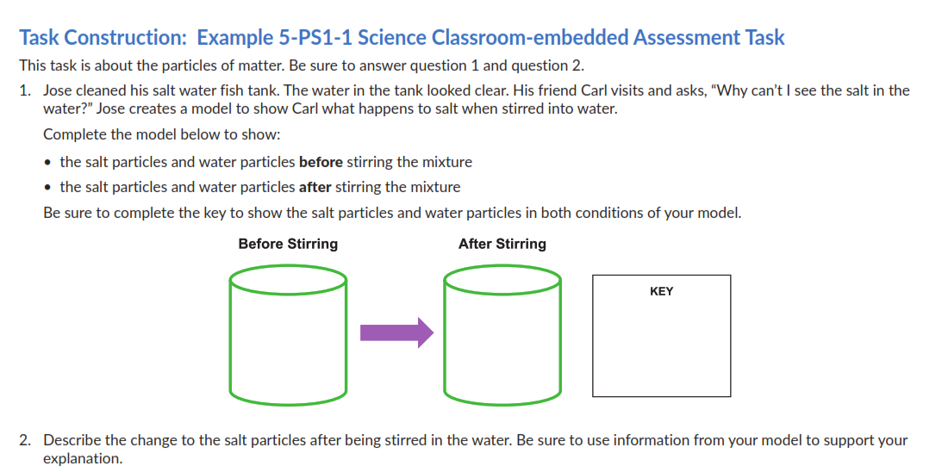
Authentic scenario with reason to draw a model.

Directions remind students of expectations.
Option to complete on paper or on the computer allowing for Assistive Technology.
Key words are bolded and student expectations are visually delineated.
Student has choices on how to complete the model.
Non-assessed skills (e.g., drawing shapes) can be supported (e.g., choice of shape stamps to create model and key; help with spelling).
Optional ways to describe (e.g., write, type, dictate, use AAC device, describe first in primary language and then transcribe).

Optional presentation of directions can be provided (e.g., placed on a checklist for student to monitor completion).
SIPS Three-dimensional Classroom Science Task Accessibility Checklist
Accessibility and Fairness Review Worksheet
Review Criteria Category | Description | Agree | Disagree | For any statements of Disagree, please provide specific feedback to explain aspects of the tasks that need improvement.
The scenario, design problem, prompts, presented information, and expectations for the collection of student evidence…
Bias/Sensitivity:  The task does not provide an unfair disadvantage for a sub-group of students through the use of unfamiliar language, contexts or examples or content that provokes negative feelings or challenges beliefs or values. | use appropriate vocabulary, phrases, and/or sentence structure for the assessed grade level. | ☐ | ☐ | Click or tap here to enter text.
 | do not use content and language that may be considered offensive based on race, gender, sexual orientation, age, religion, ethnicity, socio-economic status and regional location. | ☐ | ☐ | Click or tap here to enter text.
 | do not use vocabulary that may be considerably more familiar to some groups than others. | ☐ | ☐ | Click or tap here to enter text.
 | do not include content that portrays any group of people in a negative or stereotypical manner. | ☐ | ☐ | Click or tap here to enter text.
Accessibility:  The task is accessible to all students and adheres to the principles of Universal Design for Learning. | are accessible to students from Nebraska and will not interfere with students’ ability to demonstrate their knowledge or understanding. | ☐ | ☐ | Click or tap here to enter text.
 | provide equal opportunities for students to demonstrate their knowledge, skills, and abilities without giving students an unfair advantage over other students. | ☐ | ☐ | Click or tap here to enter text.
 | include all information needed for students to demonstrate their knowledge, skills and abilities in response to each question. | ☐ | ☐ | Click or tap here to enter text.
 | provide a variety of response modes as represented by the types of work products (constructed response, drawing, completing a graph, selected response, etc.). | ☒ | ☐ | Click or tap here to enter text.

