Stackable Instructionally-
embedded Portable Science
(SIPS) Assessments Project

SIPS Grade 8 Unit 2 End-of-Unit Assessment Scoring Guide

June 2023

The SIPS Grade 8 Unit 2 End-of-Unit Assessment Scoring Guide was developed with funding from the U.S. Department of Education under the Competitive Grants for State Assessments Program, CFDA 84.368A. The contents of this paper do not represent the policy of the U.S. Department of Education, and no assumption of endorsement by the Federal government should be made.

All rights reserved. Any or all portions of this document may be reproduced and distributed without prior permission, provided the source is cited as: Stackable Instructionally-embedded Portable Science (SIPS) Assessments Project. (2023). SIPS Grade 8 Unit 2 End-of-Unit Assessment Scoring Guide. Lincoln, NE: Nebraska Department of Education.
Table of Contents

SIPS Grade 8 Unit 2 EOU Assessment Task 1: Orbiting Around ............................................................... 1

Task 1 Scoring Rubric ........................................................................................................................... 7

Task 1 Student Exemplars .................................................................................................................. 11

SIPS Grade 8 Unit 2 EOU Assessment Task 2: Earth, Moon, and Sun .................................................... 14

Task 2 Scoring Rubric .............................................................................................................................. 18
Task 2 Student Exemplars ....................................................................................................................... 21

SIPS Grade 8 Unit 2 EOU Assessment Task 3: Earth’s Solar System ....................................................... 24

Task 3 Scoring Rubric .............................................................................................................................. 31
Task 3 Student Exemplars ....................................................................................................................... 35

SIPS Grade 8 Unit 2 EOU Assessment Task 1: Orbiting Around

Student Worksheet

This task is about the regular orbital motions of the planets around the sun and the moons around the planets.
You need to use a ruler and may use a calculator to complete this task.

Task
The solar system includes space materials that range from very small, dust-like and sand-sized particles to very immense asteroids and planets.
Most meteoroids burn up as they enter Earth's atmosphere causing little or no damage. However, asteroids, which are smaller than a planet but larger than meteoroids, can cause significant damage when they collide with Earth.
Some asteroids orbit the sun in a path that takes them near Earth. What keeps objects in the solar system in orbit around the sun?

Prompt 1
Part A.
Isaac Newton stated that two factors, inertia and gravity, combine to keep the planets in orbit around the sun. Recall that Newton’s First Law of Motion is often stated as:
An object at rest stays at rest and an object in motion stays in motion with the same speed and in the same direction unless acted upon by an unbalanced force.

Write the corresponding letter for each of the labels below in the blank spaces in Figure 1.
- Planet’s motion without gravity
- Actual orbit
- Force of gravity

Figure 1. Planetary Orbit Around the Sun
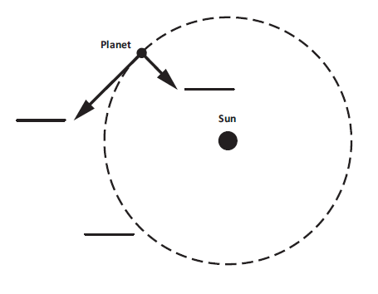
Part B.

What would happen if the planet in Figure 1 had no inertia?
_________________________________________________________________________

__________________________________________________________________________

__________________________________________________________________________

Prompt 2
Table 1 provides information about the planets in our solar system, including the dwarf planet Pluto.
Table 1. Planets in our Solar System
Planet | Distance traveled in one complete orbit of the Sun (in miles) | Amount of time for one complete orbit of the Sun (in Earth months)
Earth | 584,000,000 | 12
Jupiter | 3,037,000,000 | 142
Mars | 888,000,000 | 23
Mercury | 223,700,000 | 3
Neptune | 17,562,300,000 | 1,979
Pluto | 22,698,700,000 | 2,977
Saturn | 5,565,900,000 | 354
Uranus | 11,201,300,000 | 1,009
Venus | 422,500,000 | 7

Part A.
Explain how the distance traveled by each planet when completing one orbit of the sun can be used to determine the order of the planets outward from the sun. Use data from Table 1 to support your response.
_____________________________________________________________________________
______________________________________________________________________________
______________________________________________________________________________
Part B.
Explain how the amount of time it takes for each planet to complete one orbit of the sun can be used to identify the inner planets from the outer planets. Use data from Table 1 to support your response.
_____________________________________________________________________________
_____________________________________________________________________________
_____________________________________________________________________________
_____________________________________________________________________________

Prompt 3
Distances in the solar system can be measured as Lunar distances, or LD. The distance from Earth to the moon is about 385,000 kilometers (km), which is the same as 1 LD.
A near-Earth object (NEO) is an asteroid or comet that passes close to Earth's orbit. In March of 2022, a NEO came within approximately 7 LDs to Earth.
Part A.
Use a ruler to draw and label a scale model in Figure 2 that represents how close the NEO was to Earth. Use the scale of 1 LD equals one-half inch as shown in the key. In your model, be sure to show:
- Earth
- the moon
- the NEO
Be sure to complete the key.
Figure 2. Scale Model of Earth, Moon, NEO System
½ inch

Part B.
Consider if the same scale model you used in Figure 2, which compares the distance between the objects in the Earth, moon, and NEO system, also needs to represent the diameter of each object drawn to scale. Table 2 shows the diameters of the Earth, moon, and NEO.
Table 2. Diameters of the Earth, Moon, and NEO
Object | Diameter (km)
Earth | 12,742.00
Moon | 3,474.00
NEO | 0.02
Why would it be challenging to represent the diameter AND the distances of the three objects accurately and to scale when looking at Figure 2? Remember, the distance between the moon and Earth is approximately 385,000 kilometers (km) or 1 LD.
______________________________________________________________________________
______________________________________________________________________________
______________________________________________________________________________
______________________________________________________________________________
______________________________________________________________________________
______________________________________________________________________________

Part C.
Asteroid impacts are relatively rare on Earth. However, NEOs of many different sizes can pose serious threats.
Figure 3 shows the diameter of asteroids versus the number of asteroids in our solar system.
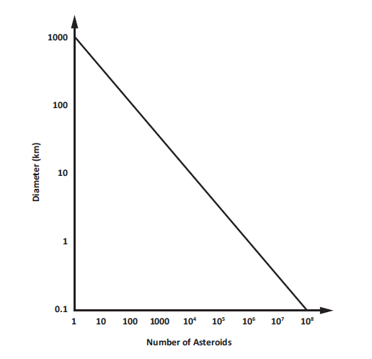
Figure 3. Asteroid Diameter versus Number Identified in Earth’s Solar System

Describe the relationship between asteroid diameters and the number of asteroids in Earth’s solar system shown in Figure 3.
_____________________________________________________________________________
_____________________________________________________________________________
_____________________________________________________________________________
_____________________________________________________________________________
_____________________________________________________________________________

SIPS Grade 8 Unit 2 Task 1 Rubric (MS-ESS1-2 and MS-ESS1-3)
Prompt | Score Point 0 | Score Point 1 | Score Point 2 | Score Point 3 | Score Point 4
Prompt 1  Part A. & Part B. | No aspect of the response is correct | Response includes one (1) of the four (4) aspects | Response includes two (2) of the four (4) aspects | Response includes three (3) of the four (4) aspects | Response includes the following aspects:  Part A  - A: the planet’s motion without gravity (straight line from the planet)  - B. the actual orbit (dotted curved line)  - C: the force of gravity (line from the planet to the sun)  Part B  - Without inertia a planet would be pulled into or toward the sun
Prompt 2 Part A. & Part B. | No aspect of the response is correct | Response includes one (1) of the three (3) aspects | Response includes two (2) of the three (3) aspects | Response includes the following aspects:  Part A  - Describes that the longer the distance and/or the longer it takes for one location indicates the planet is further from the sun using information from Table 1  Part B  - Describes the inner planets as closer to the sun and the other planets as farther  - Identifies which planets are the inner planets and which planets are the outer planets | NA
Prompt 3 Part A. & Part B. | No aspect of the response is correct | Response includes the following aspects:  Part A  - Distortions in scale  - Inaccurate labels  Part B  - Inaccurate or missing description of a limitation based on the scale constraints | Response includes the following aspects:  Part A  - Accurate drawing of distances but is not correctly labeled  OR  - Correctly labeled but contains distortions in the scale  Part B  - Identifies at least one limitation of objects with that wide a difference in size | Response includes the following aspects:  Part A  - Accurate drawing of distances using the scale indicated in the key  - Correctly labels the model using the symbols indicated in the key  Part B  - Identifies at least one limitation of objects with that wide of a difference in size (e.g., either that the NEO (or moon) would be too small to be seen, or that the model would be too large to fit in the provided space) | NA
Prompt 3 Part C. | No aspect of the response is correct | Response includes one (1) of the two (2) aspects | Response includes the following aspects:  - Recognizes the inverse relationship between the size and number of asteroids  - Supports answer with data from Figure 3

Student Exemplar(s)
Student exemplars represent high-quality responses that align to full-point rubric scores. The exemplar responses are intended to assist educators’ understanding of the nature and expectations of each prompt. Note the exemplars serve as examples of high-quality responses, and students may respond with equally relevant, scientifically accurate responses and ideas that meet the expectations of a full-point rubric score.

Prompt 1
Part A.
Write the corresponding letter for each of the labels below in the blank spaces in Figure 1.
- Planet’s motion without gravity
- Actual orbit
- Force of gravity

Figure 1. Planetary Orbit Around the Sun
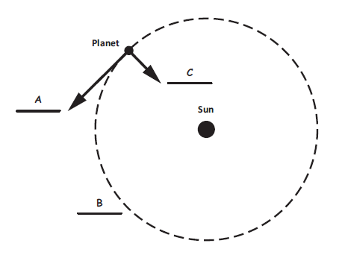
Part B.
What would happen if the planet in Figure 1 had no inertia?
If a planet had no inertia, it would be pulled into the sun.

Prompt 2
Part A.
Explain how the distance traveled by each planet when completing one orbit of the sun can be used to determine the order of the planets outward from the sun. Use data from Table 1 to support your response.
By ordering the distances from least to greatest, you can order the planets from nearest to farthest from the sun. For example, Mercury must be the closest to the sun because the distance it travels to make one orbit is the shortest at 223,700,000 miles. This means that the dwarf planet Pluto must be the farthest from the sun because it has the longest orbital distance at 22,698,700,000 miles.
Part B.
Explain how the amount of time it takes for each planet to complete one orbit of the sun can be used to identify the inner planets from the outer planets. Use data from Table 1 to support your response.
The inner planets must be Mercury, Venus, Earth, and Mars. They take from 3 to 23 Earth months to complete an orbit around the sun. The outer planets must be Jupiter, Saturn, Uranus, Neptune, and Pluto. They take from 142 to 2977 Earth months to complete an orbit around the sun because they are much farther away from the sun.
Prompt 3
Part A.
Use a ruler to draw and label a scale model in Figure 2 that represents how close the NEO was to Earth. Use the scale of 1 LD equals one-half inch as shown in the key. In your model, be sure to show:
- Earth
- the moon
- the NEO
Be sure to complete the key.

Figure 2. Scale Model of Earth, Moon, NEO System
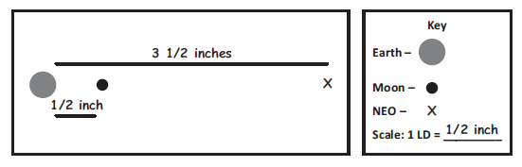
½ inch

Part B.
Why would it be challenging to represent the diameter AND the distances of the three objects accurately and to scale when looking at Figure 2? Remember, the distance between the moon and Earth is approximately 385,000 kilometers (km) or 1 LD.
The scale of both the distance AND the size on one model cannot be represented accurately. The objects will be too small if a scale for distance is used for diameter as well, based on what I used to represent distance in kilometers in my model. Or the distances will be too large for my model if I use that scale for the size of the objects as well as distance.
Part C.
Describe the relationship between asteroid diameters and the number of asteroids in Earth’s solar system shown in Figure 3.
As the size decreases from 100 km diameter to less than 1 km, the number of asteroids increases. There are many more small asteroids than very large asteroids. For example, there are a few more than 100 asteroids that are over 100 km in diameter, yet hundreds of thousands of asteroids that are less than 1 km in diameter.

SIPS Grade 8 Unit 2 EOU Assessment Task 2: Earth, Moon, and Sun

Student Worksheet

This task is about the regular orbital motion of Earth around the sun.

You may use a calculator to complete this task.

Task
Ancient astronomers studied the movement of the sun and the moon as they appeared to travel across the sky. They observed the patterns of the seasons, moon phases, and eclipses, just as we do today. What causes these age-old patterns in the sky?

Prompt 1
In Figure 1 below, the flashlight represents the sun. The globe represents Earth. Earth’s axis is tilted at an angle of 23.5ᵒ away from vertical. The part of the globe that the flashlight is shining on represents daytime.
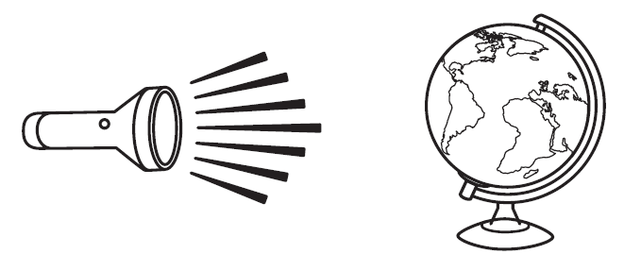
Figure 1. Earth-Sun System Model

Part A.
How could you use the model shown in Figure 1 to represent a day AND to represent a year?
__________________________________________________________________________
__________________________________________________________________________
__________________________________________________________________________
__________________________________________________________________________

Part B.
What two factors cause the cycle of the seasons?
__________________________________________________________________________
__________________________________________________________________________
__________________________________________________________________________

Part C.
According to Figure 1, which areas on Earth are consistently the coolest? Which areas are consistently the warmest? Why?
__________________________________________________________________________
__________________________________________________________________________

__________________________________________________________________________

__________________________________________________________________________

__________________________________________________________________________

__________________________________________________________________________

Prompt 2
Sometimes the moon appears round. Other times, it appears as a thin sliver or crescent. The different appearances of the moon seen from Earth are called phases.

Part A.
Figure 2 shows Earth and the moon phases as observed from Earth. The sun is shining from the right. The Waxing crescent, New moon, and Waning gibbous are shown.
Use the letters A, B, C, D, and E to correctly sequence the moon phases in Figure 2.

Waning crescent | 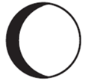  Waxing gibbous | 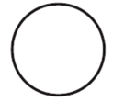  Full moon | First quarter | Third quarter
A | B | C | D | E

Figure 2. Moon Phases

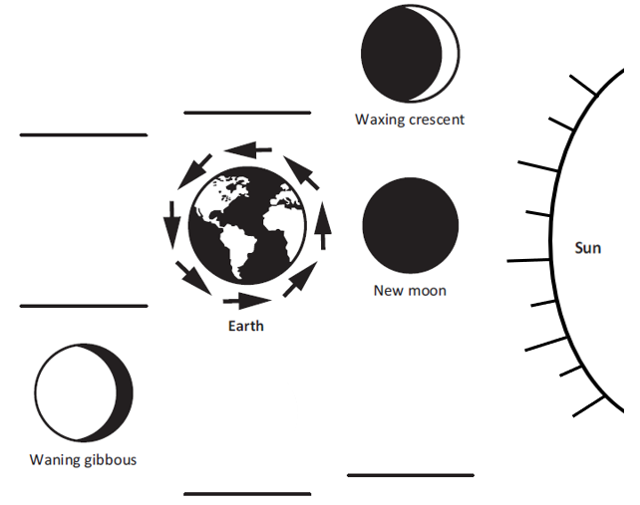

Part B.
Why do the moon phases as observed from Earth change as the month progresses? Refer to Figure 2 and the positions of the Earth, sun, and moon to support your response.
__________________________________________________________________________

__________________________________________________________________________

__________________________________________________________________________

__________________________________________________________________________

SIPS Grade 8 Unit 2 EOU Assessment Task 2 Rubric (MS-ESS1-1 and MS-ESS1-3)
Prompt | Score Point 0 | Score Point 1 | Score Point 2 | Score Point 3 | Score Point 4
Prompt 1 Part A. | No aspect of the response is correct | Response includes one (1) of the two (2) aspects | Response includes the following aspects:  - The day is represented by the globe making one full rotation (or spins once)  - The year is represented by the globe making one full revolution around the flashlight | NA | NA
Prompt 1 Part B. | No aspect of the response is correct | Response includes one (1) of the two (2) aspects | Response includes the following aspects:  - Earth’s tilt  - Earth’s orbit around the sun during the course of a year | NA | NA
Prompt 1 Part C. | No aspect of the response is correct | Response includes one (1) of the three (3) aspects | Response includes two (2) of the three (3) aspects | Response includes the following aspects:  - The equator (or middle) as the warmest area  - The poles (or ends) as the coldest  - Relates the temperature to where the sun/flashlight shines directly on the surface | NA
Prompt 2 Part A. | No aspect of the response is correct | Response includes the correct identification of one (1) or two (2) of the five (5) moon phases | Response includes the correct identification of three (3) of the five (5) moon phases | Response includes the correct identification of five (5) of the five (5) moon phases | NA
Prompt 2 Part B. | No aspect of the response is correct | Response includes one (1) of the two (2) aspects | Response includes the following aspects:  - The positions of the sun, moon, and Earth affect the phases  - The angle of the sunlight reaching the side of the moon that faces Earth affects the phases | NA | NA

Student Exemplar(s)
Student exemplars represent high-quality responses that align to full-point rubric scores. The exemplar responses are intended to assist educators’ understanding of the nature and expectations of each prompt. Note the exemplars serve as examples of high-quality responses, and students may respond with equally relevant, scientifically accurate responses and ideas that meet the expectations of a full-point rubric score.

Prompt 1

Part A.
How could you use the model shown in Figure 1 to represent a day AND to represent a year?
To represent a day, the globe would have to make one full rotation on its axis. To represent a year, the globe would have to make one complete revolution around the flashlight.

Part B.
What two factors cause the cycle of the seasons?
Earth has seasons because its axis is tilted as it revolves around the sun during the year.

Part C.
According to Figure 1, which areas on Earth are consistently the coolest? Which areas are consistently the warmest? Why?
The equator is where it is consistently the warmest because sunlight hits Earth's surface directly. It is consistently coolest at the poles where the sunlight hits Earth's surface at an angle. So, the sun's energy is spread out over a greater area.

Prompt 2

Part A.
Figure 2 shows Earth and the moon phases as observed from Earth. The sun is shining from the right. The Waxing crescent, New moon, and Waning gibbous are shown.
Use the letters A, B, C, D, and E to correctly sequence the moon phases in Figure 2.
Figure 2. Moon Phases

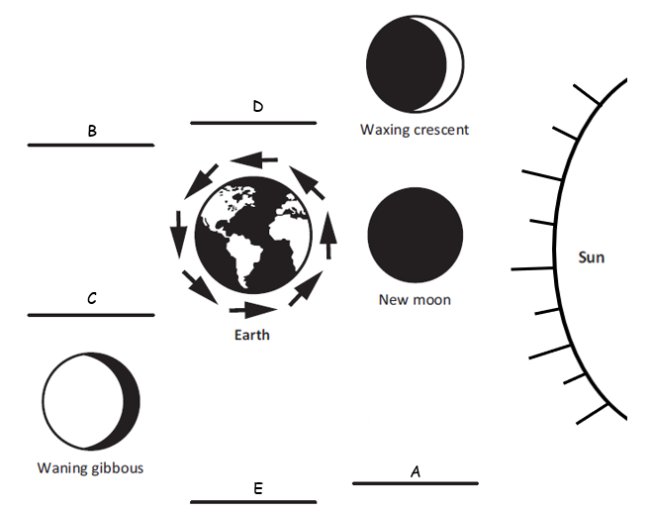

Part B.
Why do the moon phases as observed from Earth change as the month progresses? Refer to Figure 2 and the positions of Earth, sun, and moon to support your response.
Phases are caused by the positions of the sun, moon, and Earth. As the moon revolves around Earth, you see the moon from different angles. The phase of the moon depends on how much of the sunlit side of the moon faces Earth.

SIPS Grade 8 Unit 2 EOU Assessment Task 3: Earth’s Solar System

Student Worksheet

This task is about the solar system.
You may use a calculator to complete this task.

Task
The Milky Way galaxy is just one of the billions of galaxies in the universe. It contains Earth and its solar system. The Milky Way galaxy has at least 100 billion stars. One of these stars is Earth’s sun.
The sun’s gravitational pull binds together the objects that compose our solar system. Each object in our solar system has its own gravitational pull defined by its density, size, mass, and distance from other celestial bodies.

Prompt 1

Part A.
If an object is dropped from 1,000 meters to the surface of the Earth, assuming there is no air resistance, the object would reach an ending velocity of 502 km/hr. On Earth’s moon, the same object dropped 1,000 meters above the surface of the moon would reach an ending velocity of 203 km/hr.
What must be true about the gravity of Earth compared to the gravity of the moon? Explain how the ending velocities support your statement.
__________________________________________________________________________

__________________________________________________________________________

__________________________________________________________________________

Part B.
Table 1 shows the approximate gravitational pull of some objects in our solar system.

Table 1. Gravitational Pull of Solar System Objects
Object | Gravity (in m/s²)
Mercury | 3.7
Venus | 8.9
Earth | 9.8
Mars | 3.7
Jupiter | 23.1
Saturn | 9.0
Uranus | 8.7
Neptune | 11.0
Pluto | 0.7

Use information from Table 1 to complete the statements below.

Assume a person weighs 100 lbs. on Earth. On Jupiter, the same person would
weigh ________________________________. (Circle one.)
more the same less

This is because_________________________________________________________________

_____________________________________________________________________________

_____________________________________________________________________________

Assume a person weighs 100 lbs. on Earth. On Mars, the same person would
weigh ________________________________. (Circle one.)
more the same less

This is because________________________________________________________________

_____________________________________________________________________________

_____________________________________________________________________________

Part C.
If you were to land a spacecraft on the surface of a planet, you would want to know your rate of descent.
Which object listed in Table 1 would be most likely to land like a floating feather with a low rate of descent? Why?
__________________________________________________________________________

__________________________________________________________________________

__________________________________________________________________________

Prompt 2

Table 2 shows the density of each planet in our solar system.
Table 2. Density of Planets in our Solar System
Planet | Mercury | Mars | Uranus | Venus | Saturn | Earth | Neptune | Jupiter
Density (in kg/m³) | 5,429 | 3,934 | 1,270 | 5,243 | 687 | 5,514 | 1,638 | 1,326
Source: Planetary Fact Sheet (nasa.gov)

Part A.
Sort and list the rocky planets and the gaseous planets in Chart 1 using the data in Table 2.

Chart 1. Rocky Planets versus Gaseous Planets
Rocky Planets | Gaseous Planets

Part B.
Explain your reasoning for sorting the planets as either Rocky Planets or Gaseous Planets. Include how you used data from Table 2 to sort the planets.
__________________________________________________________________________
__________________________________________________________________________

__________________________________________________________________________

__________________________________________________________________________
__________________________________________________________________________

Prompt 3
Diagram 1 shows an imaginary, newly discovered planetary system around Star Beta. The orbital periods of the three planets are:
- Planet X – 75 Earth days
- Planet Y – 200 Earth days
- Planet Z – 300 Earth days
Diagram 1. Star Beta’s System

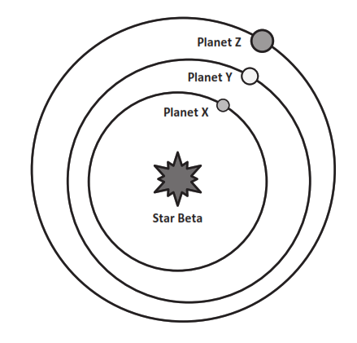

Part A.
Is it ever possible for Planet Z to be closer to Planet X than to Planet Y? Circle YES or NO.

YES NO
Explain your answer by considering the planets’ orbital periods AND by drawing the relative orbital positions of the planets on Diagram 1.
__________________________________________________________________________
__________________________________________________________________________
__________________________________________________________________________
__________________________________________________________________________
__________________________________________________________________________

Part B.
The following information relates to the Star Beta system in Diagram 1:
- Planet X is closest to Star Beta. Planet X has no atmosphere. During the day, the side facing Star Beta reaches temperatures of 500ᵒC. At night, all the heat escapes into space. The temperature drops to −200ᵒC.
- Planet Y has a thick atmosphere. All days on Planet Y are cloudy. The average daily temperature on this planet is 475ᵒC.
Explain why Planet Y is hotter on average than Planet X, even though Planet Y is further from Star Beta. Use your knowledge of the characteristics of the planets in our solar system in your explanation.
__________________________________________________________________________

__________________________________________________________________________

__________________________________________________________________________

__________________________________________________________________________

__________________________________________________________________________

Prompt 4.
It is theorized that after the Big Bang, matter in the universe separated into galaxies such as the Milky Way Galaxy. Where Earth’s solar system is now, there was a cloud of gas and dust.
Figure 1 illustrates the sequence of events that led to the formation of Earth’s solar system.
Figure 1. Formation of Earth’s Solar System
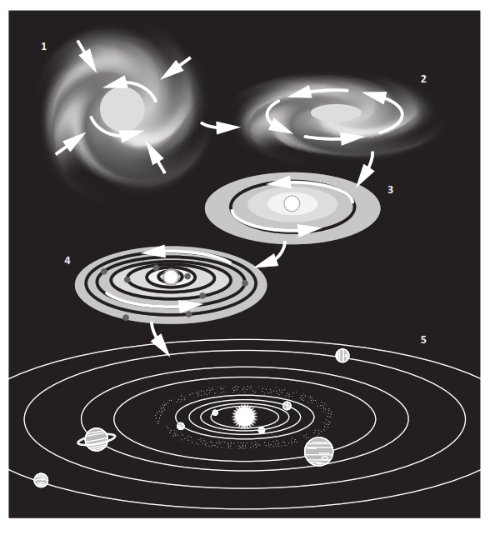

Part A.
Use the numbers 1, 2, 3, 4, and 5 to correctly sequence the events in Chart 2. Use your understanding of the Big Bang theory and Figure 1 to match the description of the events that formed Earth's solar system.

Chart 2. Sequence of Events in the Formation of Earth’s Solar System
Sequence Number | Event
 | The cloud contracted under its gravity and shrank to form a spinning disk.
 | Small planetesimals collided and clumped together to form rocky planets. The gases spun out further from the sun and cooled to form the gaseous planets.
 | Within the nebula, the matter in the disk of gas began to collect to form bigger clumps of matter due to gravity.
 | Earth’s sun formed in the center of a disk of gas. The remainder of the cloud formed a swirling disk called the solar nebula.
 | The sun and all the planets of our solar system began as a giant cloud of gas and dust.

Part B.
Describe why the gaseous planets formed further from the sun.
__________________________________________________________________________

__________________________________________________________________________

__________________________________________________________________________

Part C.
What has become of the leftover debris in the solar system that never became planets?
___________________________________________________________________________
___________________________________________________________________________
___________________________________________________________________________

SIPS Grade 8 Unit 2 EOU Assessment Task 3 Rubric (MS-ESS1-1, MS-ESS1-2, MS-ESS1-3, and MS-PS2-4)
Prompt | Score Point 0 |  | Score Point 1 | Score Point 2 | Score Point 3
Prompt 1  Part A. | No aspect of the response is correct |  | Response includes one (1) of the two (2) aspects | Response includes the following aspects:  - Gravity of the moon is less than Earth’s  - Evidence based on lower ending velocity | NA
Prompt 1  Part B. | No aspect of the response is correct |  | Response includes one (1) of the three (3) aspects | Response includes two (2) of the three (3) aspects | Response includes the following aspects:  - A planet with greater gravitational pull is one on which the student would be heavier  - A planet with less gravitational pull is one on which the student would be lighter  - Both conditions are accurately supported with data from Table 1
Prompt 1 Part C. | No aspect of the response is correct |  | Response includes one (1) of the two (2) aspects | Response includes the following aspects:  - A planet with a much lower gravitational pull (e.g., Pluto)  - Evidence for lower gravitational pull from Table 1 | NA
Prompt 2  Part A. & Part B. | No aspect of the response is correct |  | Response includes one (1) of the two (2) aspects | Response includes the following aspects:  Part A  - Correct sorting of at least three (3) of the four (4) Rocky Planets and three (3) of the four (4) Gaseous planets  Part B  - Identifies that all Rocky planets have much higher density than all Gaseous planets based on data from Table 2 | Response includes the following aspects:  Part A  - Correct sorting of four (4) Rocky Planets and four (4) Gaseous planets  Part B  - Identifies that all Rocky planets have much higher density than all Gaseous planets based on data from Table 2
Prompt 3  Part A. | No aspect of the response is correct |  | Response includes one (1) of the three (3) aspects | Response includes two (2) of the three (3) aspects | Response includes the following aspects:  - Circles “YES”  - Provides orbital periods or describes the situation in which the described orbital conditions occur  - Accurate representation on the diagram of the location of the planets at the specified time point
Prompt 3 Part B. | No aspect of the response is correct | Response includes one (1) of the two (2) aspects |  | Response includes the following aspects:  - Atmosphere traps heat  - Uses evidence (i.e., loss of heat on Planet X) due to lack of atmosphere as evidence | NA
Prompt 4  Part A., Part B., & Part C. | No aspect of the response is correct | Response includes one (1) of the three (3) aspects |  | Response includes two (2) of the three (3) aspects | Response includes the following aspects:  Part A  - Correct sequence of events as 2, 5, 4, 3, 1  Part B  - Description of why the gaseous planets formed in the colder outer solar system  Part C  - Identifies what became of the materials that were not pulled to form planets (e.g., asteroids, comets, and meteoroids)

Student Exemplar(s)
Student exemplars represent high-quality responses that align to full-point rubric scores. The exemplar responses are intended to assist educators’ understanding of the nature and expectations of each prompt. Note the exemplars serve as examples of high-quality responses, and students may respond with equally relevant, scientifically accurate responses and ideas that meet the expectations of a full-point rubric score.

Prompt 1

Part A.
What must be true about the gravity of Earth compared to the gravity of the moon? Explain how the ending velocities support your statement.
The moon's gravitational pull must be less than Earth's because the ending velocity is much less on the moon.

Part B.
Use information from Table 1 to complete the statements below.

Assume a person weighs 100 lbs. on Earth. On Jupiter, the same person would
weigh ________________________________. (Circle one.)
more the same less

This is because the gravitational pull is greater than Earth's. Earth’s gravitational
pull is a lot smaller at 9.8 m/s² compared to Jupiter’s which is 23.1 m/s².

Assume a person weighs 100 lbs. on Earth. On Mars, the same person would
weigh ________________________________. (Circle one.)
more the same less

This is because the gravitational pull is less than Earth's. Mars’ gravitational pull is a
lot smaller at 3.7 m/s² compared to Earth’s which is 9.8 m/s².

Part C.
Which object listed in Table 1 would be most likely to land like a floating feather with a low rate of descent? Why?
Pluto is most likely to land like a floating feather because the gravitational pull is only 0.7 m/s²
Prompt 2

Part A.
Sort and list the rocky planets and the gaseous planets in Chart 1 using the data in Table 2.

Chart 1. Rocky versus Gaseous Planets
Rocky Planets | Gaseous Planets
Mercury, Venus, Mars, Earth | Saturn, Neptune, Uranus, Jupiter

Part B.
Explain the reasoning for sorting the planets as either Rocky Planets or Gaseous Planets. Include how you used data from Table 2 to sort the planets.

The rocky planets must be denser than the gaseous planets because rock is denser than gas. Mercury, Venus, Mars, and Earth have densities between 2,370 and 5,514 kg/m³. The other planets have densities less than 1,638 kg/m³.

Prompt 3
Diagram 1 shows an imaginary, newly discovered planetary system around Star Beta. The orbital periods of the three planets are:
- Planet X – 75 Earth days
- Planet Y – 200 Earth days
- Planet Z – 300 Earth days
Location of Planet Y
after 300 days

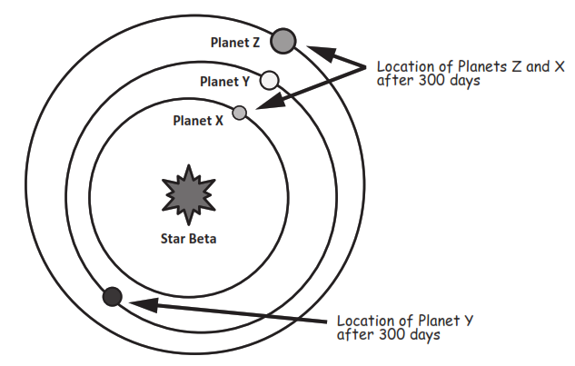
Diagram 1. Star Beta’s System

Part A.
Is it ever possible for Planet Z to be closer to Planet X than to Planet Y? Circle YES or NO.
YES NO

Explain your answer by considering the planets’ orbital periods AND drawing the relative orbital positions of the planets on Diagram 1.
Yes, it is possible. After 300 days, Planet X will complete four complete 75 orbits and be in the same position. Planet Z will have completed one orbit and be in the same position. But Planet Y will have completed only 1.5 orbits and will be on the opposite side of Star Beta than the other planets. That is when Planets X and Z will be closer together than Planet Y.

Part B.
Explain why Planet Y is hotter on average than Planet X, even though Planet Y is further from Star Beta. Use your knowledge of the characteristics of the planets in our solar system in your explanation.
The atmosphere on Planet Y traps the heat. This is like the atmosphere on Venus. Also, it is called the 'Greenhouse Effect' on Earth. Without an atmosphere to hold the heat, Planet Y's warmth would escape into space like Planet X. This is like Mercury.

Prompt 4.

Part A.
Use the numbers 1, 2, 3, 4, and 5 to correctly sequence the events in Chart 2. Use your understanding of the Big Bang theory and Figure 1 to match the description of the events that formed Earth's solar system.

Chart 2. Sequence of Events in the Formation of Earth’s Solar System
Sequence Number | Event
2 | The cloud contracted under its gravity and shrank to form a spinning disk.
5 | Small planetesimals collided and clumped together to form rocky planets. The gases spun out further from the sun and cooled to form the gaseous planets.
4 | Within the nebula, the matter in the disk of gas began to collect to form bigger clumps of matter due to gravity.
3 | Earth’s sun formed in the center of a disk of gas. The remainder of the cloud formed a swirling disk called the solar nebula.
1 | The sun and all the planets of our solar system began as a giant cloud of gas and dust.

Part B.
Describe why the gaseous planets formed further from the sun.
The sun's energy warmed the objects in our solar system, like the rocky planets in the inner solar system. There, it was too warm for lightweight gases to condense. When the gases reached the cold temperatures of the outer solar system, they condensed onto the gaseous planets.

Part C.
What has become of the leftover debris in the solar system that never became planets?
The leftover debris has formed things like the Asteroid Belt, comets, and meteoroids.

