SIPS Grade 8 Unit 2 EOU Assessment Task 1: Orbiting Around

Student Worksheet

This task is about the regular orbital motions of the planets around the sun and the moons around the planets.
You need to use a ruler and may use a calculator to complete this task.

Task
The solar system includes space materials that range from very small, dust-like and sand-sized particles to very immense asteroids and planets.
Most meteoroids burn up as they enter Earth's atmosphere causing little or no damage. However, asteroids, which are smaller than a planet but larger than meteoroids, can cause significant damage when they collide with Earth.
Some asteroids orbit the sun in a path that takes them near Earth. What keeps objects in the solar system in orbit around the sun?

Prompt 1
Part A.
Isaac Newton stated that two factors, inertia and gravity, combine to keep the planets in orbit around the sun. Recall that Newton’s First Law of Motion is often stated as:
An object at rest stays at rest and an object in motion stays in motion with the same speed and in the same direction unless acted upon by an unbalanced force.

Write the corresponding letter for each of the labels below in the blank spaces in Figure 1.
- Planet’s motion without gravity
- Actual orbit
- Force of gravity

Figure 1. Planetary Orbit Around the Sun
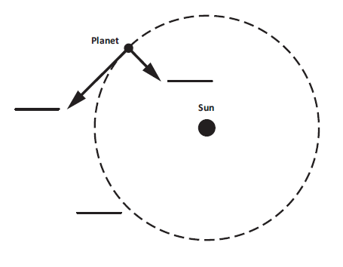
Part B.

What would happen if the planet in Figure 1 had no inertia?
_________________________________________________________________________

__________________________________________________________________________

__________________________________________________________________________

Prompt 2
Table 1 provides information about the planets in our solar system, including the dwarf planet Pluto.
Table 1. Planets in our Solar System
Planet | Distance traveled in one complete orbit of the Sun (in miles) | Amount of time for one complete orbit of the Sun (in Earth months)
Earth | 584,000,000 | 12
Jupiter | 3,037,000,000 | 142
Mars | 888,000,000 | 23
Mercury | 223,700,000 | 3
Neptune | 17,562,300,000 | 1,979
Pluto | 22,698,700,000 | 2,977
Saturn | 5,565,900,000 | 354
Uranus | 11,201,300,000 | 1,009
Venus | 422,500,000 | 7

Part A.
Explain how the distance traveled by each planet when completing one orbit of the sun can be used to determine the order of the planets outward from the sun. Use data from Table 1 to support your response.
_____________________________________________________________________________
______________________________________________________________________________
______________________________________________________________________________
Part B.
Explain how the amount of time it takes for each planet to complete one orbit of the sun can be used to identify the inner planets from the outer planets. Use data from Table 1 to support your response.
_____________________________________________________________________________
_____________________________________________________________________________
_____________________________________________________________________________
_____________________________________________________________________________

Prompt 3
Distances in the solar system can be measured as Lunar distances, or LD. The distance from Earth to the moon is about 385,000 kilometers (km), which is the same as 1 LD.
A near-Earth object (NEO) is an asteroid or comet that passes close to Earth's orbit. In March of 2022, a NEO came within approximately 7 LDs to Earth.
Part A.
Use a ruler to draw and label a scale model in Figure 2 that represents how close the NEO was to Earth. Use the scale of 1 LD equals one-half inch as shown in the key. In your model, be sure to show:
- Earth
- the moon
- the NEO
Be sure to complete the key.
Figure 2. Scale Model of Earth, Moon, NEO System
½ inch

Part B.
Consider if the same scale model you used in Figure 2, which compares the distance between the objects in the Earth, moon, and NEO system, also needs to represent the diameter of each object drawn to scale. Table 2 shows the diameters of the Earth, moon, and NEO.
Table 2. Diameters of the Earth, Moon, and NEO
Object | Diameter (km)
Earth | 12,742.00
Moon | 3,474.00
NEO | 0.02
Why would it be challenging to represent the diameter AND the distances of the three objects accurately and to scale when looking at Figure 2? Remember, the distance between the moon and Earth is approximately 385,000 kilometers (km) or 1 LD.
______________________________________________________________________________
______________________________________________________________________________
______________________________________________________________________________
______________________________________________________________________________
______________________________________________________________________________
______________________________________________________________________________

Part C.
Asteroid impacts are relatively rare on Earth. However, NEOs of many different sizes can pose serious threats.
Figure 3 shows the diameter of asteroids versus the number of asteroids in our solar system.
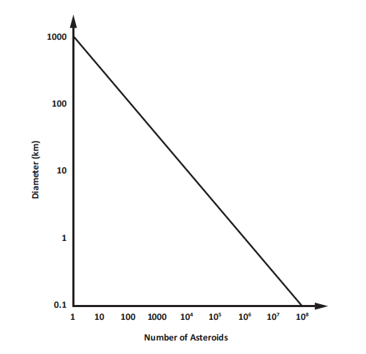
Figure 3. Asteroid Diameter versus Number Identified in Earth’s Solar System

Describe the relationship between asteroid diameters and the number of asteroids in Earth’s solar system shown in Figure 3.
_____________________________________________________________________________
_____________________________________________________________________________
_____________________________________________________________________________
_____________________________________________________________________________
_____________________________________________________________________________

SIPS Grade 8 Unit 2 EOU Assessment Task 2: Earth, Moon, and Sun

Student Worksheet

This task is about the regular orbital motion of Earth around the sun.

You may use a calculator to complete this task.

Task
Ancient astronomers studied the movement of the sun and the moon as they appeared to travel across the sky. They observed the patterns of the seasons, moon phases, and eclipses, just as we do today. What causes these age-old patterns in the sky?

Prompt 1
In Figure 1 below, the flashlight represents the sun. The globe represents Earth. Earth’s axis is tilted at an angle of 23.5ᵒ away from vertical. The part of the globe that the flashlight is shining on represents daytime.
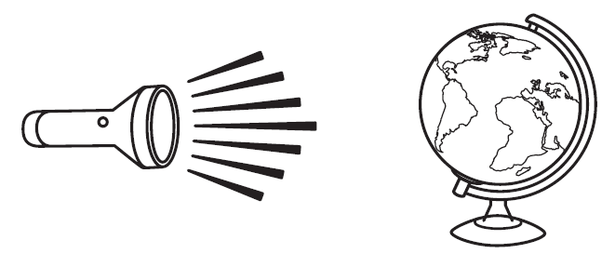
Figure 1. Earth-Sun System Model

Part A.
How could you use the model shown in Figure 1 to represent a day AND to represent a year?
__________________________________________________________________________
__________________________________________________________________________
__________________________________________________________________________
__________________________________________________________________________

Part B.
What two factors cause the cycle of the seasons?
__________________________________________________________________________
__________________________________________________________________________
__________________________________________________________________________

Part C.
According to Figure 1, which areas on Earth are consistently the coolest? Which areas are consistently the warmest? Why?
__________________________________________________________________________
__________________________________________________________________________

__________________________________________________________________________

__________________________________________________________________________

__________________________________________________________________________

__________________________________________________________________________

Prompt 2
Sometimes the moon appears round. Other times, it appears as a thin sliver or crescent. The different appearances of the moon seen from Earth are called phases.

Part A.
Figure 2 shows Earth and the moon phases as observed from Earth. The sun is shining from the right. The Waxing crescent, New moon, and Waning gibbous are shown.
Use the letters A, B, C, D, and E to correctly sequence the moon phases in Figure 2.

Waning crescent | Waxing gibbous | Full moon | First quarter | Third quarter
A | B | C | D | E

Figure 2. Moon Phases

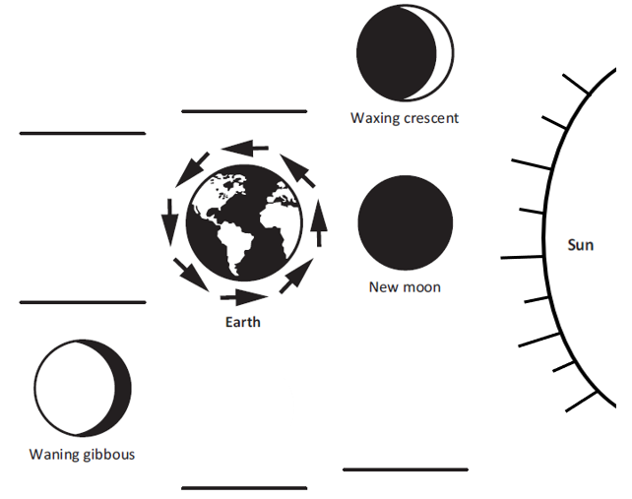

Part B.
Why do the moon phases as observed from Earth change as the month progresses? Refer to Figure 2 and the positions of the Earth, sun, and moon to support your response.
__________________________________________________________________________

__________________________________________________________________________

__________________________________________________________________________

__________________________________________________________________________

SIPS Grade 8 Unit 2 EOU Assessment Task 3: Earth’s Solar System

Student Worksheet

This task is about the solar system.
You may use a calculator to complete this task.

Task
The Milky Way galaxy is just one of the billions of galaxies in the universe. It contains Earth and its solar system. The Milky Way galaxy has at least 100 billion stars. One of these stars is Earth’s sun.
The sun’s gravitational pull binds together the objects that compose our solar system. Each object in our solar system has its own gravitational pull defined by its density, size, mass, and distance from other celestial bodies.

Prompt 1

Part A.
If an object is dropped from 1,000 meters to the surface of the Earth, assuming there is no air resistance, the object would reach an ending velocity of 502 km/hr. On Earth’s moon, the same object dropped 1,000 meters above the surface of the moon would reach an ending velocity of 203 km/hr.
What must be true about the gravity of Earth compared to the gravity of the moon? Explain how the ending velocities support your statement.
__________________________________________________________________________

__________________________________________________________________________

__________________________________________________________________________

Part B.
Table 1 shows the approximate gravitational pull of some objects in our solar system.
Table 1. Gravitational Pull of Solar System Objects
Object | Gravity (in m/s²)
Mercury | 3.7
Venus | 8.9
Earth | 9.8
Mars | 3.7
Jupiter | 23.1
Saturn | 9.0
Uranus | 8.7
Neptune | 11.0
Pluto | 0.7

Use information from Table 1 to complete the statements below.

Assume a person weighs 100 lbs. on Earth. On Jupiter, the same person would
weigh ________________________________. (Circle one.)
more the same less

This is because_________________________________________________________________

_____________________________________________________________________________

_____________________________________________________________________________

Assume a person weighs 100 lbs. on Earth. On Mars, the same person would
weigh ________________________________. (Circle one.)
more the same less

This is because________________________________________________________________

_____________________________________________________________________________

_____________________________________________________________________________

Part C.
If you were to land a spacecraft on the surface of a planet, you would want to know your rate of descent.
Which object listed in Table 1 would be most likely to land like a floating feather with a low rate of descent? Why?
__________________________________________________________________________

__________________________________________________________________________

__________________________________________________________________________

Prompt 2

Table 2 shows the density of each planet in our solar system.
Table 2. Density of Planets in our Solar System
Planet | Mercury | Mars | Uranus | Venus | Saturn | Earth | Neptune | Jupiter
Density (in kg/m³) | 5,429 | 3,934 | 1,270 | 5,243 | 687 | 5,514 | 1,638 | 1,326
Source: Planetary Fact Sheet (nasa.gov)

Part A.
Sort and list the rocky planets and the gaseous planets in Chart 1 using the data in Table 2.

Chart 1. Rocky Planets versus Gaseous Planets
Rocky Planets | Gaseous Planets

Part B.
Explain your reasoning for sorting the planets as either Rocky Planets or Gaseous Planets. Include how you used data from Table 2 to sort the planets.
__________________________________________________________________________
__________________________________________________________________________

__________________________________________________________________________

__________________________________________________________________________
__________________________________________________________________________

Prompt 3
Diagram 1 shows an imaginary, newly discovered planetary system around Star Beta. The orbital periods of the three planets are:
- Planet X – 75 Earth days
- Planet Y – 200 Earth days
- Planet Z – 300 Earth days
Diagram 1. Star Beta’s System

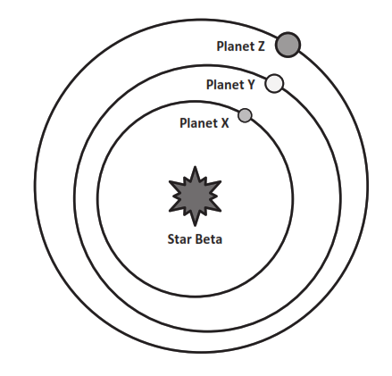

Part A.
Is it ever possible for Planet Z to be closer to Planet X than to Planet Y? Circle YES or NO.

YES NO
Explain your answer by considering the planets’ orbital periods AND by drawing the relative orbital positions of the planets on Diagram 1.
__________________________________________________________________________
__________________________________________________________________________
__________________________________________________________________________
__________________________________________________________________________
__________________________________________________________________________

Part B.
The following information relates to the Star Beta system in Diagram 1:
- Planet X is closest to Star Beta. Planet X has no atmosphere. During the day, the side facing Star Beta reaches temperatures of 500ᵒC. At night, all the heat escapes into space. The temperature drops to −200ᵒC.
- Planet Y has a thick atmosphere. All days on Planet Y are cloudy. The average daily temperature on this planet is 475ᵒC.
Explain why Planet Y is hotter on average than Planet X, even though Planet Y is further from Star Beta. Use your knowledge of the characteristics of the planets in our solar system in your explanation.
__________________________________________________________________________

__________________________________________________________________________

__________________________________________________________________________

__________________________________________________________________________

__________________________________________________________________________

Prompt 4.
It is theorized that after the Big Bang, matter in the universe separated into galaxies such as the Milky Way Galaxy. Where Earth’s solar system is now, there was a cloud of gas and dust.
Figure 1 illustrates the sequence of events that led to the formation of Earth’s solar system.
Figure 1. Formation of Earth’s Solar System
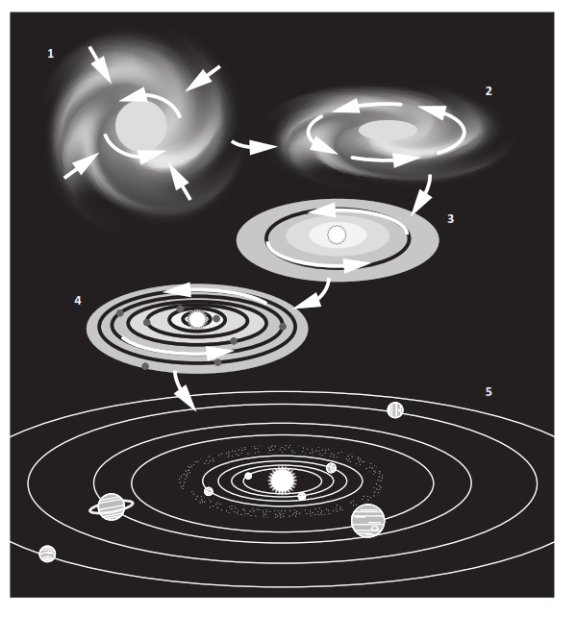

Part A.
Use the numbers 1, 2, 3, 4, and 5 to correctly sequence the events in Chart 2. Use your understanding of the Big Bang theory and Figure 1 to match the description of the events that formed Earth's solar system.

Chart 2. Sequence of Events in the Formation of Earth’s Solar System
Sequence Number | Event
 | The cloud contracted under its gravity and shrank to form a spinning disk.
 | Small planetesimals collided and clumped together to form rocky planets. The gases spun out further from the sun and cooled to form the gaseous planets.
 | Within the nebula, the matter in the disk of gas began to collect to form bigger clumps of matter due to gravity.
 | Earth’s sun formed in the center of a disk of gas. The remainder of the cloud formed a swirling disk called the solar nebula.
 | The sun and all the planets of our solar system began as a giant cloud of gas and dust.

Part B.
Describe why the gaseous planets formed further from the sun.
__________________________________________________________________________

__________________________________________________________________________

__________________________________________________________________________

Part C.
What has become of the leftover debris in the solar system that never became planets?
___________________________________________________________________________
___________________________________________________________________________
___________________________________________________________________________

