Stackable Instructionally-embedded Portable Science (SIPS) Assessments Project

Grade 8 Science
Unit 3 Instructionally-embedded Assessment Task:
“Building a Tree of Life”
Understanding Earth History and the Origin of Species
July 2023

The SIPS Grade 8 Science Unit 3 Instructionally-embedded Assessment Task: “Building a Tree of Life” was developed with funding from the U.S. Department of Education under the Competitive Grants for State Assessments Program, CFDA 84.368A. The contents of this paper do not represent the policy of the U.S. Department of Education, and no assumption of endorsement by the Federal government should be made.

All rights reserved. Any or all portions of this document may be reproduced and distributed without prior permission, provided the source is cited as: Stackable Instructionally-embedded Portable Science (SIPS) Assessments Project. (2023). SIPS Grade 8 Science Unit 3 Instructionally-embedded Assessment Task: “Building a Tree of Life”. Lincoln, NE: Nebraska Department of Education.
SIPS Grade 8 Unit 3 Instructionally-embedded Assessment Task
Grade 8 | Unit 3 | Instructional Segment 2 | Task Title: Building a Tree of Life
NGSS Performance Expectations Code(s) and Description(s)
Code | Description
MS-LS4-1. | Analyze and interpret data for patterns in the fossil record that document the existence, diversity, extinction, and change of life forms throughout the history of life on Earth under the assumption that natural laws operate today as in the past. [Clarification Statement: Emphasis is on finding patterns of changes in the level of complexity of anatomical structures in organisms and the chronological order of fossil appearance in the rock layers.] [Assessment Boundary: Assessment does not include the names of individual species or geological eras in the fossil record.]
MS-LS4-2. | Apply scientific ideas to construct an explanation for the anatomical similarities and differences among modern organisms and between modern and fossil organisms to infer evolutionary relationships. [Clarification Statement: Emphasis is on explanations of the evolutionary relationships among organisms in terms of similarity or differences of the gross appearance of anatomical structures.]
Acquisition Goals Number(s) and Descriptions(s)
A6. | Compare, integrate, and evaluate sources of information from print resources and articles to solve a problem related to patterns presented in fossil records.
A9. | Develop an explanation about what caused the similarities and differences between organisms today and organisms from fossil records.
Evidence Statements
- Identify and describe evidence in fossil records that relate to the similarities and differences between organisms today and fossilized organisms.
- Explain how organisms that share anatomical features are likely closely related while recognizing that structures can be used for the same purpose, but structural differences show they are not closely related (wings of birds vs. insects).
- Use changes over time in the fossil record to infer lines of descent based on shared features.

Source Documentation and Information Resources References (e.g., publications, websites, citations, images, videos, etc.)  Please include source name, description, citation, and a link to its original location below. Include additional rows as needed. | Licensing: Please mark an “X” under the appropriate licensing. If resource is not under a creative commons (CC) license, please attempt to find a source with CC licensing. If you are unable, please select other and provide additional information about the source in the source documentation section.
 | CC0/  Public Domain | CC BY | CC BY-SA | CC BY-NC | CC BY-NC-SA | CC BY-ND | CC BY-NC-ND | Other
Associated with Prompt 1:  - Hippopotamus Hippo Mammal - Free photo on Pixabay - Pixabay  [https://pixabay.com/photos/hippopotamus-hippo-mammal-zoo-2780699/]  - Pig Boar November - Free photo on Pixabay - Pixabay  [https://pixabay.com/photos/pig-boar-november-frost-1818624/] | X
- MS-LS4-2 Assessment - Anatomical Evidence of Evolutionary Relationships (NY) - Google Docs  [https://docs.google.com/document/d/1yxBPLfH13Aj5YDWRDw3L-9_ALISr9x6OHFqBGiui0gM/template/preview] |  |  |  | X
Associated with Prompt 2:  - Wikimedia Commons  [https://commons.wikimedia.org/wiki/File:Fish_anatomy_(berycid).png] |  |  | X
Used in Exemplar:  - Cladogram showing the phylogenetic relationship of Eocene cetacean taxa... | Download Scientific Diagram (researchgate.net)  [https://www.researchgate.net/figure/Cladogram-showing-the-phylogenetic-relationship-of-Eocene-cetacean-taxa-examined-here_fig1_11369878] |  |  |  |  |  |  |  | X

Teacher Administration Guide

Introduction
- Educators developed the accompanying classroom task to align to one or more aspects of the NGSS Performance Expectation(s) (PEs) to determine where students are in their learning at a specific point in time during an instructional sequence. Educators will need to make intentional decisions about when and how to use this task based on their students’ learning needs, the purpose of giving the task, and the intended use of the evidence gathered.
- This task is designed to measure students’ ability to integrate the dimensions and demonstrate their knowledge, skills, and abilities as represented by NGSS Performance Expectation MS-LS4-1 and MS-LS4-2. By administering this task, educators can gather and evaluate evidence to make accurate and meaningful judgments about students’ science learning and determine how instruction may need to be adjusted along an instructional sequence to best support students.
- The phenomenon in this task is the observation that present-day organisms have many anatomical similarities in addition to their differences. These comparisons can also be observed between present-day and extinct organisms using the fossil record. Key aspects of this phenomenon include observing that anatomical differences and similarities between various organisms living today and between them and organisms in the fossil record enable evolutionary history to be reconstructed. Also included is the idea that scientists have found similarities and differences between existing and extinct species which infer biological relationships.
- In this task, students utilize a list of organisms and their anatomical adaptations to construct an explanation as to how that adaptation is beneficial. They observe and identify patterns within the structures of the model organisms and use them to develop explanations related to the evolutionary relationships between living organisms and their extinct relatives. Once they have analyzed a teacher-generated data set related to these structures, they are asked to research a new organism and use prior scientific reasoning and comparative anatomy to identify the origins and relationships to the new organism.
Administration Guidelines
- Two (2) class periods (Day 1 Introduction/background information, scaffolding; Day 2 Initiate research, gather resources, writing templates; Possible 3rd-day option for full completion).
- Segment 2 Lesson: Building a Tree of Life
- Students individually complete a series of prompts reflecting the following chain of sensemaking:
  - Students use an anatomical comparison of pigs and hippopotamuses to describe common characteristics and how they show relatedness.
  - Students use a display of forelimb structures of four animals to determine commonalities and relatedness of structure and function.
  - Students develop an explanation of the relationships of homologous and analogous structures.
  - Students relate an extinct organism to a present-day organism based on anatomical structures.
  - Students identify an organism group of their choosing to use as the topic of a cladogram to show evolutionary relationships to extinct organisms.

- Preview the websites associated with Prompt 3 to provide guidance for student navigation of the resource as a tool for constructing the cladogram.
- Consider sharing examples such as Cladogram V.1 or Cladogram V.2, which are some modern and fossil ancestors of whales to support student understanding.
Accessibility Considerations
Providing a range of accessibility considerations in the task (e.g., multiple ways of representing information, multiple types of supports, multiple ways in which students respond) promotes equity and fairness across a wide range of students who may be at different points in their science learning. In turn, these considerations can promote student interest and engagement in the tasks resulting in a more complete and accurate collection of evidence of students’ science learning.
Accommodations for students with a disability or Multilingual Learners that are part of their on-going instructional programs are to be provided during the administration of this task. Accommodations should be consistent with those provided student’s daily instructional strategies and assessment opportunities including assistive technology devices if appropriate. These accessibility considerations and accommodations enable accurate inferences about student learning and inform meaningful adjustments to planning and instruction.
Ancillary Materials
- ‘Scratch paper’ to draft the cladograms and then transfer them to the assessment task.
- Websites for research:
  - https://evolution.berkeley.edu/what-are-evograms/
  - https://animaldiversity.org/
  - https://www.onezoom.org/
Instructions for Administering the Performance Task or Implementing the Research Task, Design Project, or Lab
- Pose the scenario: How do scientists determine how organisms are related?
- Students will explore how anatomical structures can be used to determine the relatedness of extinct and living organisms.
Scoring Guidance
- A task-and prompt-specific scoring rubric indicates scoring criteria for each prompt across a range of score points.
- Student exemplars represent high-quality responses that align to full-point rubric scores. The exemplar responses are intended to assist educators’ understanding of the nature and expectations of each prompt when applying the scoring rubric. Note the exemplars serve as examples of high-quality responses, and students may respond with equally relevant, scientifically accurate responses and ideas that meet the expectations of a full-point rubric score. In general, the exemplar response associated with the highest score point in the rubric meets expectations and is scientifically accurate, complete, coherent, and consistent with the type of student evidence expected as described in the rubric.
- The approximate scoring time for this task will be 10 to 20 minutes per student.

Student Task
This task is about anatomical structures and evolutionary relationships.
Task Scenario
Some living organisms look like organisms that once lived on Earth. Fossils provide evidence about the types of organisms that existed long ago. The fossil record and comparisons of organisms’ anatomical similarities help scientists determine evolutionary relationships.

Prompt 1
Scientists once thought that pigs were very close relatives to hippopotamuses.
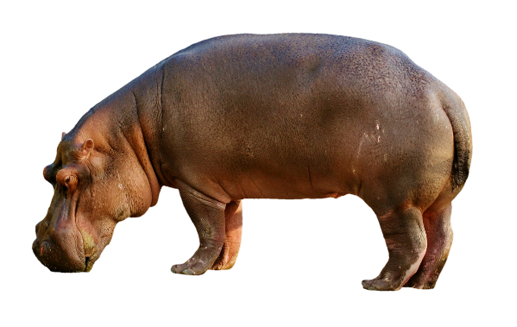
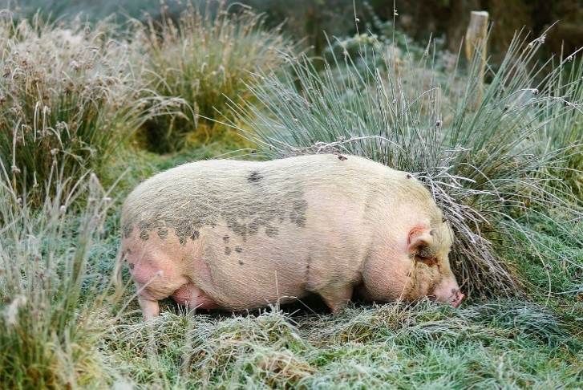

Part A.
What observations of anatomical similarities may scientists have used to determine that pigs and hippos are close relatives?

_____________________________________________________________________________________

_____________________________________________________________________________________

______________________________________________________________________________
_____________________________________________________________________________________

_____________________________________________________________________________________

______________________________________________________________________________

Part B.
One way scientists find evidence of shared ancestry among organisms is by studying fossils. Figure 1 shows the forelimb structure of different organisms. Forelimb structure can be used to identify relationships between similar organisms.
The arrow points to a similar bone called the ulna in the forelimb in each of the four organisms.
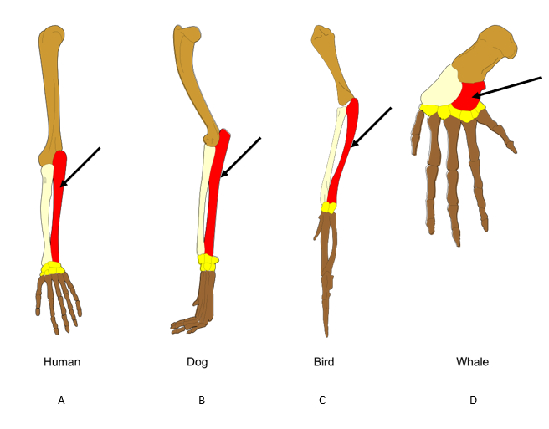
Figure 1. Forelimb Structure of Four Organisms

Adapted From: Волков Владислав Петрович, CC BY-SA 4.0 <https://creativecommons.org/licenses/by-sa/4.0>, via Wikimedia Commons

Select two organisms from Figure 1 to explain how an organism’s forelimb bone structure and size relate to how the organism uses its forelimb.
_____________________________________________________________________________________
_____________________________________________________________________________________

_____________________________________________________________________________________

_____________________________________________________________________________________

_____________________________________________________________________________________

Part C.
In Figure 1, two organisms that are most closely related based on characteristics of the ulna are

_______________________________ and _________________________________.

Part D.
Scientists classify anatomical structures as being homologous or analogous.
Homologous structures are structures that related species share and are evidence of a common ancestor.

Analogous structures serve the same function in two species but are NOT evidence of a common ancestor.

The anatomical structures of the species in Figure 1 are: (Circle your answer.)
Homologous Analogous

Explain how the forelimb structures support your answer.
_____________________________________________________________________________________
_____________________________________________________________________________________

_____________________________________________________________________________________

_____________________________________________________________________________________
Prompt 2
Scientists study the fossil record to identify patterns of change in the anatomical structures of organisms. For example, fossils of an extinct freshwater fish named Diplomystus have been found in what is now known as Wyoming, Colorado, and Utah.
Figure 2 shows a comparison of the features of Diplomystus and a modern ray-finned fish. Both fish’s fins are webs of skin supported by numerous bony spines called rays.
Figure 2. Diplomystus Compared to a Modern Ray-finned Fish
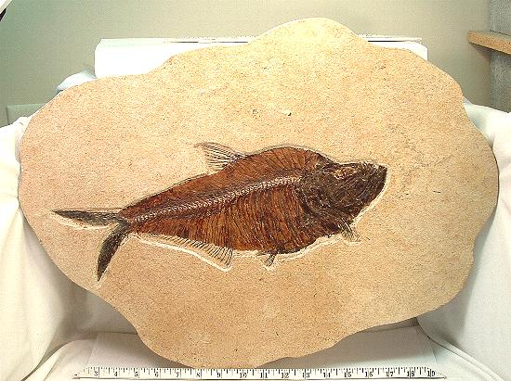 | 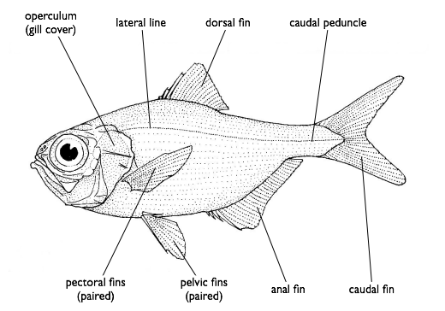
Diplomystus  From: Image included in assessment designed by NY teachers and licensed under a Creative Commons Attribution-NonCommercial 4.0 International License. | Modern Ray-finned Fish  From: Diagram by User:Gdr based on a drawing by Dr Tony Ayling. This file is licensed under the CC-BY-SA license.

Select whether you agree or disagree with the following statement:
The structure of a ray-finned fish’s fin shows evidence of common ancestry between ray-finned fish, the Diplomystus, and a whale’s fin (see Figure 1).
Circle your response.
Agree Disagree
Use the terms anatomical, homologous, and analogous structures to support your answer.
_____________________________________________________________________________________

______________________________________________________________________________
_____________________________________________________________________________________

_____________________________________________________________________________________

______________________________________________________________________________

Prompt 3
One way scientists develop diagrams to show how groups of organisms are related to each other is by describing lines of descent based on the shared anatomical structures of different organisms. These diagrams look like trees and are called "cladograms."

See this website for steps about how to make a cladogram:  - https://www.instructables.com/How-to-Make-a-Cladogram/ | Use these websites to focus your research on a specific group of organisms that you choose (e.g., living whales, humans, modern horses, etc.):  - https://evolution.berkeley.edu/what-are-evograms/  - https://animaldiversity.org/  - https://www.onezoom.org/
Part A.
Construct a cladogram showing common ancestry and including clear labels in the space provided.

- Include and label at least five organisms beginning with an extinct organism.
- For each new organism, add its branch line and name in the appropriate place in the cladogram.
- Indicate the degrees of the evolutionary relationship of the organism group you have chosen.

Part B.
Explain the selection and placement of each organism in your cladogram.
_____________________________________________________________________________________

_____________________________________________________________________________________

_____________________________________________________________________________________

_____________________________________________________________________________________

_____________________________________________________________________________________

_____________________________________________________________________________________

_____________________________________________________________________________________

_____________________________________________________________________________________

_____________________________________________________________________________________

_____________________________________________________________________________________

Task Rubric to Evaluate Student Evidence
Task | Score Point 0 | Score Point 1 | Score Point 2 | Score Point 3 | Score Point 4
Prompt 1 | No aspect of the response is correct | Response includes one (1) of the four (4) aspects | Response includes two (2) of the four (4) aspects | Response includes three (3) of the four (4) aspects | Response includes the following aspects:  Part A.  - Provides more than one (1) similarity in the appearance of pigs and hippos  Part B.  - Provides a description of how two organisms’ bone structure and size relate to how it uses its limbs  Part C.  - Identifies human and dog as the two most closely related organisms  Part D.  - Selects and explains how the structures are homologous
Prompt 2 | No aspect of the response is correct | Response includes one (1) of the three (3) aspects | Response includes two (2) of the three (3) aspects | Response includes the following aspects:  - Identifies the common ancestry between the ray-finned fish and the Diplomystus  - Identifies a fish fin and a whale flipper as analogous structures and not evidence of a recent common ancestor  - Supports by comparing the anatomical structures of the ray-finned fish’s fin made of bony rays to both the Diplomystus’s fin and the whale’s forelimb | NA
Prompt 3 Part A. | No aspect of the response is correct | Response includes one (1) of the three (3) aspects | Response includes two (2) of the three (3) aspects | Response includes the following aspects:  - At least five organisms beginning with an extinct organism  - Each organism has its branch line and name in the appropriate place in the cladogram  - Degrees of evolutionary relationships indicated by appropriate spacing | NA
Prompt 3 Part B. | No aspect of the response is correct | Response includes one (1) of the two (2) aspects | Response includes the following aspects:  - Description of the rationale for placing each of the organisms on the cladogram  - Description of how changes over time in the fossil record is used to infer lines of descent based on shared features | NA | NA

Exemplar Responses
Prompt 1
Part A.
What observations of anatomical similarities may scientists have used to determine that pigs and hippos are close relatives?
They look alike: short legs, fat bodies, snouts, short tails, little ears, not very hairy, etc.
Prompt 1
Part B.
Select two organisms from Figure 1 to explain how an organism’s forelimb bone structure and size relate to how the organism uses its forelimb.
The dog’s ulna is long and thick, providing a structure for running and to support the weight of the dog’s body. The whale’s forelimb is short with long finger-like parts. The long fingers support a wide flipper used for swimming.
Prompt 1
Part C.
In Figure 1, two organisms that are most closely related based on characteristics of the ulna are the human and the dog.
Prompt 1
Part D.
The anatomical structures of the species in Figure 1 are: (Circle your answer.)
Homologous Analogous
Explain how the forelimb structures support your answer.
All of these organisms have a similar set of bones in the structure of the forelimb.
Prompt 2
Select whether you agree or disagree with the following statement:
The structure of a ray-finned fish’s fin shows evidence of common ancestry between ray-finned fish, the Diplomystus, and a whale’s fin (see Figure 1).
Circle your response.
Agree Disagree
Use the terms anatomical, homologous, and analogous structures to support your answer.
A fish fin and a whale flipper are not evidence of a recent common ancestor. Fins and flippers are used for similar purposes, moving in water. But a flipper has bones and a ray-finned fish fin does not. Evidence of a common ancestor is determined by two organisms having similar structures. The structures of the fins of a ray-finned fish and the Diplomystus are similar, so they do have a common ancestor.
Prompt 3
Part A.
Construct a cladogram in the space provided including clear labels showing common ancestry.
- Include and label at least five organisms beginning with an extinct organism.
- For each new organism, add its branch line and name in the appropriate place in the cladogram.
- Indicate the degrees of the evolutionary relationship of the organism group you have chosen.
[Refer to the Cladogram Showing the Phylogenetic Relationship of Eocene Cetacean Taxa Shown in Figure 3 here: https://www.researchgate.net/figure/Cladogram-showing-the-phylogenetic-relationship-of-Eocene-cetacean-taxa-examined-here_fig1_11369878.] Note: Various cladograms of other groups of organisms are acceptable.
Prompt 3
Part B.
Explain the selection and placement of each organism in your cladogram.
The Mysticetes is a group of whales called Baleen Whales that share anatomical structures with other whales as well as other organisms living and extinct. The Mysticetes and Odontocetes share two characteristics, lacking hind limbs and having shifted nasal openings, which shows that they are closely related.
- Mysticetes and Odontocetes both completely lack hind limbs.
- Mysticetes and Odontocetes have or had nasal openings shifted to the back of their skulls.
- Mysticetes and Odontocetes have or had tail flukes on their tail fin.
Note: Descriptions of cladograms of other groups of organisms are acceptable.
Task Notes:

