Stackable Instructionally-embedded Portable Science (SIPS) Assessments Project

Grade 8 Science
Unit 3 Instructionally-embedded Assessment Task:
“Environmental and Physical Factors Impact Traits in Populations”
Understanding Earth History and the Origin of Species
July 2023

The SIPS Grade 8 Science Unit 3 Instructionally-embedded Assessment Task: “Environmental and Physical Factors Impact Traits in Populations” was developed with funding from the U.S. Department of Education under the Competitive Grants for State Assessments Program, CFDA 84.368A. The contents of this paper do not represent the policy of the U.S. Department of Education, and no assumption of endorsement by the Federal government should be made.

All rights reserved. Any or all portions of this document may be reproduced and distributed without prior permission, provided the source is cited as: Stackable Instructionally-embedded Portable Science (SIPS) Assessments Project. (2023). SIPS Grade 8 Science Unit 3 Instructionally-embedded Assessment Task: “Environmental and Physical Factors Impact Traits in Populations”. Lincoln, NE: Nebraska Department of Education.
SIPS Grade 8 Unit 3 Instructionally-embedded Assessment Task
Grade 8 | Unit 3 | Instructional Segment 4 | Task Title: Environmental and Physical Factors Impact Traits in Populations
NGSS Performance Expectations Code(s) and Description(s)
Code | Description
MS-LS4-6. | Use mathematical representations to support explanations of how natural selection may lead to increases and decreases of specific traits in populations over time. [Clarification Statement: Emphasis is on using mathematical models, probability statements, and proportional reasoning to support explanations of trends in changes to populations over time.] [Assessment Boundary: Assessment does not include Hardy Weinberg calculations.]
Acquisition Goals Number(s) and Descriptions(s)
A15. | Develop and/or use a model that shows the relationships between genes, mutations, proteins, structures, and functions.
A16. | Determine similarities and differences using patterns in findings related to the proportions of a species in a population across generations.
A17. | Use mathematical representations to support scientific conclusions about how environmental conditions caused species to change over time.
A19. | Construct an explanation about how a species' survival rate is due to the presence of an advantageous trait.
Evidence Statements
- Generate mathematical representations of the relationship between environmental conditions and changes in traits of species over time.
- Describe how mathematical representations support conclusions about how environmental conditions caused species to change over time.
- Accurately identify patterns related to the proportions of a species with a particular trait or traits across generations.
- Construct an accurate explanation that describes how an advantageous trait in a population led to an increase in the population of a species.

Source Documentation and Information Resources References (e.g., publications, websites, citations, images, videos, etc.)  Please include source name, description, citation, and a link to its original location below. Include additional rows as needed. | Licensing: Please mark an “X” under the appropriate licensing. If resource is not under a creative commons (CC) license, please attempt to find a source with CC licensing. If you are unable, please select other and provide additional information about the source in the source documentation section.
 | CC0/  Public Domain | CC BY | CC BY-SA | CC BY-NC | CC BY-NC-SA | CC BY-ND | CC BY-NC-ND | Other
- Snowshoe hare_L.Scott Mills research photo.jpg (1000×750) (usanpn.org)  [https://usanpn.org/files/shared/images/snowshoe%20hare_L.Scott%20Mills%20research%20photo.jpg] |  | X
- File:Snowshoe Hare, Shirleys Bay.jpg - Wikipedia  [https://en.wikipedia.org/wiki/File:Snowshoe_Hare,_Shirleys_Bay.jpg] | X
- Climate change means snowshoe hares stand out like lightbulbs against a snowless background | USA National Phenology Network (usanpn.org)  [https://www.usanpn.org/node/22253] |  | X
- Peppered Moth Simulation (Paper & Pencil) (biologycorner.com)  [https://www.biologycorner.com/worksheets/peppermoth_paper.html] |  |  |  |  | X
- Will Snowshoe Hares Win a Race Between Evolution and Climate Change? | National Geographic - YouTube  [https://www.youtube.com/watch?v=NwZzmTuhs3M] |  |  |  | X
- 807px-Peppered_moths.jpg (807×900) (wikimedia.org)  [https://upload.wikimedia.org/wikipedia/commons/thumb/6/6d/Peppered_moths.jpg/807px-Peppered_moths.jpg?20130428105519] | X
- 1+ Free Saddleback Tortoise & Tortoise Images - Pixabay  [https://pixabay.com/images/search/saddleback tortoise/] | X
- 1,000+ Free Tortoise & Turtle Images - Pixabay  [https://pixabay.com/images/search/tortoise/] | X

Teacher Administration Guide

Introduction
- Educators developed the accompanying classroom task to align to one or more aspects of the NGSS Performance Expectation(s) (PEs) to determine where students are in their learning at a specific point in time during an instructional sequence. Educators will need to make intentional decisions about when and how to use this task based on their students’ learning needs, the purpose of giving the task, and the intended use of the evidence gathered.
- This task is designed to measure students’ ability to integrate the dimensions and demonstrate their knowledge, skills, and abilities as represented by NGSS Performance Expectation MS-LS4-6. By administering this task, educators can gather and evaluate evidence to make accurate and meaningful judgments about students’ science learning and determine how instruction may need to be adjusted along an instructional sequence to best support students.
- The phenomenon in this task is related to the adaptive traits of snowshoe hares. These comparisons can also be observed between present-day and extinct organisms using the fossil record. Students observe and identify what traits allow the snowshoe hare to avoid predation. Students read an article and/or watch a video about snowshoe hares, then students identify another adaptive trait of the snowshoe hare and explain what makes it an adaptation. Students are given a written scenario and illustration related to the phenomenon of peppered moths during the industrial revolution. Students graph data and analyze that data to recognize patterns related to the changes in peppered moth adaptive traits over time. Students explain the cause of the patterns by referring to evidence from the scenario. Students have prior knowledge that for any particular environment, some kinds of organisms survive well, some survive less well, and some cannot survive at all.
Administration Guidelines
- One (1) class period
- Segment 4 Lesson: Environmental and Physical Factors Impact Traits in Populations
- Students individually complete a series of prompts reflecting the following chain of sensemaking:
  - Students observe snowshoe hares in two environments.
  - Students identify which hare would be more vulnerable to predators.
  - Students read an article and/or watch a video about snowshoe hare adaptations.
  - Students identify at least one other adaptive trait for snowshoe hares.
  - Students explain why that trait is an adaptation for the snowshoe hare.
  - Students predict what would happen to the snowshoe hare population in response to the effects of climate change.
  - Students will analyze a data table and/or graph about population changes in peppered-moth populations over time.
  - Students will use the data to explain why the environmental conditions caused the species to change over time.
Accessibility Considerations
Providing a range of accessibility considerations in the task (e.g., multiple ways of representing information, multiple types of supports, multiple ways in which students respond) promotes equity and fairness across a wide range of students who may be at different points in their science learning. In turn, these considerations can promote student interest and engagement in the tasks resulting in a more complete and accurate collection of evidence of students’ science learning.
Accommodations for students with a disability or Multilingual Learners that are part of their on-going instructional programs are to be provided during the administration of this task. Accommodations should be consistent with those provided student’s daily instructional strategies and assessment opportunities including assistive technology devices if appropriate. These accessibility considerations and accommodations enable accurate inferences about student learning and inform meaningful adjustments to planning and instruction.
Ancillary Materials
- Teacher-generated data set
- Websites for research:
  - Macroevolution through evograms - Understanding Evolution (berkeley.edu)
[https://evolution.berkeley.edu/what-are-evograms/]
  - ADW: Home (animaldiversity.org)
[https://animaldiversity.org/]
  - OneZoom Tree of Life Explorer
[https://www.onezoom.org/]
Instructions for Administering the Performance Task or Implementing the Research Task, Design Project, or Lab
- Pose the scenario: How do organisms change over time in response to changes in the environment?
- Students will use the practices of constructing explanations and using mathematical and computational thinking and the cross-cutting concept of cause-and-effect to describe biological evolution.
Scoring Guidance
- A task-and prompt-specific scoring rubric indicates scoring criteria for each prompt across a range of score points.
- Student exemplars represent high-quality responses that align to full-point rubric scores. The exemplar responses are intended to assist educators’ understanding of the nature and expectations of each prompt when applying the scoring rubric. Note the exemplars serve as examples of high-quality responses, and students may respond with equally relevant, scientifically accurate responses and ideas that meet the expectations of a full-point rubric score. In general, the exemplar response associated with the highest score point in the rubric meets expectations and is scientifically accurate, complete, coherent, and consistent with the type of student evidence expected as described in the rubric.
- The approximate scoring time for this task will be 10 to 15 minutes per student.

Student Task
This task is about how organisms change over time in response to changes in the environment.
Task Scenario
Adaptations are the behaviors and physical characteristics of species that allow them to live successfully in their environments. Changes that make organisms better suited to their environments develop through a process called natural selection.

Prompt 1
Living organisms are adapted for obtaining food or for living in a particular environment. For example, the snowshoe hare has wide feet which prevent it from sinking into the snow when it hops and walks. Like wearing snowshoes!
Part A.
Figure 1 shows a snowshoe hare in the winter and a snowshoe hare in early spring before its fur has turned brown for the summer.

Figure 1. Snowshoe Hare in Winter and Spring
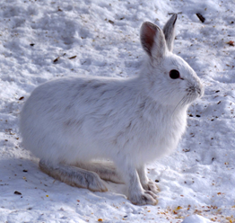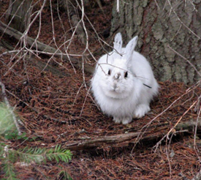

Winter Spring

A predator of the snowshoe hare is the Canada lynx.
How might camouflage be an adaptation that arises through evolution?

_____________________________________________________________________________________

_____________________________________________________________________________________

______________________________________________________________________________
_____________________________________________________________________________________

_____________________________________________________________________________________

______________________________________________________________________________
Part B.
Use the following article and/or video to make a prediction about the snowshoe hare:

Article: Climate change means snowshoe hares stand out like lightbulbs against a snowless background
[https://www.usanpn.org/node/22253]

Video: Will Snowshoe Hares Win a Race Between Evolution and Climate Change?
[https://www.youtube.com/watch?v=NwZzmTuhs3M]

Predict what would happen to the snowshoe hare population if the hares were unable to change the timing of their coat color change to help them blend in with their surroundings.
_____________________________________________________________________________________
_____________________________________________________________________________________

_____________________________________________________________________________________

_____________________________________________________________________________________

_____________________________________________________________________________________
Prompt 2
The Galapagos Islands are home to many different species. Saddleback tortoises live on drier islands where vegetation is higher above the ground. They have a shell with a high curve in front and long necks. Domed tortoises live on wetter islands with lots of vegetation that is low to the ground. These tortoises have rounded or domed shells and short necks. Figure 2 shows the different Galapagos tortoises.
Figure 2. Galapagos Tortoises
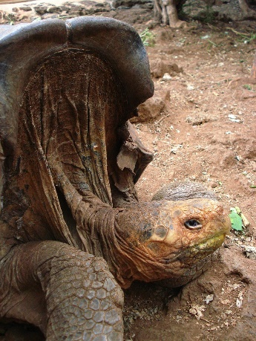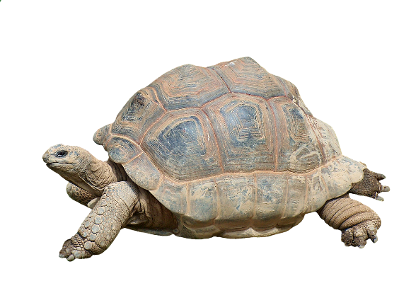
Saddleback Tortoise Domed Tortoise
Why do you think that saddleback tortoises have necks that can reach higher and domed tortoises have a shell that is lower around the neck? Consider how the adaptations of the tortoises shown in Figure 2 help each tortoise survive in their environment.
_____________________________________________________________________________________

_____________________________________________________________________________________

______________________________________________________________________________
_____________________________________________________________________________________

_____________________________________________________________________________________
Prompt 3
There was a period of time called the Industrial Revolution in Manchester, England which caused a lot of pollution. Before the industrial revolution, the trunks of the trees in the forest around Manchester were light-colored. Most of the peppered moths in the area were light-colored with dark spots. As the industrial revolution progressed, the tree trunks became covered with soot and turned dark. Over a period of 45 years, the dark variety of the peppered moth became more common.

Figure 3. Peppered Moth’s Habitat Before and After Industrial Pollution
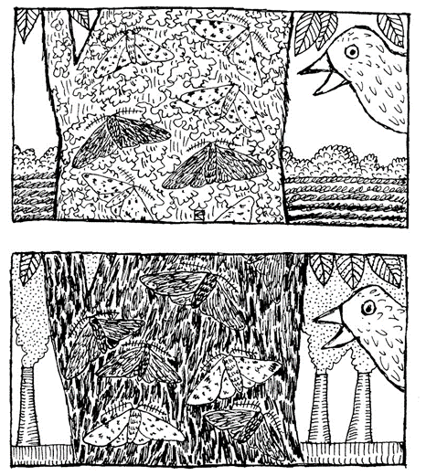

Part A.
Table 1 shows the number of light-colored moths and dark-colored moths observed on tree trunks in a study lasting approximately ten years during the industrial revolution.

Table 1. Number of Light-colored Moths and Dark-colored Moths Observed Over Time
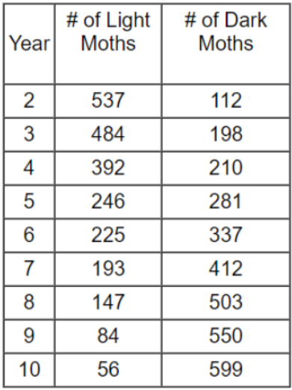

Plot the data for both the light-colored moths and dark-colored moths on the graph. Draw a line showing the pattern for each type of moth. Use a solid line to represent the light moths and a dashed line to represent the dark moths. There should be two lines on the graph.
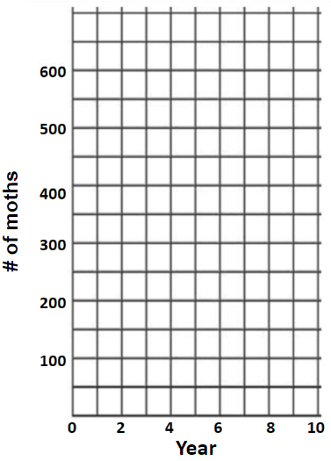

Part B.
Based on the data in Table 1, what is the pattern between the number of light moths observed between the years 2 to 10 compared to the number of dark moths observed between the years 2 to 10?
_____________________________________________________________________________________

_____________________________________________________________________________________

_____________________________________________________________________________________

_____________________________________________________________________________________

Part C.
Explain what caused the patterns in both the light and the dark peppered moths’ populations. Use your scientific knowledge and evidence from your graph to support your answer.
____________________________________________________________________________________

_____________________________________________________________________________________

_____________________________________________________________________________________

_____________________________________________________________________________________

_____________________________________________________________________________________

_____________________________________________________________________________________

_____________________________________________________________________________________

_____________________________________________________________________________________

_____________________________________________________________________________________

_____________________________________________________________________________________

Task Rubric to Evaluate Student Evidence
Task | Score Point 0 | Score Point 1 | Score Point 2 | Score Point 3 | Score Point 4
Prompt 1 Part A. | No aspect of the response is correct | Response includes one (1) of the three (3) aspects | Response includes two (2) of the three (3) aspects | Response includes the following aspects:  - Prey animals or hares that blend in with their surroundings are more likely to survive and reproduce  - Increased survival leads to higher reproductive success  - Increased reproduction leads to more organisms with the beneficial trait in the population | NA
Prompt 1 Part B. | No aspect of the response is correct | Response includes one (1) of the two (2) aspects | Response includes the following aspects:  - The population will decrease  - Prey animals or hares that do not blend in with their surroundings are more likely to be taken by predators | NA | NA
Prompt 2 | No aspect of the response is correct | Response includes one (1) of the two (2) aspects | Response includes the following aspects:  - Relates the physical characteristics of both turtles to their environment  - Relates the shape of shell OR the length of the neck to describe the successful adaptation | NA | NA
Prompt 3 | No aspect of the response is correct | Response includes one (1) of the four (4) aspects | Response includes two (2) of the four (4) aspects | Response includes three (3) of the four (4) aspects | Response includes the following aspects:  - Data points connected for light-colored and dark-colored are shown and plotted correctly  - Recognizes the decreasing population trend of light compared to dark moths during the study  - Describes the factors that changed in the environment (e.g., tree trunks darkening by soot/pollution)  - Describes the protection of camouflage changing over time

Exemplar Responses
Prompt 1
Part A.
How might camouflage be an adaptation that arises through evolution?
Prey animals that better match their surroundings are likely to have a better chance of surviving predation, and because they are more likely to survive and reproduce, their genes are more likely to become common in the population over time and generations.
Prompt 1
Part B.
Predict what would happen to the snowshoe hare population if the hares were unable to change the timing of their coat color change to help them blend in with their surroundings.
The population will decrease. If the hares were unable to change their coat color to match their surroundings, then they will not be camouflaged, and predators are more likely to find them.
Prompt 2
Why do you think that saddleback tortoises have necks that can reach higher and domed tortoises have a shell that is lower around the neck? Consider how the adaptations of the tortoises shown in Figure 2 help each tortoise survive in their environment.
The saddleback tortoise can reach the higher vegetation where it lives since it has a longer neck and more space between the neck and the shell. The domed tortoise can get the vegetation on the ground since it can’t reach very high.
Prompt 3
Part A.
Plot the data for both the light-colored moths and dark-colored moths on the graph. Draw a line showing the pattern for each type of moth. Use a solid line to represent the light moths and a dashed line to represent the dark moths. There should be two lines on the graph.
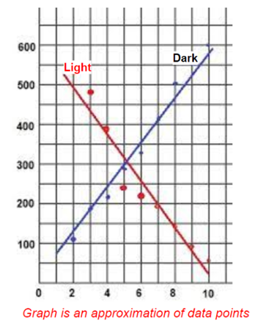
Prompt 3
Part B.
Based on the data in the table above, what is the pattern between the number of light moths observed between the years 2 to 10 compared to the number of dark moths observed between the years 2 to 10?
From the years 2 to 10, the number of light-colored moths decreased, and the number of dark-colored moths increased.
Prompt 3
Part C.
Explain what caused the patterns in both the light and the dark peppered moths’ populations. Use your scientific knowledge and evidence from your graph to support your answer.
The number of light-colored moths decreased because the environment that the moths live in became darker and the moths were unable to camouflage, which meant they were more visible to predators and more likely to not survive.
The number of dark-colored moths increased because the environment became darker, and they were able to camouflage with their surroundings to avoid predation.
Task Notes:

