SIPS Grade 5 Unit 4 EOU Assessment Task 1: Here Comes the Sun

Student Worksheet

This task is about patterns of daylight.

Task
If you want to know the time, you can use a watch or a clock. In ancient times, people used sundials to tell time. A sundial is a flat, round disc with a thin wedge standing in its center. Light from the sun causes the thin wedge to cast a shadow onto the disc. The position of the shadow on the sundial shows what time it is.
Picture 1. Ancient Sundial
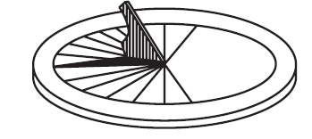
Prompt 1
Your class is studying patterns of shadows. You go outside and observe the position of a shadow at different times of the day. For each observation, you record:
- the position of the sun in the sky
- the position of the shadow of a tree at different times of the day
You stand in the same location for each observation. Figure 1 shows drawings of what you observed.

Part A.
Suppose you are not able to observe the position of the sun and the shadow at 3:00 p.m.
Draw the position of the sun AND the direction and length of the tree’s shadow to show what you would observe at 3:00 p.m. in Figure 1.
Figure 1. Drawing of Observations
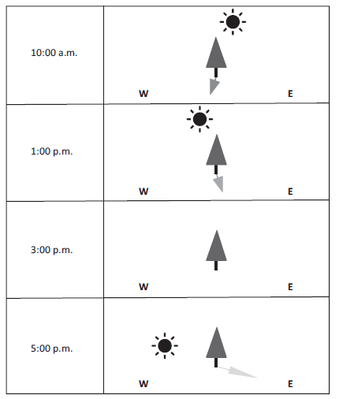

Part B.
The next day, you record the length of the shadow made by a post in the ground at each hour between 9:00 a.m. and 3:00 p.m. The data is shown in Table 1.

Table 1. Shadow Lengths During the Day
y
Time | 9:00 a.m. | 10:00 a.m. | 11:00 a.m. | 12:00 p.m. | 1:00 p.m. | 2:00 p.m. | 3:00 p.m. | 4:00 p.m.
Length of Shadow in Centimeters (cm) | 47 | 43 | 37 | 22 | 35 | 42 | 45 | ?

Graph 1 shows the relationship between the time of day and the length of the post's shadow. The graph shows data collected between 9:00 a.m. and 12:00 p.m.

Complete Graph 1 for 1:00 p.m., 2:00 p.m., and 3:00 p.m. using data from Table 1. Include a bar showing the predicted length of the post's shadow at 4:00 p.m.

Graph 1. Shadow Lengths During the Day

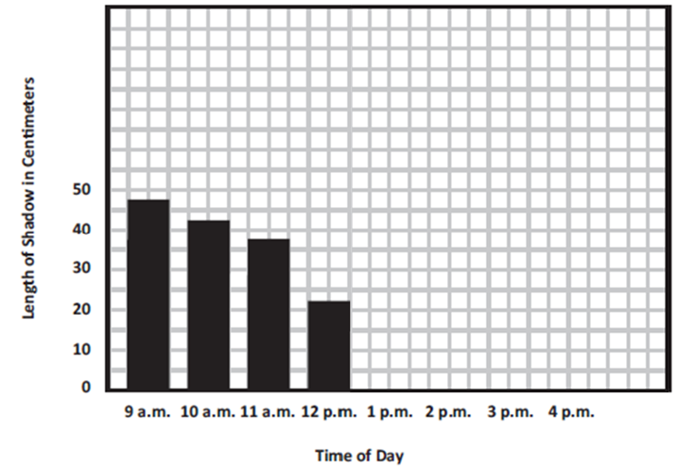

Part C.
Explain how you predicted the length of the shadow at 4:00 p.m.
_____________________________________________________________________________
_____________________________________________________________________________
_____________________________________________________________________________

Part D.
Use the word bank to complete the sentences below. Not all words need to be used and some can be used more than once.
Word Bank
just before sunset | angle | orbit
just after sunrise | long | axis
during the middle of the day | short | distance

- The shortest shadows are seen _________________________________________________.

- The pattern in Graph 1 shows that shadow lengths are ______________________________

in the morning, ______________________ in the afternoon, and then

__________________ again in the evening.

- The length of shadows is caused by the ______________________ of the light from the sun

when it strikes the surface of Earth as Earth rotates on its ___________________________.

Prompt 2
A sundial’s shadow will point north at 12:00 p.m. in the northern middle latitudes. This is true in any season. However, the length and direction of the shadow at other times of the day may vary depending on the season.

Figure 2 shows the position of the sun across the sky during summer and winter in the northern middle latitudes.
Figure 2. Apparent Path of the Sun
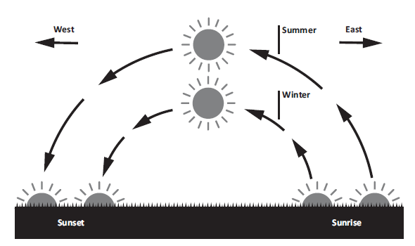
Circle the correct word to complete the sentence.
shorter longer
The length of the shadow on the sundial in the summer will be ___________________ than the length of the shadow in the winter.
Describe what causes the length of the shadow on the sundial to change from summer to winter.
______________________________________________________________________________
______________________________________________________________________________
______________________________________________________________________________
______________________________________________________________________________
______________________________________________________________________________
______________________________________________________________________________

SIPS Grade 5 Unit 4 EOU Assessment Task 2: Meet the Beetles!

Student Worksheet

This task is about stars in the night sky.

Task
Long ago, humans traveled across Earth’s oceans. Maps and compasses were not invented. So, early sailors relied on the locations of stars and constellations to steer their ships.
Organisms on Earth, both humans and animals, use stars to know which way to go. Dung beetles are insects that travel by the stars. How do travelers use the locations of stars to know which way to go?
Prompt 1
On Earth, we experience repeating periods of day and night. At night, the sky is filled with stars, planets, and constellations.
Figure 1 shows the position of a constellation, the Big Dipper, in the night sky during different times of the year in the Northern Hemisphere. Each view is from the same location on Earth in each of the four seasons: winter, spring, summer, and fall.
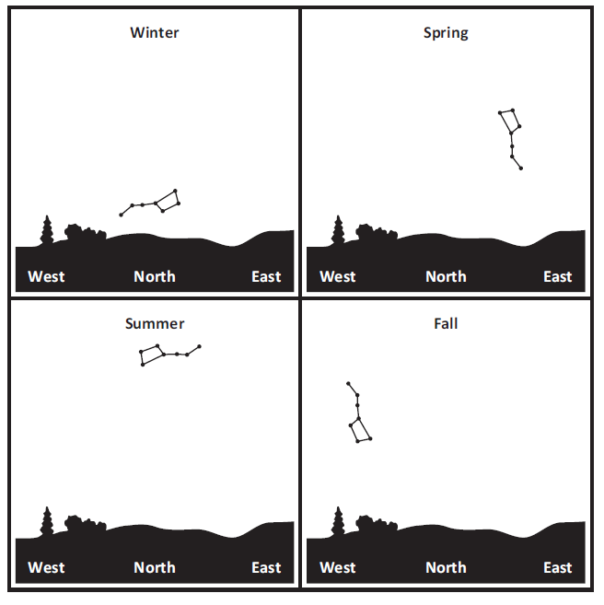
Figure 1. Positions of the Big Dipper in Different Seasons
Describe the pattern of movement of the position of the Big Dipper in the night sky. Use information from Figure 1.
_____________________________________________________________________________
_____________________________________________________________________________
_____________________________________________________________________________
Explain why the position of the Big Dipper appears to move in the night sky during the year.
_____________________________________________________________________________
_____________________________________________________________________________
_____________________________________________________________________________
_____________________________________________________________________________
_____________________________________________________________________________

Prompt 2
Part A.
Stars are so far away that a measure of distance, called light years, is used to describe their distances from Earth. One light year is equal to how far light can travel in one year.
Table 1 shows the distances and brightness of stars. Brightness from Earth is defined as how bright the star appears as viewed from Earth. Actual Brightness is how bright the star is from a fixed point of 33 light years away from Earth.
Table 1. Distance and Brightness of Stars
Star | Distance from Earth  (light-year) | Brightness from Earth | Actual Brightness
Sirius | 8.6 | -1.5 | 1.4
Sun | <1 | -26.7 | 4.8
Procyon | 11 | 0.3 | 2.7
Rigel | 860 | 0.1 | -8.1
Castor | 52 | 1.6 | 0.6
Pollux | 34 | 1.2 | 1.1
The values in Table 1 include negative numbers. Negative numbers are less than zero and have a negative sign (-) in front of them. Numbers greater than zero are called positive numbers.
Brighter stars have smaller values than dim stars. As values become larger, the star’s light gets dimmer. For example, the star Sirius (-1.4) is brighter than Castor (1.6) when seen from Earth’s night sky.
Castor
Sirius
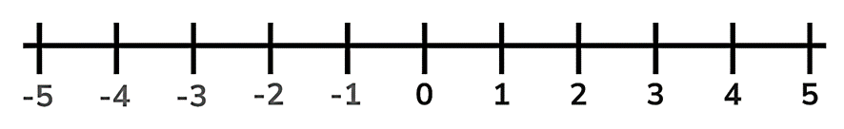
Brighter
Dimmer

Use Table 1 to order the stars from brightest to dimmest as seen from Earth.

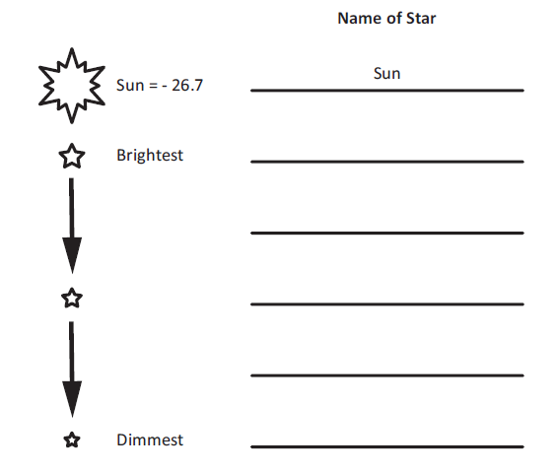
= - 26.7

Part B.
A student makes the following claim:
A star with greater actual brightness will always appear brighter than a star with less actual brightness when viewed from Earth.

Circle if you agree or disagree with the claim. Include evidence from Table 1 to support your response.
Evidence
Agree
Disagree

Part C.
Another student makes the following claim:
A star that is closer to Earth will always appear brighter than a star that is farther away when viewed from Earth.

Circle if you agree or disagree with the claim. Include evidence from Table 1 to support your response.
Evidence
Agree
Disagree

Prompt 3
At nighttime, a dung beetle feeds on animal dung. After finding a fresh pile of dung, the dung beetle must roll a small ball of dung away from other beetles so it does not get stolen. The safest way to protect its ball is to roll it away in a straight path in a short amount of time.
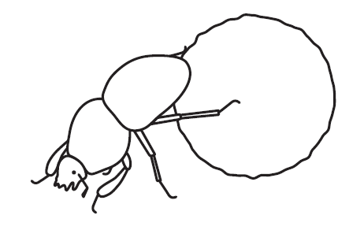
Table 2 shows how well the beetles are able to roll a dung ball to their nest during different conditions of the night sky.
Table 2. Results of Dung Beetle Observations
Conditions of the Night Sky | Do dung beetles roll their dung balls in a straight path?
When the sky is clear with many visible stars | Yes
When the sky is cloudy with no visible stars | No
When the night is moonless with many visible stars | Yes
When the moon is full and bright with few visible stars | No

Describe how dung beetles are able to roll a dung ball in a straight path at night. Use two pieces of evidence from Table 2 to support your answer.
_____________________________________________________________________________
_____________________________________________________________________________
_____________________________________________________________________________
_____________________________________________________________________________
_____________________________________________________________________________
_____________________________________________________________________________

SIPS Grade 5 Unit 4 EOU Assessment Task 3: Turn, Turn, Turn

Student Worksheet

This task is about calendars.

Task
People in ancient times developed calendars to keep track of days and seasons. By counting days, they could predict patterns of changes in the weather. They used these patterns to decide when to plant crops and predict when winter would come. What patterns can be used to predict seasons?
Prompt 1
On Earth, the rising and setting of the sun are quite predictable.
Table 1 shows the approximate sunrise and sunset times in a U.S. city during the year 2022. The length of the day is calculated by finding the number of hours and minutes between sunrise and sunset.
Table 1. Sunrise, Sunset, and Length of Day for a U.S. City in 2022
(H = Hours; M = Minutes)
Date | Jan 1 | Feb 1 | Mar 1 | Apr 1 | May 1 | Jun 21 | Aug 1 | Sept 1 | Oct 1 | Nov 15 | Dec 21
Length of Day | 9 H  30 M | 10 H 15 M | 11 H 20 M | 11 H 40 M | 13 H 50 M | 14 H 55 M | 14 H 10 M | 13 H | 11 H 50 M | 10 H  5 M | 9 H  20 M

Table 2 shows the date when each of the four seasons begins in 2022.
Table 2. Beginning Date of Seasons in 2022
Season | Date
Spring | March 20, 2022
Summer | June 21, 2022
Fall | September 22, 2022
Winter | December 21, 2022

Compare a pattern in the length of daylight during the year for two seasons. Include data from Table 1 and Table 2.
_____________________________________________________________________________
_____________________________________________________________________________
_____________________________________________________________________________
_____________________________________________________________________________
_____________________________________________________________________________

Prompt 2
Earth revolves around the sun, creating the predictable pattern of the seasons. The moon creates another predictable pattern as it revolves around Earth.
Part A.
People can observe four main phases of the moon (New Moon, First Quarter, Full Moon, Last Quarter) as the moon revolves around Earth.

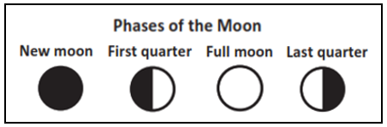

Table 3 shows the dates of each phase of the moon.
Table 3. Moon Phases for January through March 2022

Use the dates in Table 3 to draw the moon phases (New Moon, First Quarter, Full Moon, Last Quarter) in Figure 2. The moon phases for the first row of dates in Table 3 are shown in Figure 2.
Figure 2. 2022 Calendar
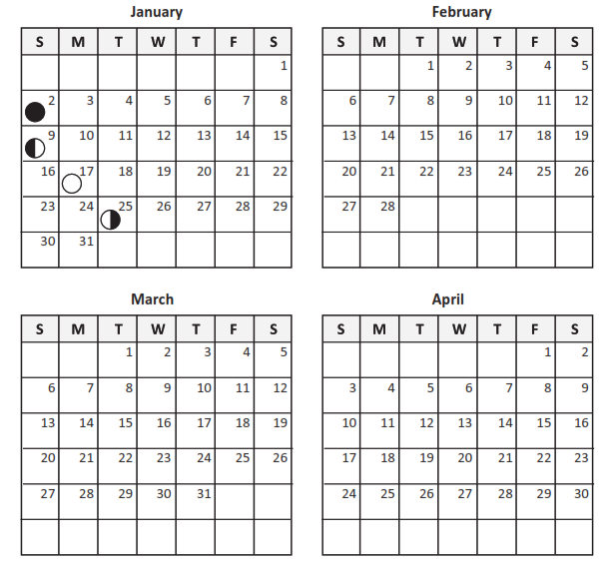Part B.

Predict the dates of the next New Moon, First Quarter, Full Moon, and Last Quarter in Table 4. Use information from your completed Figure 2 to support your prediction.
Table 4. Dates of Moon Phases
New Moon | First Quarter | Full Moon | Last Quarter
Part C.
A student makes the following claim:
If I see a full moon on the first day of the month in October, I will see the next full moon on the first day of November.

Circle one of the following:
I agree with the claim. I disagree with the claim.
Support your answer using evidence from Table 3 and Figure 2.
_____________________________________________________________________________
_____________________________________________________________________________
_____________________________________________________________________________
_____________________________________________________________________________

Prompt 3
Earth’s gravity pulls all of Earth's mass toward its center. So, due to gravity, Earth maintains its spherical shape.
How can a lunar eclipse provide evidence that Earth is shaped like a sphere?
_____________________________________________________________________________
_____________________________________________________________________________
_____________________________________________________________________________
_____________________________________________________________________________
_____________________________________________________________________________
_____________________________________________________________________________
_____________________________________________________________________________
_____________________________________________________________________________

