Stackable Instructionally-embedded Portable Science (SIPS) Assessments Project

SIPS Grade 8 Unit 1 End-of-Unit Assessment Scoring Guide

May 2023

The SIPS Grade 8 Unit 1 End-of-Unit Assessment Scoring Guide was developed with funding from the U.S. Department of Education under the Competitive Grants for State Assessments Program, CFDA 84.368A. The contents of this paper do not represent the policy of the U.S. Department of Education, and no assumption of endorsement by the Federal government should be made.
All rights reserved. Any or all portions of this document may be reproduced and distributed without prior permission, provided the source is cited as: Stackable Instructionally-embedded Portable Science (SIPS) Assessments Project. (2023). SIPS Grade 8 Unit 1 End-of-Unit Assessment Scoring Guide. Lincoln, NE: Nebraska Department of Education.
Table of Contents

SIPS Grade 8 Unit 1 EOU Assessment Task 1: Storing Grocery Carts ............................................ 1

Task 1 Scoring Rubric .................................................................................................................. 6

Task 1 Student Exemplars .......................................................................................................... 10

SIPS Grade 8 Unit 1 EOU Assessment Task 2: Barriers on the Highway ...................................... 14

Task 2 Scoring Rubric ................................................................................................................. 20

Task 2 Student Exemplars .......................................................................................................... 24

SIPS Grade 8 Unit 1 EOU Assessment Task 3: Roller Coaster Thrills............................................ 28

Task 3 Scoring Rubric ................................................................................................................ 34

Task 3 Student Exemplars .......................................................................................................... 37
SIPS Grade 8 Unit 1 EOU Assessment Task 1: Storing Grocery Carts

Student Worksheet
This task is about collisions.

Task
A store owner notices the walls against which grocery carts are returned are becoming damaged. A construction engineer is hired to develop a design solution to prevent further damage to the store’s walls. The construction engineer must rely on Newton’s laws of motion to support a design solution for the store owner.

Prompt 1
Part A.
The construction engineer decides to develop a model to show the store owner the forces involved in the collision.
Complete Model 1 to show the forces involved in the collision if a shopper pushes the cart into the wall. Use information in the key to:

- Draw arrows to show the amount and direction of the forces during the collision.
- Label the forces in the model as:
  - Force of the cart
  - Force of the wall
KEY
- The length of the arrow shows the amount of force:
  - large force
  - small force
- The direction of the arrow shows the direction of the force.

Model 1. Grocery Cart Wall Collision
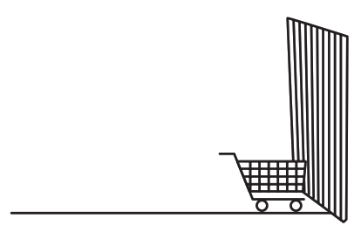

Part B
How does the mass of a moving cart affect the force needed to change its speed and direction of motion when the cart hits the wall?
Use the following terms in your response:
- Mass | - Cart
- Force | - Wall
- Impact | - Motion
______________________________________________________________________________
______________________________________________________________________________
______________________________________________________________________________
______________________________________________________________________________

Prompt 2
The store owner asks the construction engineer to propose two potential design solutions to prevent further damage to the store’s walls. The design solutions should meet three requirements:
- Budget cannot exceed $4,000
- Job must be completed in four to six weeks
- Solution should reduce the amount of damage to the walls
The construction engineer researches shopping cart information and design options for protecting the walls. Both design options will hold all of the store’s 50 carts. Table 1 compares both design options.

Table 1. Wall Protection Options
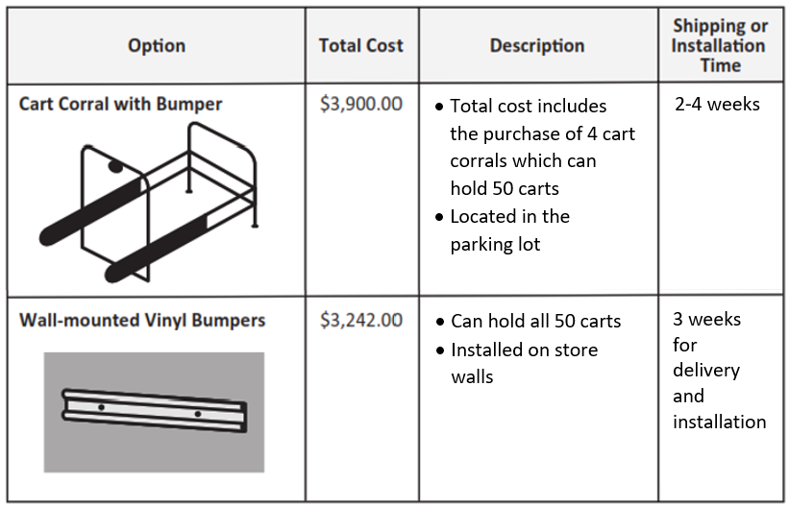
Part A.
Evaluate how well Potential Design Solution #1 meets each of the three requirements. If any requirements are not met, explain why they are not met. Use the information in Table 1 as evidence to support your evaluation.
Potential Design Solution #1:
Purchase the cart corrals with bumpers.
protection options.

______________________________________________________________________________
______________________________________________________________________________
______________________________________________________________________________
______________________________________________________________________________
______________________________________________________________________________
_____________________________________________________________________________.

Part B.
Evaluate how well Potential Design Solution #2 meets each of the three requirements. If any requirements are not met, explain why they are not met. Use the information in Table 1 as evidence to support your evaluation.
Potential Design Solution #2:
Purchase and install wall-mounted, vinyl bumpers.

______________________________________________________________________________
______________________________________________________________________________
______________________________________________________________________________
______________________________________________________________________________
______________________________________________________________________________
_____________________________________________________________________________.
Part C.
The store owner selects Design Solution #2. After the vinyl bumpers are installed, the store owner tests the solution by pushing an empty cart toward the wall. When the cart hits the bumper, it slowly bounces back.
Describe the force that causes the cart to bounce back.
______________________________________________________________________________
______________________________________________________________________________
______________________________________________________________________________

Part D.
Explain how the vinyl bumpers protect the wall from the force of the moving cart. Use Newton’s laws of motion to describe the interacting forces.
Select from the following terms to include in your response:
- Direction | - Wall
- Force | - Bumper
- Opposite | - Cart
- Equal | - Collision
______________________________________________________________________________
______________________________________________________________________________
______________________________________________________________________________
______________________________________________________________________________
______________________________________________________________________________
_____________________________________________________________________________.

Metal & Plastic Shopping Carts. (2020). Carts4u. Retrieved August 19, 2022, from https://carts4u.com/shopping-carts
W.W. Grainger, Inc. (2022). Single Wide Cart Corral. Grainger. Retrieved August 19, 2022, from https://www.grainger.com/product/GRAINGER-APPROVED-Single-Wide-Cart-Corral-Single-4YFD7
Bumper for Carts, Walls, and Equipment. (2022). Wallguard.Com. Retrieved August 19, 2022, from https://wallguard.com/cart-wall-and-equipment-protection/2256-bumper-for-carts-walls-and-equipment.html#

SIPS Grade 8 Unit 1 EOU Assessment Task 1 Rubric (MS-PS2-1, MS-PS2-2)
Prompt | Score Point 0 | Score Point 1 | Score Point 2 | Score Point 3 | Score Point 4
Prompt 1  Part A. | No aspect of the response is correct | Response includes one (1) of the four (4) key aspects | Response includes two (2) of the four (4) key aspects | Response includes three (3) of the four (4) key aspects | Response includes the  following key aspects:  - Force arrows are labeled  - Force arrows are equal in length and opposite in direction  - The force of the cart is pointing toward the wall  - The force of the wall is pointing toward the cart
Prompt 1  Part B. | No aspect of the response is correct | Response includes one (1) of the two (2) key aspects | Response includes the following key aspects:  - The greater the mass of the cart, the greater the force needed to make a change in its speed and direction.  - A cart with more mass hits the wall with more force upon impact | NA | NA
Prompt 2  Part A. | No aspect of the response is correct | Response includes one (1) of the three (3) key aspects | Response includes two (2) of the three (3) key aspects | Response includes the  following key aspects:  - Explains that Solution 1 does meet the budget constraint  - Explains that Solution 1 does meet the time requirements  - Explains that Solution 1 will not reduce the damage to the wall | NA
Prompt 2  Part B. | No aspect of the response is correct | Response includes one (1) of the three (3) key aspects | Response includes two (2) of the three (3) key aspects | Response includes the  following key aspects:  - Explains that Solution 2 does meet the budget constraint  - Explains that Solution 2 does meet the time requirements  - Explains that Solution 2 will reduce the damage to the wall | NA
Prompt 2  Part C. & Part D. | No aspect of the response is correct | Response includes one (1) of the three (3) key aspects | - Response includes two (2) of the three (3) key aspects | Response includes the  following key aspects:  Part C  - Describes that the force of the bumper causes the cart to bounce back  Part D  - Explains that the interacting forces are between the cart and the bumper  - Explains the effectiveness of the design solution based on the application of Newton’s third law of motion | NA

Student Exemplar(s)
Student exemplars represent high-quality responses that align to full-point rubric scores. The exemplar responses are intended to assist educators’ understanding of the nature and expectations of each prompt. Note the exemplars serve as examples of high-quality responses, and students may respond with equally relevant, scientifically accurate responses and ideas that meet the expectations of a full-point rubric score.

Prompt 1

Part A.
Complete Model 1 to show the forces involved in the collision if a shopper pushes the cart into the wall. Use information in the key to:
- Draw arrows to show the amount of force and direction of the forces during the collision.
- Label the forces in the model as:
  - Force of the cart
  - Force of the wall
KEY
- The length of the arrow shows the amount of force:

  - large force
  - small force
- The direction of the arrow shows the direction of the force.

Part B.
How does the mass of a moving cart affect the force needed to change its speed and direction of motion when the cart hits the wall?

Use the following terms in your response:
- Mass | - Cart
- Force | - Wall
- Impact | - Motion
The heavier the cart is the more force is needed to change its speed and direction of motion. The wall provides the force in the opposite direction of the cart on impact. That means a cart with more mass hits the wall with more force.

Prompt 2
Part A.
Evaluate how well Potential Design Solution #1 meets each of the three requirements. If any requirements are not met, explain why they are not met. Use the information in Table 1 as evidence to support your evaluation.
Potential Design Solution #1:
Purchase the cart corrals with bumpers.
protecton optons.

The bumper corrals can be shipped in time to meet the requirements. The bumper corrals will cost $3,900 which meets the budget requirement. But the bumper corrals will be in the parking lot so the carts will not be returned inside the store by the shoppers. If a shopper does return the cart to the store, it will still hit the wall.
Part B.
Evaluate how well Potential Design Solution #2 meets each of the three requirements. If any requirements are not met, explain why they are not met. Use the information in Table 2 as evidence to support your evaluation.

Potential Design Solution #2:
Purchase and install wall-mounted, vinyl bumpers.
protection options.

The vinyl bumpers will cost a total of $3,342 to purchase and install. The vinyl bumpers can be shipped and installed in three weeks. Because vinyl bumpers can be installed on the store’s walls, the walls will be protected.
Part C.
Describe the force that causes the cart to bounce back.
The moving cart hits the bumper with force. Then the bumper pushes back against the cart with a force in the opposite direction. That is why the cart bounced backward.
Part D.
Explain how the vinyl bumpers protect the wall from the force of the moving cart. Use Newton’s laws of motion to describe the interacting forces.
Select from the following terms to include in your response:
- Direction | - Wall
- Force | - Bumper
- Opposite | - Cart
- Equal | - Collision

The bumpers are protecting the wall because the cart hits the bumper and not the wall. According to Newton’s third law, the force of the moving cart moves toward the bumper. When the cart hits the bumper, the cart is bounced back in the opposite direction by the force of the bumper. So, the collision forces are between the cart and the barrier.
OR
According to Newton’s third law of motion, the force exerted by the cart on the bumper is equal in strength to the force that the bumper exerts on the cart, but in the opposite direction. So, the carts bounce back from the bumper instead of hitting the wall during the collision.

SIPS Grade 8 Unit 1 EOU Assessment Task 2: Barriers on the Highway

Student Worksheet
This task is about kinetic energy and collisions.

Task
On interstate highways in construction zones, solid concrete barriers often separate the travel lane from roadside equipment.
Diagram 1. Construction Zone
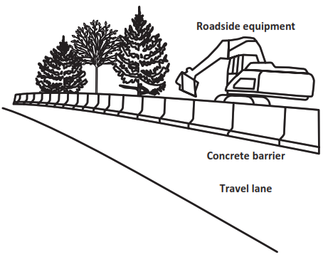

Prompt 1
Part A.
The highway department asks you to design a barrier that will decrease the amount of damage to a vehicle in a collision. Different barrier types are able to absorb different amounts of kinetic energy during an accident with a moving vehicle.
To explain your design to the highway department, you need to describe the relationships between kinetic energy, mass, and velocity of different vehicles.

Choose from the following phrases to correctly complete each sentence.
greater than equal to less than

The kinetic energy of a heavier vehicle will be _____________________ the kinetic energy of a smaller or lighter vehicle traveling at the same velocity.
The kinetic energy of a faster vehicle will be ______________________ the kinetic energy of the same vehicle traveling at a slower velocity.
Part B.
Explain why it is important to calculate the kinetic energy of collisions involving vehicles with different masses traveling at different velocities before designing a barrier for the highway department.
______________________________________________________________________________
______________________________________________________________________________
______________________________________________________________________________

Prompt 2
Table 1 shows the kinetic energy [KE (kj)] of three vehicles with different masses traveling at different velocities. Each vehicle travels at velocities of 11.2, 24.6, and 31.3 meters per second (m/s).
Table 1. Kinetic Energy of Three Vehicles
Vehicle | Mass (kg) | Velocity (m/s) | KE (kj)
Vehicle 1 | 3783 | 11.2 | 237.3
 |  | 24.6 | 1146.6
 |  | 31.3 | 1853.1
Vehicle 2 | 1620 | 11.2 | 101.6
 |  | 24.6 | 490.2
 |  | 31.3 | 793.6
Vehicle 3 | 703 | 11.2 | 44.1
 |  | 24.6 | 212.7
 |  | 31.3 | 344.4

Part A.
Use a line graph to complete Graph 1 below.
- Use Table 1 to plot the kinetic energy of each of the three vehicles traveling at 31.3 m/s.
- Draw a line, starting at zero (0), to show the relationship between mass and kinetic energy.
Graph 1. Kinetic Energy of Three Vehicles Traveling at 31.3 m/s
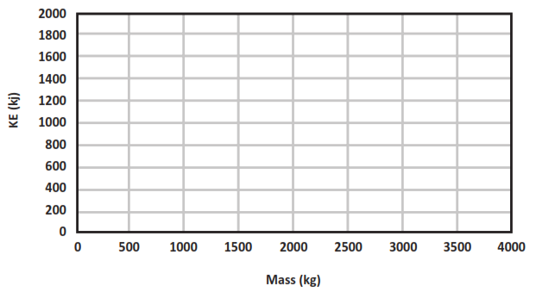

Part B.
Which statement describes the relationship between changes in mass and the kinetic energy of the three vehicles shown by your graph? Circle one.
Statement 1:  Increasing a vehicle's mass results in a directly proportional increase of the vehicle's kinetic energy. | Statement 2:  Increasing a vehicle's mass results in an increase of the vehicle's kinetic energy proportional to the square of its mass.
Part C.
Describe the mathematical relationship between mass and kinetic energy to support your answer in Part B. Use data in Graph 1 and/or Table 1 to support your response.
______________________________________________________________________________
______________________________________________________________________________
______________________________________________________________________________

Prompt 3
Part A.
Graph 2 shows the kinetic energy of Vehicle 1 traveling at 11.2, 24.6, and 31.3 m/s.
In Graph 2, use data from Table 1 to plot the KE for Vehicle 3 traveling at 11.2 m/s, 24.6 m/s, and 31.3 m/s. Use a different shape, like a star or square, to represent Vehicle 3. (Vehicle 1 is represented by circles on the graph.)
Graph 2. Kinetic Energy (KE) versus Velocity of Vehicle 1
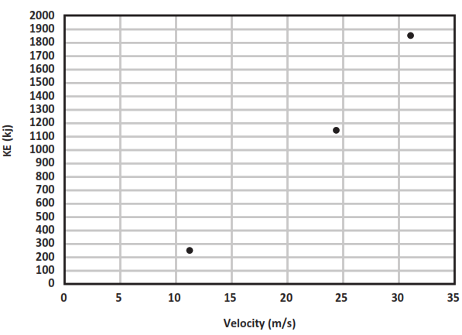
Part B.
Which statement describes the relationship between changes in velocity and the kinetic energy of the two vehicles shown in Graph 2? Circle one.
Statement 1:  Increasing a vehicle's velocity results in a directly proportional increase of the vehicle's kinetic energy. | Statement 2:  Increasing a vehicle's velocity results in an increase of the vehicle's kinetic energy proportional to the square of its velocity.

Part C.
Use the patterns of the data shown by Graphs 1 and 2 to explain which variable—mass OR velocity—has a greater effect on kinetic energy. Explain why you selected that variable.
______________________________________________________________________________
______________________________________________________________________________
______________________________________________________________________________
______________________________________________________________________________
Prompt 4
Table 2 provides a description of two highway barriers and the impact on a moving vehicle during a collision.
Table 2. Highway Barriers
Type of Barrier | Description of Barrier | Description of Impact
Jersey Barrier  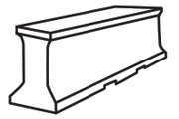 | - Concrete reinforced with steel | - Vehicle is not slowed before stopping
Guard Rail  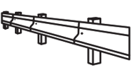 | - Metal rail supported on wooden posts | - Vehicle is slowed before stopping
The highway department has two requirements for the design solution:
- The barrier should minimize the amount of damage to the vehicle.
- The barrier should minimize the amount of force experienced by the passengers when the vehicle comes to a stop.
Part A.
The barrier type that would result in stopping a moving vehicle and result in the least damage to the vehicle is the ____________________________________________________.

Part B.
Explain why this barrier type will be better at reducing damage and injury than the other barrier type. Reference the information in Table 2, the relationships among kinetic energy, mass, and velocity, and Newton’s third law of motion to support your response.
This barrier type will be better at reducing damage and injury because ____________________
______________________________________________________________________________
______________________________________________________________________________
______________________________________________________________________________
______________________________________________________________________________
______________________________________________________________________________
______________________________________________________________________________
______________________________________________________________________________
______________________________________________________________________________
_____________________________________________________________________________.

SIPS Grade 8 Unit 1 EOU Assessment Task 2 Rubric (MS-PS3-1, MS-PS2-1)
Prompt | Score Point 0 | Score Point 1 | Score Point 2 | Score Point 3 | Score Point 4
Prompt 1 | No aspect of the response is correct | Response includes one (1) of the two (2) aspects | Response includes the following aspects:  Part A  - Selected greater than for both statements  Part B  - Support for collecting different values of velocities and masses of vehicles | NA | NA
Prompt 2. | No aspect of the response is correct | Response includes one (1) of the three (3) aspects | Response includes two (2) of the three (3) aspects | The graph includes the following aspects:  Part A  - Accurate plotting of the kinetic energy for each of the three vehicles traveling at 31.3 m/s, including a line showing the correct linear relationship between mass and kinetic energy that starts at “0”  Part B  - Selects “Statement 1”  Part C  - Describes the direct relationship between mass and kinetic energy, indicating that as mass increases so does kinetic energy | NA
Prompt 3 | No aspect of the response is correct | Response includes one (1) of the four (4) aspects | Response includes two (2) of the four (4) aspects | - Response includes three (3) of the four (4) aspects | Response includes the following aspects:  Part A  - Accurate plotting of the KE for Vehicle 3 traveling at three (3) different speeds  Part B  - Selects “Statement 2”  Part C  - Describes the relationship between mass and kinetic energy AND between velocity and kinetic energy using patterns of data shown by each graph  - Explains that an increase in velocity results in a greater relative rate of change in kinetic energy than an increase in mass based on the analysis of the data in the graphs
Prompt 4 | No aspect of the response is correct | Response includes one (1) of the four (4) aspects | Response includes two (2) of the four (4) aspects | Response includes three (3) of the four (4) aspects | Response includes the following aspects:  Part A  - Identifies the guard rail  Part B  - Compares the impact velocity of a vehicle when stopped by each barrier type  - Explains the relationship between velocity and KE  - Explains the relationship of KE to the forces involved in the collision as related to Newton’s third law

Student Exemplar(s)
Student exemplars represent high-quality responses that align to full-point rubric scores. The exemplar responses are intended to assist educators’ understanding of the nature and expectations of each prompt. Note the exemplars serve as examples of high-quality responses, and students may respond with equally relevant, scientifically accurate responses and ideas that meet the expectations of a full-point rubric score.
Prompt 1

Part A.
Choose from the following phrases to correctly complete each sentence.
greater than equal to less than

The kinetic energy of a heavier vehicle will be greater than the kinetic energy of a smaller or lighter vehicle traveling at the same velocity.
The kinetic energy of a faster vehicle will be greater than the kinetic energy of the same vehicle traveling at a slower velocity.

Part B.
Explain why it is important to calculate the kinetic energy of collisions involving vehicles with different masses traveling at different velocities before designing a barrier for the highway department.
I have to do this because I need to make sure the barrier can absorb the amount of kinetic energy exerted on it by different vehicles of different masses traveling at different speeds.
Prompt 2

Part A.
Use a line graph to complete Graph 1 below.
- Use Table 1 to plot the kinetic energy of each of the three vehicles traveling at 31.3 m/s.
- Draw a line, starting at zero (0), to show the relationship between mass and kinetic energy.

Graph 1. Kinetic Energy of Three Vehicles Traveling at 31.3 m/s
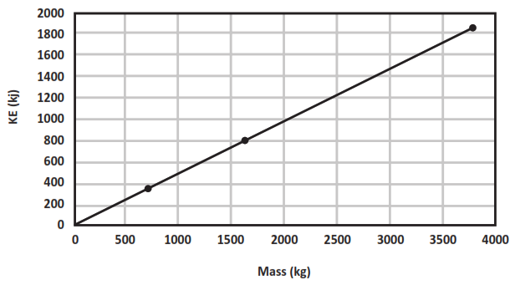

Part B.
Which statement describes the relationship between changes in mass and the kinetic energy of the three vehicles shown by your graph? Circle one.
Statement 1:  Increasing a vehicle's mass results in a directly proportional increase of the vehicle's kinetic energy. | Statement 2:  Increasing a vehicle's mass results in an increase of the vehicle's kinetic energy proportional to the square of its mass.
Part C.
Describe the mathematical relationship between mass and kinetic energy to support your answer in Part B using the data in Graph 1 and/or Table 1 to support your response.
Table 1 shows that kinetic energy has a direct/proportional relationship with mass. Vehicle 1 is 5.3 times heavier than Vehicle 2. This results in 5.3 times increase in the kinetic energy at the same velocity.
OR
The graph shows that kinetic energy and mass have a linear proportional relationship. When the mass of a vehicle increases, the kinetic energy increases.

Prompt 3
Part A.
In Graph 2, use data from Table 1 to plot the KE for Vehicle 3 traveling at 11.2 m/s, 24.6 m/s, and 31.3 m/s. Use a different shape, like a star or square, to represent Vehicle 3. (Vehicle 1 is represented by circles on the graph.)
Graph 2. Kinetic Energy (KE) versus Velocity of Vehicle 1
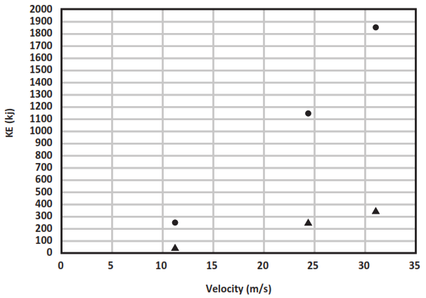
Part B.
Which statement describes the relationship between changes in velocity and the kinetic energy of the two vehicles shown in Graph 2? Circle one.
Statement 1:  Increasing a vehicle's velocity results in a directly proportional increase of the vehicle's kinetic energy. | Statement 2:  Increasing a vehicle's velocity results in an increase of the vehicle's kinetic energy proportional to the square of its velocity.

Part C.
Use the patterns of the data shown by Graphs 1 and 2 to explain which variable—mass OR velocity—has a greater effect on kinetic energy. Explain why you selected that variable.
Graph 1 shows a straight line for the relationship between vehicles of different masses traveling at the same speed. Graph 2 shows a relationship that is not a straight line but increases more steeply when comparing kinetic energy to velocity. So, increasing the velocity of an object causes a bigger increase in kinetic energy than increasing the mass.
Prompt 4
Part A.
The barrier type that would result in stopping a moving vehicle and result in the least damage to the vehicle is the Guard Rail.
Part B.
Explain why this barrier type will be better at reducing damage and injury than the other barrier type. Reference the information in Table 2, the relationships among kinetic energy, mass, and velocity, and Newton’s third law of motion to support your response.
This barrier type will be better at reducing damage and injury because when a vehicle hits the Jersey barrier it is not slowed before it stops. When a vehicle hits the guard rail, it is slowed before it stops. That means the vehicle will have much lower KE when it is stopped by this type of barrier. So, that means the KE or force of the collision will be less for the guard rail than the Jersey barrier in a collision. According to Newton’s third law, the opposite force the guard rail applies to the vehicle will also be smaller. That is why the guard rail is better at reducing damage and injury than the Jersey barrier.
SIPS Grade 8 Unit 1 EOU Assessment Task 3: Roller Coaster Thrills

Student Worksheet
This task is about energy and motion.

Task
Some people enjoy going to amusement parks to ride roller coasters. They love the height, speed, and thrill of riding a roller coaster. They ride in a group of connected, open cars on a track. The group of cars is not powered by an engine. How is it possible for a roller coaster to travel fast without an engine?
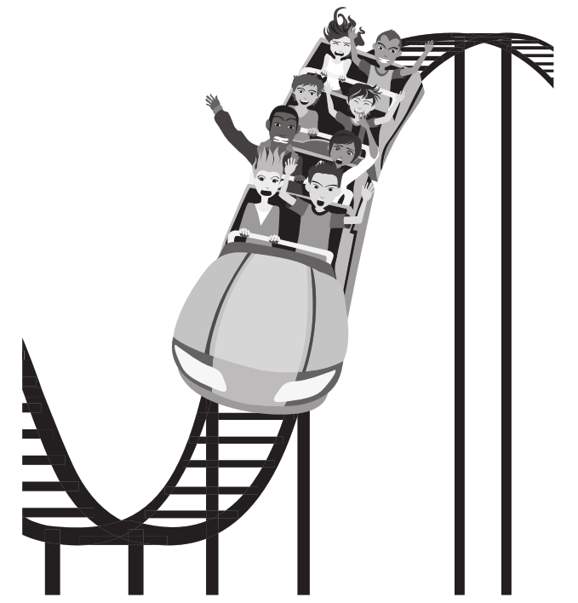

Prompt 1

Part A.
Diagram 1 shows two roller coaster systems labeled System 1 and System 2. Each system includes three components: the track, the ground, and the roller coaster.
- The System 1 roller coaster and the System 2 roller coaster begin the drop from the same height.
- The System 2 roller coaster has twice the mass of the System 1 roller coaster.
Diagram 1. System 1 and System 2
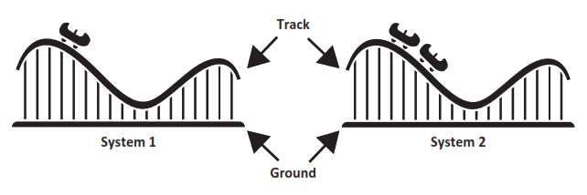

Which sentence compares the gravitational potential energy in the two systems? (Circle one.)
- System 1 has more gravitational potential energy.
- System 2 has more gravitational potential energy.
- Systems 1 and 2 have equal amounts of gravitational potential energy.

Part B.
Explain how to increase the potential energy of the roller coaster in either system. Use the gravitational relationship between the roller coaster and the ground to support your answer.
_____________________________________________________________________________________
_____________________________________________________________________________________
_____________________________________________________________________________________
_____________________________________________________________________________________
_____________________________________________________________________________________

Part C.

In Diagram 1, when the System 1 and System 2 roller coasters begin the drop, gravitational potential energy is transformed into kinetic energy.
- Which phrase below accurately compares the kinetic energy of the roller coaster in motion in System 2 to the roller coaster in motion in System 1? (Circle one.)
THE SAME TWICE AS MUCH FOUR TIMES AS MUCH
- Describe the relationship of an object’s kinetic energy to its mass.

__________________________________________________________________________

__________________________________________________________________________

__________________________________________________________________________

Prompt 2
Some people think only massive objects have gravity. They also think that there is no gravitational force of attraction between objects such as a pencil and a car because they do not observe a pencil being attracted toward a car.
Explain why the gravitational force of attraction between a pencil and a car is not observable. In your explanation, include information about the mass of objects and gravitational force.
______________________________________________________________________________
______________________________________________________________________________
______________________________________________________________________________
______________________________________________________________________________
______________________________________________________________________________

Prompt 3
The faster an object moves, the more kinetic energy it possesses. Diagram 2 shows an inclined plane that can be used to model the motion of a falling object. When a ball is released, it begins rolling down the inclined plane. When the ball is released from different heights, the amount of kinetic energy possessed by the moving ball can be calculated.
Diagram 2. Inclined Plane
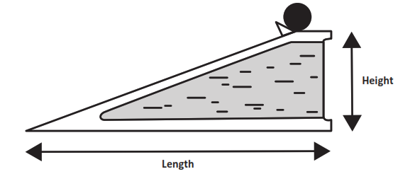
Table 1 shows the calculations of the velocity and kinetic energy of a 5 kg ball rolling down an inclined plane positioned at different heights.
Table 1. Rolling on an Inclined Plane
Height  (meters) | Length  (meters) | Velocity (meters/sec) | Time to Reach Bottom of Inclined Plane (minutes) | Kinetic Energy (Joules)
10 | 2,000 | 10.44 | 6.39 | 272.48
50 | 2,000 | 23.35 | 2.86 | 1,363.06
100 | 2,000 | 33.02 | 2.02 | 2,725.80
500 | 2,000 | 73.82 | 0.90 | 13,623.48

Use the data in Table 1 to describe the proportional relationship of kinetic energy to the velocity of the ball by comparing the results when the ball is released from different heights.
Use the following terms in your response:
- height of the ramp  - gravity  - potential energy | - kinetic energy  - velocity of the ball

______________________________________________________________________________
______________________________________________________________________________
______________________________________________________________________________
______________________________________________________________________________
_____________________________________________________________________________
______________________________________________________________________________
______________________________________________________________________________
______________________________________________________________________________
______________________________________________________________________________

Prompt 4
Table 2 compares two roller coasters. For each roller coaster, it includes the height, velocity, length of the tallest drop, time to reach the bottom, and number of riders.
Table 2. Roller Coaster Comparison
Name | Height (feet) | Velocity (miles/hr) | Length of Drop  (feet) | Time to Reach Bottom of Drop (seconds) | Riders per Roller Coaster
Kingda Ka | 456 | 128 | 418 | 2.2 | 18
Millennium Force | 310 | 93 | 300 | 2.2 | 36
Part A.
Write a claim about which roller coaster, Kingda Ka OR Millennium Force, has the greater kinetic energy as it reaches the bottom of the tallest drop on the track. (Assume the mass of each empty roller coaster is the same.)
______________________________________________________________________________
______________________________________________________________________________
______________________________________________________________________________
Part B.
Support your claim using:
- The relationship of kinetic energy to the mass of an object
- The relationship of kinetic energy to the speed of an object
- Data in Table 1 and Table 2
______________________________________________________________________________
______________________________________________________________________________

______________________________________________________________________________

______________________________________________________________________________
______________________________________________________________________________

SIPS EOU Unit 1 Grade 8 Task 3 Rubric (MS-PS2-4, MS-PS3-1)
Prompt | Score Point 0 | Score Point 1 | Score Point 2 | Score Point 3 | Score Point 4
Prompt 1  Part A. & Part B. | No aspect of the response is correct | Response includes one (1) of the two (2) aspects | Response includes the following aspects:  Part A  - Identifies System 2 has more gravitational potential energy  AND  Part B  - Explains that an increase in the mass AND/OR height of the roller coaster in either system will result in an increase in potential energy | NA | NA
Prompt 1  Part C. | No aspect of the response is correct | Response includes one (1) of the two (2) aspects | Response includes the following aspects:  - Identifies System 2 has twice the kinetic energy as System 1  - Explains that as mass doubles KE doubles OR there is a linear/direct relationship between KE and mass | NA | NA
Prompt 2 | No aspect of the response is correct | Response includes one (1) of the three (3) aspects | Response includes two (2) of the three (3) aspects | Response includes the following aspects:  - Gravitational forces exist between all objects  - Earth’s gravitational attraction is exceptionally large compared to the attraction between any other two objects on Earth  - Because the gravitational attraction is so large between an object and the Earth, the attraction between smaller objects is not observed | NA
Prompt 3 | No aspect of the response is correct | Response includes one (1) of the four (4) aspects | Response includes two (2) of the four (4) aspects | Response includes three (3) of the four (4) aspects | Response includes the following aspects:  - The higher ramp having more potential gravitational force or a reference to ramp height and gravity  - The potential energy is converted into kinetic energy as the ball rolls  - Kinetic energy is proportional to velocity  - Data comparison(s) from Table 1
Prompt 4 | No aspect of the response is correct | Response includes one (1) of the three (3) aspects | - Response includes two (2) of the three (3) aspects | Response includes the following aspects:  Part A  - Identifies Kingda Ka as the roller coaster with greater kinetic energy  AND  Part B  - Provides comparison of KE using the data from Tables 1 & 2  - Provides evidence showing Kingda Ka has greater kinetic energy than Millennium Force | NA

Student Exemplar(s)
Student exemplars represent high-quality responses that align to full-point rubric scores. The exemplar responses are intended to assist educators’ understanding of the nature and expectations of each prompt. Note the exemplars serve as examples of high-quality responses, and students may respond with equally relevant, scientifically accurate responses and ideas that meet the expectations of a full-point rubric score.

Prompt 1

Part A.

Which sentence compares the gravitational potential energy in the two systems? (Circle one.)
- System 1 has more gravitational potential energy.
- System 2 has more gravitational potential energy.
- Systems 1 and 2 have equal amounts of gravitational potential energy.

Part B.
Explain how to increase the potential energy of the roller coaster in either system. Use the gravitational relationship between the roller coaster and the ground to support your answer.
To increase the gravitational potential energy in either system, I would increase the mass of the roller coaster because when the mass of the roller coaster increases, then the gravitational forces between the roller coaster and the ground are also increased.
OR
To increase the gravitational potential energy in either system, I would increase the height of the roller coaster because when the height of the roller coaster increases, then the gravitational forces between the roller coaster and the ground are also increased.

Part C.
- Which phrase below accurately compares the kinetic energy of the roller coaster in motion in System 2 to the roller coaster in motion in System 1? (Circle one.)
THE SAME TWICE AS MUCH FOUR TIMES AS MUCH
- Describe the relationship of an object’s kinetic energy to its mass.
The kinetic energy doubles as the mass of an object doubles.

Prompt 2
Explain why the gravitational force of attraction between a pencil and a car is not observable. In your explanation, include information about the mass of objects and gravitational force.
The force of gravity exists between any two objects. But unless one is massive, like Earth, the force of gravity is not noticeable. Objects like pencils and cars have very little mass compared to Earth. So, the gravitational force between them is very small and cannot be seen.

Prompt 3
Use the data in Table 1 to describe the proportional relationship of kinetic energy to the velocity of the ball by comparing the results when the ball is released from different heights.
Use the following terms in your response:
- height of the ramp  - gravity  - potential energy | - kinetic energy  - velocity of the ball
When the height of the ramp changes from 10 m to 500 m, the velocity increases from 10.44 m/s to 73.82 m/s. The increase in ramp height increases the speed. This is because the ball on a higher ramp has more potential energy. The energy is stored as the result of gravity. As the ball rolls down the ramp, the potential energy converts to kinetic energy. The velocity of the ball is proportional to its kinetic energy. I know this because when the speed goes up from 10.44 m/s to 73.82 m/s, the kinetic energy goes up from 272.48 J to 13,623.48 J.

Prompt 4

Part A.
Write a claim about which roller coaster, Kingda Ka OR Millennium Force, has the greater kinetic energy as it reaches the bottom of the tallest drop on the track. (Assume the mass of each empty roller coaster is the same.)
The Kingda Ka has greater kinetic energy when it reaches the bottom of the drop than the Millennium Force.

Part B.
Support your claim using:
- The relationship of kinetic energy to the mass of an object
- The relationship of kinetic energy to the speed of an object
- Data in Table 1 and Table 2
The Kingda Ka travels at 128 mph and the Millennium Force reaches a top speed of 93 mph. That is a 35-mph difference. In Table 1, when the speed of the ball a little more than doubles from 10.44 to 23.35 m/s, the KE increases from 272.48 J to 1,363.06 J. That is much more than double. So, the higher speed of the Kingda Ka results in more kinetic energy when it reaches the bottom of the drop. Also, according to Table 2, the height of the ramp for the Kingda Ka is 146 feet higher than the Millennium Force. This means the Kingda Ka also has greater gravitational potential energy to start with than the Millennium Force.

