SIPS Grade 8 Unit 1 EOU Assessment Task 1: Storing Grocery Carts

Student Worksheet
This task is about collisions.

Task
A store owner notices the walls against which grocery carts are returned are becoming damaged. A construction engineer is hired to develop a design solution to prevent further damage to the store’s walls. The construction engineer must rely on Newton’s laws of motion to support a design solution for the store owner.

Prompt 1
Part A.
The construction engineer decides to develop a model to show the store owner the forces involved in the collision.
Complete Model 1 to show the forces involved in the collision if a shopper pushes the cart into the wall. Use information in the key to:

- Draw arrows to show the amount and direction of the forces during the collision.
- Label the forces in the model as:
  - Force of the cart
  - Force of the wall
KEY
- The length of the arrow shows the amount of force:
  - large force
  - small force
- The direction of the arrow shows the direction of the force.

Model 1. Grocery Cart Wall Collision
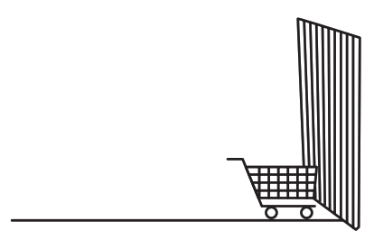

Part B
How does the mass of a moving cart affect the force needed to change its speed and direction of motion when the cart hits the wall?
Use the following terms in your response:
- Mass | - Cart
- Force | - Wall
- Impact | - Motion
______________________________________________________________________________
______________________________________________________________________________
______________________________________________________________________________
______________________________________________________________________________

Prompt 2
The store owner asks the construction engineer to propose two potential design solutions to prevent further damage to the store’s walls. The design solutions should meet three requirements:
- Budget cannot exceed $4,000
- Job must be completed in four to six weeks
- Solution should reduce the amount of damage to the walls
The construction engineer researches shopping cart information and design options for protecting the walls. Both design options will hold all of the store’s 50 carts. Table 1 compares both design options.

Table 1. Wall Protection Options
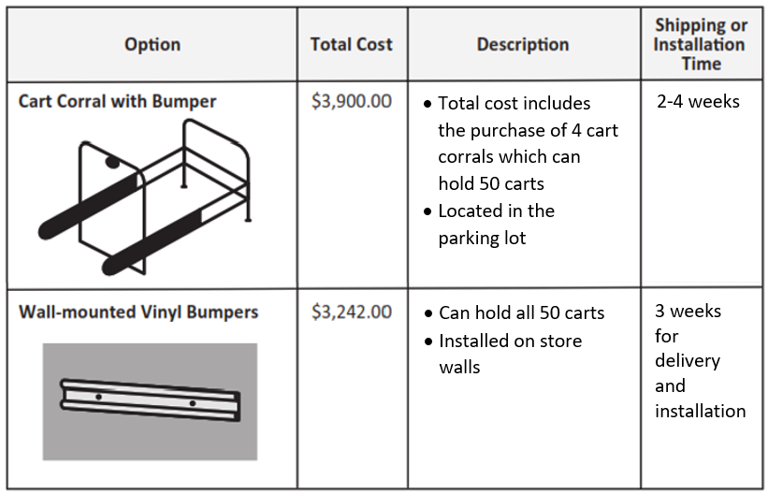
Part A.
Evaluate how well Potential Design Solution #1 meets each of the three requirements. If any requirements are not met, explain why they are not met. Use the information in Table 1 as evidence to support your evaluation.
Potential Design Solution #1:
Purchase the cart corrals with bumpers.
protection options.

______________________________________________________________________________
______________________________________________________________________________
______________________________________________________________________________
______________________________________________________________________________
______________________________________________________________________________
_____________________________________________________________________________.
Part B.
Evaluate how well Potential Design Solution #2 meets each of the three requirements. If any requirements are not met, explain why they are not met. Use the information in Table 1 as evidence to support your evaluation.
Potential Design Solution #2:
Purchase and install wall-mounted, vinyl bumpers.

______________________________________________________________________________
______________________________________________________________________________
______________________________________________________________________________
______________________________________________________________________________
______________________________________________________________________________
_____________________________________________________________________________.
Part C.
The store owner selects Design Solution #2. After the vinyl bumpers are installed, the store owner tests the solution by pushing an empty cart toward the wall. When the cart hits the bumper, it slowly bounces back.
Describe the force that causes the cart to bounce back.
______________________________________________________________________________
______________________________________________________________________________
______________________________________________________________________________

Part D.
Explain how the vinyl bumpers protect the wall from the force of the moving cart. Use Newton’s laws of motion to describe the interacting forces.
Select from the following terms to include in your response:
- Direction | - Wall
- Force | - Bumper
- Opposite | - Cart
- Equal | - Collision
______________________________________________________________________________
______________________________________________________________________________
______________________________________________________________________________
______________________________________________________________________________
______________________________________________________________________________
_____________________________________________________________________________.

Metal & Plastic Shopping Carts. (2020). Carts4u. Retrieved August 19, 2022, from https://carts4u.com/shopping-carts
W.W. Grainger, Inc. (2022). Single Wide Cart Corral. Grainger. Retrieved August 19, 2022, from https://www.grainger.com/product/GRAINGER-APPROVED-Single-Wide-Cart-Corral-Single-4YFD7
Bumper for Carts, Walls, and Equipment. (2022). Wallguard.Com. Retrieved August 19, 2022, from https://wallguard.com/cart-wall-and-equipment-protection/2256-bumper-for-carts-walls-and-equipment.html#
SIPS Grade 8 Unit 1 EOU Assessment Task 2: Barriers on the Highway

Student Worksheet
This task is about kinetic energy and collisions.

Task
On interstate highways in construction zones, solid concrete barriers often separate the travel lane from roadside equipment.
Diagram 1. Construction Zone
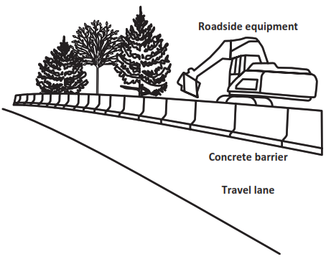

Prompt 1
Part A.
The highway department asks you to design a barrier that will decrease the amount of damage to a vehicle in a collision. Different barrier types are able to absorb different amounts of kinetic energy during an accident with a moving vehicle.
To explain your design to the highway department, you need to describe the relationships between kinetic energy, mass, and velocity of different vehicles.

Choose from the following phrases to correctly complete each sentence.
greater than equal to less than

The kinetic energy of a heavier vehicle will be _____________________ the kinetic energy of a smaller or lighter vehicle traveling at the same velocity.
The kinetic energy of a faster vehicle will be ______________________ the kinetic energy of the same vehicle traveling at a slower velocity.
Part B.
Explain why it is important to calculate the kinetic energy of collisions involving vehicles with different masses traveling at different velocities before designing a barrier for the highway department.
______________________________________________________________________________
______________________________________________________________________________
______________________________________________________________________________

Prompt 2
Table 1 shows the kinetic energy [KE (kj)] of three vehicles with different masses traveling at different velocities. Each vehicle travels at velocities of 11.2, 24.6, and 31.3 meters per second (m/s).
Table 1. Kinetic Energy of Three Vehicles
Vehicle | Mass (kg) | Velocity (m/s) | KE (kj)
Vehicle 1 | 3783 | 11.2 | 237.3
 |  | 24.6 | 1146.6
 |  | 31.3 | 1853.1
Vehicle 2 | 1620 | 11.2 | 101.6
 |  | 24.6 | 490.2
 |  | 31.3 | 793.6
Vehicle 3 | 703 | 11.2 | 44.1
 |  | 24.6 | 212.7
 |  | 31.3 | 344.4

Part A.
Use a line graph to complete Graph 1 below.
- Use Table 1 to plot the kinetic energy of each of the three vehicles traveling at 31.3 m/s.
- Draw a line, starting at zero (0), to show the relationship between mass and kinetic energy.
Graph 1. Kinetic Energy of Three Vehicles Traveling at 31.3 m/s
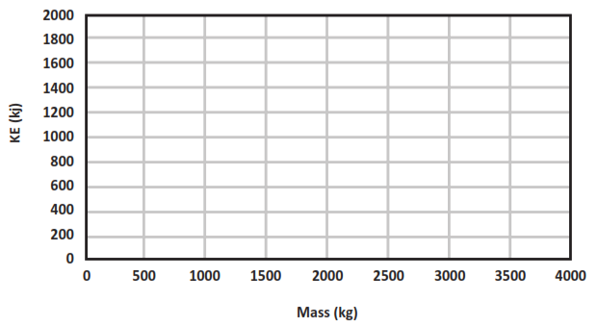

Part B.
Which statement describes the relationship between changes in mass and the kinetic energy of the three vehicles shown by your graph? Circle one.
Statement 1:  Increasing a vehicle's mass results in a directly proportional increase of the vehicle's kinetic energy. | Statement 2:  Increasing a vehicle's mass results in an increase of the vehicle's kinetic energy proportional to the square of its mass.
Part C.
Describe the mathematical relationship between mass and kinetic energy to support your answer in Part B. Use data in Graph 1 and/or Table 1 to support your response.
______________________________________________________________________________
______________________________________________________________________________
______________________________________________________________________________

Prompt 3
Part A.
Graph 2 shows the kinetic energy of Vehicle 1 traveling at 11.2, 24.6, and 31.3 m/s.
In Graph 2, use data from Table 1 to plot the KE for Vehicle 3 traveling at 11.2 m/s, 24.6 m/s, and 31.3 m/s. Use a different shape, like a star or square, to represent Vehicle 3. (Vehicle 1 is represented by circles on the graph.)
Graph 2. Kinetic Energy (KE) versus Velocity of Vehicle 1
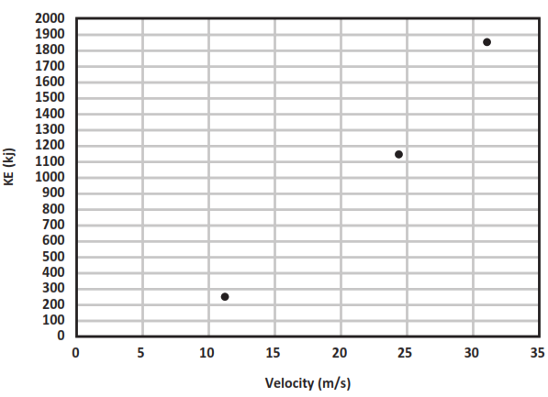
Part B.
Which statement describes the relationship between changes in velocity and the kinetic energy of the two vehicles shown in Graph 2? Circle one.
Statement 1:  Increasing a vehicle's velocity results in a directly proportional increase of the vehicle's kinetic energy. | Statement 2:  Increasing a vehicle's velocity results in an increase of the vehicle's kinetic energy proportional to the square of its velocity.

Part C.
Use the patterns of the data shown by Graphs 1 and 2 to explain which variable—mass OR velocity—has a greater effect on kinetic energy. Explain why you selected that variable.
______________________________________________________________________________
______________________________________________________________________________
______________________________________________________________________________
______________________________________________________________________________
Prompt 4
Table 2 provides a description of two highway barriers and the impact on a moving vehicle during a collision.
Table 2. Highway Barriers
Type of Barrier | Description of Barrier | Description of Impact
Jersey Barrier  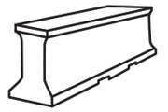 | - Concrete reinforced with steel | - Vehicle is not slowed before stopping
Guard Rail  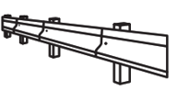 | - Metal rail supported on wooden posts | - Vehicle is slowed before stopping
The highway department has two requirements for the design solution:
- The barrier should minimize the amount of damage to the vehicle.
- The barrier should minimize the amount of force experienced by the passengers when the vehicle comes to a stop.
Part A.
The barrier type that would result in stopping a moving vehicle and result in the least damage to the vehicle is the ____________________________________________________.

Part B.
Explain why this barrier type will be better at reducing damage and injury than the other barrier type. Reference the information in Table 2, the relationships among kinetic energy, mass, and velocity, and Newton’s third law of motion to support your response.
This barrier type will be better at reducing damage and injury because ____________________
______________________________________________________________________________
______________________________________________________________________________
______________________________________________________________________________
______________________________________________________________________________
______________________________________________________________________________
______________________________________________________________________________
______________________________________________________________________________
______________________________________________________________________________
_____________________________________________________________________________.

SIPS Grade 8 Unit 1 EOU Assessment Task 3: Roller Coaster Thrills

Student Worksheet
This task is about energy and motion.

Task
Some people enjoy going to amusement parks to ride roller coasters. They love the height, speed, and thrill of riding a roller coaster. They ride in a group of connected, open cars on a track. The group of cars is not powered by an engine. How is it possible for a roller coaster to travel fast without an engine?
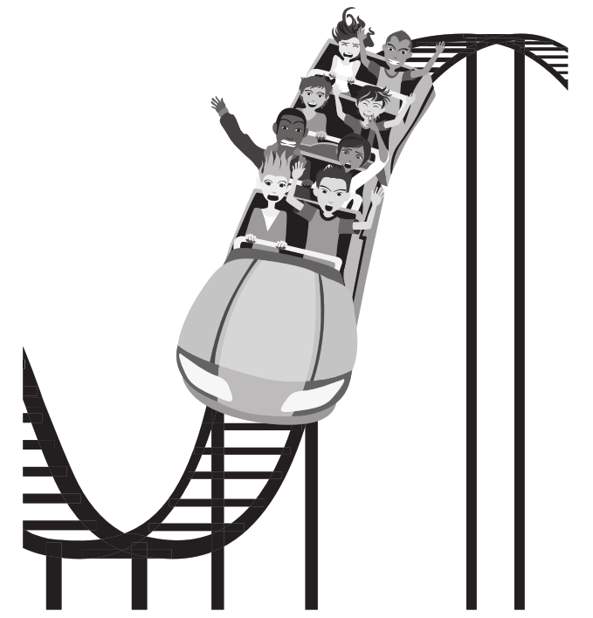

Prompt 1

Part A.
Diagram 1 shows two roller coaster systems labeled System 1 and System 2. Each system includes three components: the track, the ground, and the roller coaster.
- The System 1 roller coaster and the System 2 roller coaster begin the drop from the same height.
- The System 2 roller coaster has twice the mass of the System 1 roller coaster.
Diagram 1. System 1 and System 2
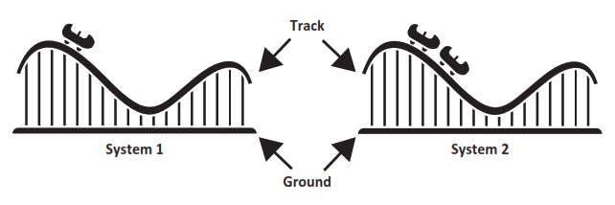

Which sentence compares the gravitational potential energy in the two systems? (Circle one.)
- System 1 has more gravitational potential energy.
- System 2 has more gravitational potential energy.
- Systems 1 and 2 have equal amounts of gravitational potential energy.

Part B.
Explain how to increase the potential energy of the roller coaster in either system. Use the gravitational relationship between the roller coaster and the ground to support your answer.
_____________________________________________________________________________________
_____________________________________________________________________________________
_____________________________________________________________________________________
_____________________________________________________________________________________
_____________________________________________________________________________________

Part C.

In Diagram 1, when the System 1 and System 2 roller coasters begin the drop, gravitational potential energy is transformed into kinetic energy.
- Which phrase below accurately compares the kinetic energy of the roller coaster in motion in System 2 to the roller coaster in motion in System 1? (Circle one.)
THE SAME TWICE AS MUCH FOUR TIMES AS MUCH
- Describe the relationship of an object’s kinetic energy to its mass.

__________________________________________________________________________

__________________________________________________________________________

__________________________________________________________________________

Prompt 2
Some people think only massive objects have gravity. They also think that there is no gravitational force of attraction between objects such as a pencil and a car because they do not observe a pencil being attracted toward a car.
Explain why the gravitational force of attraction between a pencil and a car is not observable. In your explanation, include information about the mass of objects and gravitational force.
______________________________________________________________________________
______________________________________________________________________________
______________________________________________________________________________
______________________________________________________________________________
______________________________________________________________________________

Prompt 3
The faster an object moves, the more kinetic energy it possesses. Diagram 2 shows an inclined plane that can be used to model the motion of a falling object. When a ball is released, it begins rolling down the inclined plane. When the ball is released from different heights, the amount of kinetic energy possessed by the moving ball can be calculated.
Diagram 2. Inclined Plane
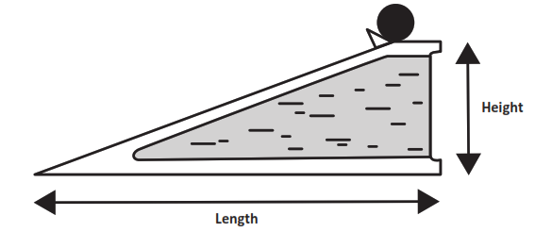
Table 1 shows the calculations of the velocity and kinetic energy of a 5 kg ball rolling down an inclined plane positioned at different heights.
Table 1. Rolling on an Inclined Plane
Height  (meters) | Length  (meters) | Velocity (meters/sec) | Time to Reach Bottom of Inclined Plane (minutes) | Kinetic Energy (Joules)
10 | 2,000 | 10.44 | 6.39 | 272.48
50 | 2,000 | 23.35 | 2.86 | 1,363.06
100 | 2,000 | 33.02 | 2.02 | 2,725.80
500 | 2,000 | 73.82 | 0.90 | 13,623.48

Use the data in Table 1 to describe the proportional relationship of kinetic energy to the velocity of the ball by comparing the results when the ball is released from different heights.
Use the following terms in your response:
- height of the ramp  - gravity  - potential energy | - kinetic energy  - velocity of the ball

______________________________________________________________________________
______________________________________________________________________________
______________________________________________________________________________
______________________________________________________________________________
_____________________________________________________________________________
______________________________________________________________________________
______________________________________________________________________________
______________________________________________________________________________
______________________________________________________________________________

Prompt 4
Table 2 compares two roller coasters. For each roller coaster, it includes the height, velocity, length of the tallest drop, time to reach the bottom, and number of riders.
Table 2. Roller Coaster Comparison
Name | Height (feet) | Velocity (miles/hr) | Length of Drop  (feet) | Time to Reach Bottom of Drop (seconds) | Riders per Roller Coaster
Kingda Ka | 456 | 128 | 418 | 2.2 | 18
Millennium Force | 310 | 93 | 300 | 2.2 | 36
Part A.
Write a claim about which roller coaster, Kingda Ka OR Millennium Force, has the greater kinetic energy as it reaches the bottom of the tallest drop on the track. (Assume the mass of each empty roller coaster is the same.)
______________________________________________________________________________
______________________________________________________________________________
______________________________________________________________________________
Part B.
Support your claim using:
- The relationship of kinetic energy to the mass of an object
- The relationship of kinetic energy to the speed of an object
- Data in Table 1 and Table 2
______________________________________________________________________________
______________________________________________________________________________

______________________________________________________________________________

______________________________________________________________________________
______________________________________________________________________________

