Stackable Instructionally-embedded Portable Science (SIPS) Assessments Project

SIPS Grade 8 Unit 4 End-of-Unit Assessment Scoring Guide

August 2023

The SIPS Grade 8 Unit 4 End-of-Unit Assessment Scoring Guide was developed with funding from the U.S. Department of Education under the Competitive Grants for State Assessments Program, CFDA 84.368A. The contents of this paper do not represent the policy of the U.S. Department of Education, and no assumption of endorsement by the Federal government should be made.

All rights reserved. Any or all portions of this document may be reproduced and distributed without
prior permission, provided the source is cited as: Stackable Instructionally-embedded Portable Science
(SIPS) Assessments Project. (2023). SIPS Grade 8 Unit 4 End-of-Unit Assessment Scoring Guide. Lincoln,
NE: Nebraska Department of Education.
Table of Contents
SIPS Grade 8 Unit 4 EOU Assessment Task 1: Now You See It .................................................................. 1
Task 1 Scoring Rubric ............................................................................................................................. 7
Task 1 Student Exemplars ...................................................................................................................... 9
SIPS Grade 8 Unit 4 EOU Assessment Task 2: Color My World .............................................................. 13
Task 2 Scoring Rubric ........................................................................................................................... 17
Task 2 Student Exemplars .................................................................................................................... 20
SIPS Grade 8 Unit 4 EOU Assessment Task 3: Sounds of Silence ………................................................... 23
Task 3 Scoring Rubric ........................................................................................................................... 29
Task 3 Student Exemplars .................................................................................................................... 32

SIPS Grade 8 Unit 4 EOU Assessment Task 1: Now You See It

Student Worksheet

This task is about the repeating patterns of simple waves with specific wavelengths, frequencies, and amplitudes.

Task
About 541 million years ago, the appearance of primitive eyes, called eyespots, allowed organisms to move in response to light. Organisms living today depend on their sense of sight for survival. Most people rely on their sense of sight more than their other senses. However, that doesn’t mean humans can see everything. In fact, some animals are able to see things that we cannot!

Prompt 1
Just like human eyes, animals’ eyes work by detecting light. To survive in the arctic tundra, polar bears hunt for their food in intense sunlight. Polar bears have a protective covering over their eyeballs that protects their eyes from the bright sunlight that reflects off the snow.
A light sensor, like an eye, can detect the intensity or brightness of light. A light sensor displays a number that shows how much light is detected by the sensor.
Figure 1 shows a model of an investigation in which a light source was directed toward a mirror at a 30° angle. A light sensor recorded the brightness of the reflected light at 15°, 30°, and 45° angles.
Figure 1. Light Source and Light Sensor
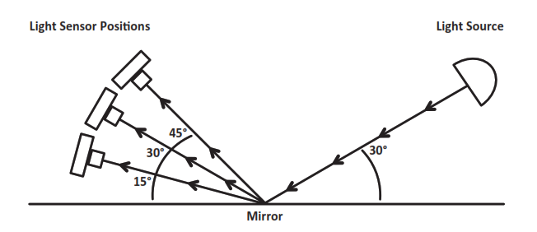

Explain which position of the light sensor in Figure 1 recorded the highest brightness, and how it relates to the law of reflection using your knowledge of light and energy.
______________________________________________________________________________

______________________________________________________________________________

______________________________________________________________________________

______________________________________________________________________________

______________________________________________________________________________

______________________________________________________________________________

______________________________________________________________________________

Prompt 2
Part A.
The energy of a light wave or its brightness depends on its amplitude. Table 1 shows the relationship between energy and amplitude. The energy transported by a wave is directly proportional to the square of the amplitude of the wave.
Table 1. Energy-Amplitude Relationship
Amplitude Units | 1 | 2 | 3 | 4
Energy Units | 2 | 8 | 18 | 32

Use the data in Table 1 to graph the change in the energy-amplitude relationship. The x-axis represents amplitude, and the y-axis represents energy. Your graph must include:
- A label for the variable represented by the x-axis
- A label for the variable represented by the y-axis
- A scale for each axis
- Data points connected with a line

Graph 1. Energy-Amplitude Relationship
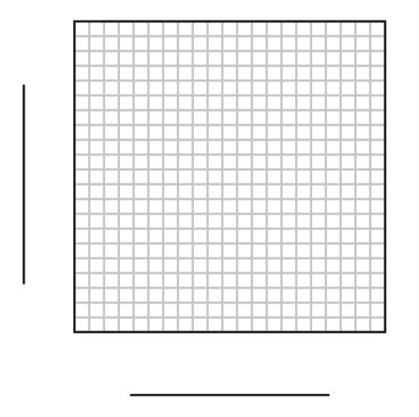
Part B.
Complete the sentences describing the relationship between the energy and amplitude of a wave. Use the Word Bank and Graph 1 to support your response.
Word Bank
halved | doubled | quadrupled | the same

The amount of energy transported by a wave is _______________________ in strength
when the amplitude is doubled. I know this because _______________________________
__________________________________________________________________________

__________________________________________________________________________

__________________________________________________________________________

__________________________________________________________________________

__________________________________________________________________________

__________________________________________________________________________

Prompt 3
The light humans can see is called visible light. This light, also known as white light, consists of a collection of colors. Humans see different wavelengths of visible light in different colors such as red, orange, yellow, green, blue, and violet.

Part A.
Table 2 shows examples of electromagnetic waves of various wavelengths.
Table 2. Examples of Electromagnetic Waves
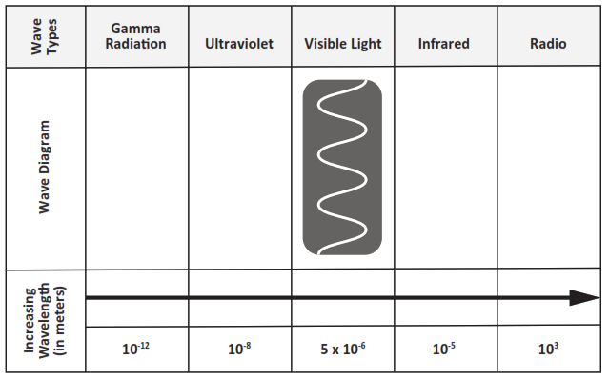
In Table 2, correctly place the letters from Table 3 to represent the wave diagrams for the following types of waves: Gamma Radiation, Ultraviolet, Infrared, and Radio.
Table 3. Wave Diagrams
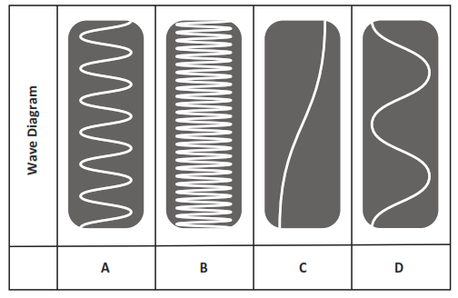
Part B.
A group of snakes, called pit vipers, can detect infrared light as thermal energy. Thus, pit vipers can easily see rodents and birds, even when their prey is hiding in grass or bushes.
A student makes the following claim:
Because pit vipers can detect infrared wavelengths, they must also be able to see light waves with higher frequencies than humans are able to see.

Circle if you agree or disagree with the claim. Include evidence from Table 2 and your scientific knowledge to support your response.
Evidence
Agree
Disagree

SIPS Grade 8 Unit 4 EOU Assessment Task 1 Rubric (MS-PS4-1 and MS-PS4-2)
Prompt | Score Point 0 | Score Point 1 | Score Point 2 | Score Point 3 | Score Point 4
Prompt 1 | No aspect of the response is correct | Response includes one (1) of the two (2) aspects | Response includes the following aspects:  - Highest reading at 30°  - Explanation of how the law of reflection supports the answer | NA | NA
Prompt 2 | No aspect of the response is correct | Response includes one (1) of the four (4) aspects | Response includes two (2) of the four (4) aspects | Response includes three (3) of the four (4) aspects | Response includes the following aspects:  Part A  - Correct labels for the x-axis (energy) and y-axis (amplitude)  - Accurate scale for the x- and y-axis with correct data points plotted and connected by a line  Part B  - Energy quadrupled in strength  - Explanation of the proportional relationship (energy is proportional to the square of the amplitude) using data
Prompt 3 | No aspect of the response is correct | Response includes one (1) of the four (4) aspects | Response includes the following aspects:  Part A  - Matches two (2) of the four (4) correct wavelengths to the types of electromagnetic waves  Part B  - Selects ‘disagree’ | Response includes three (3) of the four (4) aspects | Response includes the following aspects:  Part A  - Matches four (4) of the correct wavelengths to the types of electromagnetic waves  Part B  - Selects ‘disagree’  - Uses information from Table 2 to support response  - Relates frequency and wavelength

Student Exemplar(s)
Student exemplars represent high-quality responses that align to full-point rubric scores. The exemplar responses are intended to assist educators’ understanding of the nature and expectations of each prompt. Note the exemplars serve as examples of high-quality responses, and students may respond with equally relevant, scientifically accurate responses and ideas that meet the expectations of a full-point rubric score.

Prompt 1
Explain which position of the light sensor in Figure 1 recorded the highest brightness, and how it relates to the law of reflection using your knowledge of light and energy.
The law of reflection is that the angle of incidence equals the angle of reflection. If an incoming light beam makes a 30° angle with a mirror, the light beam leaving the mirror will also make a 30° angle. So, the highest reading on the light sensor will occur when the light enters it at the same angle as the light hits the mirror.

Prompt 2
Part A.
Use the data in Table 1 to graph the change in the energy-amplitude relationship. The x-axis represents amplitude, and the y-axis represents energy. Your graph must include:
- A label for the variable represented by the x-axis
- A label for the variable represented by the y-axis
- A scale for each axis
- Data points connected with a line

Graph 1. Energy-Amplitude Relationship

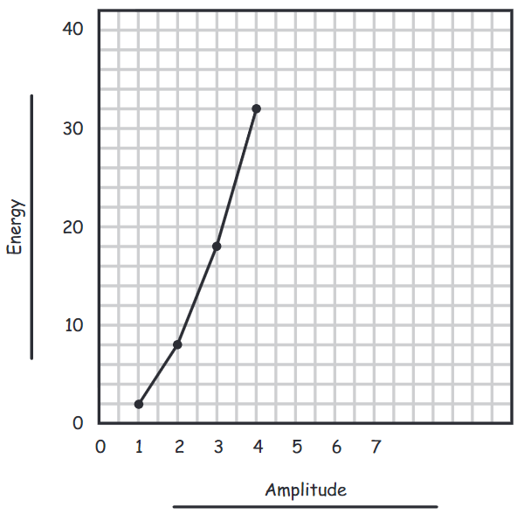

Part B.
Complete the sentences describing the relationship between the energy and amplitude of a wave. Use the Word Bank and Graph 1 to support your response.
Word Bank
halved | doubled | quadrupled | the same

The amount of energy transported by a wave is quadrupled in strength when the amplitude is doubled. I know this because the energy transported by a wave is directly proportional to the square of the amplitude of the wave. The graph shows that changing the amplitude from 2 units to 4 units represents a 2-fold increase in the amplitude and is accompanied by a 4-fold increase in the energy from 8 to 32 units. This means that a doubling of the amplitude results in a quadrupling of the energy.

Prompt 3
Part A.
Table 2. Examples of Electromagnetic Waves
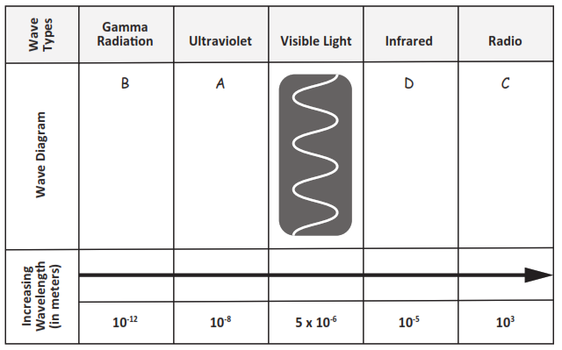

In Table 2, correctly place the letters from Table 3 to represent the wave diagrams for the following types of waves: Gamma Radiation, Ultraviolet, Infrared, and Radio.
Table 3. Wave Diagrams
Part B.
Circle if you agree or disagree with the claim. Include evidence from Table 2 and your scientific knowledge to support your response.
 | Evidence
Agree | Infrared waves are longer waves than visible light as shown in Table 2. The frequency and wavelength of a wave are indirectly proportional to each other. The longer the wavelength, the lower the frequency. That means pit vipers can see light at a lower frequency than humans. This does not support the claim that pit vipers see light at a higher frequency, like those of Gamma Radiation or Ultraviolet.
Disagree

SIPS Grade 8 Unit 4 EOU Assessment Task 2: Color My World

Student Worksheet

This task is about wave characteristics of light.

Task
On a rainy day, nature can put on one of its greatest displays—a rainbow—that appears as a multi-colored arc across the sky! A rainbow is composed of all the colors of visible light: red, orange, yellow, green, blue, indigo, and violet.
What is the connection between rain, light, and the colors of visible light in a rainbow?

Prompt 1
Part A.
Rainwater is transparent which allows light to be transmitted through it. However, whenever light travels from one medium to another, like from air to water during a rainstorm, the speed of light changes.
When light passes from air to water, does it change wavelength, frequency, or both? Explain your answer.
______________________________________________________________________________
______________________________________________________________________________
______________________________________________________________________________
______________________________________________________________________________
Part B.
The change in the speed of light can also cause light to change direction. This is called refraction. Consider the example in Figure 1 of a spear fisher looking over a lake. From where he is standing on land, the water is clear enough to see a fish in the water. The fish in the picture represents the location of the fish as it appears to the spear fisher.

Figure 1. Spear Fisher and Fish in Lake
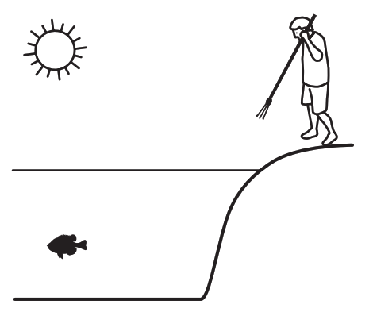
Complete the model to show the actual relationship between the spear fisher and the fish in Figure 1. Be sure to:
- Draw and label the actual location of the fish
- Use arrows to show the direction of the path of light from the light source (sun) to the actual location of the fish AND the path of light from the actual location of the fish to the spear fisher’s eyes
Part C.
Why does the fish appear to be at a different position in the water compared to where it actually is in the water?
______________________________________________________________________________
______________________________________________________________________________
______________________________________________________________________________
______________________________________________________________________________
______________________________________________________________________________

Prompt 2
Part A.
Refraction is the principle that underlies the behavior of prisms. When light is transmitted through a prism, the effect is a rainbow of colors. This is called the visible light spectrum, or white light. The human eye perceives wavelengths ranging roughly from 400 nanometers (violet) to 700 nanometers (red).
The wavelengths of visible light are:
- Violet: 380–450 nm
- Blue: 450–495 nm
- Green: 495–570 nm
- Yellow: 570–590 nm
- Orange: 590–620 nm
- Red: 620–750 nm
Whenever light passes into one side of a triangular prism, it causes violet light to travel slower through the prism than red light. Upon exiting from the other side of the triangular prism, the separation becomes even greater, and a rainbow of colors is observed.
How are the speed of the light as it travels through the prism AND the different wavelengths of the colors of visible light related to the angle of refraction for red and violet?
______________________________________________________________________________
______________________________________________________________________________
______________________________________________________________________________
______________________________________________________________________________
______________________________________________________________________________
______________________________________________________________________________
______________________________________________________________________________
______________________________________________________________________________
______________________________________________________________________________
______________________________________________________________________________
Part B.
One of nature's most amazing sights is the rainbow. A rainbow is one more piece of evidence that visible light is composed of a spectrum of wavelengths.
Why does the color pattern always appear as red, orange, green, blue, and violet from the top to bottom of a rainbow?
_____________________________________________________________________________
_____________________________________________________________________________
_____________________________________________________________________________
_____________________________________________________________________________
_____________________________________________________________________________
_____________________________________________________________________________
_____________________________________________________________________________
_____________________________________________________________________________
_____________________________________________________________________________
_____________________________________________________________________________
_____________________________________________________________________________
_____________________________________________________________________________

SIPS Grade 8 Unit 4 EOU Assessment Task 2 Rubric (MS-PS4-1 and MS-PS4-2)
Prompt | Score Point 0 | Score Point 1 | Score Point 2 | Score Point 3
Prompt 1 Part A. | No aspect of the response is correct | Response includes one (1) of the two (2) aspects | Response includes the following aspects:  - Includes the relationship between wavelength and speed of light  - Describes that frequency of light does not change when passing through different mediums | NA
Prompt 1 Part B. | No aspect of the response is correct | Response includes one (1) of the three (3) aspects | Response includes two (2) of the three (3) aspects | Response includes the following aspects:  - Draws and labels the actual location of the fish  - Includes directional arrows to show the path of light from the sun to the actual fish location  - Includes directional arrows to show the path of light from the actual fish location to the spear fisher’s eyes
Prompt 1 Part C. | No aspect of the response is correct | Response includes one (1) of the two (2) aspects | Response includes the following aspects:  - Use of the model to explain what the spear fisher sees  - Supports explanation with the relationship between the density of the medium and its effect on the speed light travels | NA
Prompt 2 Part A. | No aspect of the response is correct | Response includes one (1) of the three (3) aspects | Response includes two (2) of the three (3) aspects | Response includes the following aspects:  - Different colors of light correspond to different wavelengths  - Applies wavelength to the bend or refraction of those light waves  - Includes the relationship between wavelength and speed of light
Prompt 2 Part B. | No aspect of the response is correct | Response includes one (1) of the three (3) aspects | Response includes two (2) of the three (3) aspects | Response includes the following aspects:  - Identifies that the speed of light decreases when passing from air to water (i.e., raindrop)  - Describes the relationship between speed and wavelength of light  - Applies that relationship to the angle of refraction to support the explanation of the ROYGBV sequence of the colors of a rainbow

Student Exemplar(s)
Student exemplars represent high-quality responses that align to full-point rubric scores. The exemplar responses are intended to assist educators’ understanding of the nature and expectations of each prompt. Note the exemplars serve as examples of high-quality responses, and students may respond with equally relevant, scientifically accurate responses and ideas that meet the expectations of a full-point rubric score.

Prompt 1
Part A.
When light passes from air to water, does it change wavelength, frequency, or both? Explain your answer.
When the light wave moves from air to a denser medium like water, its speed decreases. So, the wavelength of the wave also decreases. The frequency of the light wave remains constant in any medium.
Part B.
Complete the model showing the relationship between the spear fisher and the fish in Figure 1. Be sure to:
- Draw and label the actual location of the fish
- Use arrows to show the direction of the path of light from the light source (sun) to the actual location of the fish AND the path of light from the actual location of the fish to the spear fisher’s eyes
Figure 1. Spear Fisher and Fish in Lake
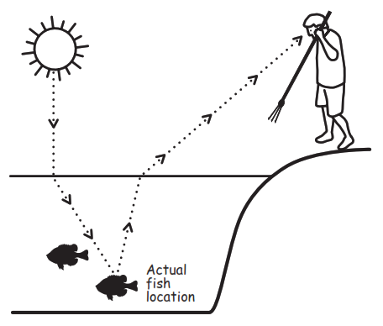

Part C.
Why does the fish appear to be at a different position in the water compared to where it actually is in the water?
In the model, the spear fisher sees a fish that appears to be directly in his line of vision. But the light coming from the fish refracts when it hits the surface. A change in density changes the angle of bend when light travels from one medium to another. This is refraction, which is the reason why the fish appears to be nearer the surface of the water than it actually is.
OR
In the model, the spear fisher sees a fish as if the light travels from the fish to his eyes in a straight line. But, the speed of light changes when it passes from one medium to another. This change in speed can cause light to change direction. This phenomenon is known as refraction. That is the reason why an object immersed in water appears to be closer to the surface than it actually is.

Prompt 2
Part A.
How are the speed of the light as it travels through the prism AND the different wavelengths of the colors of visible light related to the angle of refraction for red and violet?
Colors of the visible light spectrum that have shorter wavelengths (BIV) will deviate more from their original path than the colors with longer wavelengths (ROY). The violet light bends a bit more than the red light. I know this because the violet light has traveled further downward when passing through the prism. So, the speed of violet light is slowed down to a greater extent by the absorption and re-emission process than red light. That is why violet light refracts more than red light.
Part B.
Why does the color pattern always appear as red, orange, green, blue, and violet from the top to bottom of a rainbow?
When white light from the sun passes through the raindrops the speed of light slows down related to colors’ characteristic wavelength, with red moving fastest and violet moving slowest. The shorter wavelengths of blue and violet light refract a slightly greater amount than the longer wavelength of red light. So, the colors in a rainbow are always in order of their wavelength, from longest to shortest: red, orange, yellow, green, blue, and violet. That is why the pattern always appears as red, orange, green, blue, and violet from top to bottom.

SIPS Grade 8 Unit 4 EOU Assessment Task 3: Sounds of Silence

Student Worksheet

This task is about sound waves.

Task
You are part of a team designing a recording studio for a local band. The design solution must demonstrate an understanding of the properties of sound waves. It must also consider materials, costs, and testing of the proposed solution.

Prompt 1
A guitarist controls the loudness of a single note on a guitar by changing the force used to pluck a string, causing it to vibrate.
Graph 1 shows a position versus time graph for a vibrating guitar string. The position of the sound wave is shown by the displacement distance from the resting position of the vibrating string.
Graph 1. Position vs. Time for a Vibrating Guitar String
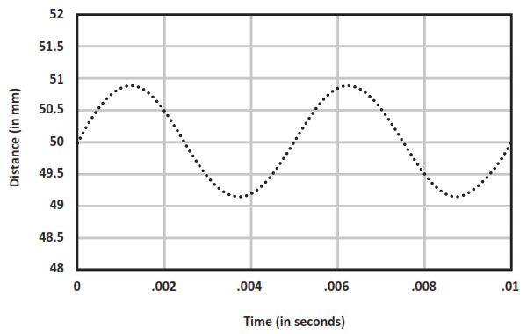
Draw another sound wave on Graph 1 to show the same note plucked with less force.

Prompt 2
Part A.
You need to figure out how loud the guitar sounds from different locations in the recording studio. You collect measurements from different locations in the recording studio to know where to place a microphone when you are ready to record.
Graph 2 shows the data from your collected measurements.
Graph 2. Amount of Energy Transmitted vs. Amplitude
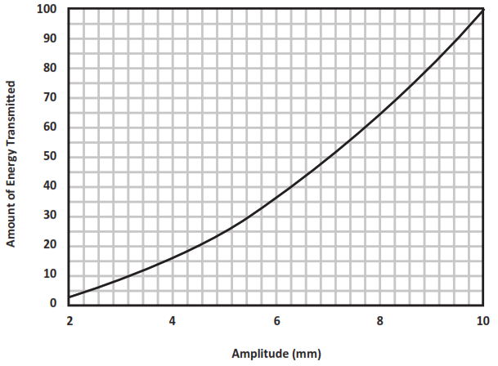
Table 1 shows some of the collected data.

Fill in the missing data points for Locations B, D, and E in Table 1 using data from Graph 2.
Table 1. Amount of Energy Transmitted vs. the Amplitude
Location | Amplitude of Sound Wave (in mm) | Amount of Energy Transmitted (in energy units)
A | 2 | 4
B | 4 | ______
C | 5 | 25
D | ______ | 64
E | 9 | _______
F | 10 | 100
Part B.
Describe the relationship between the amount of energy and the amplitude of the sound produced by plucking the guitar string using information from Graph 2 and Table 1.
______________________________________________________________________________
______________________________________________________________________________
______________________________________________________________________________
______________________________________________________________________________
______________________________________________________________________________
______________________________________________________________________________
______________________________________________________________________________
______________________________________________________________________________
Part C.

A guitarist knows that the different strings on the guitar make different notes when they are plucked. The guitarist wonders how the movement of the string that produces a high-pitch note compares to the movement of the string that produces a low-pitch note.

Compare and explain the pattern of motion of two different strings after each is plucked with the same force. In your response, include a written description, model, OR graph to show your understanding.

Prompt 3
Part A.
You visit the room where you are asked to design a recording studio. There is an open window, and you hear the noise of cars passing by on the street. After you close the window, you notice the noise of the passing cars is quieter, but you can still hear cars’ honking horns.
Explain why you can still hear outside noises even in a room that is surrounded by solid materials, such as walls and a closed window.
_____________________________________________________________________________
_____________________________________________________________________________
_____________________________________________________________________________
_____________________________________________________________________________
_____________________________________________________________________________
Part B.
Decibels (dB) measure the intensity or amplitude of sound. The decibel scale increases by ten as the sound gets louder. For example, a 60 dB sound, such as normal speech, is six powers 10 times (i.e., 1,000,000) more intense than a 1 dB sound, such as a faint whisper.
A recording studio should be very quiet, only as loud as 25 to 30 decibels, or as loud as a library. You can use a decibel meter to measure the noise in the room at different locations and times of day.
Table 2 provides a selection of noise reduction products, their costs, Noise Reduction Coefficients (NRC), and uses to consider for the design of the recording studio. The NRC rating is a scale from 0 to 1 that indicates the amount of noise a material can absorb with 1 being best.
Table 2. Noise Reduction Products
Product | Cost | Noise Reduction Coefficient (NRC) | Description
Product A | $2.50 per sq ft | 0.90 | - must be installed inside the walls  - will require a lot of time and effort
Product B | $26.00 per sq ft | 0.95 | - easy to install on walls or ceilings  - thick and heavy material
Product C | $11.00 per sq ft | 0.40 | - easy to install on walls or ceilings  - light material, easily tears
Product D | $8.00 per sq ft | 0.55 | - ceiling or wall covering  - strong material
Product E | $60.00 per pair | 0.85 | - acoustic curtains for windows  - curtains must remain closed if studio is in use

Based on the three aspects of each of the noise reduction products (cost, NRC, and description), explain why you should evaluate each aspect when evaluating products to provide a very quiet environment inside the recording studio. Use the information about the different types of noise reduction products in Table 2 to support your response.
- ___________________________________________________________________________
___________________________________________________________________________
___________________________________________________________________________

- ___________________________________________________________________________

___________________________________________________________________________

___________________________________________________________________________

- ___________________________________________________________________________

___________________________________________________________________________

___________________________________________________________________________
Part C.
You need to develop a testing plan to evaluate the effectiveness of your proposed recording studio design regarding the noise levels in the room.
Explain where you would measure the intensity of sound in the studio and what scale you would use to test your proposed design.
______________________________________________________________________________
______________________________________________________________________________
______________________________________________________________________________
______________________________________________________________________________
______________________________________________________________________________
______________________________________________________________________________

SIPS Grade 8 Unit 4 EOU Assessment Task 3 Rubric (MS-PS4-1, MS-PS4-2, MS-ETS1-1)
Prompt | Score Point 0 | Score Point 1 | Score Point 2 | Score Point 3
Prompt 1 | No aspect of the response is correct | Response includes one (1) of the two (2) aspects | Response includes the following aspects:  Part A  - New sound wave with a decreased amplitude  - New sound wave with the same wavelength | NA
Prompt 2  Part A. & Part B. | No aspect of the response is correct | Response includes one (1) of the two (2) aspects | Response includes the following aspects:  Part A  - Three correct data point approximations for three (3) locations (e.g., Location B, 16; Location D, 8; Location E, 81)  Part B  - Describes the relationship between amplitude and energy | NA
Prompt 2 Part C. | No aspect of the response is correct | Response includes one (1) of the two (2) aspects | Response includes a written description, model, OR graph that includes the following aspects:  - Relates pitch to the frequency of a low note  - Relates pitch to the frequency of a high note | NA
Prompt 3 Part A. | No aspect of the response is correct | Response includes one (1) of the two (2) aspects | Response includes the following aspects:  - Describes that sound can travel through solid materials  - Describes sound waves as needing a medium through which to travel | NA
Prompt 3 Part B. | No aspect of the response is correct | Response includes the following aspects:  - Explains the rationale for evaluating one (1) aspect of at least two (2) of the noise reduction products | Response includes the following aspects:  - Explains the rationale for evaluating two (2) aspects of at least three (3) noise reduction products  OR  - Explains the rationale for evaluating three (3) aspects of at least two (2) of the noise reduction products | Response includes the following aspects:  - Explains the rationale for evaluating three (3) aspects of at least three (3) of the noise reduction products
Prompt 3  Part C. | No aspect of the response is correct | Response includes one (1) of the three (3) aspects | Response includes two (2) of the three (3) aspects | Response includes the following aspects:  - Describes the need for multiple measurements/  locations in the room  - Describes the use of a decibel meter to measure sound levels  - Describes the scale or dB range of sound that is required

Student Exemplar(s)
Student exemplars represent high-quality responses that align to full-point rubric scores. The exemplar responses are intended to assist educators’ understanding of the nature and expectations of each prompt. Note the exemplars serve as examples of high-quality responses, and students may respond with equally relevant, scientifically accurate responses and ideas that meet the expectations of a full-point rubric score.

Prompt 1
Part A.
Draw another sound wave on Graph 1 to show the same note plucked with less force.
Graph 1. Position vs. Time for a Vibrating Guitar String
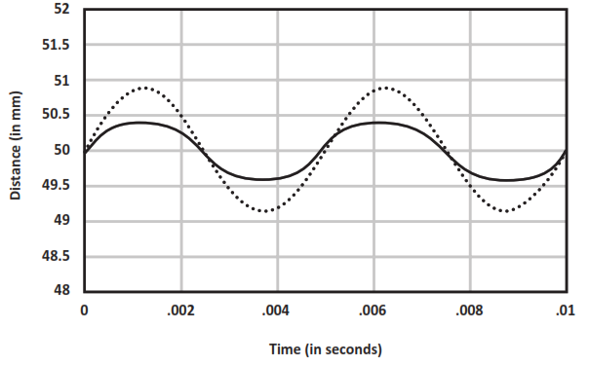

Prompt 2
Part A.
Fill in the missing data points for Locations B, D, and E in Table 1 using data from Graph 2.
Table 1. Amount of Energy Transmitted vs. the Amplitude
Location | Amplitude of Sound Wave (in mm) | Amount of Energy Transmitted (in energy units)
A | 2 | 4
B | 4 | 16
C | 5 | 25
D | 8 | 64
E | 9 | 81
F | 10 | 100
Part B.
Describe the relationship between the amount of energy and the amplitude of the sound produced by plucking the guitar string using information from Graph 2 and Table 1.
The amount of energy carried by a wave is related to the amplitude of the wave. A high-energy wave is characterized by a high amplitude; a low-energy wave is characterized by a low amplitude.
Part C.

Compare and explain the pattern of motion of two different strings after each is plucked with the same force. In your response, include a written description, model, OR graph to show your understanding.
When you pluck a string or anything that makes sound, it is going to vibrate. To make a low note you need to vibrate less than you would with a high-pitch note. So, a high-pitch string will vibrate more or have a higher frequency than a low-pitch string.

OR
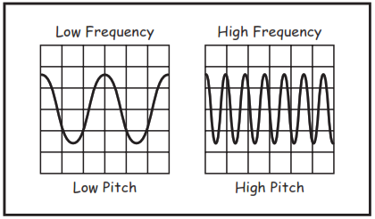

Prompt 3
Part A.
Explain why you can still hear outside noises even in a room that is surrounded by solid materials, such as walls and a closed window.
The sound coming from the road traffic goes through the solid materials. This is because sound energy can be transmitted through any type of matter. This is because sound needs a medium in order to be transmitted.
Part B.
Based on the three aspects of each of the noise reduction products (cost, NRC, and description), explain why you should evaluate each aspect when evaluating products to provide a very quiet environment inside the recording studio. Use the information about the different types of noise reduction products in Table 2 to support your response.
- The cost should be considered because I will probably have a limited budget and some products are much more expensive than others. Product B is very expensive compared to the others.
- The NRC rating is also important because I want to ensure that I maximize the amount of noise the different products can provide as some products have higher ratings. Products A, B, and E are the best.
- Descriptions of how easy the products are to work with, where to install, and how strong the materials are is important. Product A should go into walls but other products would require a lot less work and can be used right on the walls of the studio or on the windows like Product E.
Part C.
Explain where you would measure the intensity of sound in the studio and what scale you would use to test your proposed design.
It is important to use a decibel meter to record the noise levels in different parts of the room to be sure all the unwanted noise has been blocked appropriately. I would be sure to measure the sound levels by the window and use the decibel scale to check that it is between 25-30 dB.

