SIPS Grade 8 Unit 4 EOU Assessment Task 1: Now You See It

Student Worksheet

This task is about the repeating patterns of simple waves with specific wavelengths, frequencies, and amplitudes.

Task
About 541 million years ago, the appearance of primitive eyes, called eyespots, allowed organisms to move in response to light. Organisms living today depend on their sense of sight for survival. Most people rely on their sense of sight more than their other senses. However, that doesn’t mean humans can see everything. In fact, some animals are able to see things that we cannot!

Prompt 1
Just like human eyes, animals’ eyes work by detecting light. To survive in the arctic tundra, polar bears hunt for their food in intense sunlight. Polar bears have a protective covering over their eyeballs that protects their eyes from the bright sunlight that reflects off the snow.
A light sensor, like an eye, can detect the intensity or brightness of light. A light sensor displays a number that shows how much light is detected by the sensor.
Figure 1 shows a model of an investigation in which a light source was directed toward a mirror at a 30° angle. A light sensor recorded the brightness of the reflected light at 15°, 30°, and 45° angles.
Figure 1. Light Source and Light Sensor
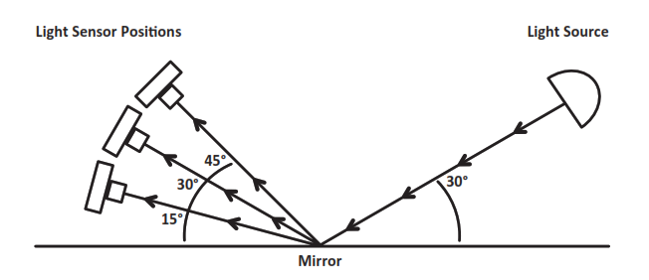

Explain which position of the light sensor in Figure 1 recorded the highest brightness, and how it relates to the law of reflection using your knowledge of light and energy.
______________________________________________________________________________

______________________________________________________________________________

______________________________________________________________________________

______________________________________________________________________________

______________________________________________________________________________

______________________________________________________________________________

______________________________________________________________________________

Prompt 2
Part A.
The energy of a light wave or its brightness depends on its amplitude. Table 1 shows the relationship between energy and amplitude. The energy transported by a wave is directly proportional to the square of the amplitude of the wave.
Table 1. Energy-Amplitude Relationship
Amplitude Units | 1 | 2 | 3 | 4
Energy Units | 2 | 8 | 18 | 32

Use the data in Table 1 to graph the change in the energy-amplitude relationship. The x-axis represents amplitude, and the y-axis represents energy. Your graph must include:
- A label for the variable represented by the x-axis
- A label for the variable represented by the y-axis
- A scale for each axis
- Data points connected with a line

Graph 1. Energy-Amplitude Relationship
Part B.
Complete the sentences describing the relationship between the energy and amplitude of a wave. Use the Word Bank and Graph 1 to support your response.
Word Bank
halved | doubled | quadrupled | the same

The amount of energy transported by a wave is _______________________ in strength
when the amplitude is doubled. I know this because _______________________________
__________________________________________________________________________

__________________________________________________________________________

__________________________________________________________________________

__________________________________________________________________________

__________________________________________________________________________

__________________________________________________________________________

Prompt 3
The light humans can see is called visible light. This light, also known as white light, consists of a collection of colors. Humans see different wavelengths of visible light in different colors such as red, orange, yellow, green, blue, and violet.

Part A.
Table 2 shows examples of electromagnetic waves of various wavelengths.
Table 2. Examples of Electromagnetic Waves
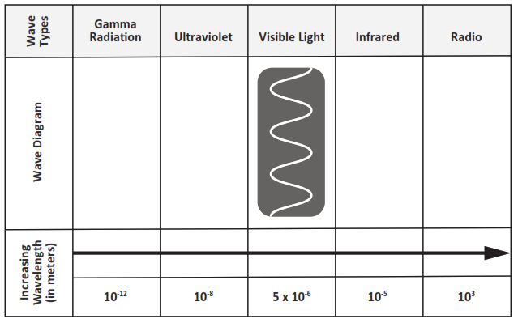
In Table 2, correctly place the letters from Table 3 to represent the wave diagrams for the following types of waves: Gamma Radiation, Ultraviolet, Infrared, and Radio.
Table 3. Wave Diagrams
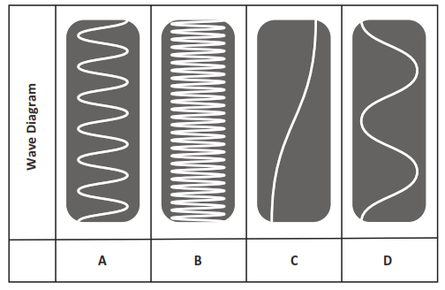
Part B.
A group of snakes, called pit vipers, can detect infrared light as thermal energy. Thus, pit vipers can easily see rodents and birds, even when their prey is hiding in grass or bushes.
A student makes the following claim:
Because pit vipers can detect infrared wavelengths, they must also be able to see light waves with higher frequencies than humans are able to see.

Circle if you agree or disagree with the claim. Include evidence from Table 2 and your scientific knowledge to support your response.
Evidence
Agree
Disagree

SIPS Grade 8 Unit 4 EOU Assessment Task 2: Color My World

Student Worksheet

This task is about wave characteristics of light.

Task
On a rainy day, nature can put on one of its greatest displays—a rainbow—that appears as a multi-colored arc across the sky! A rainbow is composed of all the colors of visible light: red, orange, yellow, green, blue, indigo, and violet.
What is the connection between rain, light, and the colors of visible light in a rainbow?

Prompt 1
Part A.
Rainwater is transparent which allows light to be transmitted through it. However, whenever light travels from one medium to another, like from air to water during a rainstorm, the speed of light changes.
When light passes from air to water, does it change wavelength, frequency, or both? Explain your answer.
______________________________________________________________________________
______________________________________________________________________________
______________________________________________________________________________
______________________________________________________________________________
Part B.
The change in the speed of light can also cause light to change direction. This is called refraction. Consider the example in Figure 1 of a spear fisher looking over a lake. From where he is standing on land, the water is clear enough to see a fish in the water. The fish in the picture represents the location of the fish as it appears to the spear fisher.

Figure 1. Spear Fisher and Fish in Lake
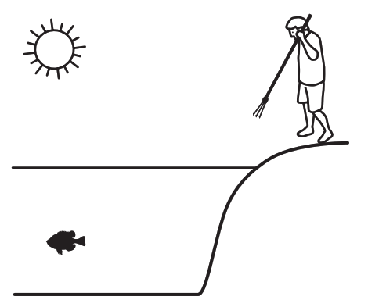
Complete the model to show the actual relationship between the spear fisher and the fish in Figure 1. Be sure to:
- Draw and label the actual location of the fish
- Use arrows to show the direction of the path of light from the light source (sun) to the actual location of the fish AND the path of light from the actual location of the fish to the spear fisher’s eyes
Part C.
Why does the fish appear to be at a different position in the water compared to where it actually is in the water?
______________________________________________________________________________
______________________________________________________________________________
______________________________________________________________________________
______________________________________________________________________________
______________________________________________________________________________

Prompt 2
Part A.
Refraction is the principle that underlies the behavior of prisms. When light is transmitted through a prism, the effect is a rainbow of colors. This is called the visible light spectrum, or white light. The human eye perceives wavelengths ranging roughly from 400 nanometers (violet) to 700 nanometers (red).
The wavelengths of visible light are:
- Violet: 380–450 nm
- Blue: 450–495 nm
- Green: 495–570 nm
- Yellow: 570–590 nm
- Orange: 590–620 nm
- Red: 620–750 nm
Whenever light passes into one side of a triangular prism, it causes violet light to travel slower through the prism than red light. Upon exiting from the other side of the triangular prism, the separation becomes even greater, and a rainbow of colors is observed.
How are the speed of the light as it travels through the prism AND the different wavelengths of the colors of visible light related to the angle of refraction for red and violet?
______________________________________________________________________________
______________________________________________________________________________
______________________________________________________________________________
______________________________________________________________________________
______________________________________________________________________________
______________________________________________________________________________
______________________________________________________________________________
______________________________________________________________________________
______________________________________________________________________________
______________________________________________________________________________
Part B.
One of nature's most amazing sights is the rainbow. A rainbow is one more piece of evidence that visible light is composed of a spectrum of wavelengths.
Why does the color pattern always appear as red, orange, green, blue, and violet from the top to bottom of a rainbow?
_____________________________________________________________________________
_____________________________________________________________________________
_____________________________________________________________________________
_____________________________________________________________________________
_____________________________________________________________________________
_____________________________________________________________________________
_____________________________________________________________________________
_____________________________________________________________________________
_____________________________________________________________________________
_____________________________________________________________________________
_____________________________________________________________________________
_____________________________________________________________________________

SIPS Grade 8 Unit 4 EOU Assessment Task 3: Sounds of Silence

Student Worksheet

This task is about sound waves.

Task
You are part of a team designing a recording studio for a local band. The design solution must demonstrate an understanding of the properties of sound waves. It must also consider materials, costs, and testing of the proposed solution.

Prompt 1
A guitarist controls the loudness of a single note on a guitar by changing the force used to pluck a string, causing it to vibrate.
Graph 1 shows a position versus time graph for a vibrating guitar string. The position of the sound wave is shown by the displacement distance from the resting position of the vibrating string.
Graph 1. Position vs. Time for a Vibrating Guitar String
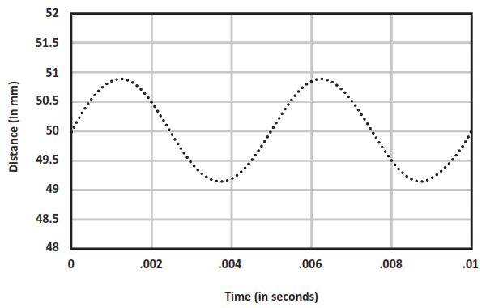
Draw another sound wave on Graph 1 to show the same note plucked with less force.

Prompt 2
Part A.
You need to figure out how loud the guitar sounds from different locations in the recording studio. You collect measurements from different locations in the recording studio to know where to place a microphone when you are ready to record.
Graph 2 shows the data from your collected measurements.
Graph 2. Amount of Energy Transmitted vs. Amplitude
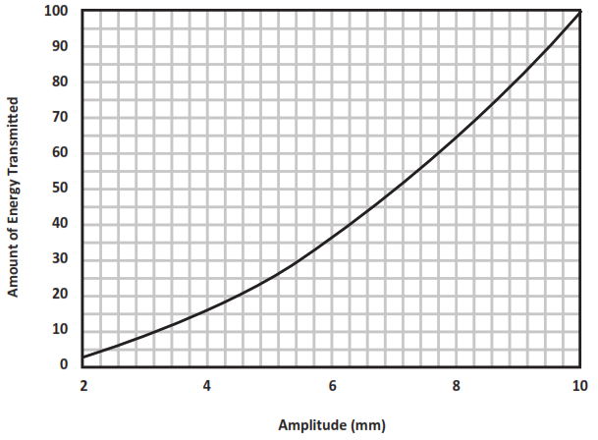
Table 1 shows some of the collected data.

Fill in the missing data points for Locations B, D, and E in Table 1 using data from Graph 2.
Table 1. Amount of Energy Transmitted vs. the Amplitude
Location | Amplitude of Sound Wave (in mm) | Amount of Energy Transmitted (in energy units)
A | 2 | 4
B | 4 | ______
C | 5 | 25
D | ______ | 64
E | 9 | _______
F | 10 | 100
Part B.
Describe the relationship between the amount of energy and the amplitude of the sound produced by plucking the guitar string using information from Graph 2 and Table 1.
______________________________________________________________________________
______________________________________________________________________________
______________________________________________________________________________
______________________________________________________________________________
______________________________________________________________________________
______________________________________________________________________________
______________________________________________________________________________
______________________________________________________________________________
Part C.

A guitarist knows that the different strings on the guitar make different notes when they are plucked. The guitarist wonders how the movement of the string that produces a high-pitch note compares to the movement of the string that produces a low-pitch note.

Compare and explain the pattern of motion of two different strings after each is plucked with the same force. In your response, include a written description, model, OR graph to show your understanding.

Prompt 3
Part A.
You visit the room where you are asked to design a recording studio. There is an open window, and you hear the noise of cars passing by on the street. After you close the window, you notice the noise of the passing cars is quieter, but you can still hear cars’ honking horns.
Explain why you can still hear outside noises even in a room that is surrounded by solid materials, such as walls and a closed window.
_____________________________________________________________________________
_____________________________________________________________________________
_____________________________________________________________________________
_____________________________________________________________________________
_____________________________________________________________________________
Part B.
Decibels (dB) measure the intensity or amplitude of sound. The decibel scale increases by ten as the sound gets louder. For example, a 60 dB sound, such as normal speech, is six powers 10 times (i.e., 1,000,000) more intense than a 1 dB sound, such as a faint whisper.
A recording studio should be very quiet, only as loud as 25 to 30 decibels, or as loud as a library. You can use a decibel meter to measure the noise in the room at different locations and times of day.
Table 2 provides a selection of noise reduction products, their costs, Noise Reduction Coefficients (NRC), and uses to consider for the design of the recording studio. The NRC rating is a scale from 0 to 1 that indicates the amount of noise a material can absorb with 1 being best.
Table 2. Noise Reduction Products
Product | Cost | Noise Reduction Coefficient (NRC) | Description
Product A | $2.50 per sq ft | 0.90 | - must be installed inside the walls  - will require a lot of time and effort
Product B | $26.00 per sq ft | 0.95 | - easy to install on walls or ceilings  - thick and heavy material
Product C | $11.00 per sq ft | 0.40 | - easy to install on walls or ceilings  - light material, easily tears
Product D | $8.00 per sq ft | 0.55 | - ceiling or wall covering  - strong material
Product E | $60.00 per pair | 0.85 | - acoustic curtains for windows  - curtains must remain closed if studio is in use

Based on the three aspects of each of the noise reduction products (cost, NRC, and description), explain why you should evaluate each aspect when evaluating products to provide a very quiet environment inside the recording studio. Use the information about the different types of noise reduction products in Table 2 to support your response.
- ___________________________________________________________________________
___________________________________________________________________________
___________________________________________________________________________

- ___________________________________________________________________________

___________________________________________________________________________

___________________________________________________________________________

- ___________________________________________________________________________

___________________________________________________________________________

___________________________________________________________________________
Part C.
You need to develop a testing plan to evaluate the effectiveness of your proposed recording studio design regarding the noise levels in the room.
Explain where you would measure the intensity of sound in the studio and what scale you would use to test your proposed design.
______________________________________________________________________________
______________________________________________________________________________
______________________________________________________________________________
______________________________________________________________________________
______________________________________________________________________________
______________________________________________________________________________

