Stackable Instructionally-embedded Portable Science (SIPS) Assessments Project

SIPS Grade 5 Unit 2 End-of-Unit Assessment Scoring Guide

June 2023

The SIPS Grade 5 Unit 2 End-of-Unit Assessment Scoring Guide was developed with funding from the U.S. Department of Education under the Competitive Grants for State Assessments Program, CFDA 84.368A. The contents of this paper do not represent the policy of the U.S. Department of Education, and no assumption of endorsement by the Federal government should be made.
All rights reserved. Any or all portions of this document may be reproduced and distributed without prior permission, provided the source is cited as: Stackable Instructionally-embedded Portable Science (SIPS) Assessments Project. (2023). SIPS Grade 5 Unit 2 End-of-Unit Assessment Scoring Guide. Lincoln, NE: Nebraska Department of Education.
Table of Contents
SIPS Grade 5 Unit 2 EOU Assessment Task 1: What it Takes to Grow 1
Task 1 Scoring Rubric 5
Task 1 Student Exemplars 7
SIPS Grade 5 Unit 2 EOU Assessment Task 2: Our Friend the Worm 9
Task 2 Scoring Rubric 13
Task 2 Student Exemplars 16
SIPS Grade 5 Unit 2 EOU Assessment Task 3: Cycling Through a System 19
Task 3 Scoring Rubric 24
Task 3 Student Exemplars 27

SIPS Grade 5 Unit 2 EOU Assessment Task 1: What it Takes to Grow

Student Worksheet

This task is about how plants and animals grow.

Task
You can find different types of plants wherever you live, whether it’s near or far from mountains, plains, deserts, rivers, or the shoreline. Unlike animals, plants produce their own food or matter. You can think of plants as sun-powered, food-making factories. Now that’s pretty amazing. But what do plants need to make their own food?

Prompt 1
Table 1 shows collected data from a pea plant growing investigation. One pea seed is placed in each of the four containers.
- All four containers receive the same amount of sunlight during the day.
- All the seeds are allowed to grow for the same length of time.
- Each container is given different growing conditions.
For each of the four growing conditions, the before and after weight of the pea plant is measured and recorded in Table 1.

Table 1. Pea Plant Investigation
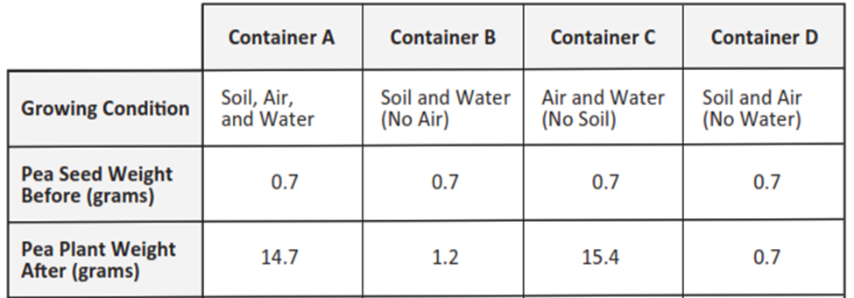

To complete the claim, compare the growing conditions in containers A, B, C, and D and the before and after data related to plant weight.
Then, support the claim with evidence from Table 1.
The Claim:
The materials plants need to make food and grow are _________________________________.
Evidence to Support the Claim:
In containers _________________________________, the data shows____________________
______________________________________________________________________________
______________________________________________________________________________
______________________________________________________________________________
In containers _________________________________, the data shows ____________________
______________________________________________________________________________
______________________________________________________________________________
______________________________________________________________________________

Prompt 2
Some animals, like rabbits, only eat plants for food. When rabbits eat plants, the plant matter is broken down into tiny particles.
Identify and describe how the materials in the food a rabbit uses to grow come from the same materials a plant uses to grow.
______________________________________________________________________________
______________________________________________________________________________
_____________________________________________________________________________.

Prompt 3
Part A.
All living things need energy to grow. Animals get energy and grow by eating food. For example, rabbits may eat parts of a pea plant to get energy.
Draw arrows to show the transfer of energy between the objects in Model 1. Remember, each arrow points to the transfer of energy from one object to another.

Model 1. Transfer of Energy in a Garden
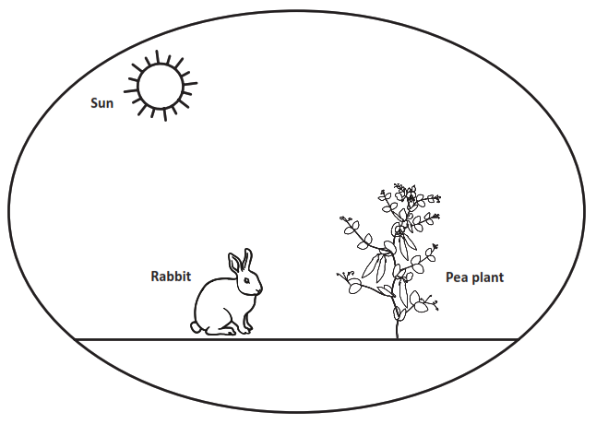
Part B.
The energy a plant uses to grow comes from _________________________________________.
Describe how the energy in the food a rabbit uses to grow comes from the same energy a plant uses to grow. Use Model 1 to support your response.
______________________________________________________________________________
______________________________________________________________________________
______________________________________________________________________________
______________________________________________________________________________

______________________________________________________________________________

SIPS Grade 5 Unit 2 EOU Assessment Task 1 Rubric (5-LS1-1, 5-PS3-1)
Prompt | Score Point 0 | Score Point 1 | Score Point 2 | Score Point 3 | Score Point 4
Prompt 1 | No aspect of the response is correct | Response includes:  - Air or water needed by plants to make food and grow  - Supports claim with flawed or no information from Table 1 | Response includes:  - Air or water needed by plants to make food and grow  - Supports the claim by comparing one (1) set or pair of growing conditions (any combination of A, B, C, or D) using data from Table 1 | Response includes:  - Air and water are needed by plants to make food and grow  - Supports the claim by comparing one (1) set or pair of growing conditions (any combination of A, B, C, or D) using data from Table 1 | Response includes:  - Air and water are needed by plants to make food and grow  - Supports the claim by comparing two (2) sets or pairs of growing conditions (any combination of A, B, C, or D) using data from Table 1 that verifies air and water are required and soil is not required for growth
Prompt 2 | No aspect of the response is correct | Response includes:  - Air or water is a material used by rabbits and plants to grow  - Supports claim with flawed or no information | Response includes:  - Air or water is a material used by rabbits and plants to grow  - The source of materials in the rabbit’s food is traced back to air or water | Response includes:  - Air and water are the materials used by rabbits and plants to grow  - The source of materials in the rabbit’s food is traced back to air and water | NA
Prompt 3 | No aspect of the response is correct | Response includes one (1) of the two (2) aspects | Response includes the following aspects:  Part A  - Arrow pointing from sun to pea plant and an arrow pointing from pea plant to rabbit  Part B  - The sun is needed to provide energy for plants to grow | Response includes the following aspects:  Part A  - Arrow pointing from sun to pea plant and an arrow pointing from pea plant to rabbit  Part B  - The sun is needed to provide energy for plants to grow  - The source of energy in the rabbit’s food is traced back to the sun using relationships shown in Model 1 | NA

Student Exemplar(s)
Student exemplars represent high-quality responses that align to full-point rubric scores. The exemplar responses are intended to assist educators’ understanding of the nature and expectations of each prompt. Note the exemplars serve as examples of high-quality responses, and students may respond with equally relevant, scientifically accurate responses and ideas that meet the expectations of a full-point rubric score.

Prompt 1

To complete the claim, compare the growing conditions in containers A, B, C, and D and the before and after data related to plant weight.
Then, support the claim with evidence from Table 1.
The Claim:
The materials that plants need to make food and grow are air and water.
Evidence to Support the Claim:
In containers A and C, the data shows the plant in Container A grew almost the same amount as the plant in Container C. Both containers had air and water. Container A also had soil, but the soil did not make the plant grow more than in Container C.
In containers B and D, the data shows the plants in Containers B and D grew very little. In Container B, the plant had no air. In Container C, the plant had no water.
NOTE: Any other comparisons which demonstrate that plants need air and water to grow are acceptable.

Prompt 2
Identify and describe how the materials in the food a rabbit uses to grow come from the same materials a plant uses to grow.
Rabbits get the materials they need to grow from the food they eat. The food they eat is from plants. Plants grow using materials that come from air and water. So, the rabbits’ food also comes from air and water.

Prompt 3
Part A.
Draw arrows to show the transfer of energy between the objects in Model 1. Remember, each arrow points to the transfer of energy from one object to another.
Model 1. Transfer of Energy in a Garden

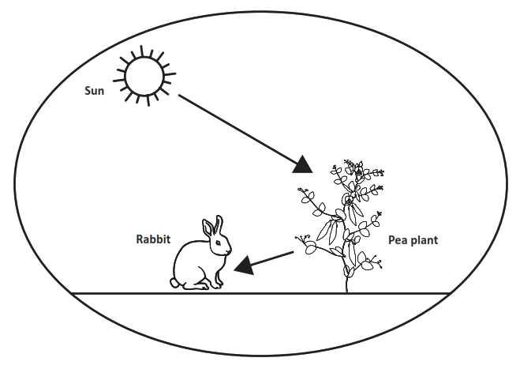
Part B.
The energy a plant uses to grow comes from the sun.
Describe how the energy in the food a rabbit uses to grow comes from the same energy a plant uses to grow. Use Model 1 to support your response.
The model shows that the energy the pea plant needs to grow comes from the sun. Rabbits get the energy they need to grow from the food they eat. The food they eat is from plants. So, when rabbits eat plants the food energy comes from the sun.

SIPS Grade 5 Unit 2 EOU Assessment Task 2: Our Friend the Worm

Student Worksheet
This task is about the cycling of matter and energy.

Task
Compost is organic material. Organic material can come from plants that are rotting. It can be added to soil to help plants grow.
Vermicomposting is a way of making compost using worms. People take food leftovers like vegetables or cut grass from their lawns and put them into a container. The container has worms in it. The worms eat 1/3 to 1/2 of their body weight every day. The waste the worms produce adds nutrients back into the soil. Plants can use these nutrients to grow. The worms are making natural fertilizer!

Prompt 1
Part A.
Vermicomposting is a natural way of recycling organic material, like vegetables, cut grass, or leaves into rich, usable soil.
The steps in the vermicomposting process are shown by the letters A through F. The steps are not in the correct order.
- Humans eat fresh food.
- Compost helps plants grow.
- Worms decompose food waste.
- Humans place food scraps into the composter.
- Compost is produced.
- Plants produce fresh food.

Write the steps of vermicomposting in the correct sequence using the letters A through F in Figure 1. Use your knowledge of decomposition to sequence the steps. Step A is included in Figure 1.
Figure 1. The Sequence of Vermicomposting
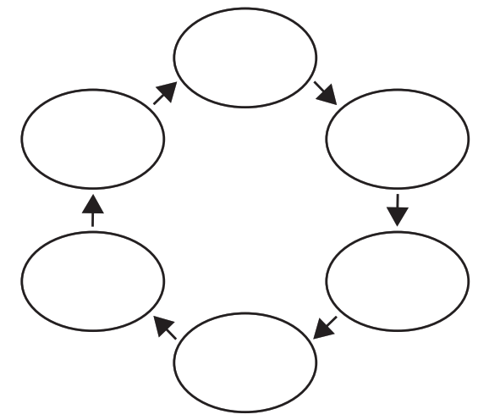
A
Part B.
Describe how plant matter moves between different organisms and is recycled in the system. In your response, include plants, humans, worms, and information from your completed Figure 1.
______________________________________________________________________________
______________________________________________________________________________
______________________________________________________________________________
______________________________________________________________________________
______________________________________________________________________________

Prompt 2
What would happen if an ecosystem contained producers and consumers but no decomposers?
______________________________________________________________________________
______________________________________________________________________________
______________________________________________________________________________
______________________________________________________________________________

Prompt 3
Part A.
Composting is a natural way of recycling organic material into the soil. Compost adds nutrients to the soil which helps plants grow.
Show the energy transfer in Model 1. Write the terms below in the correct boxes in the model.
- Decomposers
- Animals
- Plants
Model 1. Energy Transfer
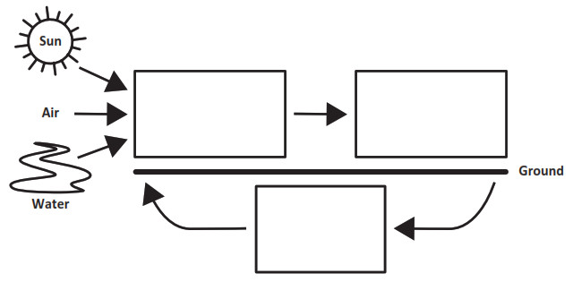

Part B.
Support the claim below with at least two pieces of evidence. Use Model 1 and your science knowledge to determine the evidence.
Claim:
Energy from the sun becomes part of the nutrients in the soil that help plants grow.

First, my model shows ___________________________________________________________
______________________________________________________________________________
______________________________________________________________________________
_____________________________________________________________________________.
Second, I know that _____________________________________________________________
______________________________________________________________________________

______________________________________________________________________________

_____________________________________________________________________________.

SIPS Grade 5 Unit 2 EOU Assessment Task 2 Rubric (5-LS2-1, 5-PS3-1)
Prompt | Score Point 0 | Score Point 1 | Score Point 2 | Score Point 3 | Score Point 4
Prompt 1  Part A. | No aspect of the response is correct | Response includes three (3) of the five (5) steps in the correct sequence | Response includes a sequence of the remaining five (5) steps in the correct sequence | NA | NA
Prompt 1 Part B. | No aspect of the response is correct | Response includes one (1) of the three (3) aspects | Response includes two (2) of the three (3) aspects | Response includes the following aspects:  - References plants, humans, and worms  - Describes the sequence of plant matter movement shown in Figure 1  - Describes how the sequence recycles materials in the system | NA
Prompt 2 | No aspect of the response is correct | Response includes one (1) of the three (3) aspects | Response includes two (2) of the three (3) aspects | Response includes the following aspects:  - Includes the terms producers, consumers, and decomposers  - Describes how matter would not be recycled in the system  - Describes the results (e.g., few plants, less food for consumers, no materials in the soil for plants, etc.) | NA
Prompt 3 | No aspect of the response is correct | Only includes one (1) of the three (3) aspects | Only includes two (2) of the three (3) aspects | Response includes the following aspects:  Part A  - Correct placement of decomposers, animals, and plants  Part B  - Describes the model as showing the transfer of energy from the sun to plants, then to animals, then to decomposers, and back to plants  - Describes how composting or decomposing organic materials, which uses energy from the sun to grow, creates nutrients used by plants to grow | NA

Student Exemplar(s)
Student exemplars represent high-quality responses that align to full-point rubric scores. The exemplar responses are intended to assist educators’ understanding of the nature and expectations of each prompt. Note the exemplars serve as examples of high-quality responses, and students may respond with equally relevant, scientifically accurate responses and ideas that meet the expectations of a full-point rubric score.

Prompt 1
Part A.
Write the steps of vermicomposting in the correct sequence using the letters A through F in Figure 1. Use your knowledge of decomposition to sequence the steps. Step A is included in Figure 1.
Figure 1. The Sequence of Vermicomposting
F
B
E
C
D
A
Part B.
Describe how plant matter moves between different organisms and is recycled in the system. In your response, include plants, humans, worms, and information from your completed Figure 1.
Humans eat plant matter and put uneaten food scraps into a composter.
The decomposers in the composter are worms. Worms break down plant matter. The plant matter is turned into compost which is used by plants to grow. When the plants are grown, humans eat new plants for food. Figure 1 shows arrows between each of these steps and how the movement of plant matter is recycled in the system.

Prompt 2
What would happen if an ecosystem contained producers and consumers but no decomposers?
If there were no decomposers in an ecosystem, nothing would get broken down. That would mean everything would just keep piling up. Also, there would be no materials in the soil for plants to turn back into food. Then the animals would have no more food to eat and would die.

Prompt 3
Part A.
Show the energy transfer in this system in Model 1. Write the terms below in the correct boxes in the model.
- Decomposers
- Animals
- Plants

Model 1. Energy Transfer
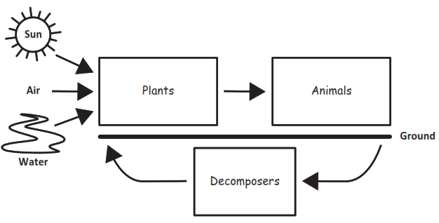
Part B.
Support the claim below with at least two pieces of evidence. Use Model 1 and your science knowledge to determine the evidence.
Claim:
Energy from the sun becomes part of the nutrients in the soil that help plants grow.

First, my model shows that energy from the sun is used by plants to grow and make food. Animals eat plants for food. When plants and animals die, they are broken down by decomposers. The decomposers recycle the dead matter into nutrients that go back into plants.

Second, I know that composting recycles organic matter. This means when worms or decomposers break down dead material, it adds nutrients back into the soil. Plants can use these nutrients to grow.

SIPS Grade 5 Unit 2 EOU Assessment Task 3: Cycling Through a System

Student Worksheet

This task is about energy and matter flow in an ecosystem.

Task
Sometimes a new species of animal or plant is introduced by mistake into an ecosystem. This means that the species does not live naturally in the area. The species may harm other living things and the environment. Consider what happens if someone releases pet goldfish into a local pond. You visit the same pond a year later and see goldfish everywhere! What could have happened?

Prompt 1
An invasive species is an organism that is not found naturally in an ecosystem. The goldfish in the pond are an invasive species. When goldfish feed on different living things in a pond, they stir up the mud at the bottom. This reduces the amount of sunlight reaching underwater plants. When the plants die, there is less food for the native fish species. Also, goldfish reproduce at a high rate. They do not have natural predators.

Figure 1 shows a model that predicts the effect of releasing the goldfish into the pond over three years.

Figure 1. Pond Populations
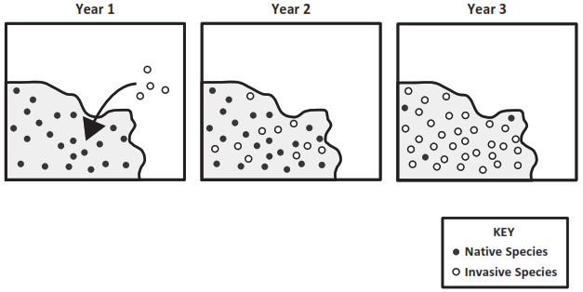

Describe the effect of releasing the goldfish in the pond shown in Figure 1. Be sure to include:
- information about the native fish species
- information about the invasive fish species
- a prediction of the effect on the pond system over time

______________________________________________________________________________

______________________________________________________________________________

______________________________________________________________________________

______________________________________________________________________________

______________________________________________________________________________

______________________________________________________________________________

Prompt 2
Part A.
In an ecosystem, living things depend on a food chain to survive. Some organisms, such as bacteria, break down dead plants and animals.

Figure 2 is an incomplete model of a forest ecosystem. Complete the model to show the movement of energy between living things in the ecosystem.

- Label each picture of a living thing as a decomposer, animal, or plant in the boxes outside the circle.
- Draw arrows to show the movement of energy between living things in the boxes inside the circle.
Figure 2. Model of a Forest Ecosystem
bacteria
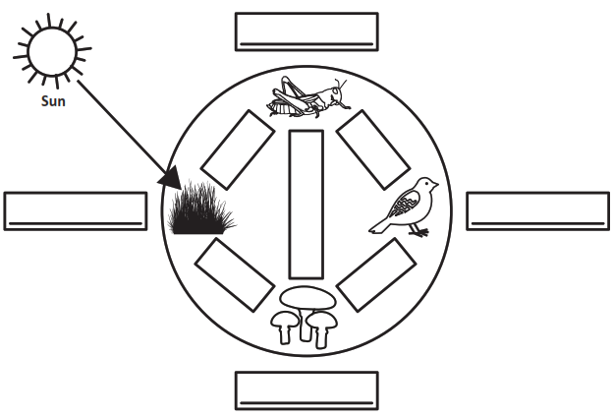

Part B.
Describe what you know about the movement of energy in an ecosystem. Use the information from Figure 2 and the terms decomposers, animals, the sun, and plants to complete the sentences below.

The movement of energy in the ecosystem begins with energy from ____________________. This energy is used by ____________________ to make matter.
Next, the matter is eaten by ____________________. Some ____________________ only eat ____________________. Some ____________________ eat other ____________________.
All waste and dead materials are broken down by ____________________ into nutrients in the soil. Then, ____________________ absorb those nutrients, and the cycle starts again.

Prompt 3
A balanced ecosystem has many organisms. Together, organisms are able to meet their needs to grow, reproduce, and survive.
A local forest ecosystem may have many mice, rabbits, and small birds. These animals eat plants, like grasses. Large birds like hawks and owls must eat smaller animals to survive.
Read the information below about an invasive species that is released into an ecosystem.

Pythons are popular pets. These snakes can grow to a length of 15 to 23 feet. They live on the ground and in trees and water. If some pythons, kept as pets, are released into a forest ecosystem, the populations of small mammals like rabbits and mice will decrease.
Explain the effects of an invasive species like pythons on the balance of a local forest ecosystem. In your explanation, be sure to:
- Describe how and why the populations of small mammals are affected.
- Predict what will happen to other animals in the ecosystem such as owls or hawks and why this will happen.
- Predict what will happen to the plants in the ecosystem and why this will happen.
______________________________________________________________________________

______________________________________________________________________________

______________________________________________________________________________

______________________________________________________________________________

______________________________________________________________________________

______________________________________________________________________________

______________________________________________________________________________

______________________________________________________________________________

SIPS Grade 5 Unit 2 EOU Assessment Task 3 Rubric (5-LS2-1, 5-PS3-1)
Prompt | Score Point 0 | Score Point 1 | Score Point 2 | Score Point 3 | Score Point 4
Prompt 1 | No aspect of the response is correct | Response includes one (1) of the three (3) aspects | Response includes two (2) of the three (3) aspects | Response includes the following aspects:  - Describes that the native fish species rely on underwater plants for survival  - Describes how goldfish cause the underwater plants to die  - Predicts that without the plant, the native species will die or disappear from the pond system | NA
Prompt 2  Part A. | No aspect of the response is correct | Response includes one (1) of the four (4) aspects | Response includes two (2) of the four (4) aspects | Response includes three (3) of the four (4) aspects | Response includes the following aspects:  - The plant is the grass  - The animal as the grasshopper and bird  - The decomposer as the bacteria  - Arrows showing the flow of energy pointing from the plant to the grasshopper, the grasshopper to the bird, from both animals to the decomposer, and the decomposer to the plant
Prompt 2  Part B. | No aspect of the response is correct | Response includes the following aspects:  - Terms correctly applied in at least two (2) of the eight (8) blanks | Response includes the following aspects:  - Terms correctly applied in the eight (8) blanks | NA | NA
Prompt 3 | No aspect of the response is correct | Explanation includes one (1) of the four (4) aspects | Explanation includes two (2) of the four (4) aspects | Explanation includes three (3) of the four (4) aspects | Explanation includes the following aspects:  - The snake will eat the small animals so the population of small animals will decrease  - There will be fewer small animals for hawks and owls to eat, so hawks and owls will reduce in population (or will change what they eat)  - Fewer small animals that eat grass means more grass  - Summarizes the impact on the balance of the ecosystem

Student Exemplar(s)
Student exemplars represent high-quality responses that align to full-point rubric scores. The exemplar responses are intended to assist educators’ understanding of the nature and expectations of each prompt. Note the exemplars serve as examples of high-quality responses, and students may respond with equally relevant, scientifically accurate responses and ideas that meet the expectations of a full-point rubric score.

Prompt 1
Describe the effect of releasing the goldfish in the pond shown in Figure 1. Be sure to include:
- information about the native fish species
- information about the invasive fish species
- a prediction of the effect on the pond system over time
Because goldfish have no natural predators and reproduce at a high rate, their population grows fast. Also, they destroy parts of the pond system like the plants that native species rely on for food. The figure shows how the number of goldfish increases each year and the number of native species decreases. At some point in the future, the native species will disappear.

Prompt 2
Part A.
Figure 2 is an incomplete model of a forest ecosystem. Complete the model to show the movement of energy between living things in the ecosystem.
- Label each picture of a living thing as a decomposer, animal, or plant in the boxes outside the circle.
- Draw arrows to show the movement of energy between living things in the boxes inside the circle.

Figure 2. Model of a Forest Ecosystem
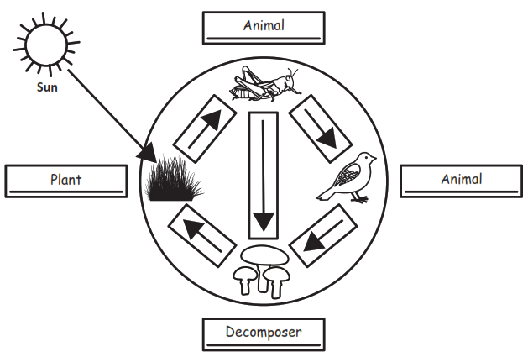
bacteria
Part B.
Describe what you know about the movement of energy in an ecosystem. Use the information from Figure 2 and the terms decomposers, animals, the sun, and plants to complete the sentences below.
The movement of energy in the ecosystem begins with energy from the sun.
This energy is used by plants to make matter.
Next, the matter is eaten by animals. Some animals only eat plants. Some animals eat other animals.
All waste and dead materials are broken down by decomposers into nutrients in the soil. Then, plants absorb those nutrients, and the cycle starts again.

Prompt 3
Read the information below about an invasive species that is released into an ecosystem.
Pythons are popular pets. These snakes can grow to a length of 15 to 23 feet. They live on the ground and in trees and water. If some pythons, kept as pets, are released into a forest ecosystem, the populations of small mammals like rabbits and mice will decrease.

Explain the effects of an invasive species like pythons on the balance of a local forest ecosystem.
In your explanation, be sure to:

- Describe how and why the populations of small mammals are affected.
- Predict what will happen to other animals in the ecosystem such as owls or hawks and why this will happen.
- Predict what will happen to the plants in the ecosystem and why this will happen.

The snakes will eat small mammals like mice and rabbits, so there will be fewer of those animals. If those animal populations decrease, then there will be less food for the hawks and owls. So, the hawks and owls may change what they eat or may not have enough food and so will not grow. Without the small mammals, there will be more grass. In a balanced ecosystem, all the different organisms can meet their needs to grow, reproduce, and survive. An invasive species can ruin this balance.

