SIPS Grade 5 Unit 2 EOU Assessment Task 1: What it Takes to Grow

Student Worksheet

This task is about how plants and animals grow.

Task
You can find different types of plants wherever you live, whether it’s near or far from mountains, plains, deserts, rivers, or the shoreline. Unlike animals, plants produce their own food or matter. You can think of plants as sun-powered, food-making factories. Now that’s pretty amazing. But what do plants need to make their own food?

Prompt 1
Table 1 shows collected data from a pea plant growing investigation. One pea seed is placed in each of the four containers.
- All four containers receive the same amount of sunlight during the day.
- All the seeds are allowed to grow for the same length of time.
- Each container is given different growing conditions.
For each of the four growing conditions, the before and after weight of the pea plant is measured and recorded in Table 1.

Table 1. Pea Plant Investigation
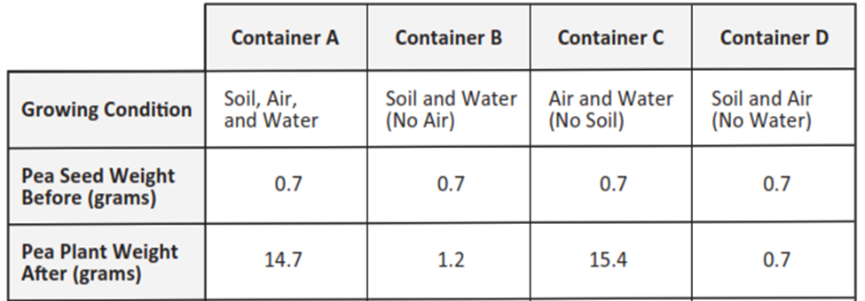

To complete the claim, compare the growing conditions in containers A, B, C, and D and the before and after data related to plant weight.
Then, support the claim with evidence from Table 1.
The Claim:
The materials plants need to make food and grow are _________________________________.
Evidence to Support the Claim:
In containers _________________________________, the data shows____________________
______________________________________________________________________________
______________________________________________________________________________
______________________________________________________________________________
In containers _________________________________, the data shows ____________________
______________________________________________________________________________
______________________________________________________________________________
______________________________________________________________________________

Prompt 2
Some animals, like rabbits, only eat plants for food. When rabbits eat plants, the plant matter is broken down into tiny particles.
Identify and describe how the materials in the food a rabbit uses to grow come from the same materials a plant uses to grow.
______________________________________________________________________________
______________________________________________________________________________
_____________________________________________________________________________.

Prompt 3
Part A.
All living things need energy to grow. Animals get energy and grow by eating food. For example, rabbits may eat parts of a pea plant to get energy.
Draw arrows to show the transfer of energy between the objects in Model 1. Remember, each arrow points to the transfer of energy from one object to another.

Model 1. Transfer of Energy in a Garden
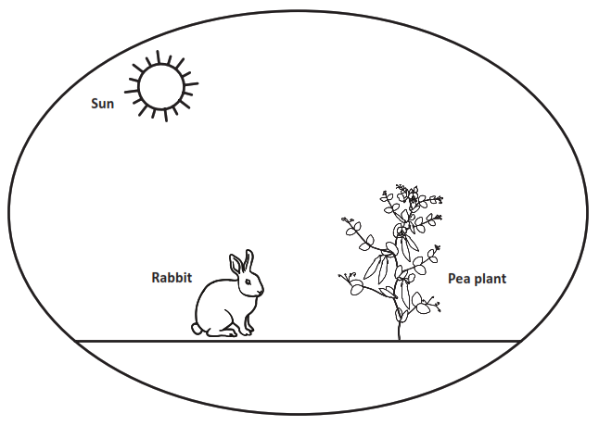
Part B.
The energy a plant uses to grow comes from _________________________________________.
Describe how the energy in the food a rabbit uses to grow comes from the same energy a plant uses to grow. Use Model 1 to support your response.
______________________________________________________________________________
______________________________________________________________________________
______________________________________________________________________________
______________________________________________________________________________

______________________________________________________________________________

SIPS Grade 5 Unit 2 EOU Assessment Task 2: Our Friend the Worm

Student Worksheet
This task is about the cycling of matter and energy.

Task
Compost is organic material. Organic material can come from plants that are rotting. It can be added to soil to help plants grow.
Vermicomposting is a way of making compost using worms. People take food leftovers like vegetables or cut grass from their lawns and put them into a container. The container has worms in it. The worms eat 1/3 to 1/2 of their body weight every day. The waste the worms produce adds nutrients back into the soil. Plants can use these nutrients to grow. The worms are making natural fertilizer!

Prompt 1
Part A.
Vermicomposting is a natural way of recycling organic material, like vegetables, cut grass, or leaves into rich, usable soil.
The steps in the vermicomposting process are shown by the letters A through F. The steps are not in the correct order.
- Humans eat fresh food.
- Compost helps plants grow.
- Worms decompose food waste.
- Humans place food scraps into the composter.
- Compost is produced.
- Plants produce fresh food.

Write the steps of vermicomposting in the correct sequence using the letters A through F in Figure 1. Use your knowledge of decomposition to sequence the steps. Step A is included in Figure 1.
Figure 1. The Sequence of Vermicomposting
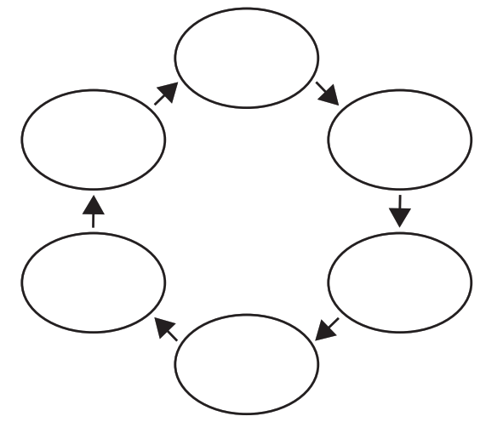
A
Part B.
Describe how plant matter moves between different organisms and is recycled in the system. In your response, include plants, humans, worms, and information from your completed Figure 1.
______________________________________________________________________________
______________________________________________________________________________
______________________________________________________________________________
______________________________________________________________________________
______________________________________________________________________________

Prompt 2
What would happen if an ecosystem contained producers and consumers but no decomposers?
______________________________________________________________________________
______________________________________________________________________________
______________________________________________________________________________
______________________________________________________________________________

Prompt 3
Part A.
Composting is a natural way of recycling organic material into the soil. Compost adds nutrients to the soil which helps plants grow.
Show the energy transfer in Model 1. Write the terms below in the correct boxes in the model.
- Decomposers
- Animals
- Plants
Model 1. Energy Transfer
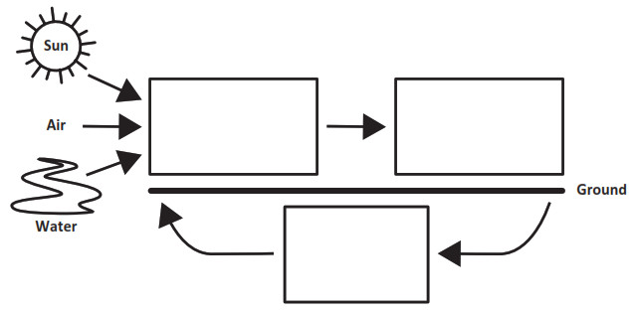

Part B.
Support the claim below with at least two pieces of evidence. Use Model 1 and your science knowledge to determine the evidence.
Claim:
Energy from the sun becomes part of the nutrients in the soil that help plants grow.

First, my model shows ___________________________________________________________
______________________________________________________________________________
______________________________________________________________________________
_____________________________________________________________________________.
Second, I know that _____________________________________________________________
______________________________________________________________________________

______________________________________________________________________________

_____________________________________________________________________________.

SIPS Grade 5 Unit 2 EOU Assessment Task 3: Cycling Through a System

Student Worksheet

This task is about energy and matter flow in an ecosystem.

Task
Sometimes a new species of animal or plant is introduced by mistake into an ecosystem. This means that the species does not live naturally in the area. The species may harm other living things and the environment. Consider what happens if someone releases pet goldfish into a local pond. You visit the same pond a year later and see goldfish everywhere! What could have happened?

Prompt 1
An invasive species is an organism that is not found naturally in an ecosystem. The goldfish in the pond are an invasive species. When goldfish feed on different living things in a pond, they stir up the mud at the bottom. This reduces the amount of sunlight reaching underwater plants. When the plants die, there is less food for the native fish species. Also, goldfish reproduce at a high rate. They do not have natural predators.

Figure 1 shows a model that predicts the effect of releasing the goldfish into the pond over three years.

Figure 1. Pond Populations
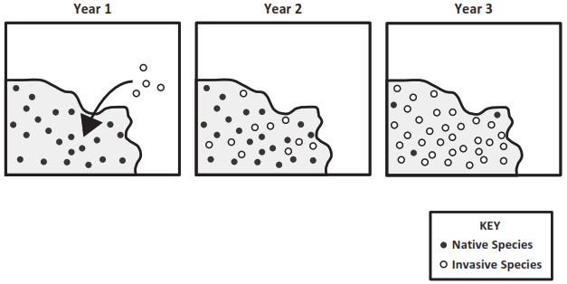

Describe the effect of releasing the goldfish in the pond shown in Figure 1. Be sure to include:
- information about the native fish species
- information about the invasive fish species
- a prediction of the effect on the pond system over time

______________________________________________________________________________

______________________________________________________________________________

______________________________________________________________________________

______________________________________________________________________________

______________________________________________________________________________

______________________________________________________________________________

Prompt 2
Part A.
In an ecosystem, living things depend on a food chain to survive. Some organisms, such as bacteria, break down dead plants and animals.

Figure 2 is an incomplete model of a forest ecosystem. Complete the model to show the movement of energy between living things in the ecosystem.

- Label each picture of a living thing as a decomposer, animal, or plant in the boxes outside the circle.
- Draw arrows to show the movement of energy between living things in the boxes inside the circle.
Figure 2. Model of a Forest Ecosystem
bacteria
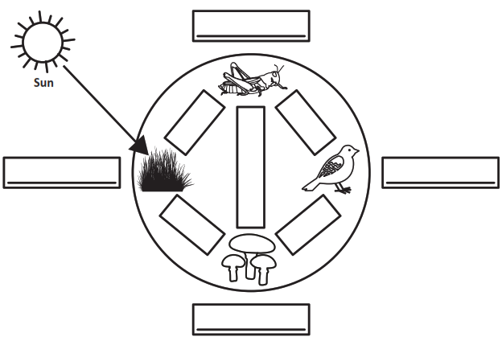

Part B.
Describe what you know about the movement of energy in an ecosystem. Use the information from Figure 2 and the terms decomposers, animals, the sun, and plants to complete the sentences below.

The movement of energy in the ecosystem begins with energy from ____________________. This energy is used by ____________________ to make matter.
Next, the matter is eaten by ____________________. Some ____________________ only eat ____________________. Some ____________________ eat other ____________________.
All waste and dead materials are broken down by ____________________ into nutrients in the soil. Then, ____________________ absorb those nutrients, and the cycle starts again.

Prompt 3
A balanced ecosystem has many organisms. Together, organisms are able to meet their needs to grow, reproduce, and survive.
A local forest ecosystem may have many mice, rabbits, and small birds. These animals eat plants, like grasses. Large birds like hawks and owls must eat smaller animals to survive.
Read the information below about an invasive species that is released into an ecosystem.

Pythons are popular pets. These snakes can grow to a length of 15 to 23 feet. They live on the ground and in trees and water. If some pythons, kept as pets, are released into a forest ecosystem, the populations of small mammals like rabbits and mice will decrease.
Explain the effects of an invasive species like pythons on the balance of a local forest ecosystem. In your explanation, be sure to:
- Describe how and why the populations of small mammals are affected.
- Predict what will happen to other animals in the ecosystem such as owls or hawks and why this will happen.
- Predict what will happen to the plants in the ecosystem and why this will happen.
______________________________________________________________________________

______________________________________________________________________________

______________________________________________________________________________

______________________________________________________________________________

______________________________________________________________________________

______________________________________________________________________________

______________________________________________________________________________

______________________________________________________________________________

