Stackable Instructionally-embedded Portable Science (SIPS) Assessments Project

Grade 5 Science
Unit 4 Instructionally-embedded Assessment Task:
“Star Light, Star Bright”
Earth and Its Gravitational Force and Motion
September 2023

The SIPS Grade 5 Science Unit 4 Instructionally-embedded Assessment Task: “Star Light, Star Bright” was developed with funding from the U.S. Department of Education under the Competitive Grants for State Assessments Program, CFDA 84.368A. The contents of this paper do not represent the policy of the U.S. Department of Education, and no assumption of endorsement by the Federal government should be made.

All rights reserved. Any or all portions of this document may be reproduced and distributed without prior permission, provided the source is cited as: Stackable Instructionally-embedded Portable Science (SIPS) Assessments Project. (2023). SIPS Grade 5 Science Unit 4 Instructionally-embedded Assessment Task: “Star Light, Star Bright”. Lincoln, NE: Nebraska Department of Education.
SIPS Grade 5 Unit 4 Instructionally-embedded Assessment Task
Grade 5 | Unit 4 | Instructional Segment 1 | Task Title: Star Light, Star Bright
NGSS Performance Expectations Code(s) and Description(s)
Code | Description
5-ESS1-1. | Support an argument that the apparent brightness of the sun and stars is due to their relative distances from the Earth. [Clarification Statement: Absolute brightness of stars is the result of a variety of factors. Relative distance from Earth is one factor that affects apparent brightness and is the one selected to be addressed by the performance expectation.] [Assessment Boundary: Assessment is limited to relative distances, not sizes, of stars. Assessment does not include other factors that affect apparent brightness (such as stellar masses, age, stage).]
Acquisition Goals Number(s) and Descriptions(s)
Number | Description
A1. | Develop and/or use a model to describe that light from stars reaches Earth even when those stars' distances vary greatly.
A2. | Support an argument that stars range greatly in their distance from Earth and they emit light that can reach Earth, using evidence, data, or a model.
A3. | Represent data in graphical displays to reveal that the sun is closer than other stars and that the sun appears larger and brighter than other stars.
Evidence Statements
- Identify evidence that supports an explanation about the relationship between distance and apparent size and/or brightness of the sun versus all other stars.
- Identify what evidence or data supports an argument that stars range greatly in their distance from Earth and/or that stars emit light that can reach Earth.
- Describe how data shows that the sun is closer than other stars and/or that the sun appears larger and brighter than other stars.

Source Documentation and Information Resources References (e.g., publications, websites, citations, images, videos, etc.)  Please include source name, description, citation, and a link to its original location below. Include additional rows as needed. | Licensing: Please mark an “X” under the appropriate licensing. If resource is not under a creative commons (CC) license, please attempt to find a source with CC licensing. If you are unable, please select other and provide additional information about the source in the source documentation section.
 | CC0/  Public Domain | CC BY | CC BY-SA | CC BY-NC | CC BY-NC-SA | CC BY-ND | CC BY-NC-ND | Other
Flashlight  - Search media - Wikimedia Commons  [https://commons.wikimedia.org/w/index.php?search=flashlight&title=Special:MediaSearch&go=Go&type=image] | X

Teacher Administration Guide

Introduction
- Educators developed the accompanying classroom task to align to one or more aspects of the NGSS Performance Expectation(s) (PEs) to determine where students are in their learning at a specific point in time during an instructional sequence. Educators will need to make intentional decisions about when and how to use this task based on their students’ learning needs, the purpose of giving the task, and the intended use of the evidence gathered.
- This task is designed to measure students’ ability to integrate the dimensions and demonstrate their knowledge, skills, and abilities as represented by NGSS Performance Expectation 5-ESS1-1. By administering this task, educators can gather and evaluate evidence to make accurate and meaningful judgments about students’ science learning and determine how instruction may need to be adjusted along an instructional sequence to best support students.
- The phenomenon in this task involves an investigation into how the apparent brightness of the sun and stars is due to their relative distances from the Earth.
- In this task, students provide reasoning to explain how the evidence/data supports explanations related to comparing stars’ distance from Earth and absolute brightness to the stars’ apparent brightness when viewed from Earth. Students then use multiple pieces of evidence/data from different sources, such as tables and graphs, to construct an argument containing a claim, evidence/data, and appropriate reasoning about how the apparent brightness of stars, including Earth’s sun, is due to their relative distances from the Earth.
- Background Information:
  - Students previously discovered that (1) light from stars reaches Earth even when those stars’ distances vary greatly and (2) the Earth rotates about an axis and takes approximately 24 hours for a complete rotation.
  - In this assessment, students are presented with information and data related to stars’ absolute brightness, apparent brightness, and distance from Earth and a scenario of a science class in which students are investigating the relationship between brightness and distance using a flashlight to explain the Earth’s sun is a star that appears larger and brighter than other stars because it is closer.
Administration Guidelines
- One (1) class period
- Segment 1 Lessons: “The Sun and Stars” and “Big, Small, it is all Relative”
- Students individually complete a series of prompts reflecting the following chain of sensemaking:
  - Compare data of apparent brightness vs. absolute brightness for two stars to explain which star is further away.
  - Compare data of absolute brightness vs. distance of two stars to predict which will appear brighter from Earth.
  - Represent the distance of three stars from Earth in a graphic to support a claim related to a star’s apparent brightness and distance from Earth to show distance vs. apparent brightness of stars.
  - Plot data related to the scenario of students’ investigation of apparent brightness using a flashlight and changes in the diameter of the beam when the flashlight is moved away from the wall.
  - Make a claim and develop an argument with evidence about why the Earth’s sun appears brighter and larger than other similar stars.
Accessibility Considerations
Providing a range of accessibility considerations in the task (e.g., multiple ways of representing information, multiple types of supports, multiple ways in which students respond) promotes equity and fairness across a wide range of students who may be at different points in their science learning. In turn, these considerations can promote student interest and engagement in the tasks resulting in a more complete and accurate collection of evidence of students’ science learning.
Accommodations for students with a disability or Multilingual Learners that are part of their on-going instructional programs are to be provided during the administration of this task. Accommodations should be consistent with those provided student’s daily instructional strategies and assessment opportunities including assistive technology devices if appropriate. These accessibility considerations and accommodations enable accurate inferences about student learning and inform meaningful adjustments to planning and instruction.
Ancillary Materials
- None
Instructions for Administering the Performance Task or Implementing the Research Task, Design Project, or Lab
- Pose the scenario: how humans classify stars by distance, absolute, and apparent brightness.
- Students will make a comparison of the apparent brightness of two identical light sources (i.e., a flashlight) at different distances from a wall and what conclusions can be made.
Scoring Guidance
- A task-and prompt-specific scoring rubric indicates scoring criteria for each prompt across a range of score points.
- Student exemplars represent high-quality responses that align to full-point rubric scores. The exemplar responses are intended to assist educators’ understanding of the nature and expectations of each prompt when applying the scoring rubric. Note the exemplars serve as examples of high-quality responses, and students may respond with equally relevant, scientifically accurate responses and ideas that meet the expectations of a full-point rubric score. In general, the exemplar response associated with the highest score point in the rubric meets expectations and is scientifically accurate, complete, coherent, and consistent with the type of student evidence expected as described in the rubric.
- The approximate scoring time for this task will be 10 to 15 minutes per student.

Student Task
This task is about the brightness of stars.
Task Scenario
Humans see stars as tiny points of light in the night sky. But stars come in a range of sizes and brightness. A glance at the night sky above Earth shows that some stars are much brighter than others.
From Earth, it looks as though the brighter stars are closer to us and the dimmer stars are farther away from us. Are the brightest stars we see at night actually the brightest stars?

Prompt 1
Part A.
Table 1 shows the apparent and absolute brightness of the stars Capella and Rigel.
- Apparent brightness is defined as how bright the star appears when viewed from Earth. The smaller the number, the brighter the star is. The more negative the number, the greater the brightness.
- Absolute brightness is how bright the star is from a fixed point 33 light years away from Earth. The more positive the value, the greater the brightness. One light year is equal to how far light can travel in one year.
Table 1. Apparent and Absolute Brightness of Capella and Rigel
Star | Apparent Brightness | Absolute Brightness
Capella | 0.1 | -0.4
Rigel | 0.1 | -8.1

Which star is further away? Explain your answer using the data in Table 1.
The star that is further away is______________________________________.

I know this because_____________________________________________________________

_____________________________________________________________________________

_____________________________________________________________________________.

Part B.
Table 2 shows the absolute brightness and distance from Earth of the stars Canopus and Archenar. Their distance from Earth is about the same, but their absolute brightness is different.
Table 2. Absolute Brightness and Distance from Earth of Canopus and Archenar
Star | Absolute Brightness | Distance From Earth  (light years) *
Canopus | 0.5 | 74
Archenar | -1.3 | 75
*One light year is equal to how far light can travel in one year.
Which star will look brighter when seen from Earth? Support your answer using data about absolute brightness and distances from Earth in Table 2.
The star that looks the brightest from Earth is___________________________________.

I know this because_____________________________________________________________
_____________________________________________________________________________
_____________________________________________________________________________.
Prompt 2
Table 3 shows the magnitudes of absolute and apparent brightness of three stars, Alpha Centauri B, Delta Pavonis, and 72 Hercules. Their absolute brightness is about the same.
Table 3. Information about Alpha Centauri B, Delta Pavonis, and 72 Hercules
Star | Apparent Brightness | Absolute Brightness
Alpha Centauri B | 1.4 | 4
Delta Pavonis | 3.6 | 4.6
72 Hercules | 5.4 | 4.4

Circle your answer to complete a claim about the apparent brightness of stars based on data in Table 3.
As a star’s distance from Earth increases, the apparent brightness of the star (Circle one)
increases. decreases. stays the same.

Show the distance from Earth of Alpha Centauri B, Delta Pavonis, and 72 Hercules using data from Table 3 on Model 1.  Write the name of the star on the line labeled A, B, or C to show the distance of each star from Earth in light years (LY). | 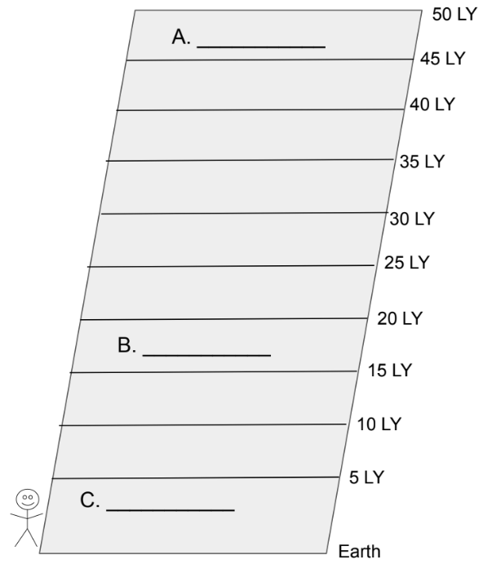  Model 1. Distances of Stars from Earth

How does Model 1 support your claim?

_____________________________________________________________________________________

______________________________________________________________________________
______________________________________________________________________________

Prompt 3
Students in a science classroom were investigating apparent brightness. They used a flashlight and observed the change in the diameter of a beam of light shining on a wall as the flashlight was moved away from the wall.

Near the wall Farther from wall

The data collected by the students is shown in Table 4.
Table 4. Distance from Wall and Diameter of Beam of Light
Distance from Wall (in) | 1 | 2 | 3 | 4 | 5 | 6 | 7 | 8 | 9 | 10
Diameter of Beam (in) | 1 | 1 | 2 | 2.5 | 3 | 4 | 4.5 | 4.5 | 5 | 6
Part A.
Make a line graph to show the relationship between each distance from the wall and the diameter of the flashlight’s beam on Graph 1. Use data from Table 4.
Graph 1. Distance from Wall and Diameter of Beam of Light
Diameter of Beam (in)
Distance from Wall (in)

Circle the statement which best represents the data plotted in Graph 1.
- If the distance of the light source is farther, then the diameter of the beam is smaller.

- If the distance of the light source is closer, then the diameter of the beam is smaller.

- If the distance of the light source is closer, then the diameter of the beam is larger.

Part B.
The absolute brightness of Earth’s sun has a magnitude of 4.8 which means that the sun has the same absolute magnitude of brightness as Alpha Centauri B, Delta Pavonis, and 72 Hercules.
Complete a claim and support with evidence and reasoning to explain the apparent brightness of Earth’s sun compared to other stars. Select from the following terms to complete the claim.
closer | farther | dimmer
smaller | larger | brighter

Claim
If the distance of the light source is ________________________, then the light source appears_______________________. So, the sun appears __________________________
and ________________________ than other stars when observed from Earth.
Evidence
Use at least two pieces of evidence from at least one of Tables 1 - 4 and Graph 1 to support your claim.
Evidence from Tables 1, 2, 3 or 4
1. ___________________________________________________________________________________
_____________________________________________________________________________________

_____________________________________________________________________________________
Evidence from Graph 1
2. ___________________________________________________________________________________
_____________________________________________________________________________________
_____________________________________________________________________________________

Reasoning
Explain how the evidence supports your claim.

The star closest to Earth is the sun. The sun appears the _______________________________.
This is because _________________________________________________________________
______________________________________________________________________________

_____________________________________________________________________________.

Task Rubric to Evaluate Student Evidence
Task | Score Point 0 | Score Point 1 | Score Point 2 | Score Point 3 | Score Point 4
Prompt 1  Part A. | No aspect of the response is correct | Response includes one (1) of the three (3) aspects | Response includes two (2) of the two (3) aspects | Response includes the following aspects:  - Identifies Riegel as further away  - Identify apparent brightness of both stars as the same  - Concludes Riegel is further away based on comparing the absolute brightness of both stars | NA
Prompt 1  Part B. | No aspect of the response is correct | Response includes one (1) of the two (2) aspects | Response includes the following aspects:  - Identifies Canopus as appearing the brightest from Earth  - Concludes Canopus as appearing the brightest from Earth based on comparing the distance and absolute brightness | NA | NA
Prompt 2 | No aspect of the response is correct | Response includes one (1) of the three (3) aspects | - Response includes two (2) of the three (3) aspects | Response includes the following aspects:  - Circles the term ‘decreases’  - A – 72 Hercules  B – Delta Pavonis  C – Alpha Centauri B  - Explanation for supporting the claim with data and/or reference to model | NA
Prompt 3 Part A. | No aspect of the response is correct | Response includes one (1) of the two (2) aspects | Response includes the following aspects:  - Correctly plots at least six (6) points  - Circles response ‘B’ | Response includes the following aspects:  - Correctly plots all ten (10) points  - Circles response ‘B’ | NA
Prompt 3 Part B. | No aspect of the response is correct | Response includes one (1) of the four (4) aspects | Response includes two (2) of the four (4) aspects | Response includes three (3) of the four (4) aspects | Response includes the following aspects:  - Completes a claim that the nearer a light source, the brighter it is thus the sun appears larger and brighter than other stars  - Includes evidence from at least one (1) of Tables 1 - 4  - Includes evidence from Graph 1  - Reasoning explains the apparent brightness of the star furthest from Earth as compared to the sun

Exemplar Responses
Prompt 1
Part A.
Which star is further away? Explain your answer using the data in Table 1.
The star that is further away is Rigel.
I know this because the absolute brightness of Rigel is much greater than Capella. Since both stars appear the same from Earth, Rigel's light must come from much farther away to appear the same as Capella.
Prompt 1
Part B.
Which star will look brighter when seen from Earth? Support your answer using data about absolute brightness and distances from Earth in Table 2.
The star that looks the brightest from Earth is Canopus.
I know this because the absolute brightness of Canopus, 0.5 is greater than -1.3. Since both stars have the same distance from Earth, 74 light years, Canopus will appear brighter from Earth.
Prompt 2
Circle your answer to complete a claim about the apparent brightness of stars based on data in Table 3.
As a star’s distance from Earth increases, the apparent brightness of the star (Circle one)
increases. decreases. stays the same.

Show the distance from Earth of Alpha Centauri B, Delta Pavonis, and 72 Hercules using data from Table 3 on Model 1.
Write the name of the star on the line labeled A, B, or C to show the distance of each star from Earth in light years (LY).
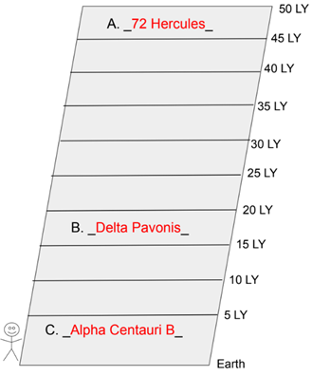

How does Model 1 support your claim?
The graphic representation shows that the closer the star is to Earth, the brighter the star appears. Alpha Centauri B is closest to Earth and has the greatest apparent brightness. 72 Hercules is farthest from Earth and has the least apparent brightness.
Prompt 3
Part A.
Make a line graph to show the relationship between each distance from the wall and the diameter of the flashlight’s beam on Graph 1. Use data from Table 4.
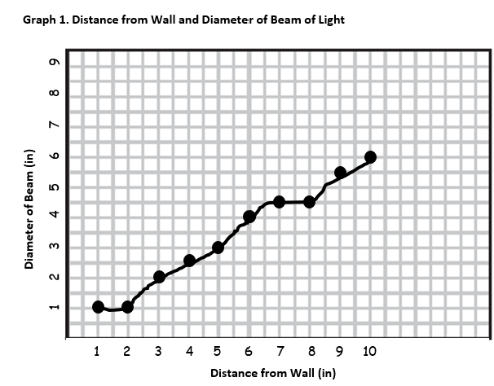
Graph 1. Distance from Wall and Diameter of Beam of Light

Circle the statement which best represents the data plotted in Graph 1.
- If the distance of the light source is farther, then the diameter of the beam is smaller.

- If the distance of the light source is closer, then the diameter of the beam is smaller.

- If the distance of the light source is closer, then the diameter of the beam is larger.
Part B.
Claim
If the distance of the light source is farther, then the light source appears dimmer. So, the sun appears brighter and larger than other stars when observed from Earth.
Evidence
Use at least two pieces of evidence from at least one of Tables 1 - 4 and Graph 1 to support your claim.
Evidence from Tables 1, 2, 3 or 4
- The absolute brightness of the Sun is 4.83. The absolute brightness of 72 Hercules is 4.43. They have about the same absolute brightness. But the sun appears much brighter because it is very close to Earth compared to 72 Hercules which is 46.9 Light Years from Earth.
Evidence from Graph 1
- The graph showing the flashlight data shows how light from a close light source appears small and bright compared to when the flashlight is further away, and the light is more spread out and less bright.
Note: Answers may vary. Accept reasonable evidence that shows the Sun would have the greatest apparent brightness.
Reasoning
Explain how the evidence supports your claim.
The star closest to Earth is the sun. The sun appears the largest and brightest. This is because it is closer to the Earth than other stars.
Task Notes:

