Stackable Instructionally-embedded Portable Science (SIPS) Assessments Project

Grade 8 Science
Unit 4 Instructionally-embedded Assessment Task:
“Representing Wave Properties Mathematically”
Providing Solutions to Problems Using Simple Wave Properties
August 2023

The SIPS Grade 8 Science Unit 4 Instructionally-embedded Assessment Task: “Representing Wave Properties Mathematically” was developed with funding from the U.S. Department of Education under the Competitive Grants for State Assessments Program, CFDA 84.368A. The contents of this paper do not represent the policy of the U.S. Department of Education, and no assumption of endorsement by the Federal government should be made.

All rights reserved. Any or all portions of this document may be reproduced and distributed without prior permission, provided the source is cited as: Stackable Instructionally-embedded Portable Science (SIPS) Assessments Project. (2023). SIPS Grade 8 Science Unit 4 Instructionally-embedded Assessment Task: “Representing Wave Properties Mathematically”. Lincoln, NE: Nebraska Department of Education.
SIPS Grade 8 Unit 4 Instructionally-embedded Assessment Task
Grade 8 | Unit 4 | Instructional Segment 1 | Task Title: Representing Wave Properties Mathematically
NGSS Performance Expectations Code(s) and Description(s)
Code | Description
MS-PS4-1. | Use mathematical representations to describe a simple model for waves that includes how the amplitude of a wave is related to the energy in a wave. [Clarification Statement: Emphasis is on describing waves with both qualitative and quantitative thinking.] [Assessment Boundary: Assessment does not include electromagnetic waves and is limited to standard repeating waves.]
Acquisition Goals Number(s) and Descriptions(s)
A4. | Develop and use a model to describe and identify the wavelength, frequency, and amplitude of a wave.
A5. | Use mathematical and computational thinking to show that the wavelength and frequency of a wave are related to one another by the speed of travel of the wave.
A6. | Apply their understanding to real-world phenomena about the ability of waves to transfer energy without overall displacement.
Evidence Statements
- Accurately describe how a simple wave has a repeating pattern of specific wavelength, frequency, and amplitude.
- Accurately apply the simple mathematical wave model to a physical system or phenomenon to identify how a wave is a repeating pattern of motion that transfers energy from place to place.
- Accurately describe how a simple mathematical wave model corresponds to the properties of a physical phenomenon.
- Accurately apply the simple mathematical wave model to a physical system or phenomenon to identify how the wave model characteristics correspond with physical observations.
- Generate mathematical representations of the relationship between properties of waves to show that the wavelength and frequency of a wave are related to one another by the speed of travel of the wave.
- Accurately identify the evidence that supports a claim about how waves are a repeating pattern of motion that transfers energy from place to place without overall displacement of matter.
- Describe how mathematical representations support conclusions about differences in one property of a wave that will result in differences in the amount of energy present or transmitted.
Source Documentation and Information Resources References (e.g., publications, websites, citations, images, videos, etc.)  Please include source name, description, citation, and a link to its original location below. Include additional rows as needed. |  |  |  | Licensing: Please mark an “X” under the appropriate licensing. If resource is not under a creative commons (CC) license, please attempt to find a source with CC licensing. If you are unable, please select other and provide additional information about the source in the source documentation section.
 |  |  |  | CC0/  Public Domain | CC BY | CC BY-SA | CC BY-NC | CC BY-NC-SA | CC BY-ND | CC BY-NC-ND | Other
The World’s Loneliest Whale  - The World's Loneliest Whale - YouTube  [https://www.youtube.com/watch?v=spFrDWfvnds] |  |  |  |  |  |  |  |  |  |  | X
OpenSciEd Frequency Simulation  - Hitting the High Notes (openscied-static.s3.amazonaws.com)  [https://openscied-static.s3.amazonaws.com/HTML+Files/openscied-sound-interactives-master/sound.html?version=v3] |  |  |  |  | X
National Oceanic and Atmospheric Administration  - Blue Whale Call 1  [pmel.noaa.gov/acoustics/whales/sounds/whalewav/nepblue24s10x.wav] |  |  |  | X
National Oceanic and Atmospheric Administration  - Blue Whale Call 2  [pmel.noaa.gov/acoustics/whales/sounds/whalewav/etpb3_10xc-BlueWhaleSouthPacific-10x.wav] |  |  |  | X
National Oceanic and Atmospheric Administration  - 52 Blue Call 3  [pmel.noaa.gov/acoustics/whales/sounds/whalewav/ak52_10x.wav] |  |  |  | X

Teacher Administration Guide

Introduction
- Educators developed the accompanying classroom task to align to one or more aspects of the NGSS Performance Expectation(s) (PEs) to determine where students are in their learning at a specific point in time during an instructional sequence. Educators will need to make intentional decisions about when and how to use this task based on their students’ learning needs, the purpose of giving the task, and the intended use of the evidence gathered.
- This task is designed to measure students’ ability to integrate the dimensions and demonstrate their knowledge, skills, and abilities as represented by NGSS Performance Expectation MS-PS4-1. By administering this task, educators can gather and evaluate evidence to make accurate and meaningful judgments about students’ science learning and determine how instruction may need to be adjusted along an instructional sequence to best support students.
- The phenomenon in this task is related to how scientists have identified Blue 52, ‘The Loneliest Whale,’ using properties of waves and mathematical models of sound waves to identify aquatic mammals (i.e., a blue whale).
- In this task, students develop and use a mathematical representation to explain how different amplitudes or frequencies of mechanical waves have different amounts of energy when in the same medium.
- Background information:
  - Students previously discovered that (1) a wave is a repeating pattern, and (2) for a given wave, wavelength, frequency, and amplitude are properties that do not change and can be repeated in a given time.
  - In this assessment, students are presented with a scenario related to the whale known as Blue 52, a large male whale that is possibly a hybrid of two other species of whale. The wave characteristic used to identify this whale by its call is the frequency, 52Hertz. No other whales making this whale call have been detected.
Administration Guidelines
- One (1) class period
- Segment 1 Lesson: “Wave Properties Investigation”
- Students individually complete a series of prompts reflecting the following chain of sensemaking:
  - Students determine that sound is a series of vibrations of matter that transfer energy, not matter.
  - Students interpret models of sound waves to describe the qualitative and quantitative relationships among wave properties (wavelength, frequency, wave speed, and amplitude).
  - Students use a model of a transverse wave to apply mathematical and computational thinking to show that the wavelength and frequency of a wave are related to one another by the speed of travel of the wave.
  - Students apply understanding of sound waves to real-world phenomena (i.e., the frequencies heard by various organisms and the scenario of Blue 52, ‘The Loneliest Whale’).
Accessibility Considerations
Providing a range of accessibility considerations in the task (e.g., multiple ways of representing information, multiple types of supports, multiple ways in which students respond) promotes equity and fairness across a wide range of students who may be at different points in their science learning. In turn, these considerations can promote student interest and engagement in the tasks resulting in a more complete and accurate collection of evidence of students’ science learning.
Accommodations for students with a disability or Multilingual Learners that are part of their on-going instructional programs are to be provided during the administration of this task. Accommodations should be consistent with those provided student’s daily instructional strategies and assessment opportunities including assistive technology devices if appropriate. These accessibility considerations and accommodations enable accurate inferences about student learning and inform meaningful adjustments to planning and instruction.
- Turn on closed captioning when showing video.
Ancillary Materials
- Access to view video, The World’s Loneliest Whale, (https://www.youtube.com/watch?v=spFrDWfvnds) presented in the Task Scenario as a whole class or individually with earbuds.
- Access to a laptop to listen to the Blue Whale calls in Figure 1 (https://openscied-static.s3.amazonaws.com/HTML+Files/openscied-sound-interactives-master/sound.html?version=v3).
Instructions for Administering the Performance Task or Implementing the Research Task, Design Project, or Lab
- Read aloud the Task Scenario and show the linked video, The World’s Loneliest Whale (https://www.youtube.com/watch?v=spFrDWfvnds). Allow 1.24 minutes to view the video.
- Make sure closed captioning is on.
- Teachers may choose to play the linked Blue Whale sounds to the whole class, or students may use earbuds to listen on their own.
- Students work independently to complete the remainder of the task.
Scoring Guidance
- A task-and prompt-specific scoring rubric indicates scoring criteria for each prompt across a range of score points.
- Student exemplars represent high-quality responses that align to full-point rubric scores. The exemplar responses are intended to assist educators’ understanding of the nature and expectations of each prompt when applying the scoring rubric. Note the exemplars serve as examples of high-quality responses, and students may respond with equally relevant, scientifically accurate responses and ideas that meet the expectations of a full-point rubric score. In general, the exemplar response associated with the highest score point in the rubric meets expectations and is scientifically accurate, complete, coherent, and consistent with the type of student evidence expected as described in the rubric.
- The approximate scoring time for this task will be 5 to 10 minutes per student.

Student Task
This task is about the properties of waves.
Task Scenario
Whales communicate with each other through the production of clicks that travel across sound waves. Just as with humans, each group of whales has its own dialect.
In 1989, a team of scientists discovered a unique sound in the ocean. It was later determined that the sound came from a single whale that communicates at an unusual frequency of 52 Hertz (Hz). A frequency of 52 Hz means fifty-two vibrations per second. This whale is often referred to as “Blue 52.”
Watch the video, “The World’s Loneliest Whale,” to find out more about the characteristics of Blue 52.

Prompt 1
Use the word bank to complete the sentences below. Not all words need to be used and some words can be used more than once.
Word Bank
energy | perpendicularly | transverse
speed | wave | longitudinal
horizontally | wavelength | matter

A _____________ is a disturbance that transfers _____________ from one place to another.

- A wave transfers _________________ without transferring ___________________.

- The particles involved in sound waves move back and forth ____________________ to the way the wave is going.

- A ____________________ wave moves up and down while a ___________________ wave moves side to side.

Prompt 2

Whale calls can be represented as simple wave models. Figure 1 shows three different blue whale calls. The time period for each wave model is 1 second.
Figure 1. Blue Whale Call Wave Models
Blue Whale Call  and Pitch | Wave Cycles In 1 Second
Call 1  Blue Whale Call 1  Lower pitch | 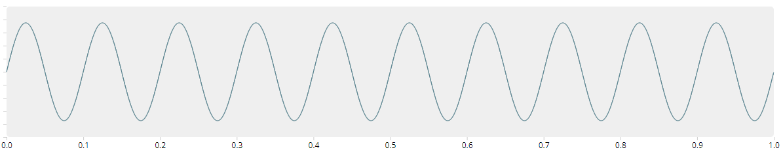  1  0  -1  Frequency = 10 Hz
Call 2  Blue Whale Call 2  Medium pitch | 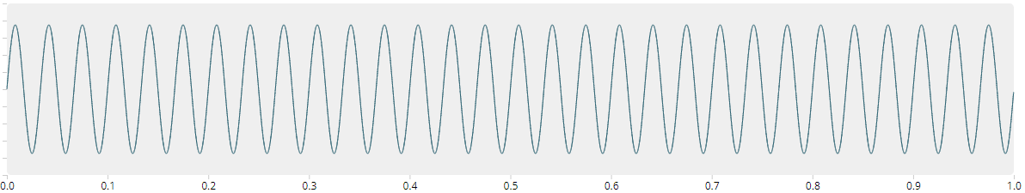  1  0  -1  Frequency = 30 Hz
Call 3  Blue 52 Call 3  Higher pitch | 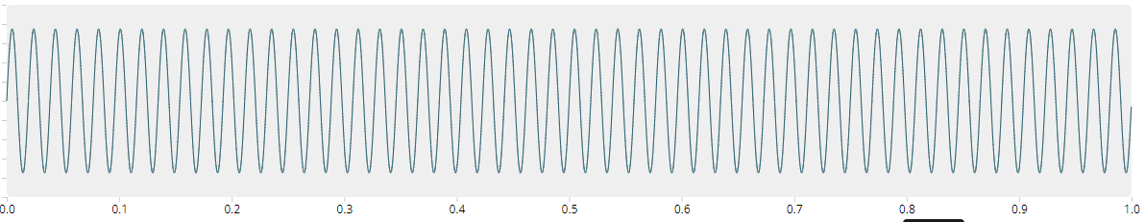  1  0  -1  Frequency = 52 Hz

What is the relationship between frequency and pitch in Figure 1?

The greater the frequency, _______________________________________________________.

What is the relationship between frequency and wavelength in Figure 1?

The greater the frequency, _______________________________________________________.

Prompt 3
Wave diagrams can be used to show the properties of waves. Figure 2 shows the troughs and crests of a transverse wave.
Figure 2. Transverse Wave Diagram
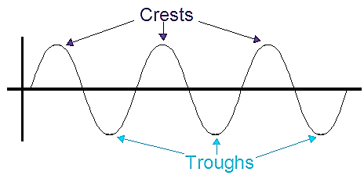
Part A.
Consider a wave having a vertical distance of 16 cm from its trough to crest and a horizontal distance of 24 cm from its crest to the nearest trough.
Determine the amplitude and wavelength of such a wave. Use the properties of a wave shown in Figure 2 to explain your answer.
_____________________________________________________________________________________

_____________________________________________________________________________________

______________________________________________________________________________

_____________________________________________________________________________________
Part B.
The speed of sound in water, at 25°C, is 1,498 m/s. The sound produced by the whale “Blue 52” is 52Hz.
Calculate the wavelength of Blue 52’s call. Show your work in the space below.

Part C.
What is the relationship between the speed of sound, frequency, and wavelength of a sound wave? Assume the frequency of the wave remains constant.

______________________________________________________________________________

______________________________________________________________________________

______________________________________________________________________________

______________________________________________________________________________
Prompt 4
Part A.
The frequency of “Blue 52’s” call is 52 Hz.

Table 1 shows the range of frequencies heard by different animals.

Table 1. Frequency Range Heard by Animals
Animal | Frequency (Hz)
Bat | 2,000 – 110,000
Porpoise | 75 – 150,000
Cat | 45 – 64,000
Beluga whale | 1,000 – 123,000
Elephant | 16 – 12,000
Human | 20 – 20,000
Dog | 67 – 45,000

Identify which animal or animals shown in Table 1 cannot hear “Blue 52’s” call. Explain your answer.
_____________________________________________________________________________________

_____________________________________________________________________________________

_____________________________________________________________________________________

_____________________________________________________________________________________

_____________________________________________________________________________________

Part B.
A porpoise can make calls up to 120,000 Hz, while blue whales can make calls down to 14 Hz.

Explain why OR why NOT humans can hear the high- and low-pitched sounds made by porpoises and blue whales.

_____________________________________________________________________________________

_____________________________________________________________________________________

_____________________________________________________________________________________

Part C.
In the open ocean, low frequency sounds travel further with less scattering and distortion.

List two reasons why the pitch of the “Blue 52’s” call as compared to other blue whales results in “Blue 52” being known as the world’s loneliest whale.

Reason 1:_____________________________________________________________________________

_____________________________________________________________________________________

_____________________________________________________________________________________

Reason 2:_____________________________________________________________________________

_____________________________________________________________________________________

_____________________________________________________________________________________

Task Rubric to Evaluate Student Evidence
Task | Score Point 0 | Score Point 1 | Score Point 2 | Score Point 3 | Score Point 4
Prompt 1 | No aspect of the response is correct | Response includes the following aspects:  - At least two (2) sentences are correct | Response includes the following aspects:  - All four (4) sentences are correct | NA | NA
Prompt 2 | No aspect of the response is correct | - Response includes one (1) of the two (2) aspects | Response includes the following aspects:  - Greater frequency corresponds to higher pitch  - Greater frequency corresponds to shorter wavelength | NA | NA
Prompt 3 Part A. | No aspect of the response is correct | Response includes one (1) of the three (3) aspects | Response includes two (2) of the three (3) aspects | Response includes the following aspects:  - Amplitude is 8 cm  - Wavelength is 48 cm  - Explanation of how calculations are made based on crests and troughs | NA
Prompt 3 Part B. & Part C. | No aspect of the response is correct | Response includes one (1) of the three (3) aspects | - Response includes two (2) of the three (3) aspects | Response includes the following aspects:  Part B  - Wavelength is 28.8 m with work shown  Part C  - Relationship between frequency and wavelength is inverse  - Relationship between speed and wavelength is direct | NA
Prompt 4. | No aspect of the response is correct | Response includes one (1) of the four (4) aspects | - Response includes two (2) of the four (4) aspects | Response includes three (3) of the four (4) aspects | Response includes the following aspects:  Part A  - Bats, porpoises, beluga whales, and dogs cannot hear Blue 52  Part B  - Humans cannot hear very low-pitched sounds (14 Hz) or very high-pitched sounds (120,000 Hz)  Part C  - Pitch of the Blue 52 song is higher than the sounds made by other blue whales  - The low pitch of Blue 52’s call will not travel as far as other blue whales’ calls due to scattering and distortion

Exemplar Responses
Prompt 1
Use the word bank to complete the sentences below. Not all words need to be used and some words can be used more than once.

A wave is a disturbance that transfers energy from one place to another.
- A wave transfers energy without transferring matter.
- The particles involved in sound waves move back and forth perpendicular to the way the wave is going.
- A transverse wave moves up and down while a longitudinal wave moves side to side.
Prompt 2
What is the relationship between frequency and pitch in Figure 1?
The greater the frequency, the higher the pitch.
What is the relationship between frequency and wavelength in Figure 1?
The greater the frequency, the shorter the wavelength.
Prompt 3
Part A.
Determine the amplitude and wavelength of such a wave. Use the properties of a wave shown in Figure 2 to explain your answer.
The amplitude is 8 cm and the wavelength is 48 cm. Amplitude is the distance from the rest position to the crest position which is half the vertical distance from a trough to a crest. Wavelength is the distance from crest to crest, which is twice the horizontal distance from crest to nearest trough.
Part B.
The speed of sound in water, at 25°C, is 1,498 m/s. The sound produced by the whale “Blue 52” is 52Hz. Calculate the wavelength of Blue 52’s call. Show your work in the space below.
Wavelength = speed/frequency
Wavelength = 1,498m/s ÷ 52/sec
Wavelength = 28.8 m
Part C.
What is the relationship between the speed of sound, frequency, and wavelength of a sound wave? Assume the frequency of the wave remains constant.
The relationship between the speed of sound, its frequency, and wavelength is the same as for all waves: speed = frequency/wavelength. The relationship between frequency wavelength is inverse. So, the higher the frequency, the shorter the wavelength of a sound wave. If the frequency does not change, then a wave traveling faster will have a greater wavelength.
Prompt 4
Part A.
Identify which animal or animals shown in Table 1 cannot hear “Blue 52’s” call. Explain your answer.
Bats, porpoises, beluga whales, and dogs cannot hear Blue 52 because they cannot detect sounds as low as 52 Hz.
Part B.
Explain why OR why NOT humans can hear the high- and low-pitched sounds made by porpoises and blue whales.
No, humans cannot hear very low or very high-pitched sounds. Humans cannot detect sounds as low as 14 Hz or sounds as high as 120,000 Hz. So, a human would not hear these sounds.
Part C.
List two reasons why the pitch of the “Blue 52’s” call as compared to other blue whales results in “Blue 52” being known as the world’s loneliest whale.
Reason 1: The pitch of Blue 52’s call is higher than the low-pitched sounds made by other blue whales.
Reason 2: Also, because Blue 52’s call is a higher pitch, the sound will not travel as far. So other blue whales will not recognize Blue 52’s sound or could be too far away to hear it.
Task Notes:

