Stackable Instructionally-embedded Portable Science (SIPS) Assessments Project

Grade 5 Science
Unit 4 Instructionally-embedded Assessment Task:
“How Does My Constellation Move?”
Earth and Its Gravitational Force and Motion
September 2023

The SIPS Grade 5 Science Unit 4 Instructionally-embedded Assessment Task: “How Does My Constellation Move?” was developed with funding from the U.S. Department of Education under the Competitive Grants for State Assessments Program, CFDA 84.368A. The contents of this paper do not represent the policy of the U.S. Department of Education, and no assumption of endorsement by the Federal government should be made.

All rights reserved. Any or all portions of this document may be reproduced and distributed without prior permission, provided the source is cited as: Stackable Instructionally-embedded Portable Science (SIPS) Assessments Project. (2023). SIPS Grade 5 Science Unit 4 Instructionally-embedded Assessment Task: “How Does My Constellation Move?”. Lincoln, NE: Nebraska Department of Education.
SIPS Grade 5 Unit 4 Instructionally-embedded Assessment Task
Grade 5 | Unit 4 | Instructional Segment 4 | Task Title: How Does My Constellation Move?
NGSS Performance Expectations Code(s) and Description(s)
Code | Description
5-ESS1-2. | Represent data in graphical displays to reveal patterns of daily changes in length and direction of shadows, day and night, and the seasonal appearance of some stars in the night sky. [Clarification Statement: Examples of patterns could include the position and motion of Earth with respect to the sun and selected stars that are visible only in particular months.] [Assessment Boundary: Assessment does not include causes of seasons.]
Acquisition Goals Number(s) and Descriptions(s)
Number | Description
A17. | Analyze and interpret data on the visible constellations at a location to determine if some constellations are visible throughout the year.
A18. | Engage in argument from evidence on why some constellations are visible at a location only at some part of the year.
Evidence Statements
- Describe patterns in data to determine if some constellations are visible throughout the year.
- Represent data about the visibility of constellations to determine if some constellations are visible throughout the year.
- Use data to support conclusions about whether or not some constellations are visible throughout the year.
- Identify evidence that supports an explanation that some constellations are visible throughout the year.

Source Documentation and Information Resources References (e.g., publications, websites, citations, images, videos, etc.)  Please include source name, description, citation, and a link to its original location below. Include additional rows as needed. | Licensing: Please mark an “X” under the appropriate licensing. If resource is not under a creative commons (CC) license, please attempt to find a source with CC licensing. If you are unable, please select other and provide additional information about the source in the source documentation section.
 | CC0/  Public Domain | CC BY | CC BY-SA | CC BY-NC | CC BY-NC-SA | CC BY-ND | CC BY-NC-ND | Other
Video  - Follow the Drinking Gourd - YouTube  [https://www.youtube.com/watch?v=pw6N_eTZP2U] | X
Ursa Major and Ursa Minor image  - What is the North Star and How Do You Find It? – NASA Solar System Exploration *  [https://solarsystem.nasa.gov/news/1944/what-is-the-north-star-and-how-do-you-find-it/] | X
Protractor  - File: Protractor measure small.gif - Wikimedia Commons  [https://commons.wikimedia.org/wiki/File:Protractor_measure_small.gif] | X
Night sky  - File: Night sky from Tony Grove Lake, United States.jpg - Wikimedia Commons  [https://commons.wikimedia.org/wiki/File:Night_sky_from_Tony_Grove_Lake,_United_States.jpg] | X

*NASA content – images, audio, video, and computer files used in the rendition of 3-dimensional models, such as texture maps and polygon data in any format – generally are not subject to copyright in the United States. You may use this material for educational or informational purposes, including photo collections, textbooks, public exhibits, computer graphical simulations, and Internet Web pages. This general permission extends to personal Web pages.

Teacher Administration Guide

Introduction
- Educators developed the accompanying classroom task to align to one or more aspects of the NGSS Performance Expectation(s) (PEs) to determine where students are in their learning at a specific point in time during an instructional sequence. Educators will need to make intentional decisions about when and how to use this task based on their students’ learning needs, the purpose of giving the task, and the intended use of the evidence gathered.
- This task is designed to measure students’ ability to integrate the dimensions and demonstrate their knowledge, skills, and abilities as represented by NGSS Performance Expectation 5-ESS1-2. By administering this task, educators can gather and evaluate evidence to make accurate and meaningful judgments about students’ science learning and determine how instruction may need to be adjusted along an instructional sequence to best support students.
- The phenomenon in this task involves using data to identify patterns and make predictions related to the appearance of some stars and/or constellations in the sky all year while others appear only at certain times of the year.
- In this task, students are introduced to stories about the Big Dipper from different times and human cultures. Students then use multiple pieces of evidence/data from different sources, such as tables and graphs to construct an explanation of the apparent movement of objects in the sky due to Earth's rotation on its axis and its revolution around the Sun using evidence/data, information from the task, and scientific knowledge in support.
- Background Information:
  - Students previously discovered (1) what causes shadows to change throughout the day and how it is related to the movement of the Earth around the sun, sunrises, and sunsets, and (2) how they’re connected to movements of the Earth.
  - In this assessment, students are assessed on their ability to analyze and interpret data and engage in arguments about how the changes in the positions of objects in the sky form predictable patterns as well as explaining the visibility of constellations throughout the year. For this task, the familiar asterism, The Big Dipper, and the star Polaris are the context.
Administration Guidelines
- One (1) class period
- Segment 4 Lesson: “How Does My Constellation Move?”
- Students individually complete a series of prompts reflecting the following chain of sensemaking:
  - Interpret the lyrics of an African-American folk song with regard to the positions of objects in the sky.
  - Use the lyrics of the folk son and a Native American story about Ursa Major, which includes the Big Dipper, to complete a representation showing the seasonal pattern of the appearance of the Big Dipper in the night sky as viewed from the Northern Hemisphere.
  - Use a bar graph showing the measured angle of a visible star over time to identify a pattern and make a prediction.
  - Develop an explanation with evidence about why the patterns of movement of objects in the day and night sky can be predicted and explained by Earth’s rotation on its axis, revolution around the sun, and position in the galaxy.
Accessibility Considerations
Providing a range of accessibility considerations in the task (e.g., multiple ways of representing information, multiple types of supports, multiple ways in which students respond) promotes equity and fairness across a wide range of students who may be at different points in their science learning. In turn, these considerations can promote student interest and engagement in the tasks resulting in a more complete and accurate collection of evidence of students’ science learning.
Accommodations for students with a disability or Multilingual Learners that are part of their on-going instructional programs are to be provided during the administration of this task. Accommodations should be consistent with those provided student’s daily instructional strategies and assessment opportunities including assistive technology devices if appropriate. These accessibility considerations and accommodations enable accurate inferences about student learning and inform meaningful adjustments to planning and instruction.
Ancillary Materials
- None
Instructions for Administering the Performance Task or Implementing the Research Task, Design Project, or Lab
- Preview and pose the scenario which includes the folk song, The Drinking Gourd, [https://www.youtube.com/watch?v=pw6N_eTZP2U] showing 1:12/2:28 min and the apparent movement of objects in the sky.
- Students will explore patterns of movement of objects in the day and night sky and relate those observations to Earth’s rotation on its axis, revolution around the sun, and position in the galaxy.
Scoring Guidance
- A task-and prompt-specific scoring rubric indicates scoring criteria for each prompt across a range of score points.
- Student exemplars represent high-quality responses that align to full-point rubric scores. The exemplar responses are intended to assist educators’ understanding of the nature and expectations of each prompt when applying the scoring rubric. Note the exemplars serve as examples of high-quality responses, and students may respond with equally relevant, scientifically accurate responses and ideas that meet the expectations of a full-point rubric score. In general, the exemplar response associated with the highest score point in the rubric meets expectations and is scientifically accurate, complete, coherent, and consistent with the type of student evidence expected as described in the rubric.
- The approximate scoring time for this task will be 10 to 15 minutes per student.

Student Task
This task is about how stars move across the sky.
Task Scenario
Since early times, people have found shapes in the stars. These shapes are called constellations. Many cultures created stories and myths about the stars we call the Big Dipper.
Follow the Drinking Gourd is an American folksong that is about how enslaved people in the American pre-Civil War South made their way north to freedom. The folksong provides a set of secret directions for using the stars as a map to travel north. A drinking gourd is a hollowed-out gourd used as a water dipper. In the song, the drinking gourd is a code name for a star formation, the Big Dipper.
Listen to the folksong here: Follow the Drinking Gourd – YouTube

Prompt 1
Part A.
Figure 1 shows Polaris, known as the North Star, which sits nearly directly above Earth's north pole along its rotational axis.
Figure 1. Location of Polaris as Seen from Earth
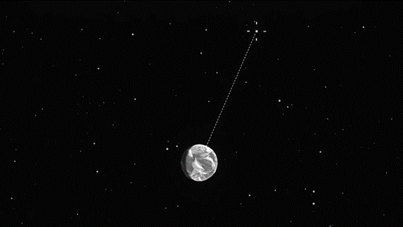
Earth
Polaris

When viewed from the Northern Hemisphere, Polaris always stays in about the same place in the sky. The Big Dipper can be used to locate Polaris. The two stars at the end of the Big Dipper's "cup" point the way to Polaris (See Figure 2).
Figure 2. Big Dipper and Little Dipper
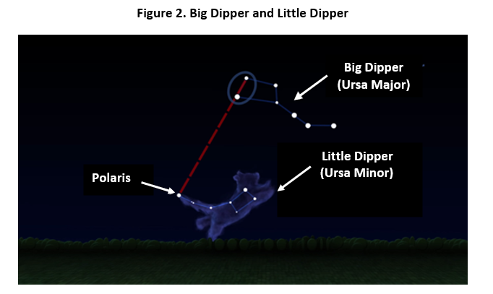

How does the song, Follow the Drinking Gourd, provide directions for enslaved people to make their way north at night?

_____________________________________________________________________________________

______________________________________________________________________________
______________________________________________________________________________

______________________________________________________________________________

______________________________________________________________________________

______________________________________________________________________________

Part B.
The Micmac people and the Iroquois people living in the northern hemisphere also had a story about the Big Dipper. The stars of Ursa Major (shown in Figure 2) include what we call the Big Dipper. They called this formation of stars Big Bear. They share a story about Big Bear in which seven hunters (the handle) chase the bear (the cup). As fall approaches, the star representing the hunters dips below the horizon. In late fall when the last hunter wounds the bear, the Big Dipper is no longer visible. During the following spring, a new bear leaves the den when the Big Dipper reappears in the night sky.
Figure 3 is an incomplete model of the Big Dipper’s apparent motion around Polaris during the four seasons of the year.

Complete the apparent motion of the Big Dipper during the other three seasons in Figure 3. The position of the Big Dipper is shown during the summer. Use clues from the song Follow the Drinking Gourd, how to locate Polaris using the Big Dipper, and the story told by the Micmac and the Iroquois people to show the locations of the Big Dipper in the other three seasons.

Draw the relative position of the Big Dipper by showing its seven (7) stars in fall, spring, and winter with respect to Polaris in the empty boxes.

Label each of your drawings as fall, spring, or winter on the blank line paired with each box.

Figure 3. Model of the Big Dipper’s Apparent Motion around Polaris

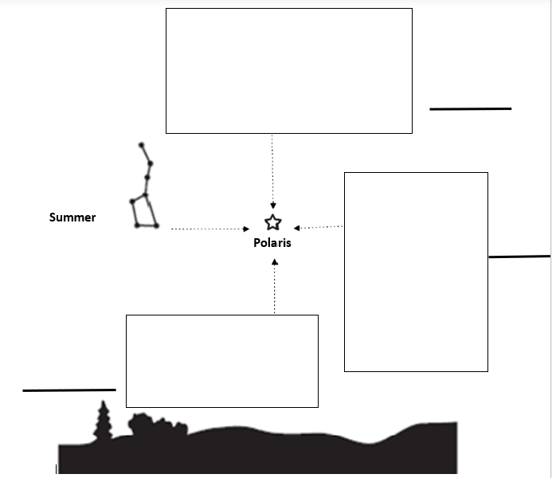
Summer

Part C.
The Big Dipper is to the west of Polaris in the Northern Hemisphere during the summer. Over the year, its position in the sky changes. A protractor, which measures 180 degrees or a half circle, can represent the horizon on Earth.
The Big Dipper contains a star named Dubhe. Dubhe is the star located at the lip of the cup in the Big Dipper. Figure 4 shows the Big Dipper’s star, named Dubhe, at approximately 45° above the horizon shown by the arrow.
Figure 4. Dubhe Located at 45° Above the Horizon
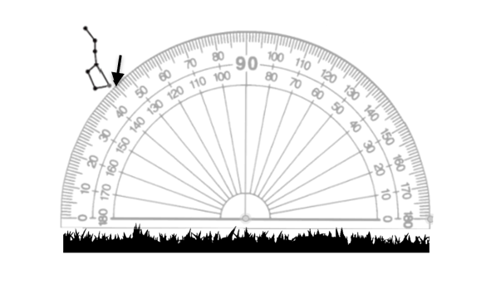

A student is collecting data about the position of the Big Dipper in the night sky. The observed angle of Dubhe in the night sky is measured at the same position and time of night for many weeks. The data collected is shown in Graph 1.
Graph 1. Angle of Dubhe in the Night Sky
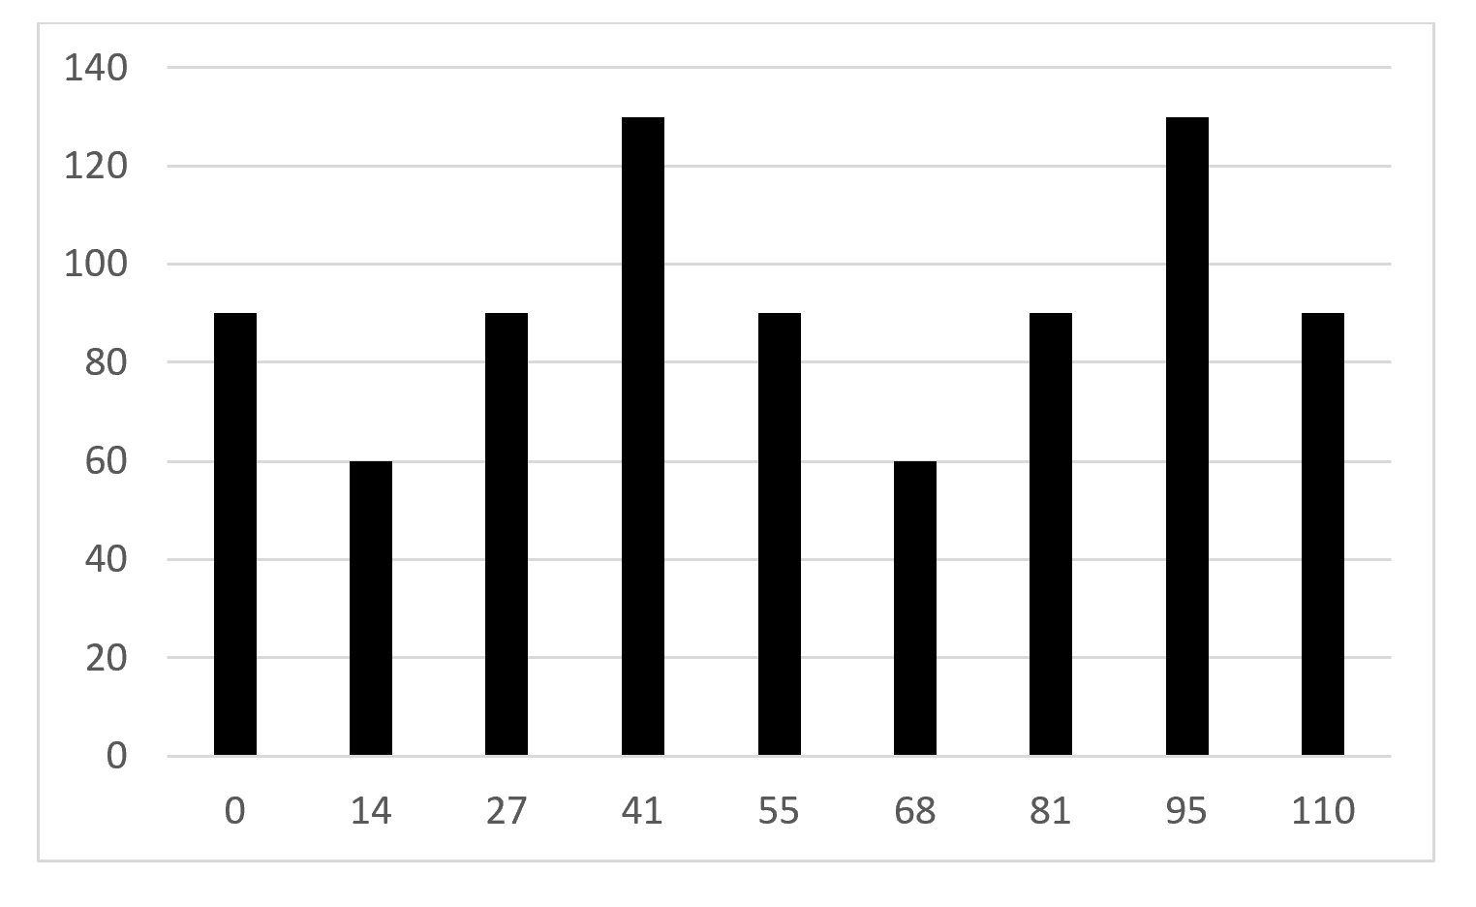
Number of Weeks
Angle (degrees)

Circle the statement which best describes the pattern shown in Graph 1.
- The star Dubhe can be seen in the night sky only sometimes.
- The star Dubhe is the most visible star in the Big Dipper.
- The position of star Dubhe does not change over time.
- The position of Dubhe in the night sky is predictable.

Prompt 2
Part A.
Two students are talking about another star, the sun, and its apparent location in the sky between sunrise and sunset. They each drew a picture to explain their ideas. Figure 5 shows the drawings and explanations made by Student A and Student B.
Figure 5. Drawings and Explanations from Students A and B
Student A: “I think the sun rises upward in the morning and sets downward towards night.” | Student B: “I think the sun rises on one side of Earth and sets on the other.”
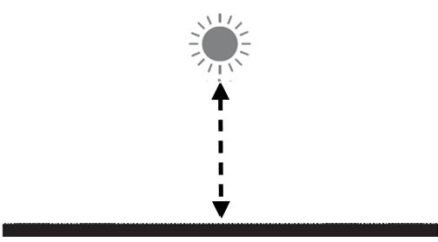 | 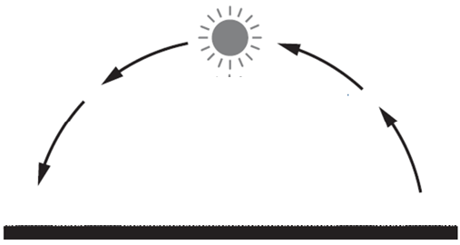

Which student’s drawing and explanation is correct? Circle your answer.
Student A Student B
Support your answer using what you know about the Sun-Earth system.

I know this because______________________________________________________________

______________________________________________________________________________

______________________________________________________________________________

Part B.
People since ancient times have used patterns of changes in the appearance of the sun in the daytime sky and the appearance of constellations in the night sky to predict seasonal changes in the weather. We know that:
- Earth’s sun is a star. From Earth, we can estimate the time of day by the pattern of sunrises and sunsets.
- The Big Dipper is formed by seven stars. From Earth, we can estimate the seasons by the pattern of movement of the stars in relation to Polaris.

Explain the movement of Earth which allows us to observe these regular daily AND yearly patterns when we look up at the daytime or nighttime sky.

Use the following terms in your explanation. Not all terms need to be used.

rotate | revolve | season | Earth | sun | axis
day | night | star | Big Dipper | direction | orbit

_____________________________________________________________________________________

______________________________________________________________________________
______________________________________________________________________________
_____________________________________________________________________________________

______________________________________________________________________________
_____________________________________________________________________________________

______________________________________________________________________________
______________________________________________________________________________

Task Rubric to Evaluate Student Evidence
Task | Score Point 0 | Score Point 1 | Score Point 2 | Score Point 3 | Score Point 4
Prompt 1  Part A. | No aspect of the response is correct | Response includes one (1) of the three (3) aspects | Response includes two (2) of the two (3) aspects | Response includes the following aspects:  - Identifies the drinking gourd as the Big Dipper  - Describes how the Big Dipper can be used to locate Polaris  - Concludes that facing Polaris ensured the enslaved person was traveling northwards | NA
Prompt 1  Part B. | No aspect of the response is correct | Response includes one (1) of the three (3) aspects | Response includes two (2) of the two (3) aspects | Model includes the following aspects:  - Three drawings of Big Dipper showing the two stars of the ‘cup’ (Dubhe & Merak) lining up with Polaris  - Three drawings of Big Dipper correctly showing the orientation of the Big Dipper’s ‘tail’ and cup  - Moving clockwise, labels spring, winter, fall | NA
Prompt 1 Part C. | No aspect of the response is correct | Response includes the following aspects:  - Selects option ‘D’ | NA | NA | NA
Prompt 2  Part A. | No aspect of the response is correct | Response includes one (1) of the two (2) aspects | Response includes the following aspects:  - Circles ‘Student B’  - Explanation describes the Sun-Earth system interaction resulting in the movement of the sun across the daytime sky | NA | NA
Prompt 2  Part B. | No aspect of the response is correct | Response includes one (1) of the three (3) aspects | Response includes two (2) of the three (3) aspects | Response includes the following aspects:  - Incorporates correctly at least nine (9) of the twelve (12) terms in the response  - Explains the cause of observable daily patterns of objects in the sky such as dawn & dusk due to the relative position of the Earth and its sun  - Explains the cause of observable annual patterns of objects in the sky such as the position of the Big Dipper, due to the relative positions of Earth, its sun, and the stars | NA

Exemplar Responses
Prompt 1
Part A.
How does the song, Follow the Drinking Gourd, provide directions for enslaved people to make their way north at night?
The "drinking gourd" is a secret name for the Big Dipper. The two stars that form part of the cup always point to Polaris. As long as you are facing Polaris, you are moving north. So, an enslaved person always knew the right direction to travel at night.
Prompt 1

Part B.

Complete the apparent motion of the Big Dipper during the other three seasons in Figure 3. The position of the Big Dipper is shown during the summer. Use clues from the song Follow the Drinking Gourd, how to locate Polaris using the Big Dipper, and the story told by the Micmac and the Iroquois people to show the locations of the Big Dipper in the other three seasons.

Draw the relative position of the Big Dipper, showing its seven (7) stars in fall, spring, and winter with respect to Polaris in the empty spaces.

Label each of your drawings as fall, spring, or winter on the blank line paired with each box.
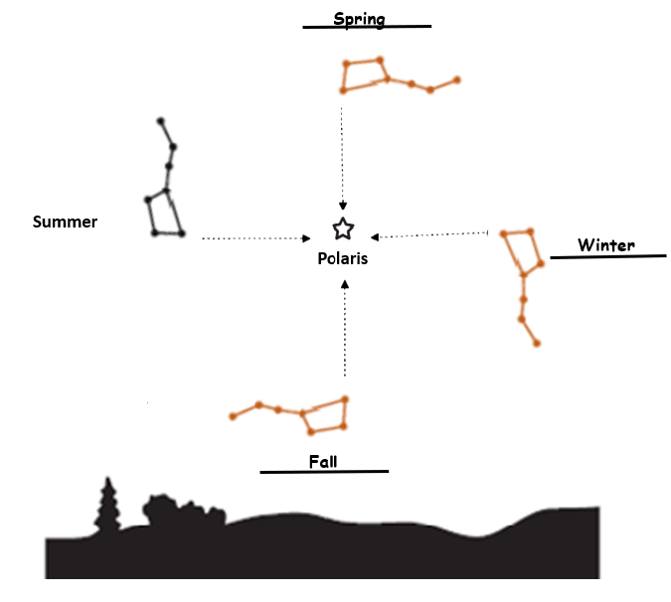
Prompt 1

Part C.
Circle the statement which best describes the pattern shown in Graph 1.
- The star Dubhe can be seen in the night sky only sometimes.
- The star Dubhe is the most visible star in the Big Dipper.
- The position of star Dubhe does not change over time.
- The position of Dubhe in the night sky is predictable.
Prompt 2
Part A.
Which student’s drawing and explanation is correct? Circle your answer.
Student A Student B
Support your answer using what you know about the Sun-Earth system.
I know this because the sun rises on the eastern horizon in the morning. Then the sun appears to travel across the sky and sets on the western horizon at night.
Note: Other appropriate explanations, such as Earth’s orbit around the sun, are acceptable.
Part B.
Explain the movement of Earth which allows us to observe these regular daily AND yearly patterns when we look up at the daytime or nighttime sky.
Use the following terms in your explanation. Not all terms need to be used.
rotate | revolve | season | Earth | sun | axis
day | night | star | Big Dipper | direction | orbit
We see the pattern of night and day because the Earth rotates on its axis once every day. When Earth rotates, one side of the planet faces the sun. That side experiences day. The side facing away from the sun is having night. The changes we see in the position of the Big Dipper are due to Earth’s orbit around the sun. As Earth orbits the sun, the side facing away sees the stars and constellations. Depending on the direction Earth is facing, the constellations appear differently in the night sky.
Task Notes:

