Stackable Instructionally-embedded Portable Science (SIPS) Assessments Project



SIPS Grade 8 Unit 3 End-of-Unit Assessment Scoring Guide

May 2025

The SIPS Grade 8 Unit 3 End-of-Unit Assessment Scoring Guide was developed with funding from the U.S. Department of Education under the Competitive Grants for State Assessments Program, CFDA 84.368A. The contents of this paper do not represent the policy of the U.S. Department of Education, and no assumption of endorsement by the Federal government should be made.

All rights reserved. Any or all portions of this document may be reproduced and distributed without
prior permission, provided the source is cited as: Stackable Instructionally-embedded Portable Science
(SIPS) Assessments Project. (2025). SIPS Grade 8 Unit 3 End-of-Unit Assessment Scoring Guide. Lincoln,
NE: Nebraska Department of Education.
Table of Contents
SIPS Grade 8 Unit 3 EOU Assessment Task 1: A Whale of a Tale! ..............................................................1
Task 1 Scoring Rubric ..............................................................................................................................7
Task 1 Student Exemplars .......................................................................................................................9
SIPS Grade 8 Unit 3 EOU Assessment Task 2: Hold Your Horses! .............................................................12
Task 2 Scoring Rubric .............................................................................................................................19
Task 2 Student Exemplars ......................................................................................................................22
SIPS Grade 8 Unit 3 EOU Assessment Task 3: What Beak-ame of You? ………............................................25
Task 3 Scoring Rubric .............................................................................................................................31
Task 3 Student Exemplars ......................................................................................................................34


SIPS Grade 8 Unit 3 EOU Assessment Task 1: A Whale of a Tale!

Student Worksheet

This task is about the fossil record.

Task
In the 1980s, a fossil was discovered in a mountainous, semi-arid region of Pakistan. Scientists determined it was a terrestrial, wolf-like animal that lived along the margins of a large shallow ocean where it ate fish and small animals. The extinct animal’s fossils and images are shown in Picture 1.
Picture 1. Extinct Fossil and Image
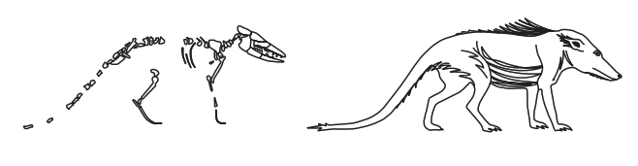
By studying fossils, scientists can piece together what happened in Earth’s past and the evolutionary history between organisms living today!

Prompt 1
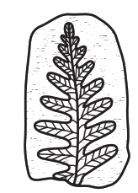
Fossils can be used to reconstruct the environment in the location at the time an organism was living.
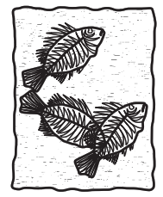

Fossil A Fossil B

Part A.
Describe the type of ecosystem in which each fossil, Fossil A and Fossil B, was formed. Explain your answer for each fossil.
______________________________________________________________________________

______________________________________________________________________________

______________________________________________________________________________

______________________________________________________________________________
Part B.
Geologists use geologic columns to describe and explain the rock strata and fossils found in a given location. For example, a dotted pattern may represent sandstone, and a block pattern may represent limestone. That way, geologists know what types of rocks are in the sequence at that location. Then they can compare the rocks of the same relative age across various locations to develop a composited column.
Figure 1. Geologic Columns from Three Locations
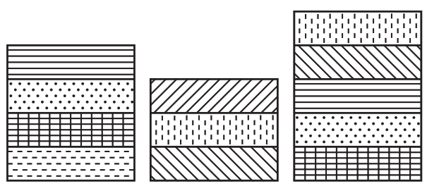
Location 1 Location 2 Location 3

Figure 2 shows two different fossils found in rock strata in Location 1 and Location 2 from Figure 1.

Figure 2. Geologic Columns Containing Found Fossils
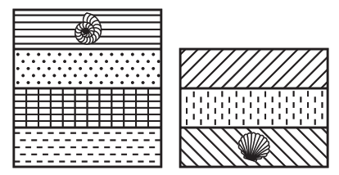

Location 1 Location 2

Identify the location in which the oldest fossil was found. Explain how you used the geologic columns in Figure 1 and Figure 2 to identify the relative ages of the two fossils.

______________________________________________________________________________

______________________________________________________________________________

______________________________________________________________________________

______________________________________________________________________________

______________________________________________________________________________

______________________________________________________________________________

Prompt 2
Part A.
To learn about Earth’s history, scientists also look at the shape of the fossils they find and compare them to the bones of living creatures today.
The images in Table 1 are fossils of organisms that lived long ago. Each fossil is an ancestor of modern dolphins and whales.
Table 1. Fossils of Extinct Organisms
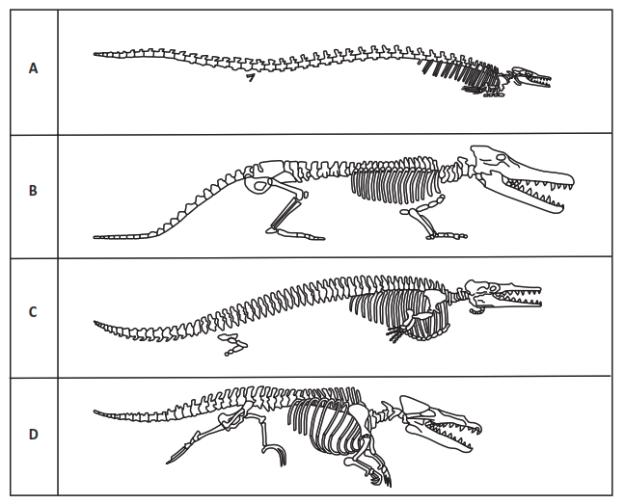

Figure 3 shows the relationship of extinct organisms from a wolf-like terrestrial mammal shown at the top of the figure that led to today’s dolphins and whales at the bottom of the figure.
Use the letters in Table 1 (A, B, C, D) to sequence the organisms and their changes over time in the boxes in Figure 3. Use one letter in each box.
Figure 3. Changes in Organisms Over Time
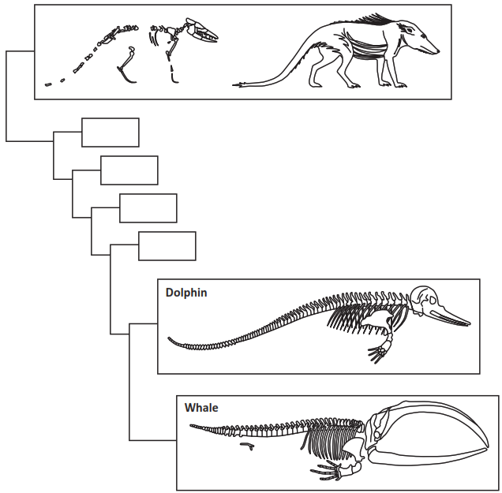

Part B.
Identify at least two patterns in the fossil record shown in your completed Figure 3 and the fossils shown in Table 1 that can be used to determine the sequence of changes over time that led to today’s whales. ______________________________________________________________________________
______________________________________________________________________________
______________________________________________________________________________
______________________________________________________________________________
______________________________________________________________________________
Part C.
Use your completed Figure 3 to support the following claim:
Prehistoric creatures with whale-like features once lived on land. The fossil record shows a gradual change in physical features which corresponds to adaptation to living in aquatic environments. These adaptations led to modern-day whales.

Include information about:
- Features for living on land versus living in water
- Structures of the fossils which resemble modern whales
- Transitional forms of prehistoric creatures to more well-known species of groups of organisms
______________________________________________________________________________
______________________________________________________________________________
______________________________________________________________________________
______________________________________________________________________________
______________________________________________________________________________
______________________________________________________________________________
______________________________________________________________________________
______________________________________________________________________________

SIPS Grade 8 Unit 3 EOU Assessment Task 1 Rubric (MS-ESS1-4, MS-LS4-1, MS-LS4-2)
Prompt | Score Point 0 | Score Point 1 | Score Point 2 | Score Point 3 | Score Point 4
Prompt 1  Part A.  Scored Responses | No aspect of the response is correct | Identifies at least one (1) of the two (2) aspects | Response includes the following aspects:  - The fern/plant fossil indicates a terrestrial environment  - The fish fossil indicates an aquatic environment | NA | NA
Prompt 1  Part B.  Scored Responses | No aspect of the response is correct | Identifies one (1) of the three (3) aspects | Identifies two (2) of the three (3) aspects | Response includes the following aspects:  - Identifies the oldest fossil is in Location 1  - Describes relative age of different rock strata  - Includes a comparison of all three locations in Figure 1 (e.g., Law of Superposition) | NA
Prompt 2 Part A. & Part B.  Scored Responses | No aspect of the response is correct | Identifies one (1) of the three (3) aspects | Response includes the following three (3) aspects:  - Places two (2) of the four (4) organisms in order of anatomical similarities  - Explanation includes one (1) of the two (2) patterns of changes (e.g., the changes in the limbs; changes in vertebrae) | Response includes the following six (6) aspects:  - Places the four (4) organisms in order of anatomical similarities (B, D, C, A)  - Explanation includes two (2) patterns of changes (e.g., the changes in the limbs; changes in vertebrae) | NA
Prompt 2 Part C.  Scored Responses | No aspect of the response is correct | - Identifies one (1) of the three (3) aspects | - Identifies two (2) of the three (3) aspects | Response includes the following aspects:  - Describes the changes to features that are advantageous to living in water  - Identifies structural similarities in the fossil sequence  - Identifies evidence to support the claim | NA

Student Exemplar(s)

Student exemplars represent high-quality responses that align to full-point rubric scores. The exemplar responses are intended to assist educators’ understanding of the nature and expectations of each prompt. Note the exemplars serve as examples of high-quality responses, and students may respond with equally relevant, scientifically accurate responses and ideas that meet the expectations of a full-point rubric score.

Prompt 1
Part A.
Describe the type of ecosystem in which each fossil, Fossil A and Fossil B, was formed. Explain your answer for each fossil.
Fossil A looks like a fern plant. Ferns live on land environments. So, Fossil A may have formed in a forest environment. Fossil B is a fish fossil. Fossil B must have formed in a lake or ocean because fish live in the water.
Part B.
Identify the location in which the oldest fossil was found. Explain how you used the geologic columns in Figure 1 and Figure 2 to identify the relative ages of the two fossils.

Even though the fossil in Location 1 is in a position closer to the surface of the Earth than the fossil in Location 2, it is the older fossil. By looking at the rock types and the layers across the three locations, the oldest layer was the bottom of Location 1. If I sequence all three geological columns in Figure 1, the fossil in Location 2 would be above the fossil in Location 1.

Prompt 2
Part A.
Use the letters in Table 1 (A, B, C, D) to sequence the organisms and their changes over time in the boxes in Figure 3. Use one letter in each box.
Figure 3. Changes in Organisms Over Time
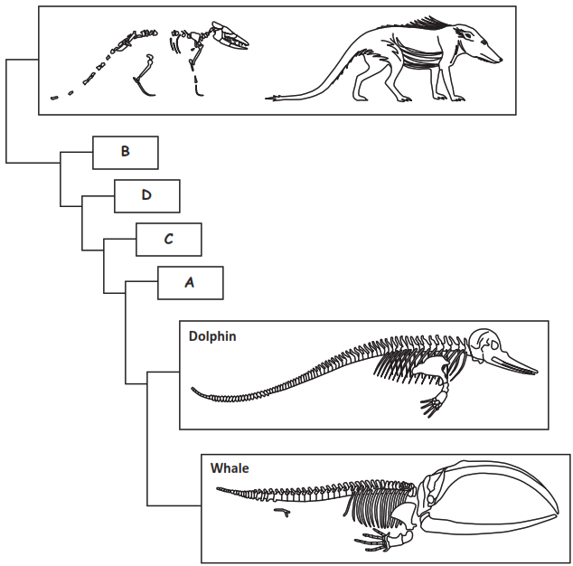

Part B.
Identify at least two patterns in the fossil record shown in your completed Figure 3 and the fossils shown in Table 1 that can be used to determine the sequence of changes over time that led to today’s whales.

Patterns of changes in the limbs from legs to flippers and changes in body shape to a more streamlined shape for swimming and the bones of the vertebrae getting larger helped determine the sequence of changes over time.
Part C.
Use your completed Figure 3 to support the following claim:
Prehistoric creatures with whale-like features once lived on land. The fossil record shows a gradual change in physical features which corresponds to adaptation to living in aquatic environments. These adaptations led to modern-day whales.

Include information about:
- Features for living on land versus living in water
- Structures of the fossils which resemble modern whales
- Transitional forms of prehistoric creatures to more well-known species of groups of organisms
Figure 3 shows a sequence of transitional fossils with some similarities in different structures with today's whales. It also shows that ancient mammals with these features walked on land. Early species had four limbs. Generally, the fossils show that these animals gradually adapted to living in the water. The gradual loss of hind legs shows these creatures no longer lived on land and developed a stronger backbone to support a tail for swimming. The fossil evidence does support the claim that prehistoric creatures with whale-like features living on land show a gradual set of adaptations that led to modern-day whales.

SIPS Grade 8 Unit 3 EOU Assessment Task 2: Hold Your Horses!

Student Worksheet

This task is about the evolution of horses.

Task
Horses can weigh well over a thousand pounds and still outrun most other animals. One of the fastest horses is Winning Brew. She has been recorded running nearly 44 miles per hour! Winning Brew is a Thoroughbred. Thoroughbreds have long legs with lean muscular bodies. They have been bred for racing. Modern horses are often bred for selected traits such as speed or strength.
Modern horses can be 6 feet tall and weigh 2,000 pounds. Compared to modern horses, one of their ancestors was only 2.5 feet tall and weighed about 20 pounds. By studying fossils, scientists can piece together the evolutionary history of horses.

Prompt 1
Part A.
Table 1 shows the change in height of horses and their ancestors over the last 50 million years.
Table 1. Height of Horses Over Time
Animal | Time (in millions of years) | Height (in centimeters)
Eohippus | 50 | 40
Mesohippus | 35 | 60
Merychippus | 15 | 100
Pliohippus | 8 | 125
Modern Horse (Equus) | 0 | 160
Source: (https://www.ck12.org/book/ck-12-life-science-for-middle-school/r13/section/7.2/)

Graph the change in the height of horses over time using the data in Table 1. The x-axis represents time, and the y-axis represents height. Your graph must include:
- a label for the x-axis and a label for the y-axis
- units
- data points connected with a line

Graph 1. Height of Horses Over Time
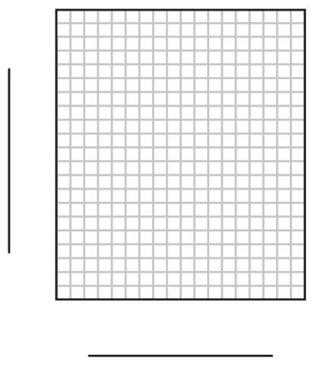

Part B.
Table 2 shows the change in the crown length of molar teeth in horses and their ancestors over the last 50 million years. The crown is the area of the tooth visible above the gum.
Table 2. Crown Length of Molar Teeth in Horses Over Time
Animal | Crown Length  of Molar Teeth (in millimeters)
Eohippus | 4
Mesohippus | 9
Merychippus | 45
Pliohippus | 60
Modern Horse (Equus) | 85

Explain the patterns of anatomical changes in horses over the last 50 million years as shown in your completed Graph 1 and Table 2.
______________________________________________________________________________

______________________________________________________________________________

______________________________________________________________________________

Prompt 2
Table 3 shows the change in the forefoot structure of horses and their ancestors over the last 50 million years.
Table 3. Forefoot Structure in Horses Over Time
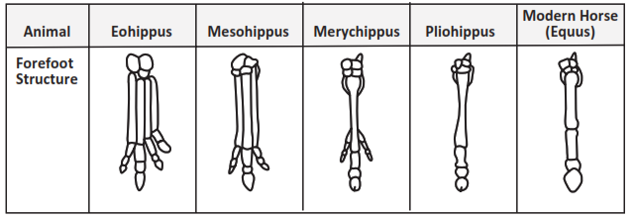
The earliest animal, the Eohippus, had four toes on its forefoot and appears to have placed most of its weight on the middle toe.
Describe the observable similarities and differences among the fossil features of the animals over millions of years within Table 3. Consider the number of toes, bone size, and where the weight might be concentrated.
__________________________________________________________________________

__________________________________________________________________________

__________________________________________________________________________

__________________________________________________________________________

Table 4 shows the size and features of the skull of horses over 50 million years.
Table 4. Skull Size and Features of Horses Over Time
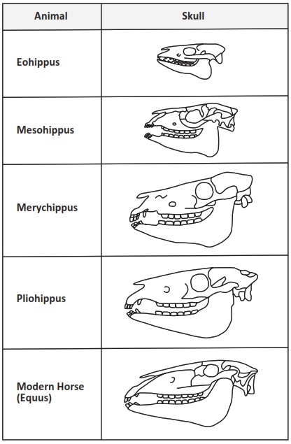

Describe the observable similarities and differences among the fossil features of the animals over millions of years within Table 4. Consider the overall shape, size, and features of the skulls.
______________________________________________________________________________

______________________________________________________________________________

______________________________________________________________________________

______________________________________________________________________________

Prompt 3
Scientists have determined that the region in which horses evolved changed over time. Over the last 50 million years, the horse evolved from a small animal that lived in rainforests into an animal standing up to 6 feet tall that adapted to living on the plains.
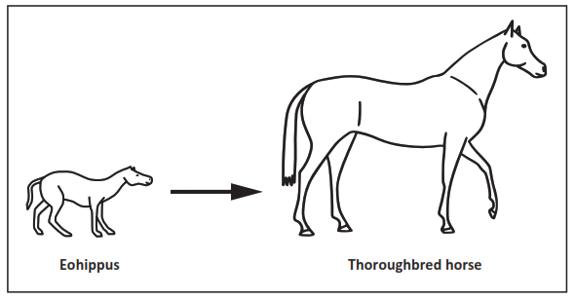
The environment of the Eohippus was heavily wooded. This provided protection from predators, soft, moist grounds for walking, and plenty of food to eat. This environment was perfect for an animal with short legs with toes, small teeth, padded feet, and a dog-like body structure.
Over millions of years, the lush forests began to thin and disappear. Grassland eventually replaced the lush tropical forest. Hard, dry soil replaced the once soft, moist ground of the environment.

Scientists studying the evolutionary history of horses and evidence of changes in horses’ environment over time have developed the following claim:
The change in the environment from forest to grassland caused changes in body structures in the population of horses over time.
Support the claim by explaining the cause-and-effect relationship between changes in the environment and the progression of changes that have led to modern-day horses. In your response:
- Use information from Tables 1, 2, and 3 AND Graph 1 to support your explanation
- Consider information about how a population may evolve in response to predators, survival, and food availability
- Use your scientific reasoning about how the process of natural selection results in the changes
______________________________________________________________________________

______________________________________________________________________________

______________________________________________________________________________

______________________________________________________________________________

______________________________________________________________________________

______________________________________________________________________________
______________________________________________________________________________
______________________________________________________________________________
______________________________________________________________________________
______________________________________________________________________________

______________________________________________________________________________

______________________________________________________________________________

SIPS Grade 8 Unit 3 EOU Assessment Task 2 Rubric (MS-LS4-2, MS-LS4-4, MS-LS4-6)
Prompt | Score Point 0 | Score Point 1 | Score Point 2 | Score Point 3 | Score Point 4
Prompt 1  Part A. & Part B.  Scored Responses | No aspect of the response is correct | Response includes one (1) of the four (4) aspects | Response includes two (2) of the four (4) aspects | Response includes three (3) of the four (4) aspects | Response includes the following aspects:  Part A  - Axis labels (x-axis labeled as “Time” and y-axis labeled as “Height”)  - Units (Time as “millions of years” or “MYA”; Height as “centimeters” or “cm”)  - Data points connected with a line  Part B  - Describes trends in Graph 1 and Table 1 as both increase in size
Prompt 2  Scored Responses | No aspect of the response is correct | Identifies one (1) of the two (2) aspects | Response includes the following aspects:  - Identifies the similarities and differences in the toe structure over time in Table 3  - Identifies the similarities and differences in the skull structure over time in Table 4 | NA | NA
Prompt 3  Scored Responses | No aspect of the response is correct | Identifies one (1) of the three (3) aspects | Identifies two (2) of the three (3) aspects | Response includes the following aspects:  - Relates the changing environment to the changes in the animals’ anatomy  - Makes connections to specific structures, such as the height and toe shape to specific environmental conditions  - Describes how natural selection and/or adaptations led to improved chances for survival | NA

Student Exemplar(s)
Student exemplars represent high-quality responses that align to full-point rubric scores. The exemplar responses are intended to assist educators’ understanding of the nature and expectations of each prompt. Note the exemplars serve as examples of high-quality responses, and students may respond with equally relevant, scientifically accurate responses and ideas that meet the expectations of a full-point rubric score.

Prompt 1
Part A.
Graph the change in the height of horses over time using the data in Table 1. The x-axis represents time, and the y-axis represents height. Your graph must include:
- a label for the x-axis and a label for the y-axis
- units
- data points connected with a line
Graph 1. Height of Horses Over Time
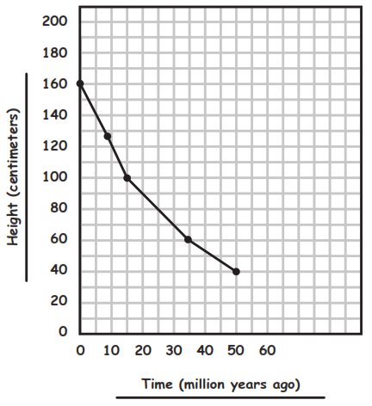
Part B.
Explain the patterns of anatomical changes in the horse over the last 50 million years as shown in your completed Graph 1 and Table 2.
Over time, the horse became larger in height. Also, their teeth became larger.

Prompt 2
Describe the observable similarities and differences among the fossil features of the animals over millions of years within Table 3. Consider the number of toes, bone size, and where the weight might be concentrated.
The features of the forefoot in Table 3 gradually changed, but the overall shape of the middle toe stayed the same. It does get longer and wider over time. The early horses spread weight across their toes. Today, most of a horse’s weight is on one toe.
Describe the observable similarities and differences among the fossil features of the animals over millions of years within Table 4. Consider the overall shape, size, and features of the skulls.
The overall shape of the skulls in Table 4 stays the same. For example, the jawbones remain similar. The main difference is that the skull gets larger.

Prompt 3
Scientists studying the evolutionary history of horses and evidence of changes in horses’ environment over time have developed the following claim:
The change in the environment from forest to grassland caused changes in body structures in the population of horses over time.
Support the claim by explaining the cause-and-effect relationship between changes in the environment and the progression of changes that have led to modern-day horses. In your response:
- Use information from Tables 1, 2, and 3 AND Graph 1 to support your explanation
- Consider information about how a population may evolve in response to predators, survival, and food availability
- Use your scientific reasoning about how the process of natural selection results in the changes
When the environment changed from forest to grassland, the horse’s predators changed, and the environment had very few trees to allow for escape or camouflage. Horses with increased height could run faster in wide-open spaces to avoid predators. The shorter horses could not outrun the predators in the grasslands, so the trait was no longer visible in the population over time. The observed change in foot structure from padded to hooves was better suited for the dry, hard soil of the grasslands. Due to the change in diet, the horses with larger, more durable teeth survived the shift from foliage to grasses.

SIPS Grade 8 Unit 3 EOU Assessment Task 3: What Beak-ame of You?

Student Worksheet

This task is about natural selection.

Task
Galapagos finches are a fascinating example of evolution by natural selection. There are 13 or 14 species, and each evolved from the same ancestor that arrived on the Galapagos Islands several million years ago from the South American mainland.
There are very few physical differences between the species of Galapagos finches. The birds generally have small, rounded wings with bodies covered in dull-colored feathers. However, the key to their differences lies in their beaks. Specifically, their size and shape, which vary according to the specific habitat in which the bird lives.

Prompt 1
Part A.
A pair of scientists working in the Galapagos Islands have studied several species of Galapagos finches for many years. In the early years of their research, they identified these types of beaks:
- very small beaks
- small beaks
- large beaks
- very large beaks
There were different types of shrubs, plants, and cacti on the islands. Some of the finches fed on the flowers of the cacti, some on very small seeds, and some on larger, hard seeds.
One year, there was a drought on the islands. Although the cactus plants survived, there were far fewer plants producing small seeds.
On one of the islands, the scientists recorded the number of birds and their beak size one day before the drought. They repeated these observations after the drought. Table 2 shows the data the scientists collected.

Table 2. Beak Sizes Before and After the Drought
Beak Size | Number of Birds Before the Drought | Number of Birds After the Drought
Very Small | 20 | 4
Small | 24 | 12
Large | 26 | 22
Very Large | 24 | 20

Create a bar graph showing the number and type of each beak size (Very Small, Small, Large, Very Large) before and after the drought. Use the data from Table 2 AND the provided key to distinguish the bars.
Your graph must include:
- labels for the x- and y-axis
- units
- labels for the bar graphs showing the before and after beak size for each type of beak
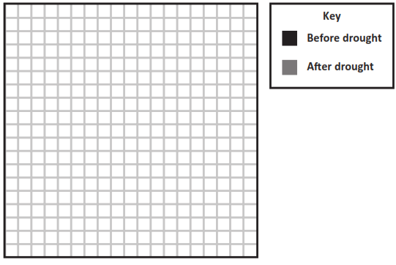

Graph 1. Beak Sizes Before and After the Drought

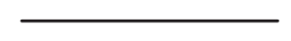
Part B.
Use the information about the environment before and after the drought and Graph 1 to answer the following questions:
- The population of finches with very small beaks and small beaks decreased because

______________________________________________________________________________

______________________________________________________________________________

- Why was the population size of the birds with large and very large beaks less affected by the drought than the population of finches with small and very small beaks?

______________________________________________________________________________

______________________________________________________________________________

Prompt 2
Part A.
Traits like differences in the beak shape of the finch populations can vary between and within species. Sometimes the instructions for traits can be altered. Suppose that a mistake occurs in one gene of a chromosome. This alteration in the genetic code is called a mutation.
DNA is a genetic code that is made of four different nucleotides that each include a different base molecule: adenine (A), thymine (T), guanine (G), and cytosine (C). In the genetic code, every nucleotide triplet, or codon, encodes for one amino acid. Some codons are "stop" codons, which signal the end of a protein.
Figure 1 shows the general codon table. The circle should be read starting from the center outwards. For example, the codon ACG encodes for threonine. Some codons code for the same amino acid. Some codons are "STOP" codons, which signal the end of a protein.

Figure 1. General Codon Table
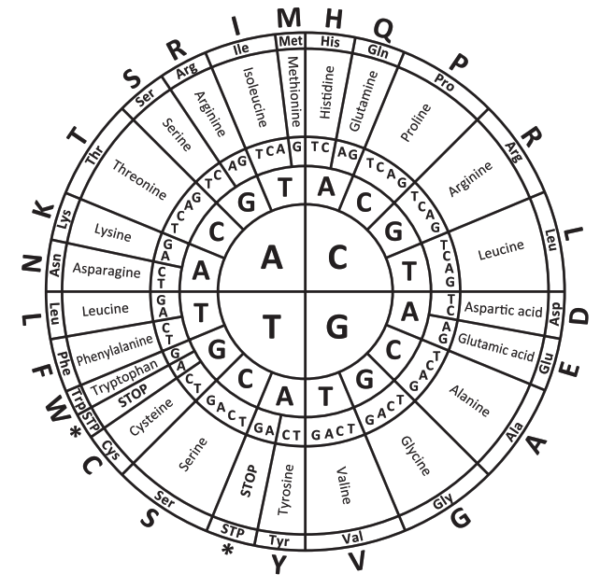

Table 3 is a random gene sequence showing the resulting protein sequence and a mutated DNA sequence.
Table 3. Random Gene Sequence
Codon | 1 | 2 | 3 | 4 | 5 | 6 | 7
DNA | ACT | TGC | CCG | CAG | TCC | AGT | TAA
Protein | Thr | Cys | Pro | Gln | Ser | Ser | Stop
Mutated DNA | ACT | TAC | CCA | CAG | GCC | AGC | TAA

Using Figure 1, which mutations in Table 3 cause a changed amino acid sequence in the resulting protein?
- Codons 3 and 6
- Codons 2 and 5
- Codons 1 and 4
- Codons 2, 3, and 6
Part B.
Explain how mutations contribute to genetic variation. In your response, include the five following terms:
DNA | protein | gene | amino acid | mutation

______________________________________________________________________________

______________________________________________________________________________

______________________________________________________________________________

______________________________________________________________________________

______________________________________________________________________________

______________________________________________________________________________

______________________________________________________________________________

______________________________________________________________________________

Prompt 3
All of the different species of finches living on the Galapagos Islands can be traced back to the same ancestor. In humans, a similar phenomenon occurred to eye color, which resulted in people having different eye colors.
Originally, all humans had brown eyes. A genetic mutation that affects one gene in our chromosomes turned off between 6,000 to 10,000 years ago. This led to humans with blue eyes. Approximately 80% of the world’s population has brown eyes. All other eye colors can be linked back to a single common ancestor.
Part A.
How is a genetic mutation, like eye color, different from the process of natural selection, like the development of different beak types of finches?
______________________________________________________________________________

______________________________________________________________________________

______________________________________________________________________________
Part B.
Why does natural selection explain what happened with the finches but not the eye color example?
______________________________________________________________________________

______________________________________________________________________________

______________________________________________________________________________

______________________________________________________________________________

SIPS Grade 8 Unit 3 EOU Assessment Task 3 Rubric (MS-LS4-4, MS-LS4-6, and MS-LS3-1)
Prompt | Score Point 0 | Score Point 1 | Score Point 2 | Score Point 3 | Score Point 4
Prompt 1  Part A. & Part B.  Scored Responses | No aspect of the response is correct | Identifies one (1) of the five (5) aspects | Identifies two (2) of the five (5) aspects | Identifies three (3) or four (4) of the five (5) aspects | Response includes the following aspects:  - Graph with x- and y- labels (x-axis labeled as “Beak Sizes” and y-axis labeled as “Number of Birds”)  - Axes shown as x-axis Beak Sizes (“Very Small Beaks”, “Small Beaks”, “Large Beaks”, and “Very Large Beaks”); y-axis Number of Birds)  - Bars accurately represent the four beak types under both conditions  - Explanation of why the birds with smaller beaks’ population decreased  - Explanation of why the percentage of birds with larger beaks did not decrease as much as a result of the drought
Prompt 2  Part A. & Part B.  Scored Responses | No aspect of the response is correct | Response includes the following aspects:  - Selects option B  OR  - A description of how mutations contribute to genetic variation using two (2) or three (3) of the five (5) terms | Response includes the following aspects:  - Selects option B  - A description of how mutations contribute to genetic variation using four (4) of the five (5) terms | Response includes the following aspects:  - Selects option B  - A description of how mutations contribute to genetic variation using all five (5) terms | NA
Prompt 3 Part A. & Part B.  Scored Responses | No aspect of the response is correct | Response includes one (1) of the three (3) aspects | Response includes two (2) of the three (3) aspects | Response includes the following aspects:  Part A  - Contrasts the mechanism of genetic variation by mutation and natural selection  Part B  - Describes the process of natural selection using a real-world example of both environmental pressure and resulting traits  - Describes how the process of a genetic mutation (i.e., eye color) cannot be used to explain the phenomena of finches’ beaks | NA

Student Exemplar(s)
Student exemplars represent high-quality responses that align to full-point rubric scores. The exemplar responses are intended to assist educators’ understanding of the nature and expectations of each prompt. Note the exemplars serve as examples of high-quality responses, and students may respond with equally relevant, scientifically accurate responses and ideas that meet the expectations of a full-point rubric score.

Prompt 1
Part A.
Create a bar graph showing the number and type of each beak size (Very Small, Small, Large, Very Large) before and after the drought. Use the data from Table 2 AND the provided key to distinguish the bars.
Your graph must include:
- labels for the x- and y-axis
- units
- labels for the bar graphs showing the before and after beak size for each type of beak

Graph 1. Beak Sizes Before and After the Drought
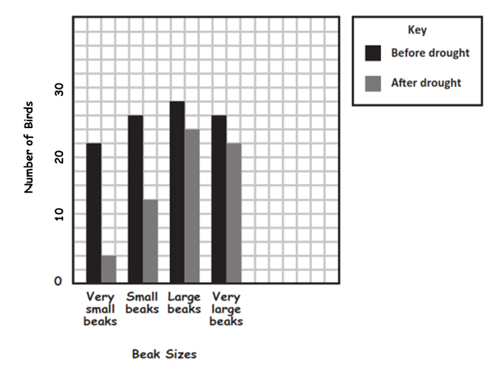Part B.
Use the information about the environment before and after the drought and Graph 1 to answer the following questions:
- The population of finches with very small beaks and small beaks decreased because the drought eliminated small seeds, causing a greater number of the small-beaked finches to die.
- Why was the population size of the birds with large and very large beaks less affected by the drought than the population of finches with small and very small beaks? The drought affected the types of plants that produced the small seeds which finches with small and very small beaks relied on for food. This caused the population of these birds to decrease a lot. The drought did not affect the cactus plants or plants that produced larger, harder seeds. That is why the population size of birds with large and very large beaks was less affected by the drought.

Prompt 2
Part A.
Using Figure 1, which mutations in Table 3 cause a changed amino acid sequence in the resulting protein?
- Codons 3 and 6
- Codons 2 and 5 *
- Codons 1 and 4
- Codons 2, 3, and 6
Part B.
Explain how mutations contribute to genetic variation. In your response, include the five following terms:
DNA | protein | gene | amino acid | mutation

Mutations can alter the DNA sequence. That will change the coding to a different amino acid sequence. The new protein will have different properties or functions than what was supposed to be coded. So, a mutation on a parent’s gene can be passed onto their offspring, like the difference in eye color. This is how mutations result in genetic variation.

Prompt 3
Part A.
How is a genetic mutation, like eye color, different from the process of natural selection, like the development of different beak types of finches?
Mutations occur by chance or randomly. Natural selection occurs due to the environment. Natural selection is an evolution of characteristics of living organisms that happens over many generations, leading to huge variations.
Part B.
Why does natural selection explain what happened with the finches but not the eye color example?
The changes in the appearance and number of types of finches can be related to their habitat and food sources. These environmental conditions, like a drought, lead to changes in the population due to survival. But mutation is a random occurrence on the genes which is not related to the environment. That is why it is very unlikely that a random mutation would explain a wide variety of beak sizes and shapes that are so well suited to the finches living in different environments on the Galapagos Islands.

