
Coherence and Alignment Among Science Curriculum, Instruction, and Assessment (CASCIA) Project

Grade 5 Unit 1: Matter and Its Interactions

Family Guidance and Learning Resources for Performance Category 1

October 2023

Grade 5 Unit 1: Matter and Its Interactions, Family Guidance and Learning Resources for Performance Category 1 was developed with funding from the U.S. Department of Education under the Competitive Grants for State Assessments Program CFDA 84.368A. The contents of this paper do not represent the policy of the U.S. Department of Education, and no assumption of endorsement by the Federal government should be made.
All rights reserved. Any or all portions of this document may be reproduced and distributed without prior permission, provided the source is cited as: Coherence and Alignment Among Science Curriculum, Instruction, and Assessment (CASCIA) Project. (2023). Grade 5 Unit 1: Matter and Its Interactions, Family Guidance and Learning Resources for Performance Category 1. Lincoln, NE: Nebraska Department of Education.
Purpose
The purpose of this document is to help families understand their student’s performance on the Grade 5 Unit 1 Science Assessment and to provide resources and recommendations for engaging their student in science learning at home.
Unit Overview
By engaging in this unit, students deepen their knowledge of matter and its properties, physical and chemical changes, and how properties of matter can be investigated and used to describe substances, including the conservation of mass during changes. Students develop their experience and skills by developing models, making observations, and conducting investigations about matter and properties of matter.
Performance Category 1: Model the Structure of Matter
Prompts for this performance category require students to develop or use models to support descriptions of how:
- Matter is made of particles too small to be seen
- Condensation, the movement of water particles in the air to a surface, demonstrates that matter is made from particles that are too small to see
Instructions for Parents/Guardians
- Refer to your student’s score report to determine their instructional needs level—red, yellow, or green—for this performance category.
- Use the Interpretive Guidance (see page 2) to understand what your student likely knows and is able to do based on their instructional needs level.
- Use the Family Resources and Recommendations (see page 3) to engage with and support your student’s science learning at home.

Grade 5 Unit 1: Matter and Its Interactions
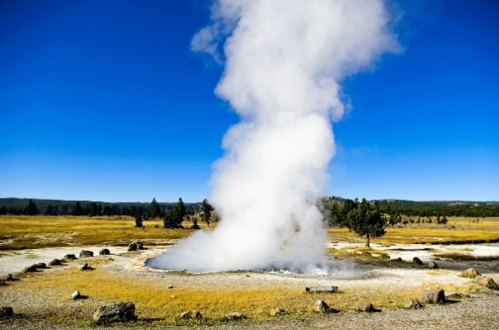


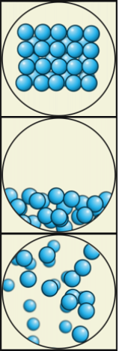

Particle Models by Julio Miguel A Enriquez and Monica Muñoz - Wiki Learing Tec de Monterrey, CC BY-SA 4.0, https://commons.wikimedia.org/w/index.php?curid=64130757
Interpretive Guidance for Performance Category 1:
Model the Structure of Matter
Red (0-4 score points earned)  - Extensive additional instruction and reteaching of these skills is recommended.  - The student needs significant opportunities to reinforce and apply these skills in future learning. | Yellow (5-7 score points earned)  - Moderate additional instruction on these skills is recommended.  - The student needs additional opportunities to strengthen these skills in future learning. | Green (8-10 score points earned)  - Minimal to no additional instruction on these skills is recommended.  - The student is ready to extend these skills in future learning.
What These Results Mean
This student is likely able to:  - Present incomplete and/or inaccurate representations of molecules in various phases including relative particle arrangement and spacing.  - Use the model to develop incomplete and largely inaccurate explanations of macro-phenomena resulting from the bulk movement and rearrangement of particles too small to be seen.  - Demonstrate partial understanding of relationship between microscopic properties of materials such as particle size, arrangement, and spacing and, show limited understanding of how these affect macroscopic properties of the same materials such as visibility and the ability to hold shape. | This student is likely able to:  - Present clear and complete, representations with minor errors or omissions of molecules in various phases including relative particle arrangement and spacing.  - Use the model to develop incomplete but accurate explanations of macro-phenomena resulting from the bulk movement and rearrangement of particles too small to be seen.  - Demonstrate partial understanding of relationship between microscopic properties of materials such as particle size, arrangement, and spacing, and apply some of these concepts to describe macroscopic properties of the same materials such as visibility and the ability to hold shape. | This student is likely able to:  - Present clear, complete, and accurate representations of molecules in various phases including relative particle arrangement and spacing.  - Use the model to develop thorough and accurate explanations of macro-phenomena resulting from the bulk movement and rearrangement of particles too small to be seen.  - Demonstrate complete and accurate understanding of the relationship between microscopic properties of materials such as particle size, arrangement, and spacing, and macroscopic properties of the same materials such as visibility and the ability to hold shape.

Family Resources and Recommendations for Performance Category 1:
Model the Structure of Matter
Resources and Recommendations to Support Science Learning at Home
Engage in the Topic  What is matter? What are things made up of? | Everything around us that we can touch is matter. Watch this video with your student to learn more about how matter makes up everything we see, feel, smell, etc.  Engage your student in a discussion of how H₂O can be water, ice, and steam:  - What does your student know?  - What does your student wonder?
Explore the Topic  There are three common states of matter. What are they? | Explore with your student at home using simple experiments such as the States of Matter in a Baggie Activity to observe and discuss the three common states of matter and their properties:  - Solids – relatively rigid, definite volume and shape. In a solid, particles are attached to each other.  - Liquids – definite volume but able to change shape by flowing. In a liquid, particles are loosely attached to each other.  - Gases – no definite volume or shape.
Explain with Evidence  What matter is in your world that you can tell me about? | Have your student watch this video about the properties of matter before describing matter they observe in the world around them.  Matter is anything that takes up space and can be weighed. In other words, matter has volume and mass. There are many different substances, or types of matter, in the universe. Some specific examples of matter include:  - Solids: table, chair, pencil, rock, iron, gold  - Liquids: water, juice, milk, oil  - Gases: air, oxygen, nitrogen, carbon dioxide, natural gas
Evaluate Understanding  Answer this quiz to check for understanding. | Check for understanding by having your student complete this quick quiz on the three states of matter and their principles. For each question, encourage your student to:  - Restate what the question is asking.  - Share what they know about the question.  - Identify and explain their answer to the question.  - Share what they wonder or want to know about the question.
Resources
- States of Matter for Kids – What are the states of matter? Solid, liquid, and gas, video by Smile and Learn
[https://youtu.be/JQ4WduVp9k4?si=aOcQGwFipdaj1MeR]
- States of Matter in a Baggie Activity , by Education.com
[https://www.education.com/activity/article/states_of_matter_second/]
- What’s Matter? – Crash Course Kids #3.1, video by Crash Course Kids
[https://www.youtube.com/watch?v=ELchwUIlWa8]
- States of Matter Quiz, by Footprints Science
[https://www.footprints-science.co.uk/index.php?quiz=States_of_matter]

