
Coherence and Alignment Among Science Curriculum, Instruction, and Assessment (CASCIA) Project

Grade 5 Unit 1: Matter and Its Interactions

Family Guidance and Learning Resources for Performance Category 2

October 2023

Grade 5 Unit 1: Matter and Its Interactions, Family Guidance and Learning Resources for Performance Category 2 was developed with funding from the U.S. Department of Education under the Competitive Grants for State Assessments Program CFDA 84.368A. The contents of this paper do not represent the policy of the U.S. Department of Education, and no assumption of endorsement by the Federal government should be made.
All rights reserved. Any or all portions of this document may be reproduced and distributed without prior permission, provided the source is cited as: Coherence and Alignment Among Science Curriculum, Instruction, and Assessment (CASCIA) Project. (2023). Grade 5 Unit 1: Matter and Its Interactions, Family Guidance and Learning Resources for Performance Category 2. Lincoln, NE: Nebraska Department of Education.
Purpose
The purpose of this document is to help families understand their student’s performance on the Grade 5 Unit 1 Science Assessment and to provide resources and recommendations for engaging their student in science learning at home.
Unit Overview
By engaging in this unit, students deepen their knowledge of matter and its properties, physical and chemical changes, and how properties of matter can be investigated and used to describe substances, including the conservation of mass during changes. Students develop their experience and skills by developing models, making observations, and conducting investigations about matter and properties of matter.
Performance Category 2: Use Observations and Measurements of Properties of Matter
Prompts for this performance category require students to use observations and measurements as evidence to describe how:
- To develop a procedure to identify materials based on their properties
- Data can be used to support an explanation of the identification of materials
Instructions for Parents/Guardians
- Refer to your student’s score report to determine their instructional needs level—red, yellow, or green—for this performance category.
- Use the Interpretive Guidance (see page 2) to understand what your student likely knows and is able to do based on their instructional needs level.
- Use the Family Resources and Recommendations (see page 3) to engage with and support your student’s science learning at home.
Grade 5 Unit 1: Matter and Its Interactions
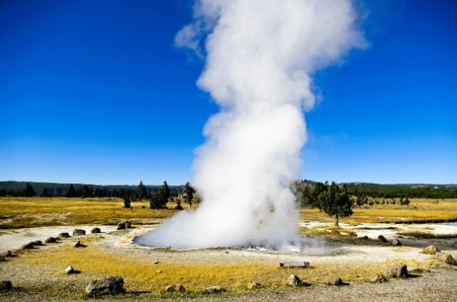


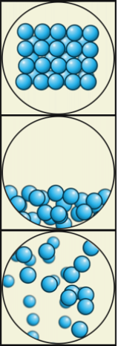

Particle Models by Julio Miguel A Enriquez and Monica Muñoz - Wiki Learing Tec de Monterrey, CC BY-SA 4.0, https://commons.wikimedia.org/w/index.php?curid=64130757
Interpretive Guidance for Performance Category 2:
Use Observations and Measurements of Properties of Matter
Red (0-3 score points earned)  - Extensive additional instruction and reteaching of these skills is recommended.  - The student needs significant opportunities to reinforce and apply these skills in future learning. | Yellow (4-7 score points earned)  - Moderate additional instruction on these skills is recommended.  - The student needs additional opportunities to strengthen these skills in future learning. | Green (8-11 score points earned)  - Minimal to no additional instruction on these skills is recommended.  - The student is ready to extend these skills in future learning.
What These Results Mean
This student is likely able to:  - Determine few relevant observations of the properties of a given substance needed to determine its identity.  - Suggest experimental conditions that demonstrate a limited understanding of how observations of properties can determine the identity of unknown substances.  - Inaccurately or inconsistently determine the identity of an unknown substance.  - Present partial, irrelevant, or inaccurate evidence to support the identification of a particular substance. | This student is likely able to:  - Determine some relevant observations of the properties of a given substance needed to determine its identity.  - Suggest appropriate experimental conditions to elicit data needed to determine the identity of an unknown substance about half of the time.  - Utilize data from observations to determine the identity of an unknown substance about half of the time.  - Present some relevant evidence to support the identification of a particular substance. | This student is likely able to:  - Determine convincing, valid, and reliable observations of the properties of a given substance needed to determine its identity.  - Design appropriate and systematic experimental conditions to elicit data needed to determine the identity of an unknown substance.  - Utilize data from observations to consistently and accurately determine the identity of an unknown substance.  - Consistently present convincing, valid, and reliable evidence to support the identification of a particular substance.

Family Resources and Recommendations for Performance Category 2:
Use Observations and Measurements of Properties of Matter
Resources and Recommendations to Support Science Learning at Home
Engage in the Topic  What are properties of matter? | Properties of matter are observable and measurable characteristics of substances. Watch this video with your student to learn more about the properties of substances and how they can be observed and measured.  Engage your student in a discussion:  - What properties are helpful for identifying substances? (e.g., length, width, height, volume, weight, color, hardness, magnetism, solubility, conductivity, etc.)  - How can observing and measuring the properties of substances help us design solutions to problems? Can you think of any examples?
Explore the Topic  How are properties observed, measured, and used to define types of matter? | Explore the physical properties of matter and how they can be measured and observed with your student using this interactive lesson. On slides 1-6, have your student read about the physical properties that define different types of matter, watch a series of short videos, and engage with animations that explain physical properties and how they are unique for each substance. After taking notes and online quizzes, your student will have an opportunity to review and reflect on what they have learned.  Note: To start the interactive, click the “Launch” button and select “Continue as a Guest.”
Elaborate on the Topic  How can fair tests be designed to identify substances based on their properties? | Substances can be identified by observing and measuring their properties. Review and discuss this reading passage with your student about the solubility of different substances. Ask your student to consider the best way to design a solubility test to see if there is a difference between the solubility of sugar, salt, and alum. Discuss with your student the procedures that would ensure a fair test (e.g., using the same types of cups, adding the same amount of salt and sugar, adding the same amount of water at the same time, swirling or stirring the solution in the same way).  Use the student activity sheet to guide your student through an experiment to explore the solubility of sugar, salt, and alum using simple household ingredients. Alternatively, your student can view the animated slide show to observe what happens when sugar, salt, and alum are mixed with water.
Evaluate  What have you learned? | Ask your student to reflect on the previous experiment on the solubility of various substances:  - What did you observe during the experiment?  - Which has the greatest solubility in water—salt, sugar, or alum?  - Which has the least solubility in water—salt, sugar, or alum?  - How can properties, like solubility, be used to identify unknown substances?  Refer to this explanatory video for background information to support the discussion with your student.

Resources
- Hunting for Properties: Crash Course Kids #9.1, video by Crash Course Kids [https://www.youtube.com/watch?v=ZZYnERZe3Cg&list=PLhz12vamHOnaY7nvpgtQ0SIbuJdC4HA5O&index=4]
- Matter’s Physical Properties: Interactive Lesson, by PBS NC Science
[https://wkar.pbslearningmedia.org/resource/ilunctv18-sci-ilmattersphysicalproperties/matters-physical-properties-interactive-lesson-unc-tv-science/]
- Using Dissolving to Identify Substances, reading passage by American Chemical Society
[https://www.acs.org/content/dam/acsorg/education/k-8/inquiry-in-action/fifth-grade/g5-l2.1-reading.pdf]
- A Dissolving Test to Identify Substances, student activity sheet by American Chemical Society
[https://www.acs.org/content/dam/acsorg/education/k-8/inquiry-in-action/fifth-grade/g5-l2.1-sas.pdf]
- Identifying Crystals by How They Dissolve, animated slide show by American Chemical Society
[https://www.acs.org/education/resources/k-8/inquiryinaction/fifth-grade/dissolving-crystals.html]
- Fifth Grade Lesson 2.1 Dissolving to Identify Substances, explanatory video by American Chemical Society
[https://www.youtube.com/watch?v=kStOJKoykvM]

