
Coherence and Alignment Among Science Curriculum, Instruction, and Assessment (CASCIA) Project

Grade 5 Unit 1: Matter and Its Interactions

Family Guidance and Learning Resources for Performance Category 3

October 2023

Grade 5 Unit 1: Matter and Its Interactions, Family Guidance and Learning Resources for Performance Category 3 was developed with funding from the U.S. Department of Education under the Competitive Grants for State Assessments Program CFDA 84.368A. The contents of this paper do not represent the policy of the U.S. Department of Education, and no assumption of endorsement by the Federal government should be made.
All rights reserved. Any or all portions of this document may be reproduced and distributed without prior permission, provided the source is cited as: Coherence and Alignment Among Science Curriculum, Instruction, and Assessment (CASCIA) Project. (2023). Grade 5 Unit 1: Matter and Its Interactions, Family Guidance and Learning Resources for Performance Category 3. Lincoln, NE: Nebraska Department of Education.
Purpose
The purpose of this document is to help families understand their student’s performance on the Grade 5 Unit 1 Science Assessment and to provide resources and recommendations for engaging their student in science learning at home.
Unit Overview
By engaging in this unit, students deepen their knowledge of matter and its properties, physical and chemical changes, and how properties of matter can be investigated and used to describe substances, including the conservation of mass during changes. Students develop their experience and skills by developing models, making observations, and conducting investigations about matter and properties of matter.
Performance Category 3: Use Observations and Measurements of Chemical Reactions
Prompts for this performance category require students to use observations and measurements as evidence to describe how:
- Changes in observed and measured properties of two substances before and after mixing indicates a new substance is formed
- The total amount of matter is conserved no matter what reaction or change in properties occurs
Instructions for Parents/Guardians
- Refer to your student’s score report to determine their instructional needs level—red, yellow, or green—for this performance category.
- Use the Interpretive Guidance (see page 2) to understand what your student likely knows and is able to do based on their instructional needs level.
- Use the Family Resources and Recommendations (see page 3) to engage with and support your student’s science learning at home.
Grade 5 Unit 1: Matter and Its Interactions
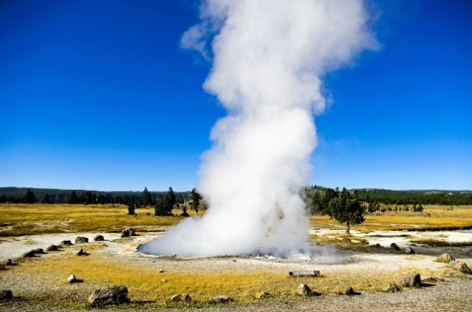
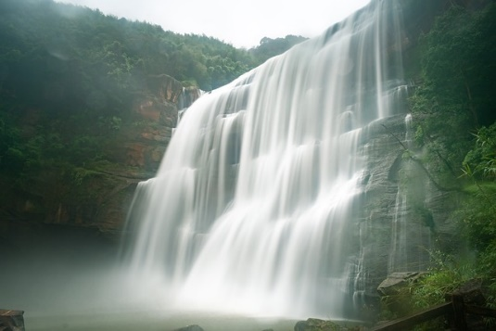
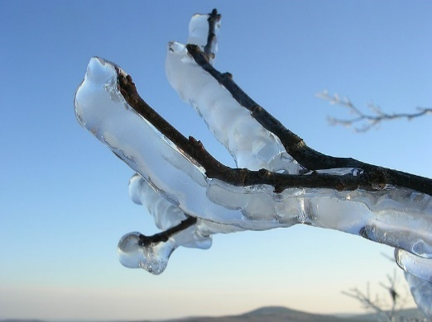
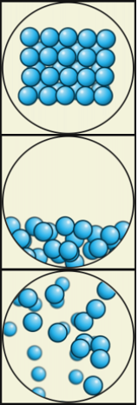

Particle Models by Julio Miguel A Enriquez and Monica Muñoz - Wiki Learing Tec de Monterrey, CC BY-SA 4.0, https://commons.wikimedia.org/w/index.php?curid=64130757
Interpretive Guidance for Performance Category 3:
Use Observations and Measurements of Chemical Reactions
Red (0-3 score points earned)  - Extensive additional instruction and reteaching of these skills is recommended.  - The student needs significant opportunities to reinforce and apply these skills in future learning. | Yellow (4-5 score points earned)  - Moderate additional instruction on these skills is recommended.  - The student needs additional opportunities to strengthen these skills in future learning. | Green (6-7 score points earned)  - Minimal to no additional instruction on these skills is recommended.  - The student is ready to extend these skills in future learning.
What These Results Mean
This student is likely able to:  - Attempt to determine if a new substance has been formed, with varying results.  - Present partial, inaccurate, or irrelevant qualitative evidence to make a conclusion about the formation of a new substance.  - Attempt to represent provided data in a graph.  - Provide little relevant quantitative data to support an incomplete or inaccurate explanation of the conservation of mass before and after mixing substances, no matter the change in properties. | This student is likely able to:  - Utilize data to determine if a new substance has been formed, with varying results.  - Present valid and reliable qualitative evidence to make a conclusion about the formation of a new substance.  - Attempt to represent provided data in a graph.  - Provide some relevant quantitative data to support a reasonable explanation of the conservation of mass before and after mixing substances, no matter the change in properties. | This student is likely able to:  - Utilize data to accurately determine if a new substance has been formed.  - Present convincing, valid, and reliable qualitative evidence to support an accurate conclusion about the formation of a new substance.  - Accurately represent provided data in a graph, using simple computational thinking as necessary.  - Provide quantitative data to support a complete and accurate explanation of the conservation of mass before and after mixing substances, no matter the change in properties.

Family Resources and Recommendations for Performance Category 3:
Use Observations and Measurements of Chemical Reactions
Resources and Recommendations to Support Science Learning at Home
Explore the Topic  Will the mass change when ice melts in water? | Watch this video, Conservation of Mass: Water and Ice, with your student. Ask your student to summarize what is happening in the video. Use the below prompts to support your student, if needed:  - What question is this person trying to answer?  - How does this person set up the experiment?  - What data does this person collect, and why?  - How well do the results answer the question?
Explain with Evidence  Can matter be created or destroyed? | Ask your student to explain using pictures, writing, or words how the data collected by the person in the video demonstrates that matter (which has mass) cannot be created or destroyed. Reinforce these ideas with your student:  - Matter can go through a physical change, like the melting ice or when water evaporates from a glass, but the same amount of matter remains.  - Matter can also go through chemical changes, like baking a cake, and the same amount of matter is present before and after the chemical change.
Explore the Topic  How do you know when a new substance is formed? | Find examples of changes that happen around you, then ask your student to decide if the change is an example of a physical change or a chemical change.  - Use this article from CK-12 for examples of physical and chemical changes.
Explain with Evidence  Was a new substance formed? | Ask your student to give an example of a physical change and an example of a chemical change, and then explain why their example represents either the physical or chemical change.  - Physical changes are changes that DO NOT change the substance's or object's identity.  - Chemical changes are changes that DO change the substance's or object's identity.
Evaluate Understanding  Which type of change is occurring? | Evaluate understanding by having your student watch this video, “5-Minute Quiz: Physical vs. Chemical Changes”  - While watching, ask your student to explain why they chose each answer.  - If your student chooses the wrong option, ask them if the change can be reversed or not.
Resources
- Conservation of Mass: Water and Ice, by STEMAZING Systems Thinking
[https://www.youtube.com/watch?v=ejlcEz_le-M]
- Physical and Chemical Changes in Matter, article by CK-12 Foundation
[https://www.ck12.org/book/ck-12-fifth-grade-science/section/1.7/]
- 5-Minute Quiz: Physical vs. Chemical Changes, by Raffy – Teacher
[https://www.youtube.com/watch?v=Gol4u1gAxKM]

