
Coherence and Alignment Among Science Curriculum, Instruction, and Assessment (CASCIA) Project

Grade 5 Unit 3: Earth Systems and the Solution of Water Problems

Family Guidance and Learning Resources for Performance Category 1

January 2024

Grade 5 Unit 3: Earth Systems and the Solution of Water Problems, Family Guidance and Learning Resources for Performance Category 1 was developed with funding from the U.S. Department of Education under the Competitive Grants for State Assessments Program CFDA 84.368A. The contents of this paper do not represent the policy of the U.S. Department of Education, and no assumption of endorsement by the Federal government should be made.
All rights reserved. Any or all portions of this document may be reproduced and distributed without prior permission, provided the source is cited as: Coherence and Alignment Among Science Curriculum, Instruction, and Assessment (CASCIA) Project. (2023). Grade 5 Unit 3: Earth Systems and the Solution of Water Problems, Family Guidance and Learning Resources for Performance Category 1. Lincoln, NE: Nebraska Department of Education.
Purpose
The purpose of this document is to help families understand their student’s performance on the Grade 5 Unit 3 Science Assessment and to provide resources and recommendations for engaging their student in science learning at home.
Unit Overview
By engaging in this unit, students deepen their knowledge of the interconnectedness of Earth’s systems, how different Earth systems interact with each other, and how water plays an important role for each system, especially the biosphere. With a focus on defining problems, finding solutions, and comparing multiple solutions using criteria and constraints, students engage in real-world problem-solving of human impacts on Earth’s systems.
Performance Category 1: Analyze Data to Describe the Availability of Needed Natural Resources
Prompts for this performance category require students to analyze and interpret data and graphs to support conclusions about:
- the effects of a given human activity on the environment
- the distribution of saltwater and freshwater reservoirs on Earth and the importance of maintaining supplies of fresh water
- water conservation and human stewardship of Earth
Instructions for Parents/Guardians
- Refer to your student’s score report to determine their instructional needs level—green, yellow, or red—for this performance category.
- Use the Interpretive Guidance (see page 2) to understand what your student likely knows and is able to do based on their instructional needs level.
- Use the Family Resources and Recommendations (see pages 3-5) to engage with and support your student’s science learning at home.
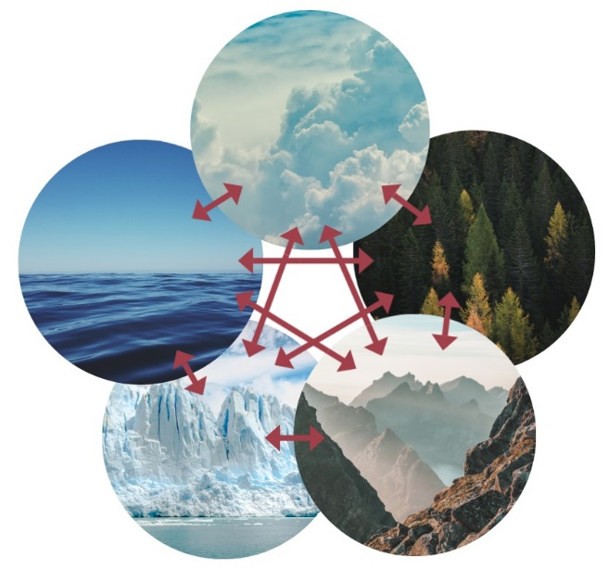
Grade 5 Unit 3: Earth Systems and the Solution of Water Problems
Image: Climate System
Credit: Femkemilene
Source: Own work
License: CC BY-SA 4.0

Interpretive Guidance for Performance Category 1:
Analyze Data to Describe the Availability of Needed Natural Resources
Red (0-8 score points earned)  - Extensive additional instruction and reteaching of these skills is recommended.  - The student needs significant opportunities to reinforce and apply these skills in future learning. | Yellow (9-13 score points earned)  - Moderate additional instruction on these skills is recommended.  - The student needs additional opportunities to strengthen these skills in future learning. | Green (14-15 score points earned)  - Minimal to no additional instruction on these skills is recommended.  - The student is ready to extend these skills in future learning.
What These Results Mean
This student is likely able to:  - Make little or no attempt to utilize data to determine the effects of a given human activity on the environment.  - Partially complete a mathematical model/graph with multiple inaccuracies to represent relationships among the amounts of freshwater in various reservoirs on Earth.  - Use no or limited evidence or information to support a description of the importance of water conservation and human stewardship of Earth.  - Use no or limited evidence or information to inaccurately describe the importance of freshwater springs. | This student is likely able to:  - Correctly identify and utilize some data to determine the effects of a given human activity on the environment.  - Complete a mathematical model/graph with few inaccuracies to represent relationships among the amounts of salt water and freshwater in various reservoirs on Earth.  - Accurately identify relationships shown in a diagram or graph to describe the importance of water conservation and human stewardship of Earth.  - Use some relevant evidence effectively to partially communicate information related to the importance of freshwater springs. | This student is likely able to:  - Correctly identify and completely utilize data to determine the effects of a given human activity on the environment.  - Develop a mathematical model/graph with no inaccuracies to represent relationships among the amounts of salt water and freshwater in various reservoirs on Earth.  - Accurately interpret patterns or relationships shown in a diagram and graph to provide clear and concise answers about the importance of water conservation and human stewardship of Earth.  - Completely and effectively combine and communicate information related to the importance of freshwater springs.

Family Resources and Recommendations for Performance Category 1:
Analyze Data to Describe the Availability of Needed Natural Resources
Resources and Recommendations to Support Science Learning at Home
Engage in the Topic  Let’s look at data about the amount and availability of water on Earth.  - Where is all the water?  - Can we use all the water we can see? Why or why not?  - Is all water drinkable? | Have your student put a spoonful of salt in a cup of water and then dip their finger in the cup to taste it. Ask your student: What does it taste like? Would you like to drink it? Would it be healthy to drink every day?  Show your student these data graphics and tables about saltwater and freshwater. Ask your student about the distribution of saltwater and freshwater reservoirs on Earth.  - What do you see? Where is all the water?  - Can we use all the water we see?  There is limited freshwater for us (and other life) to use. Ask your student to consider how different animals have adapted to deal with different amounts of water where they live. Watch this short video [4:55] with your student and pause throughout the video to discuss two examples: Nerpas in Russia’s Lake Baikal [1:40-3:00] and Addax Antelopes in Africa’s Lake Chad in the Sahara Desert [3:00-4:20].
Explore the Topic  - Where does most of our freshwater come from?  - What is an aquifer? | Did you know that about 30 percent of all readily available freshwater worldwide is groundwater? Groundwater is stored in and moves through underground aquifers.  Watch this video [3:09] with your student to learn more about groundwater and aquifers. Have your student take the aquifer quiz after you finish watching and discussing the video. The Groundwater Foundation offers hands-on activities and resources that explain groundwater and its importance to a community.
Explain the Topic  - What does it mean to ration and conserve water? | Communities can help conserve their water resources so they don’t have to ration water.  Watch this video [2:51] with your student on what it means to conserve water.  Talk to your student about where the water in your home comes from, such as a well or a community water supply. Explore these tips for conserving water in your home with your student.  - Are there any tips that you already practice in your home?  - Which tips would make the biggest difference in conserving water?  Does your family take showers? Help your student understand how much water this consumes, and challenge them to see how much water they can save.
Elaborate on the Topic  Practice water conservation in your home.  - How can you save water?  - Where do you waste water during the day? | Water is so important to all of us. To best share our planet and give everyone a better future, we must all do our part to conserve water.  Figure out your family’s Water Footprint. Luckily, the methods to ensure a water-saver future aren’t too difficult or costly to manage.  - Play this game with your student to learn about and understand your water usage. You will receive tips on the best ways to save water in your household.  - Learn about water supply and demand. This video presents an activity you can do with your student as you imagine that you are in control of a small country’s water supply.

Resources
- How Much Water Is on Earth? - Earth How
[https://earthhow.com/how-much-water-is-on-earth/]
- Water Water Everywhere: Crash Course Kids #14.2 - Youtube
[https://www.youtube.com/watch?v=SkAhB-8CtZg]
- Aquifer Adventure - St. Johns River Water Management District
[https://www.sjrwmd.com/education/aquifer-travels/]
- Aquifer Travels Quiz - Survey Monkey
[https://www.surveymonkey.com/r/YXSQGBQ]
- Resources - The Groundwater Foundation
[https://groundwater.org/resources/]
- Conserve Water with Aqua - Water Footprint Calculator
[https://www.watercalculator.org/resource/water-conservation-video/]
- Water Conservation Tips For Kids - Think H2O
[https://www.thinkh2onow.com/water_conservation_tips_kids.php]
- Save Water and Energy By Showering Better - EPA Water Sense
[https://www.epa.gov/sites/default/files/2017-02/documents/ws-ourwater-shower-better-learning-resource_0.pdf]
- What's Your Water Footprint - Water Footprint Calculator Home Page (watercalculator.org)
[https://www.watercalculator.org/]
- Water saving game - Water Battle
[https://waterbattle.com/]
- Water Supply and Demand | Planet H2O - PBS Learning Media
[https://www.pbslearningmedia.org/resource/485194b3-8637-4cb1-9d4d-ec585fb1ec46/water-supply-and-demand/]

