
Coherence and Alignment Among Science Curriculum, Instruction, and Assessment (CASCIA) Project

Grade 5 Unit 3: Earth Systems and the Solution of Water Problems

Family Guidance and Learning Resources for Performance Category 3

February 2024

Grade 5 Unit 3: Earth Systems and the Solution of Water Problems, Family Guidance and Learning Resources for Performance Category 3 was developed with funding from the U.S. Department of Education under the Competitive Grants for State Assessments Program CFDA 84.368A. The contents of this paper do not represent the policy of the U.S. Department of Education, and no assumption of endorsement by the Federal government should be made.
All rights reserved. Any or all portions of this document may be reproduced and distributed without prior permission, provided the source is cited as: Coherence and Alignment Among Science Curriculum, Instruction, and Assessment (CASCIA) Project. (2023). Grade 5 Unit 3: Earth Systems and the Solution of Water Problems, Family Guidance and Learning Resources for Performance Category 3. Lincoln, NE: Nebraska Department of Education.
Purpose
The purpose of this document is to help families understand their student’s performance on the Grade 5 Unit 3 Science Assessment and to provide resources and recommendations for engaging their student in science learning at home.
Unit Overview
By engaging in this unit, students deepen their knowledge of the interconnectedness of Earth’s systems, how different Earth systems interact with each other, and how water plays an important role for each system, especially the biosphere. With a focus on defining problems, finding solutions, and comparing multiple solutions using criteria and constraints, students engage in real-world problem-solving of human impacts on Earth’s systems.
Performance Category 3: Model Relationships to Communicate Information about Earth’s Surface Materials and Processes
Prompts for this performance category require students to develop or use models to support descriptions and predictions of relationships about:
- interactions among the components of Earth systems (hydrosphere, biosphere, geosphere, atmosphere) in a specific context or ecosystem
- interactions among components of various Earth systems in a stream environment
- the interaction of Earth’s spheres which result in the formation of a freshwater spring
- how Earth’s hydrosphere is involved in an event related to soil erosion with and without vegetation
- how Earth’s atmosphere is involved in an event related to wind erosion

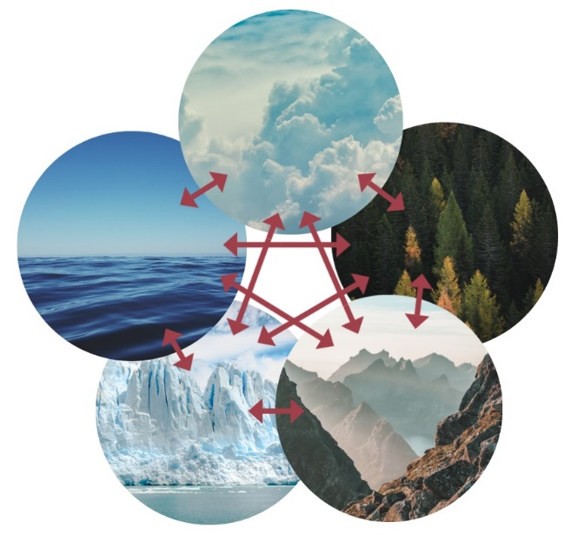
Grade 5 Unit 3: Earth Systems and the Solution of Water Problems
Image: Climate System Credit: Femkemilene
Source: Own work License: CC BY-SA 4.0
Instructions for Parents/Guardians
- Refer to your student’s score report to determine their instructional needs level—green, yellow, or red—for this performance category.
- Use the Interpretive Guidance (see page 2) to understand what your student likely knows and is able to do based on their instructional needs level.
- Use the Family Resources and Recommendations (see pages 3-5) to engage with and support your student’s science learning at home.

Interpretive Guidance for Performance Category 3:
Model Relationships to Communicate Information about Earth’s Surface Materials and Processes
Red (0-4 score points earned)  - Extensive additional instruction and reteaching of these skills is recommended.  - The student needs significant opportunities to reinforce and apply these skills in future learning. | Yellow (5-8 score points earned)  - Moderate additional instruction on these skills is recommended.  - The student needs additional opportunities to strengthen these skills in future learning. | Green (9-11 score points earned)  - Minimal to no additional instruction on these skills is recommended.  - The student is ready to extend these skills in future learning.
What These Results Mean
This student is likely able to:  - Make little or no attempt to utilize data to determine the effects of a given human activity on the environment.  - Partially complete a mathematical model/graph with multiple inaccuracies to represent relationships among the amounts of freshwater in various reservoirs on Earth.  - Use no or limited evidence or information to support a description of the importance of water conservation and human stewardship of Earth.  - Use no or limited evidence or information to inaccurately describe the importance of freshwater springs. | This student is likely able to:  - Correctly identify and utilize some data to determine the effects of a given human activity on the environment.  - Complete a mathematical model/graph with few inaccuracies to represent relationships among the amounts of salt water and freshwater in various reservoirs on Earth.  - Accurately identify relationships shown in a diagram or graph to describe the importance of water conservation and human stewardship of Earth.  - Use some relevant evidence effectively to partially communicate information related to the importance of freshwater springs. | This student is likely able to:  - Correctly identify and completely utilize data to determine the effects of a given human activity on the environment.  - Develop a mathematical model/graph with no inaccuracies to represent relationships among the amounts of salt water and freshwater in various reservoirs on Earth.  - Accurately interpret patterns or relationships shown in a diagram and graph to provide clear and concise answers about the importance of water conservation and human stewardship of Earth.  - Completely and effectively combine and communicate information related to the importance of freshwater springs.

Family Resources and Recommendations for Performance Category 3:
Model Relationships to Communicate Information about Earth’s Surface Materials and Processes
Resources and Recommendations to Support Science Learning at Home
Engage in the Topic  - How did the ecosystem change? The land, the animals, the stream, the skies? | With your student, analyze the ecosystem changes shown in the pictures. The pictures are drawings of the Yellowstone National Park ecosystem in Wyoming. Try to spot the changes between today, on the right, and many years ago, on the left. Ask your student to make a list of at least four changes they observe.
Explore the Topic  - What are Earth’s four spheres?  - What do you notice about the stream? Did it change? | The Earth has four interacting spheres: geosphere, biosphere, hydrosphere, and atmosphere. Use this Quick Reference Sheet to discuss and describe the components (parts) of Earth’s spheres. Ask your student:  - Which sphere or spheres are related to the four changes you observed?  - Did each change involve only one of Earth’s spheres or more than one sphere?  Let’s talk about the changes to the stream. Why do you think the changes occurred? Let’s zoom in on what might be happening with the stream (hydrosphere) and the stream bank (geosphere). Watch this video [0:54 - 3:00] on weathering and erosion.
Explain the Topic  - How is the change to the two water ecosystems (ocean and river) the same? | Now, let’s apply what we learned from the video about how the Atlantic Ocean eroded North Beach to the river and its banks in the Yellowstone National Park ecosystem. Ask your student:  - How do the riverbanks differ in the pictures of the Yellowstone ecosystem? (The stream's banks are wider, and many more plants are growing along the banks in the picture on the right.)  - Which spheres are involved in the erosion of the streambank? (hydrosphere and geosphere)  - What types and numbers of animals and plants changed? (For example, the types of animals change from more wolves and fewer elk; there is a variety of birds; there are plants along the streambank and grasses on the land around the stream.)  - Describe how the streambank and stream changed. (The streambank is less rocky, and the stream is wider.)
Elaborate on the Topic  - How do the hydrosphere and geosphere interact to cause erosion?  - Can changes in the amount of rainfall (hydrosphere) cause changes to Earth’s other spheres? | Weathering and erosion still occur in Yellowstone. In 2022, for example, many roads through the park needed to be shut down due to flooding! Read this news article together and watch the video showing how the road is affected by the river's water levels. Ask your student to describe how the road, the geosphere, and the hydrosphere are affected.  Let’s go back to the other changes you observed in the pictures.  - Describe how components of the biosphere interact with the hydrosphere to compare changes from the picture on the right taken many years ago to the picture on the left taken today.  - Describe which spheres interact as the eagle interacts and soars through the air.
Extend the Topic  - Describe the model. | Notice the changes to the number and types of plants growing on the stream banks in the picture of the Yellowstone ecosystem today, on the right.  As you watch the video (2:00-6:00) in which Jared models how plants filter soil, resulting in clean water, ask your student to make predictions about what will happen as he pours the same amount of water into each of the three system models. Ask your student:  - If a heavy rainfall occurs, will the plants’ roots (biosphere) help the streambanks (geosphere) from flowing down the stream (hydrosphere)?

Resources
- How Do Wolves Promote a Healthy Ecosystem? – Kennedy Meadows Canine Conservation [https://kmwildcanineconservation.com/wolves-and-the-ecosystem]
- Spheres of Earth – NASA
[https://ares.jsc.nasa.gov/interaction/eeab/pdfs/SOE/QuickReferenceSheet_SpheresOfEarth.pdf]
- Weathering and Erosion – You Tube
[https://www.youtube.com/watch?v=R-Iak3Wvh9c]
- Yellowstone officials assess damage after historic floods – KSTCV
[https://ksltv.com/496071/yellowstone-officials-assess-damage-after-historic-floods/]
- Erosion and Soil – Funsciencedemos
[https://www.youtube.com/watch?v=im4HVXMGI68]

