
Coherence and Alignment Among Science Curriculum, Instruction, and Assessment (CASCIA) Project

Grade 5 Unit 4: Earth and its Gravitational Force and Motion

Family Guidance and Learning Resources for Performance Category 1

April 2024

Grade 5 Unit 4: Earth and its Gravitational Force and Motion, Family Guidance and Learning Resources for Performance Category 1 was developed with funding from the U.S. Department of Education under the Competitive Grants for State Assessments Program CFDA 84.368A. The contents of this paper do not represent the policy of the U.S. Department of Education, and no assumption of endorsement by the Federal government should be made.
All rights reserved. Any or all portions of this document may be reproduced and distributed without prior permission, provided the source is cited as: Coherence and Alignment Among Science Curriculum, Instruction, and Assessment (CASCIA) Project. (2023). Grade 5 Unit 4: Earth and its Gravitational Force and Motion, Family Guidance and Learning Resources for Performance Category 1. Lincoln, NE: Nebraska Department of Education.
Purpose
The purpose of this document is to help families understand their student’s performance on the Grade 5 Unit 4 Science Assessment and to provide resources and recommendations for engaging their student in science learning at home.
Unit Overview
By engaging in this unit, students deepen their knowledge of the direction of the Earth’s gravitational forces and how distance from the Earth influences the brightness of the sun and stars. With a focus on developing and using models, constructing explanations and designing solutions, analyzing and interpreting data, and engaging in argument from evidence, students learn about the gravitational force of Earth, how these cause observable patterns, and the brightness of the sun and other stars.

Performance Category 1: Support Arguments Related to Interactions Within the Earth, Sun, and Moon System
Prompts for this performance category require students to support an argument with evidence, data, or a model to explain how:
Image: The Solar System
Credit: Harman Smith and Laura Generosa
Source: Based on Image:Solar_sys.jpg, with Pluto removed
License: CC0 1.0 DEED
- the length and direction of shadows relates to the time of day
- the position and motion of objects in the Earth-sun system relate to the length and direction of shadows during the day
- the length of shadows changes from summer to winter
- observable patterns can be used to predict dates of various moon phases
- gravity is the force that maintains Earth’s spherical shape

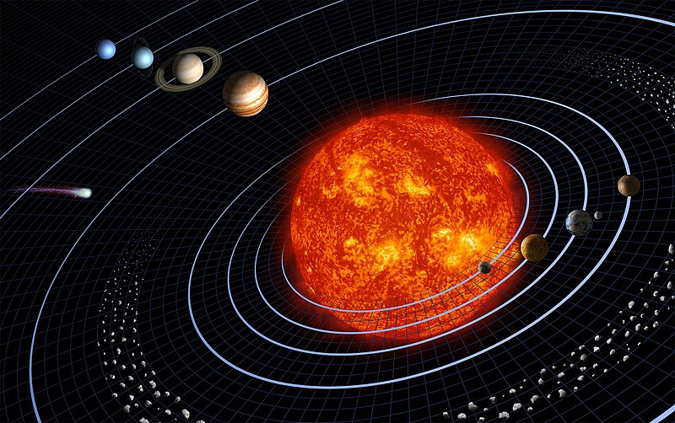
Grade 5 Unit 4: Earth and its Gravitational Force and Motion

Instructions for Parents/Guardians
- Refer to your student’s score report to determine their instructional needs level—green, yellow, or red—for this performance category.
- Use the Interpretive Guidance (see page 2) to understand what your student likely knows and is able to do based on their instructional needs level.
- Use the Family Resources and Recommendations (see page 4) to engage with and support your student’s science learning at home.

Interpretive Guidance for Performance Category 1:
Support Arguments Related to Interactions Within the Earth, Sun, and Moon System
Red (0-3 score points earned)  - Extensive additional instruction and reteaching of these skills is recommended.  - The student needs significant opportunities to reinforce and apply these skills in future learning. | Yellow (4-9 score points earned)  - Moderate additional instruction on these skills is recommended.  - The student needs additional opportunities to strengthen these skills in future learning. | Green (10-12 score points earned)  - Minimal to no additional instruction on these skills is recommended.  - The student is ready to extend these skills in future learning.

What These Results Mean
This student is likely able to:  - Present an inaccurate representation of the position of the sun, the direction, and/or the length of an object’s shadow.  - State some science ideas or information to provide an inaccurate description or conclusion about the length and direction of shadows over the course of a day and/or a year.  - Use some science ideas and/or information about the motion of objects in the Earth-moon system to attempt to refute a claim.  - Use some science ideas or information related to gravity or a lunar eclipse to attempt a description or conclusion. | This student is likely able to:  - Partially complete a diagram with a minor error to represent the position of the sun, the direction, or the length of an object’s shadow.  - Use some correct and relevant science concepts, mathematical representations, or information to construct an accurate but incomplete argument about the length and direction of shadows over the course of a day and/or a year (i.e., change in shadows’ length from summer to winter).  - Use some relevant concepts, mathematical representations, or information to demonstrate understanding of the pattern of motion of objects in the Earth-moon system to partially refute a claim with minor errors.  - Use some relevant science information about gravity and a lunar eclipse and apply some of these concepts to construct an argument. | This student is likely able to:  - Complete a diagram to correctly represent relationships among the position of the sun, and the direction and the length of an object’s shadow.  - Use correct and relevant science concepts, mathematical representations, or information to construct a clear and convincing argument about the length and direction of shadows over the course of a day and a year (i.e., change in shadows length from summer to winter).  - Use relevant science concepts, mathematical representations, and information to demonstrate understanding of the pattern of motion of objects in the Earth-moon system to accurately refute a claim with at least two pieces of evidence.  - Correctly use relevant science concepts or information about gravity and a lunar eclipse to construct a clear and convincing argument.

Family Resources and Recommendations for Performance Category 1:
Support Arguments Related to Interactions Within the Earth, Sun, and Moon System
Resources and Recommendations to Support Science Learning at Home
Explore the Topic:  - How do the position and motion of objects in the Earth-sun system relate to the length and direction of shadows during the day? | Watch this video [4:52] with your student to learn about what a shadow is and follow along in an investigation to see how shadows change over the course of a day. Stop the video to discuss the length (shorter or longer) and the direction of the shadow at different times of the day and where the sun appears in the sky.  Ask your student to fill in the blank in each sentence. (You can pause the video at [3:45] to show the bar graph.)  - The sun created long shadows in the (blank) (morning) when it was rising in the (blank) (East).  - When the sun was almost directly overhead at (blank) (noon), the shadows were (blank) (shorter/shortest).  - The shadows got (blank) (longer) in the afternoon when the sun was setting in the (blank) (West).  Play all three interactive games with your student to better understand shadows.  After playing, discuss how the movement of the model of the sun and the length and angle of the statue’s shadow compare to observations of your student’s shadow or an object’s shadow when they go outside on a sunny day.
Explore the Topic:  - From Earth, how do the sun and moon appear to be moving across the sky?  - Why do the sun and the moon appear to be moving? | Ask your student to describe what they have noticed about where the sun and moon appear in the sky at different times of the day.  Click on the arrows in this interactive model to observe 1) the apparent position of the sun and changes in sunlight on Earth and 2) the apparent position of the moon and changes in the moon phases.  Stop the model at different time points to compare observations about differences in the location of the sun, the amount of light, the location of the moon, and the phase of the moon.  Scroll down, select, and watch the video “Observe Patterns in the Sky” [1:20] with your student, which shows sunrise, sunset, moonrise, and moonset, to gather more information and facts about how objects in the sky appear to move.

Explain the Topic:  - Does the amount of sunlight different parts of Earth receive change over a year? Why? | Watch this video [3:11] with your student to observe Earth’s tilt as it rotates and orbits the sun. Also, observe how much area north and south of the equator is lit up when Earth is at different points in its orbit around the sun. Discuss these questions with your student:  - Does the Earth’s tilt remain the same no matter what time of year it is? (Yes. As the Earth orbits the sun each year, it stays tilted in the same direction all year round.)  - Does the sun’s light shine differently on Earth at different times of the year? (Yes. As Earth orbits the sun, its tilted axis always points in the same direction. So, throughout the year, different parts of Earth get more or less of the sun’s direct rays.)  Why do summer days have more direct sunlight and winter days have less direct sunlight? (Due to the tilt of the Earth on its axis and where Earth is in its orbit around the sun, summer days have more direct sunlight, while winter days have more indirect light. In Earth's June position in orbit [1:51 to 2:10], the northern hemisphere tilts toward the sun. During Earth's December position in orbit [0:41 to 1:05), the southern hemisphere tilts toward the sun.
Explain the Topic  - What causes the length of shadows to change from summer to winter? | It may seem confusing that the length of your shadow or an object’s shadow depends on the season. Watch this video [2:18] with your student to collect more evidence to support the idea that shadows are longer in the winter than in the summer. Discuss these key points with your student.  - When Earth orbits the sun, there are times when parts of the planet are tilted toward the sun and times when parts are tilted away from the sun.  In the summer, we are tilted toward the sun, so it is higher in the sky. In the winter, we are tilted away from the sun, so the sun appears lower in the sky. This means that the length of shadows depends on the seasons.
Evaluate the Topic  - What evidence do you have to explain when shadows are the longest? | Check your student’s understanding of the Earth and sun system and the length and direction of shadows in different seasons. Ask your student to use evidence (facts and information) from the videos and your discussions to describe (including words, drawings, or models):  - When are shadows the longest? (Shadows are the longest in the winter.)  - How do you know? (Since Earth is tilted away from the sun, the sun appears lower in the sky. That means the sun's light hits objects at a lower angle, making longer shadows. Since the sun is higher in the summer, the shadows are shorter.) The further north you travel in our hemisphere in the fall and winter, the lower the sun will appear in the sky. The lower it appears, the longer the shadow will be.)  This optional activity has a cut-out worksheet to build a model of the Earth-sun-moon system. Have fun!

Resources
- Following the Sun, Crash Course Kids
[https://www.youtube.com/watch?v=1SN1BOpLZAs]
- The Sun, the Sky, and a Whole Lotta Pie!, PBS Learning Media Games
[https://contrib.pbslearningmedia.org/WGBH/buac18/buac18-int-ruffshadowgame/index.html]
- Earth, Moon, and Sun Model, PBS Learning Media
[https://contrib.pbslearningmedia.org/WGBH/buac19/buac19-int-earthsunmoon35model/index.html]
- Observe Patterns in the Sky, PBS Learning Media
[https://ca.pbslearningmedia.org/resource/buac18-k2-sci-ess-predictpatterns/predictable-patterns-in-the-sky/]
- Earth In Orbit, PBS Learning Media
[https://ca.pbslearningmedia.org/resource/buac18-35-sci-ess-earthinorbit/earth-in-orbit/]
- Hey Ray! Why Our Shadows Are Long In Winter, CBS News
[https://www.cbsnews.com/pittsburgh/news/hey-ray-long-winter-shadows/]
- Earth, Sun & Moon Cut-out Worksheet, Weebly
[https://zoomintothemoon.weebly.com/earth-sun-and-moon-orbits-cut-out-worksheet.html]

