
Coherence and Alignment Among Science Curriculum, Instruction, and Assessment (CASCIA) Project

Grade 5 Unit 4: Earth and its Gravitational Force and Motion

Family Guidance and Learning Resources for Performance Category 2

April 2024

Grade 5 Unit 4: Earth and its Gravitational Force and Motion, Family Guidance and Learning Resources for Performance Category 2 was developed with funding from the U.S. Department of Education under the Competitive Grants for State Assessments Program CFDA 84.368A. The contents of this paper do not represent the policy of the U.S. Department of Education, and no assumption of endorsement by the Federal government should be made.
All rights reserved. Any or all portions of this document may be reproduced and distributed without prior permission, provided the source is cited as: Coherence and Alignment Among Science Curriculum, Instruction, and Assessment (CASCIA) Project. (2023). Grade 5 Unit 4: Earth and its Gravitational Force and Motion, Family Guidance and Learning Resources for Performance Category 2. Lincoln, NE: Nebraska Department of Education.
Purpose
The purpose of this document is to help families understand their student’s performance on the Grade 5 Unit 4 Science Assessment and to provide resources and recommendations for engaging their student in science learning at home.
Unit Overview
By engaging in this unit, students deepen their knowledge of the direction of the Earth’s gravitational forces and how distance from the Earth influences the brightness of the sun and stars. With a focus on developing and using models, constructing explanations and designing solutions, analyzing and interpreting data, and engaging in argument from evidence, students learn about the gravitational force of Earth, how these cause observable patterns, and the brightness of the sun and other stars.

Performance Category 2: Analyze Data to Describe Observable Patterns Related to the Earth, Sun, and Moon System
Prompts for this performance category require students to analyze and interpret data and graphs to reveal patterns or relationships about:
Image: The Solar System
Credit: Harman Smith and Laura Generosa
Source: Based on Image:Solar_sys.jpg, with Pluto removed
License: CC0 1.0 DEED
- predicting shadow length during regular intervals over the course of a day
- the pattern of movement of the position of the Big Dipper in the night sky can be predicted
- approximate sunrise and sunset times (e.g., length of daylight) during regular intervals over the course of a year
- the appearance of the moon every four weeks (e.g., moon phases) during regular intervals over the course of four months
- gravity is the force that maintains Earth’s spherical shape

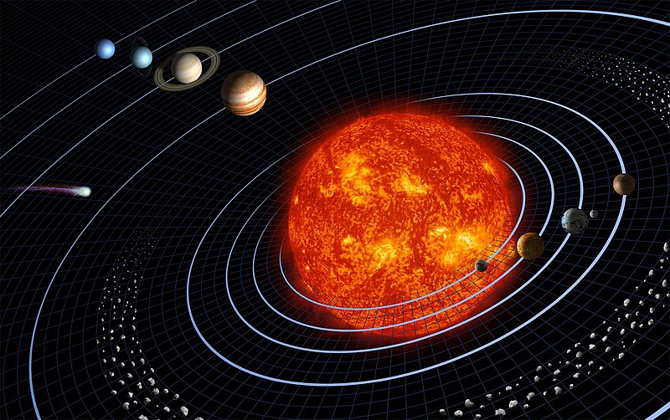
Grade 5 Unit 4: Earth and its Gravitational Force and Motion

Instructions for Parents/Guardians
- Refer to your student’s score report to determine their instructional needs level—green, yellow, or red—for this performance category.
- Use the Interpretive Guidance (see page 2) to understand what your student likely knows and is able to do based on their instructional needs level.
- Use the Family Resources and Recommendations (see page 3) to engage with and support your student’s science learning at home.

Interpretive Guidance for Performance Category 2:
Analyze Data to Describe Observable Patterns Related to the Earth, Sun, and Moon System
Red (0-5 score points earned)  - Extensive additional instruction and reteaching of these skills is recommended.  - The student needs significant opportunities to reinforce and apply these skills in future learning. | Yellow (6-9 score points earned)  - Moderate additional instruction on these skills is recommended.  - The student needs additional opportunities to strengthen these skills in future learning. | Green (10-13 score points earned)  - Minimal to no additional instruction on these skills is recommended.  - The student is ready to extend these skills in future learning.

What These Results Mean
This student is likely able to:  - Partially complete a mathematical model/graph with multiple inaccuracies to represent relationships between the time of day and the length of an object’s shadow and/or make an inaccurate prediction.  - Use no or limited evidence and/or information to support a description of the pattern of movement of the position of the Big Dipper or its appearance at regular intervals during the year.  - Make little or no attempt to utilize data to compare sunrise and sunset times at regular intervals during the year.  - Partially complete a mathematical model/graph with multiple inaccuracies and incorrectly predict phases of Earth’s moon. | This student is likely able to:  - Partially complete a mathematical model/graph with few inaccuracies to represent relationships between the time of day and the length of an object’s shadow to make a reasonable prediction.  - Accurately identify at least one relationship shown in a diagram or graph to describe the pattern of movement of the position of the Big Dipper and its appearance at regular intervals during the year.  - Attempts to identify or utilize some data to compare sunrise and sunset times at regular intervals during the year.  - Partially complete a figure or diagram with some inaccuracies to predict the phases of Earth’s moon with minor errors. | This student is likely able to:  - Complete a mathematical model/graph with no inaccuracies to represent relationships between the time of day and the length of an object’s shadow to make an accurate prediction.  - Accurately identify more than one relationship shown in a diagram or graph to describe the pattern of movement of the position of the Big Dipper and its appearance at regular intervals during the year.  - Correctly identify and utilize sufficient data to compare sunrise and sunset times at regular intervals during the year.  - Complete a figure or diagram with few inaccuracies to accurately predict phases of Earth’s moon.

Family Resources and Recommendations for Performance Category 2:
Analyze Data to Describe Observable Patterns Related to the Earth, Sun, and Moon System
Resources and Recommendations to Support Science Learning at Home
Engage with the Topic:  - What shapes do you see when you look at the moon? | Watch this video [stop at 1:25] with your student, showing the moon’s appearance from Earth’s northern hemisphere. Ask your students these questions:  - What do you notice? (Students should notice that the moon’s shape/appearance changes.)  - What patterns do you see? (Students should identify that the area of the moon that is lit begins as large, then gets small, and then large again. Students may also notice that the same side of the moon is always facing Earth.)
Explore the Topic:  - What patterns do we see in the moon’s appearance this month? | View the Moon Phase Calendar From the Farmers’ Almanac with your student. First, enter your location or ZIP code, and tap “search” to see the moon phases over the current month. Discuss the moon's appearance, the labeled moon phase, and the percentage showing the percent of the moon that is illuminated. Make connections with your students to the patterns they saw in the time-lapse video from the Engage with the Topic step. Ask your student these questions:  - How do the phases of the moon over the month compare to the images you saw in the time-lapse video? (The pattern of the appearance of the different moon phases during a month is the same/related to the appearance of the moon in the time-lapse video.)  - What patterns do you notice in the illumination data (%) shown under each moon? (The Illumination data increases between the new moon and the full moon, then decreases between the full moon and the new moon.)
Explain the Topic:  - What causes the moon phases?  - Do the phases repeat each cycle? | Watch this video [5:41] with your student to see what causes the phases of the moon. Ask your student these questions:  - What causes the moon’s appearance to change throughout the month? (The moon’s appearance changes based on where the moon is in its orbit around Earth and how much of the bright side of the moon we can see from Earth.)  - What does the moon look like during a new moon? Why does it look this way? (During a new moon, the moon does not appear at all. We can’t see the moon because it is between the sun and the Earth, so we do not see the lit side of the moon.)  - What does the moon look like during a full moon? Why does it look this way? (During a full moon, the moon appears fully lit. We see this because the moon is on the side of Earth, so we see the fully lit side of the moon.)
Elaborate on the Topic:  - What will the moon look like over the next month based on the patterns we have observed? | Go to When Is the Next Full Moon in the Farmers’ Almanac with your student and scroll down to the Full Moon Calendar 2024. After reviewing the calendar, ask your student:  - Do the dates when the full moon can be seen change from month to month? (Yes)  - How do the dates change from month to month? (Sometimes, the full moon is a day or two sooner the next month, a day later the next month, or the same day the next month. The full moon repeats approximately every 28 days.)  On the same page, scroll down to the Full Moon Calendar 2025  - On the Full Moon Calendar 2024, the full moon is on May 23. On the Full Moon Calendar 2025, what is the date of the full moon in May? (May 12)  - Why is the full moon so much later in 2025, in the month of May? (From May 2024 to May 2025, the full moon must occur one day later or so each month, so the date of the full moon would be about 11 days earlier in 2025 in the month of May as compared to 2024 in the month of May.)  Next, on the same page, scroll down to the Lunar Phases Explained diagram.  - How is the illumination data related to the location of the sun, moon, and Earth in space? (The Illumination data shows how much of the lit side of the moon we see each day. The amount of the lit side of the moon (the area illuminated by direct sunlight) that we see depends on where the moon is in its orbit around the Earth. The more direct sunlight the moon receives, the percent illuminated increases.)

Resources
- Moon Phases 2015 – video by NASA
[https://www.youtube.com/watch?v=LC5rEhxGqT4]
- Moon Phases Calendar – calendar by Farmer’s Almanac
[https://www.farmersalmanac.com/calendar/moon-phases]
- Phases of the Moon: Astronomy and Space for Kids – video by FreeSchool
[https://www.youtube.com/watch?v=f4ZHdzl6ZWg]
- Phases of the Moon – Earth Now
[https://earthhow.com/major-moon-phases/]

