Coherence and Alignment Among Science Curriculum, Instruction, and Assessment (CASCIA)  Grade 5 Unit 1  End-of-Unit Assessment  Task Interpretation Guide  August 2023  The Interpretation Guide for the SIPS Assessment Model: A Coherent NGSS- and Framework-aligned System of Science Curriculum, Instruction, and Assessment was developed with funding from the U.S. Department of Education under the Competitive Grants for State Assessments Program, CFDA 84.368A. The contents of this guide do not represent the policy of the U.S. Department of Education, and no assumption of endorsement by the Federal government should be made. |  |   All rights reserved. Any or all portions of this document may be reproduced and distributed without prior permission, provided the source is cited as: Stackable Instructionally-embedded Portable Science (SIPS) Assessments Project. (2023). Interpretation Guide for the SIPS Assessment Model: A Coherent NGSS- and Framework-aligned System of Science Curriculum, Instruction, and Assessment. Lincoln, NE: Nebraska Department of Education.
Table of Contents
Introduction 1
Purpose 1
Contents 2
SIPS Grade 5 Unit 1 EOU Assessment Task 1: What’s the Matter 3
Prompt 1 – Parts A and B 3
Prompt 2 9
Prompt 3 11
SIPS Grade 5 Unit 1 EOU Assessment Task 2: What Just Happened? 15
Prompt 1 – Part A 15
Prompt 1 – Part B 18
Prompt 2 21
Prompt 3 – Parts A and B 24
SIPS Grade 5 Unit 1 EOU Assessment Task 3: Change or Not? 28
Prompt 1 Parts A and B 28
Prompt 2 Parts A and B 31

Introduction  Research on the influence of assessment practices on student learning is clear. The use of formative assessment practices, with informative and immediate feedback that leads to adjustments to instructional next steps, has been shown to be effective in helping students learn (Black & Wiliam, 1998; Wylie & Lyon, 2009; Heritage, 2010). Interim or large-scale summative assessments, such as those required under the Every Student Succeeds Act of 2015 (ESSA), cannot and are not meant to inform daily instruction because of how and when they are administered. These forms of assessment can bring value to an assessment system, but only if coordinated and meaningfully aligned within a comprehensive, coherent system.  The Coherence and Alignment Among Science Curriculum, Instruction, and Assessment (CASCIA) Project brings together three partner states—Nebraska, Alabama, and Alaska—with a team of researchers and experts to establish science assessment resources that are coordinated and aligned across all parts of the assessment system. With coherence as the guiding principle, these state-level educators and national science education and measurement experts have joined with hundreds of local educators to address states’ need for quality, standards-aligned science assessments that generate meaningful, interpretable, and actionable results, and to design a scoring and score reporting framework that builds educators’ capacity to track, interpret, and communicate students’ learning in science and to offer effective instruction for all students.  Purpose  The purpose of the Grade 5 Unit 1 End-of-Unit Assessment Task Interpretation Guide is to support educators’ understanding of the Grade 5 Unit 1 End-of-Unit assessment tasks and prompts, their features, and the evidence (i.e., knowledge and skills) they are designed to elicit about student learning, and how the assessment and the information it provides can be used to plan instruction and learning opportunities for students, whether it involves planning for instruction prior to teaching the instructional unit, reflecting on the quality and sufficiency of prior |  |  | instruction and instructional materials or planning additional student learning opportunities or interventions in the subsequent unit (e.g., SIPS Unit 2).  The Grade 5 Unit 1 Science Assessment includes three science tasks, each including multiple scorable prompts. Task 1, What’s the Matter?, includes three prompts and 11 possible score points with one prompt having three parts—Part A, Part B, and Part C; Task 2, What Just Happened?, includes three prompts and 10 possible score points with two of the three prompts having two parts—Part A and Part B; Task 3, Change or Not?, includes two prompts and seven possible score points with two of the three prompts having two parts—Part A and Part B.  Prompts from the three tasks that measure similar combinations of dimensions (i.e., Disciplinary Core Ideas, Science and Engineering Practices, and Crosscutting Concepts) from the Next Generation Science Standards (NGSS) are organized into three performance categories. The NGSS Performance Expectations (PEs) are addressed in one or more performance categories to provide multiple opportunities to demonstrate flexible thinking and competency in different situations and contexts.
  Performance Category | NGSS PEs | Prompts in Performance Category | Points Possible
  Model the Structure of Matter | 5-PS1-1 | Task 1, Prompt 1  Task 2, Prompt 1 | 10 points
  Use Observations and Measurements of Properties of Matter | 5-PS1-3 | Task 1, Prompt 2  Task 1, Prompt 3  Task 2, Prompt 2  Task 2, Prompt 3 | 11 points
  Use Observations and Measurements of Chemical Reactions | 5-PS1-2 5-PS1-4 | Task 3, Prompt 1  Task 3, Prompt 2 | 7 points
Contents  This document includes interpretive guidance to support educators’ understanding of each prompt on the Grade 5 Unit 1 EOU Assessment, its features, and the evidence it is designed to elicit about students’ learning, and offers important connections to the learning goals, formative assessment opportunities, and lesson descriptions within the SIPS Grade 5 Unit 1 Map / Instructional Framework as well as connections to future learning opportunities in the next unit.  For each prompt, the following information is provided:  - Performance Category – The performance category to which the prompt is aligned.  - Acquisition Goals – The acquisition goals from Stage 1 of the unit map / instructional framework that the prompt is intended to measure.  - Prompt Knowledge and Skills for Measurement – The evidence of student learning the prompt is designed to elicit.  - Prompt and Exemplar Response – The prompt with an example exemplar response. An exemplar response represents a high-quality response that provides evidence that students have demonstrated the knowledge, skills, and abilities assessed by the prompt. Student exemplars are intended to assist in understanding the nature and expectations of the prompt. However, students may respond with other relevant scientifically accurate responses, evidence, observations, and ideas.  In general, a full-point exemplar response meets expectations and is:  - scientifically accurate  - complete  - coherent  - consistent with the type of student evidence expected as described in the rubric  For examples of student responses for each prompt representative of the full range of score points possible based on the scoring rubric, access the Grade 5 Unit 1 EOU Assessment Scoring Guide. |  |  | - Prompt Complexity – The complexity features of the prompt based on the SIPS Complexity Framework. The sophistication of students’ ability to demonstrate sense-making is characterized by their ability to (a) use disciplinary core ideas (DCIs), scientific and engineering practices (SEPs), and crosscutting concepts (CCCs) together in the service of sense-making about a phenomenon or problem, and (b) engage with and respond to items and tasks designed using variable features representing combinations of Low, Moderate, and High complexity designations. These combinations of features are based on the SIPS Complexity Framework.  Adapted from the Cambridge Alignment Methodology (Forte, 2021) and informed by aspects of Achieve’s Framework to Evaluate Cognitive Complexity in Science Assessments (Achieve, 2019), the SIPS Complexity Framework is grounded in sense-making and students’ ability to flexibly apply knowledge through the integration of the same and new/different combinations of dimensions within the PEs from a unit bundle, in the context of a phenomenon or phenomenon-rooted design problem based on the focal DCIs.  - Prompt Connections to the Unit Map / Instructional Framework – A high-level overview of the evidence elicited by the prompt related to the acquisition goals, connections to the instructionally-embedded formative assessment opportunities within stage 2 of the unit map, and connections to opportunities to learn based on the lesson descriptions within stage 3 of the unit map.  For each of the three tasks, the following information is provided:  - Connections to Future Learning Opportunities – The knowledge, skills, and abilities elicited by the prompt that can be leveraged and extended in future learning. Unit connections highlight where and how an educator can emphasize connections for students in the next unit.
SIPS Grade 5 Unit 1 EOU Assessment Task 1: What’s the Matter  Prompt 1 – Parts A and B  Performance Category: Model the Structure of Matter  Acquisition Goals  - A4. Develop or use a model that shows that a substance, regardless of the quantity, is made up of particles too small to be seen.  - A5. Construct an explanation to support the claim that substances are made up of particles too small to be seen.  Prompt 1 Parts A and B measure students’ ability to:  - Develop or use models to support descriptions of how matter is made of particles too small to be seen.  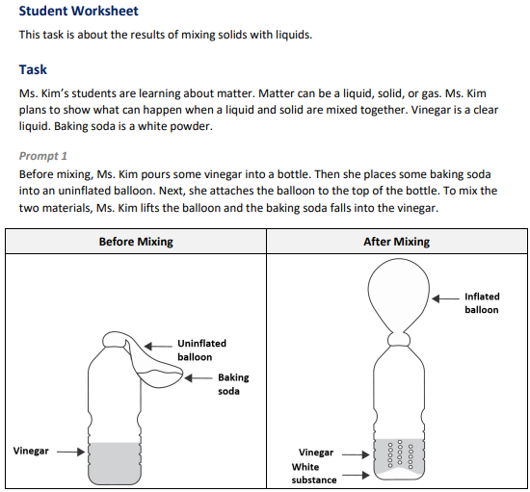 |  |  | 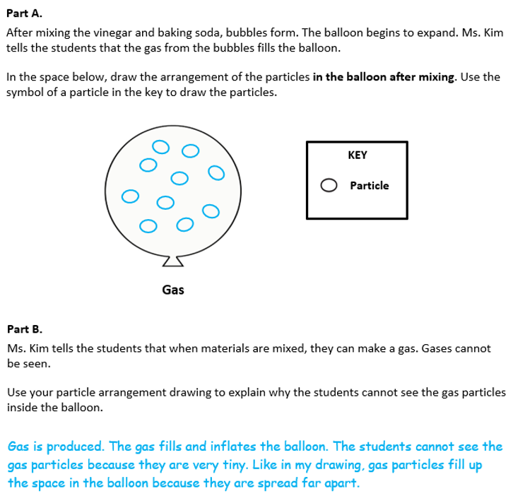
  Task 1 Prompt 1 Parts A and B Complexity
  Degree and Nature of Sensemaking | Moderate | This prompt…  - Requires integration of two dimensions in the service of sensemaking  - Requires a combination of previously learned ideas or concepts and newly presented information
  Complexity of the Presentation | Moderate | - The amount and type of information provided in the scenario supports multiple evident connections among ideas or concepts  - Provides graphics/data/models  - Phenomenon or problem presented with some level of uncertainty
  Cognitive Demand of Response Development | Moderate | - Requires application of ideas and practices given cues and guidance  - Requires drawing relationships and connecting ideas and practices  - Response requires a moderate level of sophistication with typical but relatively complex representation of ideas and application of skills
  Cognitive Demand of Response Production | Moderate | - Responses include one or more sentences or a paragraph, a moderately complex graphic, or multiple steps in a simple or moderately complex process
  Task 1 Prompt 1 Parts A and B
  Connections to the Instructional Framework
  Integration of Knowledge and Skills for Response Development
  Part A
  - Students read the task scenario and observe the illustrations of the uninflated balloon and the inflated balloon before and after pouring baking soda into the uninflated balloon.
  - Students conclude that matter that cannot be seen but can be detected in other ways.
  - Students conclude that gas particles have mass and take up space.
  - Students select and identify relevant aspects of the task situation to include in their model and draw the arrangement of particles in the balloon after mixing.
  Part B
  - Students refer to their particle arrangement model to reason about the phenomenon.
  - Students use their particle arrangement to describe and explain the phenomena that gas particles are too small to be seen.
  - Students use their particle arrangement to describe and explain the phenomena that gas particles fill up space in the balloon.
  Formative Assessments | Opportunities to Learn
  Segment 1, pp. 8  Informal Assessment: Classroom Check-ins About Particle Theory of Matter (A4)  - Students develop a model that accurately represents that the particles of a substance in multiple quantities are the same and made up of particles too small to be seen. | Segment 1, pp. 25-26  What is Air? (A4)  - Students gather observations and data that show how air, a gas, is made of matter and has weight, takes up space, and has certain properties.
Prompt 1 – Part C  Performance Category: Model the Structure of Matter  Acquisition Goals  - A4. Develop or use a model that shows that a substance, regardless of the quantity, is made up of particles too small to be seen.*  - A5. Construct an explanation to support the claim that substances are made up of particles too small to be seen.  - A10. Construct an explanation to support the claim that when matter changes state, it is still composed of the same particles (that were in the previous state).  Prompt 1 Part C measures students’ ability to:  - Develop or use models to support descriptions of how matter is made of particles too small to be seen.  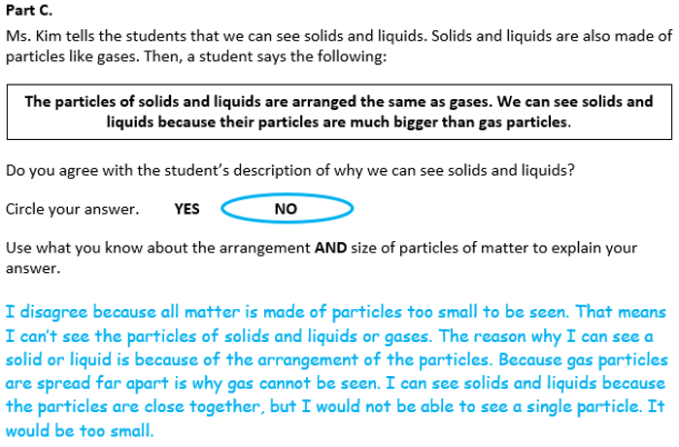
  Task 1 Prompt 1 Parts A and B
  Connections to the Instructional Framework, Continued
  Formative Assessments | Opportunities to Learn
  Segment 1, p. 10  Informal Assessment: Annotated Drawings: Particle Theory of Matter (A4, A5)  - Students accurately identify information in a model or evidence that describes appropriate properties of air as having mass, taking up space, and being made of particles too small to be seen and spread apart.  Segment 1, pp. 10-11  Formal Assessment: What is Air?  (A4, A5)  - Students develop a model that accurately represents that the substances are made up of particles that are too small to be seen.  - Students accurately identify and/or describe the evidence that supports a claim that substances are made up of particles that are too small to be seen. | Segment 1, pp. 26-27  Zooming in on Air (A4, A5)  - Students draw a model that connects to the anchoring phenomenon.  - After viewing a simulation, students discuss that matter is made of particles that are too small to be seen.  - Students consider how molecules look in solids, liquids, and gases.  Segment 1, pp. 27-28  Three States of Water: Ice, Steam, and Liquid. Are They All the Same? (A4, A5)  - Students engage in a state of matter characteristic card sort and discuss characteristics of solids, liquids, and gases.  - Students discuss the particle nature of matter, create a visual model of the arrangement of particles in each state, and construct a written explanation to support the claim that when matter changes state, it is still composed of the same particles.
  Task 1 Prompt 1 Part C
  Connections to the Instructional Framework
  Integration of Knowledge and Skills for Response Development
  - Students conclude that gas particles are spread far apart, which is why gas cannot be seen, and that particles in solids and liquids are close together, which is why they can be seen.
  - Students use their conclusion that all matter, including gas, is made of particles too small to be seen and their knowledge of the arrangement of particles of matter to explain why solids and liquids are visible but gases are not.
  Formative Assessments | Opportunities to Learn
  Segment 1, p. 9  Informal Assessment: Annotated Drawings: Particle Theory of Matter (A5, A10)  - Students construct an explanation to accurately support a claim that a given substance in different states of matter is made up of the same particles too small to be seen.  Segment 1, pp. 9-10  Formal Assessment: Conducting Investigations on the States of Matter (A5, A10)  - Students construct an explanation to accurately support a claim that a given substance in different states of matter is made up of the same particles too small to be seen. | Segment 1, p. 26  Zooming in on Air (A4, A5)  - Students explore a simulation of moving air particles and discuss that matter is made of particles too small to be seen.  - Students observe different states of matter and consider how the molecules look in solids, liquids, and gases.  Segment 1, pp. 27-28  Three States of Water: Ice, Steam, and Liquid. Are They All the Same? (A4, A5, A10)  - Students engage in a state of matter characteristic card sort and discuss characteristics of solids, liquids, and gases.
  Task 1 Prompt 1 Part C
  Connections to the Instructional Framework, Continued
  Formative Assessments | Opportunities to Learn
  Segment 1, pp. 11-12
  Formal Assessment: Three States of Water: Ice, Steam, and Liquid. Are They All the Same? (A4*, A10)
  - Students accurately identify and/or describe the information in a model that supports the idea that substances in different states of matter are made up of particles too small to be seen.
  - Students use information provided in a model to accurately explain that substances in different states of matter are made up of the same particles too small to be seen.
  - Students construct an explanation to accurately support a claim that a given substance in different states of matter is made up of the same particles too small to be seen.
  Task 1 Prompt 1 Parts A and B
  Connections to the Instructional Framework, Continued
  Formative Assessments | Opportunities to Learn
  - Construct an explanation to accurately support a claim that substances are made of particles that are too small to be seen.  Segment 1, pp. 12-13  Formal Assessment: How Did We Make a Cloud in Our Mouth?  (A4, A5)  - Students develop a model that accurately represents that the substances are made up of particles that are too small to be seen.  - Students accurately identify and/or describe the evidence that supports a claim that substances are made up of particles that are too small to be seen.  - Students construct an explanation to accurately support a claim that substances are made of particles that are too small to be seen. | Segment 1, p. 28  How Did We Make a Cloud in Our Mouth? (A4, A5)  - Students create an explanatory model/explanation that uses their annotated drawings, observations, numeric data, and reasoning to develop an explanation of what led to the cloud being formed in their mouth.
  Task 1 Prompt 1 Part C Complexity
  Degree and Nature of Sensemaking | Low | This prompt…  - Requires one or two dimensions  - One dimension may have a greater degree of emphasis than another  - Requires previously learned ideas or concepts
  Complexity of the Presentation | Low | - The amount and type of information provided in the scenario supports limited simple connections among ideas or concepts  - Phenomenon or problem presented in a concrete way with high level of certainty
  Cognitive Demand of Response Development | Moderate | - Requires drawing relationships and connecting ideas and practices  - Response requires a moderate level of sophistication with typical but relatively complex representation of ideas and application of skills
  Cognitive Demand of Response Production | Moderate | - Response includes one or more sentences or a paragraph, a moderately complex graphic, or multiple steps in a simple or moderately complex process
  Task 1 Prompt 1 Part C
  Connections to the Instructional Framework, Continued
  Formative Assessments | Opportunities to Learn
  - Draw appropriate conclusions from data about the properties of solids, liquids, and gases.  Segment 1, pp. 10-11  Formal Assessment: Conducting Investigations on the States of Matter (A5, A10)  - Students accurately identify and/or describe the evidence that supports a claim that a given substance in different states of matter is made up of the same particles too small to be seen.  - Students construct an explanation to accurately support a claim that a given substance in different states of matter is made up of the same particles too small to be seen. | - Students discuss the particle nature of matter, create a visual model of the arrangement of particles in each state, and construct a written explanation to support a claim that when matter changes state, it is still composed of the same particles.  Segment 1, p. 28  How Did We Make a Cloud in Our Mouth? (A4, A5, A10)  - Students create an explanatory model/explanation that uses their annotated drawings, observations, numeric data, and reasoning to develop an explanation of what led to the cloud being formed in their mouth.
  Task 1 Prompt 1 Part C
  Connections to the Instructional Framework, Continued
  Formative Assessments | Opportunities to Learn
  Segment 1, pp. 12-13
  Formal Assessment: How Did We Make a Cloud in Our Mouth?
  (A4, A5, A10)
  - Students develop a model that accurately represents that the substances are made up of particles too small to be seen.
  - Students accurately identify and/or describe the evidence that supports a claim that substances are made up of particles too small to be seen.
  - Students construct an explanation to accurately support a claim that substances are made up of particles too small to be seen.
  - Students accurately identify and/or describe the information in a model that supports the idea that substances in different states of matter are made up of particles too small to be seen.
  - Students use the information provided in a model to accurately explain that substances in different states of matter are made up of particles too small to be seen.
Prompt 2  Performance Category: Use Observations and Measurements of Properties of Matter  Acquisition Goals  - A1. Describe how properties of matter can be used to compare and contrast materials.  - A3. Conduct an investigation to measure and/or qualitatively describe the properties of substances.  - A6. Conduct an investigation to identify a substance by measuring and/or qualitatively describing certain properties of substances.  Prompt 2 measures students’ ability to:  - Use observations and measurements as evidence to describe how to develop a procedure to identify materials based on their properties. |  |  | 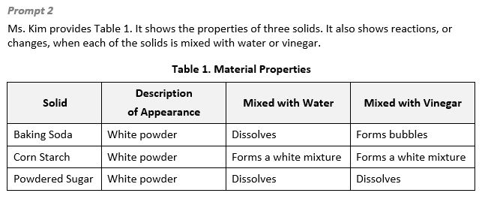  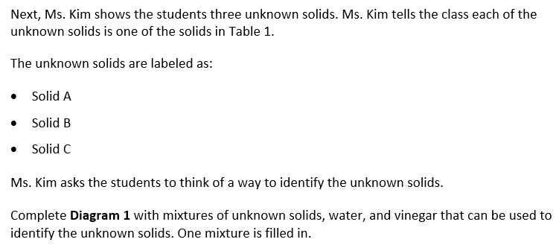  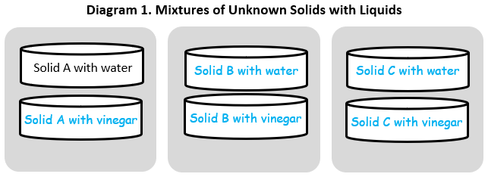
  Task 1 Prompt 2 Complexity
  Degree and Nature of Sensemaking | Moderate | This prompt…  - Required integration of two dimensions in the service of sense-making
  Complexity of the Presentation | Moderate | - The amount and type of  information provided in the  scenario supports multiple evident connections among  ideas or concepts  - Provides graphics/data/models  - Phenomenon or problem  presented with some level of uncertainty
  Cognitive Demand of Response Development | Moderate | - Requires application of ideas and practices given cues and guidance  - Requires drawing relationships and connecting ideas and  practices
  Cognitive Demand of Response Production | Low | - Responses include selection from a small set of options presented as text (e.g., word, short phrase) or other formats (e.g., a simple graphic or process)
  Task 1 Prompt 2
  Connections to the Instructional Framework
  Integration of Knowledge and Skills for Response Development
  - Students read through Table 1, which serves as the basis for evidence for an explanation of the phenomenon.
  - Students identify the purpose of the investigation.
  - Students conclude that properties can be used to identify materials and that properties may include changes in response to other properties as observable and measurable properties.
  - Students use Table 1, which shows the properties of three solids, to identify the mixtures that can be used to identify the unknown solids.
  Formative Assessments | Opportunities to Learn
  Segment 2, p. 13  Informal Assessment: Matter and Its Properties (A1, A3, A6)  - Students identify and/or describe appropriate properties of matter to use when comparing and contrasting materials.  - Students accurately identify and/or describe properties of matter after combining substances.  - Students accurately compare and contrast properties of matter before and after combining substances.  - Students draw appropriate conclusions from data about the properties of a substance. | Segment 2, p. 29  What is This? (A1, A3*, A6)  - Students engage in a class discussion of the different types of properties that can be used to describe substances, including both characteristic properties (e.g., solubility, flammability, odor, heat conductivity, magnetism) and non-characteristic properties (e.g., weight, volume).  - Students plan an investigation to describe the properties of given substances.
 |  |  | Prompt 3  Performance Category: Use Observations and Measurements of Properties of Matter  Acquisition Goals  - A1. Describe how properties of matter can be used to compare and contrast materials.  - A2. Use mathematical and computational thinking on the properties of substances to identify a substance.  - A3. Conduct an investigation to measure and/or qualitatively describe the properties of substances.  - A6. Conduct an investigation to identify a substance by measuring and/or qualitatively describing certain properties of substances.  Prompt 3 measures students’ ability to:  - Use observations and measurements as evidence to describe how to develop a procedure to identify materials based on their properties.  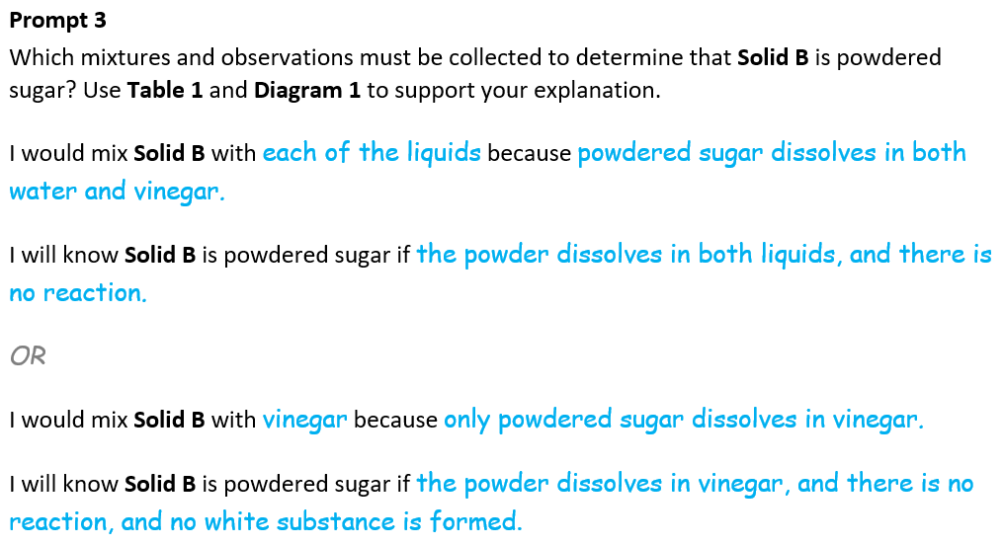
  Task 1 Prompt 2
  Connections to the Instructional Framework, Continued
  Formative Assessments | Opportunities to Learn
  Segment 2, p. 14  Formal Assessment: Investigating the Mystery Matter (A3, A6)  - Accurately describe the procedure for an investigation to determine the properties of a substance.  - Make appropriate observations and/or measurements to produce data that will help identify a substance.  - Identify and/or describe appropriate patterns in data on the properties of a substance. | Segment 2, p. 29  What Could it Be? (A1, A3, A6)  - Students carry out their planned investigation and record data to organize the different properties of different materials.  - Students construct explanations about how properties of matter can be used to compare and contrast materials.

  Task 1 Prompt 3 Complexity
  Degree and Nature of Sensemaking | Moderate | This prompt…  - Required integration of two dimensions in the service of sense-making
  Complexity of the Presentation | Low | - The amount and type of information provided in the scenario supports limited simple connections among ideas or concepts  - Provides few, simple graphics/data/models  - Phenomenon or problem presented in a concrete way with high level of certainty
  Cognitive Demand of Response Development | Moderate | - Requires application of ideas and practices given cues and guidance  - Requires drawing relationships and connecting ideas and  practices
  Cognitive Demand of Response Production | High | - Responses include multiple paragraphs, multiple graphics of at least moderate complexity, or multiple steps in a complex process
  Task 1 Prompt 3
  Connections to the Instructional Framework
  Integration of Knowledge and Skills for Response Development
  - Students refer to Table 1 and Diagram 1, which serve as the basis for evidence for an explanation of the phenomenon.
  - Students identify the purpose of the investigation.
  - Students conclude that properties can be used to identify materials and that properties may include changes in response to other properties as observable and measurable properties.
  - Students use Table 1 and Diagram 1 to determine which mixtures and observations must be collected to determine that Solid B is powdered sugar.
  Formative Assessments | Opportunities to Learn
  Segment 2, p. 13  Informal Assessment: Matter and Its Properties (A1, A3, A6)  - Students accurately identify and/or describe properties of matter after combining substances.  - Students accurately compare and contrast properties of matter before and after combining substances.  - Students draw appropriate conclusions from data about the properties of a substance. | Segment 2, p. 29  What is This? (A1, A2, A3, A6)  - Students engage in a class discussion of the different types of properties that can be used to describe substances, including both characteristic properties (e.g., solubility, flammability, odor, heat conductivity, magnetism) and non-characteristic properties (e.g., weight, volume).  - Students plan an investigation to describe the properties of given substances.  Segment 2, p. 29  What Could it Be? (A1, A2, A3, A6)  - Students carry out their planned investigation and record data to organize the different properties of different materials.
Task 1 Prompt 3
Connections to the Instructional Framework, Continued
Formative Assessments | Opportunities to Learn
Segment 2, p. 14  Formal Assessment: Investigating the Mystery Matter (A2, A3, A6)  - Students identify and/or describe appropriate patterns in data on the properties of a substance.  - Students make appropriate observations and/or measurements to produce data that will help identify a substance.  - Students draw appropriate conclusions from data about the identity of a substance.  Segment 2, pp. 14-15  Formal Assessment: What’s the Mystery Matter? (A2, A3*)  - Students make appropriate observations and/or measurements to produce data that will help identify a substance.  - Students identify and/or describe appropriate patterns in data on the properties of a substance.  - Students draw appropriate conclusions from data about the identity of a substance. | - Students construct explanations about how properties of matter can be used to compare and contrast materials.  Segment 2, p. 30  What is the Mystery Matter?  (A2, A6)  - Students use observations and evidence to explain the physical properties of a mystery substance and identify what the substance is made of.

Future Learning Connected to evidence elicited in Task 1
Crosscutting Concepts
- In Unit 1, students focus on Cause & Effect and Scale, Proportion, and Quantity. Cause and Effect lies at the heart of science. Cause and Effect is also closely associated with the practice of “Engaging in Argument from Evidence.” In Unit 2, students will “Develop and use Models” of ecosystems and food webs to construct and support evidence-based “Arguments” that center around ecosystems. An understanding of Scale involves not only understanding systems and processes vary in size, time span, and energy, but also different mechanisms operate at different scales. The crosscutting concept of Scale, Proportion, and Quantity are essential considerations when deciding how to model a phenomenon and figures prominently in the practice of “Analyzing and Interpreting Data.” In Unit 2, students will explore the needs of plants, and use that data to refine their explanatory model to create scientifically accurate explanations. The Unit 1 Crosscutting Concepts serve as a starting point for students to understand what they will use to understand and make sense of phenomena explained in Unit 2, such as matter being transported into, out of, and within systems.
Disciplinary Core Ideas
- In Unit 1, students learn that matter is made up of particles too small to be seen and that mass is conserved. This will help students build future understanding in Unit 2 students develop an understanding of the idea that plants get the materials they need for growth chiefly from air and water. Using models, students can describe the movement of matter among plants, animals, decomposers, and the environment. In Unit 2, Acquisition Goal 12 requires students to develop a model to describe how matter cycles among living and non-living components within an ecosystem. Students are given a variety of biotic and abiotic (living and nonliving) picture cards and create a model of how matter moves through an ecosystem. (Formal Assessment: Movement of Matter Through an Ecosystem: Can You Show It?, pp. 14-15)
Science and Engineering Practices
- In Unit 1, students experience developing and using models to illustrate that substances are composed of particles and/or particle motion. In Unit 2, they use their experience building descriptive models to help them as they model different concepts. In Unit 2, Acquisition Goal 6 requires students to use a model to describe that plants form the foundation of the food web. Students progressively add to an explanatory model of the owl/predator’s food web using the knowledge they gain from looking at what animals eat and do with that food. (Formal Assessment: Modeling Energy and Food Webs, pp. 9-10)
- In Unit 1, students conduct investigations to collect data that can be used as evidence for their claims, and they develop models to describe phenomena. These experiences working with models, data, and evidence help prepare them for engaging in an argument that makes use of these three forms of scientific information. In Unit 2, Acquisition Goal 10 requires students to engage in an argument from evidence about the role of sunlight in the process of making food by plants. Students are presented with plants that they watch over time in various conditions, with individual groups selecting different variables. The data from the experiments will give students the opportunity to describe the pattern of the role that each of these variables has on plant growth. (Formal Assessment: Conditions for Plant Growth, pp. 12-13)

SIPS Grade 5 Unit 1 EOU Assessment Task 2: What Just Happened?  Prompt 1 – Part A  Performance Category: Model the Structure of Matter  Acquisition Goals  - A4. Develop or use a model that shows that a substance, regardless of the quantity, is made up of particles too small to be seen.  - A13. Develop or use a model to determine if substances in different states of matter are made of particles that are too small to be seen.  Prompt 1 Part A measures students’ ability to:  - Develop or use models to support descriptions of how condensation, the movement of water particles in the air to a surface, demonstrates that matter is made from particles that are too small to see. |  | 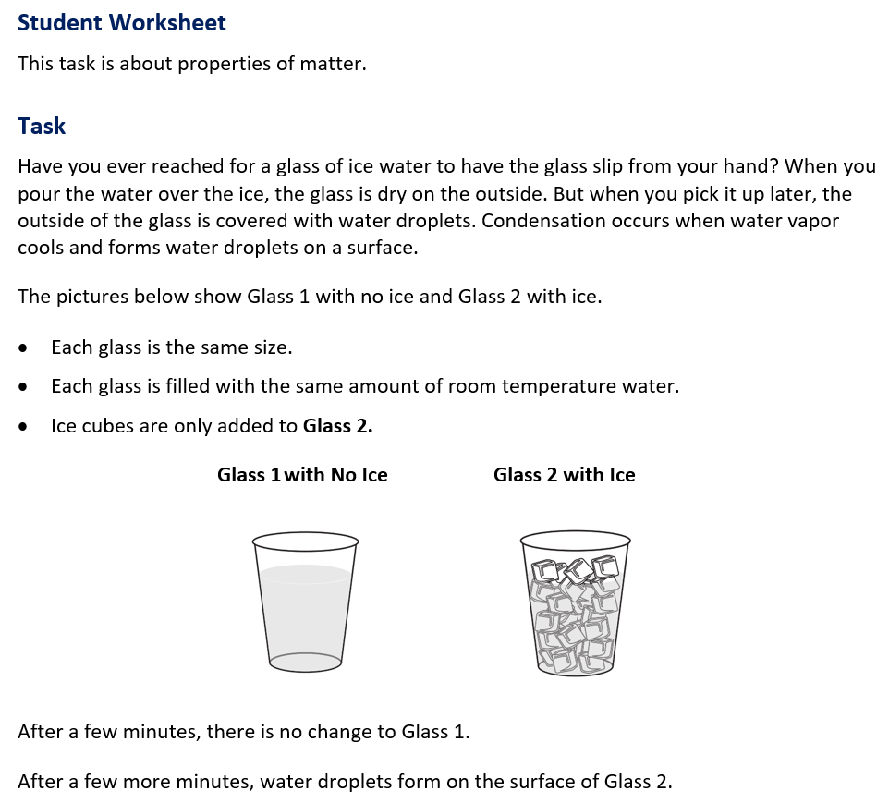

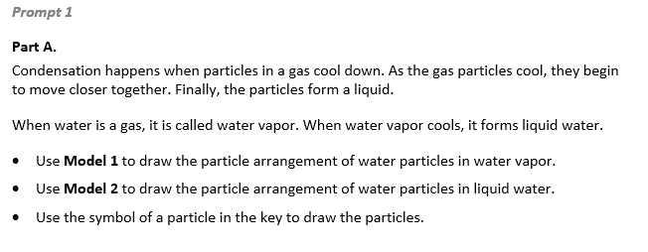  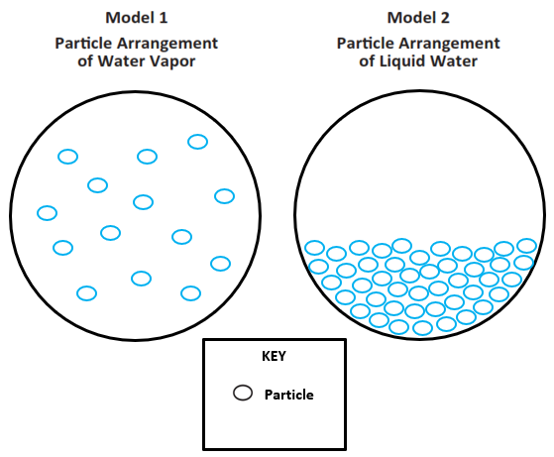
  Task 2 Prompt 1 Part A Complexity
  Degree and Nature of Sensemaking | Moderate | This task…  - Requires integration of two dimensions in the service of sense-making  - Requires a combination of previously learned ideas or concepts and newly presented information
  Complexity of the Presentation | Low | - The amount and type of information provided in the scenario supports limited simple connections among ideas or concepts  - Provides few, simple graphics/data/models  - Phenomenon or problem presented in a concrete way with high level of certainty
  Cognitive Demand of Response Development | Low | - Requires well-defined set of actions or procedures  - Response requires a low level of sophistication with routinely encountered well-practiced applications
  Cognitive Demand of Response Production | Moderate | - Responses include one or more sentences or a paragraph, a moderately complex graphic, or multiple steps in a simple or moderately complex process
  Task 2 Prompt 1 Part A
  Connections to the Instructional Framework
  Integration of Knowledge and Skills for Response Development
  - Students review the provided informational text and model about condensation.
  - Students use the provided information about condensation and apply this definition to what they have learned about water vapor and liquid water.
  - Students develop a model to describe what happens to the particle arrangement of water particles in water vapor and liquid water.
  Formative Assessments | Opportunities to Learn
  Segment 1, p. 9  Informal Assessment: Annotated Drawings: Particle Theory of Matter (A4, A13)  - Students identify information in a model/evidence that describes appropriate properties of air as having mass, taking up space, and being made of particles too small to be seen and spread apart.  - Students identify information in a model/evidence that describes appropriate properties of liquids as having mass, taking up space, and being made of particles close together but able to move about. | Segment 1, pp. 26-27  Zooming in on Air (A4)  - Students observe a simulation of air particles moving around and different states of matter and consider how molecules look in solids, liquids, and gases.  Segment 1, pp. 27-28  Three States of Water: Ice, Steam, and Liquid. Are They All the Same? (A4, A13)  - Students engage in a state of matter characteristic card sort and discuss characteristics of solids, liquids, and gases.  - Students discuss the particle nature of matter and create a visual model of the arrangement of particles in each state.
  Task 2 Prompt 1 Part A
  Connections to the Instructional Framework, Continued
  Formative Assessments | Opportunities to Learn
  Segment 1, pp. 11-12  Formal Assessment: Three States of Water: Ice, Steam, and Liquid. Are They All the Same? (A4*, A13)  - Students accurately identify and/or describe the information in a model that supports the idea that substances in different states of matter are made up of particles that are too small to be seen.  - Students use the information provided in a model to accurately explain that substances in different states of matter are made up of particles that are too small to be seen.  Segment 1, pp. 12-13  Formal Assessment: How Did We Make a Cloud in Our Mouth? (A4, A13)  - Students develop a model that accurately represents that the substances are made up of particles that are too small to be seen. | Segment 1, p. 28  How Did We Make a Cloud in Our Mouth? (A4, A13)  Students develop an explanation using logic and reasoning to describe a phenomenon.
Prompt 1 – Part B  Performance Category: Model the Structure of Matter  Acquisition Goals  - A10. Construct an explanation to support the claim that when matter changes state, it is still composed of the same particles (that were in the previous state).  - A13. Develop or use a model to determine if substances in different states of matter are made of particles that are too small to be seen.  Prompt 1 Part B measures students’ ability to:  - Develop or use models to support descriptions of how condensation, the movement of water particles in the air to a surface, demonstrates that matter is made from particles that are too small to see.  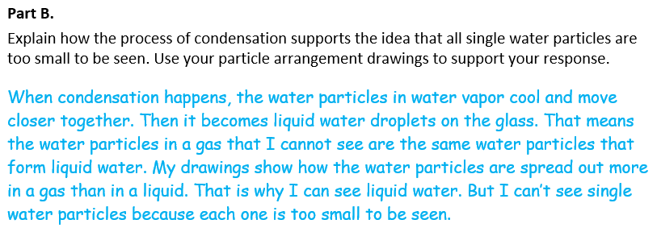
  Task 2 Prompt 1 Part B Complexity
  Degree and Nature of Sensemaking | Moderate | This prompt…  - Requires integration of two dimensions in the service of sensemaking  - Requires a combination of previously learned ideas or concepts and newly presented information
  Complexity of the Presentation | Low | - The amount and type of information provided in the scenario supports limited simple connections among ideas or concepts  - Phenomenon or problem presented in a concrete way with high level of certainty
  Cognitive Demand of Response Development | Moderate | - Requires drawing relationships and connecting ideas and practices  - Requires a moderate level of sophistication with typical and relatively complex representation of ideas and application of skills
  Cognitive Demand of Response Production | High | - Responses include multiple paragraphs, multiple graphics of at least moderate complexity, or multiple steps in a complex process
  Task 2 Prompt 1 Part B
  Connections to the Instructional Framework
  Integration of Knowledge and Skills for Response Development
  - To explain what happens during condensation, students reason about the relationships between different components of the model.
  - Students use their particle arrangement models to reason about the phenomenon that all single water particles are too small to be seen.
  - Students describe that all water particles are too small to be seen and understand that when matter changes state, it is still composed of the same particles.
  Formative Assessments | Opportunities to Learn
  Segment 1, p. 9  Informal Assessment: Annotated Drawings: Particle Theory of Matter (A10, A13)  - Students accurately identify information in a model/evidence that describes properties of air as having mass, taking up space, and being made of particles too small to be seen and spread apart.  - Students accurately identify information in a model/evidence that describes properties of liquids as having mass, taking up space, and being made of particles close together but able to move about.  - Students construct an explanation to accurately support a claim that a given substance in different states of matter is made of the same particles that are too small to be seen. | Segment 1, pp. 27-28  Three States of Water: Ice, Steam, and Liquid. Are They All the Same? (A10, A13)  - Students engage in a state of matter characteristic card sort and discuss characteristics of solids, liquids, and gases.  - Students discuss the particle nature of matter and create a visual model of the arrangement of particles in each state.  Segment 1, p. 28  How Did We Make a Cloud in Our Mouth? (A10, A13)  - Students develop an explanation using logic and reasoning to describe a phenomenon.
  Task 2 Prompt 1 Part B
  Connections to the Instructional Framework, Continued
  Formative Assessments | Opportunities to Learn
  Segment 1, p. 11-12
  Formal Assessment: Three States of Water: Ice, Steam, and Liquid. Are They All the Same? (A10, A13)
  - Students accurately identify and/or describe the information in a model that supports the idea that substances in different states of matter are made up of particles that are too small to be seen.
  - Students use the information provided in a model to accurately explain that substances in different states of matter are made up of particles that are too small to be seen.
  - Students construct an explanation to accurately support a claim that a given substance in different states of matter is made up of the same particles that are too small to be seen.
Task 2 Prompt 1 Part B
Connections to the Instructional Framework, Continued
Formative Assessments | Opportunities to Learn
Segment 1, pp. 12-13
Formal Assessment: How Did We Make a Cloud in Our Mouth? (A10, A13)
- Students construct an explanation to accurately support a claim that substances are made up of particles that are too small to be seen.
- Students use the information provided in a model to accurately explain that substances in different states of matter are made up of particles that are too small to be seen.

Prompt 2  Performance Category: Use Observations and Measurements of Properties of Matter  Acquisition Goals  - A1. Describe how properties of matter can be used to compare and contrast materials.  - A2. Use mathematical and computational thinking on the properties of substances to identify a substance.  Prompt 2 measures students’ ability to:  - Use observations and measurements as evidence to describe how data can be used to support an explanation of the identification of materials.  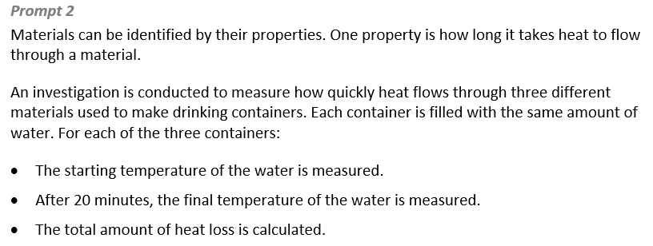 |  |  | 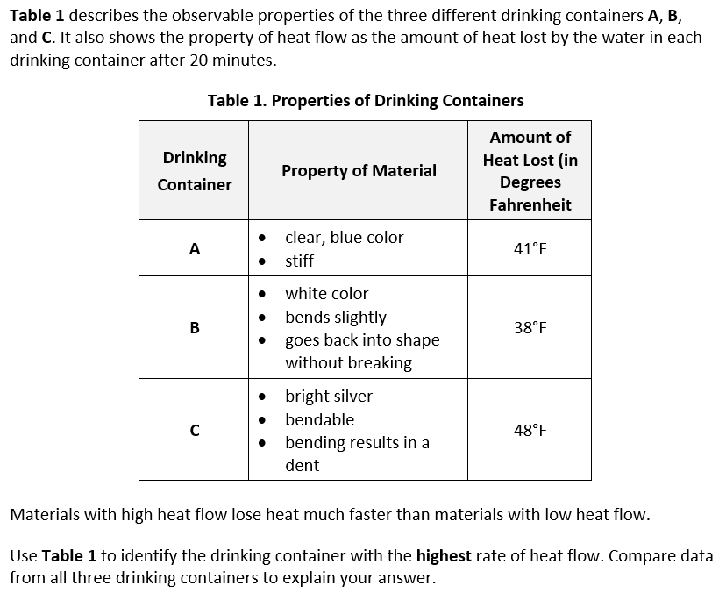
  Task 2 Prompt 2 Complexity
  Degree and Nature of Sensemaking | Moderate | This prompt…  - Requires integration of two dimensions in the service of sensemaking  - Requires a combination of previously learned ideas or concepts and newly presented information
  Complexity of the Presentation | Moderate | - The amount and type of information provided in the scenario supports multiple evident connections among ideas or concepts  - Provides graphics/data/models
  Cognitive Demand of Response Development | Low | - Requires well-defined set of actions or procedures  - Requires a connection or retrieval of factual information  - Response requires a low level of sophistication with routinely encountered well-practiced applications
  Cognitive Demand of Response Production | Moderate | - Response includes one or more sentences or a paragraph, a moderately complex graphic, or multiple steps in a simple or moderately complex process
  Task 2 Prompt 2
  Connections to the Instructional Framework
  Integration of Knowledge and Skills for Response Development
  - Students read the provided text to identify the purpose of the investigation.
  - Students conclude that measurements of a variety of properties can be used to identify materials and that properties can be measured.
  - Students reference Table 1 to use data from the investigation as evidence for explaining which drinking container has the highest rate of heat flow based on its observable properties.
  - Students describe physical quantities such as temperature and understand the units used to measure and compare quantities.
  - Students conclude that Container C lost the most amount of heat from start to finish and therefore has the highest rate of flow.
  Formative Assessments | Opportunities to Learn
  Segment 2, p. 13  Informal Assessment: Matter and Its Properties (A1)  - Students accurately identify and/or describe appropriate properties of matter to use when comparing and contrasting materials.  - Students draw appropriate conclusions from data about the properties of a substance. | Segment 2, p. 29  What is This? (A1, A2)  - Students engage in a class discussion of the different types of properties that can be used to describe substances, including both characteristic properties (e.g., solubility, flammability, odor, heat conductivity, magnetism) and non-characteristic properties (e.g., weight, volume).
Task 2 Prompt 2
Connections to the Instructional Framework, Continued
Formative Assessments | Opportunities to Learn
Segment 2, p. 14  Formal Assessment: Investigating the Mystery Matter (A2)  - Students identify and/or describe appropriate patterns in data on the properties of a substance.  - Students draw appropriate conclusions from data about the identity of a substance.  Segment 2, pp. 14-15  Formal Assessment: What is the Mystery Matter? (A2)  - Students identify and/or describe appropriate patterns in data on the properties of a substance.  - Students draw appropriate conclusions from data about the identity of a substance. | Segment 2, p. 30  What Could it Be? (A1, A2)  - Students make observations and take measurements on different types of properties (e.g., magnetism, volume, weight, color, odor, solubility in water, etc.). Students record data in tables to organize the different properties of the different materials. After gathering the data, students work in small groups to construct an explanation about how properties of matter can be used to compare and contrast materials.  Segment 2, p. 30  What is the Mystery Matter? (A2)  - Students identify the mystery matter by making connections between the physical properties of the mystery matter and the physical properties they observed. Students explain what the mystery matter is made of using previously collected evidence.

Prompt 3 – Parts A and B  Performance Categories: Use Observations and Measurements of Properties of Matter  Acquisition Goals:  - A1. Describe how properties of matter can be used to compare and contrast materials.  - A2. Use mathematical and computational thinking on the properties of substances to identify a substance.  Prompt 3 Parts A and B measure students’ ability to:  - Use observations and measurements as evidence to describe how data can be used to support an explanation of the identification of materials.  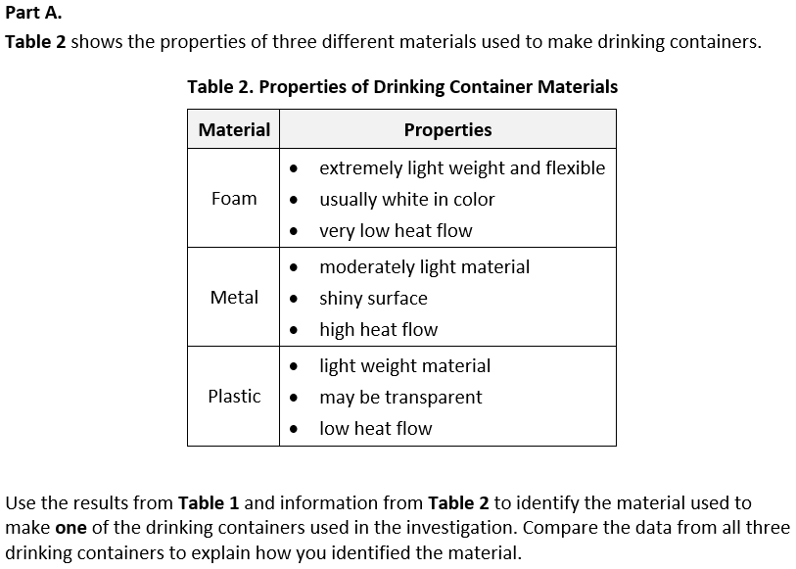 |  |  | 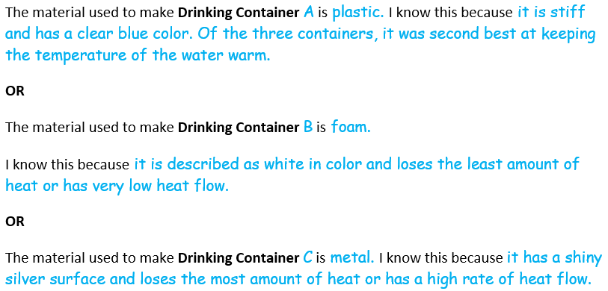
  Task 2 Prompt 3 Parts A and B Complexity
  Degree and Nature of Sensemaking | Moderate | This prompt…  - Requires integration of two dimensions in the service of sensemaking  - Requires a combination of previously learned ideas or concepts and newly presented information
  Complexity of the Presentation | Moderate | - The amount and type of information provided in the scenario supports multiple evident connections among ideas or concepts  - Provides graphics/data/models
  Cognitive Demand of Response Development | High | - Requires selection and application of multiple complex ideas and practices  - Requires high degree of sensemaking, reasoning, and/or transfer  - Response requires a high level of sophistication with non-routine or abstract representation of ideas and application of skills
  Cognitive Demand of Response Production | Moderate | - Response includes one or more sentences or a paragraph, a moderately complex graphic, or multiple steps in a simple or moderately complex process
  Task 2 Prompt 3 Parts A and B
  Connections to the Instructional Framework
  Integration of Knowledge and Skills for Response Development
  Part A
  - Students read the provided text to identify the purpose of the investigation.
  - Students conclude that measurements of a variety of properties can be used to identify materials and that properties can be measured.
  - Students reference Table 1 and Table 2 to use data from the investigation as evidence to identify and explain the material used to make a drinking container based on its observable properties.
  - Students can describe physical quantities such as temperature and understand the units used to measure and compare quantities.
  - Students conclude what material a drinking container is made of and use data to support their explanation.
  Part B
  - Students explain the most useful measurements and observations provided in the tables to identify the material of the drinking container.
  Formative Assessments | Opportunities to Learn
  Segment 2, p. 13  Informal Assessment: Matter and Its Properties (A1)  - Students accurately identify and/or describe appropriate properties of matter to use when comparing and contrasting materials.  - Students draw appropriate conclusions from data about the properties of a substance. | Segment 2, p. 29  What is This? (A1, A2)  - Students engage in a class discussion of the different types of properties that can be used to describe substances, including both characteristic properties (e.g., solubility, flammability, odor, heat conductivity, magnetism) and non-characteristic properties (e.g., weight, volume).
Task 2 Prompt 3 Parts A and B
Connections to the Instructional Framework, Continued
Formative Assessments | Opportunities to Learn
Segment 2, p. 14  Formal Assessment: Investigating the Mystery Matter (A2)  - Students identify and/or describe appropriate patterns in data on the properties of a substance.  - Students draw appropriate conclusions from data about the identity of a substance.  Segment 2, pp. 14-15  Formal Assessment: What is the Mystery Matter? (A2)  - Students identify and/or describe appropriate patterns in data on the properties of a substance.  - Students draw appropriate conclusions from data about the identity of a substance. | Segment 2, p. 30  What Could it Be? (A1, A2)  - Students make observations and take measurements on different types of properties (e.g., magnetism, volume, weight, color, odor, solubility in water, etc.). Students record data in tables to organize the different properties of the different materials. After gathering the data, students work in small groups to construct an explanation about how properties of matter can be used to compare and contrast materials.  Segment 2, p. 30  What is the Mystery Matter? (A2)  - Students identify the mystery matter by making connections between the physical properties of the mystery matter and the physical properties they observed. Students explain what the mystery matter is made of using previously collected evidence.

Future Learning Connected to evidence elicited in Task 2
Crosscutting Concepts
- In Unit 1, students focus on Cause & Effect and Scale, Proportion, and Quantity. Cause and Effect lies at the heart of science. Cause and Effect is also closely associated with the practice of “Engaging in Argument from Evidence.” In Unit 2, students will “Develop and use Models” of ecosystems and food webs to construct and support evidence-based “Arguments” that center around ecosystems. An understanding of Scale involves not only understanding systems and processes vary in size, time span, and energy, but also different mechanisms operate at different scales. The crosscutting concept of Scale, Proportion, and Quantity are essential considerations when deciding how to model a phenomenon and figures prominently in the practice of “Analyzing and Interpreting Data.” In Unit 2, students will explore the needs of plants, and use that data to refine their explanatory model to create scientifically accurate explanations. The Unit 1 Crosscutting Concepts serve as a starting point for students to understand what they will use to understand and make sense of phenomena explained in Unit 2, such as matter being transported into, out of, and within systems.
Disciplinary Core Ideas
- In Unit 1, students learn that matter is made up of particles too small to be seen and that mass is conserved. This will help students build future understanding in Unit 2, students develop an understanding of the idea that plants get the materials they need for growth chiefly from air and water. Using models, students can describe the movement of matter among plants, animals, decomposers, and the environment. In Unit 2, Acquisition Goal 12 requires students to develop a model to describe how matter cycles among living and non-living components within an ecosystem. Students are given a variety of biotic and abiotic (living and nonliving) picture cards and create a model of how matter moves through an ecosystem. (Formal Assessment: Movement of Matter Through an Ecosystem: Can You Show It?, pp. 14-15)
Science and Engineering Practices
- In Unit 1, students experience developing and using models to illustrate that substances are composed of particles and/or particle motion. In Unit 2, they use their experience building descriptive models to help them as they model different concepts. In Unit 2, Acquisition Goal 6 requires students to use a model to describe that plants form the foundation of the food web. Students progressively add to an explanatory model of the owl/predator’s food web using the knowledge they gain from looking at what animals eat and do with that food. (Formal Assessment: Modeling Energy and Food Webs, pp. 9-10)
- In Unit 1, students conduct investigations to collect data that can be used as evidence for their claims, and they develop models to describe phenomena. These experiences working with models, data, and evidence help prepare them for engaging in an argument that makes use of these three forms of scientific information. In Unit 2, Acquisition Goal 10 requires students to engage in an argument from evidence about the role of sunlight in the process of making food by plants. Students are presented with plants that they watch over time in various conditions, with individual groups selecting different variables. The data from the experiments will give students the opportunity to describe the pattern of the role that each of these variables has on plant growth. (Formal Assessment: Conditions for Plant Growth, pp. 12-13)

SIPS Grade 5 Unit 1 EOU Assessment Task 3: Change or Not?  Prompt 1 Parts A and B  Performance Category: Use Observations and Measurements of Chemical Reactions  Acquisition Goals:  - A12. Describe how properties of matter can be used to compare and contrast materials and describe the outcomes of combining substances.  - A17. Construct an explanation by comparing properties to determine whether mixing two or more substances results in a new substance.  Prompt 1 measures students’ ability to:  - Use observations and measurements as evidence to describe how changes in observed and measured properties of two substances before and after mixing indicates a new substance is formed. |  | 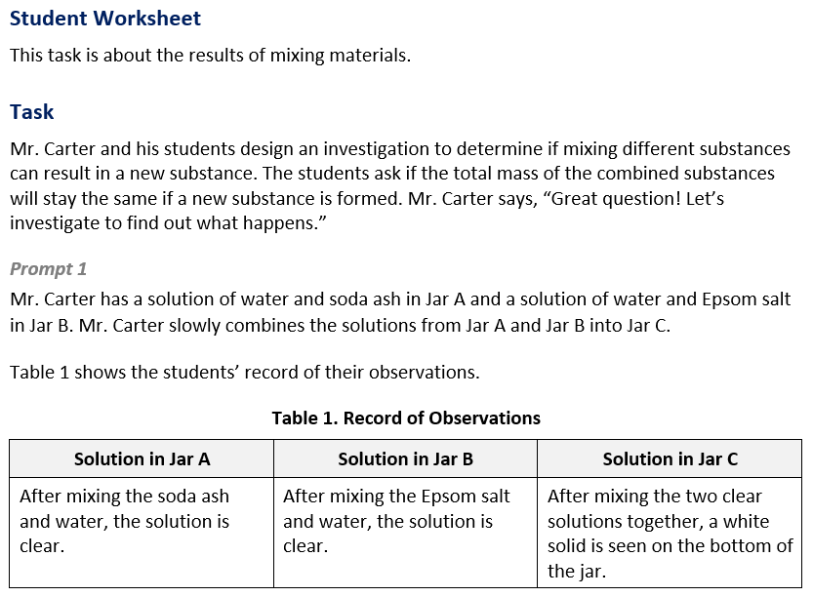  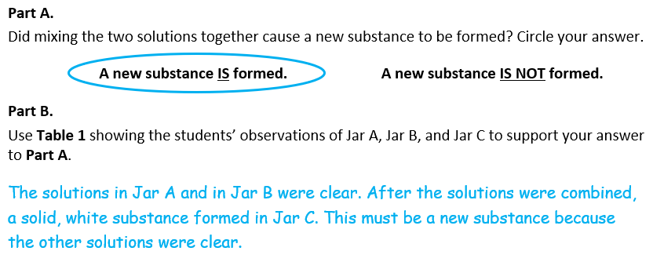

  Task 3 Prompt 1 Parts A and B Complexity
  Degree and Nature of Sensemaking | Moderate | This prompt…  - Requires integration of two dimensions in the service of sense-making
  Complexity of the Presentation | Moderate | - The amount and type of information provided in the scenario supports multiple evident connections among ideas or concepts  - Provides graphics/data/models
  Cognitive Demand of Response Development | Moderate | - Requires drawing relationships and connecting ideas and practices  - Requires a moderate level of sophistication with typical and relatively complex representation of ideas and application of skills
  Cognitive Demand of Response Production | Moderate | - Response includes one or more sentences or a paragraph, a moderately complex graphic, or multiple steps in a simple or moderately complex process
  Task 3 Prompt 1 Parts A and B
  Connections to the Instructional Framework
  Integration of Knowledge and Skills for Response Development
  Part A
  - Students read the informational text to identify if mixing the two substances together caused a new substance to be formed.
  - Students understand that when two or more different substances are mixed, a new substance with different properties may be formed.
  - Students use this information to decide if a change has occurred and a new substance has formed.
  Part B
  - Students use Table 1 to look at the properties of beginning substances and compare them to the properties of the final product and use this information to support their answer in Part A.
  Formative Assessments | Opportunities to Learn
  Segment 3, p. 17  Formal Assessment: Messin’ with Mixtures (A12, A17)  - Students accurately compare and contrast properties of matter before and after combining substances.  - Students accurately identify and/or describe the evidence that supports a claim about whether or not mixing two substances results in a new substance. | Segment 2, p. 29  What is This? (A12)  - Students engage in a class discussion of the different types of properties that can be used to describe substances, including both characteristic properties (e.g., solubility, flammability, odor, heat conductivity, magnetism) and non-characteristic properties (e.g., weight, volume).

  Task 3 Prompt 1 Parts A and B
  Connections to the Instructional Framework, Continued
  Formative Assessments | Opportunities to Learn
  Segment 3, pp. 17-18  Formal Assessment: Why Did it Mooove? (A12)  - Students accurately compare and contrast properties of matter before and after combining substances.  - Students draw appropriate conclusions from data about which properties of substances change after being mixed.  - Students accurately describe which properties of a substance are changed and how they are changed after being mixed.  Segment 4, pp. 19-20  Formal Assessment: How Did the Balloon Fill? (A17)  - Students accurately compare and contrast properties of matter before and after combining substances.  - Students accurately identify and/or describe the evidence that supports a claim about whether or not mixing two substances results in a new substance. | Segment 2, pp. 29-30  Investigating the Mystery Matter (A12)  - Students use properties of substances to determine if substances are the same or different before and after mixing.  Segment 4, pp. 33-34  Where Did it Go? (A12, A17)  - To introduce the idea of mixing and chemical changes, the teacher mixes baking soda (base) and vinegar/lemon juice (acid). The class measures the mass of the acid, base, and container before the reaction. The class discusses the physical characteristics of these items using physical characteristics of these two reactants.  Segment 4, p. 34  What Happened? (A12, A17)  - Students obtain information from curated resources that help explain how to determine if a new substance was formed using properties of the substance(s) before and after.
  Task 3 Prompt 1 Parts A and B
  Connections to the Instructional Framework, Continued
  Formative Assessments | Opportunities to Learn
  Segment 4, p. 20  Formal Assessment: Physical Change or Chemical Change? (A12)  - Students accurately compare and contrast properties of matter before and after combining substances.  - Students accurately identify and/or describe the evidence that supports a claim about whether or not mixing two substances results in a new substance.  Segment 4, pp. 20-21  Formal Assessment: What Happened in the Anchoring Phenomenon (A17)  - Students construct an appropriate explanation and identify the evidence to support a claim about whether or not mixing two substances results in a new substance.  - Students accurately identify and/or describe properties of matter after combining substances.  - Students accurately compare and contrast properties of matter before and after combining substances. | Segment 4, p. 35  What Went Right? (A12, A17)  - Students go through a recipe to connect the learning experiences from the unit to the steps, highlighting examples of mixtures, solutions, physical and chemical changes, changes of state, and the interaction of particles.
Prompt 2 Parts A and B  Performance Categories: Use Observations and Measurements of Chemical Reactions  Acquisition Goals:  - A9. Measure and graph weights to produce data that shows that the total weight of substances when heating, cooling, or before or after they are mixed is equal to the total weight of the substance(s) that are formed after they are mixed when a new substance doesn’t form.  - A18. Analyze and interpret data to identify the pattern that the total weight of substances before they are mixed is equal to the total weight of the substance(s) that are formed after they are mixed.  Prompt 2 Parts A and B measure students’ ability to:  - Use observations and measurements as evidence to describe how the total amount of matter is conserved no matter what reaction or change in properties occurs. |  | 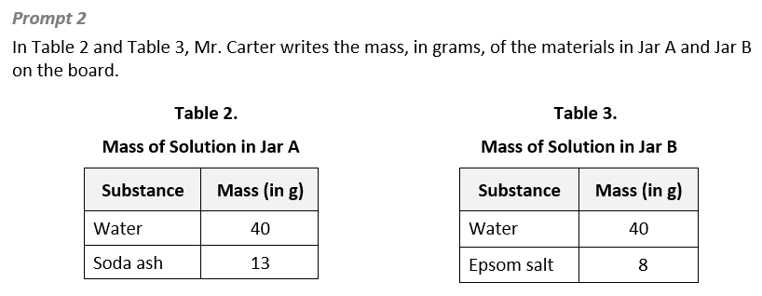  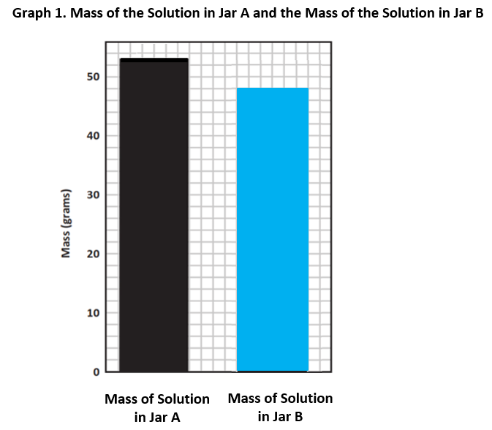
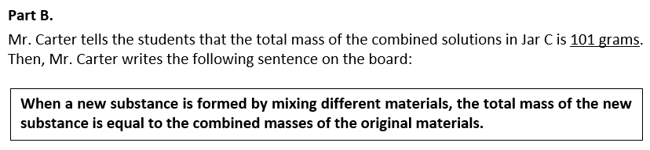  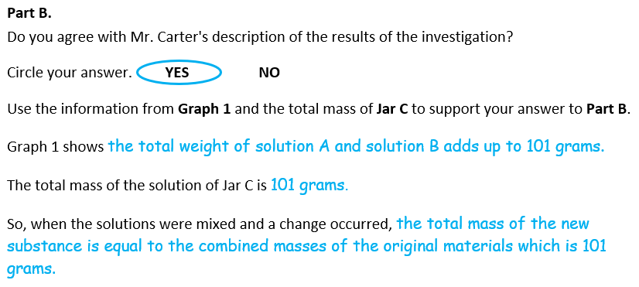
  Task 3 Prompt 2 Parts A and B Complexity
  Degree and Nature of Sensemaking | High | This prompt…  - Requires integration of three dimensions in the service of sense-making
  Complexity of the Presentation | Moderate | - The amount and type of information provided in the scenario supports multiple evident connections among ideas or concepts  - Provides graphics/data/models
  Cognitive Demand of Response Development | Moderate | - Requires drawing relationships and connecting ideas and practices  - Requires a moderate level of sophistication with typical and relatively complex representation of ideas and application of skills
  Cognitive Demand of Response Production | High | - Responses include multiple paragraphs, multiple graphics of at least moderate complexity, or multiple steps in a complex process
  Task 3 Prompt 2 Parts A and B
  Connections to the Instructional Framework
  Integration of Knowledge and Skills for Response Development
  Part A
  - Students observe the data in Tables 2 and 3.
  - Students use the data to reveal patterns that suggest relationships, such as that no matter what reaction or change in properties occurs, the total weight of the substances does not change.
  - Students use the data in Table 3 to complete Graph 1 to show the total mass of the solution in Jar B.
  Part B
  - Students read the statement and decide if they agree or disagree with the statement using information from Graph 1 and Jar C.
  - Students describe that mass is conserved or remains the same after mixing.
  Formative Assessments | Opportunities to Learn
  Segment 3, pp. 16-17  Formal Assessment: Weight of Water (A9)  - Students generate accurate graphs of data on the properties of a substance before and after a physical change.  - Students measure and graph the weight of water in different phases. | Segment 3, p. 31  Weight of Water (A9, A18)  - Students focus more specifically on the weight of a substance to determine that when substances are physically mixed, heated, or cooled, the total weight does not change.
  Task 3 Prompt 2 Parts A and B
  Connections to the Instructional Framework, Continued
  Formative Assessments | Opportunities to Learn
  Segment 4, p. 20  Formal Assessment: Physical Change or Chemical Change? (A18)  - Students accurately compare and contrast properties of matter before and after combining substances. | Segment 3, pp. 32-33  Messin’ with Mixtures (A9, A18)  - As students work through the investigation, they document the physical characteristics of the different materials as well as make measurements of the weight of the different elements individually and as a whole.
Future Learning Connected to evidence elicited in Task 3
Crosscutting Concepts
- In Unit 1, students focus on Cause & Effect and Scale, Proportion, and Quantity. Cause and Effect lies at the heart of science. Cause and Effect is also closely associated with the practice of “Engaging in Argument from Evidence.” In Unit 2, students will “Develop and use Models” of ecosystems and food webs to construct and support evidence-based “Arguments” that center around ecosystems. An understanding of Scale involves not only understanding systems and processes vary in size, time span, and energy, but also different mechanisms operate at different scales. The crosscutting concept of Scale, Proportion, and Quantity are essential considerations when deciding how to model a phenomenon and figures prominently in the practice of “Analyzing and Interpreting Data.” In Unit 2, students will explore the needs of plants, and use that data to refine their explanatory model to create scientifically accurate explanations. The Unit 1 Crosscutting Concepts serve as a starting point to make sense of phenomena explained in Unit 2, such as matter being transported into, out of, and within systems.
Disciplinary Core Ideas
- In Unit 1, students learn that matter is conserved when it changes form, that if a change in properties occurs, the total weight of the substances does not change, and that when two or more substances are mixed, a new substance is formed. This will help students build future understanding in Unit 2 that matter cycles between air and soil and among plants, animals, and microbes as organisms live and die and that organisms obtain gases and water from the environment and release waste matter back into the environment. In Unit 2, Acquisition Goal 12 requires students to develop a model to describe how matter cycles among living and non-living components within an ecosystem. Students are given a variety of biotic and abiotic (living and nonliving) picture cards and create a model of how matter moves through an ecosystem. (Formal Assessment: Movement of Matter Through an Ecosystem: Can You Show It?, pp. 14-15)
Science and Engineering Practices
- In Unit 1, students conduct investigations to collect data that can be used as evidence for their claims and use mathematical and computational thinking. These experiences working with models, data, and evidence help prepare them for engaging in an argument that makes use of these three forms of scientific information. In Unit 2, Acquisition Goal 8 requires students to plan or carry out an investigation on the role of air and water in plant growth. Students are presented with plants that they watch over time in various conditions, with individual groups selecting different variables. The data from the experiments will give students the opportunity to describe the pattern of the role that each of these variables has on plant growth. (Formal Assessment: Conditions for Plant Growth, pp. 12-13)

