
Coherence and Alignment Among Science Curriculum, Instruction, and Assessment (CASCIA) Project

Grade 8 Unit 1: Forces and Energy

Family Guidance and Learning Resources for Performance Category 1

October 2023

Grade 8 Unit 1: Forces and Energy, Family Guidance and Learning Resources for Performance Category 1 was developed with funding from the U.S. Department of Education under the Competitive Grants for State Assessments Program CFDA 84.368A. The contents of this paper do not represent the policy of the U.S. Department of Education, and no assumption of endorsement by the Federal government should be made.
All rights reserved. Any or all portions of this document may be reproduced and distributed without prior permission, provided the source is cited as: Coherence and Alignment Among Science Curriculum, Instruction, and Assessment (CASCIA) Project. (2023). Grade 8 Unit 1: Forces and Energy, Family Guidance and Learning Resources for Performance Category 1. Lincoln, NE: Nebraska Department of Education.
Purpose
The purpose of this document is to help families understand their student’s performance on the Grade 8 Unit 1 Science Assessment and to provide resources and recommendations for engaging their student in science learning at home.
Unit Overview
By engaging in this unit, students deepen their knowledge of forces, including gravitational forces, motion, and energy related to mass, and how these concepts can be used to explain phenomena including collisions, the changes in motion that result, and the effect of collisions on objects. Students develop their experience and skills in planning and carrying out investigations and constructing and interpreting graphical displays of data in support of arguments to explain interactions between energy, forces, and motion in a system.
Performance Category 1: Designing the Best Solution to a Problem Involving Energy, Forces, and Motion
Prompts for this performance category require students to design a solution to a problem based on forces and the objects involved by:
- Identifying the best design within given criteria/constraints and providing justification for the design based on the application of Newton’s third law of motion.
- Making comparisons between the rate of change between mass and kinetic energy, speed and kinetic energy, and the forces involved in a collision.

Grade 8 Unit 1: Forces and Energy

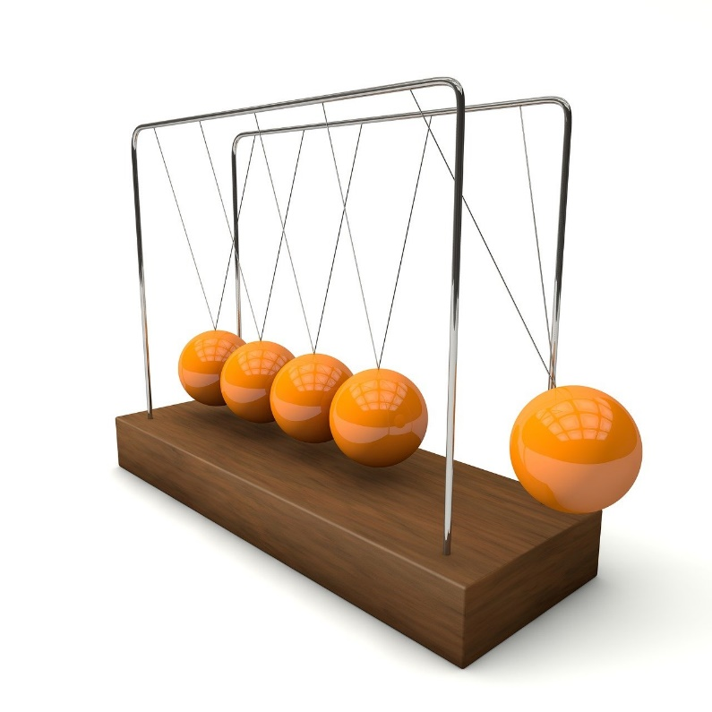

Instructions for Parents/Guardians
- Refer to your student’s score report to determine their instructional needs level—red, yellow, or green—for this performance category.
- Use the Interpretive Guidance (see page 2) to understand what your student likely knows and is able to do based on their instructional needs level.
- Use the Family Resources and Recommendations (see page 3) to engage with and support your student’s science learning at home.

Interpretive Guidance for Performance Category 1:
Designing the Best Solution to a Problem Involving Energy, Forces, and Motion
Red (0-4 score points earned)  - Extensive additional instruction and reteaching of these skills is recommended.  - The student needs significant opportunities to reinforce and apply these skills in future learning. |  | Yellow (5-8 score points earned)  - Moderate additional instruction on these skills is recommended.  - The student needs additional opportunities to strengthen these skills in future learning. | Green (9-10 score points earned)  - Minimal to no additional instruction on these skills is recommended.  - The student is ready to extend these skills in future learning.
What These Results Mean
This student is likely able to:  - Use insufficient information to evaluate the relative usefulness of a design solution to a presented problem involving energy, forces, and motion, supported with limited or unrelated evidence pertaining to a few specified design parameters.  - Solution addresses few or no constraints or some constraints are not accurately analyzed to address a problem involving energy, forces, and motion.  - Attempt to consider one or two alternative solutions with procedural or conceptual errors relating to the relationship among kinetic energy, mass, and velocity with little to no supporting evidence of how the solution meets the stated criteria, constraints, and technical feasibility. |  | This student is likely able to:  - Accurately evaluate and clearly articulate the relative usefulness of a design solution to a presented problem involving energy, forces, and motion by clearly utilizing evidence relevant to most of the specified design parameters.  - Solution connects some relevant information to a design characteristic(s) problem involving energy, forces, and motion in a way that uses scientific language appropriately to describe the proposed solution.  - Demonstrate partial understanding of the relationship among kinetic energy, mass, and velocity by attempting to explain how the solution meets the stated criteria, constraints, and technical feasibility. | This student is likely able to:  - Accurately evaluate and clearly articulate the relative usefulness of a design solution to a presented problem involving energy, forces, and motion by effectively utilizing evidence relevant to all specified design parameters.  - Solution connects all relevant information to design characteristics to a problem involving energy, forces, and motion in a way that convinces the audience that the proposed solution is the best one available.  - Demonstrate a complete and accurate understanding of the relationship among kinetic energy, mass, and velocity when explaining how the solution meets the stated criteria, constraints, and technical feasibility.
Family Resources and Recommendations for Performance Category 1:
Designing the Best Solution to a Problem Involving Energy, Forces, and Motion
Resources and Recommendations to Support Science Learning at Home
Engage in the Topic  How do skateboards move? | There are three laws of motion.  - The 1st Law: Objects stay at rest or in motion unless acted on by another force.  - So, when a person is riding a skateboard, and it hits the curb, the board will stop. But the person will keep moving right off the skateboard!  - The 2nd Law: Acceleration of an object depends on its mass and the amount of force acting on it.  - A person pushing down on the ground with a lot of force to move the skateboard will go faster than if the same person is pushing down with a little bit of force.  - The 3rd Law: For every action, there is an equal or opposite reaction.  - If a person is riding a skateboard and runs into the side of a skate ramp, the force of the ramp pushing back causes the skateboarder to bounce backward.  Watch this video with your student for a few examples of the laws of motion. (Stop viewing the video at the 2:55 mark.)
Explore the Problem  What happens when two objects hit each other? | The result of colliding into the side of a skate ramp can be embarrassing and hurt!  Problem: How could a skateboarder be protected from injury when colliding with the side of a skate ramp?  Engage your student in a discussion based on the video:  - What does a skateboarder wear to reduce the impact of a collision? (e.g., helmets, knee pads, elbow pads)  - Skateboarders often bend their knees when they land a jump. How does this reduce the force of landing on the ground after a jump? (Bending knees helps absorb the impact of hitting the ground.)  - What other variables may be involved in a collision between a skateboarder and a skate ramp?  If your student does not have an idea, ask, “Will you change the speed of the skateboarder, change what the skateboarder is wearing, or add padding or barriers?”

Explain the Topic  Why are forces and motion important for skateboarders? | Skateboarders need to understand Newton’s Laws of Motion! Watch this video with your student. (Stop watching the video at the 40-second mark.)  Engage in discussion about the skate ramp problem.  - What are the action-reaction pairs?  - How can the forces at the moment of the collision be reduced? (reduce the speed of the skateboarder, add padding to the ramp or the skateboarder, etc.)
Evaluate the Solution  How well does the solution address the problem? | A solution is only effective if it is applied correctly. The skatepark needs to install extra padding on all the sides of all the skate ramps before, for example, the Summer Skateboard Games. Why would the owners of the skate park need to evaluate many different types of padding materials, the time it takes to install the padding, and the costs?  Can you think of other considerations that the skatepark owners could address to reduce injuries when a skateboarder hits the side of a skate ramp?

Resources
- Dr. Skateboard’s Action Science – Newton’s Laws 3 – Third Law of Motion, video by Bill Robertson
[https://www.youtube.com/watch?v=B_xFfg6eTFs}
- How to Wear Skateboard Pads and Why…, video by Ollie Anthem
[https://www.youtube.com/watch?v=YPo9L0KljyE]

