
Coherence and Alignment Among Science Curriculum, Instruction, and Assessment (CASCIA) Project

Grade 8 Unit 1: Forces and Energy

Family Guidance and Learning Resources for Performance Category 2

October 2023

Grade 8 Unit 1: Forces and Energy, Family Guidance and Learning Resources for Performance Category 2 was developed with funding from the U.S. Department of Education under the Competitive Grants for State Assessments Program CFDA 84.368A. The contents of this paper do not represent the policy of the U.S. Department of Education, and no assumption of endorsement by the Federal government should be made.
All rights reserved. Any or all portions of this document may be reproduced and distributed without prior permission, provided the source is cited as: Coherence and Alignment Among Science Curriculum, Instruction, and Assessment (CASCIA) Project. (2023). Grade 8 Unit 1: Forces and Energy, Family Guidance and Learning Resources for Performance Category 2. Lincoln, NE: Nebraska Department of Education.
Purpose
The purpose of this document is to help families understand their student’s performance on the Grade 8 Unit 1 Science Assessment and to provide resources and recommendations for engaging their student in science learning at home.
Unit Overview
By engaging in this unit, students deepen their knowledge of forces, including gravitational forces, motion, and energy related to mass, and how these concepts can be used to explain phenomena including collisions, the changes in motion that result, and the effect of collisions on objects. Students develop their experience and skills in planning and carrying out investigations and constructing and interpreting graphical displays of data in support of arguments to explain interactions between energy, forces, and motion in a system.
Performance Category 2: Use Experimental Features of an Investigation to Explain Interactions Between Objects
Prompts for this performance category require students to identify variables, controls, and what and how much data is needed to construct an explanation to:
- Describe how the materials in a design solution function to reduce the damage to an object in a collision
- The cause-and-effect relationships of kinetic energy to the mass of an object and to the speed of an object
- Support a claim regarding the relationship between the speed of objects, gravitational forces, and the kinetic energy the objects possess as they reach Earth’s surface

Grade 8 Unit 1: Forces and Energy

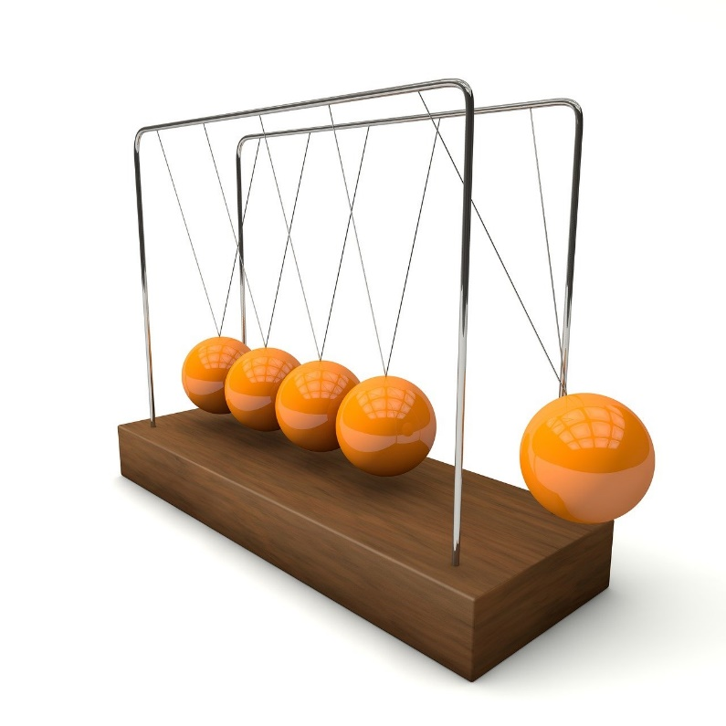

Instructions for Parents/Guardians
- Refer to your student’s score report to determine their instructional needs level—red, yellow, or green—for this performance category.
- Use the Interpretive Guidance (see page 2) to understand what your student likely knows and is able to do based on their instructional needs level.
- Use the Family Resources and Recommendations (see page 3) to engage with and support your student’s science learning at home.

Interpretive Guidance for Performance Category 2:
Use Experimental Features of an Investigation to Explain Interactions Between Objects
Red (0-3 score points earned)  - Extensive additional instruction and reteaching of these skills is recommended.  - The student needs significant opportunities to reinforce and apply these skills in future learning. | Yellow (4-6 score points earned)  - Moderate additional instruction on these skills is recommended.  - The student needs additional opportunities to strengthen these skills in future learning. | Green (7-8 score points earned)  - Minimal to no additional instruction on these skills is recommended.  - The student is ready to extend these skills in future learning.
What These Results Mean
This student is likely able to:  - Determine variables, controls, and appropriate data to attempt an explanation of how the materials in a design solution function to solve a design problem based on the relationship of kinetic energy to the mass of an object and to the speed of an object with little to no supporting evidence.  - Attempt to evaluate at least one (1) alternative solution with major conceptual or procedural errors.  - Attempt to support a claim regarding the usefulness of materials in a design solution with a mostly inaccurate explanation of the relationship among velocity, mass, or kinetic energy of an object. | This student is likely able to:  - Make basic connections among variables, controls, and appropriate data to generate a partial explanation of how the materials in a design solution function to solve a design problem based on the relationship of kinetic energy to the mass of an object and to the speed of an object mostly supported by evidence with some minor errors.  - Evaluate at least one (1) alternative solution for technical feasibility.  - Support a claim regarding the usefulness of materials in a design solution with a vague but mostly accurate explanation of the relationship between velocity, mass, or kinetic energy of an object. | This student is likely able to:  - Make accurate connections based upon scientific reasoning to explain how the materials in a design solution function to solve a design problem based on the relationship of kinetic energy to the mass of an object and to the speed of an object while clearly communicating the effectiveness of the solution.  - Critically evaluate all alternative design solutions by analyzing each for technical feasibility.  - Support a claim regarding the usefulness of materials in a design solution that explains why or how that solution is effective by applying a clear and complete explanation of the relationship among velocity, mass, or kinetic energy of an object.

Family Resources and Recommendations for Performance Category 2:
Use Experimental Features of an Investigation to Explain Interactions Between Objects
Resources and Recommendations to Support Science Learning at Home
Engage the Topic  How do parachutes work? | Parachutes rely on air resistance to perform well and to return people safely to Earth after they jump out of planes. Watch this video with your student and experience a skydiver’s first time skydiving. Share your observations and reactions.
Explore the Topic  Why do objects seem to fall at different speeds? | The Earth’s atmosphere pushes against objects as they fall. The air is an upward force of friction and acts against gravity and slows down the rate at which an object falls. This friction is called air resistance. Watch this video with your student to see why some objects fall more slowly even though gravity on Earth acts on all objects equally. Consider how an object’s shape affects how quickly it falls.  Try the simple investigation shown in the video using two pieces of paper with your student. Discuss the results of the investigation to review key science concepts:  - Do the two pieces of paper have the same mass? (Yes) Do they have the same shape? (No)  - What makes the flat paper seem to fall more slowly than the crumpled paper? (Air resistance)
Explore the Problem  How could you design a parachute to show how it increases or decreases air resistance? | Read “How Do Parachutes Work?” and “How Parachutes Fly” in this article.  Present the following problem: How could you design a parachute to safely land a 70 kg person on Earth?  Ask your student:  - How could each of the following variables affect the velocity of a person’s landing on Earth (falling speed)? Be sure to discuss how changes to these variables affect air resistance.  - Type of materials used to make the parachute  - The amount of surface area of the parachute  - The mass of the parachute  - The shape/design of the parachute (skinny, wide, length, with or without holes, etc.)  - Which variable does not change and is considered a control? (weight of the object)
Explain the Interactions  How does a parachute’s design increase or decrease the speed of a falling object and why? | Watch the video with your student and engage in discussion:  - Which two forces affect the fall rate of the parachute? (air resistance and gravity)  - Which force can be addressed by the design of a parachute? (air resistance)  - Parachute A has a larger surface area than Parachute B. Which parachute experiences a greater gravitational force? Explain. (Parachute A experiences a greater gravitational force because it has more surface area.)
Elaborate the Solution  How do air resistance, mass, and gravity change the speed of a falling object? | Ask your student to support the following claim:  - A 70 kg person will land on the ground more slowly using a parachute with a larger surface area as compared to a parachute with a smaller surface area.  - Support your answer by including the factors of air resistance, mass, and gravity.  (More air particles push against the parachute with more surface area. The force of gravity is the same for both parachutes, but there is more gravity acting on a bigger parachute. However, a parachute with a small surface area will have less air resistance and will fall much more quickly. That is why a person will more likely land safely when using a larger parachute than a smaller one.)

Resources
- First time SKYDIVING, video by Raffaella Giampaolo
[https://www.youtube.com/watch?v=WocwDTsIvQE]
- Danger! Falling Objects: Crash Course Kids, video by Crash Course Kids
[https://www.youtube.com/watch?v=dxcx35x5L9Y]
- How Does a Parachute Work?, article by Wisconsin Skydiving Center
[https://wisconsinskydivingcenter.com/blog/how-parachutes-work/]
- The Physics of Skydiving, video by MITK12Videos
[https://www.youtube.com/watch?v=qEWCRKxhEZo]

