
Coherence and Alignment Among Science Curriculum, Instruction, and Assessment (CASCIA) Project

Grade 8 Unit 1: Forces and Energy

Family Guidance and Learning Resources for Performance Category 3

October 2023

Grade 8 Unit 1: Forces and Energy, Family Guidance and Learning Resources for Performance Category 3 was developed with funding from the U.S. Department of Education under the Competitive Grants for State Assessments Program CFDA 84.368A. The contents of this paper do not represent the policy of the U.S. Department of Education, and no assumption of endorsement by the Federal government should be made.
All rights reserved. Any or all portions of this document may be reproduced and distributed without prior permission, provided the source is cited as: Coherence and Alignment Among Science Curriculum, Instruction, and Assessment (CASCIA) Project. (2023). Grade 8 Unit 1: Forces and Energy, Family Guidance and Learning Resources for Performance Category 3. Lincoln, NE: Nebraska Department of Education.
Purpose
The purpose of this document is to help families understand their student’s performance on the Grade 8 Unit 1 Science Assessment and to provide resources and recommendations for engaging their student in science learning at home.
Unit Overview
By engaging in this unit, students deepen their knowledge of forces, including gravitational forces, motion, and energy related to mass, and how these concepts can be used to explain phenomena including collisions, the changes in motion that result, and the effect of collisions on objects. Students develop their experience and skills in planning and carrying out investigations and constructing and interpreting graphical displays of data in support of arguments to explain interactions between energy, forces, and motion in a system.
Performance Category 3: Analyze Data to Describe Interactions Between Objects
Prompts for this performance category require students to analyze data to describe interactions between objects:
- The relationship of kinetic energy to the mass of an object
- The relationship of kinetic energy to the speed of an object
- The relationship between the height of an object (gravitational potential energy) and the transformation into kinetic energy as the object falls to the ground

Grade 8 Unit 1: Forces and Energy

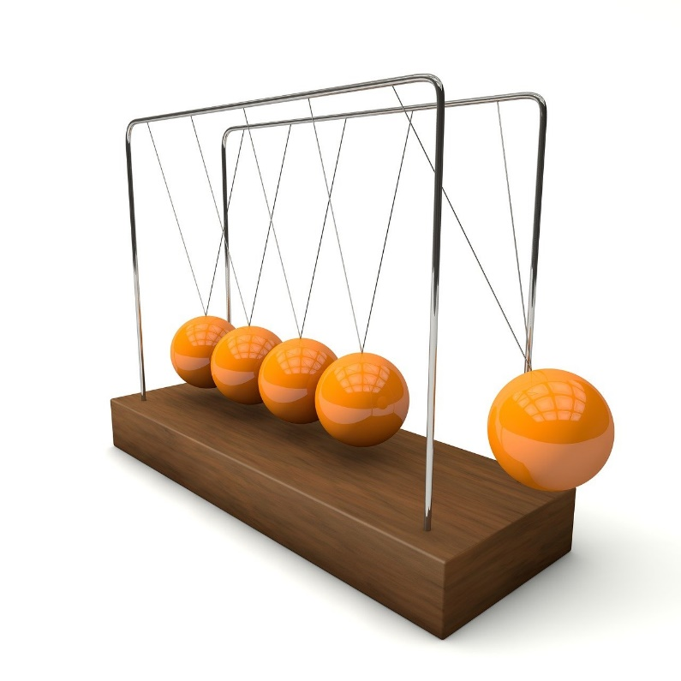

Instructions for Parents/Guardians
- Refer to your student’s score report to determine their instructional needs level—red, yellow, or green—for this performance category.
- Use the Interpretive Guidance (see page 2) to understand what your student likely knows and is able to do based on their instructional needs level.
- Use the Family Resources and Recommendations (see page 3) to engage with and support your student’s science learning at home.

Interpretive Guidance for Performance Category 3:
Analyze Data to Describe Interactions Between Objects
Red (0-4 score points earned)  - Extensive additional instruction and reteaching of these skills is recommended.  - The student needs significant opportunities to reinforce and apply these skills in future learning. | Yellow (5-8 score points earned)  - Moderate additional instruction on these skills is recommended.  - The student needs additional opportunities to strengthen these skills in future learning. | Green (9-11 score points earned)  - Minimal to no additional instruction on these skills is recommended.  - The student is ready to extend these skills in future learning.
What These Results Mean
This student is likely able to:  - Attempt to represent provided data in a graph.  - Provide some quantitative data to support an incomplete or inaccurate explanation of the relationship of kinetic energy to the mass and speed of an object, as well as the relationship between the height of an object and the kinetic energy the object has as it falls to the ground.  - Attempt to describe a relationship or pattern among variables in the data with major conceptual or procedural errors. | This student is likely able to:  - Attempt to represent provided data in a graph, using simple computational thinking, as necessary.  - Provide adequate quantitative data to support a reasonable explanation of the relationship of kinetic energy to the mass and speed of an object, as well as the relationship between the height of an object and the kinetic energy the object has as it falls to the ground.  - Describe the relationship between variables and identify patterns (qualitative or quantitative) among variables represented in the data but analyses include some minor errors. | This student is likely able to:  - Accurately represent provided data in a graph, using computational thinking, as necessary.  - Provide thorough quantitative data to support a complete and accurate explanation of the relationship of kinetic energy to the mass and speed of an object, as well as the relationship between the height of an object and the kinetic energy the object has as it falls to the ground.  - Mathematically describe the relationship between variables and identify patterns (qualitative or quantitative) among variables represented in the data.

Family Resources and Recommendations for Performance Category 3:
Analyze Data to Describe Interactions Between Objects
Resources and Recommendations to Support Science Learning at Home
Engage in the Topic  What types of energy do objects have? | Energy can be changed or converted from one type of energy to another. Gravitational potential energy is the energy possessed by an object due to its mass and position (e.g., height). Kinetic energy is the energy an object has because of its motion. Watch this video of the world’s biggest roller coaster drop with your student to see an example of gravitational potential energy converted into kinetic energy.  Engage your student in a discussion:  - Where do you think the roller coaster is when it has the greatest potential energy? (At the top of the track before the drop)  - Where do you think the roller coaster is when it has the greatest kinetic energy? (At the bottom of the drop)
Explore the Topic  How do we describe potential energy and kinetic energy? | All forms of energy can never be created or destroyed, but rather energy can only be transferred between objects or a system. Watch this video with your student to build their knowledge of different types of potential energy (stored energy) and different types of kinetic energy (motion or energy that involves movement).
Explain the Topic  How can we explain the transfer of potential energy to kinetic energy? | Watch the first 5:05 minutes of this video with your student and pause to answer the following questions when presented in the video:  - Does potential energy always turn into kinetic energy?  - Would you rather be hit on the head by a tennis ball falling from 2 feet above your head or a tennis ball falling from 50 feet above your head? Explain.
Evaluate the Data  What is the relationship between mass and kinetic energy?  What is the relationship between velocity and kinetic energy? | Kinetic energy has a positive relationship with mass and velocity. That means that as mass or velocity increases, so does kinetic energy. Lighter objects moving at greater speeds can have more kinetic energy.  To learn more about the skill of organizing, graphing, analyzing, and interpreting different sources of data and why it is an important skill for your student, watch this video.  Examine and use the data in this graph with your student to ask the questions:  - Compare the kinetic energy of a 500 kg car traveling at 100 km/hr to the car that has twice the mass, or a 1,000 kg, traveling at the same velocity. What do you notice? (When the mass is doubled, the kinetic energy is doubled.)  - Compare the kinetic energy of a 3,000 kg car traveling at 40 km/hr to the same car traveling at twice the velocity, or 80 km/hr. What do you notice? (When the velocity is doubled, the kinetic energy increases by almost four times as much or goes up from 200 kJ to almost 800 kJ.)  - Which relationship between kinetic energy is directly proportional—the relationship between kinetic energy and mass OR the relationship between kinetic energy and velocity? How do you know? (The relationship between kinetic energy and mass is directly proportional because the graph shows that as one doubles, so does the other.)  - If you were riding a roller coaster, would you most likely feel a greater amount of energy at the bottom of the drop on a heavier roller coaster OR on a faster roller coaster? Why? (You would feel the most energy in a faster roller coaster because kinetic energy goes up faster with velocity than it does with mass.)  - Would the same roller coaster have the same kinetic energy when it reaches the bottom of a short drop as it would from a tall drop? Why? (No, it would not because it has more gravitational potential energy from a tall drop.)

Resources
- The Biggest Roller Coaster Drop in the World, video by Liron Nehmadi
[https://www.youtube.com/watch?v=5aF7dgWvQ6Y]
- What is Kinetic and Potential Energy? [Stored Energy & Energy of Movement], video by STEAMspirations
[https://www.youtube.com/watch?v=GDmII-8RLIQ&t=104s]
- How to Analyze Kinetic and Potential Energy Graphs, video by Coach Spivey Science
[https://www.youtube.com/watch?app=desktop&v=SeykSc_A0L4]
- SEP4: Analyzing and Interpreting Data, video by The Wonder of Science
[https://thewonderofscience.com/videos/2017/12/10/analyzing-and-interpreting-data-1]
- Kinetic Energy vs Velocity Graph
[https://www.engineeringtoolbox.com/docs/documents/944/kinetic_energy_in_moving_car.png]

