
Coherence and Alignment Among Science Curriculum, Instruction, and Assessment (CASCIA) Project

Grade 8 Unit 2: Gravity and Motion of Objects in the Solar System

Family Guidance and Learning Resources for Performance Category 1

October 2023

Grade 8 Unit 2: Gravity and Motion of Objects in the Solar System, Family Guidance and Learning Resources for Performance Category 1 was developed with funding from the U.S. Department of Education under the Competitive Grants for State Assessments Program CFDA 84.368A. The contents of this paper do not represent the policy of the U.S. Department of Education, and no assumption of endorsement by the Federal government should be made.
All rights reserved. Any or all portions of this document may be reproduced and distributed without prior permission, provided the source is cited as: Coherence and Alignment Among Science Curriculum, Instruction, and Assessment (CASCIA) Project. (2023). Grade 8 Unit 2: Gravity and Motion of Objects in the Solar System, Family Guidance and Learning Resources for Performance Category 1. Lincoln, NE: Nebraska Department of Education.
Purpose
The purpose of this document is to help families understand their student’s performance on the Grade 8 Unit 2 Science Assessment and to provide resources and recommendations for engaging their student in science learning at home.
Unit Overview
By engaging in this unit, students deepen their knowledge of Earth’s place in the universe, the force of gravity between objects with mass, and the role of gravitational force in keeping planetary objects in orbit. Students develop their experience and skills in developing and using models and analyzing and interpreting data to investigate the characteristics of objects in the solar system, explain patterns of the apparent motion of the sun, moon, and stars, and construct and support evidence-based arguments about the connections between gravitational forces and orbital motion.
Performance Category 1: Model Relationships Among Objects in Earth’s Solar System
Prompts for this performance category require students to develop or use models to support descriptions and predictions of relationships about:
- the role of gravity and inertia in the motions of planets within the solar system
- scale relationships representing distances and objects in the solar system
- lunar phases in terms of the relative positions of the sun, Earth, and moon
- the predictable motions of objects within the solar system

Grade 8 Unit 2: Gravity and Motion of Objects in the Solar System

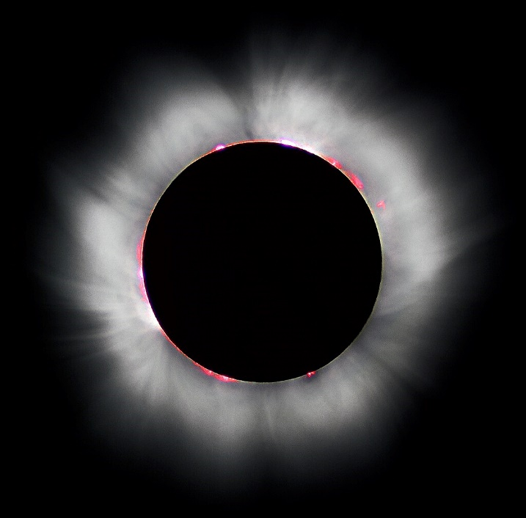
Credit: “Total solar eclipse” by Luc Viatour
Source: https://Lucnix.be
License: CC BY-SA 3.0

Instructions for Parents/Guardians
- Refer to your student’s score report to determine their instructional needs level—red, yellow, or green—for this performance category.
- Use the Interpretive Guidance (see page 2) to understand what your student likely knows and is able to do based on their instructional needs level.
- Use the Family Resources and Recommendations (see pages 3-5) to engage with and support your student’s science learning at home.

Interpretive Guidance for Performance Category 1:
Model Relationships Among Objects in Earth’s Solar System
Red (0-6 score points earned)  - Extensive additional instruction and reteaching of these skills is recommended.  - The student needs significant opportunities to reinforce and apply these skills in future learning. | Yellow (7-10 score points earned)  - Moderate additional instruction on these skills is recommended.  - The student needs additional opportunities to strengthen these skills in future learning. | Green (11-13 score points earned)  - Minimal to no additional instruction on these skills is recommended.  - The student is ready to extend these skills in future learning.
What These Results Mean
This student is likely able to:  - Present incomplete and/or inaccurate representations of the role of gravity and inertia in the motions of planets within the solar system and/or the cyclic pattern of the lunar phases.  - Present incomplete and/or inaccurate scale representations (values are incorrect with respect to each other) of a system that includes Earth.  - Use a model to develop incomplete and largely inaccurate explanations of the position and motions of objects within a galaxy and/or solar system. | This student is likely able to:  - Present clear and complete representations with minor errors of the role of gravity and inertia in the motions of planets within the solar system and/or the cyclic pattern of the lunar phases.  - Present partially accurate scale representations of a system that includes Earth with minor calculation errors.  - Use a model to develop incomplete but accurate explanations of the position and motions of objects within a galaxy and/or solar system. | This student is likely able to:  - Present clear, complete, and accurate representations of the role of gravity and inertia in the motions of planets within the solar system and/or the cyclic pattern of the lunar phases.  - Present accurate scale representations of a system that includes Earth with few calculation errors.  - Use the model to develop thorough and accurate explanations of astronomical and other observations of cyclical patterns (e.g., eclipses, tides, seasons).

Family Resources and Recommendations for Performance Category 1:
Model Relationships Among Objects in Earth’s Solar System
Resources and Recommendations to Support Science Learning at Home
Engage in the Topic  Why do objects in the solar system orbit one another? | Ask your student the following questions:  - What causes objects like satellites to orbit Earth? (Gravity and velocity.)  - Is the moon falling toward Earth? (Technically, yes.)  Watch this video (beginning at 2:55 min) with your student about the moon’s orbit for an explanation.
Explore the Topic  Does it take more than gravity to maintain orbital motion?  How do models help us understand the Earth-sun-moon system? | Ask your student the following questions:  - What stops Earth from being pulled into the sun by the sun’s large gravitational force? (Earth’s forward velocity.)  - What keeps Earth orbiting the sun? (Gravity and velocity.)  Find the answers on this website. Under the heading “What is Orbital Motion?" have your student take note of the model of Earth’s elliptical orbit (Figure 2) showing Earth at its closest and furthest positions from the sun. Explain that when Earth is closer to the Sun, the gravitational pull is stronger, causing the Earth to move faster and the orbit to bend into an ellipse. Discuss with your student how this model is useful even though it is not drawn to scale.  Find the heading “Orbital Motion of the Moon” and view a model of the moon’s orbit around Earth (Figure 3). Ask your student these questions:  - What do the force arrows show? (Acceleration due to gravity and velocity.)  - What does the line encircling the Earth represent? (The moon’s orbit.)  The orbit shown in this model is circular when, actually, the moon’s orbit is slightly elliptical. Discuss with your student why this simplified version of the model may have been used.
Explore the Topic  Why does the moon look like it is changing shape? | Have your student explore the phases of the moon as viewed from Earth and space simultaneously with this interactive webpage. They will need to “Launch” the simulation, then either press the play arrow or click and drag. The simulation starts with the New Moon. See if your student can describe the phases. You may also “Hide Details” to quiz your student on the phases.  Ask your student to describe, sketch, or build a model to illustrate the phases of the moon. They should include a representation of the sun (light source from one direction), Earth, and the moon. Your student may need to return to the simulation for assistance.
Explain the Topic  How do the positions of the sun, Earth, and moon affect the appearance of the moon? | Watch this video with your student for an explanation of how the positions of the sun, Earth, and moon affect the moon phases.  Discuss with your student these details from the video:  - The dark area of the moon is NOT a shadow made by Earth; instead, that area of the moon is simply not being illuminated by the sun at that time.  - The 1st and 3rd Quarter Moons refer to a quarter of the moon’s orbit, NOT the moon's appearance. They actually look like half-moons.  You may check your student’s understanding by having them play this short Phases of the Moon game.
Elaborate on the Topic  What else do we know about our moon? | Ask your student, “Why do we only see one side of the moon?” Watch this short video with your student for the answer!  To extend your student’s learning further, use the links found at the top of the page on this NASA website to explore Inside and Out (how the moon was formed, etc.), Moon in Motion (more on moon phases, how the moon affects tides, etc.), Observe (a Daily Moon Guide to use to study the moon outdoors and more), and Exploration (former moon missions.)

Resources
- Everything Revolves Around You , Video by Crash Course Kids
[https://www.youtube.com/watch?v=Y0_GLKU0NEY]
- Orbital Motion, Webpage by CK-12 [https://flexbooks.ck12.org/cbook/ck-12-middle-school-physical-science-flexbook-2.0/section/10.11/primary/lesson/orbital-motion-ms-ps/?gad=1&gclid=Cj0KCQiAjMKqBhCgARIsAPDgWlxtzZf28NNUBH_QqAOzW7Q39Ma2mL5Hiep9bBrxtdcpXlritkbmq7kaAiagEALw_wcB]
- Moon Phases Simulation Viewed from Earth and Space, Interactive from PBS
[https://aptv.pbslearningmedia.org/resource/buac19-35-sci-ess-earthsunmoon35model/moon-phases-simulation-viewed-from-earth-and-space/]
- What Causes the Phases of the Moon?, Video by Stile Education
[https://www.youtube.com/watch?v=YLczDRcd054]
- Phases of the Moon, Game by Softschools
[https://www.softschools.com/science/space/phases_of_moon/]
- Synchronous Rotation of the Moon, Video by Astrogirlwest
[https://www.youtube.com/watch?v=OZIB_leg75Q&t=72s]
- Earth’s Moon, Website by NASA
[https://moon.nasa.gov/moon-in-motion/sun-moonlight/overview/]

