
Coherence and Alignment Among Science Curriculum, Instruction, and Assessment (CASCIA) Project

Grade 8 Unit 2: Gravity and Motion of Objects in the Solar System

Family Guidance and Learning Resources for Performance Category 3

October 2023

Grade 8 Unit 2: Gravity and Motion of Objects in the Solar System, Family Guidance and Learning Resources for Performance Category 3 was developed with funding from the U.S. Department of Education under the Competitive Grants for State Assessments Program CFDA 84.368A. The contents of this paper do not represent the policy of the U.S. Department of Education, and no assumption of endorsement by the Federal government should be made.
All rights reserved. Any or all portions of this document may be reproduced and distributed without prior permission, provided the source is cited as: Coherence and Alignment Among Science Curriculum, Instruction, and Assessment (CASCIA) Project. (2023). Grade 8 Unit 2: Gravity and Motion of Objects in the Solar System, Family Guidance and Learning Resources for Performance Category 3. Lincoln, NE: Nebraska Department of Education.
Purpose
The purpose of this document is to help families understand their student’s performance on the Grade 8 Unit 2 Science Assessment and to provide resources and recommendations for engaging their student in science learning at home.
Unit Overview
By engaging in this unit, students deepen their knowledge of Earth’s place in the universe, the force of gravity between objects with mass, and the role of gravitational force in keeping planetary objects in orbit. Students develop their experience and skills in developing and using models and analyzing and interpreting data to investigate the characteristics of objects in the solar system, explain patterns of the apparent motion of the sun, moon, and stars, and construct and support evidence-based arguments about the connections between gravitational forces and orbital motion.
Performance Category 3: Analyze Data to Describe Interactions Among Objects in Earth’s Solar System
Prompts for this performance category require students to analyze and interpret data and graphs to support conclusions about:
- observed patterns related to the orbits of the inner planets and outer planets at different scales
- the relationship between relative sizes of objects in the solar system and the size of the gravitational force that is being exerted on an object
- using the relationship between the mass of objects interacting via gravitational forces to predict events
- features of the inner planets compared to the outer planets

Grade 8 Unit 2: Gravity and Motion of Objects in the Solar System

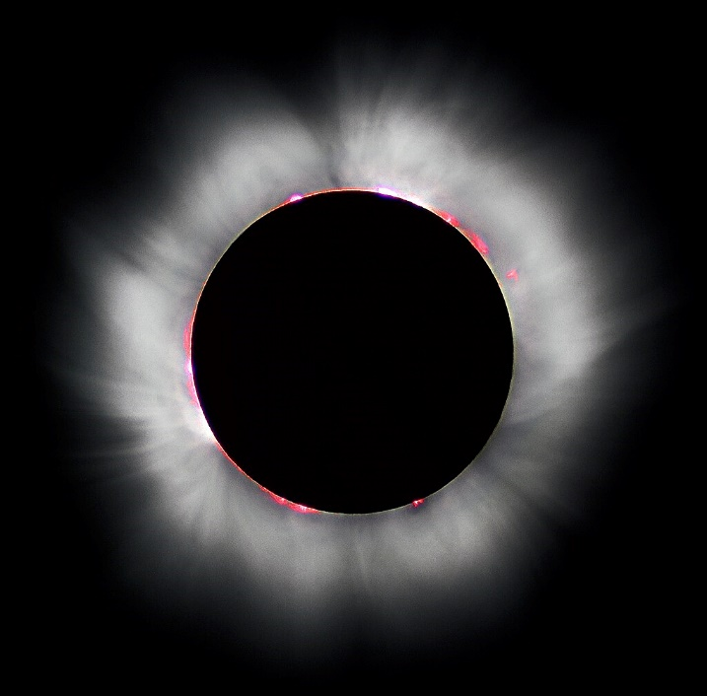
Credit: “Total solar eclipse” by Luc Viatour
Source: https://Lucnix.be
License: CC BY-SA 3.0

Instructions for Parents/Guardians
- Refer to your student’s score report to determine their instructional needs level—red, yellow, or green—for this performance category.
- Use the Interpretive Guidance (see page 2) to understand what your student likely knows and is able to do based on their instructional needs level.
- Use the Family Resources and Recommendations (see pages 3-5) to engage with and support your student’s science learning at home.

Interpretive Guidance for Performance Category 3:
Analyze Data to Describe Interactions Among Objects in Earth’s Solar System
Red (0-4 score points earned)  - Extensive additional instruction and reteaching of these skills is recommended.  - The student needs significant opportunities to reinforce and apply these skills in future learning. | Yellow (5-10 score points earned)  - Moderate additional instruction on these skills is recommended.  - The student needs additional opportunities to strengthen these skills in future learning. | Green (11-13 score points earned)  - Minimal to no additional instruction on these skills is recommended.  - The student is ready to extend these skills in future learning.
What These Results Mean
This student is likely able to:  - Provide some quantitative data to support an incomplete or inaccurate explanation of the relationships among objects in our solar system.  - Attempt to describe a relationship or pattern among variables in the data with major conceptual or procedural errors.  - Attempt to apply provided data related to properties of objects within the solar system when comparing the inner planets to the outer planets. | This student is likely able to:  - Provide adequate quantitative data to support a reasonable explanation of relative distances between the planets and their orbital paths around the sun in terms of time and distance.  - Describe the relationship between variables and identify patterns (qualitative or quantitative) among variables represented in the data, but analyses include some minor errors.  - Accurately apply some provided data, using simple mathematical thinking, as necessary to make conclusions based on properties of objects within the solar system. | This student is likely able to:  - Provide thorough quantitative data to support a complete and accurate explanation of the relationship of relative distances between the planets and their orbital paths around the sun in terms of time and distance.  - Mathematically describe the relationship between variables and identify patterns (qualitative or quantitative) among variables represented in the data to make inferences based on properties of objects within the solar system.  - Accurately use provided data, applying appropriate scale and proportion about the relationships of mass and gravitational force as related to objects in the solar system, using mathematical thinking, as necessary.

Family Resources and Recommendations for Performance Category 3:
Analyze Data to Describe Interactions Among Objects in Earth’s Solar System
Resources and Recommendations to Support Science Learning at Home
Engage with the Topic  Can what we know about our solar system help us when we look at other solar systems? | You and your student are about to go on a data-driven voyage to another solar system called TRAPPIST-1 to find the planet most like Earth in this new solar system. Watch this video from NASA about exoplanets and use the simulations about the planet TRAPPIST-1d to talk through the following questions:  - What do we know about gaseous and rocky planets in our solar system? Is this true of every solar system? (In our solar system, the rocky planets are smaller in size and closest to the sun and the gaseous planets are more massive and further away. This MAY be true of some other solar systems due to the gravitational pull from their sun, but each solar system is unique.)  - When searching for a planet with Earth-like features in another solar system such as TRAPPIST-1, what kinds of data should be collected? (Distance from the sun, presence of an atmosphere, amount of oxygen, presence of water, etc.)  - What do you notice about the TRAPPIST-1 system? What do you wonder? (Example: I notice that all the planets are close to the sun. I wonder if all the planets behave like inner planets in our solar system or if the outer planets in TRAPPIST-1 are similar to the outer planets in our solar system?)
Explore the Topic  Can we use data to make predictions about planets in other solar systems? | Review a chart showing TRAPPIST-1 planet data with your student. The data is written in terms of Earth’s properties. For example, 0.8 M_{earth} means 80% of the mass (M) of Earth.  Ask your student to use the planetary data to make predictions about the planets in the TRAPPIST-1 solar system and provide a reason(s) that supports each prediction. Respond to each question below, for example, using the following format: I predict that________because (i.e., reason(s) based on data) ________.  - What is the order of the planets from smallest to largest? (I predict that the order of the planets from smallest to largest is TRAPPIST 1-d, h, e, f, b, g, c because I compared each planet’s radius.)  - Which planets are rocky, and which planets are gaseous? (I predict that all planets in the TRAPPIST-1 system are rocky because they have a higher density than Mercury, a known rocky planet in our solar system.)  - Which planet seems most like Earth? (From this data, it is hard to tell which one is most similar to Earth because TRAPPIST 1-f is closest in size, TRAPPIST 1-b is closest in mass, TRAPPIST 1-h is closest in distance from its sun, TRAPPIST 1-e is closest in density, and TRAPPIST 1-c is closest in terms of surface gravity as compared to Earth.  - Could humans live on one of the TRAPPIST 1 planets? (I do not know because we need to know more about the atmosphere and environmental conditions on each of the planets.)  With your student, use this webpage to check the predictions they made.
Explain the Topic  How well do our predictions help identify similarities and differences between the TRAPPIST 1 system and Earth? | Use information and the video on this webpage to determine which planet in the TRAPPIST-1 system is most similar to Earth. Answer the following questions with your student.  - Which planet in the TRAPPIST-1 system is most similar to Earth? In what ways? (TRAPPIST 1-e is most like Earth in terms of density and size and it is in the “habitable zone” and may likely have water.)  - In what ways does this planet differ from Earth? (TRAPPIST 1-e is slightly smaller, denser, and receives mostly infrared light from its sun.)  - Would you weigh more or less on this planet? Why? (I would weigh less. TRAPPIST 1-e is smaller and, therefore, exerts a smaller gravitational force on objects on its surface. The smaller gravitational force results in a lower weight.)
Elaborate on the Topic  How do these exoplanets compare to Earth? | Use the diagram and chart to discuss the following:  - How does the size of the star TRAPPIST-1 and its solar system compare to Earth’s solar system? (It is much smaller. TRAPPIST-1 is also only a fraction of the size of our Sun. All seven planets discovered in orbit around the red dwarf star TRAPPIST-1 could easily fit inside the orbit of Mercury.)  - How long is one year on TRAPPIST-1 e? (One full revolution takes 6.1 Earth days.)  Extension: Use this simulation and information about the orbital time for TRAPPIST-1 e to estimate how old your student would be on this planet in its years. (To determine the age your student would be on TRAPPIST 1-e, calculate the age of your student in days rather than years. Then divide by 6.1 days.)

Resources
- Exoplanet Types: Worlds Beyond Our Solar System, Video from NASA
[https://exoplanets.nasa.gov/what-is-an-exoplanet/planet-types/overview/]
- Exoplanet Catalog: TRAPPIST 1 system, Simulations from NASA
[https://exoplanets.nasa.gov/exoplanet-catalog/5502/trappist-1-d/]
- TRAPPIST-1 Planet Data, Chart from SPITZER Space Telescope at NASA
[https://www.spitzer.caltech.edu/image/ssc2018-04c-trappist-1-planet-data-feb-2018]
- Largest Batch of Earth-size Habitable Zone Planets Found Orbiting TRAPPIST-1, Webpage from NASA.
[https://exoplanets.nasa.gov/trappist1/]
- New Clues to TRAPPIST-1 Planet Compositions, Atmospheres, Webpage from NASA
[https://science.nasa.gov/missions/hubble/new-clues-to-trappist-1-planet-compositions-atmospheres/]
- Trappist-1 Comparison, Diagram from NASA/JPL-Caltech/R. Hurt, T. Pyle (IPAC) comparing the scale of the TRAPPIST-1 system to Jupiter’s Moons and Earth’s Inner Solar System
[https://www.spitzer.caltech.edu/image/ssc2018-04d-trappist-1-compared-to-jovian-moons-and-inner-solar-system-feb-2018]
- TRAPPIST 1-e, Website from NASA
[https://exoplanets.nasa.gov/exoplanet-catalog/3453/trappist-1-e/]

