
Coherence and Alignment Among Science Curriculum, Instruction, and Assessment (CASCIA) Project

Grade 8 Unit 3: Understanding Earth History and the Origin of Species

Family Guidance and Learning Resources for Performance Category 1

February 2024

Grade 8 Unit 3: Understanding Earth History and the Origin of Species, Family Guidance and Learning Resources for Performance Category 1 was developed with funding from the U.S. Department of Education under the Competitive Grants for State Assessments Program CFDA 84.368A. The contents of this paper do not represent the policy of the U.S. Department of Education, and no assumption of endorsement by the Federal government should be made.
All rights reserved. Any or all portions of this document may be reproduced and distributed without prior permission, provided the source is cited as: Coherence and Alignment Among Science Curriculum, Instruction, and Assessment (CASCIA) Project. (2023). Grade 8 Unit 3: Understanding Earth History and the Origin of Species, Family Guidance and Learning Resources for Performance Category 1. Lincoln, NE: Nebraska Department of Education.
Purpose
The purpose of this document is to help families understand their student’s performance on the Grade 8 Unit 3 Science Assessment and to provide resources and recommendations for engaging their student in science learning at home.
Unit Overview
By engaging in this unit, students deepen their knowledge of evidence of a common ancestor interpreted through fossil records, how differences in their structure help explain present-day organisms, and how rock strata help us explain the history of Earth. Students develop and use models, analyze and interpret data, and construct explanations to reveal patterns and cause/effect relationships in the inheritance of traits through natural selection and the adaptation and change in life and populations on Earth.
Performance Category 1: Support Explanations About Organisms That Lived Long Ago
Prompts for this performance category require students to support an explanation with evidence, data, or a model to explain the:
Image: Geologic Time Scale
Credit: Joseph Graham, William Newman, and John Stacy, US Geological Survey
Source: http://commons.wikimedia.org/wiki/File:Geological_time_spiral.png
License: Public Domain
- existence, diversity, extinction, and change of many life forms throughout the history of life on Earth
- anatomical similarities and differences between modern and fossil organisms to infer evolutionary relationships
- relative ages of major events in Earth’s history

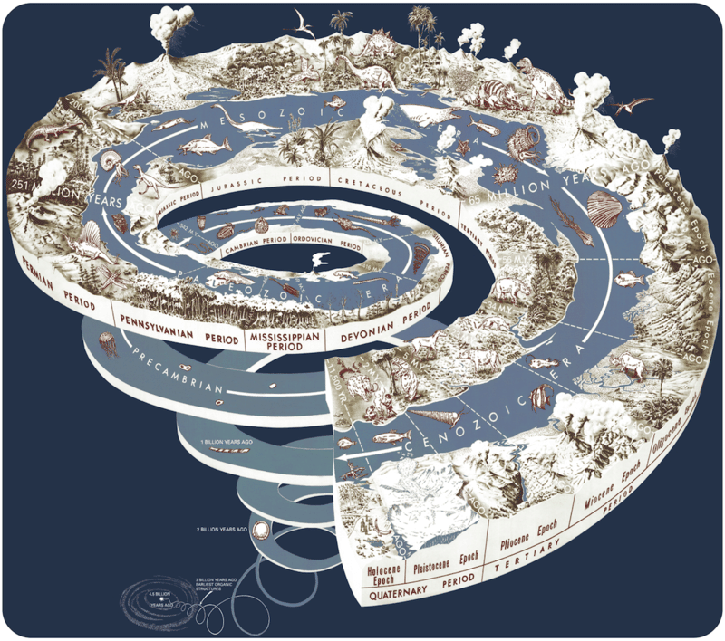
Grade 8 Unit 3: Understanding Earth History and the Origin of Species
Instructions for Parents/Guardians
- Refer to your student’s score report to determine their instructional needs level—green, yellow, or red—for this performance category.
- Use the Interpretive Guidance (see pages 2-3) to understand what your student likely knows and is able to do based on their instructional needs level.
- Use the Family Resources and Recommendations (see pages 4-6) to engage with and support your student’s science learning at home.

Interpretive Guidance for Performance Category 1:
Support Explanations About Organisms That Lived Long Ago
Red (0-5 score points earned)  - Extensive additional instruction and reteaching of these skills is recommended.  - The student needs significant opportunities to reinforce and apply these skills in future learning. | Yellow (6-9 score points earned)  - Moderate additional instruction on these skills is recommended.  - The student needs additional opportunities to strengthen these skills in future learning. | Green (10-11 score points earned)  - Minimal to no additional instruction on these skills is recommended.  - The student is ready to extend these skills in future learning.

What These Results Mean
This student is likely able to:  - Incorrectly describe how the relative age of fossils is determined.  - Attempt to apply reasoning to incompletely and/or inaccurately support a provided claim by describing similarities or differences in anatomical features over time.  - Incompletely and/or incorrectly recognize and use similarities and differences in visual representations of fossils to identify patterns of anatomical features over time.  - Attempt to support a claim, based on evolutionary history, by providing an inaccurate and/or incomplete explanation of changes in the traits of a species over time and not including a cause-and-effect relationship. | This student is likely able to:  - Use relative ordering of rock strata to accurately determine the relative ages of fossils.  - Correctly support a claim with some accurate scientific reasoning and/or some evidence to describe some advantageous changes and similarities in anatomical features in a fossil sequence.  - Correctly apply scientific reasoning and visual representations of fossils to identify some evidence of similarities and differences in patterns of anatomical features over time that support a conclusion about evolutionary relationships.  - Partially support a claim based on evolutionary history, using some sources of information/data to provide an incomplete explanation with some accurate, partial evidence and does not include an accurate cause-and-effect relationship related to changes in the environment and changes in traits of a species brought about by the process of natural selection and/or adaptations that improved chances of survival. | This student is likely able to:  - Use relative ordering of rock strata to explain the order of the procedure to accurately determine the relative ages of fossils.  - Correctly support a claim with accurate scientific reasoning and complete evidence to describe all advantageous changes and similarities in anatomical features in a fossil sequence.  - Correctly apply scientific reasoning and visual representations of fossils to identify multiple pieces of evidence of similarities and differences in patterns of anatomical features over time that support a conclusion about evolutionary relationships.  - Completely support a claim based on evolutionary history, using multiple sources of information/data to provide a valid and reliable explanation that includes an accurate cause-and-effect relationship between the changes in the environment and changes in traits of a species brought about by the process of natural selection and/or adaptations that improved chances of survival.

Family Resources and Recommendations for Performance Category 1:
Support Explanations About Organisms That Lived Long Ago
Resources and Recommendations to Support Science Learning at Home
Engage in the Topic  - How can you tell which is older? | With your student, imagine that you are walking in the midwestern U.S., and you find a rock with an embedded shark tooth. Ask your student to think about the following questions:  - How could a shark have been where there is no ocean today?  - Which do you think is older, the shark tooth or the rock?  - How does a shark tooth end up embedded in a rock?
Explore the Topic  - What do the rock layers tell us about the age of fossils? | Have your student look at where other fossils are being found in the Midwest by watching this video [1:00-3:00] and discuss how to begin to answer the questions about the shark tooth and the rock (fossil).  Have your student use this activity to place rock layers in order. It will be easier if the diagram is printed and cut into strips, but it is not a requirement. They should pay close attention to Steps 1 and 2 before responding. The answer key is at the bottom of the page.
Explore the Topic  - How are organisms from the past similar to organisms today? | Say to your student, “The fact that an ancient shark tooth looks very similar to a modern-day shark tooth raises questions about the similarities between fossils of extinct organisms and organisms living today.”  Explore the following with your student:  - Pictures and descriptions of fossils found in the same area of the Midwest Central Lowlands as the shark tooth fossil  - Video [end at 1:53] about fossil evidence  - Evolution evidence webpage
Explain the Evidence  - What evidence of evolution can be found in the rock layers?  - What evidence of evolution can be found by comparing the anatomy of organisms? | Using rock layers to determine age and relative dating is explained in this video [1:44]. The fossils found within the rock layers tell the partial story of how organisms lived, died, and evolved. They show when (and sometimes “how”) extinctions occurred. The fossils found within the rock layers also illustrate the similarities in species.  Have your student read the Evidence for Evolution Fact Sheet to review the similarities in species. If possible, read aloud the “Key Points” at the bottom of the page. In addition to fossils, homologous structures, analogous structures, vestigial structures, DNA and molecular similarities, embryological similarities, and species distribution are each evidence of evolution.
Evaluate the Topic  - What did the rock layers tell you about your fossil? | Have your student explain the following, verbally or in writing:  - How was the shark tooth fossil likely formed? (After the shark dies, its body was covered by sand and silt and was preserved in the rock layer.)  - What do the rock layers tell you about the fossil? (The relative age of the fossil—older rock layers are deeper than younger layers. The answer may include other organisms of the same age.)  - What evidence do you have to support the conclusion that once a sea covered the area where your fossil was found? (The explanation should include the shark tooth and evidence from the roadside in Iowa and/or central lowlands fossils from the website, which could include fossils of other aquatic organisms.)  If your student finds the topic interesting, encourage them to explore the Earth at Home website more thoroughly. They can examine fossils from the area where they live!

Resources
- Rock Layers and the Fossils Within | FIND Iowa – video by PBS
[https://www.youtube.com/watch?v=_U27Ohdjk1A]
- Solve a Sedimentary Layer Puzzle – PDF by American Museum of Natural History [https://www.amnh.org/content/download/1742/24677/file/solve-a-sedimentary-layers-puzzle.pdf]
- Earth at Home – website by Paleontological Research Institution
[https://earthathome.org/hoe/mw/fossils-cl]
- Fossils: Rocking the Earth – video by NOVA
[https://aptv.pbslearningmedia.org/resource/nvev-sci-fossils/fossils-rocking-the-earth/]
- Relative Dating – YouTube video by Conceptual Academy
[https://www.youtube.com/watch?v=g7Nh1ABk-FE]
- Evolution Evidence – webpage by CK-12
[https://flexbooks.ck12.org/cbook/ck-12-middle-school-life-science-2.0/section/4.5/primary/lesson/structural-evidence-for-evolution-ms-ls/]
- Evidence for Evolution Fact Sheet – PDF by Cool Australia [https://www.peekskillcsd.org/cms/lib/NY01913880/Centricity/Domain/827/Evidence-for-evolution-factsheet1.pdf]
- Here on Earth: Regional Guides to Earth Science — website by Paleontological Research Institution
[https://earthathome.org/hoe]

