
Coherence and Alignment Among Science Curriculum, Instruction, and Assessment (CASCIA) Project

Grade 8 Unit 3: Understanding Earth History and the Origin of Species

Family Guidance and Learning Resources for Performance Category 2

February 2024

Grade 8 Unit 3: Understanding Earth History and the Origin of Species, Family Guidance and Learning Resources for Performance Category 2 was developed with funding from the U.S. Department of Education under the Competitive Grants for State Assessments Program CFDA 84.368A. The contents of this paper do not represent the policy of the U.S. Department of Education, and no assumption of endorsement by the Federal government should be made.
All rights reserved. Any or all portions of this document may be reproduced and distributed without prior permission, provided the source is cited as: Coherence and Alignment Among Science Curriculum, Instruction, and Assessment (CASCIA) Project. (2023). Grade 8 Unit 3: Understanding Earth History and the Origin of Species, Family Guidance and Learning Resources for Performance Category 2. Lincoln, NE: Nebraska Department of Education.

Purpose
The purpose of this document is to help families understand their student’s performance on the Grade 8 Unit 3 Science Assessment and to provide resources and recommendations for engaging their student in science learning at home.
Unit Overview
By engaging in this unit, students deepen their knowledge of evidence of a common ancestor interpreted through fossil records, how differences in their structure help explain present-day organisms, and how rock strata help us explain the history of Earth. Students develop and use models, analyze and interpret data, and construct explanations to reveal patterns and cause/effect relationships in the inheritance of traits through natural selection and the adaptation and change in life and populations on Earth.
Performance Category 2: Analyze Data to Explain the Appearance of Specific Traits in Populations
Prompts for this performance category require students to analyze and interpret data and graphs to support conclusions about:
- how some individuals survive and reproduce in a specific environment
- how natural selection may lead to increases and decreases of genetic traits in populations over time
- how genetic variations of traits in a population increase some individuals’ probability of surviving and reproducing

Grade 8 Unit 3: Understanding Earth History and the Origin of Species
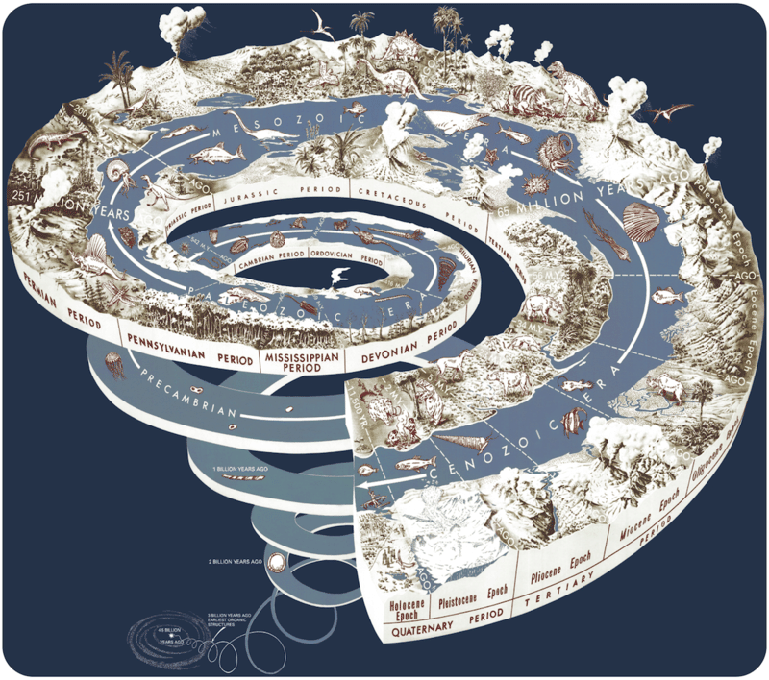
Image: Geologic Time Scale
Credit: Joseph Graham, William Newman, and John Stacy, US Geological Survey
Source: http://commons.wikimedia.org/wiki/File:Geological_time_spiral.png
License: Public Domain
Instructions for Parents/Guardians
- Refer to your student’s score report to determine their instructional needs level—green, yellow, or red—for this performance category.
- Use the Interpretive Guidance (see page 2) to understand what your student likely knows and is able to do based on their instructional needs level.
- Use the Family Resources and Recommendations (see pages 3-5) to engage with and support your student’s science learning at home.
Interpretive Guidance for Performance Category 2:
Analyze Data to Explain the Appearance of Specific Traits in Populations
Red (0-5 score points earned)  - Extensive additional instruction and reteaching of these skills is recommended.  - The student needs significant opportunities to reinforce and apply these skills in future learning. | Yellow (6-9 score points earned)  - Moderate additional instruction on these skills is recommended.  - The student needs additional opportunities to strengthen these skills in future learning. | Green (10-14 score points earned)  - Minimal to no additional instruction on these skills is recommended.  - The student is ready to extend these skills in future learning.

What These Results Mean
This student is likely able to:  - Attempt to plot and utilize data to develop an incomplete and/or inaccurate description of a change in an observable trait over time.  - Use some data as evidence to support a partial conclusion about which trait is most adaptive to a specific environmental change.  - Use information from a general codon table with little or no accuracy to explain the effects of a mutation on the resulting protein and traits of an organism.  - Attempt to utilize information to identify a difference in the process of mutation and natural selection. | This student is likely able to:  - Plot data with minor inaccuracies to develop a description of a change in an observable trait over time.  - Attempt with minor errors to communicate information obtained from graphs to explain the cause-and-effect relationship between the patterns of change in anatomical structures and environmental factors.  - Use information from a general codon table to explain the sequence of events leading to a mutation on a protein and the resulting traits of an organism with minor errors.  - Correctly utilize information to develop a partial explanation of the differences between the mechanisms of mutations as compared to natural selection. | This student is likely able to:  - Accurately plot and interpret data to identify and describe patterns of change in an observable trait over time.  - Correctly utilize data to develop complete and accurate explanations of the specific selective pressure driving an observable change in traits over time.  - Accurately use information from a general codon table to explain the sequence of events leading to a mutation on a protein and the resulting traits of an organism using correct scientific terms.  - Utilize multiple sources of information to develop an accurate and complete explanation of the differences between the mechanisms resulting in mutations as related to natural selection.

Family Resources and Recommendations for Performance Category 2:
Analyze Data to Explain the Appearance of Specific Traits in Populations
Resources and Recommendations to Support Science Learning at Home
Engage in the Topic  - How do organisms end up with specific traits? | Present this moth simulation to your student. Have students choose one of the environments, light or dark, and begin. Students control the bird to click on as many moths as they can catch (‘eat’) in one minute. After the one minute is complete, ask these questions:  - Why are there two different traits, light and dark-colored moths, at the start of the simulation? (There are two different traits because of genetic variation.)  - How did the traits in the moth population change over time? (This will depend on the environment chosen. Light-colored moth populations will increase in the light environment, while dark-colored moth populations will increase in the dark environment.)  - How do the moths’ traits, light or dark coloring, give each population an advantage or disadvantage? (This will depend on the environment. Light coloring helps moths in the light environment because those moths are harder for the bird to locate and catch. Dark coloring on moths in the light environment is a disadvantage because that makes those moths easier for the bird to locate and catch.)
Explore the Topic  - How do traits change in nature? | Read this article titled Natural Selection with your student. If time allows, watch the video [12:44] embedded in the article that explains natural selection. Ask students the following questions:  - How are traits passed down to offspring? (Traits are passed to offspring through reproduction.)  - What is the difference between genotype and phenotype? (Genotype is the genetic instructions that are inside an organism’s cells. Phenotype is the physical expression of an organism's genes, such as a moth's color.)  - Can a trait like dyed blue hair be passed down? Why or why not? (No, this trait cannot be passed down. Dying hair changes the outward appearance of an organism but not the actual genes present in that organism.)
Explain the Topic  - How does an organism develop a new trait? | Present this video [3:03] on mutations. Ask students the following questions:  - How can mutations affect an organism? (Mutations can affect an organism by changing the genes and, therefore, the traits that an organism has. Mutations can be helpful or harmful.)  - What might happen to an organism if a helpful mutation occurs? (An organism with a helpful mutation might be better suited for an environment and more successful. If an organism is more successful, it is more likely to pass that helpful trait to offspring.)  - What might happen to the offspring of an organism with a helpful mutation? (If the offspring has the helpful trait, it might be better suited to an environment and more likely to pass the trait off to its offspring, and so on.)
Elaborate on the Topic  - How can traits help organisms survive? | Revisit the moth simulation. This time, imagine most of the dark moth population has inherited a mutation that causes them to taste bitter to birds. Ask your student to select the ‘Dark Forest’ and avoid eating the bitter-tasting dark moths. After one minute, show the graphs to your student at the bottom of the screen. Ask the following questions:  - Why did the dark-colored moths survive better in the dark environment this time? (The dark-colored moths survived in greater numbers because they have two traits that gave them an advantage—their light color and bitter taste.)  - How might the light-color moth population change in future generations in both environments? Why? (In the dark environment, the number of light moths is at or close to zero after one minute. Future generations of moths in the dark forest will likely be almost all dark-colored. The light-colored moths in the light environment eventually decrease because the dark-colored moths are likely passing on their genes for bitter taste in both environments.)

Resources
- Peppered Moth Simulation – simulation by Ask a Biologist by Arizona State University
[https://askabiologist.asu.edu/peppered-moths-game/play.html]
- Natural Selection – article by CK12
[https://flexbooks.ck12.org/cbook/ck-12-middle-school-life-science-2.0/section/4.3/primary/lesson/natural-selection-ms-ls/]
- DNA: Mutations – video by Britannica
[https://www.britannica.com/video/189165/change-video-DNA-nucleotide-sequence-amino-acid]

