
Coherence and Alignment Among Science Curriculum, Instruction, and Assessment (CASCIA) Project

Grade 8 Unit 3: Understanding Earth History and the Origin of Species

Family Guidance and Learning Resources for Performance Category 3

February 2024

Grade 8 Unit 3: Understanding Earth History and the Origin of Species, Family Guidance and Learning Resources for Performance Category 3 was developed with funding from the U.S. Department of Education under the Competitive Grants for State Assessments Program CFDA 84.368A. The contents of this paper do not represent the policy of the U.S. Department of Education, and no assumption of endorsement by the Federal government should be made.
All rights reserved. Any or all portions of this document may be reproduced and distributed without prior permission, provided the source is cited as: Coherence and Alignment Among Science Curriculum, Instruction, and Assessment (CASCIA) Project. (2023). Grade 8 Unit 3: Understanding Earth History and the Origin of Species, Family Guidance and Learning Resources for Performance Category 3. Lincoln, NE: Nebraska Department of Education.
Purpose
The purpose of this document is to help families understand their student’s performance on the Grade 8 Unit 3 Science Assessment and to provide resources and recommendations for engaging their student in science learning at home.
Unit Overview
By engaging in this unit, students deepen their knowledge of evidence of a common ancestor interpreted through fossil records, how differences in their structure help explain present-day organisms, and how rock strata help us explain the history of Earth. Students develop and use models, analyze and interpret data, and construct explanations to reveal patterns and cause/effect relationships in the inheritance of traits through natural selection and the adaptation and change in life and populations on Earth.
Performance Category 3: Use Models to Describe Rock Formations and Fossils
Prompts for this performance category require students to develop or use models to support descriptions of the:
- patterns in the locations of fossils in layers of sedimentary rock
- rock strata and the fossil record

Instructions for Parents/Guardians
- Refer to your student’s score report to determine their instructional needs level—green, yellow, or red—for this performance category.
- Use the Interpretive Guidance (see page 2) to understand what your student likely knows and is able to do based on their instructional needs level.
- Use the Family Resources and Recommendations (see pages 3-5) to engage with and support your student’s science learning at home.
Grade 8 Unit 3: Understanding Earth History and the Origin of Species
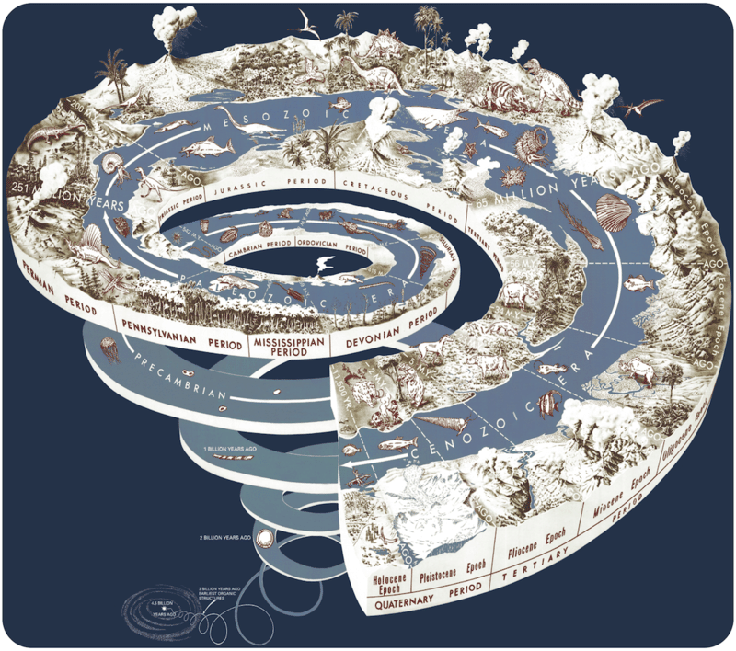
Image: Geologic Time Scale
Credit: Joseph Graham, William Newman, and John Stacy, US Geological Survey
Source: http://commons.wikimedia.org/wiki/File:Geological_time_spiral.png
License: Public Domain
Interpretive Guidance for Performance Category 3:
Use Models to Describe Rock Formations and Fossils
Red (0-1 score points earned)  - Extensive additional instruction and reteaching of these skills is recommended.  - The student needs significant opportunities to reinforce and apply these skills in future learning. | Yellow (2-3 score points earned)  - Moderate additional instruction on these skills is recommended.  - The student needs additional opportunities to strengthen these skills in future learning. | Green (4-5 score points earned)  - Minimal to no additional instruction on these skills is recommended.  - The student is ready to extend these skills in future learning.

What These Results Mean
This student is likely able to:  - Use a model to develop an incomplete and/or inaccurate conclusion related to Earth’s history and ancient organisms.  - Use a model to sequence and/or describe evolutionary relationships with multiple errors. | This student is likely able to:  - Use a model to develop a partial and accurate conclusion related to Earth’s history and ancient organisms.  - Use information to sequence the components of a model and/or use the model to support a description related to organisms and their changes over time. | This student is likely able to:  - Use a model to develop a complete and accurate conclusion related to Earth’s history and ancient organisms.  - Use information to correctly identify and accurately sequence the components of a model to support a complete description related to organisms and their changes over time.

Family Resources and Recommendations for Performance Category 3:
Use Models to Describe Rock Formations and Fossils
Resources and Recommendations to Support Science Learning at Home
Engage in the Topic  - What happened at Ashfall? | Watch the video [1:41] with your student about the Ashfall fossil site in Nebraska.  Discuss the following questions with your student:  - What is Ashfall Fossil Beds State Historical Park? (A park containing a historic fossil bed.)  - What caused Ashfall's sudden extinctions? (The animals perished at a watering hole following a massive volcanic eruption.)  - Would you expect to see these animals in Nebraska if you visited today? (No)
Explore the Topic  - What can we find out from the rock layers at Ashfall? | With your student, look at this website and use the chart from it (and below) of the Ashfall fossil site in Nebraska. The ground beneath the soil looks something like this in a cross-sectional view.  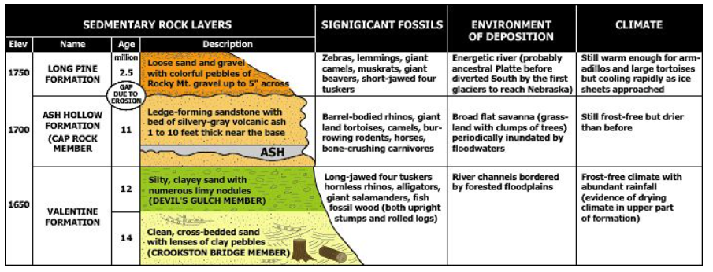  What evidence can you identify in past environments (the second column from the right) that the landscape has changed? (Different species of organisms, different climates)  What did Nebraska look like before today? (The answer depends on the time period. Answers could include energetic rivers or broad flat savannas, for example.)  List other species that lived in Nebraska in different time periods. (Answers may include zebras, lemmings, giant camels, giant beavers, and giant salamanders.)  Which layer is the oldest? (The bottom layer, or Valentine formation, is the oldest.)
Elaborate on the Topic  - How do rock layers tell us about past environments and species? | Sedimentary rock layers (strata) contain fossils that reveal clues to environmental conditions and the animal life of specific times in the past. The particles of sediment that make up the rock reveal clues about the environmental setting and how the rock was deposited.  Watch this video [3:22] with your student and discuss how rock layers have patterns and how fossils formed in the layers to help us better understand the past environment and species.
Evaluate the Topic  - How do genetic variations of traits in a population increase or decrease some individuals’ probability of surviving and reproducing in a specific environment? | With your student, look at this website. Next, consider that today, Nebraska is a temperate grassland (click on the Temperate Grassland link).  - What are the traits of animals found in Nebraska today? (Animals in temperate deciduous forests have to adapt to changing seasons. They must be able to cope with cold winters and hot summers.)  Reflect on the chart on page 3 to answer the following questions:  - How does the type of biome explain why no rhinos and camels live in Nebraska? (The climate is now cooler and wetter with more vegetation.)  - How does natural selection explain why no rhinos and camels live in Nebraska? (Over time, the climate changed. Organisms with disadvantageous traits for their environment will be less likely to survive and reproduce; therefore, over many generations they were no longer adapted for their environment and went extinct.)

Resources
- Ashfall Fossil Beds State Historical Park – video by University of Nebraska
[https://www.youtube.com/watch?v=u5NlLnSG2fw]
- About Ashfall Geology – website by University of Nebraska State Museum Ashfall Fossil Bed
[https://ashfall.unl.edu/about-ashfall/geology.html]
- Rock Layers and the Fossils Within – video by Iowa PBS
[https://www.youtube.com/watch?v=_U27Ohdjk1A]
- World Biomes – website by NCEAS
[https://kids.nceas.ucsb.edu/biomes/index.html]

