
Coherence and Alignment Among Science Curriculum, Instruction, and Assessment (CASCIA) Project

Grade 8 Unit 4: Providing Solutions to Problems Using Simple Wave Properties

Family Guidance and Learning Resources for Performance Category 1

April 2024

Grade 8 Unit 4: Providing Solutions to Problems Using Simple Wave Properties, Family Guidance and Learning Resources for Performance Category 1 was developed with funding from the U.S. Department of Education under the Competitive Grants for State Assessments Program CFDA 84.368A. The contents of this paper do not represent the policy of the U.S. Department of Education, and no assumption of endorsement by the Federal government should be made.
All rights reserved. Any or all portions of this document may be reproduced and distributed without prior permission, provided the source is cited as: Coherence and Alignment Among Science Curriculum, Instruction, and Assessment (CASCIA) Project. (2023). Grade 8 Unit 4: Providing Solutions to Problems Using Simple Wave Properties, Family Guidance and Learning Resources for Performance Category 1. Lincoln, NE: Nebraska Department of Education.
Purpose
The purpose of this document is to help families understand their student’s performance on the Grade 8 Unit 4 Science Assessment and to provide resources and recommendations for engaging their student in science learning at home.
Unit Overview
By engaging in this unit, students deepen their knowledge of properties and types of simple waves and provide design solutions to problems that involve these properties. Students ask questions and define problems, develop and use models, plan and carry out investigations, construct explanations and design solutions, and use mathematical and computational thinking to build an understanding of sound waves and how properties of matter affect light.
Performance Category 1: Analyze Data to Explain the Relationships Between Properties of Waves and Energy
Prompts for this performance category require students to analyze and interpret models, data, and graphs to support conclusions about:
Image: Sine waves different frequences
Credit: LucasVB
Source: https://en.wikipedia.org/wiki/Sound#/media/File:Sine_waves_different_frequencies.svg
License: Public Domain
- mathematical relationship between amplitude of light and sound waves and energy
- properties of electromagnetic waves and the segment of the electromagnetic spectrum that the human eye can view
- the relationship between energy and the displacement of sound waves
- the relationship between the pitch of a sound wave detectable by a human ear and its frequency

Grade 8 Unit 4: Providing Solutions to Problems Using Simple Wave Properties
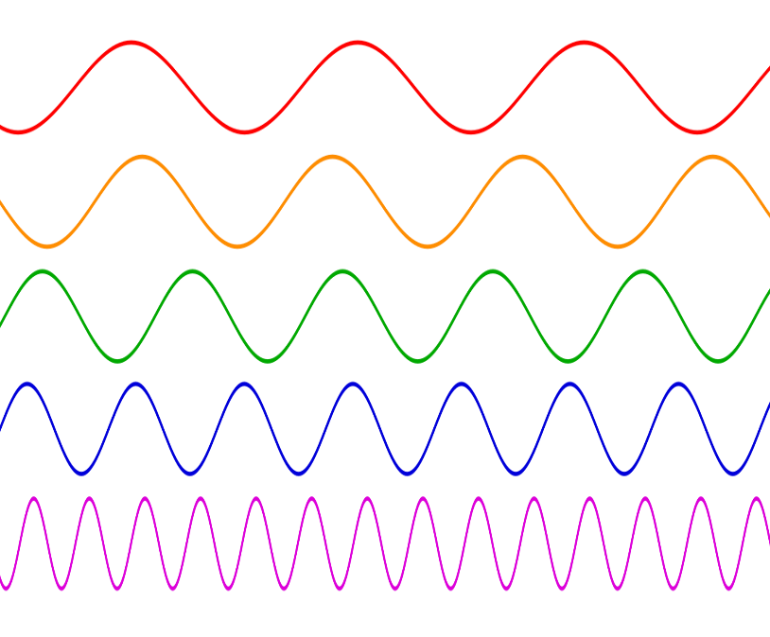

Instructions for Parents/Guardians
- Refer to your student’s score report to determine their instructional needs level—green, yellow, or red—for this performance category.
- Use the Interpretive Guidance (see page 2) to understand what your student likely knows and is able to do based on their instructional needs level.
- Use the Family Resources and Recommendations (see page 4) to engage with and support your student’s science learning at home.

Interpretive Guidance for Performance Category 1:
Analyze Data to Explain the Relationships Between Properties of Waves and Energy
Red (0-4 score points earned)  - Extensive additional instruction and reteaching of these skills is recommended.  - The student needs significant opportunities to reinforce and apply these skills in future learning. | Yellow (5-10 score points earned)  - Moderate additional instruction on these skills is recommended.  - The student needs additional opportunities to strengthen these skills in future learning. | Green (11-14 score points earned)  - Minimal to no additional instruction on these skills is recommended.  - The student is ready to extend these skills in future learning.

What These Results Mean
This student is likely able to:  - Attempt to plot and utilize data to develop an incomplete and/or inaccurate description of the relationship between the energy and amplitude of a wave.  - Use some data as evidence to support a partial conclusion about the relationship between energy and the amplitude of a sound wave.  - Complete a diagram with little or no accuracy to attempt to explain a phenomenon with insufficient evidence based on the relationship between frequency and wavelength of light.  - Partially complete a mathematical model/graph with multiple inaccuracies to represent relationships between amplitude, wavelength, and energy transmitted by a sound wave in a given time.  - Use no or limited evidence or information to inaccurately describe the relationship between pitch and frequency of sound waves. | This student is likely able to:  - Plot data with minor inaccuracies to develop a description of the relationship between the energy and amplitude of a wave.  - Attempt with minor errors to complete a data table to communicate information obtained from graphs to explain the relationship between energy and the amplitude of a sound wave.  - Attempt with minor errors to complete a diagram of forms of electromagnetic waves and/or use some relevant information to develop a partial explanation of a phenomenon based on the relationship between frequency and wavelength of light waves with minor errors.  - Complete a mathematical model with few inaccuracies to represent relationships between amplitude, wavelength, and energy transmitted by a sound wave in a given time.  - Use some relevant evidence to partially communicate information related to the relationship between pitch and frequency of sound waves. | This student is likely able to:  - Accurately plot and interpret data to identify and describe the relationship between the energy and amplitude of a light wave.  - Correctly complete a data table to develop complete and accurate explanations of the relationship between energy and the amplitude of a sound wave.  - Accurately complete a diagram comparing wave properties of visible light to other forms of electromagnetic waves and develop an accurate and complete explanation of a phenomenon based on the relationship between frequency and wavelength of light waves.  - Accurately complete a mathematical model with no inaccuracies to represent relationships between amplitude, wavelength, and energy transmitted by a sound wave in a given time.  - Completely and effectively combine and communicate information related to the relationship between pitch and frequency of sound waves.

Family Resources and Recommendations for Performance Category 1:
Analyze Data to Explain the Relationships Between Properties of Waves and Energy
Resources and Recommendations to Support Science Learning at Home
Engage in the Topic  - Do you hear what I hear? | Watch the following video [2:26] with your student and learn about how we hear sound.
Explore the Topic  - How can a flying aircraft make my windows rattle? | Watch the following video [0:31] with your student and learn about how sound causes objects to vibrate.  Very loud sounds can be harmful to people’s ears. Ask your student, “How do you think earplugs work to protect your hearing?” (Earplugs help absorb the sound waves' vibration as they attempt to enter the ear canal.)
Elaborate on the Topic  - How can I make sound vibrations? | Watch the following video [3:00] with your student and learn how to make a kazoo. A cardboard paper tube also works!  Ask your student, “How does the sound of your voice affect the waxed paper?” (It makes the waxed paper vibrate.)
Explain the Topic  - How is the amplitude of a wave related to the energy in a wave? | Watch the following video [3:26 – 4:37] with your student and learn about the mathematical relationship between a wave’s amplitude and the energy it carries.  A wave’s energy is proportional to its amplitude, squared.  Ask your student, “What would happen to a wave’s energy if you quadrupled its amplitude?” (It will have 16 times the energy, or 4².)
Evaluate the Topic  - How is loudness measured? | Ask your student to think about the following questions:  - How is the energy of the wave affected if the amplitude of the wave increases from 2 meters to 4 meters? (It is quadrupled.)  - Will a wave with a larger amplitude sound louder or quieter? (It will sound louder.)  - How is the frequency of a wave affected if an object begins to vibrate with a higher frequency? (An object that is vibrating with a higher frequency will have a higher pitch than it did before.)  If your student would like a further challenge, four more questions about graphing data and wave energy are provided, with correct answers, at this Khan Academy page.

Resources
- Journey of Sound to the Brain – video [2:26]
[https://www.youtube.com/watch?v=eQEaiZ2j9oc&t=140s]
- Sound and Vibration – video [0:31]
[https://www.youtube.com/watch?v=lFWXjzhH8a0&t=19s]
- How to Make a Kazoo – video [3:00]
[https://www.youtube.com/watch?v=pF0elA6mzmg]
- Traveling Waves – webpage
[https://www.youtube.com/watch?v=TfYCnOvNnFU&t=296s]
- Wave Questions – webpage
[https://www.khanacademy.org/science/in-in-class11th-physics/in-in-11th-physics-waves/in-in-wave-characteristics/e/wave-energy-ap-physics-1]

