
Coherence and Alignment Among Science Curriculum, Instruction, and Assessment (CASCIA) Project

Grade 8 Unit 4: Providing Solutions to Problems Using Simple Wave Properties

Family Guidance and Learning Resources for Performance Category 2

April 2024

Grade 8 Unit 4: Providing Solutions to Problems Using Simple Wave Properties, Family Guidance and Learning Resources for Performance Category 2 was developed with funding from the U.S. Department of Education under the Competitive Grants for State Assessments Program CFDA 84.368A. The contents of this paper do not represent the policy of the U.S. Department of Education, and no assumption of endorsement by the Federal government should be made.
All rights reserved. Any or all portions of this document may be reproduced and distributed without prior permission, provided the source is cited as: Coherence and Alignment Among Science Curriculum, Instruction, and Assessment (CASCIA) Project. (2023). Grade 8 Unit 4: Providing Solutions to Problems Using Simple Wave Properties, Family Guidance and Learning Resources for Performance Category 2. Lincoln, NE: Nebraska Department of Education.
Purpose
The purpose of this document is to help families understand their student’s performance on the Grade 8 Unit 4 Science Assessment and to provide resources and recommendations for engaging their student in science learning at home.
Unit Overview
By engaging in this unit, students deepen their knowledge of properties and types of simple waves and provide design solutions to problems that involve these properties. Students ask questions and define problems, develop and use models, plan and carry out investigations, construct explanations and design solutions, and use mathematical and computational thinking to build an understanding of sound waves and how properties of matter affect light.
Performance Category 2: Use Models to Describe Interactions Between Light Waves and Materials
Prompts for this performance category require students to develop and use models to support descriptions of:
Image: Sine waves different frequences
Credit: LucasVB
Source: https://en.wikipedia.org/wiki/Sound#/media/File:Sine_waves_different_frequencies.svg
License: Public Domain
- the pathway of light as it travels in air using the law of reflection
- how properties of waves are affected by the medium through which they are passing
- the path light travels at surfaces between different transparent materials (e.g., air and water) where the light path bends
- the relationship between the density of a medium and its effect on the speed light travels
- how the relationship between wavelength and speed of light are connected to different and predictable colors of visible light

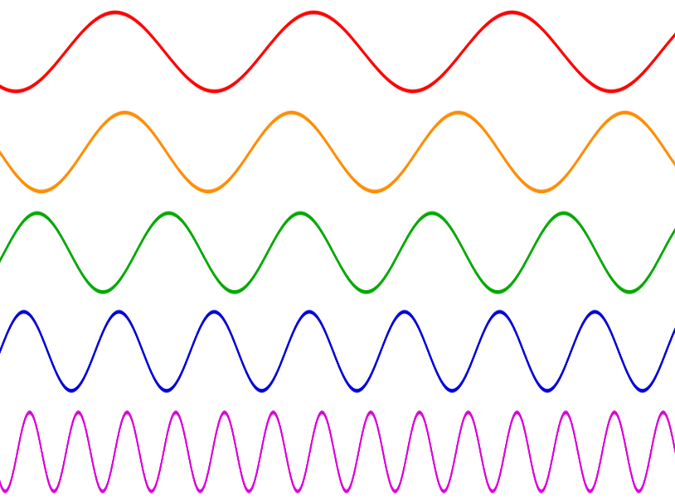
Grade 8 Unit 4: Providing Solutions to Problems Using Simple Wave Properties

Instructions for Parents/Guardians
- Refer to your student’s score report to determine their instructional needs level—green, yellow, or red—for this performance category.
- Use the Interpretive Guidance (see page 2) to understand what your student likely knows and is able to do based on their instructional needs level.
- Use the Family Resources and Recommendations (see page 4) to engage with and support your student’s science learning at home.

Interpretive Guidance for Performance Category 2:
Use Models to Describe Interactions Between Light Waves and Materials
Red (0-6 score points earned)  - Extensive additional instruction and reteaching of these skills is recommended.  - The student needs significant opportunities to reinforce and apply these skills in future learning. | Yellow (7-11 score points earned)  - Moderate additional instruction on these skills is recommended.  - The student needs additional opportunities to strengthen these skills in future learning. | Green (12-15 score points earned)  - Minimal to no additional instruction on these skills is recommended.  - The student is ready to extend these skills in future learning.

What These Results Mean
This student is likely able to:  - Use a model to develop an incomplete explanation of the pathway of light as it travels through air.  - Inaccurately describe which properties of a light wave change and which do not after passing from an original medium to a second medium.  - Develop an incomplete model showing the pathway of light passing from an original medium (air) to a second medium (water) and then back, including an inaccurate location of a visible object under the water.  - Present a limited or inaccurate description of the interactions contributing to the pathway of light and the actual location of an object underwater as seen from the surface.  - Use a prism as a model to present a limited or inaccurate description of the color and the frequency-dependent bending of light at a surface between media.  - Present a limited or inaccurate description of how the sequence of colors in a rainbow is formed. | This student is likely able to:  - Use a model to accurately identify or explain the pathway of light as it travels in air using the law of reflection.  - Accurately describe which properties of a light wave change or which do not after passing from an original medium to a second medium.  - Develop a mostly complete and accurate model showing the pathway of light passing from an original medium (air) to a second medium (water) and then back, showing both transitions (from m₁ to m₂ and from m₂ back to m₁) and including an approximate location of a visible object under the water.  - Use a model to identify interactions contributing to an event (e.g., the relationship between the density of the medium and its effect on the speed light travels).  - Use a prism as a model to accurately describe the color and the frequency-dependent bending of light at a surface between media.  - Correctly apply relationships between at least two wave properties (e.g., wavelength, frequency, amplitude, color, etc.) to support a description related to the predictable sequence of colors in a rainbow. | This student is likely able to:  - Use a model to accurately identify and explain the pathway of light as it travels in air using the law of reflection.  - Accurately describe which properties of a light wave change and which do not after passing from an original medium to a second medium.  - Develop and complete an accurate model showing the pathway of light passing from an original medium (air) to a second medium (water) and then back, showing both transitions (from m₁ to m₂ and from m₂ back to m₁) and including the accurate location of a visible object under the water.  - Use a model to correctly identify and describe interactions contributing to an event (e.g., the relationship between the density of the medium and its effect on the speed light travels).  - Use a prism as a model to develop a convincing and valid description of how color and the frequency-dependent bending of light at a surface between media can be used to explain wave behavior.  - Correctly and accurately apply relationships among multiple wave properties (e.g., wavelength, frequency, amplitude, color, etc.) to support a description of the predictable sequence of colors in a rainbow.

Family Resources and Recommendations for Performance Category 2:
Use Models to Describe Interactions Between Light Waves and Materials
Resources and Recommendations to Support Science Learning at Home
Engage in the Topic  - Why do stars appear to twinkle? | Say the following to your student: Stars are spherical as we see them from space. However, they appear to be jagged and flickering when we view them from Earth.  Think about the following questions:  - Why do stars twinkle?  - Do planets twinkle?  Have your student visit this webpage to check their answers.
Explore the Topic  - How do electromagnetic waves compare to mechanical waves? | Have your student complete the Electromagnetic Waves Escape Room tutorial. This interactive tutorial will ask your student to help a friendly alien get a message to his home planet while exploring electromagnetic waves and their properties. Your student will answer questions at the end of each segment to receive the code needed to move to the next step. The questions will be repeated until they are all answered correctly.
Explain the Topic  - What are the properties of electromagnetic waves? | Have your student read this NASA webpage about the behavior of electromagnetic waves, paying close attention to the diagrams presented with each term.  Have your student watch this video [3:15] about absorption, reflection, and refraction. After watching the video, click on the ‘close’ icon. Have your student complete the quiz (seven questions). When finished, the site displays the number of correct responses and provides a review, including the correct answers.
Elaborate on the Topic  - What do colors have to do with wavelength and the speed of light? | Read the following with your student:  Like all wavelengths of the electromagnetic spectrum, visible light travels at a constant speed of about 3.0 x 10⁸ meters per second (m/s) and can be reflected and refracted. As white light travels through a denser medium (i.e., glass prism), the speed of light changes slightly. The refraction of the light, along with the geometry of a prism, causes the different wavelengths to separate. We see this as the colors of the rainbow. After exiting the prism, light travels at its original speed, and the different wavelengths of light remain separated. As seen below, with the speed of light being constant, shorter wavelengths (ʎ) will have higher frequencies.  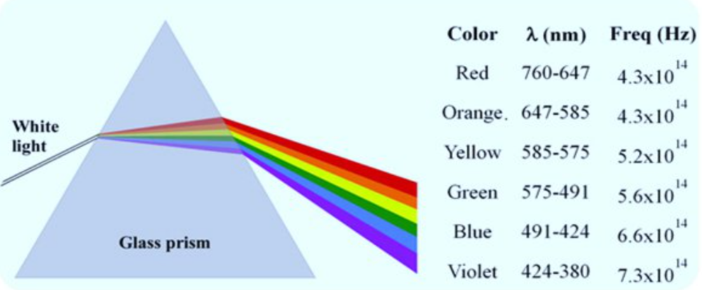  https://qph.cf2.quoracdn.net/main-qimg-acbc35444b73913b21c975212e5e39b5-pjlq
Evaluate the Topic  - How do light waves interact with different materials? | If possible, print the “Flashlight Predictions” PDF. If printing is unnecessary or not an option, your student can draw the arrows on scratch paper.  - Have your student draw arrows representing the path of light. Tell your student to assume the paper in “Diagram B” is white and the rock in “Diagram C” is black. Arrows should be straight lines that change direction at the interface between two different mediums (e.g., air and water).  - Have your student label Diagrams A through F with the following: Refract, Absorb, Reflect, Scatter, Refract more than once. The answers may be used more than once. (ANSWERS: A. Reflect, B. Scatter, C. Absorb, D. Reflect, E. Refract more than once, F. Refract. The transparent glass in D, E, and F will also “Reflect” to a lesser extent.)

Resources
- Why Do Stars Twinkle and Planets Do Not? – webpage
[https://byjus.com/physics/why-do-stars-twinkle/]
- Electromagnetic Waves: Save the Day – tutorial
[https://view.genial.ly/61c9aaf9de36770d8e6bb855]
- Wave Behaviors – webpage by NASA
[https://science.nasa.gov/ems/03_behaviors/]
- Light Absorption, Reflection, & Refraction – video [3:15] by Scholastic
[https://studyjams.scholastic.com/studyjams/jams/science/energy-light-sound/light-absorb-reflect-refract.htm]
- Why Do Different Colors of Light Have Different Speeds in a Prism? – image
[https://qph.cf2.quoracdn.net/main-qimg-acbc35444b73913b21c975212e5e39b5-pjlq]
- Flashlight Predictions – PDF
[https://static.pbslearningmedia.org/media/media_files/50d1ceb8-d22f-4f33-b7a8-a0fa961e67b4/818dd756-e713-4dd1-b366-3dee24694ba5.pdf]

