Coherence and Alignment Among Science Curriculum, Instruction, and Assessment (CASCIA)  Grade 8 Unit 1  End-of-Unit Assessment  Task Interpretation Guide  September 2023  The Interpretation Guide for the SIPS Assessment Model: A Coherent NGSS- and Framework-aligned System of Science Curriculum, Instruction, and Assessment was developed with funding from the U.S. Department of Education under the Competitive Grants for State Assessments Program, CFDA 84.368A. The contents of this guide do not represent the policy of the U.S. Department of Education, and no assumption of endorsement by the Federal government should be made. |  |   All rights reserved. Any or all portions of this document may be reproduced and distributed without prior permission, provided the source is cited as: Stackable Instructionally-embedded Portable Science (SIPS) Assessments Project. (2023). Interpretation Guide for the SIPS Assessment Model: A Coherent NGSS- and Framework-aligned System of Science Curriculum, Instruction, and Assessment . Lincoln, NE: Nebraska Department of Education.
Table of Contents
Introduction 1
Purpose 1
Contents 2
SIPS Grade 8 Unit 1 EOU Assessment Task 1: Storing Grocery Carts 3
Prompt 1 – Parts A and B 3
Prompt 2 – Parts A and B 7
Prompt 2 – Parts C and D 11
SIPS Grade 8 Unit 1 EOU Assessment Task 2: Barriers on the Highway 16
Prompt 1 – Parts A and B 16
Prompt 2 – Parts A, B, and C 20
Prompt 3 – Parts A, B, and C 24
Prompt 4 – Parts A and B 27
SIPS Grade 8 Unit 1 EOU Assessment Task 3: Roller Coaster Thrills 31
Prompt 1 – Parts A and B 31
Prompt 1 – Part C 34
Prompt 2 36
Prompt 3 38
Prompt 4 – Parts A and B 41

Introduction  Research on the influence of assessment practices on student learning is clear. The use of formative assessment practices, with informative and immediate feedback that leads to adjustments to instructional next steps, has been shown to be effective in helping students learn (Black & Wiliam, 1998; Wylie & Lyon, 2009; Heritage, 2010). Interim or large-scale summative assessments, such as those required under the Every Student Succeeds Act of 2015 (ESSA), cannot and are not meant to inform daily instruction because of how and when they are administered. These forms of assessment can bring value to an assessment system, but only if coordinated and meaningfully aligned within a comprehensive, coherent system.  The Coherence and Alignment Among Science Curriculum, Instruction, and Assessment (CASCIA) Project brings together three partner states—Nebraska, Alabama, and Alaska—with a team of researchers and experts to establish science assessment resources that are coordinated and aligned across all parts of the assessment system. With coherence as the guiding principle, these state-level educators and national science education and measurement experts have joined with hundreds of local educators to address states’ need for quality, standards-aligned science assessments that generate meaningful, interpretable, and actionable results, and to design a scoring and score reporting framework that builds educators’ capacity to track, interpret, and communicate students’ learning in science and to offer effective instruction for all students.  Purpose  The purpose of the Grade 8 Unit 1 End-of-Unit Assessment Task Interpretation Guide is to support educators’ understanding of the Grade 8 Unit 1 End-of-Unit assessment tasks and prompts, their features, and the evidence (i.e., knowledge and skills) they are designed to elicit about student learning, and how the assessment and the information it provides can be used to plan instruction and learning opportunities for students, whether it involves planning for instruction prior to teaching the instructional unit, reflecting on the quality and sufficiency of prior instruction and instructional materials, or planning additional student learning opportunities or interventions in the subsequent unit (e.g., SIPS Unit 2). |  |  | The Grade 8 Unit 1 Science Assessment includes three science tasks, each including multiple scorable prompts. Task 1, Storing Grocery Carts, includes two prompts and 21 possible score points with one prompt having Part A and B and one prompt having Part A, Part B, Part C, and Part D; Task 2, Barriers on the Highway, includes four prompts and 13 possible score points with two prompts having a Part A and Part B and two prompts having Part A, Part B, and Part C; Task 3, Roller Coaster Thrills, includes four prompts and 14 possible score points, with one prompt having Part A, Part B, and Part C and one prompt having a Part A and Part B.  Prompts from the three tasks that measure similar combinations of dimensions (i.e., Disciplinary Core Ideas, Science and Engineering Practices, and Crosscutting Concepts) from the Next Generation Science Standards (NGSS) are organized into four color-coded performance categories. The NGSS Performance Expectations (PEs) are addressed in one or more performance categories to provide multiple opportunities to demonstrate flexible thinking and competency in different situations and contexts.
  Performance Category | NGSS PEs | Prompts in Performance Category | Points Possible
  Design the Best Solution to a Problem Involving Energy, Forces, and Motion | MS-PS2-1  MS-PS3-1 | Task 1, Prompt 2A  Task 1, Prompt 2B  Task 2, Prompt 4 | 10 points
  Use Experimental Features of an Investigation to Explain Interactions Between Objects | MS-PS2-1 MS-PS2-2 MS-PS3-1 MS-PS2-4 | Task 1, Prompt 2C  Task 1, Prompt 2D  Task 2, Prompt 1  Task 3, Prompt 4 | 8 points
  Analyze Data to Describe Interactions Between Objects | MS-PS3-1 MS-PS2-4 | Task 2, Prompt 2  Task 2, Prompt 3  Task 3, Prompt 3 | 11 points
  Support Arguments About Interactions Between Objects, Forces, and Energy | MS-PS2-1, MS-PS2-2, MS-PS3-1, MS-PS2-4 | Task 1, Prompt 1  Task 3, Prompt 1A  Task 3, Prompt 1B  Task 3, Prompt 1C  Task 3, Prompt 2 | 13 points
Contents  This document includes interpretive guidance to support educators’ understanding of each prompt on the Grade 8 Unit 1 EOU Assessment, its features, and the evidence it is designed to elicit about students’ learning, and offers important connections to the learning goals, formative assessment opportunities, and lesson descriptions within the SIPS Grade 8 Unit 1 Map / Instructional Framework as well as connections to future learning opportunities in the next unit.  For each prompt, the following information is provided:  - Performance Category – The performance category to which the prompt is aligned.  - Acquisition Goals – The acquisition goals from Stage 1 of the unit map / instructional framework that the prompt is intended to measure.  - Prompt Knowledge and Skills for Measurement – The evidence of student learning the prompt is designed to elicit.  - Prompt and Exemplar Response – The prompt with an example exemplar response. An exemplar response represents a high-quality response that provides evidence that students have demonstrated the knowledge, skills, and abilities assessed by the prompt. Student exemplars are intended to assist in understanding the nature and expectations of the prompt. However, students may respond with other relevant scientifically accurate responses, evidence, observations, and ideas.  In general, a full-point exemplar response meets expectations and is:  - scientifically accurate  - complete  - coherent  - consistent with the type of student evidence expected as described in the rubric  For examples of student responses for each prompt representative of the full range of score points possible based on the scoring rubric, access the Grade 8 Unit 1 EOU Assessment Scoring Guide. |  |  | - Prompt Complexity – The complexity features of the prompt based on the SIPS Complexity Framework. The sophistication of students’ ability to demonstrate sense-making is characterized by their ability to (a) use disciplinary core ideas (DCIs), scientific and engineering practices (SEPs), and crosscutting concepts (CCCs) together in the service of sense-making about a phenomenon or problem, and (b) engage with and respond to items and tasks designed using variable features representing combinations of Low, Moderate, and High complexity designations.  Adapted from the Cambridge Alignment Methodology (Forte, 2021) and informed by aspects of Achieve’s Framework to Evaluate Cognitive Complexity in Science Assessments (Achieve, 2019), the SIPS Complexity Framework is grounded in sense-making and students’ ability to flexibly apply knowledge through the integration of the same and new/different combinations of dimensions within the PEs from a unit bundle, in the context of a phenomenon or phenomenon-rooted design problem based on the focal DCIs.  - Prompt Connections to the Unit Map / Instructional Framework – A high-level overview of the evidence elicited by the prompt related to the acquisition goals, connections to the instructionally-embedded formative assessment opportunities within stage 2 of the unit map, and connections to opportunities to learn based on the lesson descriptions within stage 3 of the unit map.  For each of the three tasks, the following information is provided:  - Connections to Future Learning Opportunities – The knowledge, skills, and abilities elicited by the prompt that can be leveraged and extended in future learning. Unit connections highlight where and how an educator can emphasize connections for students in the next unit.
SIPS Grade 8 Unit 1 EOU Assessment Task 1: Storing Grocery Carts  Prompt 1 – Parts A and B  Performance Category: Support Arguments About Interactions Between Objects, Forces, and Energy  Acquisition Goals  - A2. Create a model to show the magnitude of the forces exerted by two interacting objects on each other is equal.  - A3. Create a model to show the direction of the forces exerted by two interacting objects on each other is opposite.  - A4. Construct an explanation that describes the relationship between force and motion to describe phenomena.  - A6. Apply Newton’s Third Law to explain a situation involving the motion of two colliding objects. [MS-PS2-1]  Prompt 1 – Parts A and B measure students’ ability to:  - Support an argument with evidence, data, or a model to explain a scenario related to the application of Newton’s First and Third Law to a problem involving the motion of two colliding objects.  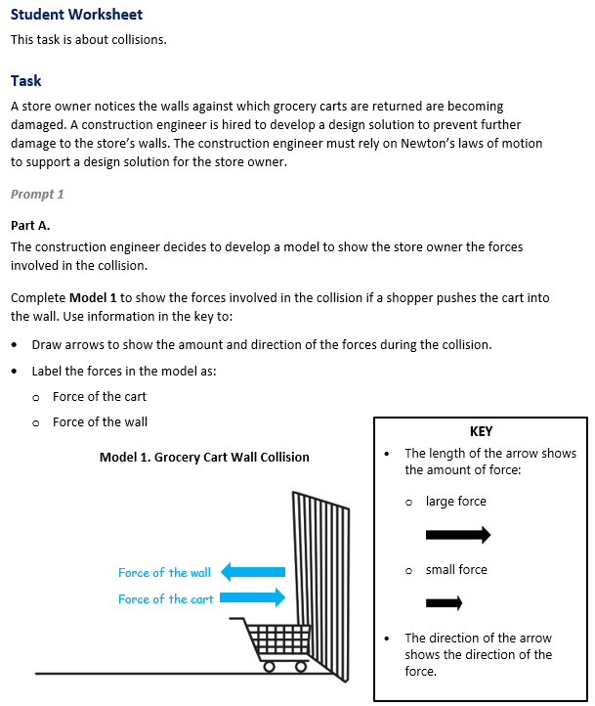 |  |  | 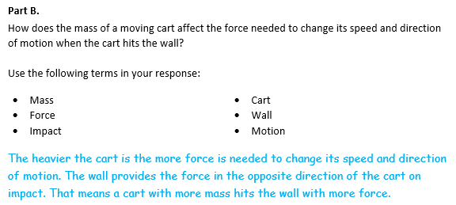
  Task 1 Prompt 1 Part A Complexity
  Degree and Nature of Sensemaking | Low | This prompt…  - Requires one or two dimensions  - One dimension may have a greater degree of emphasis than another
  Complexity of the Presentation | Low | - The amount and type of information provided in the scenario supports limited simple connections among ideas or concepts  - Provides few, simple graphics/data/models  - Phenomenon or problem is presented concretely with high level of certainty
  Cognitive Demand of Response Development | Moderate | - Requires application of ideas and practices given cues and guidance  - Requires drawing relationships and connecting ideas and practices  - Response requires a moderate level of sophistication with typical but relatively complex representation of ideas and application of skills
  Cognitive Demand of Response Production | Low | - Responses include selection from a small set of options presented as text (e.g., word, short phrase) or other formats (e.g., a simple graphic or process)
  Task 1 Prompt 1 Part B Complexity
  Degree and Nature of Sensemaking | Low | This prompt…  - Requires one or two dimensions  - Requires previously learned ideas or concepts
  Complexity of the Presentation | Low | - The amount and type of information provided in the scenario supports limited simple connections among ideas or concepts  - Phenomenon or problem is presented concretely with high level of certainty
  Cognitive Demand of Response Development | Moderate | - Requires application of ideas and practices given cues and guidance  - Requires drawing relationships and connecting ideas and practices  - Response requires a moderate level of sophistication with typical but relatively complex representation of ideas and application of skills
  Cognitive Demand of Response Production | Moderate | - Responses include one or more sentences or a paragraph, a moderately complex graphic, or multiple steps in a simple or moderately complex process.
  Task 1 Prompt 1 Parts A and B
  Connections to the Instructional Framework
  Integration of Knowledge and Skills for Response Development
  Part A
  - Students read the prompt and determine that they must apply the scientific ideas of forces and motion related to the wall and the cart.
  - Students conclude that for any pair of interacting objects, the force exerted by the first object on the second object is equal in strength to the force that the second object exerts on the first, but in the opposite direction (Newton’s third law).
  - Students conclude that action-reaction pairs of forces do not cancel each other because they are acting on separate objects.
  - Students draw the force of the wall and the force of the cart using arrows and labels indicated in the key, indicating that the force exerted on the pair of interacting objects is of the same magnitude but opposite in direction, regardless of the object’s mass.
  Part B
  - Students read the prompt and determine that they must apply the scientific ideas of forces and motion related to the wall and the cart.
  - Students conclude that the mass of the moving cart affects the force needed to change its speed and direction of motion when the cart hits the wall because forces that do not sum to zero can cause changes in the object’s speed or direction of motion.
  - Students conclude that the force exerted when the cart hits the wall is of the same magnitude but opposite in direction regardless of each object’s mass.
  - Using the terms given in the prompt, students indicate that a heavier cart will need more force to change its speed and direction of motion and that the wall provides the force in the opposite direction of the cart on impact, meaning a cart with more mass hits the wall with more force.
  Task 1 Prompt 1 Parts A and B
  Connections to the Instructional Framework, Continued
  Formative Assessments | Opportunities to Learn
  Segment 1, p. 8  Informal Assessment: Investigating Forces Acting on Objects (A2, A3, A4, A6)  - Students develop a model for a collision of two interacting objects exerting forces upon one another.  - Students’ model includes relationships among model elements that are sufficient in capturing the strength and direction of the forces each object exerts upon the other in a system.  Segment 1, pp. 9-10  Formal Assessment: Rocketing Off, With Water! (A6)  - Students construct a system model to analyze Newton’s third law forces in a collision (force directions).  - Students refer to the system model to identify how objects are interacting. | Segment 1, pp. 26-27  Oooof, My Face! (A2*, A3*, A6)  - The teacher presents students with a unique situation, such as a soccer ball striking a person in the face, which introduces the problem of injuries to the player due to the impact of the ball.  - Students watch a video or examine images of the situation and draw pictures of the situation.  - Then, students add representations of forces (often arrows are used, but students should decide), labels, and other relevant information to help explain all the forces and interactions taking place.
  Task 1 Prompt 1 Parts A and B
  Connections to the Instructional Framework, Continued
  Formative Assessments | Opportunities to Learn
  Segment 2, pp. 10-11  Informal Assessment: Supporting Claims About the Direction and Magnitude of Forces on Objects in a Collision (A4, A6)  - Students use evidence, including patterns from other data sets, and referencing the masses of the objects, make a prediction of the force that will be exerted by the first object on the second object.  Segment 2, pp. 14-15  Formal Assessment: Modeling Forces on Interacting Objects (A2, A3)  - Students develop a model for a collision of two interacting objects exerting forces upon one another.  - Model includes relationships among model elements that are sufficient in capturing the strength and direction of the forces each object exerts upon the other in a system. | Segment 1, p. 27  Equal and Opposite (A2*, A3*, A4, A6*)  - This lesson introduces students to the idea of equal and opposite forces as students measure forces with spring scales.  - Students recognize that in each situation, the interacting objects each experience the same magnitude of force being applied, but in different directions. Students also recognize that the forces do not cancel each other because they are on different objects.  Segment 1, pp. 27-28  Newton’s Third Law (A2*, A3*, A6*)  - Using stations, students engage with multiple short hands-on activities, videos, reading passages, and other media to further explore the concept of equal and opposite forces.
  Task 1 Prompt 1 Parts A and B
  Connections to the Instructional Framework, Continued
  Formative Assessments | Opportunities to Learn
  Segment 4, pp. 21-22  Formal Assessment: Modeling Changes in Motion (A2, A3, A4)  - Students develop a model for a collision of two interacting objects exerting forces upon one another.  - Model includes relationships among model elements that are sufficient in capturing the strength and direction of the forces each object exerts upon the other in a system.  Segment 4, pp. 23-24  Formal Assessment: Designing Solutions to a Problem Involving a Collision (A3, A4, A6)  - Students construct a system model to analyze Newton’s third law forces in a collision (force directions). | Segment 1, p. 28  Revising Our Explanation (A2*, A3*, A4, A6)  - Students revisit their initial explanation concerning the anchoring phenomenon. Students revise their explanation of the event and consider what could be done to limit the forces involved in the impact. Students should use what they have learned about Newton’s third law to inform their design (for example: adding arrows that are equal but opposite to the different interacting objects on their diagram).  Segment 1, p. 28  Rocketing Off, With Water! (A2, A3, A6)  - Students are challenged to create a rocket that will fly the highest or longest before returning to Earth. In small groups, students design and build their rocket and use what they have learned about Newton’s third law to justify their choices. In addition to changing the physical design of the rocket, students should also decide how much water and air they would like in the bottle.
Prompt 2 – Parts A and B  Performance Category: Design the Best Solution to a Problem Involving Energy, Forces, and Motion  Acquisition Goals  - A1. Design a solution to a problem that utilizes the fact that when two objects interact, they exert a force on each other in opposite directions.  - A6. Apply Newton’s Third Law to explain a situation involving the motion of two colliding objects. [MS-PS2-1]  Prompt 2 – Parts A and B measure students’ ability to:  - Design a solution to a problem based on forces and the objects involved by identifying the best design within given criteria/constraints and providing justification for the design based on application of Newton’s third law of motion. |  |  | 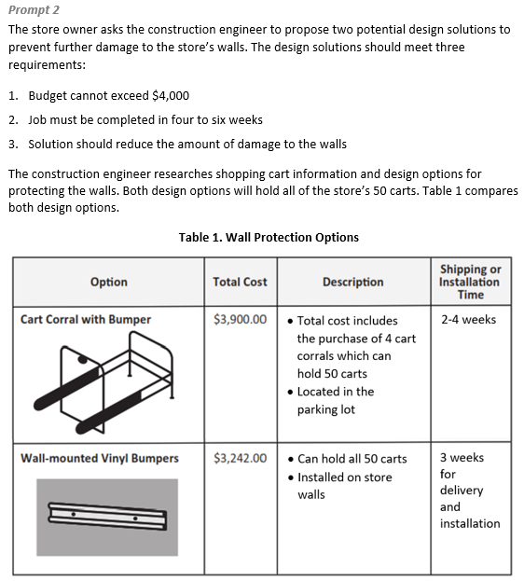
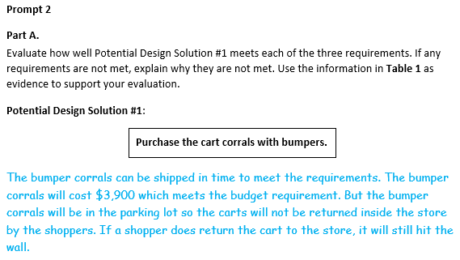  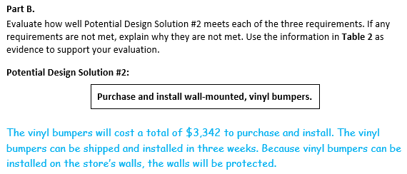
  Task 1 Prompt 2 Parts A and B Complexity
  Degree and Nature of Sensemaking | Moderate | This prompt…  - Requires integration of two dimensions in the service of sense-making
  Complexity of the Presentation | Moderate | - The amount and type of information provided in the scenario supports multiple evident connections among ideas or concepts  - Provides graphics/data/models
  Cognitive Demand of Response Development | Moderate | - Requires drawing relationships and connecting ideas and practices  - Response requires a moderate level of sophistication with typical but relatively complex representation of ideas and application of skills
  Cognitive Demand of Response Production | Moderate | - Responses include one or more sentences or a paragraph, a  moderately complex graphic, or  multiple steps in a simple or moderately complex process
  Task 1 Prompt 2 Parts A and B
  Connections to the Instructional Framework
  Integration of Knowledge and Skills for Response Development
  - Students read each prompt and Table 1, comparing both design options for shopping cart information and protecting the store’s walls.
  - Students evaluate how well each Potential Design Solution meets each of the three requirements, and if they are not met, why.
  - Students recognize that models can be used to represent systems and their interactions, and that energy and matter flow within systems.
  - Students apply their knowledge of Newton’s third law as a scientific idea to construct an explanation using a model.
  - Students conclude and explain why the solution does/does not meet the budget, time requirement, and reduce damage to the wall.
  Formative Assessments | Opportunities to Learn
  Segment 1, pp. 9-10  Formal Assessment: Rocketing Off, With Water! (A1, A6)  - Students use the appropriate scientific principle (e.g., action-reaction forces) that supports the effectiveness of the design solution to a problem involving the motion of two objects.  - Students apply scientific principles to justify the best design and to provide justification for the selection based on the application of Newton’s third law when provided a description of a physical situation involving an interaction between two objects and a list of multiple designs with given criteria. | Segment 1, p. 26  Ooof, My Face! (A1*, A6)  - Students are introduced to the anchoring phenomenon and the goal of developing a multi-modal scientific explanation and design solution to the problem it presents.  - Then, students add representations of forces (often arrows are used, but students should decide), labels, and other relevant information to help explain all the forces and interactions taking place.  - Students keep their models with the intention of revising them over the learning experience.
  Task 1 Prompt 2 Parts A and B
  Connections to the Instructional Framework, Continued
  Formative Assessments | Opportunities to Learn
  Segment 4, pp. 23-24  Formal Assessment: Designing Solutions to a Problem Involving a Collision (A1, A6)  - Students apply Newton’s third law of motion to justify and identify the best design and to provide justification for the selection based on the application of Newton’s third law of motion when provided a description of a physical situation involving a collision between two objects and a list of multiple designs with given criteria.  - Students use the appropriate scientific principle (e.g., action-reaction forces) that supports the effectiveness of the design solution to a problem involving the motion of two objects. | Segment 1, p. 27  Equal and Opposite (A1*, A6*)  - This lesson introduces students to the idea of equal and opposite forces as students measure forces with spring scales.  - Students recognize that in each situation, the interacting objects each experience the same magnitude of force being applied, but in different directions. Students also recognize that the forces do not cancel each other because they are on different objects.  Segment 1, pp. 27-28  Newton’s Third Law (A1*, A6*)  - Using stations, students engage with multiple short hands-on activities, videos, reading passages, and other media to further explore the concept of equal and opposite forces.
Task 1 Prompt 2 Parts A and B
Connections to the Instructional Framework, Continued
Formative Assessments | Opportunities to Learn
Segment 1, p. 28
Revising Our Explanation (A1*, A6)
- Students revisit their initial explanation concerning the anchoring phenomenon. Students revise their explanation of the event and consider what could be done to limit the forces involved in the impact. Students use what they have learned about Newton’s third law to inform their design (for example: adding arrows that are equal but opposite to the different interacting objects on their diagram).
Segment 1, p. 28
Rocketing Off, With Water! (A1, A6)
- Students are challenged to create a rocket that will fly the highest or longest before returning to Earth. In small groups, students design and build their rocket and use what they have learned about Newton’s third law to justify their choices. In addition to changing the physical design of the rocket, students should also decide how much water and air they would like in the bottle.

Prompt 2 – Parts C and D  Performance Category: Use Experimental Features of an Investigation to Explain Interactions Between Objects  Acquisition Goals  - A1. Design a solution to a problem that utilizes the fact that when two objects interact, they exert a force on each other in opposite directions.*  - A4. Construct an explanation that describes the relationship between force and motion to describe phenomena.  - A6. Apply Newton’s Third Law to explain a situation involving the motion of two colliding objects. [MS-PS2-1]  Prompt 2 – Parts C and D measure students’ ability to:  Identify variables, controls, and what and how much data is needed to construct an explanation to describe how the materials in a design solution function to reduce the damage to an object in a collision. |  |  | 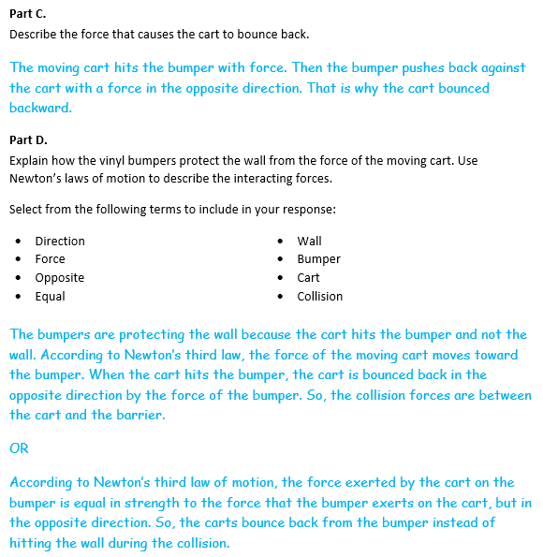
  Task 1 Prompt 2 Parts C and D Complexity
  Degree and Nature of Sensemaking | Moderate | This prompt…  - Requires integration of three dimensions in the service of sense-making
  Complexity of the Presentation | Moderate | - The amount and type of information provided in the scenario supports multiple evident connections among ideas or concepts  - Provides graphics/data/models
  Cognitive Demand of Response Development | High | - Requires selection and application of multiple complex ideas and practices  - Requires high degree of sensemaking, reasoning, and/or transfer
  Cognitive Demand of Response Production | High | - Responses include multiple paragraphs, multiple graphics of at least moderate complexity, or multiple steps in a complex process
  Task 1 Prompt 2 Parts C and D
  Connections to the Instructional Framework
  Integration of Knowledge and Skills for Response Development
  Part A
  - Students read the prompt and recall their knowledge of scientific ideas in designing a process.
  - Students recognize that models can be used to represent systems and their interactions.
  - Students use what they know about Newton’s third law and that the force exerted on a pair of interacting objects is of the same magnitude but opposite in direction regardless of each object’s mass to formulate a response.
  - Students explain that the moving cart hits the bumper with force and the bumper pushes back against the cart with a force in the opposite direction, so the cart bounces backward.
  Part B
  - Students read the prompt and recall their knowledge of Newton’s third law, using evidence and applying scientific ideas to solve design problems.
  - Students use the terms provided to explain that the interacting forces are between the cart and the bumper and the effectiveness of the design solution based on the application of Newton’s third law of motion.
  Task 1 Prompt 2 Parts C and D
  Connections to the Instructional Framework, Continued
  Formative Assessments | Opportunities to Learn
  Segment 1, p. 8  Informal Assessment: Rocketing Off, With Water! (A4, A6)  - Students identify the action-reaction force pair during the collision of two objects and the statement regarding the magnitude of the action-reaction forces involved in the collision.  - Students select appropriate reasoning based on relevant scientific concepts that explains why the force exerted by the first object on the second object is equal in strength to the force that the second object exerts on the first, but in the opposite direction.  Segment 1, pp. 9-10  Formal Assessment: Rocketing Off, With Water! (A1, A6)  - Students use the appropriate scientific principle (e.g., action-reaction forces) that supports the effectiveness of the design solution to a problem involving the motion of two objects. | Segment 1, p. 26  Ooof, My Face! (A1*, A6)  - Students are introduced to the anchoring phenomenon and the goal of developing a multi-modal scientific explanation and design solution to the problem it presents.  - Then, students add representations of forces (often arrows are used, but students should decide), labels, and other relevant information to help explain all the forces and interactions taking place.  - Students keep their models with the intention of revising them over the learning experience.  Segment 1, p. 27  Equal and Opposite (A1*, A4, A6*)  - Students measure equal and opposite forces with spring scales.  - Students recognize that in each situation, the interacting objects experience the same magnitude of force being applied, but in different directions. Students also recognize that the forces do not cancel each other because they are on different objects.
  Task 1 Prompt 2 Parts C and D
  Connections to the Instructional Framework, Continued
  Formative Assessments | Opportunities to Learn
  Segment 4, pp. 23-24  Formal Assessment: Designing Solutions to a Problem Involving a Collision (A1, A6)  - Students apply Newton’s third law of motion to justify and identify the best design and to provide justification for the selection based on the application of Newton’s third law of motion when provided a description of a physical situation involving a collision between two objects and a list of multiple designs with given criteria.  - Students use the appropriate scientific principle (e.g., action-reaction forces) that supports the effectiveness of the design solution to a problem involving the motion of two objects. | Segment 1, pp. 27-28  Newton’s Third Law (A1*, A6*)  - Using stations, students engage with multiple short hands-on activities, videos, reading passages, and other media to further explore the concept of equal and opposite forces.  Segment 1 p. 28  Revising Our Explanation (A1*, A4, A6)  - Students revisit their initial explanation concerning the anchoring phenomenon. Students revise their explanation of the event and consider what could be done to limit the forces involved in the impact. Students should use what they have learned about Newton’s third law to inform their design (for example: adding arrows that are equal but opposite to the different interacting objects on their diagram).
Task 1 Prompt 2 Parts C and D
Connections to the Instructional Framework, Continued
Formative Assessments | Opportunities to Learn
Segment 1 p. 28
Rocketing Off, With Water! (A1, A6)
- Students are challenged to create a rocket that will fly the highest or longest before returning to Earth. In small groups, students design and build their rocket and use what they have learned about Newton’s third law to justify their choices. In addition to changing the physical design of the rocket, students should also decide how much water and air they would like in the bottle.

Future Learning Connected to evidence elicited in Task 1
Crosscutting Concepts
- In Unit 1, crosscutting concepts of Scale, Proportion, and Quantity, System and System Models, and Stability and Change serve as organizing concepts for the DCIs. In Unit 2, students will use models and objects of various Scales, Proportions, and Quantities to draw inferences to explain the universe. In Unit 2, Acquisition Goal 3 requires students to develop a model that illustrates that the mass of two objects affects the gravitational forces between those objects. Students leverage prior knowledge that models can be used to represent systems and their interactions, such as the gravitational force between two objects with varying mass. (Nature of Gravitational Forces, p. 9). Stability and Change are ways of describing how a system functions. Stability can take different forms, such as a repeating pattern of cyclic change. In Unit 2, students explore, such as the moon orbiting Earth. Unit 2 Acquisition Goal 10 requires students to use a model of the Earth-sun-moon system to describe the cyclic patterns of lunar phases, eclipses of the sun and moon, and seasons. Thus, a repeating pattern can be seen as a stable situation, even though it is clearly not static.
Disciplinary Core Ideas
- In Unit 1, students learn that forces are present in systems of two objects, and then use the study of forces as a means to characterize the energy within the system and the changes in motion that result when two objects interact, either through contact or non-contact forces. For example, in Unit 1, Acquisition Goal 1 requires students to develop a model to describe that gravitational force is always attractive. In Unit 2, Acquisition Goal 2 requires students to a model that illustrates that the mass of two objects affects the gravitational forces between those objects. This is an opportunity to dig deeper than the first unit into this relationship, so it should focus on how the force changes when the masses of the objects change and correct any student misconceptions from Unit 1 (Develop a Model of Gravitational Force Showing the Relationship with Mass, pp. 11-12)
Science and Engineering Practices
- In Unit 1, students Analyze and Interpret Data by identifying significant features and patterns and use mathematics to represent relationships between variables as related to motion, forces, and energy. In Unit 2, students will be analyzing and interpreting data to determine similarities and differences among solar system objects and determine patterns to Make predictions. In Unit 2, students learn that cyclic patterns of lunar phases, eclipses of the sun and moon, and seasons can be observed, described, and predicted and that analysis and interpretation of data can be used to determine the scale properties of objects in the solar system. In both Units 1 and 2, students use models and data to Engage in Argument from Evidence.
- In Unit 1, students engage in planning and carrying out investigations to examine how forces within a system affect different outcomes and come to conclusions that allow them to construct explanations of different phenomena and design solutions to important problems that reflect the role of forces, interactions, and energy in systems. This in turn may lead to Analyzing and Interpreting Data. Thus, students’ experiences developing their skill and ability to use these SEPs in Unit 1 will aid them in Unit 2 when they will be analyzing and interpreting data, constructing explanations, and using models to examine the Earth’s place in relation to the solar system, the Milky Way Galaxy, and the universe.

SIPS Grade 8 Unit 1 EOU Assessment Task 2: Barriers on the Highway  Prompt 1 – Parts A and B  Performance Category: Use Experimental Features of an Investigation to Explain Interactions Between Objects  Acquisition Goals  - A13. Apply the scientific idea of kinetic energy (energy of motion) to design an object, tool, process, or system.*  - A14. Construct an argument supported by empirical evidence and scientific reasoning about the relationship between mass and kinetic energy in order to support or refute an explanation or model.  - A15. Construct and interpret graphical displays of data to describe the relationships of kinetic energy to the mass of an object and to the speed of an object. [MS-PS3-1]  Prompt 1 – Parts A and B measure students’ ability to:  - Identify variables, controls, and what and how much data is needed to construct an explanation of the cause-and-effect relationships of kinetic energy to the mass of an object and to the speed of an object. |  | 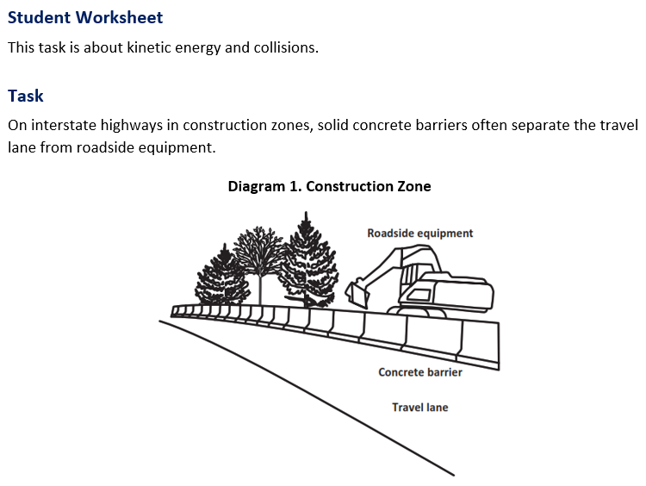
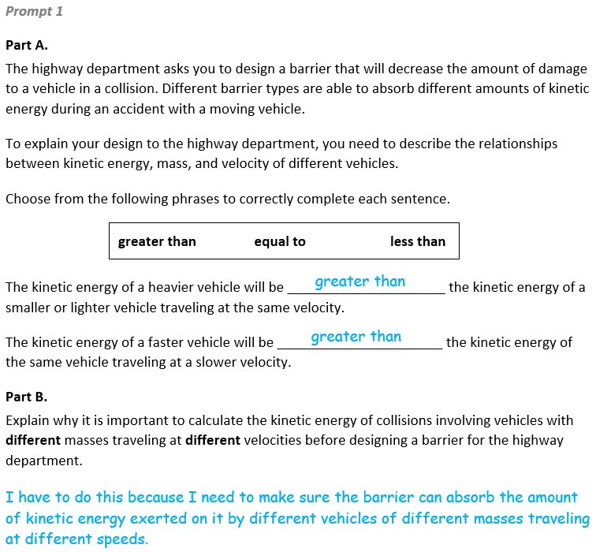
  Task 2 Prompt 1 Parts A and B Complexity
  Degree and Nature of Sensemaking | Low | This prompt…  - Requires one or two dimensions  - One dimension may have a greater degree of emphasis than another  - Requires previously learned ideas or concepts
  Complexity of the Presentation | Low | - The amount and type of information provided in the scenario supports limited simple connections among ideas or concepts  - Phenomenon or problem is presented in a concrete way with high level of certainty
  Cognitive Demand of Response Development | Moderate | - Requires drawing relationships and connecting ideas and practices  - Requires a moderate level of sophistication with typical and relatively complex representation of ideas and application of skills
  Cognitive Demand of Response Production | Moderate | - Responses include one or more sentences or a paragraph, a moderately complex graphic, or multiple steps in a simple or moderately complex process
  Task 2 Prompt 1 Parts A and B
  Connections to the Instructional Framework
  Integration of Knowledge and Skills for Response Development
  - Students read the prompt and review the graphic.
  - Students utilize what they know about kinetic energy, such as that it is proportional to the mass of the moving object and grows with the square of its speed.
  - Students recognize these proportional relationships to correctly complete each sentence, indicating “greater than” for both statements.
  - Students describe that it is necessary to collect different values of velocities and masses of vehicles to ensure that the barrier can absorb different amounts of kinetic energy.
  Formative Assessments | Opportunities to Learn
  Segment 3, pp. 15-16  Informal Assessment: Modeling Kinetic Energy and its Relation to Mass and Speed (A13*, A14, A15*)  - Students develop a model for the relationship of kinetic energy with mass and speed from available scientific principles and data. | Segment 3, pp. 31-32  Investigating How Speed and Mass Affect the Motion and Energy of an Object (A13*, A14, A15)  - Students learn that colliding objects possess energy which is released in different forms during the collision.  - After collecting the data, students graph their data in a scatter plot. They find a linear relationship between mass and energy.
  Task 2 Prompt 1 Parts A and B
  Connections to the Instructional Framework, Continued
  Formative Assessments | Opportunities to Learn
  Segment 3, pp. 16-17  Formal Assessment: Kinetic Energy vs. Mass/Speed Investigation (A13*, A14, A15*)  - Students construct an argument supported by empirical evidence and scientific reasoning that increasing the object’s mass results in a directly proportional increase of the object’s kinetic energy.  - Students construct an argument supported by empirical evidence and scientific reasoning that increasing the object’s speed results in an increase of the object’s kinetic energy proportional to the square of its speed.  - Students identify the purpose of the investigation, which includes providing evidence to describe the relationship between kinetic energy and mass and/or speed. | Segment 3, p. 32  Moving Energy (A13*, A14)  - Using stations, students engage with multiple short hands-on activities, videos, reading passages, and other media to explore the relationship between mass and kinetic energy.
Task 2 Prompt 1 Parts A and B
Connections to the Instructional Framework, Continued
Formative Assessments | Opportunities to Learn
Segment 3, pp. 17-18  Formal Assessment: Graphing KE vs. Mass and KE vs. Speed (A14, A15)  - Students construct an argument supported by empirical evidence and scientific reasoning that increasing the object’s mass results in a directly proportional increase of the object’s kinetic energy.  - Students construct an argument supported by empirical evidence and scientific reasoning that increasing the object’s speed results in an increase of the object’s kinetic energy proportional to the square of its speed.  - Students interpret data to compare the relationship between kinetic energy and mass to the relationship between speed and kinetic energy. | Segment 3, pp. 32-33  Modeling Kinetic Energy (A13*, A14, A15*)  - Students create a set of models that demonstrate the relationship between mass and kinetic energy, and the relationship between speed and kinetic energy. Students’ models are informed by their data and data analysis from prior investigations in this unit.  - Students are tasked with creating two models and using their models to make new predictions. They assess how their model demonstrates the relationship of mass, speed, and kinetic energy in a similar scenario.

Prompt 2 – Parts A, B, and C  Performance Category: Analyze Data to Describe Interactions Between Objects  Acquisition Goals  - A14. Construct an argument supported by empirical evidence and scientific reasoning about the relationship between mass and kinetic energy in order to support or refute an explanation or model.*  - A15. Construct and interpret graphical displays of data to describe the relationships of kinetic energy to the mass of an object and to the speed of an object. [MS-PS3-1]  Prompt 2 Parts A, B, and C measure students’ ability to:  - Analyze and interpret data and graphs to support conclusions about the relationship of kinetic energy to the mass of an object.  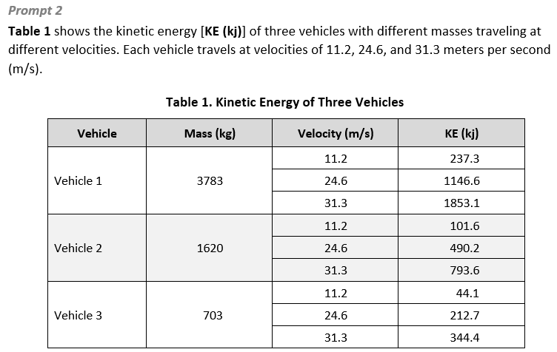 |  | 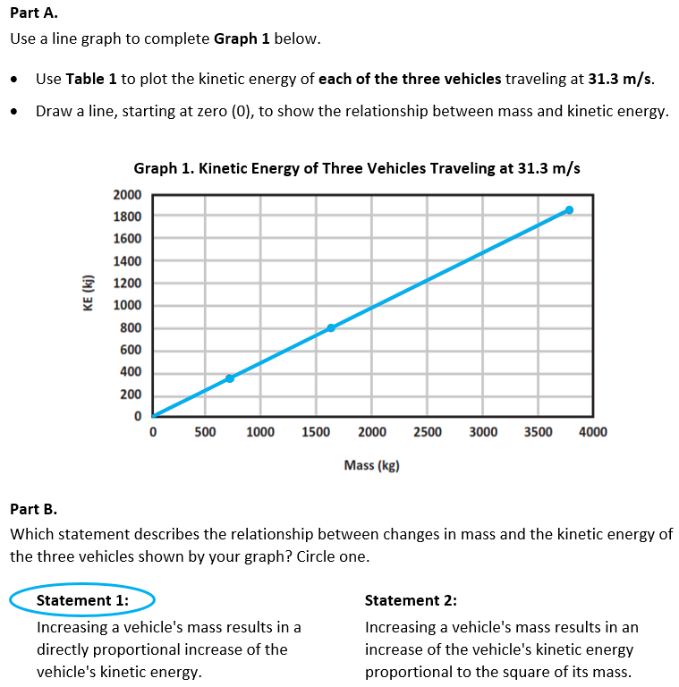
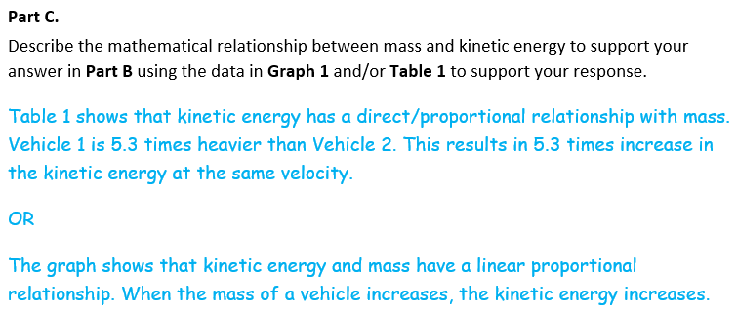
  Task 2 Prompt 2 Parts A, B, and C Complexity
  Degree and Nature of Sensemaking | Moderate | This prompt…  - Requires integration of two dimensions in the service of sensemaking  - Requires a combination of previously learned ideas or concepts and newly presented information
  Complexity of the Presentation | Moderate | - The amount and type of information provided in the scenario supports multiple evident connections among ideas or concepts  - Provides simple graphics/data/models
  Cognitive Demand of Response Development | Moderate | - Response requires a moderate  level of sophistication with  typical but relatively complex  representation of ideas and  application of skills
  Cognitive Demand of Response Production | Moderate | - Response includes one or more sentences or a paragraph, a moderately complex graphic, or multiple steps in a simple or moderately complex process
  Task 2 Prompt 2 Part A, B, and C
  Connections to the Instructional Framework
  Integration of Knowledge and Skills for Response Development
  - In Part A, students refer to Table 1 and construct a graphical display of data, plotting the kinetic energy of each of the three vehicles. Next, students draw a line to show the relationship between mass and kinetic energy.
  - In Part B, students rely on their definitions of energy to answer Part B, recognizing that motion energy is called kinetic energy, and that it is proportional to the mass of the moving object and grows with the square of its speed. Therefore, students circle Statement 1.
  - In Part C, students apply their understanding of proportional relationships among different types of quantities and linear and nonlinear relationships to explain that Table 1 shows a linear or proportional relationship between kinetic energy and mass.
  Formative Assessments | Opportunities to Learn
  Segment 3, pp. 15-16  Informal Assessment: Modeling Kinetic Energy and its Relation to Mass and Speed (A14, A15*)  - Students describe the relationship between model elements by characterizing a pattern that shows when the mass of an object increases/ decreases the KE increases/ decreases (linearly).  - Students identify elements of a model that characterize the relationship between KE and the mass of an object (KE ∝ m). | Segment 3, p. 32  Moving Energy (A14)  - Using stations, students engage with multiple short hands-on activities, videos, reading passages, and other media to explore the relationship between mass and kinetic energy.
  Task 2 Prompt 2 Part A, B, and C
  Connections to the Instructional Framework, Continued
  Formative Assessments | Opportunities to Learn
  Segment 3, pp. 16-17  Formal Assessment: Kinetic Energy vs. Mass/Speed Investigation (A14, A15*)  - Students identify the purpose of the investigation, which includes providing evidence to describe the relationship between kinetic energy and mass and/or speed.  - Students identify dependent and independent variables, as well as what variables should be controlled to examine a problem involving the relationship between kinetic energy and mass and/or speed. | Segment 3, pp. 31-32  Investigating How Speed and Mass Affect the Motion and Energy of an Object (A14, A15)  - After conducting the experiment with a constant mass and changing height, students should repeat the process but vary the mass and keep the height constant.  - After collecting the data, students graph their data in a scatter plot. They should find a linear relationship between mass and energy. The teacher facilitates a class discussion where students use evidence from the graph and work to find the pattern.
Task 2 Prompt 2 Part A, B, and C
Connections to the Instructional Framework, Continued
Formative Assessments | Opportunities to Learn
Segment 3, pp. 17-18  Formal Assessment: Graphing KE vs. Mass and KE vs. Speed (A14, A15)  - Students transform data from a table into a graph to show the linear relationship between kinetic energy and the mass of a moving object.  - Students interpret data from a graphical display(s) to characterize and describe a linear relationship between the mass of the moving object and its kinetic energy, which is as the mass of the moving object increases, the kinetic energy increases as a linear relationship.  - Students generate a visual display of data by assigning axes in a graphical display that characterize a relationship that kinetic energy is different among moving objects of different mass. | Segment 3, pp. 32-33  Modeling Kinetic Energy (A14, A15*)  - Students create a set of models that demonstrate the relationship between mass and kinetic energy, and the relationship between speed and kinetic energy. Students’ models are informed by their data and data analysis from prior investigations in this unit.  - Students are tasked with creating two models and using their models to make new predictions. They assess how their model demonstrates the relationship of mass, speed, and kinetic energy in a similar scenario.

Prompt 3 – Parts A, B, and C  Performance Categories: Analyze Data to Describe Interactions Between Objects  Acquisition Goals:  - A15. Construct and interpret graphical displays of data to describe the relationships of kinetic energy to the mass of an object and to the speed of an object. [MS-PS3-1]  Prompt 3 Parts A, B, and C measure students’ ability to:  - Analyze and interpret data and graphs to support conclusions about the relationship of kinetic energy to the speed of an object.  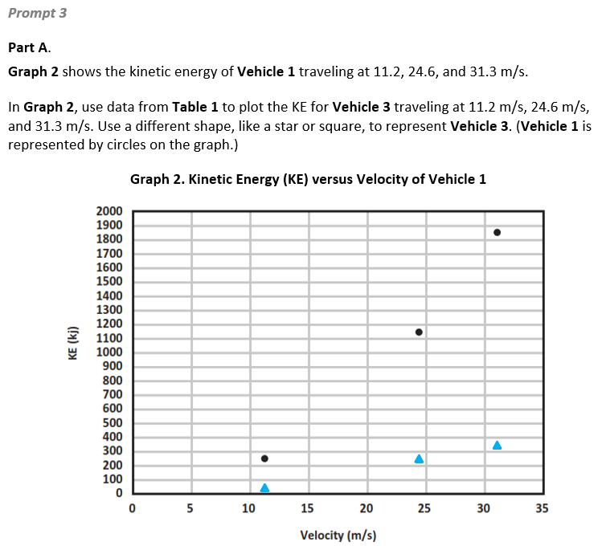 |  | 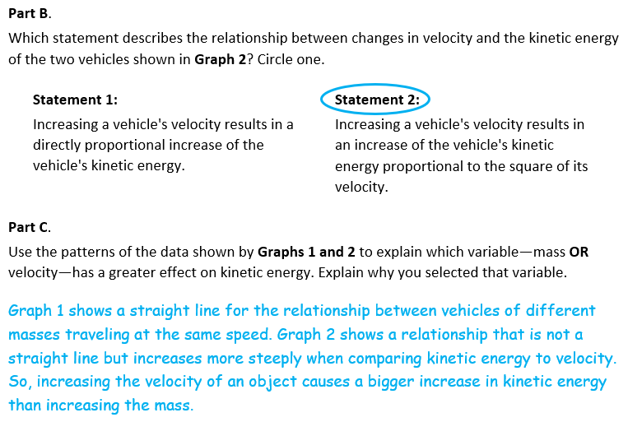
  Task 2 Prompt 3 Parts A, B, and C Complexity
  Degree and Nature of Sensemaking | Moderate | This prompt…  - Requires integration of two dimensions in the service of sensemaking  - Requires a combination of previously learned ideas or concepts and newly presented information
  Complexity of the Presentation | Moderate | - The amount and type of information provided in the scenario supports multiple evident connections among ideas or concepts  - Provides simple graphics/data/models
  Cognitive Demand of Response Development | Moderate | - Response requires a moderate  level of sophistication with  typical but relatively complex  representation of ideas and  - application of skills
  Cognitive Demand of Response Production | Moderate | - Response includes one or more sentences or a paragraph, a moderately complex graphic, or multiple steps in a simple or moderately complex process
  Task 2 Prompt 3 Parts A, B, and C
  Connections to the Instructional Framework
  Integration of Knowledge and Skills for Response Development
  - In Part A, students refer to Table 1 and construct a graphical display of data, plotting the kinetic energy for Vehicle 3 traveling at three different speeds.
  - In Part B, students rely on their definitions of energy to answer Part B, recognizing that motion energy is called kinetic energy, and that it is proportional to the mass of the moving object and grows with the square of its speed. Therefore, students circle Statement 2.
  - In Part C, students apply their understanding of proportional relationships among different types of quantities and linear and nonlinear relationships to explain that Graph 1 shows a straight line of vehicles traveling at the same speed and Graph 2 does not show a straight line, so increasing the velocity of an object causes a bigger increase in kinetic energy than increasing the mass.
  Formative Assessments | Opportunities to Learn
  Segment 3, pp. 15-16  Informal Assessment: Modeling Kinetic Energy and its Relation to Mass and Speed (A15*)  - Students identify the elements of a model that characterize the relationship between kinetic energy and the speed of a moving object (KE ∝ v2).  - Students describe the relationship between model elements by characterizing a pattern that shows when the speed of an object increases/decreases the kinetic energy increases/ decreases by the square of the speed. | Segment 3, pp. 31-32  Investigating How Speed and Mass Affect the Motion and Energy of an Object (A15)  - After conducting the experiment with a constant mass and changing height, students repeat the process but vary the mass and keep the height constant.  - After collecting the data, students graph their data in a scatter plot. They find a linear relationship between mass and energy. The teacher facilitates a class discussion where students use evidence from the graph and work to find the pattern.
  Task 2 Prompt 3 Parts A, B, and C
  Connections to the Instructional Framework, Continued
  Formative Assessments | Opportunities to Learn
  Segment 3, pp. 16-17  Formal Assessment: Kinetic Energy vs. Mass/Speed Investigation (A15*)  - Students identify the purpose of the investigation, which includes providing evidence to describe the relationship between kinetic energy and mass and/or speed.  - Students identify dependent and independent variables, as well as what variables should be controlled to examine a problem involving the relationship between kinetic energy and mass and/or speed.  - Students construct an argument supported by empirical evidence and scientific reasoning that increasing the object’s speed results in an increase of the object’s kinetic energy proportional to the square of its speed. | Segment 3, pp. 32-33  Modeling Kinetic Energy (A15*)  - Students create a set of models that demonstrate the relationship between mass and kinetic energy, and the relationship between speed and kinetic energy. Students’ models are informed by their data and data analysis from prior investigations in this unit.  - Students are tasked with creating two models and using their models to make new predictions. They assess how their model demonstrates the relationship of mass, speed, and kinetic energy in a similar scenario.
  Task 2 Prompt 3 Parts A, B, and C
  Connections to the Instructional Framework, Continued
  Formative Assessments | Opportunities to Learn
  Segment 3, pp. 17-18
  Formal Assessment: Graphing KE vs. Mass and KE vs. Speed (A15)
  - Construct an argument supported by empirical evidence and scientific reasoning that increasing the object’s speed results in an increase of the object’s kinetic energy proportional to the square of its speed.
  - Interpret data to compare the relationship between kinetic energy and mass to the relationship between speed and kinetic energy.
Prompt 4 – Parts A and B  Performance Categories: Design the Best Solution to a Problem Involving Energy, Forces, and Motion  Acquisition Goals:  - A1. Design a solution to a problem that utilizes the fact that when two objects interact, they exert a force on each other in opposite directions.  - A4. Construct an explanation that describes the relationship between force and motion to describe phenomena.  - A13. Apply the scientific idea of kinetic energy (energy of motion) to design an object, tool, process, or system.  Prompt 4 Parts A and B measure students’ ability to:  - Design a solution to a problem based on forces and the objects involved by making comparisons between the rate of change between mass and kinetic energy, speed and kinetic energy, and the forces involved in a collision. |  | 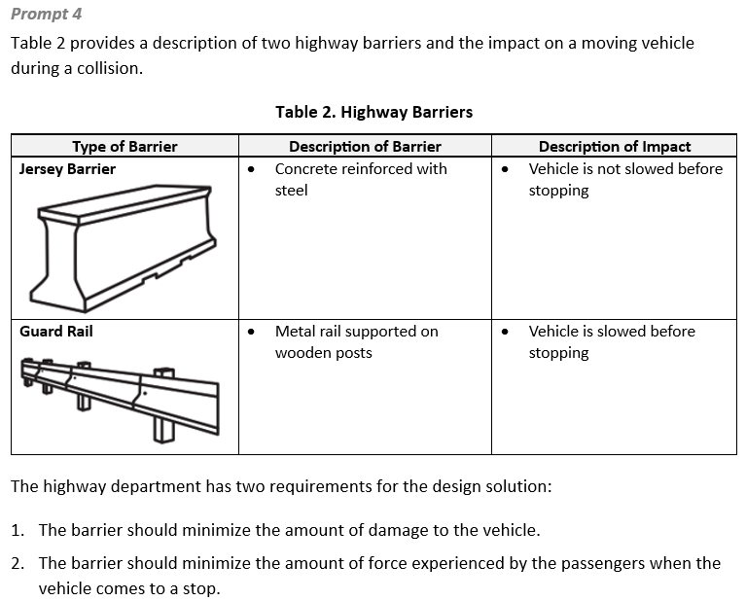  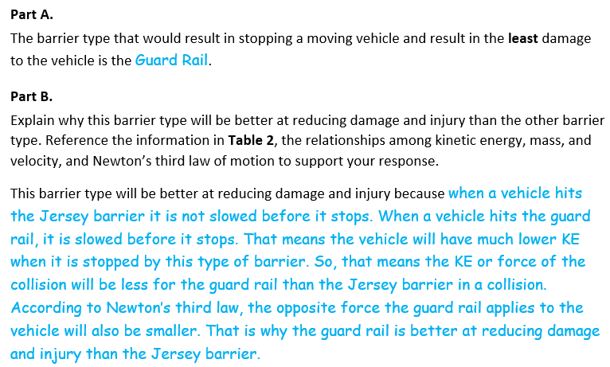
  Task 2 Prompt 4 Part A Complexity
  Degree and Nature of Sensemaking | Moderate | This prompt…  - Requires integration of two dimensions in the service of sense-making
  Complexity of the Presentation | Moderate | - The amount and type of information provided in the scenario supports multiple evident connections among ideas or concepts  - Provides simple graphics/data/models
  Cognitive Demand of Response Development | High | - Requires selection and application of multiple complex ideas and practices  - Requires high degree of sensemaking, reasoning, and/or transfer  - Response requires a high level of sophistication with non-routine or abstract representation of ideas and application of skills
  Cognitive Demand of Response Production | High | - Responses include multiple paragraphs, multiple graphics of at least moderate complexity, or multiple steps in a complex process
  Task 2 Prompt 4 Parts A and B
  Connections to the Instructional Framework
  Integration of Knowledge and Skills for Response Development
  - Students refer to Table 2 and the requirements from the highway department for the design solution.
  - Students rely on their definitions of energy to answer Part A, choosing Guard Rail as the barrier because the vehicle is slowed before stopping.
  - Students apply their understanding of forces and the objects involved by making comparisons between the rate of change between mass and KE, speed and KE, and the forces involved in a collision.
  - In Part B, students construct an explanation that compares the impact velocity of a vehicle when stopped by each barrier type and explains the relationship between velocity and KE. Students also explain the relationship of KE to the forces involved in the collision as related to Newton’s third law.
  Formative Assessments | Opportunities to Learn
  Segment 3, pp. 19-20  Formal Assessment: Racing Ahead (A13)  - Students design and present a prototype design solution that addresses appropriate scientific ideas in the context of the problem that involves KE.  - Students describe how their design solution uses scientific principles of kinetic energy (and its relation to mass and speed) to satisfy the problem's criteria and constraints. | Segment 3, pp. 32-33  Modeling Kinetic Energy (A13*)  - Students create a set of models that demonstrate the relationship between mass and kinetic energy, and the relationship between speed and kinetic energy. Students’ models are informed by their data and data analysis from prior investigations in this unit.  - Students create two models and use their models to make new predictions. They assess how their model demonstrates the relationship of mass, speed, and kinetic energy in a similar scenario.
Task 2 Prompt 4 Parts A and B
Connections to the Instructional Framework, Continued
Formative Assessments | Opportunities to Learn
Segment 4, pp. 23-24  Formal Assessment: Designing Solutions to a Problem Involving a Collision (A1, A4, A13)  - Students design a solution to optimize material selection (minimize force in the collision & minimize cost).  - Students apply Newton’s third law of motion to justify and identify the best design and to provide justification for the selection based on the application of Newton’s third law of motion when provided a description of a physical situation involving a collision between two objects and a list of multiple designs with given criteria. | Segment 3, p. 33  Revising Our Explanation (A1*, A13*)  - Students revisit their revised explanation concerning the anchoring phenomenon.  - Students revise their explanation of the event and consider what could be done to limit the energy and energy transfer in the impact. Students use what they have learned about kinetic energy to inform their explanation. For example, identifying ways in KE is transferred to other sources and the effects of the collision are reduced.  Segment 4, p. 35  Applying Understanding of Forces and Kinetic Energy to Design a Project (A1)  - Students design a prototype that meets various constraints to address an engineering problem: protecting an egg as it collides with Earth.  - Students test and refine their prototype before writing an explanation about which prototype is best and why.

Future Learning Connected to evidence elicited in Task 2
Crosscutting Concepts
- In Unit 1, crosscutting concepts of Scale, Proportion, and Quantity, System and System Models, and Stability and Change serve as organizing concepts for the DCIs. In Unit 2, students will explore Earth’s place in the solar system and galaxy by developing models representing time, space, and energy phenomena at various scales using models to study systems that are very large and explain phenomena observed at one scale that may not be observable at another scale. Acquisition Goal 2 requires students to support a claim that human-scale objects do not exert strong (observable) gravitational force. Students leverage prior knowledge about scale models representing systems to learn that time, space, and energy phenomena can be observed using scale models to study systems that are too large or too small (Lumpy Space? Empty Space? Why is Our Universe the Way it is, pp. 34-35).
Disciplinary Core Ideas
- In Unit 1, students learn about forces and energy, helping to prepare students to explain phenomena in later units on waves, mechanisms of diversity, and Earth’s place in the Universe. Examining the changes in velocity and the masses of the objects allows students to develop explanations of the proportional relationships of energy, mass, and velocity. Knowing how objects in motion possess energy and how contact and non-contact forces (i.e., electric, magnetic, and gravitational) cause objects to move, accelerate, decelerate, stop, or change directions will help students build an understanding of concepts in Unit 2 where students will learn about the Earth/sun/moon system and the solar system and the role of gravitational forces in determining the motions with these systems. In Unit 2, Acquisition Goal 9 requires students to Use a model of the Earth/sun system to show how different hemispheres will experience different amounts of sunlight during the orbit of Earth around the sun. Students leverage prior knowledge of energy and motion to understand gravity and our solar system. (Develop and Use Models of Earth’s Tilt and Seasons, p. 15)
Science and Engineering Practices
- In Unit 1, students plan and carry out investigations. The SEP Planning and Carrying Out Investigations may include elements of all of the other practices. In Unit 1, students understand that data are not evidence until used in the process of supporting a claim or an argument. In Unit 2, students will use reasoning and scientific ideas, principles, and theories to show why data can be considered evidence to support arguments relating to gravitational forces, cyclical patterns in the Earth-sun-moon system, or to support or refute an argument based on a model of a phenomenon in the universe. Also, in Unit 1, investigations provide empirical evidence that is examined by analyzing and interpreting data related to forces, motion, and energy. In Unit 2, the SEP of Analyzing and Interpreting Data is important in using evidence and observable patterns to construct and support arguments related to different aspects of how gravitational forces interact with objects in the solar system.

SIPS Grade 8 Unit 1 EOU Assessment Task 3: Roller Coaster Thrills  Prompt 1 – Parts A and B  Performance Categories: Support Arguments About Interactions Between Objects, Forces, and Energy  Acquisition Goals:  - A18. Develop and/or revise a model to show the relationships between mass and gravitational force.*  - A21. Apply the principle that gravitational force between objects depends on mass and distance in order to design a process or system.  Prompt 1 Parts A and B measure students’ ability to:  - Support an argument with evidence, data, or a model to explain a scenario related to the relationship of mass to the magnitude of gravitational force.  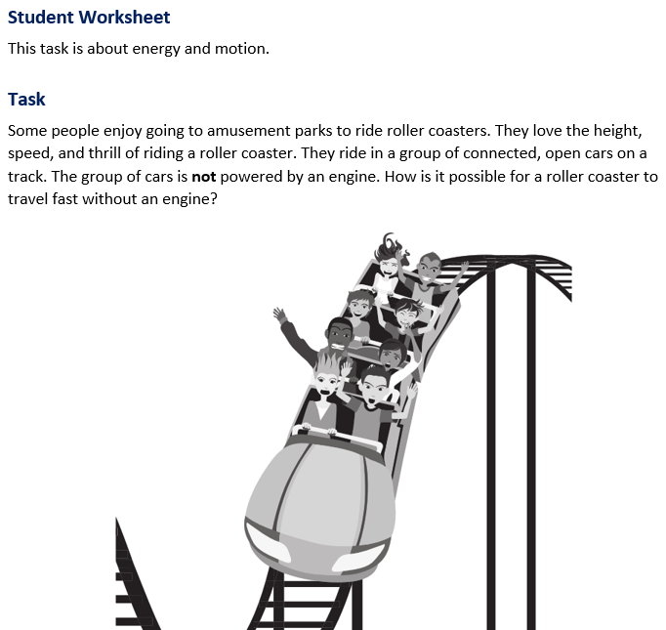 |  | 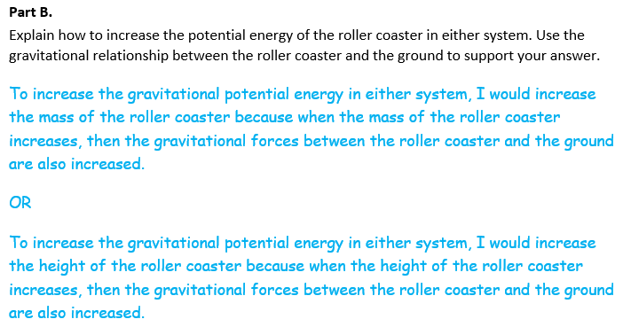  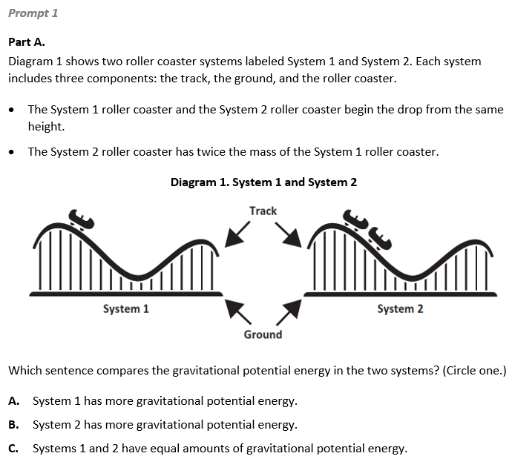
  Task 3 Prompt 1 Parts A and B Complexity
  Degree and Nature of Sensemaking | Moderate | This prompt…  - Requires integration of two dimensions in the service of sense-making
  Complexity of the Presentation | Moderate | - The amount and type of information provided in the scenario supports multiple evident connections among ideas or concepts  - Provides graphics/data/models
  Cognitive Demand of Response Development | Moderate | - Requires drawing relationships and connecting ideas and practices  - Requires a moderate level of sophistication with typical and relatively complex representation of ideas and application of skills
  Cognitive Demand of Response Production | Low | - Responses include selection  from a small set of options  presented as text (e.g., word,  short phrase) or other formats  (e.g., a simple graphic or  process)
  Task 3 Prompt 1 Parts A and B
  Connections to the Instructional Framework
  Integration of Knowledge and Skills for Response Development
  - Students refer to Diagram 1 and compare two roller coaster systems.
  - Students recall that models can be used to represent systems and their interactions and energy and matter flow within systems.
  - Students identify System 2 as having more gravitational potential energy because it has twice the mass as the System 1 roller coaster. Students circle B.
  - Students apply the principle that gravitational force between objects depends on mass and distance to explain that the potential energy of either system increases if the mass or height of the roller coaster increases.
  Formative Assessments | Opportunities to Learn
  Segment 4, p. 20  Informal Assessment: Modeling Gravitational Interactions (A18, A21*)  - Students use models to support the claim that gravitational interactions are attractive and depend on the masses of interacting objects.  - Students develop and/or use models to describe the relationships among mass, distance, and gravitational force. | Segment 4, p. 34  Simulating Gravity (A18)  - Students generate a theory about factors that impact gravity. Students choose a variable (mass or distance) to explore and write a predicted relationship to be tested. Students compare their investigation plans with each other and receive feedback on their selection of variables and planned evidence to collect.  - Students conduct their investigation and graph the results. Students compare results and make and defend claims about the relationship between the force of gravity, mass, and distance.
Task 3 Prompt 1 Parts A and B
Connections to the Instructional Framework, Continued
Formative Assessments | Opportunities to Learn
Segment 4, p. 21  Formal Assessment: Constructing and Presenting Arguments about Gravitational Interactions (A21*)  - Students construct a sound argument that contains a claim, evidence from the data provided, and reasoning that links the evidence/data to the claim that as mass increases, the magnitude of gravitational force increases.  - Students identify evidence/data that supports a claim regarding the relationship between the mass of objects interacting via gravitational forces, the magnitude of that force, and its direction.  - Students select the appropriate reasoning based on relevant scientific concepts that explains why the data provided supports a claim regarding the relationship between the mass of objects interacting via gravitational forces, the magnitude of that force, and its direction. | Segment 4, pp. 34-35  Revising Our Explanation (A21)  - Students revisit their revised explanation concerning the problem presented in the anchoring phenomenon: reducing the impact of the ball. Students use the SEP of constructing explanations and designing solutions to revise their explanation of the event and consider how the force of gravity is involved in the collision.  Segment 4, p. 35  Applying Understanding of Forces and Kinetic Energy to a Design Project (A21)  - Students create a prototype for an engineering design challenge with design constraints such as materials, size, weight, cost, etc. Students present their prototype using information from the unit.

Prompt 1 – Part C  Performance Categories: Support Arguments About Interactions Between Objects, Forces, and Energy  Acquisition Goals:  - A14. Construct an argument supported by empirical evidence and scientific reasoning about the relationship between mass and kinetic energy in order to support or refute an explanation or model.  - A23. Develop and/or use a model to predict how the kinetic energy of an object changes when its mass and/or speed changes.  Prompt 1 Part C measures the student’s ability to:  - Support an argument with evidence, data, or a model to explain a scenario related to the mathematical relationship between kinetic energy and mass.  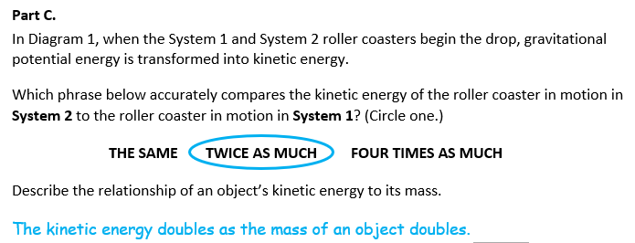
  Task 3 Prompt 1 Part C Complexity
  Degree and Nature of Sensemaking | Moderate | This prompt…  - Requires integration of two dimensions in the service of sense-making
  Complexity of the Presentation | Low | - The amount and type of information provided in the scenario supports limited simple connections among ideas or concepts  - Phenomenon or problem is presented in a concrete way with high level of certainty
  Cognitive Demand of Response Development | Low | - Requires well-defined set of actions or procedures  - Requires a connection or retrieval of factual information  - Response requires a low level of sophistication with routinely encountered well-practiced applications
  Cognitive Demand of Response Production | Moderate | - Responses include one or more sentences or a paragraph, a moderately complex graphic, or multiple steps in a simple or moderately complex process
  Task 3 Prompt 1 Part C
  Connections to the Instructional Framework
  Integration of Knowledge and Skills for Response Development
  - Students refer back to Diagram 1 to compare the kinetic energy of the roller coaster in motion in System 2 to System 1.
  - Students use what they know about definitions of energy and proportional relationships to determine that System 2 has twice the kinetic energy as System 1 because it has twice the mass.
  - Students construct an explanation that states that as mass doubles, KE doubles or that there is a direct relationship between KE and mass.
  Formative Assessments | Opportunities to Learn
  Segment 3, pp. 15-16  Informal Assessment: Modeling Kinetic Energy and its Relation to Mass and Speed (A14, A23)  - Students articulate a prediction for the kinetic energy of an object, based on data patterns that highlight the relationship that kinetic energy is linearly proportional to mass and that kinetic energy is proportional to the square of the speed of a moving object.  Segment 3, pp. 16-17  Formal Assessment: Kinetic Energy vs. Mass/Speed Investigation (A14)  - Students construct an argument supported by empirical evidence and scientific reasoning that increasing the object’s mass results in a directly proportional increase of the object’s kinetic energy. | Segment 3, p. 32  Moving Energy (A14)  - Students engage with multiple short hands-on activities, videos, reading passages, and other media to explore the relationship between mass and kinetic energy.  Segment 3, pp. 32-33  Modeling Kinetic Energy (A14, A23)  - Students create a set of models that demonstrate the relationship between mass and kinetic energy, and the relationship between speed and kinetic energy. Students’ models are informed by their data and data analysis from prior investigations in this unit.  - Students use their models to make new predictions about mass, speed, and kinetic energy in a similar scenario.
  Task 3 Prompt 1 Part C
  Connections to the Instructional Framework, Continued
  Formative Assessments | Opportunities to Learn
  Segment 3, pp. 17-18  Formal Assessment: Graphing KE vs. Mass and KE vs. Speed (A14)  - Students construct an argument supported by empirical evidence and scientific reasoning that increasing the object’s mass results in a directly proportional increase of the object’s kinetic energy.  Segment 3, pp. 18-19  Formal Assessment: Modeling Kinetic Energy (A23)  - Students describe the relationship between model elements by characterizing a pattern that shows when the mass of an object increases/decreases the kinetic energy increases/decreases (linearly). | Segment 3, pp. 33-34  Revising Our Explanation (A23*)  - Students revisit their revised explanation concerning the anchoring phenomenon. Students revise their explanation of the event and consider what could be done to limit the energy and energy transfer in the impact. Students should use what they have learned about kinetic energy to inform their explanation. For example, identifying ways in which kinetic energy is transferred to other sources and the effects of the collision are reduced. Students share their current thinking with peers, give each other feedback, and revise their explanations based on the feedback.
Prompt 2  Performance Categories: Support Arguments About Interactions Between Objects, Forces, and Energy  Acquisition Goals:  - A18: Develop and/or revise a model to show the relationships between mass and gravitational force. *  - A22: Construct and present arguments using evidence to support the claim that gravitational interactions are attractive and depend on the masses of interacting objects. [MS-PS2-4]  Prompt 2 measures students’ ability to:  - Support an argument with evidence, data, or a model to explain a scenario related to gravitational interactions between and the relative mass of the objects to what is observed.  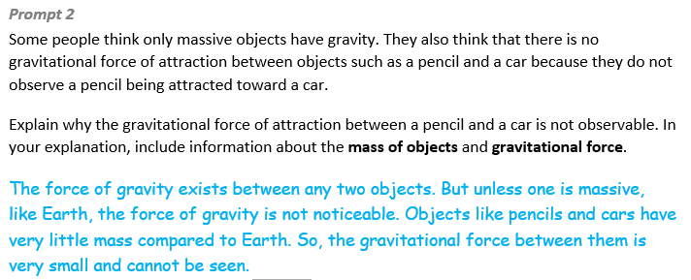
  Task 3 Prompt 2 Complexity
  Degree and Nature of Sensemaking | Moderate | This prompt…  - Requires integration of two dimensions in the service of sense-making
  Complexity of the Presentation | Low | - The amount and type of information provided in the scenario supports limited simple connections among ideas or concepts  - Phenomenon or problem is presented in a concrete way with high level of certainty
  Cognitive Demand of Response Development | Moderate | - Requires drawing relationships and connecting ideas and practices  - Requires a moderate level of sophistication with typical and relatively complex representation of ideas and application of skills
  Cognitive Demand of Response Production | Moderate | - Responses include one or more  sentences or a paragraph, a  moderately complex graphic, or multiple steps in a simple or  moderately complex process
  Task 3 Prompt 2
  Connections to the Instructional Framework
  Integration of Knowledge and Skills for Response Development
  - Students read Prompt 2 and familiarize themselves with the phenomena of gravitational force of attraction not always being observable.
  - Students recall what they know about types of interactions—that gravitational forces are always attractive, and some effects of gravitational interactions may only be observable in interactions between very massive objects.
  - Students construct a written argument supported by scientific reasoning to support an explanation for the phenomenon, stating that because the gravitational attraction is so large between an object and the Earth, the attraction between smaller objects is not observed.
  Formative Assessments | Opportunities to Learn
  Segment 4, pp. 20-21  Informal Assessment: Modeling Gravitational Interactions (A18, A22*)  - Students develop and/or use models to describe that gravitational force is always attractive.  - Students use models to support the claim that gravitational interactions are attractive and depend on the masses of interacting objects. | Segment 4, p. 34  Simulating Gravity (A18, A22)  - Students generate a theory about factors that impact gravity. Students choose a variable (mass or distance) to explore and write a predicted relationship to be tested. Students compare their investigation plans with each other and receive feedback on their selection of variables and planned evidence to collect.  - Students conduct their investigation and graph the results. Students compare results and make and defend claims about the relationship between the force of gravity, mass, and distance.
  Task 3 Prompt 2
  Connections to the Instructional Framework, Continued
  Formative Assessments | Opportunities to Learn
  Segment 4, p. 21  Formal Assessment: Constructing and Presenting Arguments about Gravitational Interactions (A22)  - Students construct a sound argument that contains a claim, evidence from the data provided, and reasoning that links the evidence/data to the claim that as mass increases, the magnitude of gravitational force increases.  - Students identify evidence/data that supports a claim regarding the relationship between the mass of objects interacting via gravitational forces, the magnitude of that force, and its direction.  - Students select the appropriate reasoning based on relevant scientific concepts that explains why the data provided supports a claim regarding the relationship between the mass of objects interacting via gravitational forces, the magnitude of that force, and its direction. | Segment 4, pp. 34-35  Revising Our Explanation (A22)  - Students revisit their revised explanation concerning the problem presented in the anchoring phenomenon: reducing the impact of the ball. Students use the SEP of constructing explanations and designing solutions to revise their explanation of the event and consider how the force of gravity is involved in the collision.
Prompt 3  Performance Categories: Analyze Data to Describe Interactions Between Objects  Acquisition Goals:  - A15. Construct and interpret graphical displays of data to describe the relationships of kinetic energy to the mass of an object and to the speed of an object. [MS-PS3-1]  Prompt 3 measures students’ ability to:  - Analyze and interpret data and graphs to support conclusions about the relationship between the height of an object (gravitational potential energy) and the transformation into kinetic energy as the object falls to the ground.  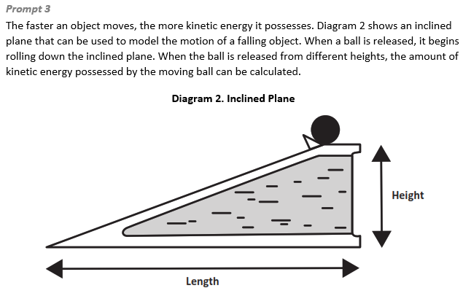 |  | 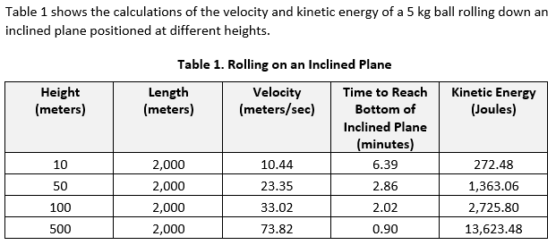  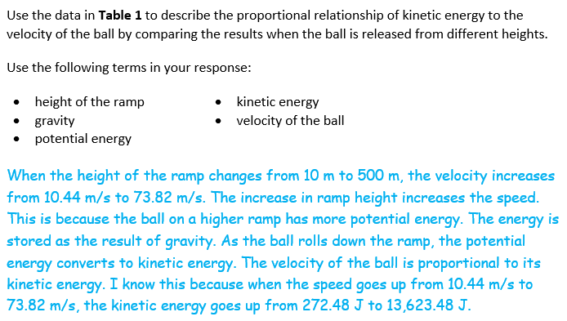
  Task 3 Prompt 3 Complexity
  Degree and Nature of Sensemaking | Moderate | This prompt…  - Requires integration of two dimensions in the service of sensemaking
  Complexity of the Presentation | High | - The amount and type of information provided in the scenario supports multiple and varied complex connections among ideas or concepts  - Provides complex graphics/data/models  - Phenomenon or problem presented with high-degree of uncertainty
  Cognitive Demand of Response Development | Moderate | - Requires application of ideas and practices given cues and guidance  - Requires drawing relationships and connecting ideas and practices  - Response requires a moderate level of sophistication with typical but relatively complex representation of ideas and application of skills
  Cognitive Demand of Response Production | Moderate | - Responses include one or more  sentences or a paragraph, a  moderately complex graphic, or multiple steps in a simple or  moderately complex process
  Task 3 Prompt 3
  Connections to the Instructional Framework
  Integration of Knowledge and Skills for Response Development
  - Students use Diagram 2 to represent the system of the inclined plane and its interactions, such as outputs and processes. Through prior learning, students know that energy and matter flow within systems.
  - Students refer to Table 1 to compare the proportional relationship between kinetic energy and velocity of the ball when the ball is released from different heights.
  - Students construct an explanation supported by scientific reasoning to answer the question. Students state in their explanation that the higher ramp has more potential gravitational force and the potential energy is converted into kinetic energy as the ball rolls. In their explanation, students use data from Table 1 and refer to the proportional relationship between kinetic energy and velocity.
  Formative Assessments | Opportunities to Learn
  Segment 3, pp. 15-16  Informal Assessment: Modeling Kinetic Energy and its Relation to Mass and Speed (A15*)  - Students articulate a prediction for the kinetic energy of an object, based on data patterns that highlight the relationship that kinetic energy is linearly proportional to mass and that kinetic energy is proportional to the square of the speed of a moving object. | Segment 3, p. 31  Investigating How Speed and Mass Affect the Motion and Energy of an Object (A15)  - After conducting the experiment with a constant mass and changing height, students repeat the process but vary the mass and keep the height constant.  - After collecting the data, students graph their data in a scatter plot. They find a linear relationship between mass and energy. The teacher facilitates a class discussion where students use evidence from the graph and work to find the pattern.
Task 3 Prompt 3
Connections to the Instructional Framework, Continued
Formative Assessments | Opportunities to Learn
Segment 3, pp. 17-18  Formal Assessment: Graphing KE vs. Mass and KE vs. Speed (A15)  - Students interpret data to compare the relationship between kinetic energy and mass to the relationship between speed and kinetic energy.  - Students construct an argument supported by empirical evidence and scientific reasoning that increasing the object’s speed results in an increase of the object’s kinetic energy proportional to the square of its speed. | Segment 3, pp. 32-33  Modeling Kinetic Energy (A15*)  - Students create a set of models that demonstrate the relationship between mass and kinetic energy, and the relationship between speed and kinetic energy. Students’ models are informed by their data and data analysis from prior investigations in this unit.  - Students use their models to make new predictions about mass, speed, and kinetic energy in a similar scenario.

Prompt 4 – Parts A and B  Performance Categories: Use Experimental Features of an Investigation to Explain Interactions Between Objects  Acquisition Goals:  - A14. Construct an argument supported by empirical evidence and scientific reasoning about the relationship between mass and kinetic energy in order to support or refute an explanation or model.  - A15. Construct and interpret graphical displays of data to describe the relationships of kinetic energy to the mass of an object and to the speed of an object. [MS-PS3-1]  - A23. Develop and/or use a model to predict how the kinetic energy of an object changes when its mass and/or speed changes.  Prompt 3 measures the student’s ability to:  - Identify variables, controls, and what and how much data is needed to construct an explanation to support a claim regarding the relationship between the speed of objects, gravitational forces, and the kinetic energy the objects possess as the reach Earth’s surface. |  | 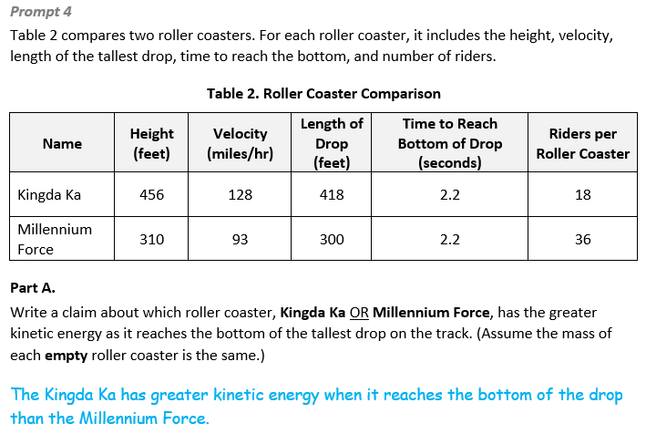  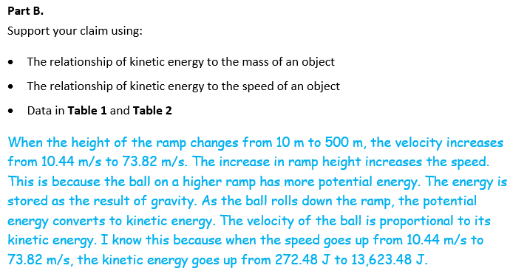
  Task 3 Prompt 4 Parts A and B Complexity
  Degree and Nature of Sensemaking | Moderate | This prompt…  - Requires integration of two dimensions in the service of sensemaking
  Complexity of the Presentation | Moderate | - The amount and type of information provided in the scenario supports multiple evident connections among ideas or concepts  - Provides graphics/data/models  - Limited use of definitions or  examples  - Phenomenon or problem  presented with some level of  uncertainty
  Cognitive Demand of Response Development | High | - Requires selection and application of multiple complex ideas and practices  - Requires high degree of sensemaking, reasoning, and/or transfer  - Response requires a high level of sophistication with non-routine or abstract representation of ideas and application of skills
  Cognitive Demand of Response Production | Moderate | - Responses include one or more  sentences or a paragraph, a  moderately complex graphic, or multiple steps in a simple or  moderately complex process
  Task 3 Prompt 4 Parts A and B
  Connections to the Instructional Framework
  Integration of Knowledge and Skills for Response Development
  - Students refer to Table 2 to compare the rollercoasters.
  - Students identify Kingda Ka as the rollercoaster with the greater kinetic energy in Part A.
  - In Part B, students provide a comparison of KE using the data from Tables 1 and 2.
  - Students provide evidence in their claim that Kingda Ka has a greater kinetic energy than Millennium Force.
  Formative Assessments | Opportunities to Learn
  Segment 3, pp. 16-17  Formal Assessment: Kinetic Energy vs. Mass/Speed Investigation (A14, A15*)  - Students construct an argument supported by empirical evidence and scientific reasoning that increasing the object’s mass results in a directly proportional increase of the object’s kinetic energy.  - Students construct an argument supported by empirical evidence and scientific reasoning that increasing the object’s speed results in an increase of the object’s kinetic energy proportional to the square of its speed. | Segment 3, p. 31  Investigating How Speed and Mass Affect the Motion and Energy of an Object (A14, A15)  - After conducting the experiment with a constant mass and changing height, students repeat the process but vary the mass and keep the height constant.  - Students graph their data in a scatter plot and engage in a discussion of the evidence to find a linear relationship between mass and energy.  Segment 3, p. 32  Moving Energy (A14)  - Students engage with multiple short hands-on activities, videos, reading passages, and other media to explore the relationship between mass and kinetic energy.
Task 3 Prompt 4 Parts A and B
Connections to the Instructional Framework, Continued
Formative Assessments | Opportunities to Learn
Segment 3, pp. 18-19  Formal Assessment: Modeling Kinetic Energy (A23)  - Students describe the relationship between model elements by characterizing a pattern that shows:  - When the mass of an object increases/decreases the kinetic energy increases/decreases (linearly), and  - When the speed of an object increases/decreases the kinetic energy increases/decreases by the square of the speed. | Segment 3, pp. 32-33  Modeling Kinetic Energy (A14, A15*, A23)  - Students create a set of models that demonstrate the relationship between mass and kinetic energy, and the relationship between speed and kinetic energy. Students’ models are informed by their data and data analysis from prior investigations in this unit.  - Students create two models and use their models to make new predictions. They assess how their model demonstrates the relationship of mass, speed, and kinetic energy in a similar scenario.  Segment 3, pp. 33-34  Revising Our Explanation (A23)  - Students revisit and revise their explanation of the anchoring phenomenon and consider what could be done to limit the energy and energy transfer in the impact. Students should use what they have learned about kinetic energy to inform their explanation.

Future Learning Connected to evidence elicited in Task 3
Crosscutting Concepts
- In Unit 1, crosscutting concepts of Scale, Proportion, and Quantity, System and System Models, and Stability and Change serve as organizing concepts for the DCIs. In Unit 1, students use what they know about systems and models to improve their understanding of how the relative masses of objects can lead to very different changes in motion, and how the relationships between kinetic energy and gravitational potential energy. In Unit 2, Acquisition Goal 1 requires students to obtain, evaluate, and/or communicate information that gravitational forces are always attractive. Students leverage prior knowledge about models representing systems to learn that time, space, and energy phenomena can be observed using models to study systems that are too large or too small (The James Webb Space Telescope, p. 25).
Disciplinary Core Ideas
- In Unit 1, students learn that the forces on an object, if unbalanced, cause changes in an object’s motion that depend on the size and direction of the forces and also on the mass of the object. Examining the changes in velocity and the masses of the objects allows students to develop explanations of the proportional relationships of energy, mass, and velocity. In Unit 2, Acquisition Goal 8 requires students to construct an explanation of the relationship between the amount of solar energy in terms of Earth’s position within its orbit around the sun. Students leverage prior knowledge to identify the evidence that supports a claim related to the relationship of the amount of solar energy reaching Earth in terms of Earth’s position within its orbit around the sun. (Develop and Use Models of the Earth-Sun-Moon System, pp. 14-15)
Science and Engineering Practices
- In Unit 1, students plan and carry out investigations. They come to conclusions about forces, interactions, and energy characterized through arguments based on evidence that allow for empirically based statements about different physical laws. These conclusions will provide the basis for constructing explanations of different phenomena and designing solutions to important problems that reflect the role of forces, interactions, and energy in systems that are subject to contact and non-contact forces. The SEP Planning and Carrying Out Investigations may include elements of all of the other practices. In Unit 1, students understand that data are not evidence until used in the process of supporting a claim or an argument. In Unit 2, students will use reasoning and scientific ideas, principles, and theories to show why data can be considered evidence to support arguments relating to gravitational forces, cyclical patterns in the Earth-sun-moon system, or to support or refute an argument based on a model of a phenomenon in the universe.

