Coherence and Alignment Among Science Curriculum, Instruction, and Assessment (CASCIA)  Grade 8 Unit 2  End-of-Unit Assessment  Task Interpretation Guide  March 2025  The Grade 8 Unit 2 End-of-Unit Assessment Task Interpretation Guide was developed with funding from the U.S. Department of Education under the Competitive Grants for State Assessments Program, CFDA 84.368A. The contents of this guide do not represent the policy of the U.S. Department of Education, and no assumption of endorsement by the Federal government should be made. |  |   All rights reserved. Any or all portions of this document may be reproduced and distributed without prior permission, provided the source is cited as: Coherence and Alignment Among Science Curriculum, Instruction, and Assessment (CASCIA) Project. (2025). Grade 8 Unit 2 End-of-Unit Assessment Task Interpretation Guide. Lincoln, NE: Nebraska Department of Education.
Table of Contents
Introduction 1
Purpose 1
Contents 2
SIPS Grade 8 Unit 2 EOU Assessment Task 1: Orbiting Around 3
Task 1 Prompt 1 – Parts A and B 3
Task 1 Prompt 2 – Parts A and B 6
Task 1 Prompt 3 – Parts A and B 9
Task 1 Prompt 3 – Part C 12
SIPS Grade 8 Unit 2 EOU Assessment Task 2: Earth, Moon, and Sun 15
Task 2 Prompt 1 – Parts A, B, and C 15
Task 2 Prompt 2 – Part A 19
Task 2 Prompt 2 – Part B 22
SIPS Grade 8 Unit 2 EOU Assessment Task 3: Earth’s Solar System 25
Task 3 Prompt 1 – Parts A, B, and C 25
Task 3 Prompt 2 – Parts A and B 30
Task 3 Prompt 3 – Part A 33
Task 3 Prompt 3 – Part B 35
Task 3 Prompt 4 – Parts A, B, and C 37

Introduction  The use of formative assessment practices, with informative and immediate feedback that leads to adjustments to instructional next steps, has been shown to be effective in helping students learn (Black & Wiliam, 1998; Wylie & Lyon, 2009; Heritage, 2010). Interim or large-scale summative assessments, such as those required under the Every Student Succeeds Act of 2015 (ESSA), cannot and are not meant to inform daily instruction because of how and when they are administered. These forms of assessment can bring value to an assessment system, but only if coordinated and meaningfully aligned within a comprehensive, coherent system.  The Coherence and Alignment Among Science Curriculum, Instruction, and Assessment (CASCIA) Project brings together three partner states—Nebraska, Alabama, and Alaska—with a team of researchers and experts to establish science assessment resources that are coordinated and aligned across all parts of the assessment system. With coherence as the guiding principle, these state-level educators and national science education and measurement experts have joined with hundreds of local educators to address states’ need for quality, standards-aligned science assessments that generate meaningful, interpretable, and actionable results, and to design a scoring and score reporting framework that builds educators’ capacity to track, interpret, and communicate students’ learning in science and to offer effective instruction for all students.  Purpose  The purpose of the Grade 8 Unit 2 End-of-Unit Assessment Task Interpretation Guide is to support educators’ understanding of the Grade 8 Unit 2 End-of-Unit assessment tasks and prompts, their features, and the evidence (i.e., knowledge and skills) they are designed to elicit about student learning, and how the assessment and the information it provides can be used to plan instruction and learning opportunities for students, whether it involves planning for instruction prior to teaching the instructional unit, reflecting on the quality and sufficiency of prior instruction and instructional materials or planning additional student |  | learning opportunities or interventions in the subsequent unit (e.g., SIPS Unit 3).  The Grade 8 Unit 2 Science Assessment includes three science tasks, each including multiple scorable prompts. Task 1, Orbiting Around, includes three prompts and 12 possible score points, with two prompts having a Part A and Part B and one prompt having a Part A, B, and C; Task 2, Earth, Moon, and Sun includes two prompts and 12 possible score points with one prompt having a Part A, B, and C and one prompt having a Part A and Part B; Task 3, Earth’s Solar System, includes four prompts and 18 possible score points, with two prompts having a Part A, B, and C and two prompts having a Part A and Part B.  Prompts from the three tasks that measure similar combinations of dimensions (i.e., Disciplinary Core Ideas, Science and Engineering Practices, and Crosscutting Concepts) from the Next Generation Science Standards (NGSS) are organized into three performance categories. The NGSS Performance Expectations (PEs) are addressed in one or more performance categories to provide multiple opportunities to demonstrate flexible thinking and competency in different situations and contexts.
  Performance Category | NGSS PEs | Prompts in Performance Category | Points Possible
  Model Relationships Among Objects in Earth’s Solar System | MS-ESS1-1  MS-ESS1-2  MS-ESS1-3 | Task 1, Prompt 1AB  Task 1, Prompt 3AB  Task 2, Prompt 2A  Task 3, Prompt 3A | 13 points
  Support Arguments About Earth’s Place in the Solar System and Universe | MS-ESS1-1  MS-ESS1-2  MS-ESS1-3  MS-PS2-4 | Task 1, Prompt 3C  Task 2, Prompt 1ABC  Task 2 Prompt 2B  Task 3, Prompt 3B  Task 3, Prompt 4 | 16 points
  Analyze Data to Describe Interactions Among Objects in Earth’s Solar System | MS-ESS1-3  MS-PS2-4 | Task 1, Prompt 2AB  Task 3, Prompt 1AB  Task 3, Prompt 1C  Task 3, Prompt 2 | 13 points
Contents  This document includes interpretive guidance to support educators’ understanding of each prompt on the Grade 8 Unit 2 EOU Assessment, its features, and the evidence it is designed to elicit about students’ learning, and offers important connections to the learning goals, formative assessment opportunities, and lesson descriptions within the SIPS Grade 8 Unit 2 Map / Instructional Framework as well as connections to future learning opportunities in the next unit.  For each prompt, the following information is provided:  - Performance Category – A classification of prompts within the EOU based on similarities in knowledge, skills, and abilities for which the prompts were designed to measure.  - Acquisition Goals – Specific goals that describe what students should understand, know, and be able to do at the end of a unit or course of instruction. The acquisition goals are derived from Stage 1 of the unit map / instructional framework that the prompt is intended to measure.  - Prompt Knowledge and Skills for Measurement – The evidence of student learning the prompt is designed to elicit.  - Prompt and Exemplar Response – The prompt consists of one to three sentences that raises an issue or asks a question to which students need to respond. An exemplar response represents a high-quality response that provides evidence that students have demonstrated the knowledge, skills, and abilities assessed by the prompt. Student exemplars are intended to assist in understanding the nature and expectations of the prompt. However, students may respond with other relevant scientifically accurate responses, evidence, observations, and ideas.  In general, a full-point exemplar response meets expectations and is:  - scientifically accurate  - complete  - coherent |  | - consistent with the type of student evidence expected as described in the rubric  For examples of student responses for each prompt representative of the full range of score points possible based on the scoring rubric, access the Grade 8 Unit 2 EOU Assessment Scoring Guide.  - Prompt Complexity – The complexity features of the prompt based on the SIPS Complexity Framework. The sophistication of students’ ability to demonstrate sense-making is characterized by their ability to (a) use disciplinary core ideas (DCIs), scientific and engineering practices (SEPs), and crosscutting concepts (CCCs) together in the service of sense-making about a phenomenon or problem, and (b) engage with and respond to items and tasks designed using variable features representing combinations of Low, Moderate, and High complexity designations. These combinations of features are based on the SIPS Complexity Framework.  Adapted from the Cambridge Alignment Methodology (Forte, 2021) and informed by aspects of Achieve’s Framework to Evaluate Cognitive Complexity in Science Assessments (Achieve, 2019), the SIPS Complexity Framework is grounded in sense-making and students’ ability to flexibly apply knowledge through the integration of the same and new/different combinations of dimensions within the PEs from a unit bundle, in the context of a phenomenon or phenomenon-rooted design problem based on the focal DCIs.  - Prompt Connections to the Unit Map / Instructional Framework – A high-level overview of the evidence elicited by the prompt related to the acquisition goals, connections to the instructionally-embedded formative assessment opportunities within stage 2 of the unit map, and connections to opportunities to learn based on the lesson descriptions within stage 3 of the unit map.  For each of the three tasks, the following information is provided:  - Connections to Future Learning Opportunities – The knowledge, skills, and abilities elicited by the prompt that can be leveraged and extended in future learning. Unit connections highlight where and how an educator can emphasize connections for students in the next unit.
SIPS Grade 8 Unit 2 EOU Assessment Task 1: Orbiting Around  Task 1 Prompt 1 – Parts A and B  Performance Category: Model Relationships Among Objects in Earth’s Solar System  Acquisition Goals  - A1. Obtain, evaluate, and/or communicate information that gravitational forces are always attractive. *  - A17. Construct a model of a two-body system showing the attractive forces and their impact on the motion of the two objects relative to one another.  - A19. Construct and present an argument about how gravitational forces lead to a regular orbital motion of a moving object.  Prompt 1 Parts A and B measure the students’ ability to:  - Develop or use models to support descriptions and predictions of relationships about the role of gravity and inertia in the motions of planets within the solar system. |  | 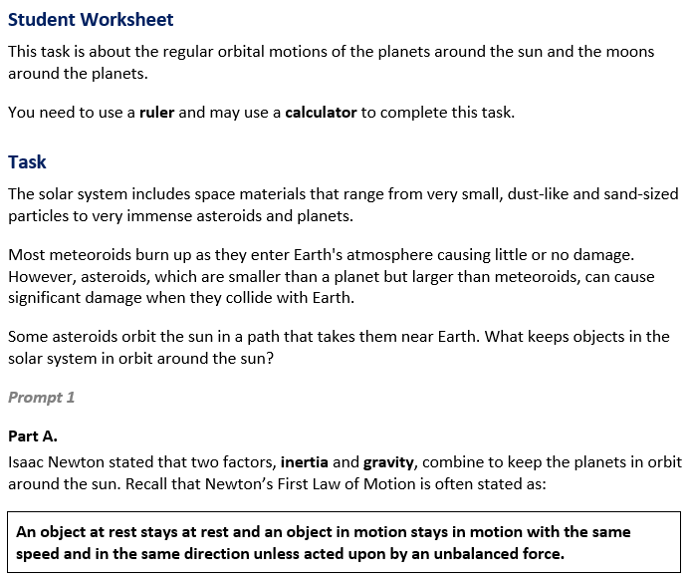
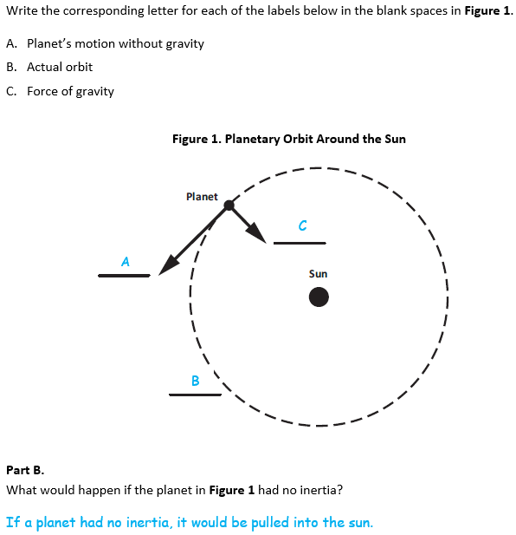
  Task 1 Prompt 1 Parts A and B Complexity
  Degree and Nature of Sensemaking | Moderate | This prompt…  - Requires integration of two dimensions in the service of sense-making
  Complexity of the Presentation | Low | - The amount and type of information provided in the scenario supports limited simple connections among ideas or  - Provides few, simple graphics/data/models
  Cognitive Demand of Response Development | Moderate | - Requires drawing relationships and connecting ideas and practices  - Requires a moderate level of sophistication with typical and relatively complex representation of ideas and application of skills
  Cognitive Demand of Response Production | Low | - Responses include selection from a small set of options presented as text (e.g., word, short phrase) or other formats (e.g., or a simple graphic or process)
Task 1 Prompt 1 Parts A and B
Connections to the Instructional Framework
Integration of Knowledge and Skills for Response Development
- Students read the task and provided background information.
- Students recall Newton’s First Law of Motion and focus on the phenomena of the orbital nature of a planet and sun interacting via gravity and inertia.
- In Part A, students use the corresponding letters for each label provided to model gravity as the attractive force that keeps solar systems together.
- In Part B, students provide a critique based on the model by citing relevant evidence that elaborates on what would happen if the planet had no inertia. Students are expected to recognize that the planet would be pulled into the sun and that gravitational forces and inertia lead to the regular orbital motion of a moving object.
Formative Assessments | Opportunities to Learn
Segment 1, pp. 12-13  Formal Assessment: Modeling How Gravitational Forces Affect Motion (A17)  - Students develop a model that shows the attractive forces in a two-body system and the impact of the forces on the motion of the two objects relative to one another. | Segment 1, p. 29  Modeling How Gravitational Forces Affect Motion (A17, A19*)  - In this lesson, students demonstrate how well they understand and can model the relationships between force, mass, and relative motion in two body systems.  Segment 3, pp. 36-37  Rotating Discs in Space (A19)  - Students explore why the disc shape in galaxies is so common and explore other questions about gravity. Students recognize that an attractive force of gravity drives all these processes.

Task 1 Prompt 2 – Parts A and B  Performance Category: Analyze Data to Describe Interactions Among Objects in Earth’s Solar System  Acquisition Goals  - A14. Obtain, evaluate, and/or communicate information that our solar system includes multiple types of objects that orbit the Sun (and may also orbit one another). *  - A15. Construct and present an argument to support or refute an explanation that our solar system includes multiple types of objects that orbit the sun (and may also orbit one another). *  - A16. Use data on orbital motions, including distances, to determine the relative masses of different objects in an orbital system. *  Prompt 2 Parts A and B measure the students’ ability to:  - Analyze and interpret data and graphs to support conclusions about observed patterns related to the orbits of the inner planets and outer planets at different scales. |  | 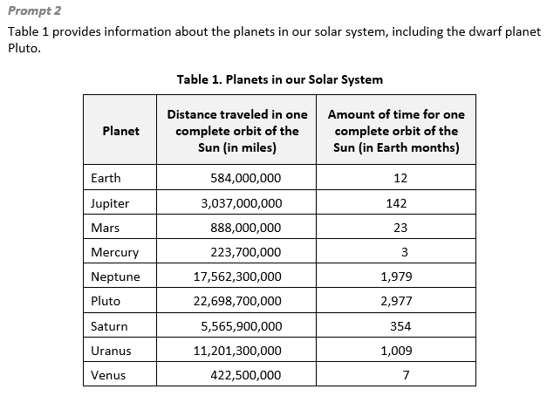  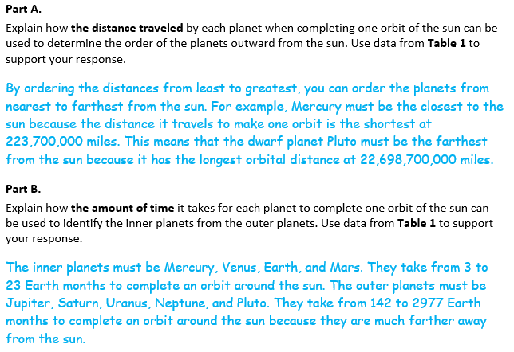
  Task 1 Prompt 2 Parts A and B Complexity
  Degree and Nature of Sensemaking | Moderate | This prompt…  - Requires integration of two dimensions in the service of sense-making
  Complexity of the Presentation | Moderate | - The amount and type of information provided in the scenario supports multiple evident connections among ideas or concepts.  - Provides graphics/data/models
  Cognitive Demand of Response Development | Moderate | - Requires drawing relationships and connecting ideas and practices.  - Requires a moderate level of sophistication with typical and relatively complex representation of ideas and application of skills
  Cognitive Demand of Response Production | Moderate | - Responses include one or more sentences or a paragraph, a moderately complex graphic, or multiple steps in a simple or moderately complex process
  Task 1 Prompt 2 Parts A and B
  Connections to the Instructional Framework
  Formative Assessments | Opportunities to Learn
  - Students describe scientific evidence about how scale (in mass, distance, and time) determines which components are relevant when understanding the solar system, galaxy, or universe.  Segment 3, pp. 19-20  Formal Assessment: Using Evidence to Develop an Argument about Objects in our Solar System (A14)  - Students describe (in degrees of magnitude) the relative spatial scales involved, from solar systems to galaxies to broader clusters in the universe.  - Students describe scientific evidence about how scale (in mass, distance, and time) determines which components are relevant when understanding the solar system, galaxy, or universe. | Segment 3, pp. 37-38  Modeling Earth, Our Solar System, and Our Galaxy: “Around We Go” (A14)  - Students have explored the why behind the universe's structure, and now they switch to the “what” of the structure of our solar system, galaxy, and the universe. Students research objects in the solar system, present to their peers, and document what they learn.
  Task 1 Prompt 2 Parts A and B
  Connections to the Instructional Framework
  Integration of Knowledge and Skills for Response Development
  - Students read the prompt text and analyze the data table that includes information about planets in our solar system.
  - Students identify a relationship between planets’ distance traveled in an orbital period and the order of planets outward from the sun.
  - Students classify planets and inner or outer based on the time taken to complete an orbital period.
  - Students use the patterns found in data to draw conclusions and identify characteristics based on planets’ locations within the solar system.
  Formative Assessments | Opportunities to Learn
  Segment 1, p. 11  Informal Assessment: Using Gravity to Find Alien Worlds (A16*)  - Students use data to answer questions and support explanations of objects in an orbital system based on orbital motions, including distances.  Segment 3, p. 18  Informal Assessment: Lumpy Space? Empty Space? Why is Our Universe the Way it is? (A14)  - Students describe (in degrees of magnitude) the relative spatial scales involved, from solar systems to galaxies to broader clusters in the universe. | Segment 1, pp. 29-30  Using Gravity to Find Alien Worlds (A16)  - Students learn about the search for exoplanets and how astronomers can find these star systems using gravity.  - Students discuss their ideas around exoplanets and consider how they might be discovered.  Segment 3, pp. 34-35  Lumpy Space? Empty Space? Why is Our Universe the Way it is? (A14)  - After students have brainstormed a set of questions they want to answer, the teacher provides students with websites that give information about the Milky Way galaxy, our solar system, and objects found in our solar system.
  Task 1 Prompt 2 Parts A and B
  Connections to the Instructional Framework
  Formative Assessments | Opportunities to Learn
  Segment 3, pp. 20-21
  Formal Assessment: Communicating About Objects in Our Solar System, The Milky Way, and the Universe (A14)
  - Students use evidence, data, or a model to support an argument that our solar system includes multiple types of objects that orbit the sun (and may also orbit one another).
Task 1 Prompt 3 – Parts A and B  Performance Category: Model Relationships Among Objects in Earth’s Solar System  Acquisition Goals  - A13. Obtain, evaluate, and/or communicate information that our solar system is located within the Milky Way galaxy, one of many galaxies. *  - A14. Obtain, evaluate, and/or communicate information that our solar system includes multiple types of objects that orbit the Sun (and may also orbit one another). *  Prompt 3 Parts A and B measure students’ ability to:  - Develop or use models to support descriptions and predictions of relationships about scale relationships representing distances and objects in the solar system. |  | 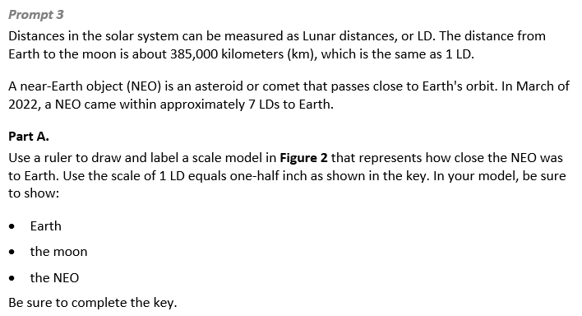  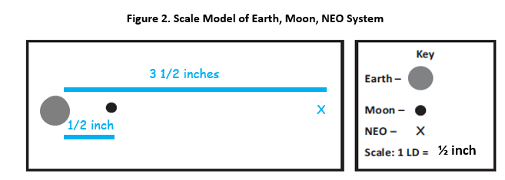
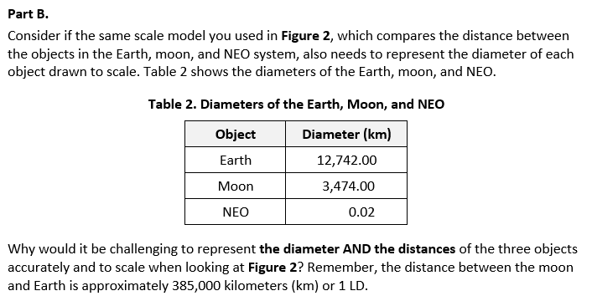  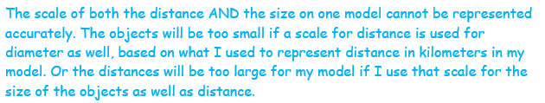
  Task 1 Prompt 3 Parts A and B
  Connections to the Instructional Framework
  Integration of Knowledge and Skills for Response Development
  - Students use a provided scale to create a model of a system that includes Earth, the moon, and a near-Earth object.
  - In Part A, students complete a model using the provided scale and objects in the key.
  - In Part B, students evaluate the limitations of the scale used in Part A by considering how to represent the diameter of the three objects in the model.
  Formative Assessments | Opportunities to Learn
  Segment 3, p. 18  Informal Assessment: Lumpy Space? Empty Space? Why is Our Universe the Way it is? (A13, A14)  - Students describe (in degrees of magnitude) the relative spatial scales involved, from solar systems to galaxies to broader clusters in the universe.  - Students describe scientific evidence about how scale (in mass, distance, and time) determines which components are relevant when understanding the solar system, galaxy, or universe. | Segment 3, pp. 34-35  Lumpy Space? Empty Space? Why is Our Universe the Way it is? (A13, A14)  - After students have brainstormed a set of questions they want to answer, the teacher provides students with websites that give information about the Milky Way galaxy, our solar system, and objects found in our solar system.
  Task 1 Prompt 3 Parts A and B Complexity
  Degree and Nature of Sensemaking | High | This prompt…  - Requires integration of three dimensions in the service of sense-making  - Requires a combination of previously learned ideas or concepts and newly presented information
  Complexity of the Presentation | Moderate | - The amount and type of information provided in the scenario supports multiple evident connections among ideas or concepts  - Provides graphics/data/models
  Cognitive Demand of Response Development | High | - Requires selection and application of multiple complex ideas and practices  - Requires high degree of sense-making, reasoning, and/or transfer
  Cognitive Demand of Response Production | High | - Responses include multiple paragraphs, multiple graphics of at least moderate complexity, or multiple steps in a complex process
  Task 1 Prompt 3 Parts A and B
  Connections to the Instructional Framework, Continued
  Formative Assessments | Opportunities to Learn
  Segment 3, pp. 19-20  Formal Assessment: Using Evidence to Develop an Argument about Objects in our Solar System (A13, A14)  - Students describe (in degrees of magnitude) the relative spatial scales involved, from solar systems to galaxies to broader clusters in the universe.  - Describe scientific evidence about how scale (in mass, distance, and time) determines which components are relevant when understanding the solar system, galaxy, or universe. | Segment 3, pp. 37-38  Modeling Earth, Our Solar System, and Our Galaxy: “Around We Go” (A13, A14)  - Students have explored the why behind the universe's structure, and now they switch to the “what” of the structure of our solar system, galaxy, and the universe. Students research objects in the solar system, present to their peers, and document what they learn.
Task 1 Prompt 3 – Part C  Performance Category: Support Arguments About Earth’s Place in the Solar System and Universe  Acquisition Goals  - A14. Obtain, evaluate, and/or communicate information that our solar system includes multiple types of objects that orbit the Sun (and may also orbit one another). *  - A15. Construct and present an argument to support or refute an explanation that our solar system includes multiple types of objects that orbit the sun (and may also orbit one another). *  Prompt 3 Part C measures students’ ability to:  - Support an argument with evidence, data, or a model to explain the relationship between asteroid diameters and frequency. |  | 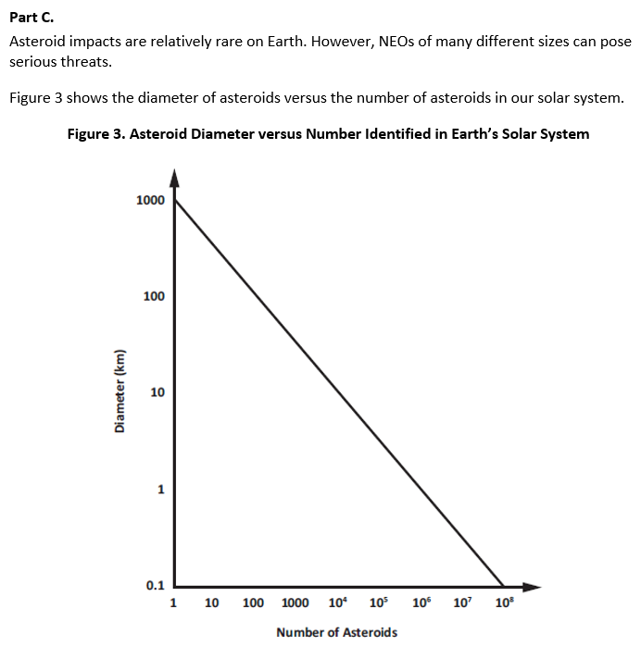  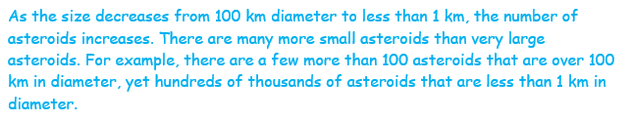
  Task 1 Prompt 3 Part C Complexity
  Degree and Nature of Sensemaking | Moderate | This prompt…  - Requires integration of two dimensions in the service of sense-making
  Complexity of the Presentation | Low | - The amount and type of information provided in the scenario supports limited simple connections among ideas or concepts
  Cognitive Demand of Response Development | Moderate | - Response requires a moderate level of sophistication with typical but relatively complex representation of ideas and application of skills
  Cognitive Demand of Response Production | Moderate | - Responses include one or more sentences or a paragraph, a moderately complex graphic, or multiple steps in a simple or moderately complex process
  Task 1 Prompt 3 Part C
  Connections to the Instructional Framework
  Integration of Knowledge and Skills for Response Development
  - Students refer to Figure 3, which shows the diameter of asteroids versus the number of asteroids in our solar system.
  - Students interpret a graph displaying a data set to describe the relationship between asteroid diameters and the number of asteroids in Earth’s solar system.
  - Students support their answer using data from Figure 3 and reasoning that is centered around the inverse relationship between the size and number of asteroids
  Formative Assessments | Opportunities to Learn
  Segment 3, pp. 20-21  Formal Assessment: Communicating About Objects in Our Solar System, The Milky Way, and the Universe (A14*, A15)  - Students identify and use evidence, data, or a model to support an argument that our solar system includes multiple types of objects that orbit the sun (and may also orbit one another). | Segment 3, pp. 34-35  Lumpy Space? Empty Space? Why is Our Universe the Way it is? (A14)  - After students have brainstormed a set of questions they want to answer, the teacher provides students with websites that give information about the Milky Way galaxy, our solar system, and objects found in our solar system.  Segment 3, pp. 37-38  Modeling Earth, Our Solar System, and Our Galaxy: “Around We Go” (A14)  - Students explore the structure of our solar system, galaxy, and universe by researching topics (e.g., stars, planets, exoplanets, comets, asteroids, etc.) and sharing their learning with peers.
Future Learning Connected to evidence elicited in Task 1
Crosscutting Concepts
- In Unit 2, students identify patterns that reveal the relationships between gravity and the place of objects with mass on Earth and the universe. Using models, students can make sense of how time, space, and gravitational force interact within the solar system. Their experience with these concepts will help them as they apply these concepts in Unit 3 to use a geological timescale to organize Earth’s history and to identify cause and effect relationships as they pertain to the adaptations, evolutionary pressures on all types of organisms, and how we use the fossil record and rock strata to learn about the history of organisms and landforms/rocks. They will also use graphs, charts, and images to identify patterns in data from fossil records as they document the existence of various lifeforms and various factors and mechanisms that lead to genetic variation. In Unit 3, Acquisition Goal 2 requires students to use mathematical representations of time appropriate for representing events and time scale(s) necessary to support conclusions about events that occurred during Earth's history. (Formal Assessment: Plotting Events to Scale, pp. 13-14)
Disciplinary Core Ideas
- In Unit 2, students analyze similarities and differences of planetary objects at different scales and understand how they are kept in place in the universe. In working with these disciplinary core ideas, students are positioned to make connections across systems of planetary objects at different scales and the role that gravity plays in keeping them in orbit. These ideas prepare students for Unit 3, in which they will focus on changes in life and land over Earth’s history, how this is related to the adaptations and evolutionary pressures on all types of organisms, and how we use the fossil record and rock strata to learn about the history of organisms and landforms/rocks. In Unit 3, Acquisition Goal 4 requires students to construct an explanation based on evidence from scientific sources about how rock strata form in the present to explain how rock strata formed earlier in Earth's history. (Informal Assessment: Utilizing Informational Texts for Learning, pp. 10-11)
Science and Engineering Practices
- In Unit 2, students develop and use models to construct and support evidence-based arguments that center around the role of gravity in keeping objects in orbit in the solar system. In Unit 3, students use models to describe and/or explain phenomena and scientific concepts. Acquisition Goal 3 requires students to develop and/or use a model of the process of rock strata formation to describe how it allows us to collect evidence about the relative age of rocks and/or landforms. (Formal Assessment: What Was First, Second, Third…, pp. 11-12)

SIPS Grade 8 Unit 2 EOU Assessment Task 2: Earth, Moon, and Sun  Task 2 Prompt 1 – Parts A, B, and C  Performance Category: Support Arguments About Earth’s Place in the Solar System and Universe  Acquisition Goals  - A7: Construct a model of Earth within the Earth-sun system that includes the tilt of Earth and that accounts for the seasonal variation in the amount of sunlight.*  - A8: Construct an explanation of the relationship between the amount of solar energy in terms of Earth's position within its orbit around the sun.*  - A9: Use a model of the Earth/sun system to show how different hemispheres will experience different amounts of sunlight during the orbit of Earth around the sun.  - A10: Develop and use a model of the Earth-sun-moon system to describe the cyclic patterns of lunar phases, eclipses of the sun and moon, and seasons.*  - A15: Construct and present an argument to support or refute an explanation that our solar system includes multiple types of objects that orbit the sun (and may also orbit one another).*  Prompt 1 Parts A, B, and C measure students’ ability to:  - Support an argument with evidence, data, or a model to explain the role of Earth’s axial tilt in causing seasons. |  | 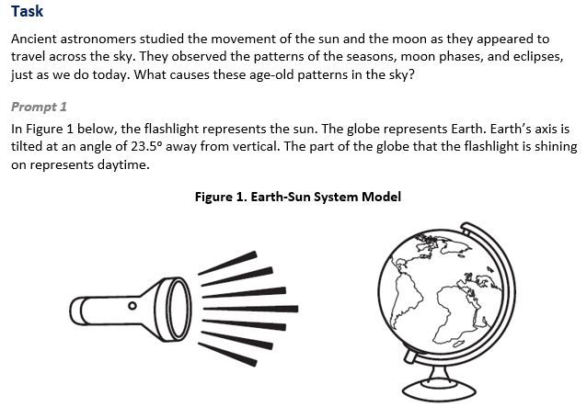  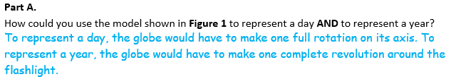  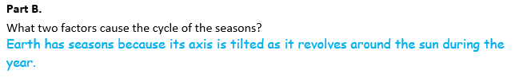  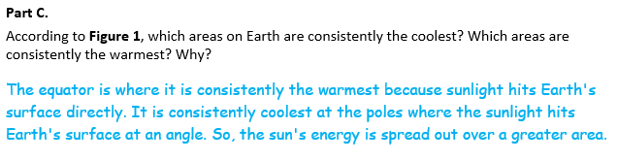

  Task 2 Prompt 1 Part A Complexity
  Degree and Nature of Sensemaking | Low | This prompt…  - Requires one or two dimensions  - One dimension may have a greater degree of emphasis than another
  Complexity of the Presentation | Low | - The amount and type of information provided in the scenario supports limited simple connections among ideas or concepts  - Provides few, simple graphics/data/models
  Cognitive Demand of Response Development | Moderate | - Requires application of ideas and practices given cues and guidance  - Requires drawing relationships and connecting ideas and practices
  Cognitive Demand of Response Production | Moderate | - Responses include one or more sentences or a paragraph, a moderately complex graphic, or multiple steps in a simple or moderately complex process
  Task 2 Prompt 1 Part B Complexity
  Degree and Nature of Sensemaking | Low | This prompt…  - Requires one or two dimensions  - One dimension may have a greater degree of emphasis than another
  Complexity of the Presentation | Low | - The amount and type of information provided in the scenario supports limited simple connections among ideas or concepts  - Provides few, simple graphics/data/models
  Cognitive Demand of Response Development | Low | - Requires a connection or retrieval of factual information  - Response requires a low level of sophistication with routinely encountered well-practiced applications
  Cognitive Demand of Response Production | Low | - Responses include selection from a small set of options presented as text (e.g., word, short phrase) or other formats (e.g., or a simple graphic or process
  Task 2 Prompt 1 Part C Complexity
  Degree and Nature of Sensemaking | Low | This prompt…  - Requires one or two dimensions  - One dimension may have a greater degree of emphasis than another
  Complexity of the Presentation | Low | - The amount and type of information provided in the scenario supports limited simple connections among ideas or concepts  - Provides few, simple graphics/data/models
  Cognitive Demand of Response Development | Moderate | - Requires application of ideas and practices given cues and guidance  - Requires drawing relationships and connecting ideas and practices
  Cognitive Demand of Response Production | Moderate | - Responses include one or more sentences or a paragraph, a moderately complex graphic, or multiple steps in a simple or moderately complex process
  Task 2 Prompt 1 Parts A, B, and C
  Connections to the Instructional Framework, Continued
  Formative Assessments | Opportunities to Learn
  Segment 2, pp. 14-15  Informal Assessment: Develop and Use Models of the Earth-Sun-Moon System (A8, A9)  - Students identify the evidence that supports a claim related to the relationship between the amount of solar energy reaching Earth and Earth's position within its orbit around the sun.  - Students describe how a model supports the idea that different hemispheres will experience different amounts of sunlight during the orbit of Earth around the sun.  Segment 2, pp. 15-16  Formal Assessment: Develop and Use Models of Earth’s Tilt and Seasons (A7*, A9)  - Students describe how a model supports the idea that the tilt of the Earth accounts for the seasonal variation in the amount of sunlight. | Segment 2, pp. 30-31  Where Are We? (A7*, A8, A9)  - The teacher provides students with materials to construct an Earth-sun-moon system model to help us understand our system's heat and light. Students use what they already know to construct their models.  Segment 2, p. 32  Solar Energy and Seasons (A8)  - Students analyze daylight hours and surface temperatures to identify patterns that arise from differences in solar radiation for various locations on Earth and use those data and patterns as evidence in their explanation about the sources of the patterns linked by the data.
  Task 2 Prompt 1 Parts A, B, and C
  Connections to the Instructional Framework
  Integration of Knowledge and Skills for Response Development
  Part A
  - Students review the provided informational text and model about the Earth-sun system.
  - Students support their argument with evidence, indicating that the day is represented by the globe making one full rotation about its axis, and the year is represented by the globe making one full revolution around the flashlight.
  Part B
  - Students review the provided informational text and model about the Earth-sun system.
  - Students use the provided model to identify a relationship between Earth’s axial tilt and appearance of seasons as it orbits the sun.
  - Students support their argument with evidence, including Earth’s tilt and orbit around the sun over a year.
  Part C
  - Students review the provided informational text and model about the Earth-sun system.
  - Students use the provided model to connect the heat generated by the flashlight and the sun as it hits the surface of the globe/Earth.
  - Students identify a relationship between the tilt of the Earth’s axis and the amount of insolation received on the Earth.
  - Students support their argument with evidence, including relating the temperature to where the sun/flashlight shines directly on the surface and recognizing the equator as the warmest area and the poles as the coldest area.
  Task 2 Prompt 1 Parts A, B, and C
  Connections to the Instructional Framework, Continued
  Formative Assessments | Opportunities to Learn
  - Students describe the relevant relationships between Earth and the sun and how different hemispheres will experience different amounts of sunlight during Earth's orbit around the sun.  - Students describe the relevant relationships between components shown in an Earth-sun model showing how the tilt of Earth accounts for the seasonal variation in the amount of sunlight.  Segment 2, p. 17  Formal Assessment: Comparing Our Model to Other Models (A7*, A8)  - Students use models to show how the change in season at a given place on Earth is directly related to the orientation of the tilted Earth and the position of Earth in its orbit around the sun. | Segment 2, p. 33  Comparing Our Model to Other Models (A8, A9)  - Having worked on and refined their models, students shift to looking at others’ models and comparing them with their own.  - Students make additional revisions to their model after examining other models. They explain any limitations to their model and how it does or does not explain natural phenomena related to the Earth-sun-moon system.
Task 2 Prompt 2 – Part A  Performance Category: Model Relationships Among Objects in Earth’s Solar System  Acquisition Goals  - A10. Develop and use a model of the Earth-sun-moon system to describe the cyclic patterns of lunar phases, eclipses of the sun and moon, and seasons.  - A14. Obtain, evaluate, and/or communicate information that our solar system includes multiple types of objects that orbit the Sun (and may also orbit one another.*  Prompt 2 – Part A measures students’ ability to:  - Develop or use models to support descriptions and predictions of relationships about lunar phases in terms of the relative positions of the sun, Earth, and moon. |  |  |  | 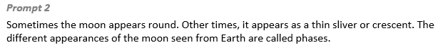  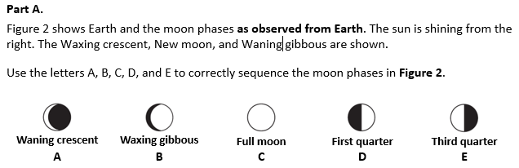  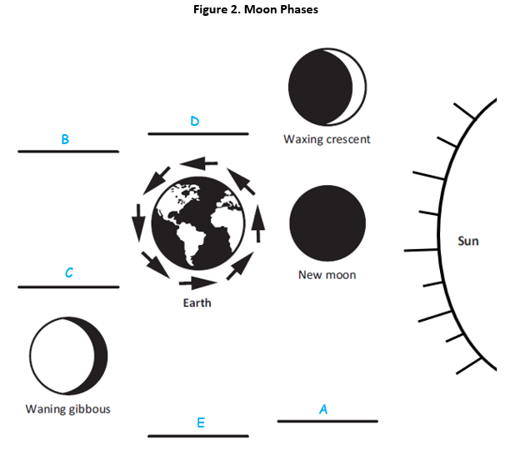
  Task 2 Prompt 2 Part A Complexity
  Degree and Nature of Sensemaking | Moderate | This prompt…  - Requires integration of two dimensions in the service of sensemaking  - Requires a combination of previously learned ideas or concepts and newly presented information
  Complexity of the Presentation | Moderate | - The amount and type of information provided in the scenario supports multiple evident connections among ideas or concepts  - Provides graphics/data/models
  Cognitive Demand of Response Development | Low | - Requires well-defined set of actions or procedures  - Requires a connection or retrieval of factual information
  Cognitive Demand of Response Production | Low | - Responses include selection from a small set of options presented as text (e.g., word, short phrase) or other formats (e.g., or a simple graphic or process)
  Task 2 Prompt 2 Part A
  Connections to the Instructional Framework, Continued
  Formative Assessments | Opportunities to Learn
  Segment 2, p. 17  Formal Assessment: Comparing Our Model to Other Models (A10)  - Students develop and use a model to describe the cyclic patterns of lunar phases and eclipses of the sun and moon and to describe the seasons. | Segment 2, pp. 31-32  Observing the Sun, Earth, and Moon (A10)  - Students explore observational data about the Earth-sun-moon system using an online resource that provides location/date-specific sky data.  - After looking at the data and discussing the patterns found, students revisit their explanatory model of the Earth-sun-moon system and modify it to account for these new observations.  Segment 2, p. 33  Comparing Our Model to Other Models (A10)  - Students evaluate and compare others’ models and their own.  - Students make additional revisions to their model after examining other models. They explain any limitations to their model and how it does or does not explain natural phenomena related to the Earth-sun-moon system.
  Task 2 Prompt 2 Part A
  Connections to the Instructional Framework
  Integration of Knowledge and Skills for Response Development
  - Students read the prompt and refer to the model showing the lunar phases' cyclic pattern.
  - Students complete the model to predict the correct sequence of the lunar cycle based on the positions of the sun, moon, and Earth relative to each other.
  Formative Assessments | Opportunities to Learn
  Segment 2, pp. 14-15  Informal Assessment: Develop and Use Models of the Earth-Sun-Moon System (A10)  - Students develop and use a model to describe the cyclic patterns of lunar phases and eclipses of the sun and moon and to describe the seasons.  Segment 2, pp. 16-17  Formal Assessment: Observing the Sun, Earth, and Moon (A10)  - Students develop and use a model to describe the cyclic patterns of lunar phases and eclipses of the sun and moon and to describe the seasons. | Segment 2, pp. 30-31  Where Are We? (A10)  - The teacher provides students with materials to construct an Earth-sun-moon system model to help us understand our system's heat and light. Students use what they already know to construct their models.
Task 2 Prompt 2 – Part B  Performance Categories: Support Arguments About Earth’s Place in the Solar System and Universe  Acquisition Goals:  - A10. Develop and use a model of the Earth-sun-moon system to describe the cyclic patterns of lunar phases, eclipses of the sun and moon, and seasons.  - A15. Construct and present an argument to support or refute an explanation that our solar system includes multiple types of objects that orbit the sun (and may also orbit one another).  Prompt 2 Part B measures students’ ability to:  - Support an argument with evidence, data, or a model to explain the lunar phases in terms of the relative positions of the sun, Earth, and moon.  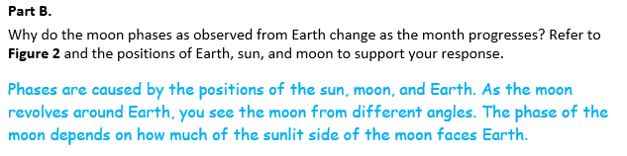
  Task 2 Prompt 2 Part B
  Connections to the Instructional Framework
  Integration of Knowledge and Skills for Response Development
  - Students read the prompt and refer to the model showing the lunar phases' cyclic pattern.
  - Students make a claim about what leads to lunar phase change.
  - Students support their claim using the cause-and-effect relationships that exist in the apparent motion of the sun and moon in the sky and lunar phases in terms of the relative positions of the sun, Earth, and moon using evidence from Figure 2.
  Formative Assessments | Opportunities to Learn
  Segment 2, pp. 14-15  Informal Assessment: Develop and Use Models of the Earth-Sun-Moon System (A10)  - Students develop and use a model to describe the cyclic patterns of lunar phases and eclipses of the sun and moon and to describe the seasons.  Segment 2, pp. 16-17  Formal Assessment: Observing the Sun, Earth, and Moon (A10)  - Students develop and use a model to describe the cyclic patterns of lunar phases and eclipses of the sun and moon and to describe the seasons. | Segment 2, pp. 30-31  Where Are We? (A10)  - The teacher provides students with materials to construct an Earth-sun-moon system model to help us understand our system's heat and light. Students use what they already know to construct their models.
  Task 2 Prompt 2 Part B Complexity
  Degree and Nature of Sensemaking | Moderate | This prompt…  - Requires integration of two dimensions in the service of sensemaking  - Requires a combination of previously learned ideas or concepts and newly presented information
  Complexity of the Presentation | Moderate | - The amount and type of information provided in the scenario supports multiple evident connections among ideas or concepts  - Provides graphics/data/models
  Cognitive Demand of Response Development | Moderate | - Requires application of ideas and practices given cues and guidance  - Requires drawing relationships and connecting ideas and practices
  Cognitive Demand of Response Production | Moderate | - Responses include one or more sentences or a paragraph, a moderately complex graphic, or multiple steps in a simple or moderately complex process
  Task 2 Prompt 2 Part B
  Connections to the Instructional Framework, Continued
  Formative Assessments | Opportunities to Learn
  Segment 2, p. 17  Formal Assessment: Comparing Our Model to Other Models (A10)  - Students develop and use a model to describe the cyclic patterns of lunar phases and eclipses of the sun and moon and to describe the seasons.  Segment 2, pp. 20-21  Formal Assessment: Communicating About Objects in Our Solar System, The Milky Way, and the Universe (A15)  - Students identify evidence, data, or models that support an argument that our solar system includes multiple types of objects that orbit the sun | Segment 2, pp. 31-32  Observing the Sun, Earth, and Moon (A10)  - Students explore observational data about the Earth-sun-moon system using an online resource that provides location/date-specific sky data.  - After looking at the data and discussing the patterns found, students revisit their explanatory model of the Earth-sun-moon system and modify it to account for these new observations.  Segment 2, p. 33  Comparing Our Model to Other Models (A10)  - Having worked on and refined their models, students shift to looking at others’ models and comparing them with their own.  - Students revise their model after examining other models and explain any limitations to their model and how it does or does not explain natural phenomena related to the Earth-sun-moon system.

Future Learning Connected to evidence elicited in Task 2
Crosscutting Concepts
- In Unit 2, students identify patterns that reveal the relationships between gravity and the place of objects with mass on Earth and the universe. Using models, students can make sense of how time, space, and gravitational force interact within the solar system. Their experience with these concepts will help them as they apply these concepts in Unit 3 to use a geological timescale to organize Earth’s history and to identify cause and effect relationships as they pertain to the adaptations, evolutionary pressures on all types of organisms, and how we use the fossil record and rock strata to learn about the history of organisms and landforms/rocks. They will also use graphs, charts, and images to identify patterns in data from fossil records as they document the existence of various lifeforms and various factors and mechanisms that lead to genetic variation. In Unit 3, Acquisition Goal 2 requires students to use mathematical representations of time appropriate for representing events and time scale(s) necessary to support conclusions about events that occurred during Earth's history. (Formal Assessment: Plotting Events to Scale, pp. 13-14)
Disciplinary Core Ideas
- In Unit 2, students engage in argumentation supported by empirical evidence in the universe about how objects with mass are affected by gravity. In working with these disciplinary core ideas, students are positioned to make connections across systems of planetary objects at different scales and the role that gravity plays in keeping them in orbit. These ideas prepare students for Unit 3, in which they will focus on how changes in life and land over Earth’s history, how this is related to the adaptations and evolutionary pressures on all types of organisms, and how we use the fossil record and rock strata to learn about the history of organisms and landforms/rocks. In Unit 3, Acquisition Goal 4 requires students to construct an explanation based on evidence from scientific sources about how rock strata form in the present to explain how rock strata formed earlier in Earth's history. (Informal Assessment: Utilizing Informational Texts for Learning, pp. 10-11)
Science and Engineering Practices
- In Unit 2, students develop and use models to construct and support evidence-based arguments that center around the role of gravity in keeping objects in orbit in the solar system and analyze and interpret data to determine similarities and differences between objects in the solar system. In Unit 3, students use models to describe and/or explain phenomena and scientific concepts. Acquisition Goal 3 requires students to develop and/or use a model of the process of rock strata formation to describe how it allows us to collect evidence about the relative age of rocks and/or landforms. (Formal Assessment: What Was First, Second, Third…, pp. 11-12)

SIPS Grade 8 Unit 2 EOU Assessment Task 3: Earth’s Solar System  Task 3 Prompt 1 – Parts A, B, and C  Performance Category: Analyze Data to Describe Interactions Among Objects in Earth’s Solar System  Acquisition Goals:  - A3. Develop a model that illustrates that the mass of two objects affects the gravitational forces between those objects. *  - A5. Analyze and interpret data on gravitational forces exerted by massive objects to show similarities and/or differences in the observed effects of those forces.  - A18. Construct a model showing that the equal and opposite force of gravity will lead to a much greater change in motion of a lighter object compared to a heavier object.*  Prompt 1 Parts A, B, and C measure students’ ability to:  - Analyze and interpret data and graphs to support conclusions about the relationship between relative sizes of objects in the solar system and the size of the gravitational force that is being exerted on an object. |  | 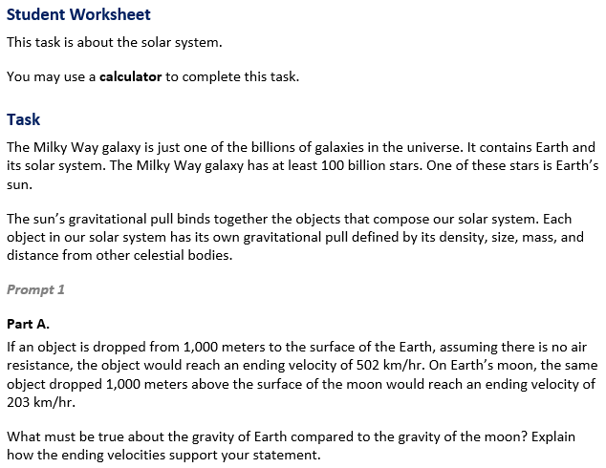

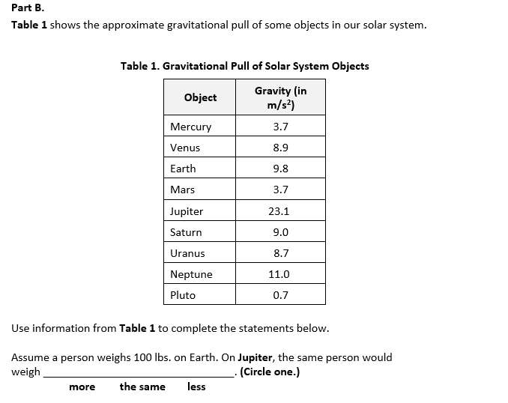  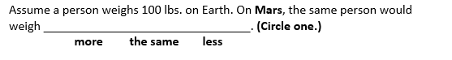 |  |  |  | 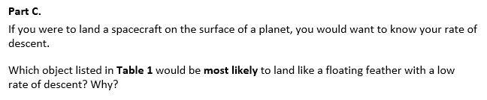
  Task 3 Prompt 1 Part A Complexity
  Degree and Nature of Sensemaking | Moderate | This prompt…  - Requires integration of two dimensions in the service of sensemaking
  Complexity of the Presentation | Low | - The amount and type of information provided in the scenario supports limited simple connections among ideas or concepts
  Cognitive Demand of Response Development | Low | - Requires well-defined set of actions or procedures  - Requires a connection or retrieval of factual information
  Cognitive Demand of Response Production | Moderate | - Response includes one or more sentences or a paragraph, a moderately complex graphic, or multiple steps in a simple or moderately complex process
  Task 3 Prompt 1 Part C Complexity
  Degree and Nature of Sensemaking | Moderate | This prompt…  - Requires integration of two dimensions in the service of sensemaking  - Requires a combination of previously learned ideas or concepts and newly presented information
  Complexity of the Presentation | Low | - The amount and type of information provided in the scenario supports limited simple connections among ideas or concepts  - Phenomenon or problem presented in a concrete way with high level of certainty
  Cognitive Demand of Response Development | Moderate | - Requires application of ideas and practices given cues and guidance  - Requires drawing relationships and connecting ideas and practices
  Cognitive Demand of Response Production | Moderate | - Responses include one or more sentences or a paragraph, a moderately complex graphic, or multiple steps in a simple or moderately complex process
  Task 3 Prompt 1 Parts A, B, and C
  Connections to the Instructional Framework, Continued
  Formative Assessments | Opportunities to Learn
  Segment 1, pp. 9-10  Informal Assessment: Nature of Gravitational Forces (A3*, A5)  - Students describe scientific evidence about how gravitational interactions are always attractive between interacting objects.  - Students describe the relevant relationships between components shown in a model of a phenomenon (i.e., the mass of two objects affects the gravitational forces between those objects) related to the relative magnitude and direction of the force each object exerts on the other.  Segment 1, pp. 10-11  Informal Assessment: Analyze and Interpret Data on Gravitational Forces and Relative Mass of Objects (A3*, A5)  - Students use data to support an explanation of the similarities and differences in forces exhibited with objects of varying masses based on mass and gravitational force. | Segment 1, pp. 26-27  Analyze and Interpret Data on Gravitational Forces and Relative Mass of Objects (A5)  - Students revisit an activity from Unit 1, where they explored the changing motion of an object in a uniform circular motion.  - Students conclude from their data that there is the presence of a net force between massive objects and all other objects and that this force depends on the mass of the objects and their distance apart.
  Task 3 Prompt 1 Part B Complexity
  Degree and Nature of Sensemaking | Moderate | This prompt…  - Requires integration of two dimensions in the service of sensemaking  - Requires a combination of previously learned ideas or concepts and newly presented information
  Complexity of the Presentation | Moderate | - The amount and type of information provided in the scenario supports multiple evident connections among ideas or concepts  - Provides graphics/data/models
  Cognitive Demand of Response Development | Moderate | - Requires application of ideas and practices given cues and guidance  - Requires drawing relationships and connecting ideas and practices
  Cognitive Demand of Response Production | Moderate | - Responses include one or more sentences or a paragraph, a moderately complex graphic, or multiple steps in a simple or moderately complex process
  Task 3 Prompt 1 Parts A, B, and C
  Connections to the Instructional Framework
  Integration of Knowledge and Skills for Response Development
  Part A
  - Students are presented with an example scenario of an object being dropped to the surface of Earth and the same object being dropped to the surface of Earth’s moon.
  - Students analyze and interpret the provided data about gravitational force as related to objects in the solar system.
  - Students use their interpretation to support a conclusion indicating that the moon's gravity is less than Earth’s, using evidence based on lower ending velocity.
  Part B
  - Students analyze and interpret the provided data in Table 1 about the gravitational pull of solar system objects.
  - Students use their interpretation to develop an argument that the ‘weight’ of an object on a planet increases with the magnitude of gravitational force using evidence from the data provided.
  Part C
  - Students analyze and interpret provided data in Table 1 about the gravitational pull of solar system objects.
  - Students use their interpretation to predict the relationship between the mass of objects interacting via gravitational forces, recognizing a planet with low gravitational pull using evidence from Table 1.
  Task 3 Prompt 1 Parts A, B, and C
  Connections to the Instructional Framework, Continued
  Formative Assessments | Opportunities to Learn
  Segment 1, pp. 11-12  Formal Assessment: Develop a Model of Gravitational Force Showing the Relationship with Mass (A3*)  - Students describe the relevant relationships between components shown in a model of a phenomenon (i.e., the mass of two objects affects the gravitational forces between those objects) related to the relative magnitude and direction of the force each object exerts on the other.  Segment 1, pp. 13-14  Formal Assessment: Modeling How Gravitational Forces Affect Motion (A18*)  - Students develop and use a model to support the idea that the equal and opposite force of gravity will lead to a much greater change in motion of a lighter object compared to a heavier object. | Segment 1, p. 29  Modeling How Gravitational Forces Affect Motion (A18*)  - In this lesson, students demonstrate how well they understand and can model the relationships between force, mass, and relative motion in two body systems.  - Students work in groups of three to four and use everyday objects to develop a model or two models of a two-body system to demonstrate their understanding of the relationships between gravitational forces, mass, and relative motion of objects.
Task 3 Prompt 2 – Parts A and B  Performance Categories: Analyze Data to Describe Interactions Among Objects in Earth’s Solar System  Acquisition Goals:  - A14. Obtain, evaluate, and/or communicate information that our solar system includes multiple types of objects that orbit the Sun (and may also orbit one another).  - A15. Construct and present an argument to support or refute an explanation that our solar system includes multiple types of objects that orbit the sun (and may also orbit one another).  Prompt 2 Parts A and B measures students’ ability to:  - Analyze and interpret data and graphs to support conclusions about features of the inner planets compared to the outer planets. |  |  | 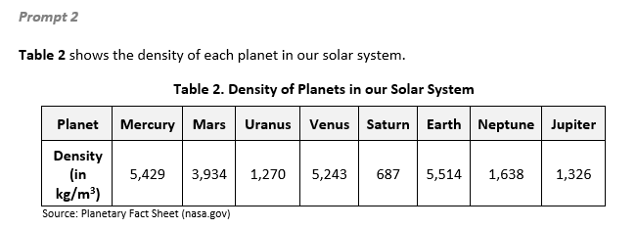  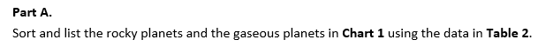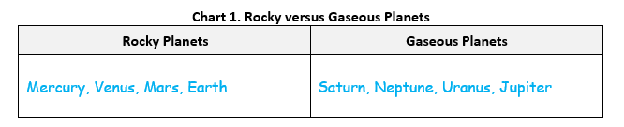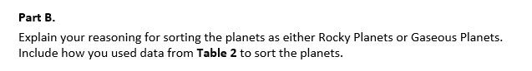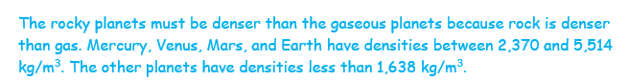
  Task 3 Prompt 2 Parts A and B Complexity
  Degree and Nature of Sensemaking | Moderate | This prompt…  - Requires integration of two dimensions in the service of sensemaking  - Requires a combination of previously learned ideas or concepts and newly presented information
  Complexity of the Presentation | Moderate | - The amount and type of information provided in the scenario supports multiple evident connections among ideas or concepts  - Provides graphics/data/models
  Cognitive Demand of Response Development | Moderate | - Requires application of ideas and practices given cues and guidance  - Requires drawing relationships and connecting ideas and practices
  Cognitive Demand of Response Production | Moderate | - Responses include one or more sentences or a paragraph, a moderately complex graphic, or multiple steps in a simple or moderately complex process
  Task 3 Prompt 2 Parts A and B
  Connections to the Instructional Framework, Continued
  Formative Assessments | Opportunities to Learn
  Segment 3, pp. 19-20  Formal Assessment: Using Evidence to Develop an Argument about Objects in Our Solar System (A14)  - Students identify information supporting the idea that our solar system includes multiple objects that orbit the sun.  - Students describe the relationships among objects in our solar system as a collection of objects, including planets, their moons, and asteroids held in orbit around the sun by its gravitational pull on them.  Segment 3, pp. 20-21  Formal Assessment: Communicating About Objects in Our Solar System, The Milky Way, and the Universe (A14)  - Students use evidence, data, or a model to support an argument that our solar system includes multiple types of objects that orbit the sun (and may also orbit one another). | Segment 3, pp. 37-38  Modeling Earth, Our Solar System, and Our Galaxy: “Around We Go” (A14)  - Students have explored the why behind the universe's structure, and now they switch to the “what” of the structure of our solar system, galaxy, and the universe as a whole. Students research objects in the solar system.
  Task 3 Prompt 2 Parts A and B
  Connections to the Instructional Framework
  Integration of Knowledge and Skills for Response Development
  - Students review the information presented in Table 2 about the density of planets in our solar system.
  - Students analyze and interpret data to determine similarities and differences in the planets' densities.
  - Students draw appropriate conclusions about objects in the solar system and correctly sort the rocky and gaseous planets, linking higher density with rocky planets and lower density with gaseous planets based on data.
  Formative Assessments | Opportunities to Learn
  Segment 3, p. 18  Informal Assessment: Lumpy Space? Empty Space? Why is Our Universe the Way it is? (A14)  - Students identify information supporting the idea that our solar system includes multiple objects that orbit the sun.  - Students describe the relationships among objects in our solar system as a collection of objects, including planets, their moons, and asteroids held in orbit around the sun by its gravitational pull on them. | Segment 3, pp. 34-35  Lumpy Space? Empty Space? Why is Our Universe the Way it is? (A14)  - After students have brainstormed a set of questions they want to answer, the teacher provides students with websites that give information about the Milky Way galaxy, our solar system, and objects found in our solar system.
Task 3 Prompt 3 – Part A  Performance Categories: Model Relationships Among Objects in Earth’s Solar System  Acquisition Goals:  - A17. Construct a model of a two-body system showing the attractive forces and their impact on the motion of the two objects relative to one another.  - A19. Construct and present an argument about how gravitational forces lead to a regular orbital motion of a moving object.  Prompt 3 Part A measures students’ ability to:  - Develop or use models to support descriptions and predictions of relationships about the predictable motions of objects within a solar system.  Task 3 Prompt 3 – Part B  Performance Categories: Support Arguments About Earth’s Place in the Solar System and Universe  Acquisition Goals:  - A14. Obtain, evaluate, and/or communicate information that our solar system includes multiple types of objects that orbit the Sun (and may also orbit one another).*  - A15. Construct and present an argument to support or refute an explanation that our solar system includes multiple types of objects that orbit the sun (and may also orbit one another).  Prompt 3 Part B measures students’ ability to:  - Support an argument with evidence, data, or a model to explain the pattern regarding the surface temperatures of planets and their location in a solar system.  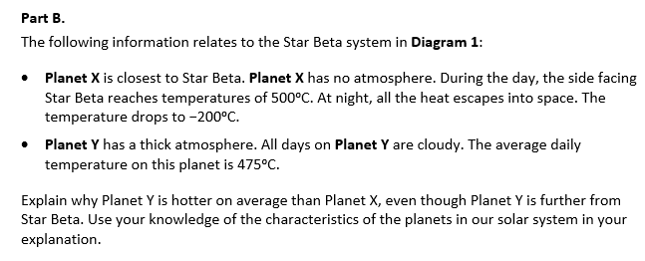  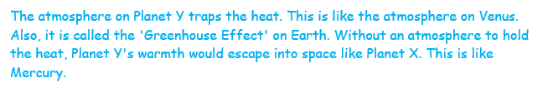  Task 3 Prompt 4 – Parts A, B, and C  Performance Categories: Support Arguments About Earth’s Place in the Solar System and Universe  Acquisition Goals:  - A3. Develop a model that illustrates that the mass of two objects affects the gravitational forces between those objects.  - A12. Develop a model to describe that our solar system is located within the Milky Way galaxy, one of many galaxies in the universe*  - A13. Obtain, evaluate, and/or communicate information that our solar system is located within the Milky Way galaxy, one of many galaxies in the universe.  - A15. Construct and present an argument to support or refute an explanation that our solar system includes multiple types of objects that orbit the sun (and may also orbit one another).  - A19. Construct and present an argument about how gravitational forces lead to a regular orbital motion of a moving object.  Prompt 4 Parts A, B, and C measure students’ ability to:  - Support an argument with evidence, data, or a model to explain the role of gravity in the sequence of events leading to the formation of Earth’s solar system.  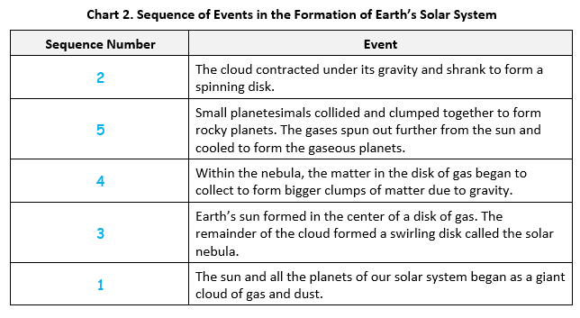  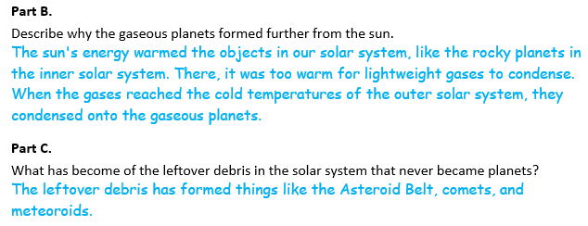 |  |  | 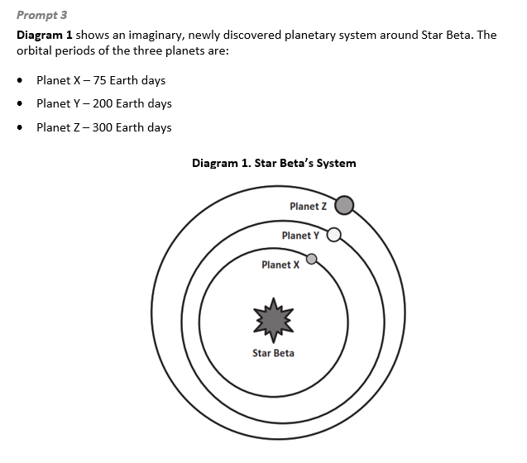  Location of Planet Y after 300 days  Location of Planets Z and X after 300 days  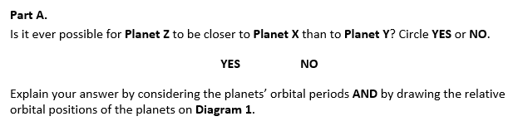  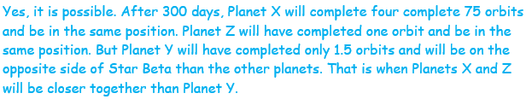  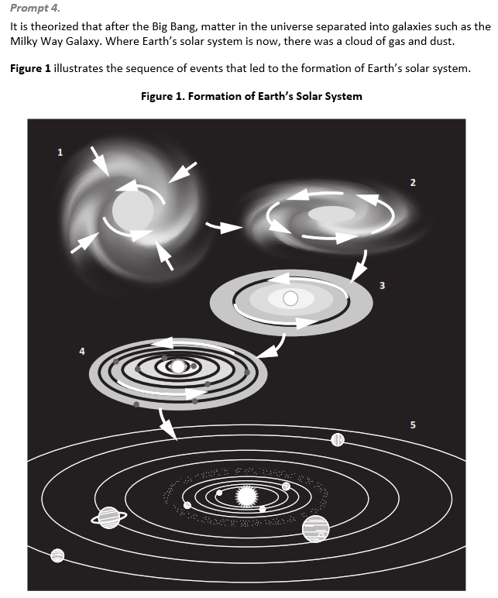  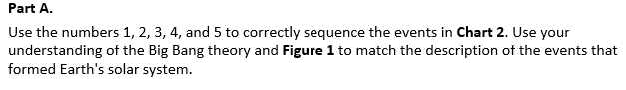
  Task 3 Prompt 3 Part A Complexity
  Degree and Nature of Sensemaking | Moderate | This prompt…  - Requires integration of two dimensions in the service of sensemaking  - Requires a combination of previously learned ideas or concepts and newly presented information
  Complexity of the Presentation | Moderate | - The amount and type of information provided in the scenario supports multiple evident connections among ideas or concepts  - Provides graphics/data/models
  Cognitive Demand of Response Development | High | - Requires high degree of sense-making, reasoning, and/or transfer  - Response requires a high level of sophistication with non-routine or abstract representation of ideas and application of skills
  Cognitive Demand of Response Production | High | - Responses include multiple paragraphs, multiple graphics of at least moderate complexity, or multiple steps in a complex process
  Task 3 Prompt 3 Part B
  Connections to the Instructional Framework
  Integration of Knowledge and Skills for Response Development
  - Students refer to Diagram 1 to explain the pattern occurring regarding planets' surface temperatures.
  - Students compare and contrast the properties of objects in the model and draw appropriate conclusions about similarities and/or differences among objects in the model.
  - Students accurately describe the pattern shown in the model, stating that the atmosphere traps heat while using the lack of the atmosphere as evidence.
  Formative Assessments | Opportunities to Learn
  Segment 3, p. 18  Informal Assessment: Lumpy Space? Empty Space? Why is Our Universe the Way it is? (A14)  - Students identify information supporting the idea that our solar system includes multiple objects that orbit the sun.  - Students describe the relationships among objects in our solar system as a collection of objects, including planets, their moons, and asteroids held in orbit around the sun by its gravitational pull on them. | Segment 3, pp. 34-35  Lumpy Space? Empty Space? Why is Our Universe the Way it is? (A14)  - After students have brainstormed a set of questions they want to answer, the teacher provides students with websites that give information about the Milky Way galaxy, our solar system, and objects found in our solar system.
  Task 3 Prompt 4 Parts A, B, and C
  Connections to the Instructional Framework
  Integration of Knowledge and Skills for Response Development
  Part A
  - Students use the evidence provided in Figure 1 to support/refute hypotheses related to the solar system's formation based on the objects' positions, relative to each other.
  - Students sequence letters in Chart 2 and Figure 1 according to the order of events pertaining to the solar system's formation.
  Part B
  - Students construct an explanation, using evidence and reasoning from Chart 2 and Figure 1, about the formation of Earth’s solar system, specifically why the gaseous planets formed in the colder outer solar system.
  Part C
  - Students accurately identify what became of the materials that were not pulled to form planets.
  Formative Assessments | Opportunities to Learn
  Segment 1, pp. 9-10  Informal Assessment: Nature of Gravitational Forces (A3)  - Students describe the relevant relationships between components shown in a model of a phenomenon (i.e., the mass of two objects affects the gravitational forces between those objects) related to the relative magnitude and direction of the force each object exerts on the other. | Segment 1, pp. 25-26  Do I Have Gravity? (A3)  - Students obtain, evaluate, and communicate information about how human-scale objects exert negligible gravitational forces. Students consider the question, “If everything with mass has gravity, why don’t we all have smaller objects orbiting us?”  - Students research gravitational forces and record data and observations that support or refute their initial thinking.
  Task 3 Prompt 4 Parts A, B, and C
  Connections to the Instructional Framework, Continued
  Formative Assessments | Opportunities to Learn
  Segment 1, pp. 13-14  Formal Assessment: Forces Modeling How Gravitational Forces Affect Motion (A19)  - Students identify evidence, data, or models that support an argument that gravity causes a pattern of smaller/less massive objects orbiting around larger/more massive objects at all system scales in the universe.  Segment 3, p. 18  Informal Assessment: Lumpy Space? Empty Space? Why is Our Universe the Way it is? (A13)  - Students describe (in degrees of magnitude) the relative spatial scales involved, from solar systems to galaxies to broader clusters in the universe.  - Students describe scientific evidence about how scale (in mass, distance, and time) determines which components are relevant when understanding the solar system, galaxy, or universe.  - Students identify information supporting the idea that our solar system includes multiple objects that orbit the sun. | Segment 3, pp. 34-35  Lumpy Space? Empty Space? Why is Our Universe the Way it is? (A13)  - The teacher engages students’ interest in obtaining information about the Milky Way galaxy by displaying a picture of the Milky Way galaxy from the Hubble Space Telescope, a picture of our solar system, and a picture of clusters of galaxies. The teacher asks, “What do you notice?” and encourages students to find similarities and differences between these three space scales.
  Task 3 Prompt 4 Parts A, B, and C
  Connections to the Instructional Framework, Continued
  Formative Assessments | Opportunities to Learn
  Segment 3, pp. 20-21  Formal Assessment: Communicating About Objects in Our Solar System, The Milky Way, and the Universe (A15)  - Students use evidence, data, or a model to support an argument that our solar system includes multiple types of objects that orbit the sun (and may also orbit one another). | Segment 3, pp. 37-38  Modeling Earth, Our Solar System, and Our Galaxy: “Around We Go” (A12*, A13)  - Students have explored the why behind the universe's structure, and now they switch to the “what” of the structure of our solar system, galaxy, and the universe as a whole. Students research objects in the solar system, present to their peers and document what they learn.
  Task 3 Prompt 3 Part A
  Connections to the Instructional Framework
  Integration of Knowledge and Skills for Response Development
  - Students are presented with a model representing phenomena related to a planet-sun system.
  - Students manipulate the components of a model to make predictions about the number of orbits each planet makes within a certain time frame within the planetary system.
  - Students accurately represent the planets’ location at the end of the specified time point.
  - Students support the accuracy of their model using the logical relationship presented by the planet's position and duration of the orbital periods to explain why planet Z can be closer to Planet X than planet Y.
  Formative Assessments | Opportunities to Lear
  Segment 1, pp. 12-13  Formal Assessment: Modeling How Gravitational Forces Affect Motion (A17)  - Students develop a model that shows the attractive forces in a two-body system and the impact of the forces on the motion of the two objects relative to one another. | Segment 1, p. 29  Modeling How Gravitational Forces Affect Motion (A17, A19*)  - Students demonstrate how well they understand and can model the relationships between force, mass, and relative motion in two body systems.  Segment 3, pp. 36-37  Rotating Discs in Space (A19)  - Students explore why the disc shape in galaxies is so common and explore other questions about gravity. Students recognize that an attractive force of gravity drives all these processes.
  Task 3 Prompt 3 Part B Complexity
  Degree and Nature of Sensemaking | Moderate | This prompt…  - Requires integration of two dimensions in the service of sensemaking  - Requires a combination of previously learned ideas or concepts and newly presented information
  Complexity of the Presentation | Low | - The amount and type of information provided in the scenario supports limited simple connections among ideas or concepts  - Phenomenon or problem presented in a concrete way with high level of certainty
  Cognitive Demand of Response Development | Moderate | - Requires application of ideas and practices given cues and guidance  - Requires drawing relationships and connecting ideas and practices
  Cognitive Demand of Response Production | Moderate | - Responses include one or more sentences or a paragraph, a moderately complex graphic, or multiple steps in a simple or moderately complex process
  Task 3 Prompt 3 Part B
  Connections to the Instructional Framework, Continued
  Formative Assessments | Opportunities to Learn
  Segment 3, pp. 19-20  Formal Assessment: Using Evidence to Develop an Argument about Objects in Our Solar System (A14)  - Students identify information supporting the idea that our solar system includes multiple objects that orbit the sun.  - Students describe the relationships among objects in our solar system as a collection of objects, including planets, their moons, and asteroids held in orbit around the sun by its gravitational pull on them.  Segment 3, pp. 20-21  Formal Assessment: Communicating About Objects in Our Solar System, The Milky Way, and the Universe (A14*, A15)  - Students use evidence, data, or a model to support an argument that our solar system includes multiple types of objects that orbit the sun (and may also orbit one another). | Segment 3, pp. 37-38  Modeling Earth, Our Solar System, and Our Galaxy: “Around We Go” (A14)  - Students have explored the why behind the universe's structure, and now they switch to the “what” of the structure of our solar system, galaxy, and the universe as a whole. Students research objects in the solar system.
  Task 3 Prompt 4 Parts A, B, and C Complexity
  Degree and Nature of Sensemaking | Moderate | This prompt…  - Requires integration of two dimensions in the service of sensemaking  - Requires a combination of previously learned ideas or concepts and newly presented information
  Complexity of the Presentation | High | - The amount and type of information provided in the scenario supports multiple and varied complex connections among ideas or concepts  - Provides complex graphics/data/models
  Cognitive Demand of Response Development | Moderate | - Requires application of ideas and practices given cues and guidance  - Requires drawing relationships and connecting ideas and practices
  Cognitive Demand of Response Production | Moderate | - Responses include one or more sentences or a paragraph, a moderately complex graphic, or multiple steps in a simple or moderately complex process
  Task 3 Prompt 4 Parts A, B, and C
  Connections to the Instructional Framework, Continued
  Formative Assessments | Opportunities to Learn
  Segment 1, pp. 10-11  Informal Assessment: Analyze and Interpret Data on Gravitational Forces and Relative Mass of Objects (A3)  - Students use data to support an explanation of the similarities and differences in forces exhibited with objects of varying masses based on mass and gravitational force.  - Students use data to support an explanation of the relative masses of different objects in an orbital system based on orbital motions, including distances.  Segment 1, pp. 11-12  Formal Assessment: Develop a Model of Gravitational Force Showing the Relationship with Mass (A3)  - Students use models to show how the mass of two objects affects the gravitational forces between those objects. | Segment 1, p. 28-29  How Does JWST Stay in Orbit? (A3)  - Students explore additional resources to understand why JWST is located where it is and why it can stay in its orbit. Students read additional information about gravity and interplanetary forces.  Segment 1, p. 29  Modeling How Gravitational Forces Affect Motion (A19)  - In this lesson, students demonstrate how well they understand and can model the relationships between force, mass, and relative motion in two body systems.
  Task 3 Prompt 4 Parts A, B, and C
  Connections to the Instructional Framework, Continued
  Formative Assessments | Opportunities to Learn
  - Students identify information supporting the idea that our solar system includes multiple objects that orbit the sun.  Segment 3, pp. 19-20  Formal Assessment: Using Evidence to Develop an Argument about Objects in Our Solar System (A13)  - Students describe (in degrees of magnitude) the relative spatial scales involved, from solar systems to galaxies to broader clusters in the universe.  - Students describe scientific evidence about how scale (in mass, distance, and time) determines which components are relevant when understanding the solar system, galaxy, or universe. | Segment 3, pp. 35-36  Gravity Pulls Us All Together (A15, A19)  - In this lesson, students explore gravity as a driving force in forming a nebula to understand the uneven distribution of mass/matter within the cloud and then watch a simulation to see how these gas clouds collapse into a solar system.  - Students consider what forces would be causing what they observe happening and then turn and talk with a classmate about their ideas before discussing them as a class.  Segment 3, pp. 36-37  Rotating Discs in Space (A12*)  - Students explore hands-on demonstrations around angular momentum to see why disc formation is so common and then explore simulations where they see the interactions of galaxies to see how disc-shaped galaxies lead to other shapes when they collide. The attractive force of gravity drives all these processes.
Future Learning Connected to evidence elicited in Task 3
Crosscutting Concepts
- In Unit 2, students identify patterns that reveal the relationships between gravity and the place of objects with mass on Earth and the universe. Using models, students can make sense of how time, space, and gravitational force interact within the solar system. Their experience with these concepts will help them as they apply these concepts in Unit 3 to use a geological timescale to organize Earth’s history and to identify cause and effect relationships as they pertain to the adaptations, evolutionary pressures on all types of organisms, and how we use the fossil record and rock strata to learn about the history of organisms and landforms/rocks. They will also use graphs, charts, and images to identify patterns in data from fossil records as they document the existence of various lifeforms and various factors and mechanisms that lead to genetic variation. In Unit 3, Acquisition Goal 2 requires students to use mathematical representations of time appropriate for representing events and time scale(s) necessary to support conclusions about events that occurred during Earth's history. (Formal Assessment: Plotting Events to Scale, pp. 13-14)
Disciplinary Core Ideas
- In Unit 2, students engage in argumentation supported by empirical evidence in the universe about how objects with mass are affected by gravity. In working with these disciplinary core ideas, students are positioned to make connections across systems of planetary objects at different scales and the role that gravity plays in keeping them in orbit. These ideas prepare students for Unit 3, in which they will focus on how changes in life and land over Earth’s history, how this is related to the adaptations and evolutionary pressures on all types of organisms, and how we use the fossil record and rock strata to learn about the history of organisms and landforms/rocks. In Unit 3, Acquisition Goal 4 requires students to construct an explanation based on evidence from scientific sources about how rock strata form in the present to explain how rock strata formed earlier in Earth's history. (Informal Assessment: Utilizing Informational Texts for Learning, pp. 10-11)
Science and Engineering Practices
- In Unit 2, students develop and use models to construct and support evidence-based arguments that center around the role of gravity in keeping objects in orbit in the solar system and analyze and interpret data to determine similarities and differences between objects in the solar system. In Unit 3, students use models to describe and/or explain phenomena and scientific concepts. Acquisition Goal 3 requires students to develop and/or use a model of the process of rock strata formation to describe how it allows us to collect evidence about the relative age of rocks and/or landforms. (Formal Assessment: What Was First, Second, Third…, pp. 11-12)

