Coherence and Alignment Among Science Curriculum, Instruction, and Assessment (CASCIA)  Grade 8 Unit 3  End-of-Unit Assessment  Task Interpretation Guide  February 2024  The Grade 8 Unit 3 End-of-Unit Assessment Task Interpretation Guide was developed with funding from the U.S. Department of Education under the Competitive Grants for State Assessments Program, CFDA 84.368A. The contents of this guide do not represent the policy of the U.S. Department of Education, and no assumption of endorsement by the Federal government should be made. |  |   All rights reserved. Any or all portions of this document may be reproduced and distributed without prior permission, provided the source is cited as: Coherence and Alignment Among Science Curriculum, Instruction, and Assessment (CASCIA) Project. (2023). Grade 8 Unit 3 End-of-Unit Assessment Task Interpretation Guide. Lincoln, NE: Nebraska Department of Education.

Table of Contents
Introduction 1
Purpose 1
Contents 2
SIPS Grade 8 Unit 3 EOU Assessment Task 1: A Whale of a Tale! 3
Task 1 Prompt 1 – Part A 3
Task 1 Prompt 1 – Part B 6
Task 1 Prompt 2 – Parts A and B 8
Task 1 Prompt 2 – Part C 14
SIPS Grade 8 Unit 3 EOU Assessment Task 2: Hold Your Horses! 18
Task 2 Prompt 1 – Parts A and B 18
Task 2 Prompt 2 22
Task 2 Prompt 3 26
SIPS Grade 8 Unit 3 EOU Assessment Task 3: What Beak-ame of You? 32
Task 3 Prompt 1 – Parts A and B 32
Task 3 Prompt 2 – Parts A and B 36
Task 3 Prompt 3 – Parts A and B 39

Introduction  The use of formative assessment practices, with informative and immediate feedback that leads to adjustments to instructional next steps, has been shown to be effective in helping students learn (Black & Wiliam, 1998; Wylie & Lyon, 2009; Heritage, 2010). Interim or large-scale summative assessments, such as those required under the Every Student Succeeds Act of 2015 (ESSA), cannot and are not meant to inform daily instruction because of how and when they are administered. These forms of assessment can bring value to an assessment system, but only if coordinated and meaningfully aligned within a comprehensive, coherent system.  The Coherence and Alignment Among Science Curriculum, Instruction, and Assessment (CASCIA) Project brings together three partner states—Nebraska, Alabama, and Alaska—with a team of researchers and experts to establish science assessment resources that are coordinated and aligned across all parts of the assessment system. With coherence as the guiding principle, these state-level educators and national science education and measurement experts have joined with hundreds of local educators to address states’ need for quality, standards-aligned science assessments that generate meaningful, interpretable, and actionable results, and to design a scoring and score reporting framework that builds educators’ capacity to track, interpret, and communicate students’ learning in science and to offer effective instruction for all students.  Purpose  The purpose of the Grade 8 Unit 3 End-of-Unit Assessment Task Interpretation Guide is to support educators’ understanding of the Grade 8 Unit 3 End-of-Unit assessment tasks and prompts, their features, and the evidence (i.e., knowledge and skills) they are designed to elicit about student learning, and how the assessment and the information it provides can be used to plan instruction and learning opportunities for students, whether it involves planning for instruction prior to teaching the instructional unit, reflecting on the quality and sufficiency of prior instruction and instructional materials or planning additional student learning opportunities or interventions in the subsequent unit (e.g., SIPS Unit 4). |  | The Grade 8 Unit 3 Science Assessment includes three science tasks, each including multiple scorable prompts. Task 1, A Whale of a Tale!, includes two prompts and 11 possible score points with Prompt 1 having Parts A and B and Prompt 2 having Parts A, B, and C; Task 2, Hold Your Horses!, includes three prompts and nine possible score points with one prompt having Parts A and B; Task 3, What Beak-ame of You?, includes three prompts and 10 possible score points, with three prompts having Parts A and B.  Prompts from the three tasks that measure similar combinations of dimensions (i.e., Disciplinary Core Ideas, Science and Engineering Practices, and Crosscutting Concepts) from the Next Generation Science Standards (NGSS) are organized into three performance categories. The NGSS Performance Expectations (PEs) are addressed in one or more performance categories to provide multiple opportunities to demonstrate flexible thinking and competency in different situations and contexts.
  Performance Category | NGSS PEs | Prompts in Performance Category | Points Possible
  Support Explanations About Organisms That Lived Long Ago | MS-LS4-1, MS-LS4-2 | Task 1, Prompt 1B  Task 1, Prompt 2C  Task 2, Prompt 2  Task 2, Prompt 3 | 11 points
  Analyze Data to Explain the Appearance of Specific Traits in Populations | MS-LS4-6, MS-LS3-1 | Task 2, Prompt 1  Task 3, Prompt 1  Task 3, Prompt 3  Task 3, Prompt 2 | 14 points
  Use Models to Describe Rock Formations and Fossils | MS-ESS1-4, MS-LS4-4 | Task 1, Prompt 1A  Task 1, Prompt 2AB | 5 points
Contents  This document includes interpretive guidance to support educators’ understanding of each prompt on the Grade 8 Unit 3 EOU Assessment, its features, and the evidence it is designed to elicit about students’ learning, and offers important connections to the learning goals, formative assessment opportunities, and lesson descriptions within the SIPS Grade 8 Unit 3 Map / Instructional Framework as well as connections to future learning opportunities in the next unit.  For each prompt, the following information is provided:  - Performance Category – A classification of prompts within the EOU based on similarities in knowledge, skills, and abilities for which the prompts were designed to measure.  - Acquisition Goals – Specific goals that describe what students should understand, know, and be able to do at the end of a unit or course of instruction. The acquisition goals are derived from Stage 1 of the unit map / instructional framework that the prompt is intended to measure.  - Prompt Knowledge and Skills for Measurement – The evidence of student learning the prompt is designed to elicit.  - Prompt and Exemplar Response – The prompt consists of one to three sentences that raises an issue or asks a question to which students need to respond. An exemplar response represents a high-quality response that provides evidence that students have demonstrated the knowledge, skills, and abilities assessed by the prompt. Student exemplars are intended to assist in understanding the nature and expectations of the prompt. However, students may respond with other relevant scientifically accurate responses, evidence, observations, and ideas.  In general, a full-point exemplar response meets expectations and is:  - scientifically accurate  - complete  - coherent  - consistent with the type of student evidence expected as described in the rubric |  | For examples of student responses for each prompt representative of the full range of score points possible based on the scoring rubric, access the Grade 8 Unit 3 EOU Assessment Scoring Guide.  - Prompt Complexity – The sophistication of students’ ability to demonstrate sense-making is characterized by their ability to (a) use disciplinary core ideas (DCIs), scientific and engineering practices (SEPs), and crosscutting concepts (CCCs) together in the service of sense-making about a phenomenon or problem, and (b) engage with and respond to items and tasks designed using variable features representing combinations of Low, Moderate, and High complexity designations. These combinations of features are based on the SIPS Complexity Framework.  Adapted from the Cambridge Alignment Methodology (Forte, 2021) and informed by aspects of Achieve’s Framework to Evaluate Cognitive Complexity in Science Assessments (Achieve, 2019), the SIPS Complexity Framework is grounded in sense-making and students’ ability to flexibly apply knowledge through the integration of the same and new/different combinations of dimensions within the PEs from a unit bundle, in the context of a phenomenon or phenomenon-rooted design problem based on the focal DCIs.  - Prompt Connections to the Unit Map / Instructional Framework – A high-level overview of the evidence elicited by the prompt related to the acquisition goals, connections to the instructionally-embedded formative assessment opportunities within Stage 2 of the unit map, and connections to opportunities to learn based on the lesson descriptions within stage 3 of the unit map.  For each of the three tasks, the following information is provided:  - Connections to Future Learning Opportunities – The knowledge, skills, and abilities elicited by the prompt that can be leveraged and extended in future learning. Unit connections highlight where and how an educator can emphasize connections for students in the next unit.
SIPS Grade 8 Unit 3 EOU Assessment Task 1: A Whale of a Tale!  Task 1 Prompt 1 – Part A  Performance Category: Use Models to Describe Rock Formations and Fossils  Acquisition Goals  - A5. Analyze and interpret data in the fossil record to make determinations about evolutionary changes that occurred in the past. *  - A6. Compare, integrate, and evaluate sources of information from print resources and articles to solve a problem related to patterns presented in fossil records. *  - A7. Determine similarities and differences between organisms today and fossilized organisms using patterns found in fossil records.  - A8. Use similarities and differences between structures of organisms today and fossilized organisms to find patterns that help draw conclusions about the origin of organisms.  Prompt 1 Part A measures the students’ ability to:  - Develop or use models to support descriptions of the patterns in the locations of fossils in layers of sedimentary rock. |  | 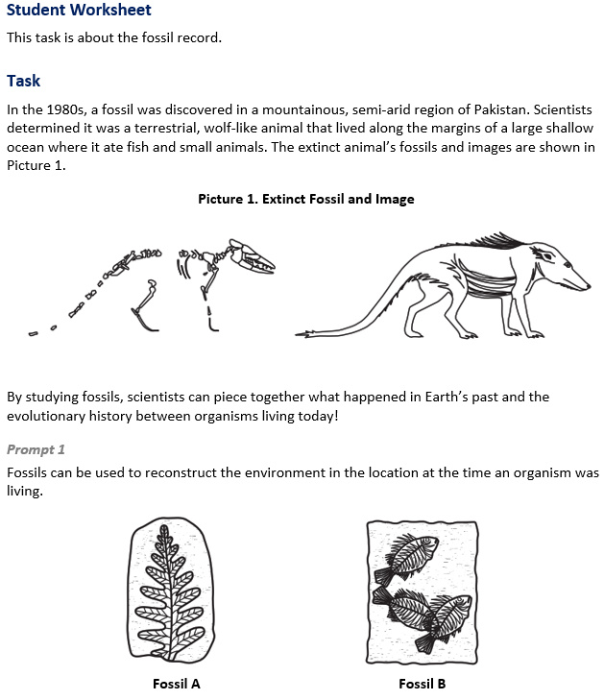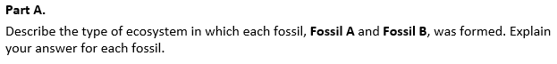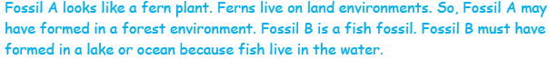
  Task 1 Prompt 1 Part A Complexity
  Degree and Nature of Sensemaking | Moderate | This task…  - Requires integration of two dimensions in the service of sense-making
  Complexity of the Presentation | Moderate | - The amount and type of information provided in the scenario supports multiple evident connections among ideas or concepts  - Provides graphics/data/models
  Cognitive Demand of Response Development | Low | - Requires well-defined set of actions or procedures  - Requires a connection or retrieval of factual information
  Cognitive Demand of Response Production | Low | - Responses include selection from a small set of options presented as text (e.g., word, short phrase) or other formats (e.g., or a simple graphic or process)
  Task 1 Prompt 1 Part A
  Connections to the Instructional Framework
  Integration of Knowledge and Skills for Response Development
  - Students read the provided background information and Picture 1, which introduces a topic related to geologic evidence of Earth’s history.
  - Students interpret a visual representation of a pair of fossils to reconstruct aspects of Earth’s history and interpret ancient environments.
  - Students develop an explanation based on evidence obtained from structural characteristics that indicate that the plant fossil represents a terrestrial environment, and the fish fossil represents an aquatic environment.
  Formative Assessments | Opportunities to Learn
  Segment 2, pp. 14-15  Informal Assessment: Analyzing Fossils: Using Data and Patterns to Connect the Past and Present (A5*, A6*, A7, A8)  - Students accurately describe similarities and differences between organisms today and fossilized organisms based on patterns found in fossil records.  - Students draw appropriate conclusions about the origin of organisms based on patterns in the structure of organisms today and fossilized organisms.  - Students explain what caused similarities and differences between organisms today and fossilized organisms based on fossil records. | Segment 2, p. 32  Ancestors and Descendants: Where Did They Come From? What Became of Them? (A5*, A7)  - Students conduct research online to identify reputable sources with information about ancestors and descendants of their fossils.  - Students gather images of fossils, drawings/representations of the organisms, approximate timeframe for the species, adaptations, and variations between ancestors, and make note of any major events that would have had an impact.
Task 1 Prompt 1 – Part B  Performance Category: Support Explanations About Organisms That Lived Long Ago  Acquisition Goals  - A3. Develop and/or use a model of the process of rock strata formation to describe how it allows us to collect evidence about the relative age of rocks and/or landforms.  - A4. Construct an explanation based on evidence obtained from scientific sources about how rock strata form in the present to explain how rock strata formed earlier in Earth's history.  - A5. Analyze and interpret data in the fossil record to make determinations about evolutionary changes that occurred in the past.  - A6. Compare, integrate, and evaluate sources of information from print resources and articles to solve a problem related to patterns presented in fossil records.  Prompt 1 Part B measures the students’ ability to:  - Support an explanation with evidence, data, or a model to explain the existence, diversity, extinction, and change of many life forms throughout the history of life on Earth.  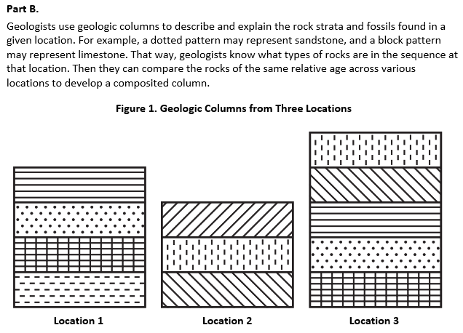  Task 1 Prompt 2 – Parts A and B  Performance Category: Use Models to Describe Rock Formations and Fossils  Acquisition Goals  - A6. Compare, integrate, and evaluate sources of information from print resources and articles to solve a problem related to patterns presented in fossil records.  - A7. Determine similarities and differences between organisms today and fossilized organisms using patterns found in fossil records.  - A8. Use similarities and differences between structures of organisms today and fossilized organisms to find patterns that help draw conclusions about the origin of organisms.  - A9. Develop an explanation about what caused the similarities and differences between organisms today and organisms from fossil records.*  Prompt 2 Parts A and B measure students’ ability to:  - Develop or use models to support descriptions of the rock strata and the fossil record.  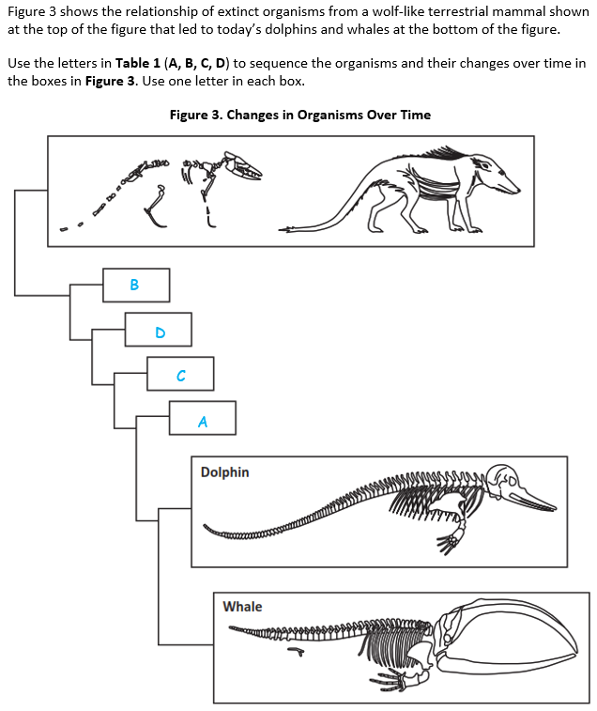 |  | 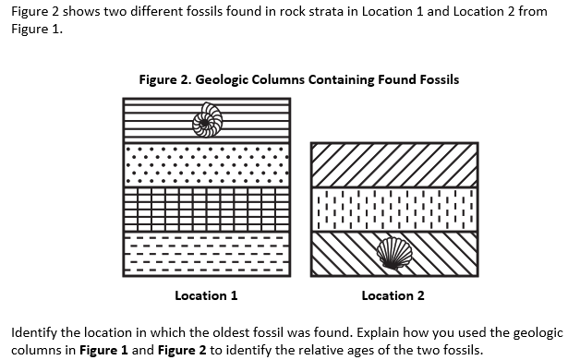  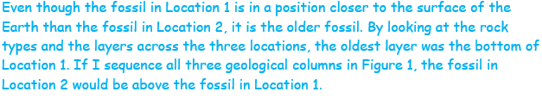  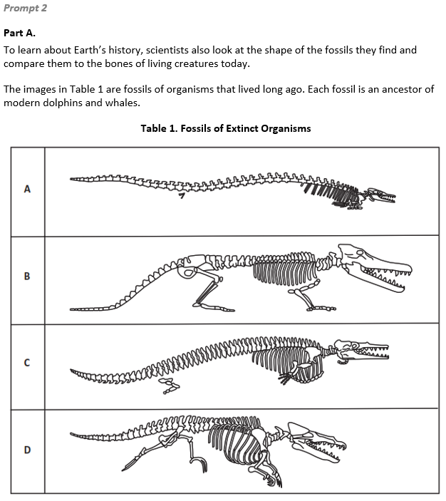  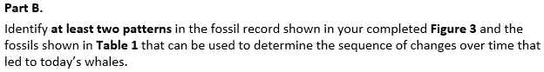  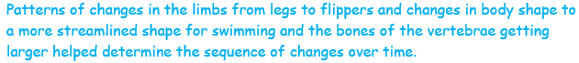
  Task 1 Prompt 1 Part A
  Connections to the Instructional Framework
  Formative Assessments | Opportunities to Learn
  Segment 2, pp. 15-16  Informal Assessment: Organizing Our Thinking: Documenting and Sorting Our Ideas to Find Patterns (A5*, A6*, A7, A8)  - Students identify patterns found in fossil records.  - Students describe similarities and differences between organisms today and fossilized organisms based on patterns found in fossil records.  - Students identify information from media sources that relate to patterns in fossil records.  - Students describe appropriate conclusions about the origin of organisms based on patterns in the structure of organisms today and fossilized organisms.  Segment 2, pp. 18-19  Formal Assessment: Changes in the Fossil Record (A5*, A7)  - Students accurately describe similarities and differences between organisms today and fossilized organisms based on patterns found in fossil records. | Segment 2, pp. 32-33  Building A Tree of Life (A5*, A7, A8)  - Students look for similarities and differences between the species represented on the cladograms.  - The class uses a modern descendant of the teacher’s fossil to compare its skeleton to other organisms in the past and present. Students suggest existing organisms that they think the modern species will be related to and find images of skeletons to put into the outline. The class discusses the similarities and differences between these organisms.  - Students create a scientific explanation that utilizes their cladogram, including the logic and reasoning behind the location of branches and the grouping of species.
  Task 1 Prompt 1 Part B Complexity
  Degree and Nature of Sensemaking | Moderate | This task…  - Requires integration of two dimensions in the service of sense-making
  Complexity of the Presentation | Moderate | - The amount and type of information provided in the scenario supports multiple evident connections among ideas or concepts  - Provides graphics/data/models
  Cognitive Demand of Response Development | Moderate | - Requires drawing relationships and connecting ideas and practices  - Requires a moderate level of sophistication with typical and relatively complex representation of ideas and application of skills
  Cognitive Demand of Response Production | Moderate | - Responses include one or more sentences or a paragraph
  Task 1 Prompt 1 Part B
  Connections to the Instructional Framework, Continued
  Formative Assessments | Opportunities to Learn
  Segment 2, pp. 14-15  Informal Assessment: Analyzing Fossils: Using Data and Patterns to Connect the Past and Present (A5, A6)  - Students accurately identify patterns found in fossil records.  - Students accurately describe similarities and differences between organisms today and fossilized organisms based on patterns found in fossil records.  - Students draw appropriate conclusions about the origin of organisms based on patterns in the structure of organisms today and fossilized organisms.  - Students explain what caused similarities and differences between organisms today and fossilized organisms based on fossil records. | Segment 2, p. 32  Ancestors and Descendants: Where Did They Come From? What Became of Them? (A5)  - Students conduct research online to identify reputable sources with information about ancestors and descendants of their fossils. Students gather images of fossils, drawings/representations of the organisms, approximate timeframe for the species, adaptations, and variations between ancestors, and make note of any major events that would have had an impact.
  Task 1 Prompt 1 Part B
  Connections to the Instructional Framework, Continued
  Formative Assessments | Opportunities to Learn
  Segment 2, pp. 18-19  Formal Assessment: Changes in the Fossil Record (A5)  - Students accurately describe similarities and differences between organisms today and fossilized organisms based on patterns found in fossil records.  Segment 4, pp. 27-28  Formal Assessment: Beneficial Traits Enhance Survival (A3)  - Students develop a model about the process of rock strata formations to provide evidence about the relative age of rocks and/or landforms.  - Students identify information in fossil records that relate to the similarities and differences between organisms today and fossilized organisms. | Segment 2, p. 33  What Was Their Life Like? (A5)  - To create a more robust understanding of evolution related to their fossils, students gather information about their fossil’s world, the world before it, and the world after it. Using the PBDB tool, students start by identifying other fossils discovered near their fossils in the same rock formation and age.  - Students present their reports to an audience and receive additional feedback.  Segment 4, p. 38  Beneficial Traits Enhance Survival (A3)  - Students create their final explanatory model about their chosen fossil and present their information by creating a piece of media, oral presentation, written report, or another format that makes sense for the student.
  Task 1 Prompt 2 Parts A and B
  Connections to the Instructional Framework
  Integration of Knowledge and Skills for Response Development
  - Students are provided with a scenario in which prehistoric creatures with whale-like features living on land show the gradual accumulation of aquatic adaptations that led to modern-day whales.
  - In Part A, students organize a representation of the fossil record that is consistent with the description by comparing, evaluating, and integrating information from Table 1 into Figure 3.
  - In Part B, students describe evidence of similarities and differences in anatomical patterns that support a conclusion.
  Formative Assessments | Opportunities to Learn
  Segment 2, pp. 14-15  Informal Assessment: Analyzing Fossils: Using Data and Patterns to Connect the Past and Present (A6, A7, A8*, A9*)  - Students describe appropriate conclusions about the origin of organisms based on patterns in the structure of organisms today and fossilized organisms.  - Students identify information from media sources that relate to patterns in fossil records.  - Students accurately identify patterns found in fossil records.  - Students accurately describe similarities and differences between organisms today and fossilized organisms based on patterns found in fossil records. | Segment 2, p. 32  Ancestors and Descendants: Where Did They Come From? What Became of Them? (A7)  - Students conduct research online to identify reputable sources with information about ancestors and descendants of their fossils. Students gather images of fossils, drawings/representations of the organisms, approximate timeframe for the species, adaptations, and variations between ancestors, and make note of any major events that would have had an impact.
  Task 1 Prompt 1 Part A
  Connections to the Instructional Framework, Continued
  Formative Assessments | Opportunities to Learn
  Segment 2, pp. 19-20  Formal Assessment: What Was Their Past, Present, and Future? (A8)  - Students draw conclusions about organisms based on patterns in the structure of organisms today and fossilized organisms. | Segment 2, p. 33  What Was Their Life Like? (A5*, A7, A8)  - To create a more robust understanding of evolution related to their fossils, students gather information about their fossil’s world, the world before it, and the world after it. Using the PBDB tool, students start by identifying other fossils discovered near their fossils in the same rock formation and age.  Segment 2, p. 34  What Was Their Past, Present, and Future? (A8)  - Students use this lesson to collect the evidence they have related to their project organism into a single report. They organize their information into an explanation of the evolution of species related to their local fossil.
  Task 1 Prompt 1 Part B
  Connections to the Instructional Framework
  Integration of Knowledge and Skills for Response Development
  - Students are provided with Figure 1 and Figure 2, which provide geoscience data to understand processes and events in Earth’s history.
  - Students use evidence and reasoning from Figure 1 to describe how relative ordering in the three locations are related and use it to determine the age of rock strata in each layer.
  - Students identify the oldest fossil in Location 1 and include comparison of all three locations in Figure 1.
  Formative Assessments | Opportunities to Learn
  Segment 1, pp. 11-12  Formal Assessment: What Was First, Second, Third… (A3, A4)  - Students describe how a model provides evidence about the relative age of rocks and/or landforms.  - Students use a model of the process of rock strata formation to describe the relative age of rocks and/or landforms.  - Students develop a model about the process of rock strata formations to provide evidence about the relative age of rocks and/or landforms.  - Students identify information from newspaper articles that relate to patterns in fossil records. | Segment 1, p. 31  What Was First, Second, Third… (A3, A4)  - Students explore media, text, and online interactive resources to learn about the process of rock formation development and relative dating through principles of superposition, horizontality, cross-cutting relationships, weathering and erosion, intrusions, and index fossils.  - Students create a multimodal explanation of the relative dating of different rock features.
  Task 1 Prompt 1 Part B
  Connections to the Instructional Framework, Continued
  Formative Assessments | Opportunities to Learn
  Segment 2, pp. 15-16  Informal Assessment: Organizing Our Thinking: Documenting and Sorting Our Ideas to Find Patterns (A5, A6)  - Students identify patterns found in fossil records.  - Students describe similarities and differences between organisms today and fossilized organisms based on patterns found in fossil records.  Segment 2, pp. 17-18  Formal Assessment: Building A Tree of Life (A6)  - Students identify and describe evidence in fossil records that relates to the similarities and differences between organisms today and fossilized organisms.  - Students develop an explanation about what caused the similarities and differences between organisms today and organisms from fossil records. | Segment 2, pp. 32-33  Building A Tree of Life (A5)  - Students look for similarities and differences between the species represented on the cladograms.  - The class uses a modern descendant of the teacher’s fossil to compare its skeleton to other organisms in the past and present.  - Students suggest existing organisms that they think the modern species will be related to and find images of skeletons to put into the outline. The class discusses the similarities and differences between these organisms.  - Students create a scientific explanation that utilizes their cladogram, including the logic and reasoning behind the location of branches and the grouping of species.
  Task 1 Prompt 2 Parts A and B Complexity
  Degree and Nature of Sensemaking | Moderate | This task…  - Requires integration of two dimensions in the service of sense-making
  Complexity of the Presentation | Moderate | - The amount and type of information provided in the scenario supports multiple evident connections among ideas or concepts  - Provides graphics/data/models
  Cognitive Demand of Response Development | High | - Requires selection and application of multiple complex ideas and practices  - Requires high degree of sense-making, reasoning, and/or transfer
  Cognitive Demand of Response Production | Moderate | - Responses include one or more sentences or a paragraph
  Task 1 Prompt 2 Parts A and B
  Connections to the Instructional Framework, Continued
  Formative Assessments | Opportunities to Learn
  Segment 2, pp. 15-16  Informal Assessment: Organizing Our Thinking: Documenting and Sorting Our Ideas to Find Patterns (A6, A7, A8*, A9*)  - Students identify information in fossil records that relate to the similarities and differences between organisms today and fossilized organisms.  - Students explain what caused similarities and differences between organisms today and fossilized organisms based on fossil records.  Segment 2, pp. 16-17  Formal Assessment: The Leg Bone Connects To… (A6)  - Students describe how to solve a problem based on information about patterns presented in fossil records.  - Students identify information from newspaper articles that relate to patterns in fossil records.  - Students identify characteristics of skeletal structures and group fossil pieces by characteristics. | Segment 2, pp. 32-33  Building A Tree of Life (A7, A8)  - Students look for similarities and differences between the species represented on the cladograms.  - The class uses a modern descendant of the teacher’s fossil to compare its skeleton to other organisms in the past and present.  - Students suggest existing organisms that they think the modern species will be related to and find images of skeletons to put into the outline. The class discusses the similarities and differences between these organisms.  - Students create a scientific explanation that utilizes their cladogram, including the logic and reasoning behind the location of branches and the grouping of species.
Task 1 Prompt 2 Parts A and B
Connections to the Instructional Framework, Continued
Formative Assessments | Opportunities to Learn
Segment 2, pp. 17-18  Formal Assessment: Building A Tree of Life (A6, A7, A9*)  - Students identify and describe evidence in fossil records that relates to the similarities and differences between organisms today and fossilized organisms.  - Students identify information from media sources that relate to patterns in fossil records.  - Students accurately identify patterns found in fossil records.  - Students accurately describe similarities and differences between organisms today and fossilized organisms based on patterns found in fossil records.  Segment 2, pp. 18-19  Formal Assessment: Changes in the Fossil Record (A7)  - Students accurately identify patterns found in fossil records.  - Students accurately describe similarities and differences between organisms today and fossilized organisms based on patterns found in fossil records. | Segment 2, p. 33  What Was Their Life Like? (A7*, A8, A9)  - To create a more robust understanding of evolution related to their fossils, students gather information about their fossil’s world, the world before it, and the world after it. Using the PBDB tool, students start by identifying other fossils discovered near their fossils in the same rock formation and age.  Segment 2, p. 33  The Leg Bone Connects To… (A6)  - Students are challenged to take up the role of archeologists at a fossil site.  - As students move through each day, they gather more evidence, leading to a change in thinking.  - Students work together across small groups to combine their findings and, using incomplete fossil records, construct their best guess of the skeletons of the different species.

Task 1 Prompt 2 – Part C  Performance Category: Support Explanations About Organisms That Lived Long Ago  Acquisition Goals  - A6. Compare, integrate, and evaluate sources of information from print resources and articles to solve a problem related to patterns presented in fossil records. *  - A7. Determine similarities and differences between organisms today and fossilized organisms using patterns found in fossil records.  - A8. Use similarities and differences between structures of organisms today and fossilized organisms to find patterns that help draw conclusions about the origin of organisms.  - A9. Develop an explanation about what caused the similarities and differences between organisms today and organisms from fossil records.  Prompt 2 Part C measures students’ ability to:  - Support an explanation with evidence, data, or a model to explain the anatomical similarities and differences between modern and fossil organisms to infer evolutionary relationships. |  | 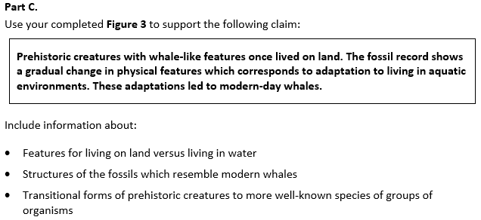  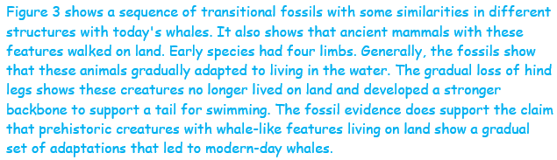
  Task 1 Prompt 2 Part C Complexity
  Degree and Nature of Sensemaking | Moderate | This task…  - Requires integration of two dimensions in the service of sense-making
  Complexity of the Presentation | Low | - The amount and type of information provided in the scenario supports limited simple connections among ideas or concepts
  Cognitive Demand of Response Development | Moderate | - Requires drawing relationships and connecting ideas and practices  - Requires a moderate level of sophistication with typical and relatively complex representation of ideas and application of skills
  Cognitive Demand of Response Production | High | - Responses include multiple paragraphs, multiple graphics of at least moderate complexity, or multiple steps in a complex process
  Task 1 Prompt 2 Part C
  Connections to the Instructional Framework, Continued
  Formative Assessments | Opportunities to Learn
  Segment 2, pp. 15-16  Informal Assessment: Organizing Our Thinking: Documenting and Sorting Our Ideas to Find Patterns (A6*, A7, A8, A9)  - Students identify patterns found in fossil records.  - Students describe similarities and differences between organisms today and fossilized organisms based on patterns found in fossil records.  - Students identify information from media sources that relate to patterns in fossil records.  - Students describe appropriate conclusions about the origin of organisms based on patterns in the structure of organisms today and fossilized organisms. | Segment 2, pp. 32-33  Building A Tree of Life (A7, A8)  - Students look for similarities and differences between the species represented on the cladograms.  - The class uses a modern descendant of the teacher’s fossil to compare its skeleton to other organisms in the past and present. Students suggest existing organisms that they think the modern species will be related to and find images of skeletons to put into the outline. The class discusses the similarities and differences between these organisms.  - Students create a scientific explanation that utilizes their cladogram, including the logic and reasoning behind the location of branches and the grouping of species.
  Task 1 Prompt 2 Part C
  Connections to the Instructional Framework
  Integration of Knowledge and Skills for Response Development
  - Students examine a claim about how patterns in the fossil record show relationships between modern organisms and their common ancestor.
  - Students identify evidence and use reasons based on three similarities and differences in Figure 3.
  - Students support a conclusion about evolutionary relationships using patterns of changes in the level of complexity of anatomical structures in organisms in the fossil record.
  Formative Assessments | Opportunities to Learn
  Segment 2, pp. 14-15  Informal Assessment: Analyzing Fossils: Using Data and Patterns to Connect the Past and Present (A6*, A7, A8, A9)  - Students accurately identify patterns found in fossil records.  - Students accurately describe similarities and differences between organisms today and fossilized organisms based on patterns found in fossil records.  - Students draw appropriate conclusions about the origin of organisms based on patterns in the structure of organisms today and fossilized organisms.  - Students explain what caused similarities and differences between organisms today and fossilized organisms based on fossil records. | Segment 2, p. 32  Ancestors and Descendants: Where Did They Come From? What Became of Them? (A7)  - Students conduct research online to identify reputable sources with information about ancestors and descendants of their fossils. Students gather images of fossils, drawings/representations/pictures of the organisms, approximate timeframe for the species, adaptations, and variations between ancestors, and make note of any major events that would have had an impact.
  Task 1 Prompt 2 Part C
  Connections to the Instructional Framework, Continued
  Formative Assessments | Opportunities to Learn
  Segment 2, pp. 18-19  Formal Assessment: Changes in the Fossil Record (A7)  - Students accurately identify patterns found in fossil records.  - Students accurately describe similarities and differences between organisms today and fossilized organisms based on patterns found in fossil records.  Segment 2, p. 20  Formal Assessment: What Was Their Past, Present, and Future? (A8, A9)  - Students draw conclusions about organisms based on patterns in the structure of organisms today and fossilized organisms.  - Students identify information in fossil records that relate to the similarities and differences between organisms today and fossilized organisms.  - Students explain what caused similarities and differences between organisms today and fossilized organisms based on fossil records. | Segment 2, p. 33  What Was Their Life Like? (A7, A8, A9)  - To create a more robust understanding of evolution related to their fossils, students gather information about their fossil’s world, the world before it, and the world after it. Using the PBDB tool, students start by identifying other fossils discovered near their fossils in the same rock formation and age.  Segment 2, p. 34  What Was Their Past, Present, and Future? (A8, A9)  - Students use this lesson to collect the evidence they have related to their project organism into a single report. They organize their information into an explanation of the evolution of species related to their local fossil.
Future Learning Connected to evidence elicited in Task 1
Crosscutting Concepts
- In Unit 3, students identify patterns in data using graphs, charts, and images and apply patterns to identify cause-and-effect relationships. Students’ experiences in Unit 3 with representing patterns in graphs/charts and considering how structures enable different functions will connect directly with their use of those two CCCs in Unit 4 when developing models of waves and designing solutions that use waves. In Unit 4, Acquisition Goal 4 requires students to develop and use a model to describe and identify the wavelength, frequency, and amplitude of a wave. Students are introduced to a design challenge and practice asking questions about wave phenomena, carrying out investigations to answer their wave-related questions, and modeling waves. (Informal Assessment: All About Waves, pp. 9-10)
Disciplinary Core Ideas
- In Unit 3, students demonstrate an understanding that geologic time can be interpreted from rock strata and provides a way to organize Earth’s history. Additionally, students understand that the analysis of rock strata and the fossil record provides only relative dates and not an absolute scale. These ideas prepare students for Unit 4, in which they will focus on criteria and constraints applied to tasks involving properties and characteristics of simple waves to bring about successful design solutions. In Unit 4, Acquisition Goal 17 requires students to describe a solution to a design problem in terms of criteria using appropriate terminology associated with waves and their motion. Students define a problem, describe how a solution can address the problem, generate a model of the solution, and complete design specifications for the solution to the problem. (Formal Assessment: Final Design Specification, pp. 20-21)
- In Unit 3, students demonstrate an understanding that the fossil record is a collection of fossils and their placement in chronological order. Additionally, students understand that the fossil record documents the existence, diversity, extinction, and change of many life forms throughout the history of life on Earth. These ideas prepare students for Unit 4, in which they will focus on criteria and constraints applied to tasks involving properties and characteristics of simple waves to bring about successful design solutions. In Unit 4, Acquisition Goal 17 requires students to describe a solution to a design problem in terms of criteria using appropriate terminology associated with waves and their motion. Students define a problem, describe how a solution can address the problem, generate a model of the solution, and complete design specifications for the solution to the problem. (Formal Assessment: Final Design Specification, pp. 20-21)
Science and Engineering Practices
- In Unit 3, students analyze and interpret data to determine similarities and differences and construct explanations about real-world phenomena. Modeling and Computational Thinking are used again in the next unit through Unit 4’s focus on waves. These models of waves (including mathematical models) offer an opportunity for students to develop their skills and abilities by using models even further in Unit 4. In Unit 4, Acquisition Goal 5 requires students to use mathematical and computational thinking to show that the wavelength and frequency of a wave are related to one another by the speed of travel of the wave. Students develop and use a mathematical representation to explain how different amplitudes or frequencies of mechanical waves have different amounts of energy when in the same medium. (Formal Assessment: Representing Wave Properties Mathematically, pp. 11-12)
SIPS Grade 8 Unit 3 EOU Assessment Task 2: Hold Your Horses!  Task 2 Prompt 1 – Parts A and B  Performance Category: Analyze Data to Explain the Appearance of Specific Traits in Populations  Acquisition Goals  - A5. Analyze and interpret data in the fossil record to make determinations about evolutionary changes that occurred in the past.  - A17. Use mathematical representations to support scientific conclusions about how environmental conditions caused species to change over time.  Prompt 1 Parts A and B measures students’ ability to:  - Analyze and interpret data and graphs to support conclusions about how some individuals survive and reproduce in a specific environment. |  | 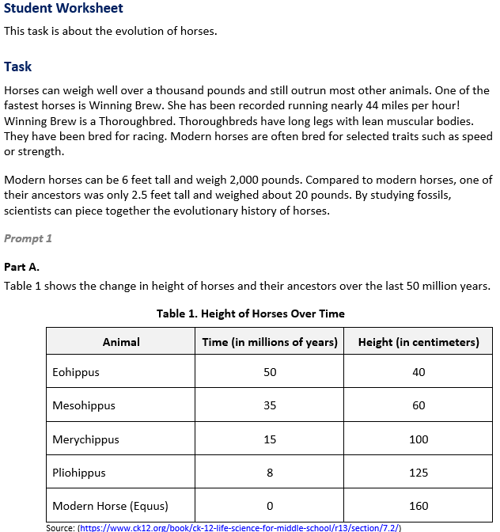

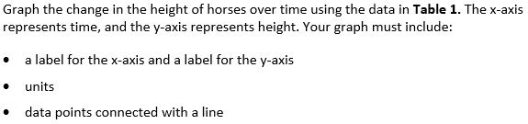  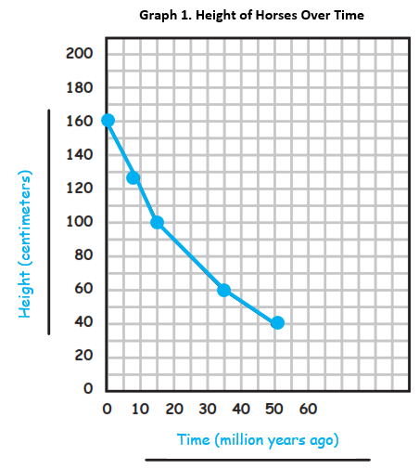 |  | 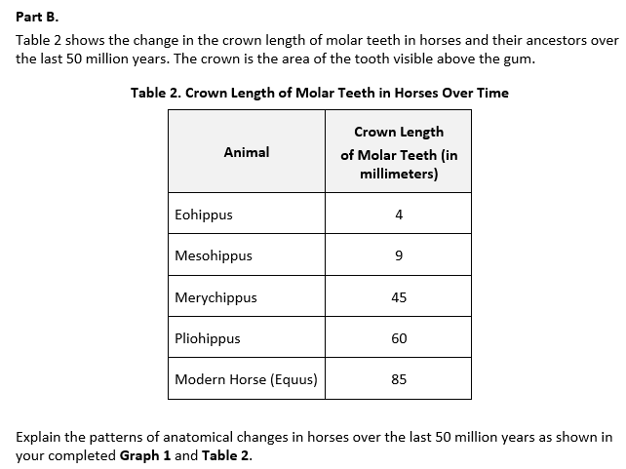
  Task 2 Prompt 1 Parts A and B Complexity
  Degree and Nature of Sensemaking | Moderate | This prompt…  - Requires integration of two dimensions in the service of sensemaking  - Requires a combination of previously learned ideas or concepts and newly presented information
  Complexity of the Presentation | Moderate | - The amount and type of information provided in the scenario supports multiple evident connections among ideas or concepts
  Cognitive Demand of Response Development | Moderate | - Requires drawing relationships and connecting ideas and practices  - Requires a moderate level of sophistication with typical and relatively complex representation of ideas and application of skills
  Cognitive Demand of Response Production | Moderate | - Response includes one or more sentences or a paragraph, a moderately complex graphic, or multiple steps in a simple or moderately complex process
  Task 2 Prompt 1 Parts A and B
  Connections to the Instructional Framework
  Integration of Knowledge and Skills for Response Development
  - Students review the provided evidence from the fossil record which suggests how species change due to natural selection.
  - In Part A, students use Table 1 to graph the change in height of horses over time.
  - In Part B, students analyze data in Table 2 and combine it with information from Table 1 to determine patterns of change in anatomical structures of the horse over time.
  Formative Assessments | Opportunities to Learn
  Segment 2, pp. 14-15  Informal Assessment: Analyzing Fossils: Using Data and Patterns to Connect the Past and Present (A5)  - Students draw a conclusion about events that occurred in the past based on data from fossil records.  Segment 2, pp. 15-16  Informal Assessment: Organizing Our Thinking: Documenting and Sorting Our Ideas to Find Patterns (A5)  - Students describe similarities and differences between organisms today and fossilized organisms based on patterns found in fossil records. | Segment 2, p. 32  Ancestors and Descendants: Where Did They Come From? What Became of Them?  (A5)  - Students conduct research online to identify reputable sources with information about ancestors and descendants of their fossils. Students gather images of fossils, drawings/representations of the organisms, approximate timeframe for the species, adaptations, and variations between ancestors, and make note of any major events that would have had an impact.
Task 2 Prompt 2  Performance Category: Support Explanations About Organisms That Lived Long Ago  Acquisition Goals  - A7. Determine similarities and differences between organisms today and fossilized organisms using patterns found in fossil records.  - A8. Use similarities and differences between structures of organisms today and fossilized organisms to find patterns that help draw conclusions about the origin of organisms.  Prompt 2 measures students’ ability to:  - Support an explanation with evidence, data, or a model to explain the anatomical similarities and differences between modern and fossil organisms to infer evolutionary relationships.  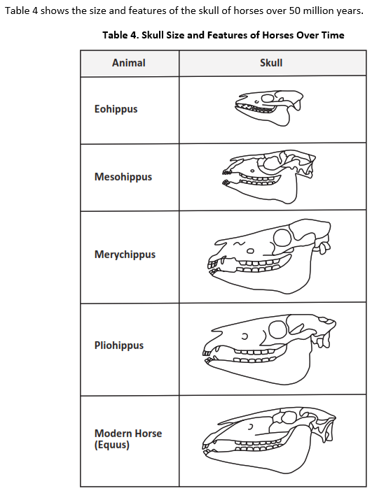 |  | 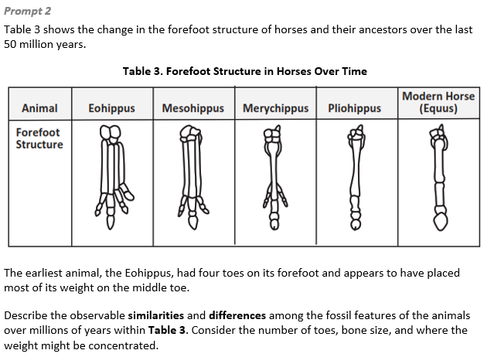  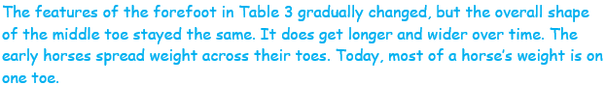
  Task 2 Prompt 1 Parts A and B
  Connections to the Instructional Framework, Continued
  Formative Assessments | Opportunities to Learn
  Segment 2, pp. 18-19  Formal Assessment: Changes in the Fossil Record (A5)  - Students accurately identify patterns found in fossil records.  - Students accurately describe similarities and differences between organisms today and fossilized organisms based on patterns found in fossil records.  Segment 4, pp. 24-25  Informal Assessment: Analyzing Population Data (A17)  - Students generate mathematical representations of the relationships between environmental conditions and changes in traits of species over time.  - Students describe how mathematical representations support conclusions about how environmental conditions caused species to change over time. | Segment 2, pp. 32-33  Building A Tree of Life (A5)  - Students look for similarities and differences between the species represented on the cladograms.  - The class uses a modern descendant of the teacher’s fossil to compare its skeleton to other organisms in the past and present. Students suggest existing organisms that they think the modern species will be related to and find images of skeletons to put into the outline. The class discusses the similarities and differences between these organisms.  - Students create a scientific explanation that utilizes their cladogram, including the logic and reasoning behind the location of branches and the grouping of species.
  Task 2 Prompt 2
  Connections to the Instructional Framework
  Integration of Knowledge and Skills for Response Development
  - Students examine evidence provided in Tables 3 and 4 to support their explanation of how patterns in the fossil record show relationships between modern organisms and their common ancestors.
  - Students identify and describe anatomical similarities and differences between horses living today and organisms in the fossil record.
  Formative Assessments | Opportunities to Learn
  Segment 2, pp. 14-15  Informal Assessment: Analyzing Fossils: Using Data and Patterns to Connect the Past and Present (A7, A8)  - Students accurately identify patterns found in fossil records.  - Students accurately describe similarities and differences between organisms today and fossilized organisms based on patterns found in fossil records.  - Students draw appropriate conclusions about the origin of organisms based on patterns in the structure of organisms today and fossilized organisms.  - Students explain what caused similarities and differences between organisms today and fossilized organisms based on fossil records. | Segment 2, p. 32  Ancestors and Descendants: Where Did They Come From? What Became of Them? (A7)  - Students conduct research online to identify reputable sources with information about ancestors and descendants of their fossils. Students gather images of fossils, drawings/representations of the organisms, approximate timeframe for the species, adaptations, and variations between ancestors, and make note of any major events that would have had an impact.
  Task 1 Prompt 1 Parts A and B
  Connections to the Instructional Framework, Continued
  Formative Assessments | Opportunities to Learn
  Segment 4, pp. 25-26  Formal Assessment: Environmental and Physical Factors Impact Traits in Populations (A17)  - Students generate mathematical representations of the relationship between environmental conditions and changes in traits of species over time.  - Students describe how mathematical representations support conclusions about how environmental conditions caused species to change over time.  Segment 4, pp. 26-27  Formal Assessment: Modeling How Populations Can Change (A17)  - Students generate mathematical representations of the relationships between environmental conditions and changes in traits of species over time.  - Students describe how mathematical representations support conclusions about how environmental conditions caused species to change over time. | Segment 2, p. 33  What Was Their Life Like? (A5)  - To create a more robust understanding of evolution related to their fossils, students gather information about their fossil’s world, the world before it, and the world after it, and identify how changes to the environment impacted the ancestors and descendants of their organism.  Segment 4, pp. 36-37  Looking At Today to Understand the Past (A17)  - Students are introduced to the deer mouse, its range, habitat, behaviors, and the CODAP data analysis tool by analyzing some provided data.  Segment 4, pp. 37-38  Populations Change Over Time (A17)  - Having learned about the environmental and cellular factors that impact the deer mouse, students zoom out to look at how the population changes because of these factors. Students use simulation data to see how the relative frequency of alleles changes over generations.
  Task 2 Prompt 2 Complexity
  Degree and Nature of Sensemaking | Moderate | This task…  - Requires integration of two dimensions in the service of sense-making
  Complexity of the Presentation | Moderate | - The amount and type of information provided in the scenario supports multiple evident connections among ideas or concepts
  Cognitive Demand of Response Development | Low | - Requires well-defined set of actions or procedures  - Requires a connection or retrieval of factual information
  Cognitive Demand of Response Production | Low | - Responses include selection from a small set of options presented as text (e.g., word, short phrase) or other formats (e.g., or a simple graphic or process)
  Task 2 Prompt 2
  Connections to the Instructional Framework, Continued
  Formative Assessments | Opportunities to Learn
  Segment 2, pp. 15-16  Informal Assessment: Organizing Our Thinking: Documenting and Sorting Our Ideas to Find Patterns (A7, A8)  - Students identify patterns found in fossil records.  - Students describe similarities and differences between organisms today and fossilized organisms based on patterns found in fossil records.  - Students identify information from media sources that relate to patterns in fossil records.  - Students draw appropriate conclusions about the origin of organisms based on patterns in the structure of organisms today and fossilized organisms.  Segment 2, pp. 18-19  Formal Assessment: Changes in the Fossil Record (A7)  - Students accurately describe similarities and differences between organisms today and fossilized organisms based on patterns found in fossil records. | Segment 2, pp. 32-33  Building A Tree of Life (A7, A8)  - Students look for similarities and differences between the species represented on the cladograms.  - The class uses a modern descendant of the teacher’s fossil to compare its skeleton to other organisms in the past and present. Students suggest existing organisms that they think the modern species will be related to and find images of skeletons to put into the outline. The class discusses the similarities and differences between these organisms.  - Students create a scientific explanation that utilizes their cladogram, including the logic and reasoning behind the location of branches and the grouping of species.
Task 2 Prompt 3  Performance Category: Support Explanations About Organisms That Lived Long Ago  Acquisition Goals  - A5. Analyze and interpret data in the fossil record to make determinations about evolutionary changes that occurred in the past.  - A7. Determine similarities and differences between organisms today and fossilized organisms using patterns found in fossil records.  - A8. Use similarities and differences between structures of organisms today and fossilized organisms to find patterns that help draw conclusions about the origin of organisms.  - A9. Develop an explanation about what caused the similarities and differences between organisms today and organisms from fossil records.  - A17. Use mathematical representations to support scientific conclusions about how environmental conditions caused species to change over time.  - A19. Construct an explanation about how a species' survival rate is due to the presence of an advantageous trait.  Prompt 3 measures students’ ability to:  - Support an explanation with evidence, data, or a model to explain the relative ages of major events in Earth’s history. |  | 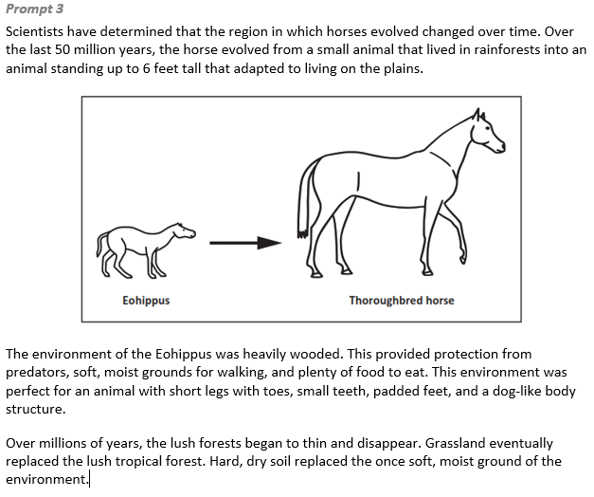
  Task 2 Prompt 2
  Connections to the Instructional Framework, Continued
  Formative Assessments | Opportunities to Learn
  Segment 2, pp. 19-20  Formal Assessment: What Was Their Past, Present, and Future? (A8)  - Students draw conclusions about organisms based on patterns in the structure of organisms today and fossilized organisms.  - Students identify information in fossil records that relate to the similarities and differences between organisms today and fossilized organisms.  - Students explain what caused similarities and differences between organisms today and fossilized organisms based on fossil records. | Segment 2, p. 33  What Was Their Life Like? (A7, A8)  - To create a more robust understanding of evolution related to their fossils, students gather information about their fossil’s world, the world before it, and the world after it, and identify how changes to the environment impacted the ancestors and descendants of their organism.  Segment 2, p. 34  What Was Their Past, Present, and Future? (A8)  - Students use this lesson to collect the evidence they have related to their project organism into a single report. They organize their information into an explanation of the evolution of species related to their local fossil.
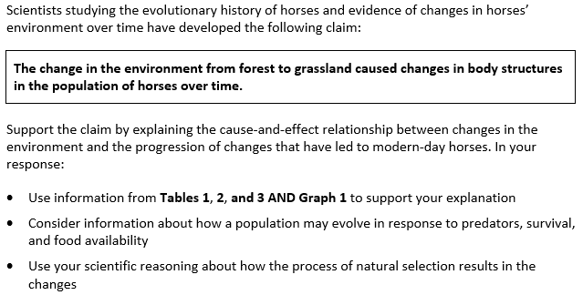  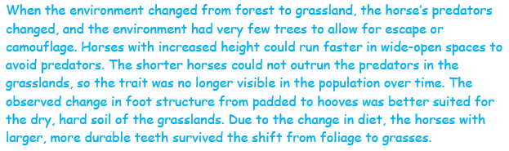
  Task 2 Prompt 3
  Connections to the Instructional Framework
  Integration of Knowledge and Skills for Response Development
  - Students examine evidence to support their explanation of how patterns in the fossil record show relationships between modern organisms and their common ancestors.
  - Students use Tables 1, 2, 3 & Graph 1 that illustrate a geologic time scale of the fossil record of horse structure over time and a description of how the environment changed over time.
  - Students support an explanation using evidence of traits and the cause-and-effect relationships between those traits that affect the probability of survival and reproduction of a given organism in an environment.
  Formative Assessments | Opportunities to Learn
  Segment 2, pp. 14-15  Informal Assessment: Analyzing Fossils: Using Data and Patterns to Connect the Past and Present (A5, A7, A8, A9)  - Students accurately describe similarities and differences between organisms today and fossilized organisms based on patterns found in fossil records. | Segment 2, p. 32  Ancestors and Descendants: Where Did They Come From? What Became of Them? (A5, A7)  - Students conduct research online to identify reputable sources with information about ancestors and descendants of their fossils. Students gather images of fossils, drawings/representations of the organisms, approximate timeframe for the species, adaptations, and variations between ancestors, and make note of any major events that would have had an impact.
  Task 2 Prompt 3
  Connections to the Instructional Framework, Continued
  Formative Assessments | Opportunities to Learn
  Segment 2, pp. 19-20  Formal Assessment: What Was Their Past, Present, and Future? (A8, A9)  - Students draw conclusions about organisms based on patterns in the structure of organisms today and fossilized organisms.  - Students analyze and interpret data to determine evidence for the existence, diversity, extinction, and change in life forms through the history of Earth.  Segment 2, p. 20  Formal Assessment: What Was Their Life Like? (A9)  - Students identify information in fossil records that relate to the similarities and differences between organisms today and fossilized organisms.  - Students explain what caused similarities and differences between organisms today and fossilized organisms based on patterns found in fossil records. | Segment 2, p. 33  What Was Their Life Like? A5, A7, A8, A9)  - Students gather information about their fossil’s world, the world before it, and the world after it. Using the PBDB tool, students start by identifying other fossils discovered near their fossils in the same rock formation and age.  Segment 2, p. 34  What Was Their Past, Present, and Future? (A8, A9)  - Students use this lesson to collect the evidence and organize their information into an explanation of the evolution of species related to their local fossil.  Segment 4, p. 37  Looking At Today to Understand the Past (A17, A19)  - Students are introduced to the deer mouse, its range, habitat, behaviors, and the CODAP data analysis tool by analyzing some provided data.
  Task 2 Prompt 3 Complexity
  Degree and Nature of Sensemaking | Moderate | This prompt…  - Requires integration of two dimensions in the service of sense-making
  Complexity of the Presentation | Low | - The amount and type of information provided in the scenario supports limited simple connections among ideas or concepts  - Phenomenon or problem presented in a concrete way with high level of certainty
  Cognitive Demand of Response Development | High | - Requires selection and application of multiple complex ideas and practices  - Requires high degree of sense-making, reasoning, and/or transfer
  Cognitive Demand of Response Production | High | - Responses include multiple paragraphs, multiple graphics of at least moderate complexity, or multiple steps in a complex process
  Task 2 Prompt 3
  Connections to the Instructional Framework, Continued
  Formative Assessments | Opportunities to Learn
  Segment 2, pp. 15-16  Informal Assessment: Organizing Our Thinking: Documenting and Sorting Our Ideas to Find Patterns (A5, A7, A8, A9)  - Students describe similarities and differences between organisms today and fossilized organisms based on patterns found in fossil records.  Segment 2, pp. 17-18  Formal Assessment: Building A Tree of Life (A9)  - Students develop an explanation about what caused the similarities and differences between organisms today and organisms from fossil records.  Segment 2, pp. 18-19  Formal Assessment: Changes in the Fossil Record (A5, A7*)  - Students accurately identify patterns found in fossil records.  - Students accurately describe similarities and differences between organisms today and fossilized organisms based on patterns found in fossil records. | Segment 2, pp. 32-33  Building A Tree of Life (A5, A7, A8)  - Students look for similarities and differences between the species represented on the cladograms.  - The class uses a modern descendant of the teacher’s fossil to compare its skeleton to other organisms in the past and present. Students suggest existing organisms that they think the modern species will be related to and find images of skeletons to put into the outline. The class discusses the similarities and differences between these organisms.  - Students create a scientific explanation that utilizes their cladogram, including the logic and reasoning behind the location of branches and the grouping of species.
  Task 2 Prompt 3
  Connections to the Instructional Framework, Continued
  Formative Assessments | Opportunities to Learn
  Segment 4, pp. 24-25  Informal Assessment: Analyzing Population Data (A17)  - Students describe how mathematical representations support conclusions about how environmental conditions caused species to change over time.  Segment 4, pp. 25-26  Formal Assessment: Environmental and Physical Factors Impact Traits in Populations (A17, A19)  - Students construct an accurate explanation that describes how an advantageous trait in a population led to an increase in the population of a species. | Segment 4, p. 37  Environmental and Physical Factors Impact Traits in Populations (A18)  - Students explore resources and information about the deer mouse at a variety of ecological levels to better understand the factors that impact the genetics of a deer mouse. Next, students explore the biological processes that give the mouse its color to better understand why different mice have different fur in different habitats.  Segment 4, pp. 37-38  Populations Change Over Time (A17)  - Having learned about the environmental and cellular factors that impact the deer mouse, students zoom out to look at how the population changes because of these factors. Students use simulation data to see how the relative frequency of alleles changes over generations.
Task 2 Prompt 3
Connections to the Instructional Framework, Continued
Formative Assessments | Opportunities to Learn
Segment 4, pp. 26-27  Formal Assessment: Modeling How Populations Can Change (A17)  - Students generate mathematical representations of the relationships between environmental conditions and changes in traits of species over time.  - Students describe how mathematical representations support conclusions about how environmental conditions caused species to change over time.  Segment 4, pp. 27-28  Formal Assessment: Beneficial Traits Enhance Survival (A9)  - Students identify information in fossil records that relate to the similarities and differences between organisms today and fossilized organisms. | Segment 4, p. 38  Modeling How Populations Change Because of Natural Selection (A19)  - After reviewing the unanswered questions from the driving board, students conduct additional research and tests to find the answers to their remaining questions about the field mouse so they can finalize their explanatory model explaining how populations change over time due to natural selection.  Segment 4, p. 38  Beneficial Traits Enhance Survival (A9)  - Students create their final explanatory model about their chosen fossil and present their information by creating a piece of media, oral presentation, written report, or another format that makes sense for the student. Students present their reports to an audience and receive additional feedback.

Future Learning Connected to evidence elicited in Task 2
Crosscutting Concepts
- In Unit 3, students identify patterns in data using graphs, charts, and images and apply patterns to identify cause-and-effect relationships. Students’ experiences in Unit 3 with representing patterns in graphs/charts and considering how structures enable different functions will connect directly with their use of those two CCCs in Unit 4 when developing models of waves and designing solutions that use waves. In Unit 4, Acquisition Goal 4 requires students to develop and use a model to describe and identify the wavelength, frequency, and amplitude of a wave. Students are introduced to a design challenge and practice asking questions about wave phenomena, carrying out investigations to answer their wave-related questions, and modeling waves. (Informal Assessment: All About Waves, pp. 9-10)
Disciplinary Core Ideas
- In Unit 3, students understand that anatomical similarities and differences between various organisms living today and the fossil record enable the reconstruction of evolutionary history. Additionally, students understand that these similarities and differences can provide information to make inferences about lines of evolutionary descent. These ideas prepare students for Unit 4, in which they will focus on criteria and constraints applied to tasks involving properties and characteristics of simple waves to bring about successful design solutions. In Unit 4, Acquisition Goal 17 requires students to describe a solution to a design problem in terms of criteria using appropriate terminology associated with waves and their motion. Students define a problem, describe how a solution can address the problem, generate a model of the solution, and complete design specifications for the solution to the problem. (Formal Assessment: Final Design Specification, pp. 20-21)
- In Unit 3, demonstrate an understanding that natural selection leads to the predominance of certain traits in a population and the suppression of others. Additionally, students demonstrate an understanding that adaptation by natural selection is a process by which species change over time in response to changes in environmental conditions. These ideas prepare students for Unit 4, in which they will focus on criteria and constraints applied to tasks involving properties and characteristics of simple waves to bring about successful design solutions. In Unit 4, Acquisition Goal 17 requires students to describe a solution to a design problem in terms of criteria using appropriate terminology associated with waves and their motion. Students define a problem, describe how a solution can address the problem, generate a model of the solution, and complete design specifications for the solution to the problem. (Formal Assessment: Final Design Specification, pp. 20-21)
Science and Engineering Practices
- In Unit 3, students analyze and interpret data to determine similarities and differences, construct explanations about real-world phenomena, and use mathematical representations to support scientific conclusions related to measurable changes in selected traits in a population over time. Modeling and Computational Thinking are used again in the next unit through Unit 4’s focus on waves. These models of waves (including mathematical models) offer an opportunity for students to develop their skills and abilities by using models even further in Unit 4. In Unit 4, Acquisition Goal 5 requires students to Use mathematical and computational thinking to show that the wavelength and frequency of a wave are related to one another by the speed of travel of the wave. Students develop and use a mathematical representation to explain how different amplitudes or frequencies of mechanical waves have different amounts of energy when in the same medium. (Formal Assessment: Representing Wave Properties Mathematically, pp. 11-12)

SIPS Grade 8 Unit 3 EOU Assessment Task 3: What Beak-ame of You?  Task 3 Prompt 1 – Parts A and B  Performance Category: Analyze Data to Explain the Appearance of Specific Traits in Populations  Acquisition Goals:  - A16. Determine similarities and differences using patterns in findings related to the proportions of a species in a population across generations.*  - A17. Use mathematical representations to support scientific conclusions about how environmental conditions caused species to change over time.  - A18. Use a model to explain how the environment causes a change in the proportion of a species across generations.*  - A19. Construct an explanation about how a species' survival rate is due to the presence of an advantageous trait.  Prompt 1 Parts A and B measure students’ ability to:  - Analyze and interpret data and graphs to support conclusions about how natural selection may lead to increases and decreases of genetic traits in populations over time. |  |  | 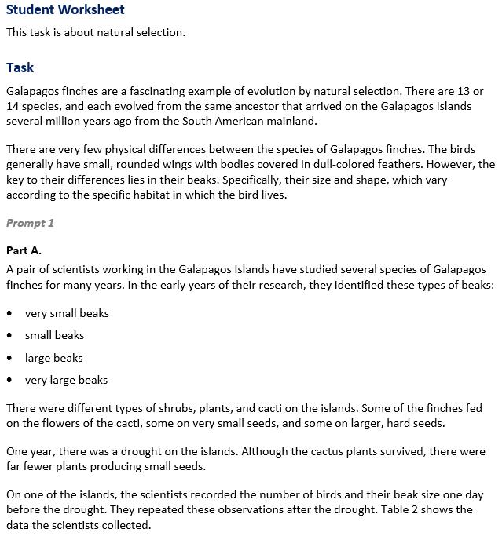
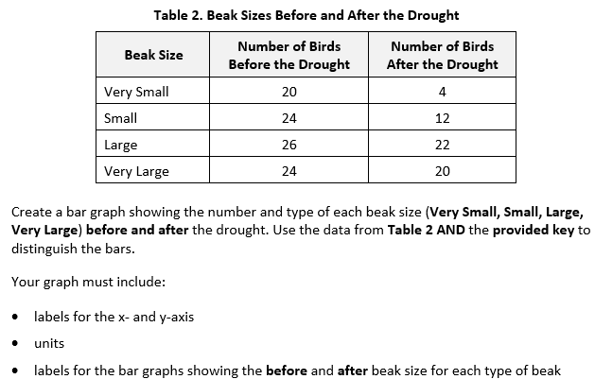  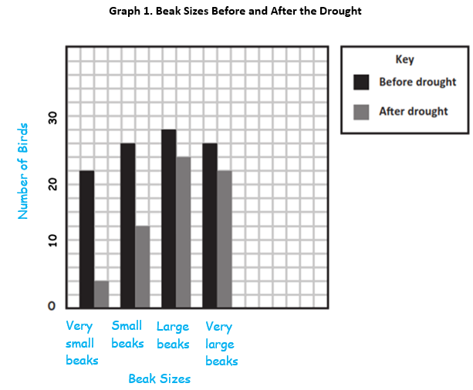 |  |  | 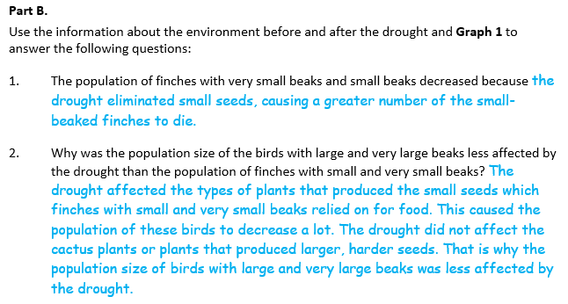
  Task 3 Prompt 1 Parts A and B Complexity
  Degree and Nature of Sensemaking | Moderate | This prompt…  - Requires integration of two dimensions in the service of sense-making
  Complexity of the Presentation | Moderate | - The amount and type of information provided in the scenario supports multiple evident connections among ideas or concepts
  Cognitive Demand of Response Development | Moderate | - Requires drawing relationships and connecting ideas and practices  - Requires a moderate level of sophistication with typical and relatively complex representation of ideas and application of skills
  Cognitive Demand of Response Production | Low | - Responses include selection from a small set of options presented as text (e.g., word, short phrase) or other formats (e.g., or a simple graphic or process)
  Task 3 Prompt 1 Parts A and B
  Connections to the Instructional Framework
  Integration of Knowledge and Skills for Response Development
  - Students review the task background and Table 2, which presents a topic related to physiological adaptations in living organisms and supports an explanation of how the climate pattern on a Galapagos Island could influence what happened to the finch populations.
  - Students analyze and graph data to explain the cause-and-effect relationship between the patterns of change in anatomical structures of finches’ beaks over time and environmental factors.
  Formative Assessments | Opportunities to Learn
  Segment 4, pp. 24-25  Informal Assessment: Analyzing Population Data (A16*, A17)  - Students accurately identify patterns related to the proportions of a species with a particular trait or traits across generations.  - Students accurately describe similarities and differences in the proportions of a species with a given trait(s) across generations of a population.  - Students describe how mathematical representations support conclusions about how environmental conditions caused species to change over time. | Segment 4, pp. 36-37  Looking At Today to Understand the Past (A17, A18*, A19)  - Students are introduced to the deer mouse, its range, habitat, behaviors, and the CODAP data analysis tool by analyzing some provided data.  Segment 4, pp. 37-38  Populations Change Over Time (A16*, A17)  - Having learned about the environmental and cellular factors that impact the deer mouse, students zoom out to look at how the population changes because of these factors. Students use simulation data to see how the relative frequency of alleles changes over generations.
Task 3 Prompt 2 – Parts A and B  Performance Category: Analyze Data to Explain the Appearance of Specific Traits in Populations  Acquisition Goals:  - A11. Develop and/or use a model that shows sexual reproduction and/or genetic mutations can affect an organism's traits.  - A12. Critically read scientific text(s) to obtain and make sense of information about genes, alleles, and chromosomes (and the relationships between them) to describe patterns in traits across organisms.*  - A13. Develop and/or use a model that shows the relationships between genes, alleles, chromosomes, and cells in order to describe why organisms have different traits. *  - A14. Critically read scientific text(s) to obtain and make sense of information about genes, proteins, and traits (and the relationships between their structures and functions) to provide evidence that genes can affect an organism's traits.  - A15. Develop and/or use a model that shows the relationships between genes, mutations, proteins, structures, and functions.  Prompt 2 Parts A and B measures students’ ability to:  - Analyze and interpret data and graphs to support conclusions about how genetic variations of traits in a population increase some individuals’ probability of surviving and reproducing.  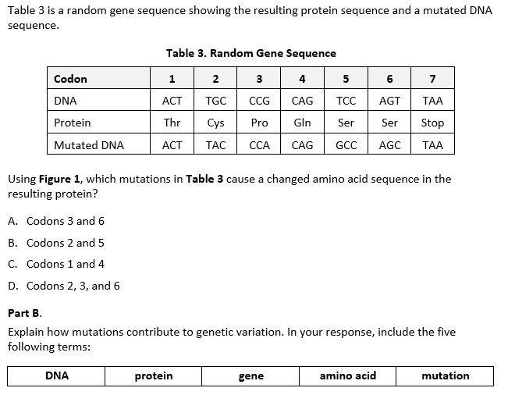  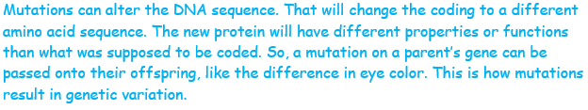  Task 3 Prompt 3 – Parts A and B  Performance Category: Analyze Data to Explain the Appearance of Specific Traits in Populations  Acquisition Goals:  - A9. Develop an explanation about what caused the similarities and differences between organisms today and organisms from fossil records.*  - A11. Develop and/or use a model that shows sexual reproduction and/or genetic mutations can affect an organism's traits.*  - A16. Determine similarities and differences using patterns in findings related to the proportions of a species in a population across generations.  - A17. Use mathematical representations to support scientific conclusions about how environmental conditions caused species to change over time.*  - A18. Use a model to explain how the environment causes a change in the proportion of a species across generations.*  - A19. Construct an explanation about how a species' survival rate is due to the presence of an advantageous trait.  Prompt 3 Parts A and B measure students’ ability to:  - Analyze and interpret data and graphs to support conclusions about how natural selection may lead to increases and decreases of genetic traits in populations over time. |  |  |  | 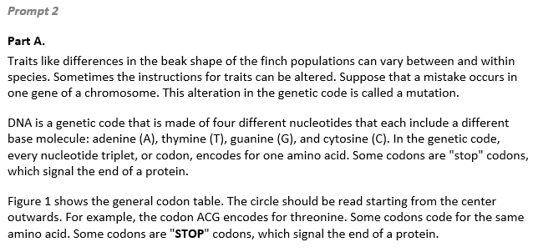  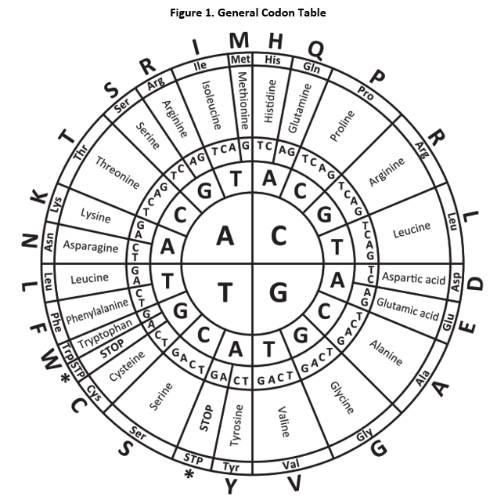  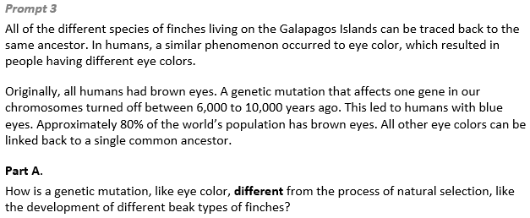  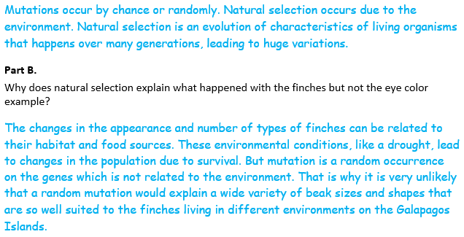
  Task 3 Prompt 1 Parts A and B
  Connections to the Instructional Framework, Continued
  Formative Assessments | Opportunities to Learn
  Segment 4, pp. 25-26  Formal Assessment: Environmental and Physical Factors Impact Traits in Populations (A16*, A17, A19)  - Students accurately identify patterns related to the proportions of a species with a particular trait or traits across generations.  - Students construct an accurate explanation that describes how an advantageous trait in a population led to an increase in the population of a species.  Segment 4, pp. 26-27  Formal Assessment: Modeling How Populations Can Change (A17, A18*)  - Students generate mathematical representations of the relationships between environmental conditions and changes in traits of species over time.  - Students describe how mathematical representations support conclusions about how environmental conditions caused species to change over time. | Segment 4, p. 38  Modeling How Populations Change Because of Natural Selection (A18*, A19)  - After reviewing the unanswered questions from the driving board, students conduct additional research and tests to find the answers to their remaining questions about the field mouse so they can finalize their explanatory model explaining how populations change over time due to natural selection.
  Task 3 Prompt 2 Parts A and B
  Connections to the Instructional Framework
  Integration of Knowledge and Skills for Response Development
  - Students review the prompt background, which includes a model of codon table with a description of DNA, a mutation, and its result.
  - Students analyze and interpret a general codon table to identify the effects of a mutation on the resulting protein and a trait of an organism and explain how changes to proteins can affect observable structures and functions in organisms.
  - Students critically interpret the text in the scenario and prompt to construct an explanation about how mutations contribute to genetic variation.
  Formative Assessments | Opportunities to Learn
  Segment 3, pp. 20-21  Informal Assessments: Scientific Notebooks (A11, A12*, A13*, A14, A15)  - Students use a model to provide evidence that sexual reproduction and/or genetic mutations can affect an organism’s traits.  - Students describe how a model shows the relationship between genes, alleles, chromosomes, and cells. | Segment 3, p. 35  From Gene to Protein to Person (A11, A12*, A14, A15)  - Students explore multimodal resources to better understand how genes are connected to proteins and that is what leads to differences between organisms.  Segment 3, p. 35  Mutations and Change in Infectious Diseases (A11)  - Students utilize interactives to simulate and draw conclusions about the impact of mutations on viruses and bacteria, and then see how the changes impact the human population through several activities.
  Task 3 Prompt 2 Parts A and B
  Connections to the Instructional Framework, Continued
  Formative Assessments | Opportunities to Learn
  Segment 4, pp. 26-27
  Formal Assessment: Modeling How Populations Can Change (A15)
  - Students describe how a model shows the relationships between genes, mutation, proteins, structures, and functions.
  - Students use a model to provide evidence about the relationship between genes, mutations, proteins, structures, and functions.
  Segment 4, pp. 27-28
  Formal Assessment: Beneficial Traits Enhance Survival (A11)
  - Students develop and use a model to show how sexual reproduction and/or genetic mutations can affect an organism's traits.
  Task 3 Prompt 3 Parts A and B Complexity
  Degree and Nature of Sensemaking | High | This prompt…  - Requires integration of three dimensions in the service of sense-making
  Complexity of the Presentation | Low | - The amount and type of information provided in the scenario supports limited simple connections among ideas or concepts
  Cognitive Demand of Response Development | Moderate | - Requires drawing relationships and connecting ideas and practices  - Requires a moderate level of sophistication with typical and relatively complex representation of ideas and application of skills
  Cognitive Demand of Response Production | High | - Responses include multiple paragraphs, multiple graphics of at least moderate complexity, or multiple steps in a complex process
  Task 3 Prompt 3 Parts A and B
  Connections to the Instructional Framework, Continued
  Formative Assessments | Opportunities to Learn
  Segment 4, pp. 24-25  Informal Assessment: Analyzing Population Data (A16, A17*, A19)  - Students accurately identify patterns related to the proportions of a species with a particular trait or traits across generations.  - Students accurately describe similarities and differences in the proportions of a species with a given trait(s) across generations of a population.  - Students describe how mathematical representations support conclusions about how environmental conditions caused species to change over time. | Segment 4, pp. 36-37  Looking At Today to Understand the Past (A17*, A19)  - Students are introduced to the deer mouse, its range, habitat, behaviors, and the CODAP data analysis tool by analyzing some provided data.  Segment 4, pp. 37-38  Populations Change Over Time (A16, A17*)  - Having learned about the environmental and cellular factors that impact the deer mouse, students zoom out to look at how the population changes because of these factors. Students use simulation data to see how the relative frequency of alleles changes over generations.
  Task 3 Prompt 3 Parts A and B
  Connections to the Instructional Framework, Continued
  Formative Assessments | Opportunities to Learn
  Segment 4, pp. 27-28
  Formal Assessment: Beneficial Traits Enhance Survival (A9, A11, A18*)
  - Students explain what caused similarities and differences between organisms today and fossilized organisms based on fossil records.
  - Students develop and use a model to show how sexual reproduction and/or genetic mutations can affect an organism's traits.
  - Students accurately identify the evidence that supports a claim about how a trait in a population led to an increase in the population of a species. Students construct an accurate explanation that describes how an advantageous trait in a population led to an increase in the population of a species.
  Task 3 Prompt 2 Parts A and B Complexity
  Degree and Nature of Sensemaking | Moderate | This prompt…  - Requires integration of two dimensions in the service of sense-making
  Complexity of the Presentation | High | - The amount and type of information provided in the scenario supports multiple and varied complex connections among ideas or concepts  - Provides complex graphics/data/models
  Cognitive Demand of Response Development | Moderate | - Requires drawing relationships and connecting ideas and practices  - Requires a moderate level of sophistication with typical and relatively complex representation of ideas and application of skills
  Cognitive Demand of Response Production | Moderate | - Response includes one or more sentences or a paragraph, a moderately complex graphic, or multiple steps in a simple or moderately complex process
  Task 3 Prompt 2 Parts A and B
  Connections to the Instructional Framework, Continued
  Formative Assessments | Opportunities to Learn
  Segment 4, pp. 24-25  Informal Assessment: Analyzing Population Data (A15)  - Students describe how a model shows the relationships between genes, mutation, proteins, structures, and functions.  - Students use a model to provide evidence about the relationship between genes, mutations, proteins, structures, and functions.  Segment 4, pp. 25-26  Formal Assessment: Environmental and Physical Factors Impact Traits in Populations (A15)  - Students describe how mathematical representations support conclusions about how environmental conditions caused species to change over time.  - Students accurately identify patterns related to the proportions of a species with a particular trait or traits across generations. | Segment 4, p. 37  Environmental and Physical Factors Impact Traits in Populations (A13*, A15)  - Students explore resources and information about the deer mouse at a variety of ecological levels to better understand the factors that impact the genetics of a deer mouse. Next, students explore the biological processes that give the mouse its color to better understand why different mice have different fur in different habitats.  Segment 4, p. 38  Beneficial Traits Enhance Survival (A11)  - Students create their final explanatory model about their chosen fossil and present their information by creating a piece of media, oral presentation, written report, or another format that makes sense for the student. Students present their reports to an audience and receive additional feedback.
  Task 3 Prompt 3 Parts A and B
  Connections to the Instructional Framework
  Integration of Knowledge and Skills for Response Development
  - Students construct and support an explanation after they examine evidence of the processes of natural selection and mutation using the finches and eye color.
  - Students compare and contrast the mechanisms and outcomes of mutations and natural selection using the example of finches vs. eye color as evidence.
  Formative Assessments | Opportunities to Learn
  Segment 3, pp. 20-21  Informal Assessments: Scientific Notebooks (A11)  - Students obtain, evaluate, and communicate to describe how variations of traits occur through patterns of inheritance or genetic mutation.  Segment 3, pp. 23-24  Formal Assessment: Explaining How a Mutation Impacts an Organism (A11)  - Students obtain, evaluate, and communicate to describe how variations of traits occur through patterns of inheritance or genetic mutation. | Segment 3, p. 35  Mutations and Change in Infectious Diseases (A11)  - Students use interactives to stimulate the impact of mutations on viruses and bacteria, and then see how the changes impact the human population through several activities.  Segment 3, p. 36  Human Impacts of Mutations (A11)  - Students use a variety of resources to obtain information and develop simple explanatory models to show how mutations in genes affect protein structure and function and how they lead to different traits in organisms.
  Task 3 Prompt 3 Parts A and B
  Connections to the Instructional Framework, Continued
  Formative Assessments | Opportunities to Learn
  Segment 4, pp. 25-26  Formal Assessment: Environmental and Physical Factors Impact Traits in Populations (A16, A17*, A19)  - Students accurately identify patterns related to the proportions of a species with a particular trait or traits across generations.  - Students construct an accurate explanation that describes how an advantageous trait in a population led to an increase in the population of a species.  Segment 4, pp. 26-27  Formal Assessment: Modeling How Populations Can Change (A17, A18)  - Students generate mathematical representations of the relationships between environmental conditions and changes in traits of species over time.  - Students describe how mathematical representations support conclusions about how environmental conditions caused species to change over time. | Segment 4, p. 38  Modeling How Populations Change Because of Natural Selection (A18*, A19)  - After reviewing the unanswered questions from the driving board, students conduct additional research and tests to find the answers to their remaining questions about the field mouse so they can finalize their explanatory model explaining how populations change over time due to natural selection.  Segment 4, p. 38  Beneficial Traits Enhance Survival (A9, A11, A18*)  - Students create a final explanatory model about their chosen fossil and present their information by creating a piece of media, oral presentation, written report, or other format.
Future Learning Connected to evidence elicited in Task 3
Crosscutting Concepts
- In Unit 3, students identify patterns in data using graphs, charts, and images and apply patterns to identify cause-and-effect relationships. Students’ experiences in Unit 3 with representing patterns in graphs/charts and considering how structures enable different functions will connect directly with their use of those two CCCs in Unit 4 when developing models of waves and designing solutions that use waves. In Unit 4, Acquisition Goal 4 requires students to develop and use a model to describe and identify the wavelength, frequency, and amplitude of a wave. Students are introduced to a design challenge and practice asking questions about wave phenomena, carrying out investigations to answer their wave-related questions, and modeling waves. (Informal Assessment: All About Waves, pp. 9-10)
Disciplinary Core Ideas
- In Unit 3, students demonstrate an understanding that genes are located in the chromosomes of cells and each distinct gene chiefly controls the production of specific proteins, which in turn affects the traits of the individual. Additionally, students demonstrate an understanding that genetic mutations can result in changes to the structure and function of proteins which may be beneficial, harmful, or neutral to the organism. These ideas prepare students for Unit 4, in which they will focus on criteria and constraints applied to tasks involving properties and characteristics of simple waves to bring about successful design solutions. In Unit 4, Acquisition Goal 17 requires students to describe a solution to a design problem in terms of criteria using appropriate terminology associated with waves and their motion. Students define a problem, describe how a solution can address the problem, generate a model of the solution, and complete design specifications for the solution to the problem. (Formal Assessment: Final Design Specification, pp. 20-21)
- In Unit 3, demonstrate an understanding that natural selection leads to the predominance of certain traits in a population and the suppression of others. Additionally, students demonstrate an understanding that adaptation by natural selection is a process by which species change over time in response to changes in environmental conditions. These ideas prepare students for Unit 4, in which they will focus on criteria and constraints applied to tasks involving properties and characteristics of simple waves to bring about successful design solutions. In Unit 4, Acquisition Goal 17 requires students to describe a solution to a design problem in terms of criteria using appropriate terminology associated with waves and their motion. Students define a problem, describe how a solution can address the problem, generate a model of the solution, and complete design specifications for the solution to the problem. (Formal Assessment: Final Design Specification, pp. 20-21)
Science and Engineering Practices
- In Unit 3, students analyze and interpret data to determine similarities and differences, construct explanations about real-world phenomena, and use mathematical representations to support scientific conclusions related to measurable changes in selected traits in a population over time. Modeling and Computational Thinking are used again in the next unit through Unit 4’s focus on waves. These models of waves (including mathematical models) offer an opportunity for students to develop their skills and abilities by using models even further in Unit 4. In Unit 4, Acquisition Goal 5 requires students to use mathematical and computational thinking to show that the wavelength and frequency of a wave are related to one another by the speed of travel of the wave. Students develop and use a mathematical representation to explain how different amplitudes or frequencies of mechanical waves have different amounts of energy when in the same medium. (Formal Assessment: Representing Wave Properties Mathematically, pp. 11-12)

