Coherence and Alignment Among Science Curriculum, Instruction, and Assessment (CASCIA)  Grade 8 Unit 4  End-of-Unit Assessment  Task Interpretation Guide  April 2024  The Grade 8 Unit 4 End-of-Unit Assessment Task Interpretation Guide was developed with funding from the U.S. Department of Education under the Competitive Grants for State Assessments Program, CFDA 84.368A. The contents of this guide do not represent the policy of the U.S. Department of Education, and no assumption of endorsement by the Federal government should be made. |  |   All rights reserved. Any or all portions of this document may be reproduced and distributed without prior permission, provided the source is cited as: Coherence and Alignment Among Science Curriculum, Instruction, and Assessment (CASCIA) Project. (2024). Grade 8 Unit 4 End-of-Unit Assessment Task Interpretation Guide. Lincoln, NE: Nebraska Department of Education.

Table of Contents
Introduction 1
Purpose 1
Contents 2
SIPS Grade 8 Unit 4 EOU Assessment Task 1: Now You See It 3
Task 1 Prompt 1 3
Task 1 Prompt 2 – Parts A and B 6
Task 1 Prompt 3 – Parts A and B 9
SIPS Grade 8 Unit 4 EOU Assessment Task 2: Color My World 14
Task 2 Prompt 1 – Part A 14
Task 2 Prompt 1 – Part B 17
Task 2 Prompt 1 – Part C 20
Task 2 Prompt 2 – Parts A and B 22
SIPS Grade 8 Unit 4 EOU Assessment Task 3: Sounds of Silence 27
Task 3 Prompt 1 27
Task 3 Prompt 2 – Parts A and B 30
Task 3 Prompt 2 – Part C 33
Task 3 Prompt 3 – Part A 37
Task 3 Prompt 3 – Parts B and C 39

Introduction  The use of formative assessment practices, with informative and immediate feedback that leads to adjustments to instructional next steps, has been shown to be effective in helping students learn (Black & Wiliam, 1998; Wylie & Lyon, 2009; Heritage, 2010). Interim or large-scale summative assessments, such as those required under the Every Student Succeeds Act of 2015 (ESSA), cannot and are not meant to inform daily instruction because of how and when they are administered. These forms of assessment can bring value to an assessment system, but only if coordinated and meaningfully aligned within a comprehensive, coherent system.  The Coherence and Alignment Among Science Curriculum, Instruction, and Assessment (CASCIA) Project brings together three partner states—Nebraska, Alabama, and Alaska—with a team of researchers and experts to establish science assessment resources that are coordinated and aligned across all parts of the assessment system. With coherence as the guiding principle, these state-level educators and national science education and measurement experts have joined with hundreds of local educators to address states’ need for quality, standards-aligned science assessments that generate meaningful, interpretable, and actionable results, and to design a scoring and score reporting framework that builds educators’ capacity to track, interpret, and communicate students’ learning in science and to offer effective instruction for all students.  Purpose  The purpose of the Grade 8 Unit 4 End-of-Unit Assessment Task Interpretation Guide is to support educators’ understanding of the Grade 8 Unit 4 End-of-Unit assessment tasks and prompts, their features, and the evidence (i.e., knowledge and skills) they are designed to elicit about student learning, and how the assessment and the information it provides can be used to plan instruction and learning opportunities for students, whether it involves planning for instruction prior to teaching the instructional unit, reflecting on the quality and sufficiency of prior instruction and instructional materials or planning additional student learning opportunities or interventions in the subsequent unit. |  | The Grade 8 Unit 4 Science Assessment includes three science tasks, each including multiple scorable prompts. Task 1, Now You See It, includes three prompts and ten possible score points with Prompts 2 and 3 having a Part A and B; Task 2, Color My World, includes two prompts and 13 possible score points with Prompt 1 having a Part A, B, and C and Prompt 2 having a Part A and B; Task 3, Sounds of Silence, includes three prompts and 14 possible score points, with Prompts 2 and 3 having a Part A, B, and C.  Prompts from the three tasks that measure similar combinations of dimensions (i.e., Disciplinary Core Ideas, Science and Engineering Practices, and Crosscutting Concepts) from the Next Generation Science Standards (NGSS) are organized into three performance categories. The NGSS Performance Expectations (PEs) are addressed in one or more performance categories to provide multiple opportunities to demonstrate flexible thinking and competency in different situations and contexts.
  Performance Category | NGSS PEs | Prompts in Performance Category | Points Possible
  Analyze Data to Explain the Relationships Between Properties of Waves and Energy | MS-PS4-1, MS-PS4-2 | Task 1, Prompt 2 Task 3, Prompt 2AB Task 1, Prompt 3 Task 3, Prompt 1 Task 3, Prompt 2C | 14 points
  Use Models to Describe Interactions Between Light Waves and Materials | MS-PS4-1, MS-PS4-2 | Task 1, Prompt 1 Task 2, Prompt 1A Task 2, Prompt 1B Task 2, Prompt 1C Task 2, Prompt 2A Task 2, Prompt 2B | 15 points
  Design the Best Solution to a Problem Involving Properties of Sound Waves and Materials | MS-PS4-1, MS-PS4-2, MS-ETS1-1 | Task 3, Prompt 3A Task 3, Prompt 3B Task 3, Prompt 3C | 8 points
Contents  This document includes interpretive guidance to support educators’ understanding of each prompt on the Grade 8 Unit 4 EOU Assessment, its features, and the evidence it is designed to elicit about students’ learning, and offers important connections to the learning goals, formative assessment opportunities, and lesson descriptions within the SIPS Grade 8 Unit 4 Map / Instructional Framework as well as connections to future learning opportunities in the next unit.  For each prompt, the following information is provided:  - Performance Category – A classification of prompts within the EOU based on similarities in knowledge, skills, and abilities for which the prompts were designed to measure.  - Acquisition Goals – Specific goals that describe what students should understand, know, and be able to do at the end of a unit or course of instruction. The acquisition goals are derived from Stage 1 of the unit map / instructional framework that the prompt is intended to measure.  - Prompt Knowledge and Skills for Measurement – The evidence of student learning the prompt is designed to elicit.  - Prompt and Exemplar Response – The prompt consists of one to three sentences that raises an issue or asks a question to which students need to respond. An exemplar response represents a high-quality response that provides evidence that students have demonstrated the knowledge, skills, and abilities assessed by the prompt. Student exemplars are intended to assist in understanding the nature and expectations of the prompt. However, students may respond with other relevant scientifically accurate responses, evidence, observations, and ideas.  In general, a full-point exemplar response meets expectations and is:  - scientifically accurate  - complete  - coherent |  | - consistent with the type of student evidence expected as described in the rubric  For examples of student responses for each prompt representative of the full range of score points possible based on the scoring rubric, access the Grade 8 Unit 4 EOU Assessment Scoring Guide.  - Prompt Complexity – The sophistication of students’ ability to demonstrate sense-making is characterized by their ability to (a) use disciplinary core ideas (DCIs), scientific and engineering practices (SEPs), and crosscutting concepts (CCCs) together in the service of sense-making about a phenomenon or problem, and (b) engage with and respond to items and tasks designed using variable features representing combinations of Low, Moderate, and High complexity designations. These combinations of features are based on the SIPS Complexity Framework.  Adapted from the Cambridge Alignment Methodology (Forte, 2021) and informed by aspects of Achieve’s Framework to Evaluate Cognitive Complexity in Science Assessments (Achieve, 2019), the SIPS Complexity Framework is grounded in sense-making and students’ ability to flexibly apply knowledge through the integration of the same and new/different combinations of dimensions within the PEs from a unit bundle, in the context of a phenomenon or phenomenon-rooted design problem based on the focal DCIs.  - Prompt Connections to the Unit Map / Instructional Framework – A high-level overview of the evidence elicited by the prompt related to the acquisition goals, connections to the instructionally-embedded formative assessment opportunities within Stage 2 of the unit map, and connections to opportunities to learn based on the lesson descriptions within stage 3 of the unit map.  For each of the three tasks, the following information is provided:  - Connections to Future Learning Opportunities – The knowledge, skills, and abilities elicited by the prompt that can be leveraged and extended in future learning. Unit connections highlight where and how an educator can emphasize connections for students in the next unit.
SIPS Grade 8 Unit 4 EOU Assessment Task 1: Now You See It  Task 1 Prompt 1  Performance Category: Use Models to Describe Interactions Between Light Waves and Materials  Acquisition Goals  - A2: Carry out an investigation to determine that light and sound waves can be reflected, absorbed, transmitted, or refracted when they enter a new medium.*  - A11: Examine how light is reflected and refracted when interacting with matter to develop questions about how properties of matter reflect or refract light waves.*  - A12: Use the ray model of light to explain how reflection and refractions of different wavelengths of light occur when interacting with a prism, lens, or other matter.  Prompt 1 measures the students’ ability to:  - Develop or use models to support descriptions of the pathway of light as it travels in air using the law of reflection. |  | 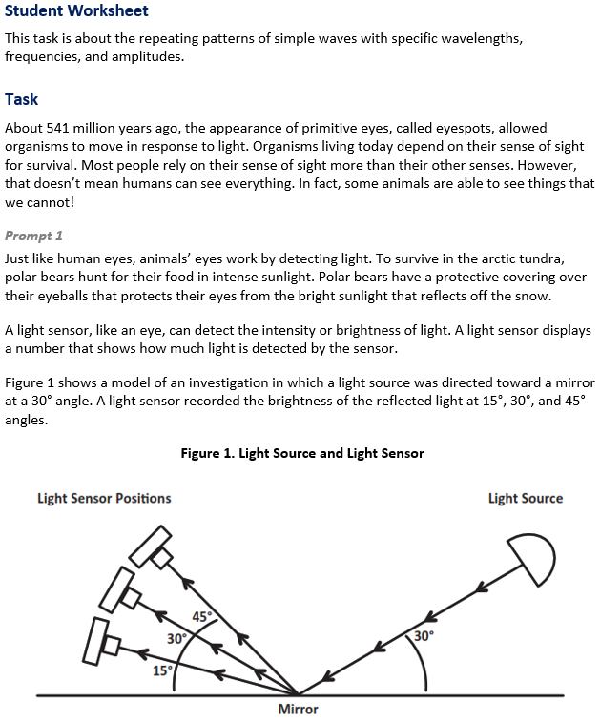
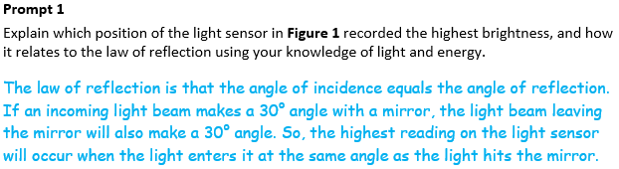
  Task 1 Prompt 1 Complexity
  Degree and Nature of Sensemaking | Low | This task…  - Requires one or two dimensions  - One dimension may have a greater degree of emphasis than another
  Complexity of the Presentation | Moderate | - The amount and type of information provided in the scenario supports multiple evident connections among ideas or concepts.  - Provides graphics/data/models
  Cognitive Demand of Response Development | Low | - Requires well-defined set of actions or procedures  - Requires a connection or retrieval of factual information
  Cognitive Demand of Response Production | Moderate | - Responses include one or more sentences or a paragraph, a moderately complex graphic, or multiple steps in a simple or moderately complex process
Task 1 Prompt 2 – Parts A and B  Performance Category: Analyze Data to Explain the Relationships Between Properties of Waves and Energy  Acquisition Goals  - A3: Use models to describe how wavelength, frequency, and amplitude of a wave do not change and can be repeated in a given time.  - A4: Develop and use a model to describe and identify the wavelength, frequency, and amplitude of a wave.  - A6: Apply their understanding to real-world phenomena about the ability of waves to transfer energy without overall displacement. *  Prompt 2 – Parts A and B measure the students’ ability to:  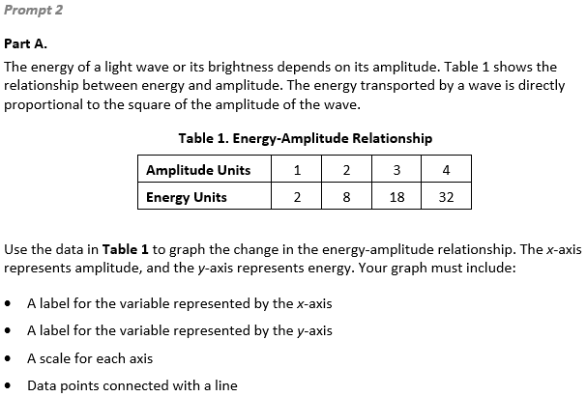  - Analyze and interpret models, data, and graphs to support conclusions about the mathematical relationship between the amplitude of light and sound waves and energy.  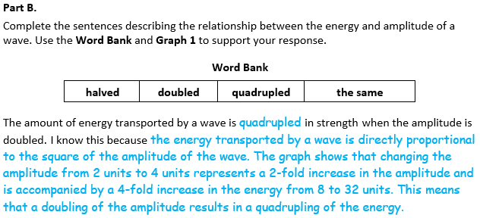 |  | 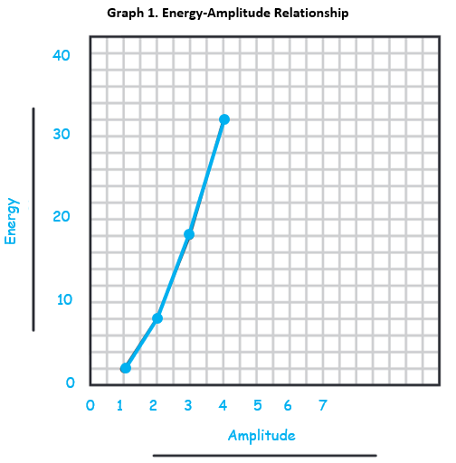  Task 1 Prompt 3 – Parts A and B  Performance Category: Analyze Data to Explain the Relationships Between Properties of Waves and Energy  Acquisition Goals  - A4: Develop and use a model to describe and identify the wavelength, frequency, and amplitude of a wave.  - A5: Use mathematical and computational thinking to show that the wavelength and frequency of a wave are related to one another by the speed of travel of the wave.  - A12: Use the ray model of light to explain how reflection and refractions of different wavelengths of light occur when interacting with a prism, lens, or other matter. *  Prompt 3 Parts A and B measures students’ ability to:  - Analyze and interpret models, data, and graphs to support conclusions about properties of electromagnetic waves and the segment of the electromagnetic spectrum that the human eye can view.  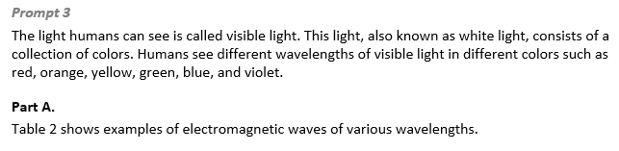
  Task 1 Prompt 1
  Connections to the Instructional Framework
  Integration of Knowledge and Skills for Response Development
  - Students read the provided background information and Figure 1, which presents an analogy of how a human eye receives light and processes light like a light sensor.
  - Students describe the law of reflection using a model and mathematical thinking to demonstrate an understanding of wave properties.
  - Students indicate the highest reading at 30° and explain how the law of reflection supports their answer.
  Formative Assessments | Opportunities to Learn
  Segment 3, pp. 15-16  Informal Assessment: Light Waves (A11*, A12)  - Students use the ray model of light to provide evidence of the process of selective reflection and refraction as different wavelengths through their interaction with a prism, lens, or other matter.  - Students make observations and/or measurements to produce data to answer scientific questions about the movement of light and its interaction with various transparent media as straight lines that bend at material transitions. | Segment 3, p. 33  What do we See? (A11*, A12)  - Students experiment with the full box model to explore factors involved in the reflection of light, finding that the mirror reflects the room with brighter light, that light travels in straight lines (rays), and that to see something, light must travel from the source to the object to our eyes.
  Task 1 Prompt 2 Parts A and B
  Connections to the Instructional Framework
  Integration of Knowledge and Skills for Response Development
  - Students graph data and use their results to describe the mathematical relationship between amplitude and energy.
  - Students refer to Table 1 to complete Graph 1 with accurate labels and scales.
  - Students analyze and interpret data by observing patterns that support scientific conclusions about how the amplitude of a wave is related to the energy in a wave.
  - In their explanation, students indicate that energy is proportional to the square of the amplitude using data.
  Formative Assessments | Opportunities to Learn
  Segment 1, pp. 9-10  Informal Assessment: All About Waves (A4)  - Students accurately describe how a simple mathematical wave model corresponds to the properties of a physical phenomenon.  - Students accurately apply the simple mathematical wave model to a physical system or phenomenon to identify how the wave model characteristics correspond with physical observations. | Segment 1, pp. 26-27  What is a Wave? (A3*, A4)  - Students are introduced to the concepts of waves beginning with vibrations, pulses, and then standing waves as generated on a string or using a slinky. The teacher provides pairs or small groups of students with Slinkies to create longitudinal and transverse waves and observations which they record in their science notebooks.
  Task 1 Prompt 2 Parts A and B
  Connections to the Instructional Framework, Continued
  Formative Assessments | Opportunities to Learn
  Segment 1, pp. 11-12
  Formal Assessment: Representing Wave Properties Mathematically (A4, A6*)
  - Students accurately apply the simple mathematical wave model to a physical system or phenomenon to identify how the wave model characteristics correspond with physical observations.
  - Students generate mathematical representations of the relationship between properties of waves to show that the wavelength and frequency of a wave are related to one another by the speed of travel of the wave.
  - Students accurately identify the evidence that supports a claim about how waves are a repeating pattern of motion that transfers energy from place to place without overall displacement of matter.
  Task 1 Prompt 1
  Connections to the Instructional Framework, Continued
  Formative Assessments | Opportunities to Learn
  Segment 3, pp. 17-18  Formal Assessment: Plan and Carry Out an Investigation on the Bending of Light Waves (A11*, A12)  - Students are provided with (or pick out) a specific research topic and asked to explore this topic. The purpose is to provide an opportunity for students to apply their knowledge to a particular question, or to demonstrate their ability to research a specific topic.  - Students design an investigation, documenting relevant properties (wavelength, nature of materials) to answer scientific questions about the movement of light and its interaction (refraction) with various transparent media. | Segment 3, pp. 33-34  Bending and Bouncing Light Rays (A11*, A12)  - Students observe and experience reflection, refraction, absorption, transmission, dispersion, and addition of light at a series of stations. Next, students utilize a one-way mirror, glass, a regular mirror, a prism, and other objects to conduct their experiment to understand how one-way light interacts with an object and is impacted by different materials.  - Students build on their multimodal explanatory model of the phenomenon after finding that the one-way mirror reflects some light and transmits some light, the regular mirror reflects most of the light, and the glass reflects a small amount of light and transmits most of the light.
  Task 1 Prompt 2 Parts A and B Complexity
  Degree and Nature of Sensemaking | Moderate | This task…  - Requires integration of two dimensions in the service of sense-making
  Complexity of the Presentation | Moderate | - The amount and type of information provided in the scenario supports multiple evident connections among ideas or concepts
  Cognitive Demand of Response Development | Moderate | - Response requires a moderate level of sophistication with typical but relatively complex representation of ideas and application of skills
  Cognitive Demand of Response Production | High | - Responses include multiple paragraphs, multiple graphics of at least moderate complexity, or multiple steps in a complex process
  Task 1 Prompt 2 Parts A and B
  Connections to the Instructional Framework, Continued
  Formative Assessments | Opportunities to Learn
  Segment 1, pp. 10-11
  Formal Assessment: What is a Wave? (A3*, A4, A6*)
  - Students accurately apply the simple mathematical wave model to a physical system or phenomenon to identify how the wave model characteristics correspond with physical observations.
  - Students accurately identify the evidence that supports a claim about how waves are a repeating pattern of motion that transfers energy from place to place without overall displacement of matter.
  - Students construct an accurate explanation that describes how waves are a repeating pattern of motion that transfers energy from place to place without overall displacement of matter.
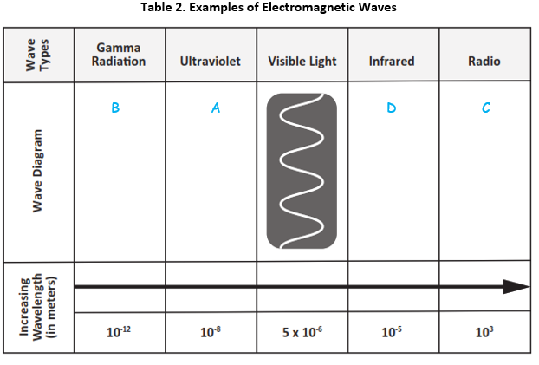  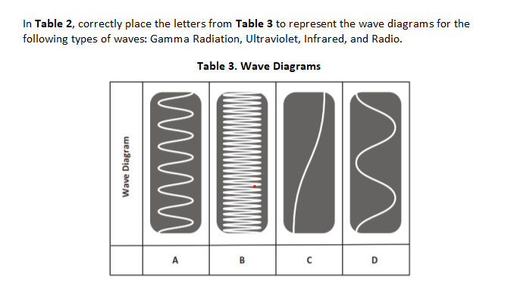 |  | 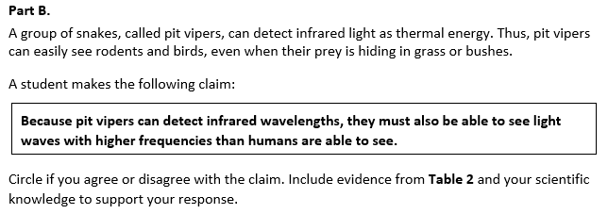  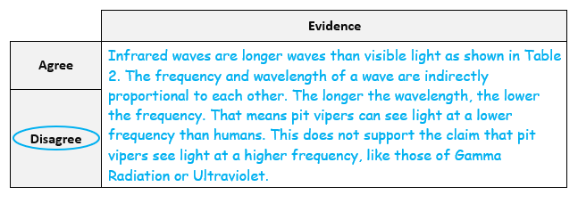
  Task 1 Prompt 3 Parts A and B Complexity
  Degree and Nature of Sensemaking | High | This prompt…  - Requires integration of three dimensions in the service of sense-making
  Complexity of the Presentation | Moderate | - The amount and type of information provided in the scenario supports multiple evident connections among ideas or concepts
  Cognitive Demand of Response Development | High | - Requires selection and application of multiple complex ideas and practices
  Cognitive Demand of Response Production | Moderate | - Responses include one or more sentences or a paragraph, a moderately complex graphic, or multiple steps in a simple or moderately complex process
  Task 1 Prompt 3 Parts A and B
  Connections to the Instructional Framework
  Integration of Knowledge and Skills for Response Development
  - Students complete a model of the electromagnetic spectrum to make connections between the light humans cannot see as opposed to what is seen by a species of snake.
  - Students complete Table 2 by matching the correct wavelengths with the types of electromagnetic waves.
  - Students select “disagree,” using information from Table 2 as evidence to support their response and relating frequency and wavelength.
  Formative Assessments | Opportunities to Learn
  Segment 1, pp. 10-11  Formal Assessment: What is a Wave? (A4)  - Students accurately apply the simple mathematical wave model to a physical system or phenomenon to identify how the wave model characteristics correspond with physical observations.  - Students accurately identify the evidence that supports a claim about how waves are a repeating pattern of motion that transfers energy from place to place without overall displacement of matter.  - Students construct an accurate explanation that describes how waves are a repeating pattern of motion that transfers energy from place to place without overall displacement of matter. | Segment 1, pp. 26-27  What is a Wave? (A4)  - Students are introduced to the concepts of waves beginning with vibrations, pulses, and then standing waves as generated on a string or using a slinky. The teacher provides pairs or small groups of students with Slinkies to create longitudinal and transverse waves and observations which they record in their science notebooks.
  Task 1 Prompt 3 Parts A and B
  Connections to the Instructional Framework, Continued
  Formative Assessments | Opportunities to Learn
  Segment 1, pp. 11-12  Formal Assessment: Representing Wave Properties Mathematically (A4, A5)  - Students accurately apply the simple mathematical wave model to a physical system or phenomenon to identify how the wave model characteristics correspond with physical observations.  - Students generate mathematical representations of the relationship between properties of waves to show that the wavelength and frequency of a wave are related to one another by the speed of travel of the wave.  - Students accurately identify the evidence that supports a claim about how waves are a repeating pattern of motion that transfers energy from place to place without overall displacement of matter. | Segment 1, pp. 27-28  Wave Properties Investigation (A5)  - Students design and conduct an experiment to find the relationship between the speed, frequency, and wavelength of the wave by collecting numerical data.  - After collecting their data, students analyze the data to find the linear relationship between frequency and wavelength, $f = vλ$, where f is frequency, lambda is the wavelength, and v is both the slope of the line and the speed of the waves.  Segment 3, p. 33  What do we See? (A12)  - Students experiment with the full box model to explore factors involved in the reflection of light, finding that the mirror reflects the room with brighter light, that light travels in straight lines (rays), and that to see something, light must travel from the source to the object to our eyes.
  Task 1 Prompt 3 Parts A and B
  Connections to the Instructional Framework, Continued
  Formative Assessments | Opportunities to Learn
  Segment 3, pp. 15-16  Informal Assessment: Light Waves (A12*)  - Students use the ray model of light to provide evidence of the process of selective reflection and refraction as different wavelengths through their interaction with a prism, lens, or other matter.  - Students make observations and/or measurements to produce data to answer scientific questions about the movement of light and its interaction with various transparent media as straight lines that bend at material transitions. | Segment 3, pp. 33-34  Bending and Bouncing Light Rays (A12)  - Students observe and experience reflection, refraction, absorption, transmission, dispersion, and addition of light at a series of stations.  - Students build on their multimodal explanatory model of the phenomenon after finding that the one-way mirror reflects some light and transmits some light, the regular mirror reflects most of the light, and the glass reflects a small amount of light and transmits most of the light.
Future Learning Connected to evidence elicited in Task 1
Crosscutting Concepts
- Unit 4 CCCs focus on using Cause and Effect, Patterns, and Structure & Function to describe wave properties and to identify cause and effect relationships as they pertain to how the presence or absence of a medium influences wave behavior. In future high school learning experiences related to wave properties, students will use empirical evidence to differentiate between cause and correlation in wave properties and make claims about specific causes and effects (HS-PS4-1).
Disciplinary Core Ideas
- Unit 4 focuses extensively on understanding the properties and types of simple waves, the wave model of light, how the presence or absence of a medium influences their behavior, and how engineering design problems can be solved by determining success criteria and constraints related to wave properties. Students’ learning and understanding increase in sophistication beyond grade 8, where they extend their knowledge to resonance in speech and music and how information can be digitized by combining waves of different frequencies, thereby encoding and transmitting. The wave model introduced in this unit is useful for explaining many features of electromagnetic radiation in later grades. The criteria and constraints they specify in this unit are later quantified and applied to global challenges facing humanity for potential solutions.
Science and Engineering Practices
- Unit 4 SEPs focus predominantly on asking questions and defining problems, using mathematical and computational thinking, and developing and using models, but also include planning and carrying out investigations, analyzing and interpreting data, constructing explanations, and designing solutions. Students will again visit these practices in their future learning experiences by using mathematical representations of phenomena or design solutions to describe and/or support claims and/or explanations (HS-PS-4-1). They will also evaluate questions that challenge an argument's premise(s), the interpretation of a data set, or the suitability of a design (HS-PS4-2).
SIPS Grade 8 Unit 4 EOU Assessment Task 2: Color My World  Task 2 Prompt 1 – Part A  Performance Category: Use Models to Describe Interactions Between Light Waves and Materials  Acquisition Goals  - A2: Carry out an investigation to determine that light and sound waves can be reflected, absorbed, transmitted, or refracted when they enter a new medium. *  - A5: Use mathematical and computational thinking to show that the wavelength and frequency of a wave are related to one another by the speed of travel of the wave. *  - A11: Examine how light is reflected and refracted when interacting with matter to develop questions about how properties of matter reflect or refract light waves.  - A13: Plan and carry out an investigation to explain how and why certain properties (wavelength, nature of materials) result in differences in the bending of light.  Prompt 1 – Part A measures students’ ability to:  - Develop or use models to support descriptions of how properties of waves are affected by the medium through which they are passing. |  | 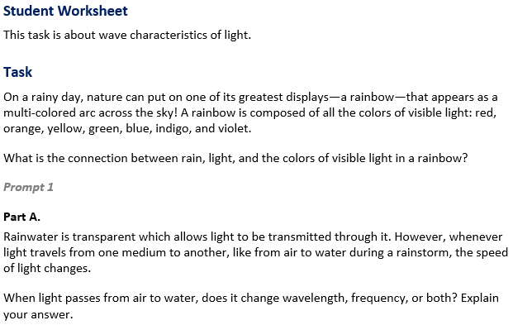  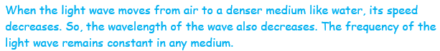

  Task 2 Prompt 1 Part A Complexity
  Degree and Nature of Sensemaking | Moderate | This task…  - Requires integration of two dimensions in the service of sense-making
  Complexity of the Presentation | Low | - The amount and type of information provided in the scenario supports limited simple connections among ideas or concepts  - Provides few, simple graphics/data/models
  Cognitive Demand of Response Development | Moderate | - Requires application of ideas and practices given cues and guidance  - Requires drawing relationships and connecting ideas and practices
  Cognitive Demand of Response Production | Moderate | - Responses include one or more sentences or a paragraph, a moderately complex graphic, or multiple steps in a simple or moderately complex process
  Task 2 Prompt 1 Part A
  Connections to the Instructional Framework
  Integration of Knowledge and Skills for Response Development
  - Students are presented with a scenario that introduces rainbows in the sky and transitions to the properties of light waves, which include the frequency-dependent bending of light at a surface between media.
  - Students interpret a scenario in which a light wave experiences a change in properties after experiencing a change in medium.
  - Students describe the relationship between wavelength and the speed of light, including that the frequency of light does not change when passing through different mediums.
  Formative Assessments | Opportunities to Learn
  Segment 1, pp. 9-10  Informal Assessment: All About Waves (A2*)  - Students accurately describe how a simple mathematical wave model corresponds to the properties of a physical phenomenon.  - Students accurately apply the simple mathematical wave model to a physical system or phenomenon to identify how the wave model characteristics correspond with physical observations. | Segment 1, p. 27  Observing Mechanical Waves in Action (A2*)  - Students observe mechanical waves in a wave tank to observe wave propagation, reflection, refraction, and diffraction. Students utilize a simulator to make observations of waves on their own and then look at images from Google Earth to observe wave properties in real life.
 |  | Task 2 Prompt 1 – Part B  Performance Category: Use Models to Describe Interactions Between Light Waves and Materials  Acquisition Goals  - A2: Carry out an investigation to determine that light and sound waves can be reflected, absorbed, transmitted, or refracted when they enter a new medium. *  - A11: Examine how light is reflected and refracted when interacting with matter to develop questions about how properties of matter reflect or refract light waves. *  - A13: Plan and carry out an investigation to explain how and why certain properties (wavelength, nature of materials) result in differences in the bending of light. *  - A16: Develop a model for the path of different frequencies of light through the interface of different media that uses the ray model of light.  Prompt 1 Part B measures students’ ability to:  - Develop or use models to support descriptions of the path light travels at surfaces between transparent materials (e.g., air and water) where the light path bends.
  Task 2 Prompt 1 Part A
  Connections to the Instructional Framework, Continued
  Formative Assessments | Opportunities to Learn
  Segment 1, pp. 11-12  Formal Assessment: Representing Wave Properties Mathematically (A5*)  - Students accurately apply the simple mathematical wave model to a physical system or phenomenon to identify how the wave model characteristics correspond with physical observations.  - Students generate mathematical representations of the relationship between properties of waves to show that the wavelength and frequency of a wave are related to one another by the speed of travel of the wave.  - Students accurately identify the evidence that supports a claim about how waves are a repeating pattern of motion that transfers energy from place to place without overall displacement of matter. | Segment 1, p. 27  Wave Properties Investigation (A5*)  - Students design and conduct an experiment to find the relationship between the speed, frequency, and wavelength of the wave by collecting numerical data.  - After collecting their data, students analyze the data to find the linear relationship between frequency and wavelength, $f = vλ$, where f is frequency, lambda is the wavelength, and v is both the slope of the line and the speed of the waves.  Segment 3, p. 32  A Mirror and A Window? (A11)  - Students observe the phenomenon of a one-way mirror and begin to generate questions about the phenomenon. Students create an initial, multimodal explanatory model using annotated drawings for the phenomenon. Using this phenomenon as a segment phenomenon, students generate a driving question board focused on light and the properties of light.
  Task 2 Prompt 1 Part A
  Connections to the Instructional Framework, Continued
  Formative Assessments | Opportunities to Learn
  Segment 3, pp. 17-18  Formal Assessment: Plan and Carry Out an Investigation on the Bending of Light Waves (A11, A13)  - Students use observations and/or data to generate a conclusion about the way that light interacts with different materials, including the way different light frequencies are affected by a transition from one medium to another.  - Students describe what evidence is needed to answer questions about a phenomenon related to the properties of light waves, lenses, and prisms, and how they help build toward an explanation of the phenomenon. | Segment 3, pp. 33-34  Bending and Bouncing Light Rays (A11, A15)  - Students observe and experience reflection, refraction, absorption, transmission, dispersion, and addition of light at a series of stations. Next, students utilize a one-way mirror, glass, a regular mirror, a prism, and other objects to conduct their experiment to understand how one-way light interacts with an object and is impacted by different materials.  - Students build on their multimodal explanatory model of the phenomenon after finding that the one-way mirror reflects some light and transmits some light, the regular mirror reflects most of the light, and the glass reflects a small amount of light and transmits most of the light.
  Task 2 Prompt 1 Part A
  Connections to the Instructional Framework, Continued
  Formative Assessments | Opportunities to Learn
  Segment 1, p. 12  Formal Assessment: Observing Waves in Action (A2*)  - Students carry out an investigation to determine that light waves can be reflected, absorbed, transmitted, or refracted when they collide with new matter.  Segment 3, pp. 16-17  Informal Assessment: Light Waves (A11, A13)  - Students make observations and/or measurements to produce data to answer scientific questions about the movement of light and its interaction with various transparent media as straight lines which bend at material transitions.  - Students use observations and/or data to generate a conclusion about frequency-dependent bending of light at a surface between media. | Segment 3, pp. 32-33  Light vs. Sound (A11)  - Students compare and contrast different types of waves and how electromagnetic waves do not require a medium. Students generate a series of observations of light and sound about a familiar phenomenon.  - Students build on the idea of mixed waves and how electromagnetic waves do not require a medium as they read over several different scenarios which use sound waves, light waves, or both.  Segment 3, p. 33  What do we See? (A11)  - Students experiment with the full box model to explore factors involved in the reflection of light, finding that the mirror reflects the room with brighter light, that light travels in straight lines (rays), and that to see something, light must travel from the source to the object to our eyes.
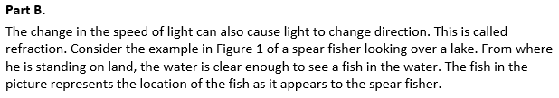  Figure 1. Spear Fisher and Fish in Lake  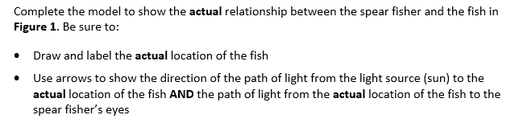  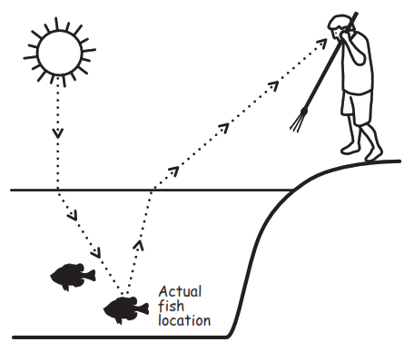  Actual fish location
  Task 2 Prompt 1 Part B Complexity
  Degree and Nature of Sensemaking | Moderate | This prompt…  - Requires integration of two dimensions in the service of sense-making
  Complexity of the Presentation | Moderate | - The amount and type of information provided in the scenario supports multiple evident connections among ideas or concepts  - Provides graphics/data/models  - Limited use of definitions or examples
  Cognitive Demand of Response Development | Moderate | - Requires application of ideas and practices given cues and guidance  - Requires drawing relationships and connecting ideas and practices
  Cognitive Demand of Response Production | High | - Responses include multiple paragraphs, multiple graphics of at least moderate complexity, or multiple steps in a complex process
Task 2 Prompt 1 – Part C  Performance Categories: Use Models to Describe Interactions Between Light Waves and Materials  Acquisition Goals:  - A2: Carry out an investigation to determine that light and sound waves can be reflected, absorbed, transmitted, or refracted when they enter a new medium. *  - A11: Examine how light is reflected and refracted when interacting with matter to develop questions about how properties of matter reflect or refract light waves. *  - A13: Plan and carry out an investigation to explain how and why certain properties (wavelength, nature of materials) result in differences in the bending of light. *  - A15: Design and carry out an investigation to determine the way that light interacts with different materials, including the way different light frequencies are affected by a transition from one medium to another. *  - A16: Develop a model for the path of different frequencies of light through the interface of different media that uses the ray model of light.  Prompt 1 Part C measures students’ ability to:  - Develop or use models to support descriptions of the relationship between density of a medium and its effect on the speed light travels.  Part C.  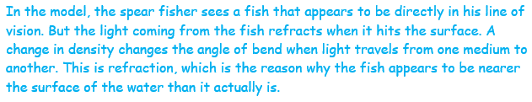  Why does the fish appear to be at a different position in the water compared to where it actually is in the water?  Task 2 Prompt 2 – Parts A and B  Performance Categories: Use Models to Describe Interactions Between Light Waves and Materials  Acquisition Goals:  - A4: Develop and use a model to describe and identify the wavelength, frequency, and amplitude of a wave. *  - A5: Use mathematical and computational thinking to show that the wavelength and frequency of a wave are related to one another by the speed of travel of the wave.  - A12: Use the ray model of light to explain how reflection and refractions of different wavelengths of light occur when interacting with a prism, lens, or other matter.  - A13: Plan and carry out an investigation to explain how and why certain properties (wavelength, nature of materials) result in differences in the bending of light.*  - A16: Develop a model for the path of different frequencies of light through the interface of different media that uses the ray model of light. *  Prompt 2 Parts A and B measure students’ ability to:  - Use models to support descriptions of how the relationship between wavelength and speed of light are connected to different and predictable colors of visible light. |  | 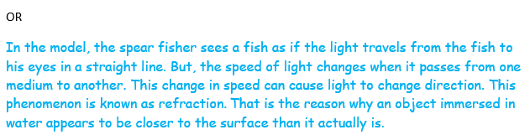  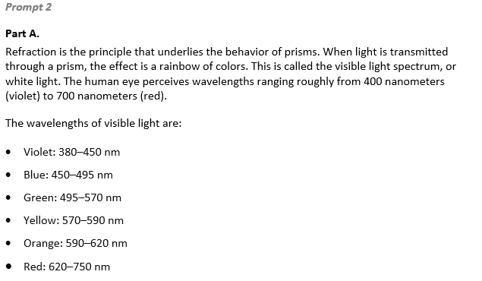  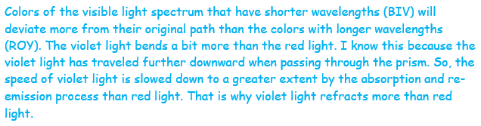  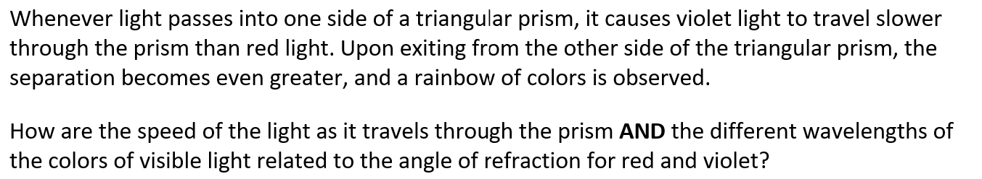  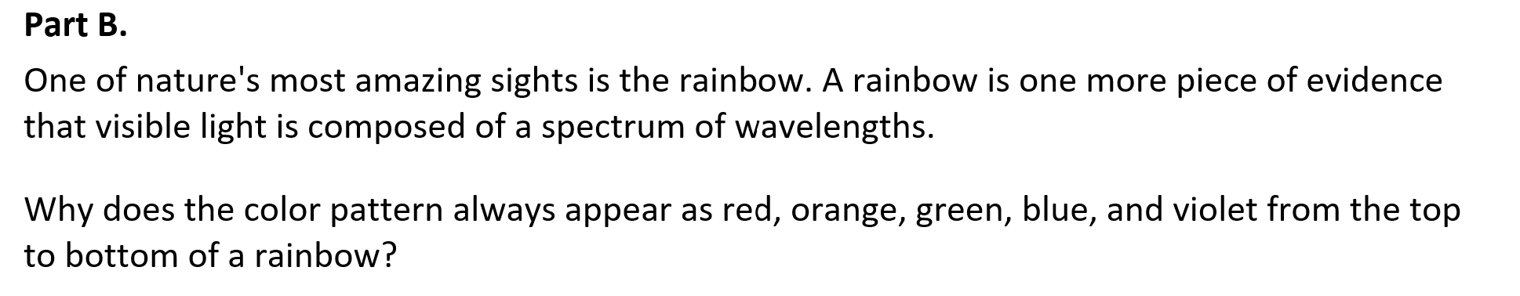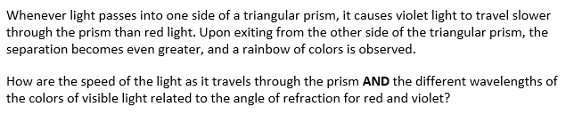  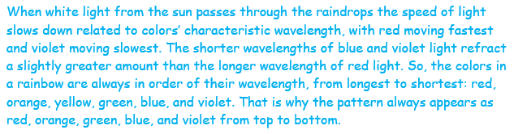
  Task 2 Prompt 1 Part B
  Connections to the Instructional Framework
  Integration of Knowledge and Skills for Response Development
  - Students review the scenario of light traveling between different transparent materials (air and water) and Figure 1.
  - Students complete a model to show the path that light travels at surfaces between different transparent materials (e.g., air and water) where the light path bends.
  - Students draw and label the fish's actual location, including directional arrows showing the path of light from the sun to the fish's location and from the fish's location to the spear fisher’s eyes.
  Formative Assessments | Opportunities to Learn
  Segment 1, pp. 9-10  Informal Assessment: All About Waves (A2*)  - Students accurately apply the simple mathematical wave model to a physical system or phenomenon to identify how the wave model characteristics correspond with physical observations.  Segment 1, p. 12  Formal Assessment: Observing Waves in Action (A2*)  - Students carry out an investigation to determine that light waves can be reflected, absorbed, transmitted, or refracted when they collide with new matter. | Segment 1, p. 27  Observing Mechanical Waves in Action (A2*)  - Students observe mechanical waves in a wave tank to observe wave propagation, reflection, refraction, and diffraction.  - Students utilize a simulator to make observations of waves on their own and then look at images from Google Earth to observe wave properties in real life.  Segment 3, p. 32  A Mirror and A Window? (A11*, A16)  - Students observe the phenomenon of a one-way mirror and begin to generate questions about the phenomenon.
  Task 2 Prompt 1 Part C
  Connections to the Instructional Framework
  Integration of Knowledge and Skills for Response Development
  - Students apply their model to describe the bending of light and the position of the fish in the water.
  - Students explain the relationship between the density of the medium and its effect on the speed light travels.
  Formative Assessments | Opportunities to Learn
  Segment 1, pp. 9-10  Informal Assessment: All About Waves (A2*)  - Students accurately apply the simple mathematical wave model to a physical system or phenomenon to identify how the wave model characteristics correspond with physical observations.  Segment 1, p. 12  Formal Assessment: Observing Waves in Action (A2*)  - Students carry out an investigation to determine that light waves can be reflected, absorbed, transmitted, or refracted when they collide with new matter. | Segment 1, p. 27  Observing Mechanical Waves in Action (A2*)  - Students observe mechanical waves in a wave tank to observe wave propagation, reflection, refraction, and diffraction. Students utilize a simulator to make observations of waves on their own and then look at images from Google Earth to observe wave properties in real life.  Segment 3, p. 32  A Mirror and A Window? (A11*, A16)  - Students observe the phenomenon of a one-way mirror and begin to generate questions about the phenomenon.  - Students create an initial, multimodal explanatory model. Using the phenomenon as a segment phenomenon, students generate a driving question board focused on light and the properties of light.
  Task 2 Prompt 2 Part A Complexity
  Degree and Nature of Sensemaking | Moderate | This prompt…  - Requires integration of two dimensions in the service of sense-making
  Complexity of the Presentation | Moderate | - The amount and type of information provided in the scenario supports multiple evident connections among ideas or concepts  - Provides graphics/data/models
  Cognitive Demand of Response Development | Moderate | - Requires application of ideas and practices given cues and guidance  - Requires drawing relationships and connecting ideas and practices
  Cognitive Demand of Response Production | Moderate | - Responses include one or more sentences or a paragraph, a moderately complex graphic, or multiple steps in a simple or moderately complex process
  Task 2 Prompt 2 Part B Complexity
  Degree and Nature of Sensemaking | Moderate | This prompt…  - Requires integration of two dimensions in the service of sense-making
  Complexity of the Presentation | Low | - The amount and type of information provided in the scenario supports limited simple connections among ideas or concepts  - Provides few, simple graphics/data/models
  Cognitive Demand of Response Development | High | - Requires selection and application of multiple complex ideas and practices  - Requires high degree of sense making, reasoning, and/or transfer
  Cognitive Demand of Response Production | Moderate | - Responses include one or more sentences or a paragraph, a moderately complex graphic, or multiple steps in a simple or moderately complex process
  Task 1 Prompt 2 Parts A and B
  Connections to the Instructional Framework, Continued
  Formative Assessments | Opportunities to Learn
  Segment 1, pp. 11-12  Formal Assessment: Representing Wave Properties Mathematically (A4*, A5)  - Students accurately apply the simple mathematical wave model to a physical system or phenomenon to identify how the wave model characteristics correspond with physical observations.  - Students generate mathematical representations of the relationship between properties of waves to show that the wavelength and frequency of a wave are related to one another by the speed of travel of the wave.  - Students accurately identify the evidence that supports a claim about how waves are a repeating pattern of motion that transfers energy from place to place without overall displacement of matter. | Segment 1, pp. 27-28  Wave Properties Investigation (A5)  - For this activity, students design and conduct an experiment to find the relationship between the speed, frequency, and wavelength of the wave by collecting numerical data.  - After collecting their data, students analyze the data to find the linear relationship between frequency and wavelength. Following their experiment and analysis, students write a conclusion based on their data.  Segment 3, p. 33  What do we See? (A12)  - Students experiment with the full box model to explore factors involved in the reflection of light, finding that the mirror reflects the room with brighter light, that light travels in straight lines (rays), and that to see something, light must travel from the source to the object to our eyes.
  Task 2 Prompt 1 Part B
  Connections to the Instructional Framework, Continued
  Formative Assessments | Opportunities to Learn
  - Students describe what evidence is needed to answer questions about a phenomenon related to the properties of light waves, lenses, and prisms, and how they help build toward an explanation of the phenomenon.  Segment 3, p. 18  Formal Assessment: I Can See You, but You Can’t See Me! (A16)  - Students develop a model to show how the path that light travels can be traced as straight lines, except at surfaces between different transparent materials (e.g., air and water, air, and glass) where the light path bends. | Segment 3, p. 34  Light Waves and Their Properties (A16)  - Students revisit the driving question board for the segment and consider what they still need to know to explain the phenomenon using an explanatory model. Students review core curricular materials, teacher-curated resources, or other resources they find to answer the remaining questions about light, light’s properties, and the segment phenomenon.  Segment 3, p. 34  I Can See You, but You Can’t See Me  - Students finalize their multimodal explanatory model on how a one-way mirror works. Students develop a scientific explanation to explain why only one side can see through a one-way mirror, provide feedback to each other, and then submit their final explanation.
  Task 2 Prompt 1 Part C Complexity
  Degree and Nature of Sensemaking | Moderate | This prompt…  - Requires integration of two dimensions in the service of sense-making
  Complexity of the Presentation | Low | - The amount and type of information provided in the scenario supports limited simple connections among ideas or concepts  - Provides few, simple graphics/data/models
  Cognitive Demand of Response Development | Moderate | - Requires application of ideas and practices given cues and guidance  - Requires drawing relationships and connecting ideas and practices
  Cognitive Demand of Response Production | Low | - Responses include selection from a small set of options presented as text (e.g., word, short phrase) or other formats (e.g., or a simple graphic or process)
  Task 2 Prompt 1 Part C
  Connections to the Instructional Framework, Continued
  Formative Assessments | Opportunities to Learn
  Segment 3, pp. 15-16  Informal Assessment: Light Waves (A11*, A15*, A16)  - Students use the ray model of light to provide evidence of the process of selective reflection and refraction as different wavelengths through their interaction with a prism, lens, or other matter.  - Students make observations and/or measurements to produce data to answer scientific questions about the movement of light and its interaction with various transparent media as straight lines that bend at material transitions.  Segment 3, pp. 17-18  Formal Assessment: Plan and Carry Out an Investigation on the Bending of Light Waves (A11*, A13*, A15*)  - Students use observations and/or data to generate a conclusion about the way that light interacts with different materials, including the way different light frequencies are affected by a transition from one medium to another. | Segment 3, pp. 33-34  Bending and Bouncing Light Rays (A11*, A16)  - Students observe and experience reflection, refraction, absorption, transmission, dispersion, and addition of light at a series of stations. Next, students utilize a one-way mirror, glass, a regular mirror, a prism, and other objects to conduct their experiment to understand how one-way light interacts with an object and is impacted by different materials.  Segment 3, p. 34  I Can See You, But You Can’t See Me! (A16)  - Students develop a scientific explanation to explain why only one side can see through a one-way mirror, provide feedback to each other, and then submit their final explanation.
  Task 1 Prompt 2 Parts A and B
  Connections to the Instructional Framework
  Integration of Knowledge and Skills for Response Development
  Part A
  - Students recall the effects of shining a light through a prism and the relationship between the speed of light and wavelength to determine the reason the colors of light spread out.
  - Students use mathematical and computational thinking to explain the effect of shining light through a prism in terms of the visible spectrum, wavelength, and speed in terms of the bending of light using patterns in a data set.
  Part B
  - Students make the connection between the properties of light waves and the production of rainbows in the sky.
  - Students use the data and the scenario to explain the phenomenon that has occurred, the production of a rainbow in the sky.
  Formative Assessments | Opportunities to Learn
  Segment 1, pp. 9-10  Informal Assessment: All About Waves (A4*)  - Students accurately describe how a simple mathematical wave model corresponds to the properties of a physical phenomenon.  - Students accurately apply the simple mathematical wave model to a physical system or phenomenon to identify how the wave model characteristics correspond with physical observations. | Segment 1, pp. 26-27  What is a Wave? (A4*)  - Students are introduced to the concepts of waves beginning with vibrations, pulses, and then standing waves as generated on a string or using a slinky. The teacher provides pairs or small groups of students with Slinkies to create longitudinal and transverse waves and observations which they record in their science notebooks.
  Task 1 Prompt 2 Parts A and B
  Connections to the Instructional Framework, Continued
  Formative Assessments | Opportunities to Learn
  Segment 3, pp. 15-16  Informal Assessment: Light Waves (A12, A13*)  - Students use the ray model of light to provide evidence of the process of selective reflection and refraction as different wavelengths through their interaction with a prism, lens, or other matter.  - Students make observations and/or measurements to produce data to answer scientific questions about the movement of light and its interaction with various transparent media as straight lines that bend at material transitions.  Segment 3, p. 18  Formal Assessment: I Can See You, but You Can’t See Me! (A16*)  - Students develop a model to show how the path that light travels can be traced as straight lines, except at surfaces between different transparent materials (e.g., air and water, air, and glass) where the light path bends. | Segment 3, pp. 33-34  Bending and Bouncing Light Rays (A12, A13*, A16*)  - Students observe and experience reflection, refraction, absorption, transmission, dispersion, and addition of light at a series of stations. Next, students utilize a one-way mirror, glass, a regular mirror, a prism, and other objects to conduct their experiment to understand how one-way light interacts with an object and is impacted by different materials.  - Students build on their multimodal explanatory model of the phenomenon after finding that the one-way mirror reflects some light and transmits some light, the regular mirror reflects most of the light, and the glass reflects a small amount of light and transmits most of the light.

Future Learning Connected to evidence elicited in Task 2
Crosscutting Concepts
- Unit 4 CCCs focus on using Cause and Effect, Patterns, and Structure & Function to describe wave properties and to identify cause and effect relationships as they pertain to how the presence or absence of a medium influences wave behavior. In future high school learning experiences related to wave properties, students will use empirical evidence to differentiate between cause and correlation in wave properties and make claims about specific causes and effects (HS-PS4-1).
Disciplinary Core Ideas
- Unit 4 focuses extensively on understanding the properties and types of simple waves, the wave model of light, how the presence or absence of a medium influences their behavior, and how engineering design problems can be solved by determining success criteria and constraints related to wave properties. Students’ learning and understanding increase in sophistication beyond grade 8. Students extend their knowledge to resonance in speech and music and how information can be digitized by combining waves of different frequencies thereby encoding and transmitting. The wave model introduced in this unit is useful for explaining many features of electromagnetic radiation in later grades. The criteria and constraints they specify in this unit are later quantified and applied to global challenges facing humanity for potential solutions.
Science and Engineering Practices
- Unit 4 SEPs focus predominantly on asking questions and defining problems, using mathematical and computational thinking, and developing and using models, but also include planning and carrying out investigations, analyzing and interpreting data, constructing explanations, and designing solutions. Students will again visit these practices in their future learning experiences by using mathematical representations of phenomena or design solutions to describe and/or support claims and/or explanations (HS-PS-4-1). They will also evaluate questions that challenge an argument's premise(s), the interpretation of a data set, or the suitability of a design (HS-PS4-2).

SIPS Grade 8 Unit 4 EOU Assessment Task 3: Sounds of Silence  Task 3 Prompt 1  Performance Category: Analyze Data to Explain the Relationships Between Properties of Waves and Energy  Acquisition Goals:  - A3: Use models to describe how wavelength, frequency, and amplitude of a wave do not change and can be repeated in a given time.  - A4: Develop and use a model to describe and identify the wavelength, frequency, and amplitude of a wave.  - A6: Apply their understanding to real-world phenomena about the ability of waves to transfer energy without overall displacement.  Prompt 1 measures students’ ability to:  - Analyze and interpret models, data, and graphs to support conclusions about the relationship between energy and the displacement of waves. |  | 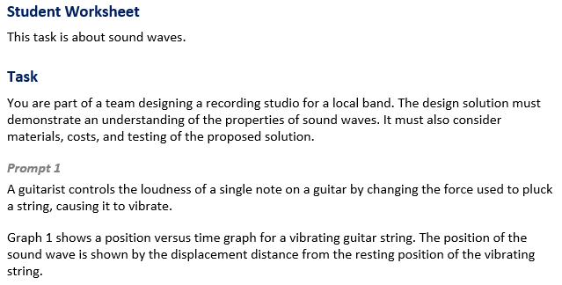  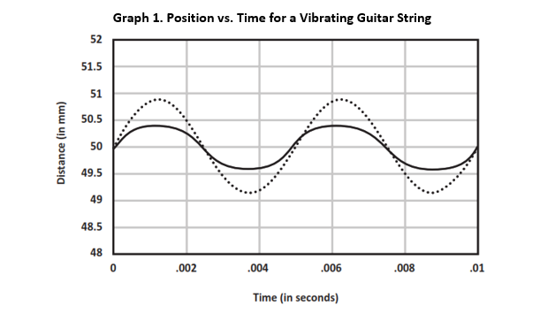
 |  | Task 3 Prompt 2 – Parts A and B  Performance Category: Analyze Data to Explain the Relationships Between Properties of Waves and Energy  Acquisition Goals  - A3: Use models to describe how wavelength, frequency, and amplitude of a wave do not change and can be repeated in a given time. *  - A4: Develop and use a model to describe and identify the wavelength, frequency, and amplitude of a wave.  - A5: Use mathematical and computational thinking to show that the wavelength and frequency of a wave are related to one another by the speed of travel of the wave. *  - A6: Apply their understanding to real-world phenomena about the ability of waves to transfer energy without overall displacement. *  Prompt 2 – Parts A and B measure the students’ ability to:  - Analyze and interpret models, data, and graphs to support conclusions about the mathematical relationship between the amplitude of light and sound waves and energy.
  Task 3 Prompt 1 Complexity
  Degree and Nature of Sensemaking | Moderate | This prompt…  - Requires integration of two dimensions in the service of sensemaking  - Requires a combination of previously learned ideas or concepts and newly presented information
  Complexity of the Presentation | Moderate | - The amount and type of information provided in the scenario supports multiple evident connections among ideas or concepts
  Cognitive Demand of Response Development | Moderate | - Requires application of ideas and practices given cues and guidance  - Requires drawing relationships and connecting ideas and practices
  Cognitive Demand of Response Production | Moderate | - Responses include one or more sentences or a paragraph, a moderately complex graphic, or multiple steps in a simple or moderately complex process
  Task 3 Prompt 1
  Connections to the Instructional Framework, Continued
  Formative Assessments | Opportunities to Learn
  Segment 1, pp. 10-11  Formal Assessment: What is a Wave? (A3, A4, A6)  - Students accurately apply the simple mathematical wave model to a physical system or phenomenon to identify how the wave model characteristics correspond with physical observations.  - Students accurately identify the evidence that supports a claim about how waves are a repeating pattern of motion that transfers energy from place to place without overall displacement of matter.  - Students construct an accurate explanation that describes how waves are a repeating pattern of motion that transfers energy from place to place without overall displacement of matter. | Segment 1, p. 28  Earthquakes: Waves of Danger (A6)  - To understand how waves transfer energy but not matter, the class explores information on recent deadly earthquakes, how buildings withstand earthquakes, and tsunami formation, and discusses why earthquakes are dangerous even when the epicenter is far away.  Segment 2, p. 29  Chladni Plates (A6)  - Students watch a video of a Chladni plate in action then they share questions they have about the video. Students draw an annotated drawing of what they think is occurring with the plate and sound.  Segment 2, p. 29  Experiencing Sound (A6)  - Students explore sound demonstrations/activities using a stations model. Students are provided enough time to visit each station and make and record observations in their scientific notebooks or by using handouts from the teacher.
  Task 3 Prompt 1
  Connections to the Instructional Framework, Continued
  Formative Assessments | Opportunities to Learn
  Segment 2, p. 13
  Informal Assessment: Modeling Sound (A6)
  - Students accurately model how sound waves transfer energy through a medium through oscillation of the particles.
  Segment 2, pp. 13-14
  Formal Assessment: Modeling Sound in Action (A6)
    - Students accurately model how sound waves transfer energy through a medium through oscillation of the particles.
  Segment 2, pp. 14-15
  Formal Assessment: How Does Sound Move? (A6)
  - Students use observations and/or data to generate a conclusion about the longitudinal nature of sound waves.
  Task 3 Prompt 1
  Connections to the Instructional Framework
  Integration of Knowledge and Skills for Response Development
  - Students review the task background, which provides a description of what a recording studio is used for and the design problem of how to minimize unwanted noise in a local recording studio.
  - Students interpret and modify a position vs. time graph related to the sound waves produced by playing different music notes on a guitar, demonstrating their understanding of loudness and amplitude.
  - Students include a new sound wave with a decreased amplitude and a new sound wave with the same wavelength.
  Formative Assessments | Opportunities to Learn
  Segment 1, pp. 9-10  Informal Assessment: All About Waves (A4)  - Students accurately describe how a simple mathematical wave model corresponds to the properties of a physical phenomenon.  - Students accurately apply the simple mathematical wave model to a physical system or phenomenon to identify how the wave model characteristics correspond with physical observations. | Segment 1, pp. 26-27  What is a Wave? (A3, A4)  - Students are introduced to the concepts of waves beginning with vibrations, pulses, and then standing waves as generated on a string or using a slinky. The teacher provides pairs or small groups of students with Slinkies to create longitudinal and transverse waves and observations which they record in their science notebooks.
  Task 3 Prompt 1
  Connections to the Instructional Framework, Continued
  Formative Assessments | Opportunities to Learn
  Segment 1, pp. 11-12  Formal Assessment: Representing Wave Properties Mathematically (A4, A6)  - Students accurately apply the simple mathematical wave model to a physical system or phenomenon to identify how the wave model characteristics correspond with physical observations.  - Students generate mathematical representations of the relationship between properties of waves to show that the wavelength and frequency of a wave are related to one another by the speed of travel of the wave.  - Students accurately identify the evidence that supports a claim about how waves are a repeating pattern of motion that transfers energy from place to place without overall displacement of matter. | Segment 2, p. 30  How Does Sound Move? (A6)  - The teacher opens the class by asking students, “What does sound look like?” and watching a video. Students develop an annotated drawing for one of the sound scenes in the video. In their drawings, they indicate changes in density (high/low areas), how the sound waves and energy are moving, and that the air particles are staying near the same place, that the density change is moving.  Segment 2, p. 30  How Do Chladni Plates Work? (A6)  - Students work either individually or in small groups to create an explanatory model for the segment phenomenon. The teacher encourages students to incorporate information from their annotated drawings, notes, or additional online research into the properties of sound and waves. Students should create a multimodal explanation that they can present in a way that makes sense for them.

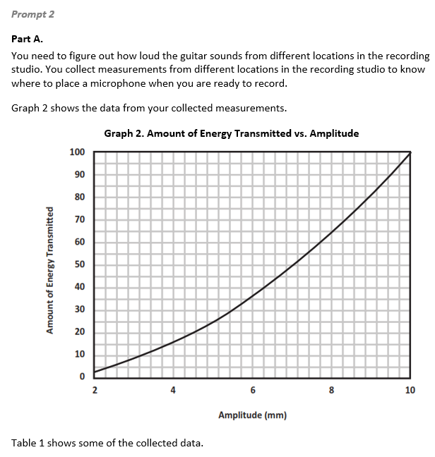 |  | 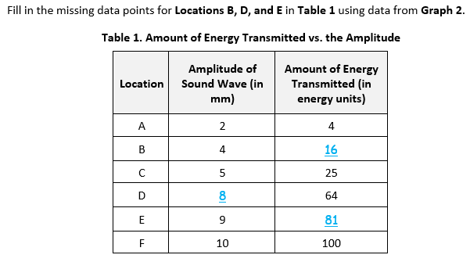  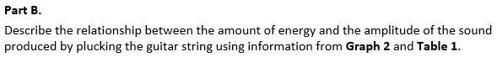  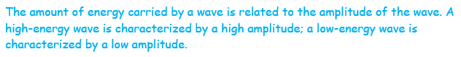
  Task 3 Prompt 2 Parts A and B Complexity
  Degree and Nature of Sensemaking | Low | This prompt…  - Requires one or two dimensions  - One dimension may have a greater degree of emphasis than another
  Complexity of the Presentation | Moderate | - The amount and type of information provided in the scenario supports multiple evident connections among ideas or concepts  - Provides graphics/data/models
  Cognitive Demand of Response Development | Moderate | - Requires application of ideas and practices given cues and guidance  - Requires drawing relationships and connecting ideas and practices
  Cognitive Demand of Response Production | Moderate | - Responses include one or more sentences or a paragraph, a moderately complex graphic, or multiple steps in a simple or moderately complex process
  Task 3 Prompt 2 Parts A and B
  Connections to the Instructional Framework
  Integration of Knowledge and Skills for Response Development
  - Students are asked to describe and mathematically support the relationship between a wave's energy and amplitude.
  - Students interpret the graph and use the mathematical relationship between amplitude and energy to complete a data table and describe the relationship between amplitude and energy (energy is proportional to the square of the amplitude).
  Formative Assessments | Opportunities to Learn
  Segment 1, pp. 9-10  Informal Assessment: All About Waves (A4)  - Students accurately describe how a simple mathematical wave model corresponds to the properties of a physical phenomenon.  - Students accurately apply the simple mathematical wave model to a physical system or phenomenon to identify how the wave model characteristics correspond with physical observations. | Segment 1, pp. 26-27  What is a Wave? (A3*, A4)  - Students are introduced to the concepts of waves beginning with vibrations, pulses, and then standing waves as generated on a string or using a slinky. The teacher provides pairs or small groups of students with Slinkies to create longitudinal and transverse waves and observations which they record in their science notebooks.
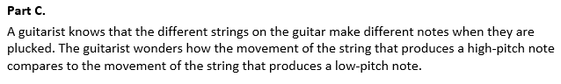  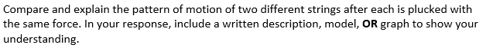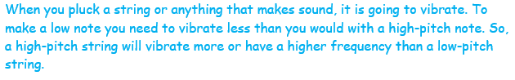OR  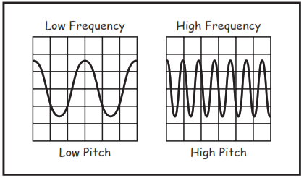  High Pitch  Low Pitch  High Frequency  Low Frequency  Task 3 Prompt 3 – Part A  Performance Category: Design the Best Solution to a Problem Involving Properties of Sound Waves and Materials  Acquisition Goals:  - A2: Carry out an investigation to determine that light and sound waves can be reflected, absorbed, transmitted, or refracted when they enter a new medium. *  - A10: Apply scientific ideas and principles to real-world phenomena to explain how sound waves require a medium to move.  Prompt 3 Part A measures students’ ability to:  - Design a solution to a problem involving sounds using properties of waves by describing the relationship among different materials and the transmission of sound waves.  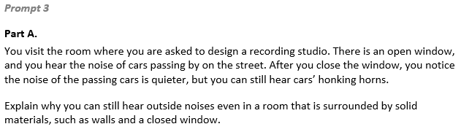  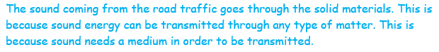 |  | Task 3 Prompt 2 – Part C  Performance Category: Analyze Data to Explain the Relationships Between Properties of Waves and Energy  Acquisition Goals:  - A4: Develop and use a model to describe and identify the wavelength, frequency, and amplitude of a wave.  - A5: Use mathematical and computational thinking to show that the wavelength and frequency of a wave are related to one another by the speed of travel of the wave.  - A6: Apply their understanding to real-world phenomena about the ability of waves to transfer energy without overall displacement. *  - A8: Develop and use models to show that sound waves are pressure waves and are longitudinal. *  Prompt 2 Part C measures students’ ability to:  - Analyze and interpret models, data, and graphs to support conclusions about the relationship between the pitch of a sound wave detectable by a human ear and its frequency.
  Task 3 Prompt 2 Parts A and B
  Connections to the Instructional Framework, Continued
  Formative Assessments | Opportunities to Learn
  Segment 1, pp. 10-11  Formal Assessment: What is a Wave? (A3*, A4, A6*)  - Students accurately apply the simple mathematical wave model to a physical system or phenomenon to identify how the wave model characteristics correspond with physical observations.  - Students accurately identify the evidence that supports a claim about how waves are a repeating pattern of motion that transfers energy from place to place without overall displacement of matter.  Segment 2, pp. 13-14  Formal Assessment: Modeling Sound in Action (A6*)  - Students explain how sound transfers energy and causes a phenomenon, such as sand moving on Chladni plates.  - Students present their models to the class in a multimodal presentation in a way that makes sense for them. | Segment 2, p. 29  Chladni Plates (A6*)  - Students make observations as they watch a video of a Chladni plate in action.
  Task 3 Prompt 2 Part C
  Connections to the Instructional Framework
  Integration of Knowledge and Skills for Response Development
  - Students are asked to develop a model of a sound wave and/or mathematically support an explanation that relates to the concept that an increase in energy results in an increase in the amplitude of the wave.
  - Students provide a written description, model, or graph to show a comparison of a high-pitch note to a low-pitch note.
  Formative Assessments | Opportunities to Learn
  Segment 1, pp. 9-10  Informal Assessment: All About Waves (A4)  - Students accurately describe how a simple mathematical wave model corresponds to the properties of a physical phenomenon.  - Students accurately apply the simple mathematical wave model to a physical system or phenomenon to identify how the wave model characteristics correspond with physical observations. | Segment 1, pp. 26-27  What is a Wave? (A4)  - Students are introduced to the concepts of waves beginning with vibrations, pulses, and then standing waves as generated on a string or using a slinky. The teacher provides pairs or small groups of students with Slinkies to create longitudinal and transverse waves and observations which they record in their science notebooks.
  Task 3 Prompt 2 Part C
  Connections to the Instructional Framework, Continued
  Formative Assessments | Opportunities to Learn
  Segment 1, pp. 11-12  Formal Assessment: Representing Wave Properties Mathematically (A4, A5, A6*)  - Students accurately apply the simple mathematical wave model to a physical system or phenomenon to identify how the wave model characteristics correspond with physical observations.  - Students generate mathematical representations of the relationship between properties of waves to show that the wavelength and frequency of a wave are related to one another by the speed of travel of the wave.  - Students accurately identify the evidence that supports a claim about how waves are a repeating pattern of motion that transfers energy from place to place without overall displacement of matter. | Segment 2, p. 29  Experiencing Sound (A6*, A8)  - Students explore a variety of sound demonstrations/activities using a stations model. Stations are set up around the classroom and students are provided enough time to visit each station and make and record observations in their scientific notebooks or using handouts from the teacher.  Segment 2, p. 30  How Does Sound Move? (A6*, A8*)  - The teacher opens class by asking students, “What does sound look like?” and watch a video. Students develop an annotated drawing for one of the sound scenes in the video. In their drawings, they indicate changes in density (high/low areas), how the sound waves and energy are moving, and that the air particles are staying near the same place, that it is the density change that is moving.
  Task 3 Prompt 2 Part C Complexity
  Degree and Nature of Sensemaking | Moderate | This prompt…  - Requires integration of two dimensions in the service of sensemaking  - Requires a combination of previously learned ideas or concepts and newly presented information
  Complexity of the Presentation | Low | - The amount and type of information provided in the scenario supports limited simple connections among ideas or concepts  - Provides few, simple graphics/data/models
  Cognitive Demand of Response Development | High | - Requires selection and application of multiple complex ideas and practices
  Cognitive Demand of Response Production | High | - Responses include multiple paragraphs, multiple graphics of at least moderate complexity, or multiple steps in a complex process
  Task 3 Prompt 2 Part C
  Connections to the Instructional Framework, Continued
  Formative Assessments | Opportunities to Learn
  Segment 1, pp. 10-11  Formal Assessment: What is a Wave? (A4, A6*)  - Students accurately apply the simple mathematical wave model to a physical system or phenomenon to identify how the wave model characteristics correspond with physical observations.  - Students accurately identify the evidence that supports a claim about how waves are a repeating pattern of motion that transfers energy from place to place without overall displacement of matter.  - Students construct an accurate explanation that describes how waves are a repeating pattern of motion that transfers energy from place to place without overall displacement of matter. | Segment 1, pp. 27-28  Wave Properties Investigation (A5)  - For this activity, students design and conduct an experiment to find the relationship between the speed, frequency, and wavelength of the wave by collecting numerical data. Students could either do this with a wave tank, a wave generator, by hand, or using a simulation.  - After collecting their data, students analyze the data to find the linear relationship between frequency and wavelength. Following their experiment and analysis, students write a conclusion based on their data.
  Task 3 Prompt 2 Part C
  Connections to the Instructional Framework, Continued
  Formative Assessments | Opportunities to Learn
  Segment 2, p. 13  Informal Assessment: Modeling Sound (A6*, A8*)  - Students investigate simple sound demonstrations (e.g., knocking on a door, plucking a string or rubber band, or viewing a speaker), observe a high-speed video of sound waves, utilize simulations, and read and view informational text and media.  - Students accurately describe how sound waves are pressure waves and can be either transverse or longitudinal.  Segment 2, pp. 13-14  Formal Assessment: Modeling Sound in Action (A6*, A8*)  - Students accurately apply a wave model to a physical system or phenomenon to identify how sound waves are pressure waves that interact with objects and the medium they move through. | Segment 2, p. 31  How Do Chladni Plates Work? (A6*, A8*)  - Students work either individually or in small groups to create an explanatory model for the segment phenomenon. The teacher encourages students to incorporate information from their annotated drawings, notes, or additional online research into the properties of sound and waves. Students should create a multimodal explanation that they can present in a way that makes sense for them.
  Task 3 Prompt 3 Part A Complexity
  Degree and Nature of Sensemaking | Low | This prompt…  - Requires one or two dimensions  - One dimension may have a greater degree of emphasis than another
  Complexity of the Presentation | Low | - The amount and type of information provided in the scenario supports limited simple connections among ideas or concepts  - Provides few, simple graphics/data/models
  Cognitive Demand of Response Development | Low | - Requires well-defined set of actions or procedures  - Requires a connection or retrieval of factual information
  Cognitive Demand of Response Production | Moderate | - Responses include one or more sentences or a paragraph, a moderately complex graphic, or multiple steps in a simple or moderately complex process
Task 3 Prompt 3 – Parts B and C  Performance Category: Design the Best Solution to a Problem Involving Properties of Sound Waves and Materials  Acquisition Goals:  - A17: Describe a solution to a design problem in terms of criteria using appropriate terminology associated with waves and their motion.  - A18: Refine a problem statement to include the expected conditions and limitations in which a solution will need to operate. *  - A19: Use a model of the behavior of waves to document the criteria and constraints that need to be considered, including precise indication of the nature of different parameters. *  - A20: Complete a design specification in terms of all criteria, constraints, and the different conditions for the performance of a device that uses waves to solve a problem.  Prompt 3 Parts B and C measure students’ ability to:  - Design a solution to a problem involving sounds using properties of waves by identifying the aspects of a solution to a problem related to properties of sound waves and providing justification for the importance of considering each when developing the solution.  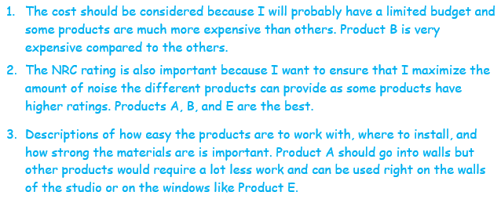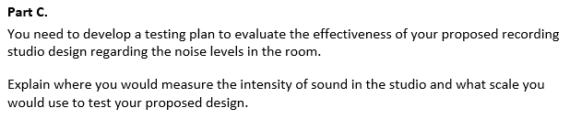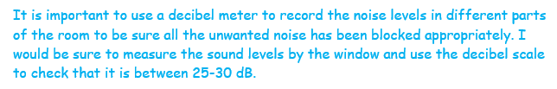 |  | 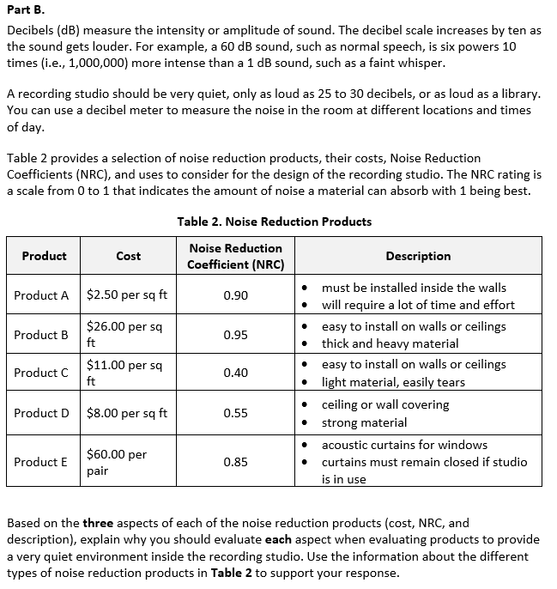
  Task 3 Prompt 3 Part A
  Connections to the Instructional Framework
  Integration of Knowledge and Skills for Response Development
  - Students are a given description of sources of unwanted noise in a recording studio and given a description of the setting.
  - Students explain why certain materials, such as sound absorbers, are good for certain functions.
  - Students construct an explanation using evidence from materials in the room and the surroundings to show that sound can travel through solid materials and that sound waves need a medium through which to travel.
  Formative Assessments | Opportunities to Learn
  Segment 1, pp. 9-10  Informal Assessment: All About Waves (A2*)  - Students accurately describe how a simple mathematical wave model corresponds to the properties of a physical phenomenon.  - Students accurately apply the simple mathematical wave model to a physical system or phenomenon to identify how the wave model characteristics correspond with physical observations. | Segment 2, p. 30  How Does Sound Move? (A10)  - The teacher opens the class by asking students, “What does sound look like?” and watching a video.  - Students develop an annotated drawing for one of the sound scenes in the video. In their drawings, they indicate changes in density (high/low areas), how the sound waves and energy are moving, that the air particles are staying near the same place, and that the density change is moving.
  Task 3 Prompt 3 Part C Complexity
  Degree and Nature of Sensemaking | Moderate | This prompt…  - Requires integration of two dimensions in the service of sense-making  - Requires integration of same or different combinations of dimensions as represented in the PE bundle
  Complexity of the Presentation | Low | - The amount and type of information provided in the scenario supports limited simple connections among ideas or concepts
  Cognitive Demand of Response Development | High | - Requires selection and application of multiple complex ideas and practices
  Cognitive Demand of Response Production | Moderate | - Responses include one or more sentences or a paragraph, a moderately complex graphic, or multiple steps in a simple or moderately complex process
  Task 3 Prompt 3 Parts B and C
  Connections to the Instructional Framework, Continued
  Formative Assessments | Opportunities to Learn
  Segment 4, pp. 20-21  Formal Assessment: Final Design Specification (A17, A18*, A19*, A20)  - Students identify the major components, including their relationships within the system, and the system boundaries to clarify the problem's definition.  - Students explain how to complete a design specification in terms of all criteria, constraints, and the different conditions for its performance. | Segment 4, pp. 34-35  Using Waves to Help People (A17, A18*, A19*, A20)  - Students finalize the design specification for a device that addresses a problem introduced through the anchoring phenomenon, in this case, helping someone with sensory issues.  - Students develop an initial design on their own and then get into groups. With their group, each student shares their initial design specifications and then the group comes to consensus on a list of the three to four most important specifications for their group. As a group, they then develop a single sketch of their prototype.  Segment 4, p. 36  Into The Shark Tank (A17, A18*, A19*, A20)  - Students work in their groups to finalize their project with the goal of presenting their idea to a panel of expert “investors.”
  Task 3 Prompt 3 Part A
  Connections to the Instructional Framework, Continued
  Formative Assessments | Opportunities to Learn
  Segment 2, p. 13  Informal Assessment: Modeling Sound (A10)  - Students accurately apply a wave model to a physical system or phenomenon to identify how sound waves are pressure waves and can be either transverse or longitudinal.  Segment 2, pp. 13-14  Formal Assessment: Modeling Sound in Action (A10)  - Students accurately apply a wave model to a physical system or phenomenon to identify how sound waves are pressure waves that interact with objects and the medium they move through.  - Students identify information that explains how sound waves require the presence of a medium to travel.  Segment 2, pp. 14-15  Formal Assessment: How Does Sound Move? (A10)  - Students identify information that explains how sound waves require the presence of a medium to travel. | Segment 2, p. 30  How Do Chladni Plates Work? (A10)  - Students work either individually or in small groups to create an explanatory model for the segment phenomenon. The teacher encourages students to incorporate information from their annotated drawings, notes, or additional online research into the properties of sound and waves. Students should create a multimodal explanation that they can present in a way that makes sense for them.
  Task 3 Prompt 3 Part B Complexity
  Degree and Nature of Sensemaking | Moderate | This prompt…  - Requires integration of two dimensions in the service of sense-making  - Requires integration of same or different combinations of dimensions as represented in the PE bundle
  Complexity of the Presentation | Moderate | - The amount and type of information provided in the scenario supports multiple evident connections among ideas or concepts
  Cognitive Demand of Response Development | Moderate | - Requires application of ideas and practices given cues and guidance  - Requires drawing relationships and connecting ideas and practices
  Cognitive Demand of Response Production | Moderate | - Responses include one or more sentences or a paragraph, a moderately complex graphic, or multiple steps in a simple or moderately complex process
  Task 3 Prompt 3 Parts B and C
  Connections to the Instructional Framework
  Integration of Knowledge and Skills for Response Development
  Part B
  - Students are given a description of sources of unwanted noise in a recording studio given a description of the setting.
  - Students use a list of products available to improve the recording studio to determine the constraints of a design problem (i.e., cost, materials, and noise reduction ratings).
  Part C
  - Students determine considerations for testing the solution.
  - Students describe the need for multiple measurements/locations in the room, using a decibel meter to measure sound levels, and the required scale or dB range of sound.
  Formative Assessments | Opportunities to Learn
  Segment 4, pp. 18-19  Informal Assessment: Criteria and Constraints of a Design Solution (A17, A18*, A19* A20)  - Students identify the major components, including their relationships within the system and the system boundaries, in order to clarify the definition of the problem.  - Students explain how to complete a design specification in terms of all criteria, constraints, and the different conditions for its performance. | Segment 1, p. 28  Earthquakes: Waves of Danger (A17, A18*)  - To understand how waves transfer energy but not matter, the class explores information on recent deadly earthquakes, how buildings withstand earthquakes, and tsunami formation, and discusses why earthquakes are dangerous even when the epicenter is far away.
Future Learning Connected to evidence elicited in Task 3
Crosscutting Concepts
- Unit 4 CCCs focus on using Cause and Effect, Patterns, and Structure & Function to describe wave properties and to identify cause and effect relationships as they pertain to how the presence or absence of a medium influences wave behavior. In future high school learning experiences related to wave properties, students will use empirical evidence to differentiate between cause and correlation in wave properties and make claims about specific causes and effects (HS-PS4-1).
Disciplinary Core Ideas
- Unit 4 focuses extensively on understanding the properties and types of simple waves, the wave model of light, how the presence or absence of a medium influences their behavior, and how engineering design problems can be solved by determining success criteria and constraints related to wave properties. Students’ learning and understanding increase in sophistication beyond grade 8, where they extend their knowledge to resonance in speech and music and how information can be digitized by combining waves of different frequencies, thereby encoding and transmitting. The wave model introduced in this unit is helpful in explaining many features of electromagnetic radiation in later grades. The criteria and constraints they specify in this unit are later quantified and applied to global challenges facing humanity for potential solutions.
Science and Engineering Practices
- Unit 4 SEPs focus predominantly on asking questions and defining problems, using mathematical and computational thinking, and developing and using models, but also include planning and carrying out investigations, analyzing and interpreting data, constructing explanations, and designing solutions. Students will again visit these practices in their future learning experiences by using mathematical representations of phenomena or design solutions to describe and/or support claims and/or explanations (HS-PS-4-1). They will also evaluate questions that challenge an argument's premise(s), the interpretation of a data set, or the suitability of a design (HS-PS4-2).

